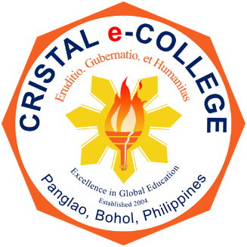
CRISTAL e-COLLEGE
Tawala, Panglao, Bohol 6340 Philippines

Quality Policy Statement

Imbued with high sense of responsibility, Cristal e-College is committed to provide quality educational opportunities to its students and professionals. The College aspires to continually improve delivery of services compliant to the needs of all interested parties.

The College is committed to provide conducive learning environment leading to knowledge, leadership, and humaneness to produce par excellent graduates who can lead local and global communities.

The College shall consistently review the policy and quality objectives regularly for continued relevance and sustainability; maintain and improve an efficient quality system.

WILL TYRON B. TIROL, Ph.D.
President

