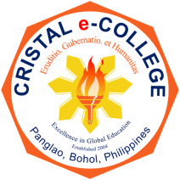 | Cristal e-College | Document Type: | DO
 | Cristal e-College | Department: | XX
 | ORGANIZATIONAL PROFILE | Document No.: | 02
 | ORGANIZATIONAL PROFILE | Issue No.: | 01
 | ORGANIZATIONAL PROFILE | Revision No.: | 01

Vision Statement

A leading institution of excellence in delivering education and training in the Philippines and
beyond.

Mission Statement

Deeply committed to promoting knowledge, humaneness and leadership.

Institutional Goals:

- Caters educational opportunities for learners to initiate generation of knowledge.

- Prepares par excellent graduates who can compassionately lead local and global communities.
- Create a highly conducive environment for teaching and non-teaching staff to thrive personally and professionally.

- Builds strong linkages, partnerships and collaborations with the local and global communities.

- Updates the equipment and facilities in providing world class amenities for the academic community.

- Translates a sturdy financial management or organizational sustainability.

Core Values:

- Highly committed

- Highly motivated

- Compassionate

- Agent of change

- Resilient

