**Daily Report**

*Task 1:*

Fixed the PDF uploading bugs while loading the web app

# Task 2:

Created Multi-page webapp for better visualizations of different templates used to generate different reference check questionaries based of the candidates resume

# Task3:

Designed the basic prompt for first analyzing the segment of the candidates resume and then passing the analysis to another chain where the reference check questionaries will be generated based on the segment analyzed.

# Task4:

# Connected the two chains using Langchain and verified the output results with a few test hits using sample resumes and job descriptions.

# 

Figure 1: Home Page

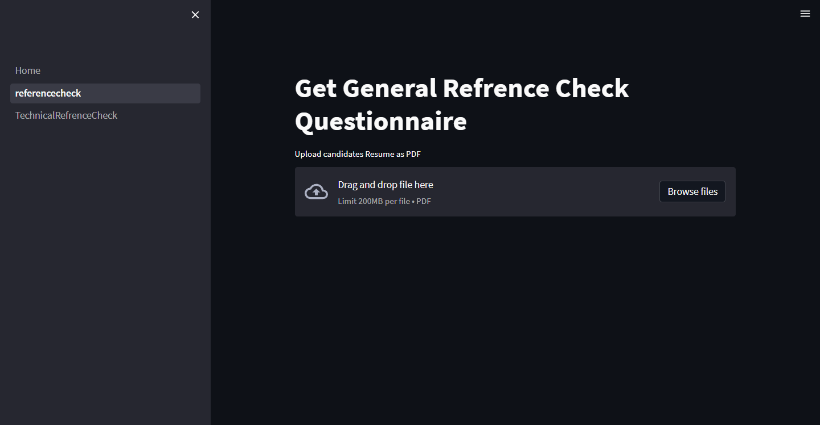

Figure 2: General Reference Check

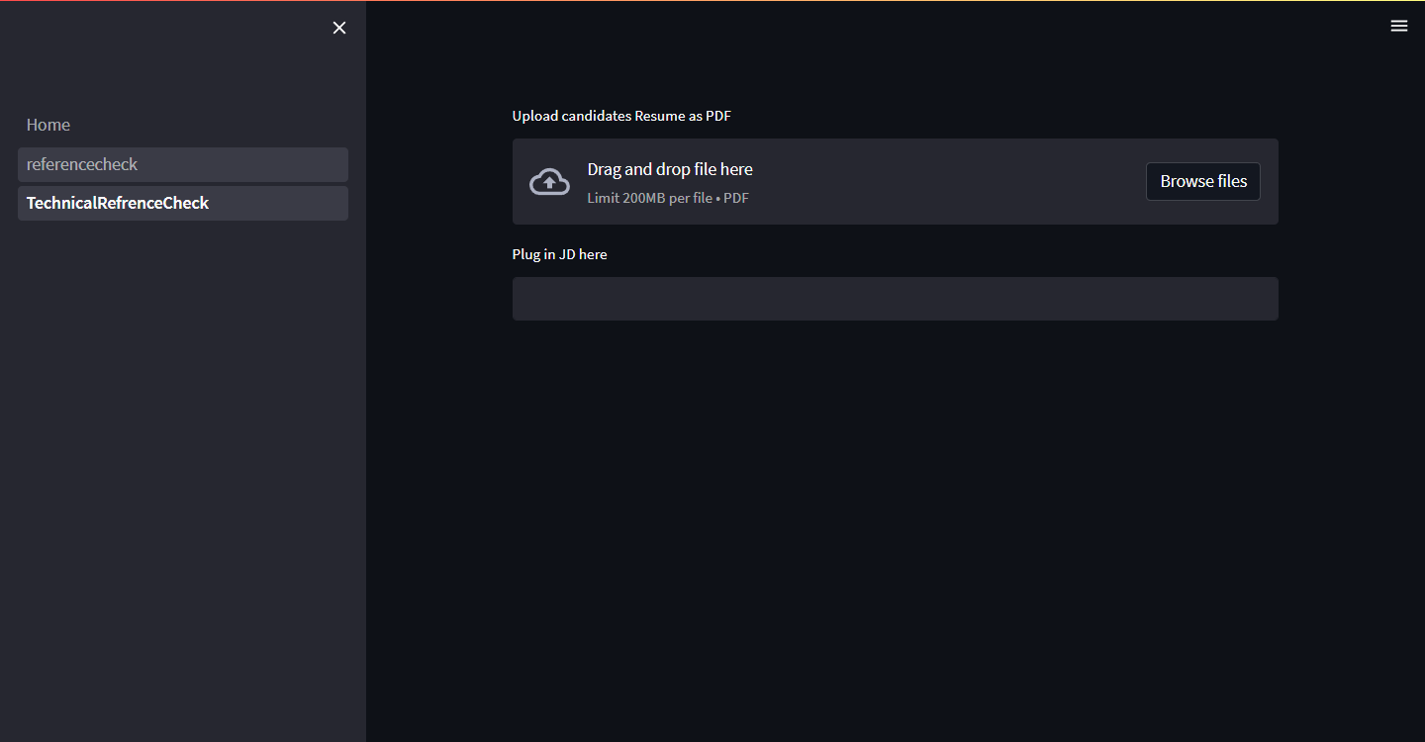

Figure 3: Technical Reference Check