**API_KEY Pricing Plan**

Buying the OPENAI_API_KEY for Development

You can buy the API_KEY of OPENAI by attaching your credit card with your OPENAI account

Link for billing overview - <https://platform.openai.com/account/billing/overview>

Hitting the link, it will land you to the page mentioned below. Then you can add you credit card details with OPENAI using the “Set up paid account” button.

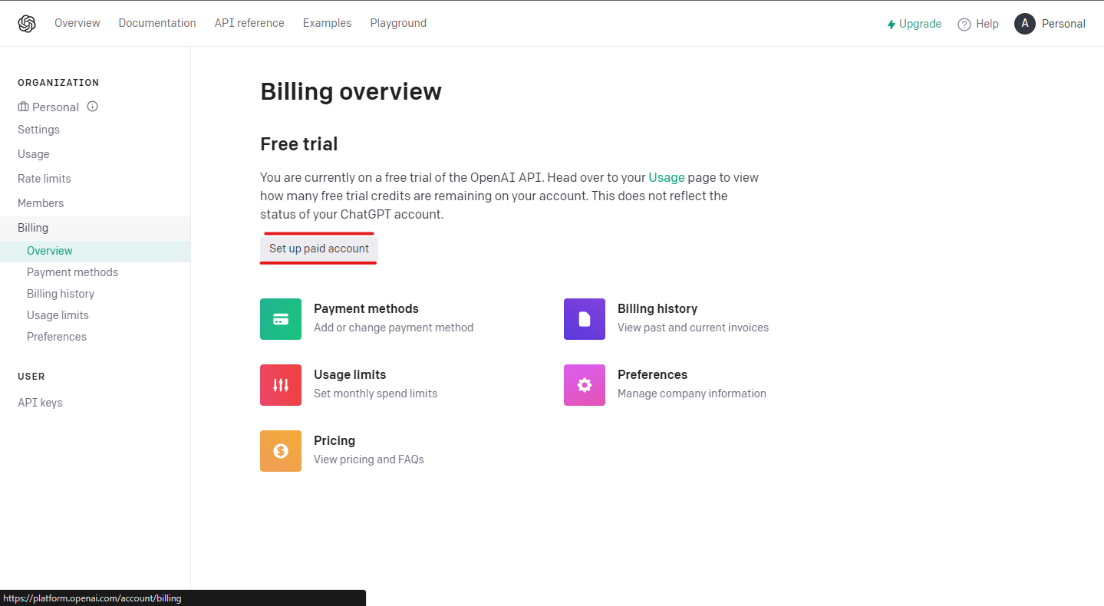

Once this is done you can generate the API key using the API keys button under USER section on the left side.

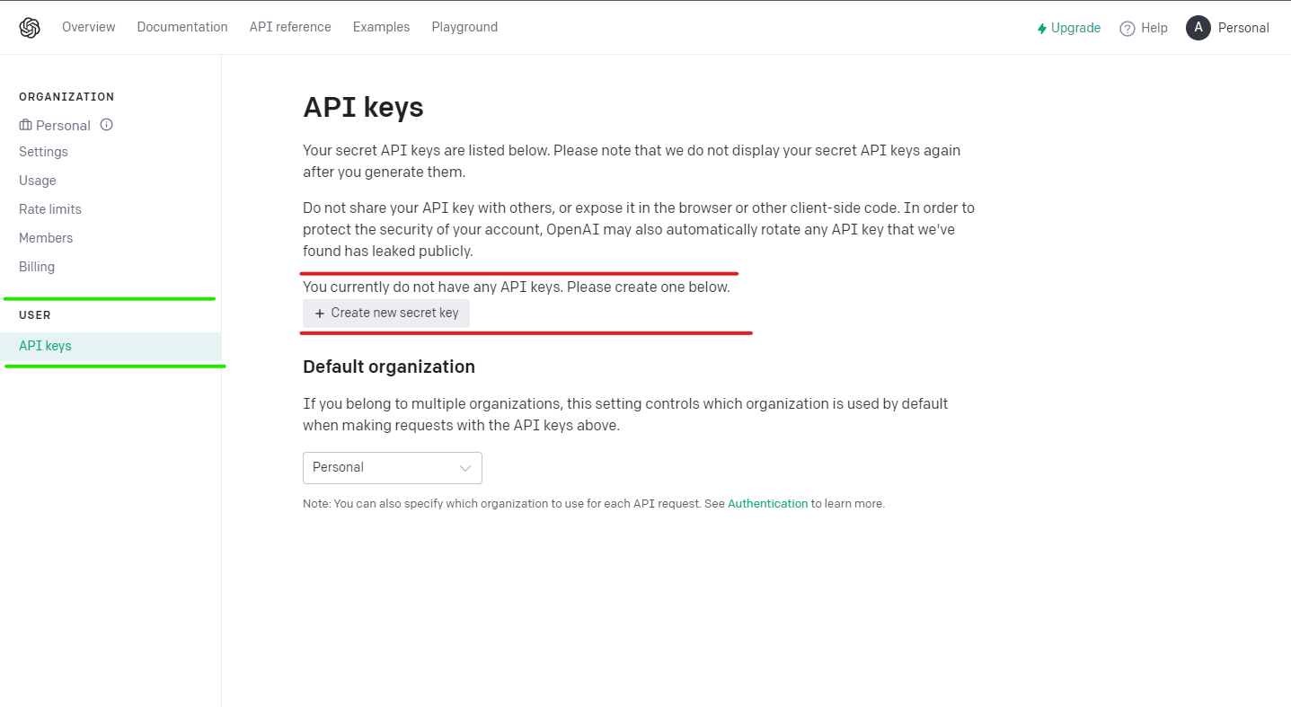Now the API key is fully setup for usage in development.

Cost of the API_Key

Link - <https://openai.com/pricing>

The cost of the apikey depends on the number of hit you make with that key and which model you are using according to your problem statement. The cost is per 1000 tokens and varies from model to model.

According to the problem statement of project 1 the most suited models will be GPT-3.5-Turbo and Davinci. The pricing of them is mentioned below for 1000 tokens. Based on the number of hits made with the API_KEY OPENAI will bill you.

GPT-3.5-Turbo Pricing

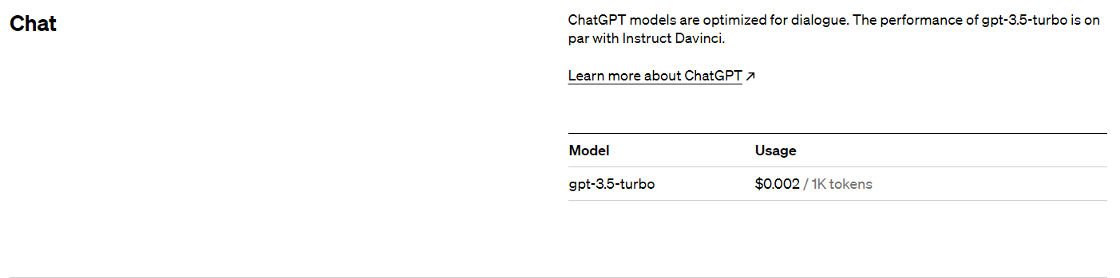

Davince Pricing

