**Projektinitiative**

**Ein Web- und Cloudbasiertes Multiple-Kernel   
 Eco-System für die automatisierte Erstellung   
 von analytischen Berichten**



Berlin

2023

**Inhaltsverzeichnis**

Bericht Block №1 9

Text Block №1 9

Tabelle №1 9

Altersverteilung für ausgewählte Länder nach WHO: Albania,Algeria,American Samoa,Andorra,Angola,Anguilla,Antigua and Barbuda,Argentina,Armenia 9

Grafik №1 10

Altersverteilung für ausgewählte Länder nach WHO: Albania,Algeria,American Samoa,Andorra,Angola,Anguilla,Antigua and Barbuda,Argentina,Armenia 10

Bericht Block №2 11

Text Block №2 11

Tabelle №2 11

Altersverteilung für ausgewählte Länder nach WHO: Aruba,Australia,Austria,Azerbaijan,Bahamas, The,Bahrain,Bangladesh,Barbados,Belarus,Belgium 11

Grafik №2 12

Altersverteilung für ausgewählte Länder nach WHO: Aruba,Australia,Austria,Azerbaijan,Bahamas, The,Bahrain,Bangladesh,Barbados,Belarus,Belgium 12

Bericht Block №3 13

Text Block №3 13

Tabelle №3 13

Altersverteilung für ausgewählte Länder nach WHO: Belize,Benin,Bermuda,Bhutan,Bolivia,Bosnia and Herzegovina,Botswana,Brazil,British Virgin Islands,Brunei 13

Grafik №3 14

Altersverteilung für ausgewählte Länder nach WHO: Belize,Benin,Bermuda,Bhutan,Bolivia,Bosnia and Herzegovina,Botswana,Brazil,British Virgin Islands,Brunei 14

Bericht Block №4 15

Text Block №4 15

Tabelle №4 15

Altersverteilung für ausgewählte Länder nach WHO: Bulgaria,Burkina Faso,Burma,Burundi,Cabo Verde,Cambodia,Cameroon,Canada,Cayman Islands,Central African Republic 15

Grafik №4 16

Altersverteilung für ausgewählte Länder nach WHO: Bulgaria,Burkina Faso,Burma,Burundi,Cabo Verde,Cambodia,Cameroon,Canada,Cayman Islands,Central African Republic 16

Bericht Block №5 17

Text Block №5 17

Tabelle №5 17

Altersverteilung für ausgewählte Länder nach WHO: Chad,Chile,China,Colombia,Comoros,Congo, Democratic Republic of the,Congo, Republic of the,Cook Islands,Costa Rica,Cote dIvoire 17

Grafik №5 18

Altersverteilung für ausgewählte Länder nach WHO: Chad,Chile,China,Colombia,Comoros,Congo, Democratic Republic of the,Congo, Republic of the,Cook Islands,Costa Rica,Cote dIvoire 18

Bericht Block №6 19

Text Block №6 19

Tabelle №6 19

Altersverteilung für ausgewählte Länder nach WHO: Croatia,Cuba,Curacao,Cyprus,Czechia,Denmark,Djibouti,Dominica,Dominican Republic,Ecuador 19

Grafik №6 20

Altersverteilung für ausgewählte Länder nach WHO: Croatia,Cuba,Curacao,Cyprus,Czechia,Denmark,Djibouti,Dominica,Dominican Republic,Ecuador 20

Bericht Block №7 21

Text Block №7 21

Tabelle №7 21

Altersverteilung für ausgewählte Länder nach WHO: Egypt,El Salvador,Equatorial Guinea,Eritrea,Estonia,Ethiopia,Faroe Islands,Fiji,Finland,France 21

Grafik №7 22

Altersverteilung für ausgewählte Länder nach WHO: Egypt,El Salvador,Equatorial Guinea,Eritrea,Estonia,Ethiopia,Faroe Islands,Fiji,Finland,France 22

Bericht Block №8 23

Text Block №8 23

Tabelle №8 23

Altersverteilung für ausgewählte Länder nach WHO: French Polynesia,Gabon,Gambia, The,Gaza Strip,Georgia,Germany,Ghana,Gibraltar,Greece,Greenland 23

Grafik №8 24

Altersverteilung für ausgewählte Länder nach WHO: French Polynesia,Gabon,Gambia, The,Gaza Strip,Georgia,Germany,Ghana,Gibraltar,Greece,Greenland 24

Bericht Block №9 25

Text Block №9 25

Tabelle №9 25

Altersverteilung für ausgewählte Länder nach WHO: Grenada,Guam,Guatemala,Guernsey,Guinea,Guinea-Bissau,Guyana,Haiti,Honduras,Hong Kong 25

Grafik №9 26

Altersverteilung für ausgewählte Länder nach WHO: Grenada,Guam,Guatemala,Guernsey,Guinea,Guinea-Bissau,Guyana,Haiti,Honduras,Hong Kong 26

Bericht Block №10 27

Text Block №10 27

Tabelle №10 27

Altersverteilung für ausgewählte Länder nach WHO: Hungary,Iceland,India,Indonesia,Iran,Iraq,Ireland,Isle of Man,Israel,Italy 27

Grafik №10 28

Altersverteilung für ausgewählte Länder nach WHO: Hungary,Iceland,India,Indonesia,Iran,Iraq,Ireland,Isle of Man,Israel,Italy 28

Bericht Block №11 29

Text Block №11 29

Tabelle №11 29

Altersverteilung für ausgewählte Länder nach WHO: Jamaica,Japan,Jersey,Jordan,Kazakhstan,Kenya,Kiribati,Korea, North,Korea, South,Kosovo 29

Grafik №11 30

Altersverteilung für ausgewählte Länder nach WHO: Jamaica,Japan,Jersey,Jordan,Kazakhstan,Kenya,Kiribati,Korea, North,Korea, South,Kosovo 30

Bericht Block №12 31

Text Block №12 31

Tabelle №12 31

Altersverteilung für ausgewählte Länder nach WHO: Kuwait,Kyrgyzstan,Laos,Latvia,Lebanon,Lesotho,Liberia,Libya,Liechtenstein,Lithuania 31

Grafik №12 32

Altersverteilung für ausgewählte Länder nach WHO: Kuwait,Kyrgyzstan,Laos,Latvia,Lebanon,Lesotho,Liberia,Libya,Liechtenstein,Lithuania 32

Bericht Block №13 33

Text Block №13 33

Tabelle №13 33

Altersverteilung für ausgewählte Länder nach WHO: Luxembourg,Macau,Macedonia,Madagascar,Malawi,Malaysia,Maldives,Mali,Malta,Marshall Islands 33

Grafik №13 34

Altersverteilung für ausgewählte Länder nach WHO: Luxembourg,Macau,Macedonia,Madagascar,Malawi,Malaysia,Maldives,Mali,Malta,Marshall Islands 34

Bericht Block №14 35

Text Block №14 35

Tabelle №14 35

Altersverteilung für ausgewählte Länder nach WHO: Mauritania,Mauritius,Mexico,Micronesia, Federated States of,Moldova,Monaco,Mongolia,Montenegro,Montserrat,Morocco 35

Grafik №14 36

Altersverteilung für ausgewählte Länder nach WHO: Mauritania,Mauritius,Mexico,Micronesia, Federated States of,Moldova,Monaco,Mongolia,Montenegro,Montserrat,Morocco 36

Bericht Block №15 37

Text Block №15 37

Tabelle №15 37

Altersverteilung für ausgewählte Länder nach WHO: Mozambique,Namibia,Nauru,Nepal,Netherlands,New Caledonia,New Zealand,Nicaragua,Niger,Nigeria 37

Grafik №15 38

Altersverteilung für ausgewählte Länder nach WHO: Mozambique,Namibia,Nauru,Nepal,Netherlands,New Caledonia,New Zealand,Nicaragua,Niger,Nigeria 38

Bericht Block №16 39

Text Block №16 39

Tabelle №16 39

Altersverteilung für ausgewählte Länder nach WHO: Northern Mariana Islands,Norway,Oman,Pakistan,Palau,Panama,Papua New Guinea,Paraguay,Peru,Philippines 39

Grafik №16 40

Altersverteilung für ausgewählte Länder nach WHO: Northern Mariana Islands,Norway,Oman,Pakistan,Palau,Panama,Papua New Guinea,Paraguay,Peru,Philippines 40

Bericht Block №17 41

Text Block №17 41

Tabelle №17 41

Altersverteilung für ausgewählte Länder nach WHO: Poland,Portugal,Puerto Rico,Qatar,Romania,Russia,Rwanda,Saint Barthelemy,Saint Helena, Ascension, and Tristan da,Saint Kitts and Nevis 41

Grafik №17 42

Altersverteilung für ausgewählte Länder nach WHO: Poland,Portugal,Puerto Rico,Qatar,Romania,Russia,Rwanda,Saint Barthelemy,Saint Helena, Ascension, and Tristan da,Saint Kitts and Nevis 42

Bericht Block №18 43

Text Block №18 43

Tabelle №18 43

Altersverteilung für ausgewählte Länder nach WHO: Saint Lucia,Saint Martin,Saint Pierre and Miquelon,Saint Vincent and the Grenadines,Samoa,San Marino,Sao Tome and Principe,Saudi Arabia,Senegal,Serb 43

Grafik №18 44

Altersverteilung für ausgewählte Länder nach WHO: Saint Lucia,Saint Martin,Saint Pierre and Miquelon,Saint Vincent and the Grenadines,Samoa,San Marino,Sao Tome and Principe,Saudi Arabia,Senegal,Serb 44

Bericht Block №19 45

Text Block №19 45

Tabelle №19 45

Altersverteilung für ausgewählte Länder nach WHO: Seychelles,Sierra Leone,Singapore,Sint Maarten,Slovakia,Slovenia,Solomon Islands,Somalia,South Africa,South Sudan 45

Grafik №19 46

Altersverteilung für ausgewählte Länder nach WHO: Seychelles,Sierra Leone,Singapore,Sint Maarten,Slovakia,Slovenia,Solomon Islands,Somalia,South Africa,South Sudan 46

Bericht Block №20 47

Text Block №20 47

Tabelle №20 47

Altersverteilung für ausgewählte Länder nach WHO: Spain,Sri Lanka,Sudan,Suriname,Swaziland,Sweden,Switzerland,Syria,Taiwan,Tajikistan 47

Grafik №20 48

Altersverteilung für ausgewählte Länder nach WHO: Spain,Sri Lanka,Sudan,Suriname,Swaziland,Sweden,Switzerland,Syria,Taiwan,Tajikistan 48

Bericht Block №21 49

Text Block №21 49

Tabelle №21 49

Altersverteilung für ausgewählte Länder nach WHO: Tanzania,Thailand,Timor-Leste,Togo,Tonga,Trinidad and Tobago,Tunisia,Turkey,Turkmenistan,Turks and Caicos Islands 49

Grafik №21 50

Altersverteilung für ausgewählte Länder nach WHO: Tanzania,Thailand,Timor-Leste,Togo,Tonga,Trinidad and Tobago,Tunisia,Turkey,Turkmenistan,Turks and Caicos Islands 50

Bericht Block №22 51

Text Block №22 51

Tabelle №22 51

Altersverteilung für ausgewählte Länder nach WHO: Tuvalu,Uganda,Ukraine,United Arab Emirates,United Kingdom,United States,Uruguay,Uzbekistan,Vanuatu,Venezuela 51

Grafik №22 52

Altersverteilung für ausgewählte Länder nach WHO: Tuvalu,Uganda,Ukraine,United Arab Emirates,United Kingdom,United States,Uruguay,Uzbekistan,Vanuatu,Venezuela 52

Bericht Block №23 53

Text Block №23 53

Tabelle №23 53

Text Block №24 54

Tabelle №24 54

Text Block №25 55

Tabelle №25 55

Text Block №26 56

Tabelle №26 56

Text Block №27 57

Tabelle №27 57

Text Block №28 58

Tabelle №28 58

Text Block №29 59

Tabelle №29 59

Text Block №30 60

Tabelle №30 60

Figure 1 10

Figure 2 12

# Bericht Block №1

## Text Block №1

***Hinweis: Alle Text Blöcke wurde vom Python-Dokumentation kopiert!***

**Document objects**

The main Document and related objects.

**constructor**

docx.**Document**(*docx=None*)

## Tabelle №1

### Altersverteilung für ausgewählte Länder nach WHO: Albania,Algeria,American Samoa,Andorra,Angola,Anguilla,Antigua and Barbuda,Argentina,Armenia

|  | *Gesamt Population* | Altersgruppen | | | | |
| --- | --- | --- | --- | --- | --- | --- |
| Median | 0-14 | 15-24 | 25-54 | 55-64 | 65+ |
| Albania | 32.9 | 18.05 | 17.47 | 41.06 | 11.54 | 11.89 |
| Algeria | 28.1 | 29.31 | 15.3 | 42.93 | 6.81 | 5.65 |
| American Samoa | 25.5 | 30.28 | 18.79 | 36.38 | 8.58 | 5.97 |
| Andorra | 44.3 | 14.4 | 9.64 | 46.18 | 14.16 | 15.61 |
| Angola | 15.9 | 48.12 | 18.25 | 28.03 | 3.26 | 2.34 |
| Anguilla | 34.8 | 22.21 | 14.08 | 43.82 | 11.06 | 8.84 |
| Antigua and Barbuda | 31.9 | 23.09 | 16.83 | 42.19 | 9.83 | 8.06 |
| Argentina | 31.7 | 24.59 | 15.28 | 39.38 | 9.13 | 11.62 |
| Armenia | 35.1 | 18.94 | 12.89 | 43.43 | 13.41 | 11.33 |
|  | ***© Dr. Alexander Wagner. All Rights Reserved*** | | | | | |

***Hinweis: Alle Text Blöcke wurde vom Python-Dokumentation kopiert!***

**objects**

*class*docx.document.**Document**[source]

WordprocessingML (WML) document.

Not intended to be constructed directly. Use **docx.Document()** to open or create a document.

## Grafik №1

### Altersverteilung für ausgewählte Länder nach WHO: Albania,Algeria,American Samoa,Andorra,Angola,Anguilla,Antigua and Barbuda,Argentina,Armenia

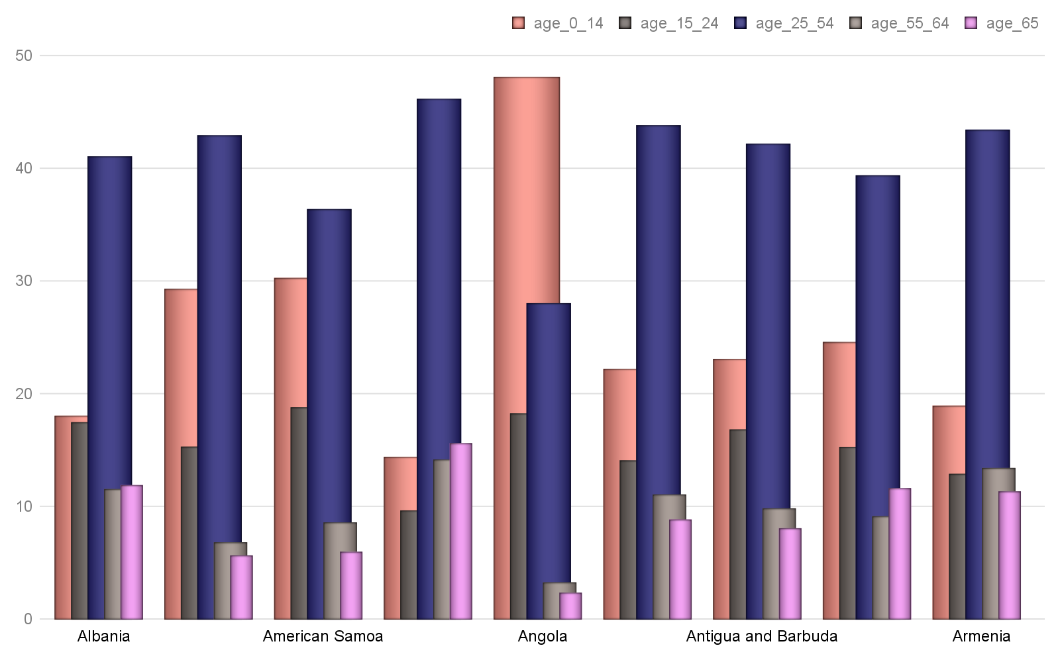

Figure 1

***Hinweis: Alle Text Blöcke wurde vom Python-Dokumentation kopiert!***

Return a heading paragraph newly added to the end of the document.

The heading paragraph will contain *text* and have its paragraph style determined by *level*. If *level* is 0, the style is set to *Title*. If *level* is 1 (or omitted), *Heading 1* is used. Otherwise the style is set to *Heading {level}*. Raises **ValueError** if *level* is outside the range 0-9.

**add_page_break**()

Return newly  object containing only a page break.

# Bericht Block №2

## Text Block №2

***Hinweis: Alle Text Blöcke wurde vom Python-Dokumentation kopiert!***

Return a paragraph newly added to the end of the document, populated with *text* and having paragraph style *style*. *text* can contain tab (\t) characters, which are converted to the appropriate XML form for a tab. *text* can also include newline (\n) or carriage return (\r) characters, each of which is converted to a line break.

**add_picture**(*image_path_or_stream*, *width=None*, *height=None*)

Return a new picture shape added in its own paragraph at the end of the document. The picture contains the image at *image_path_or_stream*, scaled based on *width* and *height*. If neither width nor height is specified, the picture appears at its native size. If only one is specified, it is used to compute a scaling factor that is then applied to the unspecified dimension, preserving the aspect ratio of the image. The native size of the picture is calculated using the dots-per-inch (dpi) value specified in the image file, defaulting to 72 dpi if no value is specified, as is often the case.

**add_section**(*start_type=2*)

## Tabelle №2

### Altersverteilung für ausgewählte Länder nach WHO: Aruba,Australia,Austria,Azerbaijan,Bahamas, The,Bahrain,Bangladesh,Barbados,Belarus,Belgium

|  | *Gesamt Population* | Altersgruppen | | | | |
| --- | --- | --- | --- | --- | --- | --- |
| Median | 0-14 | 15-24 | 25-54 | 55-64 | 65+ |
| Aruba | 39.3 | 17.64 | 12.78 | 41.72 | 14.28 | 13.59 |
| Australia | 38.7 | 17.8 | 12.79 | 41.45 | 11.83 | 16.14 |
| Austria | 44.0 | 14.01 | 11.07 | 42.42 | 13.23 | 19.26 |
| Azerbaijan | 31.3 | 22.95 | 14.84 | 45.39 | 10.17 | 6.64 |
| Bahamas, The | 32.0 | 22.55 | 16.4 | 44.14 | 9.16 | 7.75 |
| Bahrain | 32.3 | 19.08 | 15.65 | 56.04 | 6.28 | 2.95 |
| Bangladesh | 26.7 | 27.76 | 19.36 | 39.73 | 6.93 | 6.23 |
| Barbados | 38.6 | 17.97 | 12.74 | 44.06 | 13.43 | 11.81 |
| Belarus | 40.0 | 15.78 | 10.29 | 44.76 | 14.21 | 14.95 |
| Belgium | 41.4 | 17.16 | 11.34 | 40.05 | 12.86 | 18.58 |
|  | ***© Dr. Alexander Wagner. All Rights Reserved*** | | | | | |

***Hinweis: Alle Text Blöcke wurde vom Python-Dokumentation kopiert!***

**add_table**(*rows*, *cols*, *style=None*)

Add a table having row and column counts of *rows* and *cols* respectively and table style of *style*. *style* may be a paragraph style object or a paragraph style name. If *style* is **None**, the table inherits the default table style of the document.

**core_properties**

A **CoreProperties** object providing read/write access to the core properties of this document.

## Grafik №2

### Altersverteilung für ausgewählte Länder nach WHO: Aruba,Australia,Austria,Azerbaijan,Bahamas, The,Bahrain,Bangladesh,Barbados,Belarus,Belgium

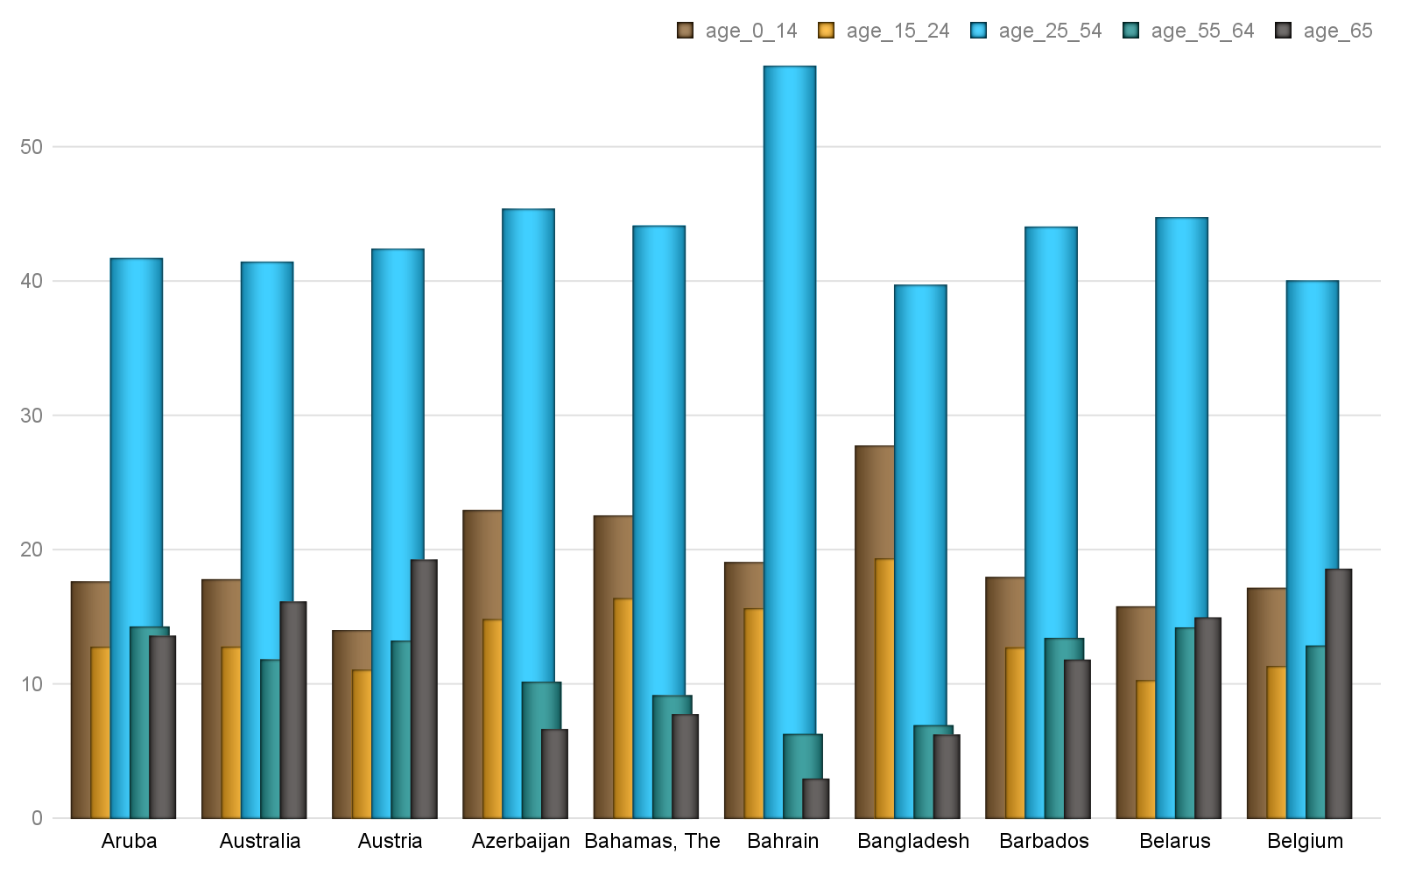

Figure 2

***Hinweis: Alle Text Blöcke wurde vom Python-Dokumentation kopiert!***

An **InlineShapes** object providing access to the inline shapes in this document. An inline shape is a graphical object, such as a picture, contained in a run of text and behaving like a character glyph, being flowed like other text in a paragraph.

**paragraphs**

A list of  instances corresponding to the paragraphs in the document, in document order. Note that paragraphs within revision marks such as <w:ins> or <w:del> do not appear in this list.

**part**

# Bericht Block №3

## Text Block №3

***Hinweis: Alle Text Blöcke wurde vom Python-Dokumentation kopiert!***

**save**(*path_or_stream*)

Save this document to *path_or_stream*, which can be either a path to a filesystem location (a string) or a file-like object.

**sections**

 object providing access to each section in this document.

## Tabelle №3

### Altersverteilung für ausgewählte Länder nach WHO: Belize,Benin,Bermuda,Bhutan,Bolivia,Bosnia and Herzegovina,Botswana,Brazil,British Virgin Islands,Brunei

|  | *Gesamt Population* | Altersgruppen | | | | |
| --- | --- | --- | --- | --- | --- | --- |
| Median | 0-14 | 15-24 | 25-54 | 55-64 | 65+ |
| Belize | 22.7 | 33.95 | 20.55 | 36.62 | 4.99 | 3.89 |
| Benin | 18.2 | 42.65 | 20.44 | 30.44 | 3.61 | 2.87 |
| Bermuda | 43.4 | 17.04 | 12.0 | 37.24 | 15.73 | 17.98 |
| Bhutan | 27.6 | 25.8 | 18.81 | 43.07 | 6.03 | 6.29 |
| Bolivia | 24.3 | 31.85 | 19.46 | 37.48 | 5.9 | 5.3 |
| Bosnia and Herzegovin | 42.1 | 13.29 | 11.58 | 45.88 | 14.83 | 14.43 |
| Botswana | 24.5 | 31.95 | 18.91 | 38.45 | 5.46 | 5.23 |
| Brazil | 32.0 | 22.33 | 16.36 | 43.86 | 9.12 | 8.33 |
| British Virgin Island | 36.5 | 16.7 | 13.37 | 49.37 | 11.6 | 8.97 |
| Brunei | 30.2 | 23.12 | 17.05 | 46.75 | 8.23 | 4.84 |
|  | ***© Dr. Alexander Wagner. All Rights Reserved*** | | | | | |

***Hinweis: Alle Text Blöcke wurde vom Python-Dokumentation kopiert!***

A  object providing access to the document-level settings for this document.

**styles**

A  object providing access to the styles in this document.

**tables**

## Grafik №3

### Altersverteilung für ausgewählte Länder nach WHO: Belize,Benin,Bermuda,Bhutan,Bolivia,Bosnia and Herzegovina,Botswana,Brazil,British Virgin Islands,Brunei

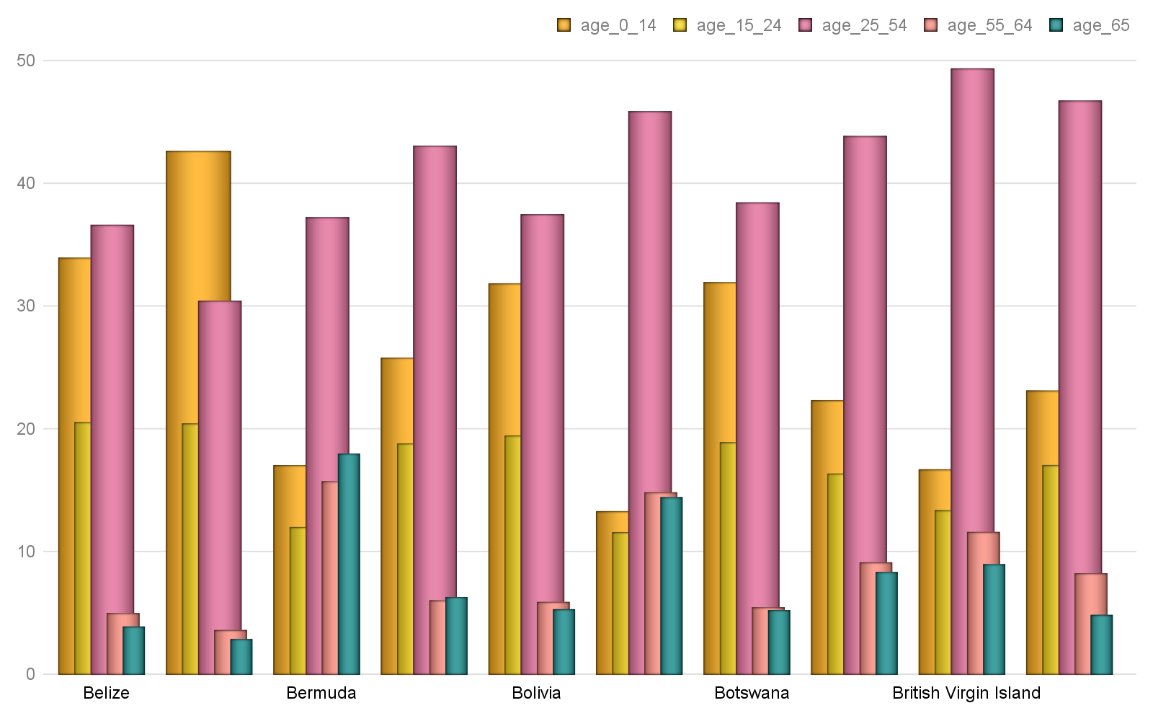

***Hinweis: Alle Text Blöcke wurde vom Python-Dokumentation kopiert!***

**objects**

Each **Document** object provides access to its **CoreProperties** object via its **core_properties** attribute. A **CoreProperties** object provides read/write access to the so-called *core properties* for the document. The core properties are author, category, comments, content_status, created, identifier, keywords, language, last_modified_by, last_printed, modified, revision, subject, title, and version.

Each property is one of three types, **str**, **datetime.datetime**, or . String properties are limited in length to 255 characters and return an empty string (‘’) if not set. Date properties are assigned and returned as **datetime.datetime** objects without timezone, i.e. in UTC. Any timezone conversions are the responsibility of the client. Date properties return **None** if not set.

python-docx does not automatically set any of the document core properties other than to add a core properties part to a presentation that doesn’t have one (very uncommon). If python-docx adds a core properties part, it contains default values for the title, last_modified_by, revision, and modified properties. Client code should update properties like revision and last_modified_by if that behavior is desired.

# Bericht Block №4

## Text Block №4

***Hinweis: Alle Text Blöcke wurde vom Python-Dokumentation kopiert!***

**author**

*string* – An entity primarily responsible for making the content of the resource.

**category**

*string* – A categorization of the content of this package. Example values might include: Resume, Letter, Financial Forecast, Proposal, or Technical Presentation.

## Tabelle №4

### Altersverteilung für ausgewählte Länder nach WHO: Bulgaria,Burkina Faso,Burma,Burundi,Cabo Verde,Cambodia,Cameroon,Canada,Cayman Islands,Central African Republic

|  | *Gesamt Population* | Altersgruppen | | | | |
| --- | --- | --- | --- | --- | --- | --- |
| Median | 0-14 | 15-24 | 25-54 | 55-64 | 65+ |
| Bulgaria | 42.7 | 14.58 | 9.58 | 43.21 | 13.35 | 19.28 |
| Burkina Faso | 17.3 | 44.88 | 20.07 | 29.42 | 3.2 | 2.43 |
| Burma | 28.2 | 26.85 | 17.75 | 42.36 | 7.52 | 5.53 |
| Burundi | 17.0 | 45.57 | 19.15 | 28.74 | 3.92 | 2.63 |
| Cabo Verde | 25.4 | 29.13 | 20.11 | 39.64 | 5.94 | 5.19 |
| Cambodia | 25.3 | 31.01 | 18.36 | 40.68 | 5.69 | 4.25 |
| Cameroon | 18.5 | 42.39 | 19.56 | 30.87 | 3.98 | 3.2 |
| Canada | 42.2 | 15.44 | 11.85 | 39.99 | 14.1 | 18.63 |
| Cayman Islands | 40.0 | 18.0 | 12.41 | 42.52 | 14.47 | 12.59 |
| Central African Repub | 19.7 | 40.09 | 19.94 | 32.45 | 4.1 | 3.43 |
|  | ***© Dr. Alexander Wagner. All Rights Reserved*** | | | | | |

***Hinweis: Alle Text Blöcke wurde vom Python-Dokumentation kopiert!***

*string* – An account of the content of the resource.

**content_status**

*string* – completion status of the document, e.g. ‘draft’

**created**

## Grafik №4

### Altersverteilung für ausgewählte Länder nach WHO: Bulgaria,Burkina Faso,Burma,Burundi,Cabo Verde,Cambodia,Cameroon,Canada,Cayman Islands,Central African Republic

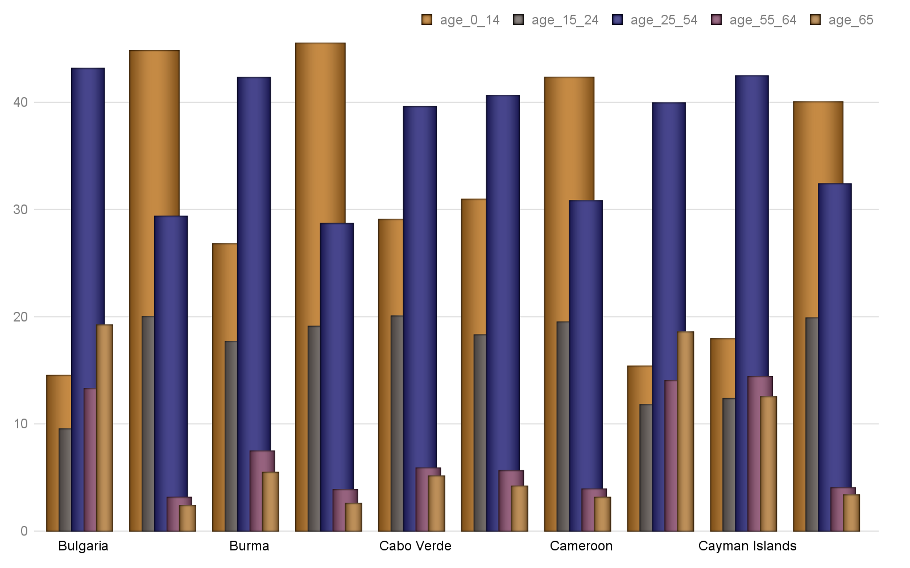

***Hinweis: Alle Text Blöcke wurde vom Python-Dokumentation kopiert!***

**identifier**

*string* – An unambiguous reference to the resource within a given context, e.g. ISBN.

**keywords**

*string* – descriptive words or short phrases likely to be used as search terms for this document

# Bericht Block №5

## Text Block №5

***Hinweis: Alle Text Blöcke wurde vom Python-Dokumentation kopiert!***

*string* – language the document is written in

**last_modified_by**

*string* – name or other identifier (such as email address) of person who last modified the document

**last_printed**

## Tabelle №5

### Altersverteilung für ausgewählte Länder nach WHO: Chad,Chile,China,Colombia,Comoros,Congo, Democratic Republic of the,Congo, Republic of the,Cook Islands,Costa Rica,Cote dIvoire

|  | *Gesamt Population* | Altersgruppen | | | | |
| --- | --- | --- | --- | --- | --- | --- |
| Median | 0-14 | 15-24 | 25-54 | 55-64 | 65+ |
| Chad | 17.8 | 43.02 | 21.46 | 28.62 | 3.88 | 3.02 |
| Chile | 34.4 | 20.11 | 15.04 | 43.08 | 10.96 | 10.81 |
| China | 37.4 | 17.15 | 12.78 | 48.51 | 10.75 | 10.81 |
| Colombia | 30.0 | 24.22 | 17.25 | 41.91 | 9.18 | 7.44 |
| Comoros | 19.9 | 39.35 | 19.53 | 32.91 | 4.27 | 3.94 |
| Congo, Democratic Rep | 18.6 | 41.74 | 21.46 | 30.53 | 3.6 | 2.67 |
| Congo, Republic of th | 19.7 | 41.67 | 17.1 | 33.89 | 4.29 | 3.06 |
| Cook Islands | 36.6 | 21.12 | 16.63 | 38.09 | 11.99 | 12.16 |
| Costa Rica | 31.3 | 22.61 | 16.35 | 44.03 | 9.2 | 7.82 |
| Cote dIvoire | 20.9 | 36.97 | 20.91 | 34.58 | 4.04 | 3.5 |
|  | ***© Dr. Alexander Wagner. All Rights Reserved*** | | | | | |

***Hinweis: Alle Text Blöcke wurde vom Python-Dokumentation kopiert!***

**modified**

*datetime* – time the document was last modified

**revision**

*int* – number of this revision, incremented by Word each time the document is saved. Note however python-docx does not automatically increment the revision number when it saves a document.

## Grafik №5

### Altersverteilung für ausgewählte Länder nach WHO: Chad,Chile,China,Colombia,Comoros,Congo, Democratic Republic of the,Congo, Republic of the,Cook Islands,Costa Rica,Cote dIvoire

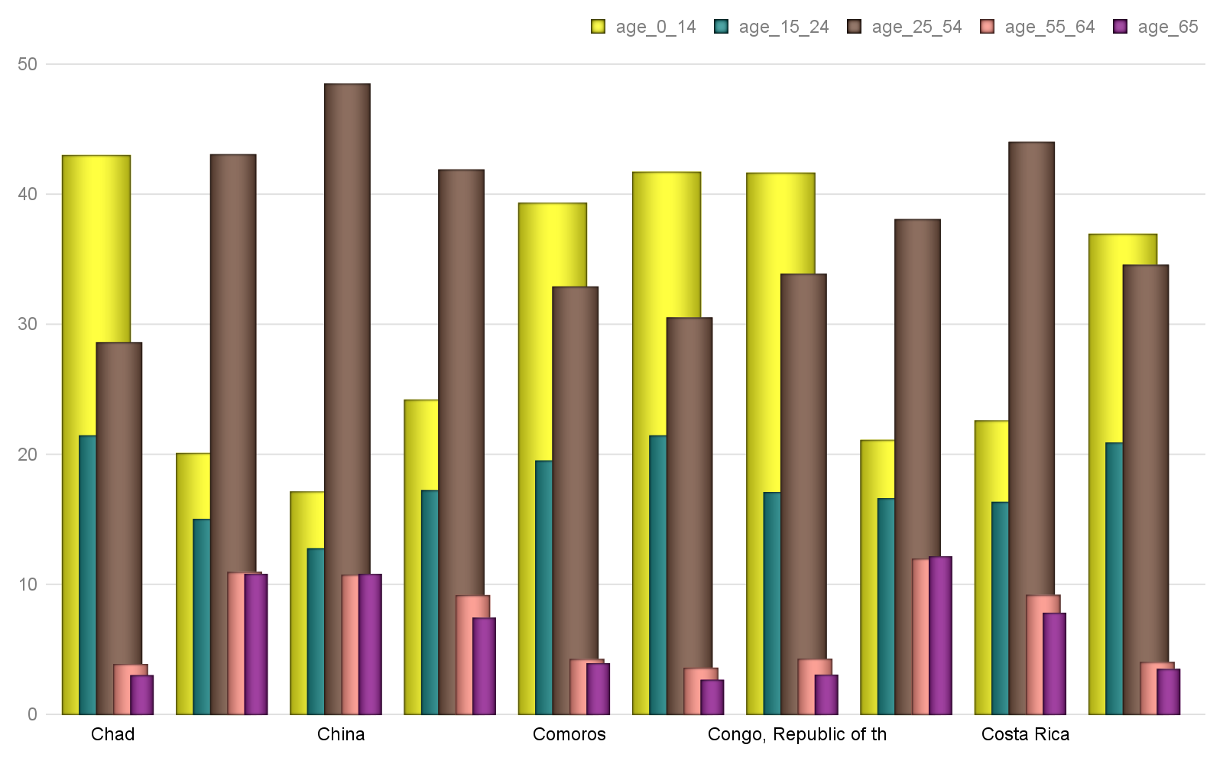

***Hinweis: Alle Text Blöcke wurde vom Python-Dokumentation kopiert!***

*string* – The topic of the content of the resource.

**title**

*string* – The name given to the resource.

**version**

# Bericht Block №6

## Text Block №6

***Hinweis: Alle Text Blöcke wurde vom Python-Dokumentation kopiert!***

**Working with Text**

To work effectively with text, it’s important to first understand a little about block-level elements like paragraphs and inline-level objects like runs.

**Block-level vs. inline text objects**

## Tabelle №6

### Altersverteilung für ausgewählte Länder nach WHO: Croatia,Cuba,Curacao,Cyprus,Czechia,Denmark,Djibouti,Dominica,Dominican Republic,Ecuador

|  | *Gesamt Population* | Altersgruppen | | | | |
| --- | --- | --- | --- | --- | --- | --- |
| Median | 0-14 | 15-24 | 25-54 | 55-64 | 65+ |
| Croatia | 43.0 | 14.21 | 11.24 | 40.43 | 14.82 | 19.31 |
| Cuba | 41.5 | 16.57 | 12.22 | 44.43 | 11.84 | 14.94 |
| Curacao | 36.1 | 20.0 | 14.33 | 36.87 | 13.69 | 15.1 |
| Cyprus | 36.8 | 15.6 | 13.81 | 47.04 | 11.45 | 12.09 |
| Czechia | 42.1 | 15.16 | 9.59 | 43.84 | 12.44 | 18.98 |
| Denmark | 42.2 | 16.41 | 13.08 | 38.76 | 12.52 | 19.23 |
| Djibouti | 23.9 | 31.14 | 21.32 | 39.03 | 4.75 | 3.76 |
| Dominica | 33.5 | 21.72 | 15.14 | 42.2 | 9.81 | 11.14 |
| Dominican Republic | 28.1 | 26.63 | 18.18 | 39.66 | 7.9 | 7.63 |
| Ecuador | 27.7 | 27.08 | 18.35 | 39.59 | 7.53 | 7.45 |
|  | ***© Dr. Alexander Wagner. All Rights Reserved*** | | | | | |

***Hinweis: Alle Text Blöcke wurde vom Python-Dokumentation kopiert!***

A block-level item flows the text it contains between its left and right edges, adding an additional line each time the text extends beyond its right boundary. For a paragraph, the boundaries are generally the page margins, but they can also be column boundaries if the page is laid out in columns, or cell boundaries if the paragraph occurs inside a table cell.

A table is also a block-level object.

An inline object is a portion of the content that occurs inside a block-level item. An example would be a word that appears in bold or a sentence in all-caps. The most common inline object is a *run*. All content within a block container is inside of an inline object. Typically, a paragraph contains one or more runs, each of which contain some part of the paragraph’s text.

The attributes of a block-level item specify its placement on the page, such items as indentation and space before and after a paragraph. The attributes of an inline item generally specify the font in which the content appears, things like typeface, font size, bold, and italic.

## Grafik №6

### Altersverteilung für ausgewählte Länder nach WHO: Croatia,Cuba,Curacao,Cyprus,Czechia,Denmark,Djibouti,Dominica,Dominican Republic,Ecuador

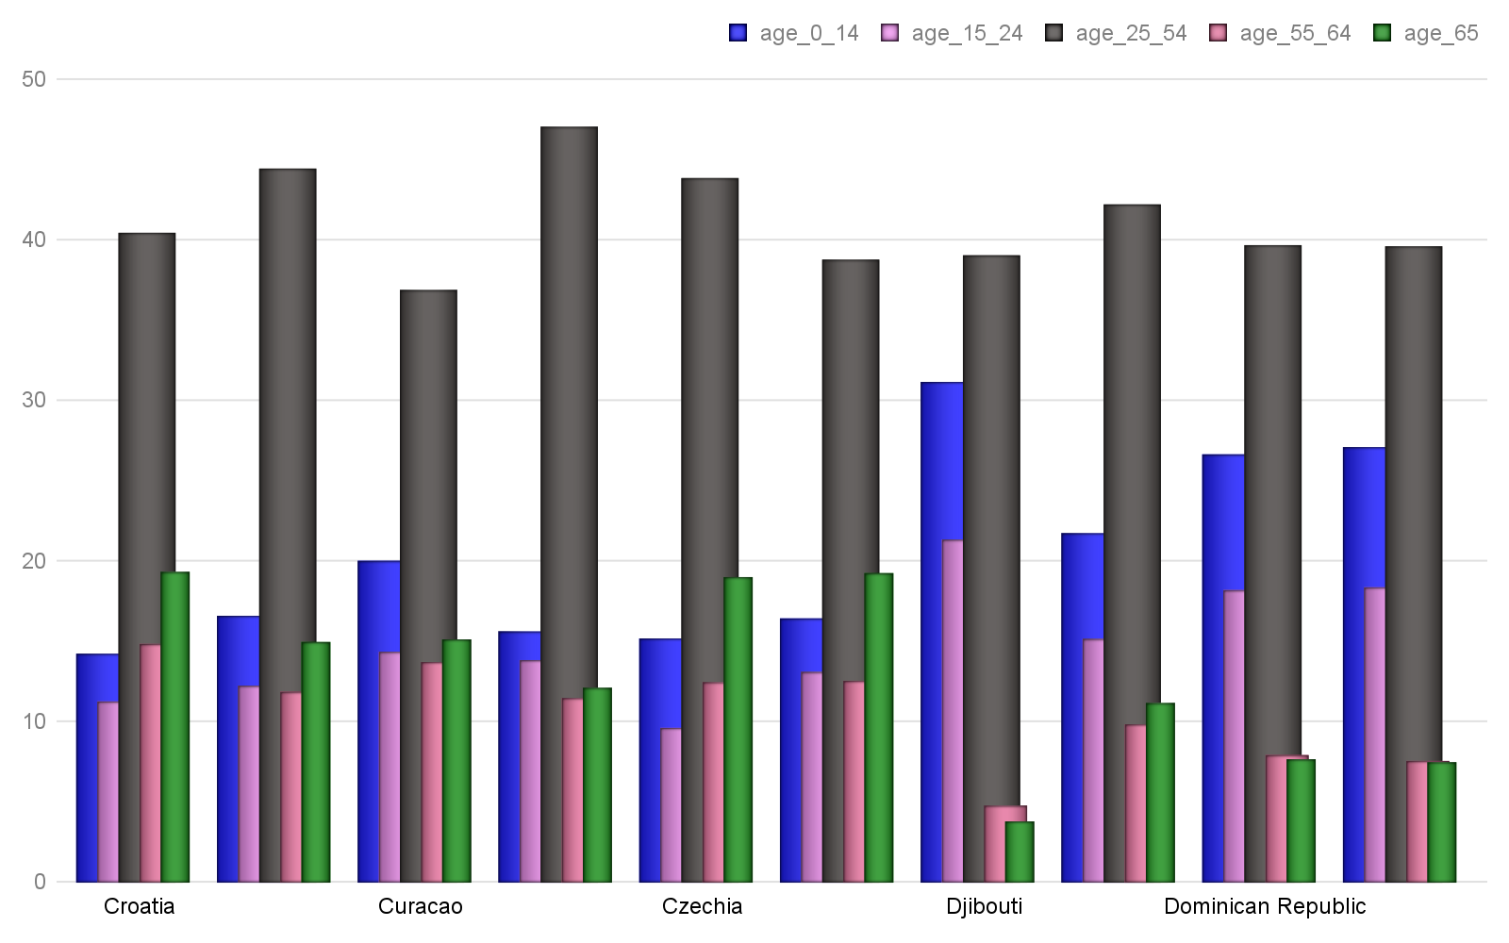

***Hinweis: Alle Text Blöcke wurde vom Python-Dokumentation kopiert!***

A paragraph has a variety of properties that specify its placement within its container (typically a page) and the way it divides its content into separate lines.

In general, it’s best to define a *paragraph style* collecting these attributes into a meaningful group and apply the appropriate style to each paragraph, rather than repeatedly apply those properties directly to each paragraph. This is analogous to how Cascading Style Sheets (CSS) work with HTML. All the paragraph properties described here can be set using a style as well as applied directly to a paragraph.

The formatting properties of a paragraph are accessed using the **ParagraphFormat** object available using the paragraph’s **paragraph_format** property.

**Horizontal alignment (justification)**

# Bericht Block №7

## Text Block №7

***Hinweis: Alle Text Blöcke wurde vom Python-Dokumentation kopiert!***

**>>> from** **docx.enum.text** **import** WD_ALIGN_PARAGRAPH

**>>>** document = Document()

**>>>** paragraph = document.add_paragraph()

**>>>** paragraph_format = paragraph.paragraph_format

## Tabelle №7

### Altersverteilung für ausgewählte Länder nach WHO: Egypt,El Salvador,Equatorial Guinea,Eritrea,Estonia,Ethiopia,Faroe Islands,Fiji,Finland,France

|  | *Gesamt Population* | Altersgruppen | | | | |
| --- | --- | --- | --- | --- | --- | --- |
| Median | 0-14 | 15-24 | 25-54 | 55-64 | 65+ |
| Egypt | 23.9 | 33.29 | 18.94 | 37.6 | 5.95 | 4.22 |
| El Salvador | 27.1 | 25.92 | 20.23 | 39.23 | 7.14 | 7.48 |
| Equatorial Guinea | 19.8 | 39.81 | 19.72 | 32.15 | 4.37 | 3.95 |
| Eritrea | 19.7 | 40.17 | 19.57 | 32.63 | 3.7 | 3.92 |
| Estonia | 42.7 | 16.23 | 8.99 | 41.37 | 13.57 | 19.85 |
| Ethiopia | 17.9 | 43.47 | 20.11 | 29.58 | 3.91 | 2.94 |
| Faroe Islands | 37.6 | 19.89 | 14.34 | 37.31 | 11.69 | 16.76 |
| Fiji | 28.9 | 27.7 | 16.13 | 41.08 | 8.53 | 6.55 |
| Finland | 42.5 | 16.43 | 11.4 | 37.78 | 13.29 | 21.1 |
| France | 41.4 | 18.53 | 11.79 | 37.78 | 12.42 | 19.48 |
|  | ***© Dr. Alexander Wagner. All Rights Reserved*** | | | | | |

***Hinweis: Alle Text Blöcke wurde vom Python-Dokumentation kopiert!***

**>>>** paragraph_format.alignment

None # indicating alignment is inherited from the style hierarchy

**>>>** paragraph_format.alignment = WD_ALIGN_PARAGRAPH.CENTER

**>>>** paragraph_format.alignment

## Grafik №7

### Altersverteilung für ausgewählte Länder nach WHO: Egypt,El Salvador,Equatorial Guinea,Eritrea,Estonia,Ethiopia,Faroe Islands,Fiji,Finland,France

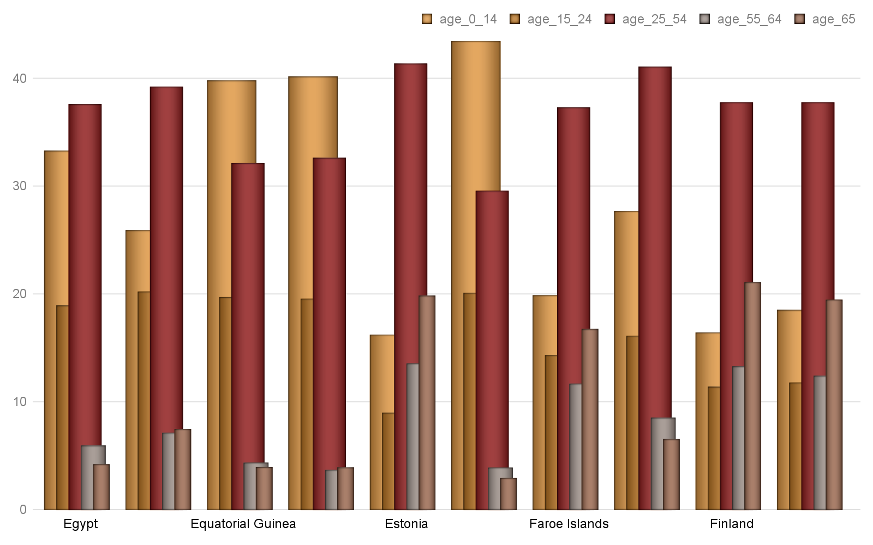

***Hinweis: Alle Text Blöcke wurde vom Python-Dokumentation kopiert!***

**Indentation**

Indentation is the horizontal space between a paragraph and edge of its container, typically the page margin. A paragraph can be indented separately on the left and right side. The first line can also have a different indentation than the rest of the paragraph. A first line indented further than the rest of the paragraph has *first line indent*. A first line indented less has a *hanging indent*.

Indentation is specified using a **Length** value, such as , , or . Negative values are valid and cause the paragraph to overlap the margin by the specified amount. A value of **None** indicates the indentation value is inherited from the style hierarchy. Assigning **None** to an indentation property removes any directly-applied indentation setting and restores inheritance from the style hierarchy:

**>>> from** **docx.shared** **import** Inches

# Bericht Block №8

## Text Block №8

***Hinweis: Alle Text Blöcke wurde vom Python-Dokumentation kopiert!***

**>>>** paragraph_format = paragraph.paragraph_format

**>>>** paragraph_format.left_indent

None # indicating indentation is inherited from the style hierarchy

## Tabelle №8

### Altersverteilung für ausgewählte Länder nach WHO: French Polynesia,Gabon,Gambia, The,Gaza Strip,Georgia,Germany,Ghana,Gibraltar,Greece,Greenland

|  | *Gesamt Population* | Altersgruppen | | | | |
| --- | --- | --- | --- | --- | --- | --- |
| Median | 0-14 | 15-24 | 25-54 | 55-64 | 65+ |
| French Polynesia | 31.9 | 22.52 | 15.73 | 44.36 | 9.42 | 7.97 |
| Gabon | 18.6 | 41.9 | 20.46 | 29.52 | 4.36 | 3.76 |
| Gambia, The | 21.0 | 37.44 | 20.47 | 34.4 | 4.2 | 3.48 |
| Gaza Strip | 17.2 | 44.78 | 21.25 | 28.02 | 3.4 | 2.54 |
| Georgia | 38.1 | 18.08 | 11.94 | 40.96 | 13.01 | 16.01 |
| Germany | 47.1 | 12.82 | 10.09 | 40.45 | 14.58 | 22.06 |
| Ghana | 21.1 | 38.01 | 18.63 | 34.14 | 4.97 | 4.25 |
| Gibraltar | 34.7 | 20.22 | 14.34 | 39.67 | 9.68 | 16.09 |
| Greece | 44.5 | 13.83 | 9.67 | 42.45 | 13.13 | 20.91 |
| Greenland | 33.9 | 21.11 | 15.48 | 41.21 | 12.96 | 9.24 |
|  | ***© Dr. Alexander Wagner. All Rights Reserved*** | | | | | |

***Hinweis: Alle Text Blöcke wurde vom Python-Dokumentation kopiert!***

**>>>** paragraph_format.left_indent

457200

**>>>** paragraph_format.left_indent.inches

0.5

## Grafik №8

### Altersverteilung für ausgewählte Länder nach WHO: French Polynesia,Gabon,Gambia, The,Gaza Strip,Georgia,Germany,Ghana,Gibraltar,Greece,Greenland

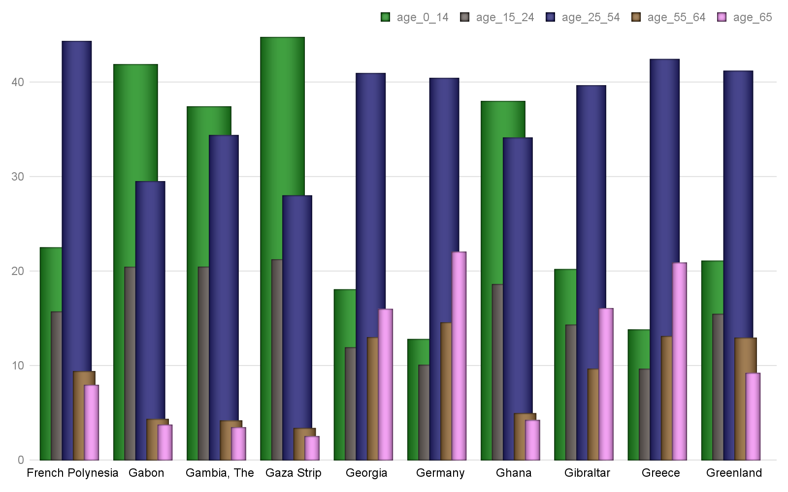

***Hinweis: Alle Text Blöcke wurde vom Python-Dokumentation kopiert!***

**>>> from** **docx.shared** **import** Pt

**>>>** paragraph_format.right_indent

None

**>>>** paragraph_format.right_indent = Pt(24)

# Bericht Block №9

## Text Block №9

***Hinweis: Alle Text Blöcke wurde vom Python-Dokumentation kopiert!***

304800

**>>>** paragraph_format.right_indent.pt

24.0

First-line indent is specified using the **first_line_indent** property and is interpreted relative to the left indent. A negative value indicates a hanging indent:

## Tabelle №9

### Altersverteilung für ausgewählte Länder nach WHO: Grenada,Guam,Guatemala,Guernsey,Guinea,Guinea-Bissau,Guyana,Haiti,Honduras,Hong Kong

|  | *Gesamt Population* | Altersgruppen | | | | |
| --- | --- | --- | --- | --- | --- | --- |
| Median | 0-14 | 15-24 | 25-54 | 55-64 | 65+ |
| Grenada | 31.5 | 23.99 | 15.03 | 40.38 | 10.52 | 10.08 |
| Guam | 29.0 | 27.54 | 16.63 | 37.44 | 9.8 | 8.59 |
| Guatemala | 22.1 | 34.5 | 21.58 | 34.12 | 5.26 | 4.54 |
| Guernsey | 43.8 | 14.51 | 11.13 | 41.67 | 13.11 | 19.58 |
| Guinea | 18.9 | 41.52 | 19.73 | 30.59 | 4.48 | 3.67 |
| Guinea-Bissau | 20.1 | 39.03 | 20.18 | 32.77 | 4.57 | 3.46 |
| Guyana | 26.2 | 26.22 | 21.56 | 38.1 | 8.03 | 6.08 |
| Haiti | 23.0 | 32.81 | 21.25 | 36.78 | 5.01 | 4.15 |
| Honduras | 23.0 | 32.95 | 21.0 | 36.63 | 5.13 | 4.29 |
| Hong Kong | 44.4 | 12.19 | 10.43 | 44.68 | 16.17 | 16.53 |
|  | ***© Dr. Alexander Wagner. All Rights Reserved*** | | | | | |

***Hinweis: Alle Text Blöcke wurde vom Python-Dokumentation kopiert!***

None

**>>>** paragraph_format.first_line_indent = Inches(-0.25)

**>>>** paragraph_format.first_line_indent

-228600

## Grafik №9

### Altersverteilung für ausgewählte Länder nach WHO: Grenada,Guam,Guatemala,Guernsey,Guinea,Guinea-Bissau,Guyana,Haiti,Honduras,Hong Kong

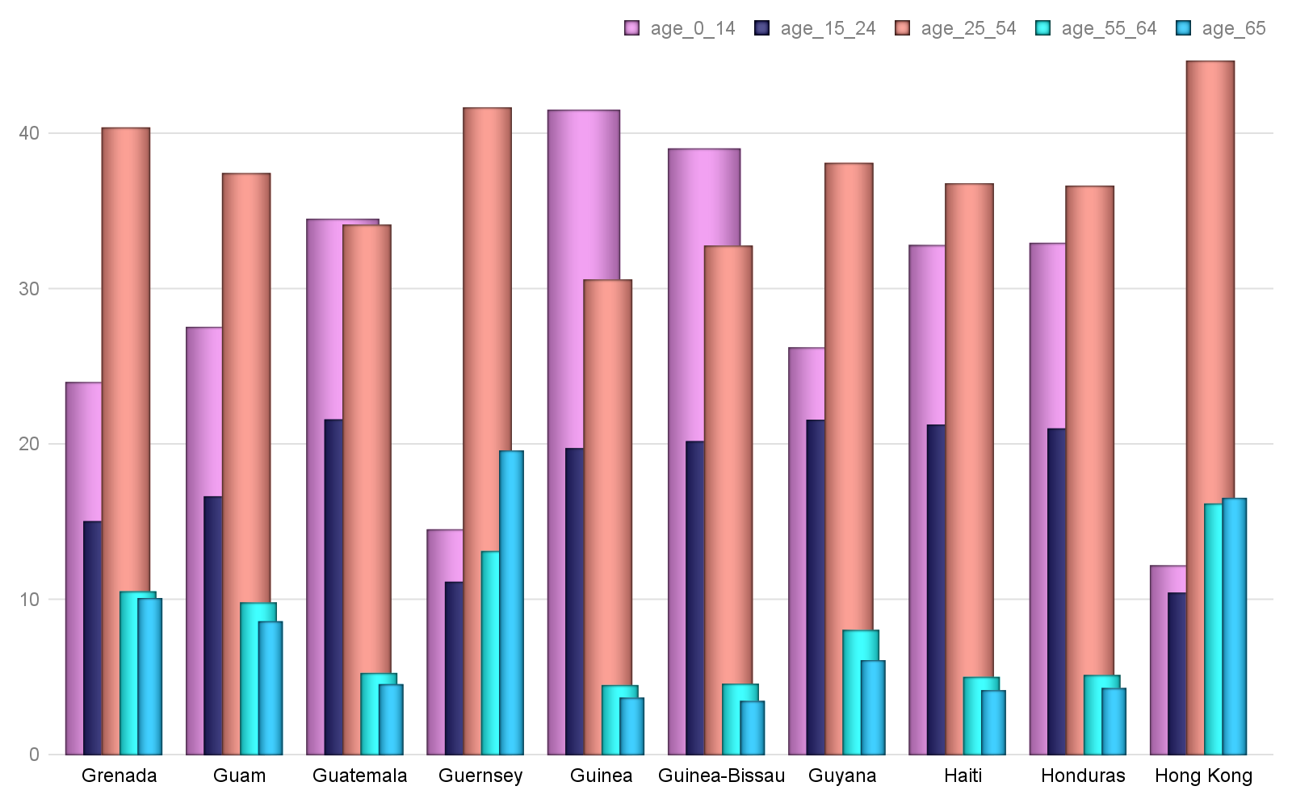

***Hinweis: Alle Text Blöcke wurde vom Python-Dokumentation kopiert!***

-0.25

**Tab stops**

A tab stop determines the rendering of a tab character in the text of a paragraph. In particular, it specifies the position where the text following the tab character will start, how it will be aligned to that position, and an optional leader character that will fill the horizontal space spanned by the tab.

The tab stops for a paragraph or style are contained in a **TabStops** object accessed using the **tab_stops** property on **ParagraphFormat**:

# Bericht Block №10

## Text Block №10

***Hinweis: Alle Text Blöcke wurde vom Python-Dokumentation kopiert!***

**>>>** tab_stops

<docx.text.tabstops.TabStops object at 0x106b802d8>

A new tab stop is added using the **add_tab_stop()** method:

**>>>** tab_stop = tab_stops.add_tab_stop(Inches(1.5))

## Tabelle №10

### Altersverteilung für ausgewählte Länder nach WHO: Hungary,Iceland,India,Indonesia,Iran,Iraq,Ireland,Isle of Man,Israel,Italy

|  | *Gesamt Population* | Altersgruppen | | | | |
| --- | --- | --- | --- | --- | --- | --- |
| Median | 0-14 | 15-24 | 25-54 | 55-64 | 65+ |
| Hungary | 42.3 | 14.71 | 10.96 | 41.88 | 13.4 | 19.05 |
| Iceland | 36.5 | 20.4 | 13.5 | 39.88 | 11.81 | 14.42 |
| India | 27.9 | 27.34 | 17.9 | 41.08 | 7.45 | 6.24 |
| Indonesia | 30.2 | 25.02 | 16.99 | 42.4 | 8.58 | 7.01 |
| Iran | 30.3 | 24.19 | 14.69 | 48.57 | 7.22 | 5.32 |
| Iraq | 20.0 | 39.46 | 19.25 | 33.84 | 3.99 | 3.46 |
| Ireland | 36.8 | 21.46 | 11.84 | 43.2 | 10.42 | 13.07 |
| Isle of Man | 44.2 | 16.28 | 11.43 | 38.79 | 13.13 | 20.36 |
| Israel | 29.9 | 27.51 | 15.53 | 37.17 | 8.46 | 11.33 |
| Italy | 45.5 | 13.65 | 9.66 | 42.16 | 12.99 | 21.53 |
|  | ***© Dr. Alexander Wagner. All Rights Reserved*** | | | | | |

***Hinweis: Alle Text Blöcke wurde vom Python-Dokumentation kopiert!***

1371600

**>>>** tab_stop.position.inches

1.5

Alignment defaults to left, but may be specified by providing a member of the  enumeration. The leader character defaults to spaces, but may be specified by providing a member of the  enumeration:

## Grafik №10

### Altersverteilung für ausgewählte Länder nach WHO: Hungary,Iceland,India,Indonesia,Iran,Iraq,Ireland,Isle of Man,Israel,Italy

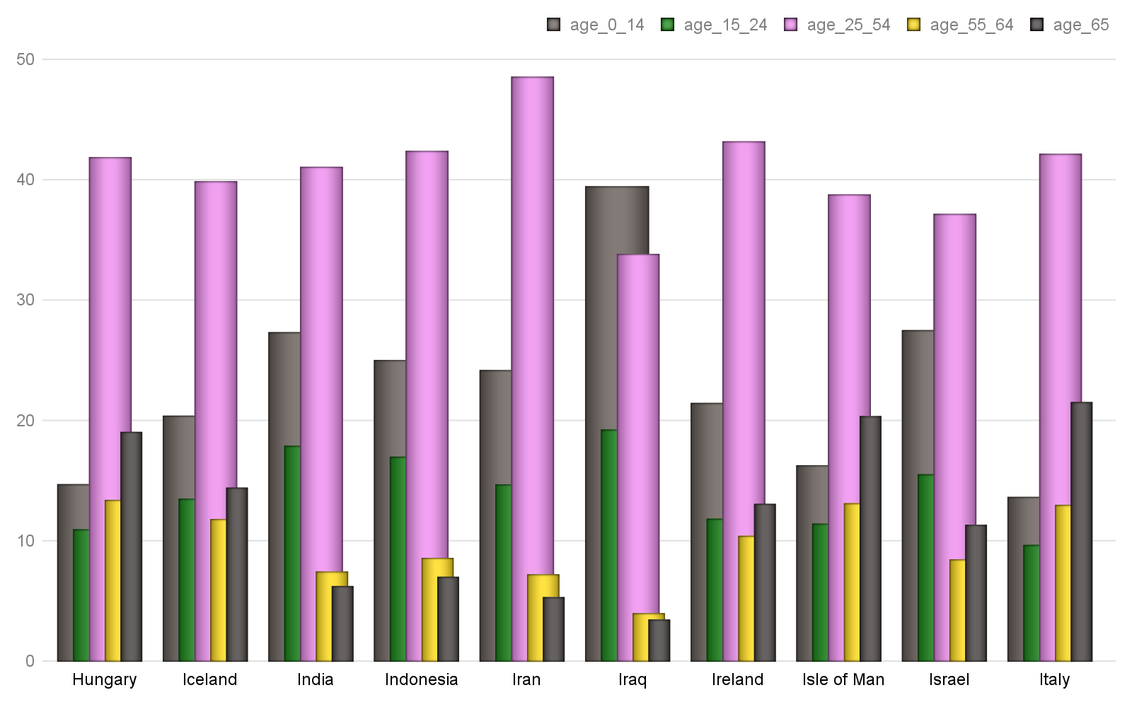

***Hinweis: Alle Text Blöcke wurde vom Python-Dokumentation kopiert!***

**>>>** tab_stop = tab_stops.add_tab_stop(Inches(1.5), WD_TAB_ALIGNMENT.RIGHT, WD_TAB_LEADER.DOTS)

**>>>** print(tab_stop.alignment)

RIGHT (2)

**>>>** print(tab_stop.leader)

# Bericht Block №11

## Text Block №11

***Hinweis: Alle Text Blöcke wurde vom Python-Dokumentation kopiert!***

Existing tab stops are accessed using sequence semantics on **TabStops**:

**>>>** tab_stops[0]

<docx.text.tabstops.TabStop object at 0x1105427e8>

More details are available in the **TabStops** and **TabStop** API documentation

## Tabelle №11

### Altersverteilung für ausgewählte Länder nach WHO: Jamaica,Japan,Jersey,Jordan,Kazakhstan,Kenya,Kiribati,Korea, North,Korea, South,Kosovo

|  | *Gesamt Population* | Altersgruppen | | | | |
| --- | --- | --- | --- | --- | --- | --- |
| Median | 0-14 | 15-24 | 25-54 | 55-64 | 65+ |
| Jamaica | 26.0 | 27.17 | 20.79 | 38.17 | 5.85 | 8.02 |
| Japan | 47.3 | 12.84 | 9.64 | 37.5 | 12.15 | 27.87 |
| Jersey | 38.0 | 16.23 | 13.91 | 40.99 | 12.53 | 16.34 |
| Jordan | 22.5 | 34.68 | 20.07 | 37.36 | 4.44 | 3.45 |
| Kazakhstan | 30.6 | 25.91 | 14.05 | 42.42 | 9.97 | 7.65 |
| Kenya | 19.7 | 40.02 | 19.15 | 33.91 | 3.92 | 3.0 |
| Kiribati | 24.6 | 29.68 | 21.07 | 38.98 | 6.04 | 4.23 |
| Korea, North | 34.0 | 20.78 | 15.59 | 44.28 | 9.77 | 9.56 |
| Korea, South | 41.8 | 13.21 | 12.66 | 45.52 | 14.49 | 14.12 |
| Kosovo | 29.1 | 25.01 | 17.22 | 42.57 | 7.92 | 7.28 |
|  | ***© Dr. Alexander Wagner. All Rights Reserved*** | | | | | |

***Hinweis: Alle Text Blöcke wurde vom Python-Dokumentation kopiert!***

The **space_before** and **space_after** properties control the spacing between subsequent paragraphs, controlling the spacing before and after a paragraph, respectively. Inter-paragraph spacing is *collapsed* during page layout, meaning the spacing between two paragraphs is the maximum of the *space_after* for the first paragraph and the *space_before* of the second paragraph. Paragraph spacing is specified as a **Length** value, often using :

**>>>** paragraph_format.space_before, paragraph_format.space_after

(None, None) # inherited by default

## Grafik №11

### Altersverteilung für ausgewählte Länder nach WHO: Jamaica,Japan,Jersey,Jordan,Kazakhstan,Kenya,Kiribati,Korea, North,Korea, South,Kosovo

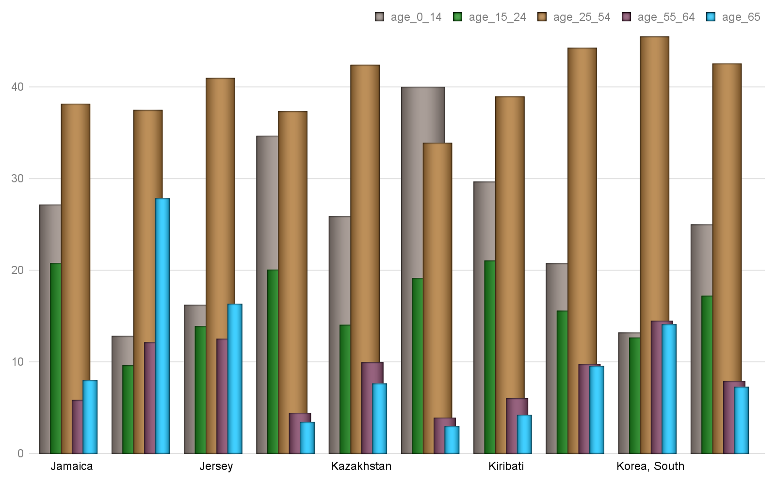

***Hinweis: Alle Text Blöcke wurde vom Python-Dokumentation kopiert!***

**>>>** paragraph_format.space_before.pt

18.0

**>>>** paragraph_format.space_after = Pt(12)

# Bericht Block №12

## Text Block №12

***Hinweis: Alle Text Blöcke wurde vom Python-Dokumentation kopiert!***

12.0

**Line spacing**

Line spacing is the distance between subsequent baselines in the lines of a paragraph. Line spacing can be specified either as an absolute distance or relative to the line height (essentially the point size of the font used). A typical absolute measure would be 18 points. A typical relative measure would be double-spaced (2.0 line heights). The default line spacing is single-spaced (1.0 line heights).

Line spacing is controlled by the interaction of the  and  properties.  is either a **Length** value, a (small-ish) **float**, or None. A **Length** value indicates an absolute distance. A **float** indicates a number of line heights. **None** indicates line spacing is inherited. **line_spacing_rule** is a member of the  enumeration or **None**:

## Tabelle №12

### Altersverteilung für ausgewählte Länder nach WHO: Kuwait,Kyrgyzstan,Laos,Latvia,Lebanon,Lesotho,Liberia,Libya,Liechtenstein,Lithuania

|  | *Gesamt Population* | Altersgruppen | | | | |
| --- | --- | --- | --- | --- | --- | --- |
| Median | 0-14 | 15-24 | 25-54 | 55-64 | 65+ |
| Kuwait | 29.3 | 25.02 | 15.1 | 52.27 | 5.07 | 2.54 |
| Kyrgyzstan | 26.5 | 30.3 | 16.79 | 39.84 | 7.8 | 5.27 |
| Laos | 23.0 | 32.76 | 21.17 | 36.7 | 5.48 | 3.89 |
| Latvia | 43.6 | 15.15 | 9.45 | 41.75 | 14.1 | 19.55 |
| Lebanon | 30.5 | 24.09 | 16.42 | 44.79 | 7.91 | 6.78 |
| Lesotho | 24.2 | 32.12 | 19.43 | 37.94 | 5.01 | 5.5 |
| Liberia | 17.8 | 43.82 | 19.56 | 30.33 | 3.43 | 2.86 |
| Libya | 28.9 | 25.84 | 17.09 | 47.28 | 5.48 | 4.31 |
| Liechtenstein | 43.2 | 15.26 | 11.65 | 41.64 | 14.03 | 17.41 |
| Lithuania | 43.7 | 15.01 | 11.09 | 40.05 | 14.17 | 19.67 |
|  | ***© Dr. Alexander Wagner. All Rights Reserved*** | | | | | |

***Hinweis: Alle Text Blöcke wurde vom Python-Dokumentation kopiert!***

**>>>** paragraph_format.line_spacing

None

**>>>** paragraph_format.line_spacing_rule

None

## Grafik №12

### Altersverteilung für ausgewählte Länder nach WHO: Kuwait,Kyrgyzstan,Laos,Latvia,Lebanon,Lesotho,Liberia,Libya,Liechtenstein,Lithuania

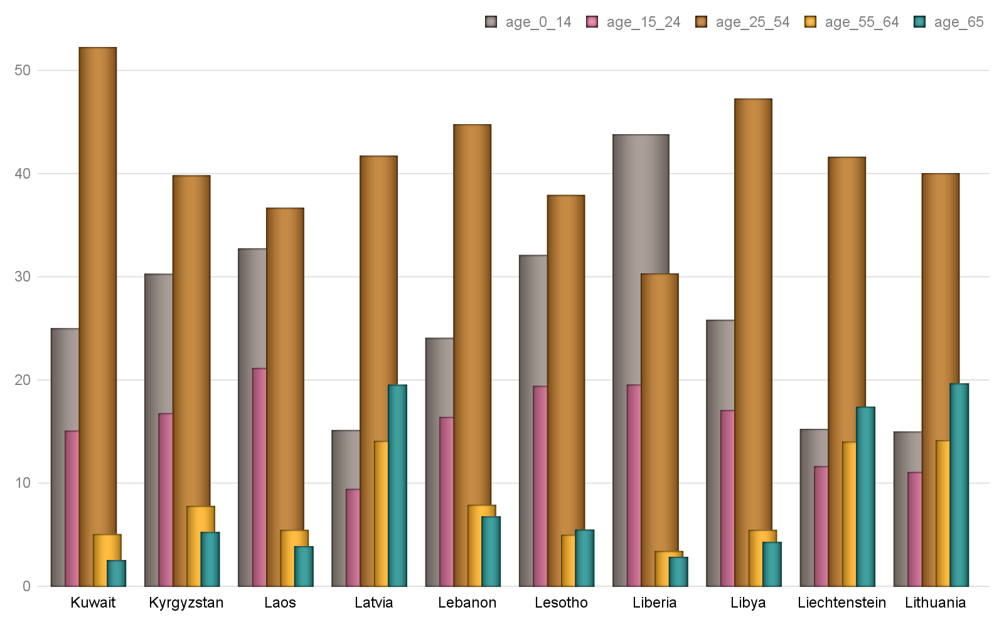

***Hinweis: Alle Text Blöcke wurde vom Python-Dokumentation kopiert!***

**>>>** paragraph_format.line_spacing = Pt(18)

**>>>** isinstance(paragraph_format.line_spacing, Length)

True

**>>>** paragraph_format.line_spacing.pt

# Bericht Block №13

## Text Block №13

***Hinweis: Alle Text Blöcke wurde vom Python-Dokumentation kopiert!***

**>>>** paragraph_format.line_spacing_rule

EXACTLY (4)

**>>>** paragraph_format.line_spacing = 1.75

## Tabelle №13

### Altersverteilung für ausgewählte Länder nach WHO: Luxembourg,Macau,Macedonia,Madagascar,Malawi,Malaysia,Maldives,Mali,Malta,Marshall Islands

|  | *Gesamt Population* | Altersgruppen | | | | |
| --- | --- | --- | --- | --- | --- | --- |
| Median | 0-14 | 15-24 | 25-54 | 55-64 | 65+ |
| Luxembourg | 39.3 | 16.77 | 12.18 | 44.27 | 11.77 | 15.02 |
| Macau | 39.3 | 14.1 | 11.73 | 50.1 | 13.5 | 10.57 |
| Macedonia | 37.9 | 17.17 | 13.41 | 43.6 | 12.41 | 13.41 |
| Madagascar | 19.7 | 39.87 | 20.34 | 32.12 | 4.38 | 3.3 |
| Malawi | 16.5 | 46.34 | 20.55 | 27.41 | 3.01 | 2.69 |
| Malaysia | 28.5 | 27.83 | 16.81 | 41.0 | 8.27 | 6.1 |
| Maldives | 28.2 | 21.4 | 20.21 | 48.1 | 5.85 | 4.45 |
| Mali | 15.8 | 48.17 | 18.84 | 26.26 | 3.7 | 3.03 |
| Malta | 41.8 | 15.04 | 11.44 | 39.98 | 13.98 | 19.56 |
| Marshall Islands | 22.9 | 34.89 | 18.0 | 37.28 | 5.82 | 4.02 |
|  | ***© Dr. Alexander Wagner. All Rights Reserved*** | | | | | |

***Hinweis: Alle Text Blöcke wurde vom Python-Dokumentation kopiert!***

1.75

**>>>** paragraph_format.line_spacing_rule

MULTIPLE (5)

**Pagination properties**

## Grafik №13

### Altersverteilung für ausgewählte Länder nach WHO: Luxembourg,Macau,Macedonia,Madagascar,Malawi,Malaysia,Maldives,Mali,Malta,Marshall Islands

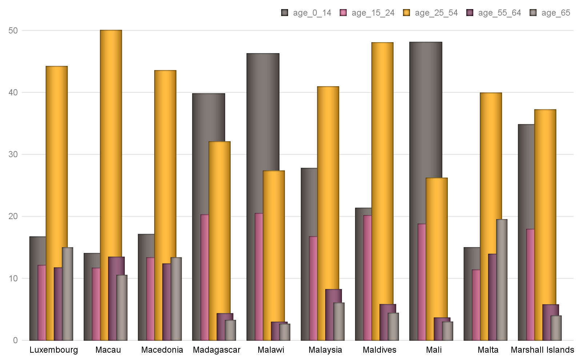

***Hinweis: Alle Text Blöcke wurde vom Python-Dokumentation kopiert!***

 causes the entire paragraph to appear on the same page, issuing a page break before the paragraph if it would otherwise be broken across two pages.

 keeps a paragraph on the same page as the subsequent paragraph. This can be used, for example, to keep a section heading on the same page as the first paragraph of the section.

 causes a paragraph to be placed at the top of a new page. This could be used on a chapter heading to ensure chapters start on a new page.

 breaks a page to avoid placing the first or last line of the paragraph on a separate page from the rest of the paragraph.

# Bericht Block №14

## Text Block №14

***Hinweis: Alle Text Blöcke wurde vom Python-Dokumentation kopiert!***

**>>>** paragraph_format.keep_together

None # all four inherit by default

**>>>** paragraph_format.keep_with_next = **True**

**>>>** paragraph_format.keep_with_next

## Tabelle №14

### Altersverteilung für ausgewählte Länder nach WHO: Mauritania,Mauritius,Mexico,Micronesia, Federated States of,Moldova,Monaco,Mongolia,Montenegro,Montserrat,Morocco

|  | *Gesamt Population* | Altersgruppen | | | | |
| --- | --- | --- | --- | --- | --- | --- |
| Median | 0-14 | 15-24 | 25-54 | 55-64 | 65+ |
| Mauritania | 20.5 | 38.56 | 19.81 | 33.21 | 4.67 | 3.76 |
| Mauritius | 35.3 | 20.16 | 14.8 | 43.74 | 11.59 | 9.71 |
| Mexico | 28.3 | 26.93 | 17.54 | 40.81 | 7.64 | 7.09 |
| Micronesia, Federated | 25.1 | 30.3 | 19.59 | 39.19 | 6.99 | 3.93 |
| Moldova | 36.7 | 18.18 | 12.32 | 43.4 | 13.46 | 12.64 |
| Monaco | 53.1 | 10.68 | 9.27 | 32.91 | 14.94 | 32.21 |
| Mongolia | 28.3 | 26.95 | 16.09 | 45.6 | 7.07 | 4.29 |
| Montenegro | 40.7 | 15.1 | 9.58 | 46.59 | 13.58 | 15.14 |
| Montserrat | 33.2 | 16.5 | 21.52 | 47.43 | 8.45 | 6.1 |
| Morocco | 29.3 | 25.77 | 17.04 | 42.32 | 8.13 | 6.74 |
|  | ***© Dr. Alexander Wagner. All Rights Reserved*** | | | | | |

***Hinweis: Alle Text Blöcke wurde vom Python-Dokumentation kopiert!***

**>>>** paragraph_format.page_break_before = **False**

**>>>** paragraph_format.page_break_before

False

**Apply character formatting**

## Grafik №14

### Altersverteilung für ausgewählte Länder nach WHO: Mauritania,Mauritius,Mexico,Micronesia, Federated States of,Moldova,Monaco,Mongolia,Montenegro,Montserrat,Morocco

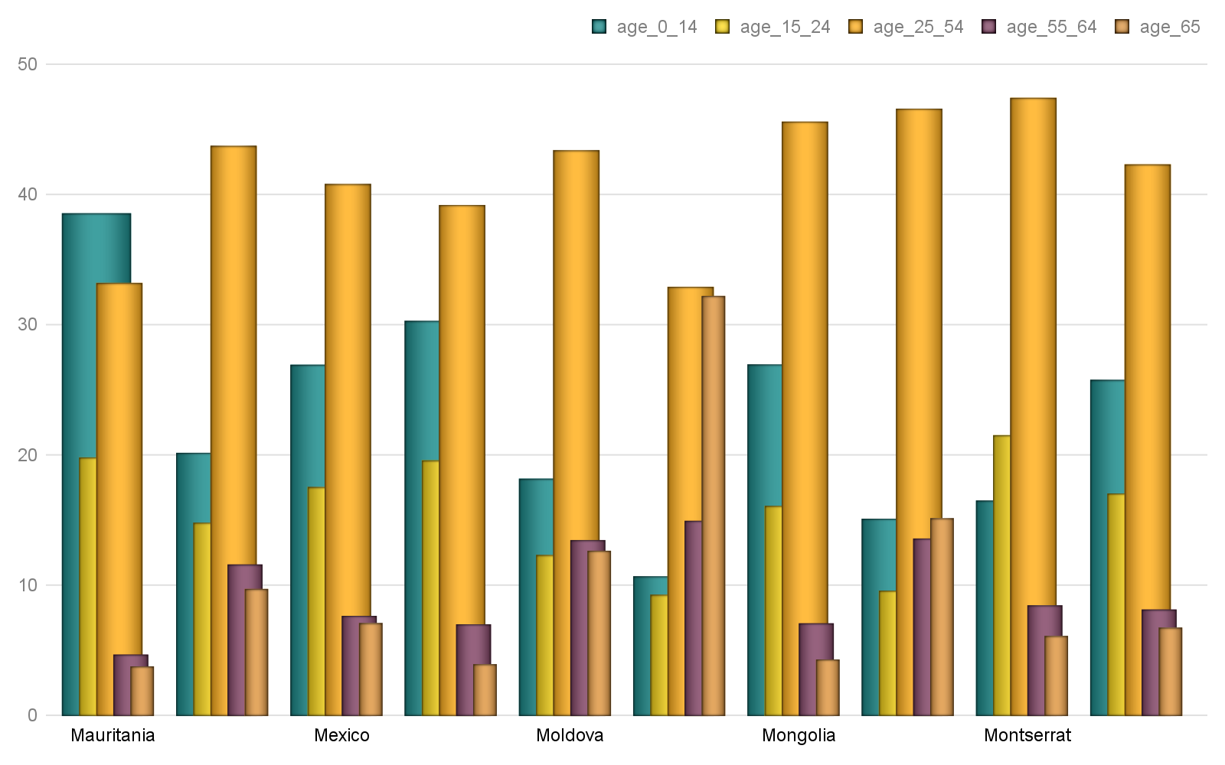

***Hinweis: Alle Text Blöcke wurde vom Python-Dokumentation kopiert!***

A  object has a read-only **font** property providing access to a  object. A run’s  object provides properties for getting and setting the character formatting for that run.

Several examples are provided here. For a complete set of the available properties, see the  API documentation.

The font for a run can be accessed like this:

**>>> from** **docx** **import** Document

# Bericht Block №15

## Text Block №15

***Hinweis: Alle Text Blöcke wurde vom Python-Dokumentation kopiert!***

**>>>** run = document.add_paragraph().add_run()

**>>>** font = run.font

Typeface and size are set like this:

**>>> from** **docx.shared** **import** Pt

## Tabelle №15

### Altersverteilung für ausgewählte Länder nach WHO: Mozambique,Namibia,Nauru,Nepal,Netherlands,New Caledonia,New Zealand,Nicaragua,Niger,Nigeria

|  | *Gesamt Population* | Altersgruppen | | | | |
| --- | --- | --- | --- | --- | --- | --- |
| Median | 0-14 | 15-24 | 25-54 | 55-64 | 65+ |
| Mozambique | 17.2 | 44.72 | 21.57 | 27.42 | 3.4 | 2.9 |
| Namibia | 21.2 | 36.97 | 20.35 | 34.37 | 4.35 | 3.96 |
| Nauru | 26.4 | 31.4 | 16.21 | 43.4 | 6.38 | 2.6 |
| Nepal | 24.1 | 30.2 | 21.73 | 36.58 | 6.32 | 5.17 |
| Netherlands | 42.6 | 16.41 | 12.07 | 39.52 | 13.28 | 18.73 |
| New Caledonia | 32.0 | 22.46 | 16.44 | 43.5 | 8.4 | 9.2 |
| New Zealand | 37.9 | 19.69 | 13.35 | 39.82 | 11.89 | 15.25 |
| Nicaragua | 25.7 | 27.24 | 21.26 | 40.24 | 5.98 | 5.28 |
| Niger | 15.4 | 49.01 | 19.1 | 25.97 | 3.28 | 2.64 |
| Nigeria | 18.4 | 42.54 | 19.61 | 30.74 | 3.97 | 3.13 |
|  | ***© Dr. Alexander Wagner. All Rights Reserved*** | | | | | |

***Hinweis: Alle Text Blöcke wurde vom Python-Dokumentation kopiert!***

**>>>** font.size = Pt(12)

Many font properties are *tri-state*, meaning they can take the values **True**, **False**, and **None**. **True** means the property is “on”, **False** means it is “off”. Conceptually, the **None** value means “inherit”. A run exists in the style inheritance hierarchy and by default inherits its character formatting from that hierarchy. Any character formatting directly applied using the  object overrides the inherited values.

Bold and italic are tri-state properties, as are all-caps, strikethrough, superscript, and many others. See the  API documentation for a full list:

**>>>** font.bold, font.italic

## Grafik №15

### Altersverteilung für ausgewählte Länder nach WHO: Mozambique,Namibia,Nauru,Nepal,Netherlands,New Caledonia,New Zealand,Nicaragua,Niger,Nigeria

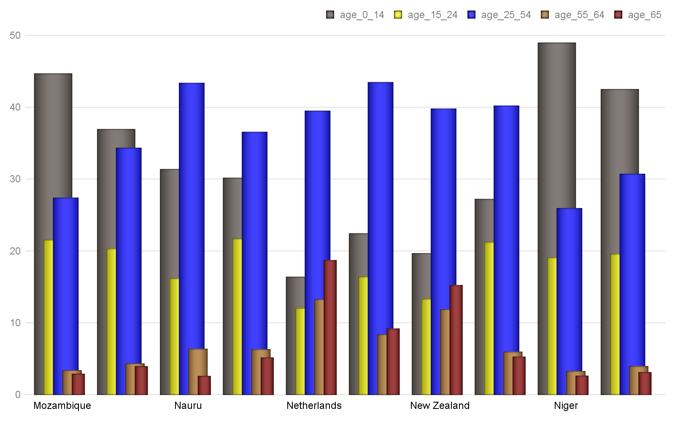

***Hinweis: Alle Text Blöcke wurde vom Python-Dokumentation kopiert!***

**>>>** font.italic = **True**

**>>>** font.italic

True

**>>>** font.italic = **False**

# Bericht Block №16

## Text Block №16

***Hinweis: Alle Text Blöcke wurde vom Python-Dokumentation kopiert!***

False

**>>>** font.italic = **None**

**>>>** font.italic

None

## Tabelle №16

### Altersverteilung für ausgewählte Länder nach WHO: Northern Mariana Islands,Norway,Oman,Pakistan,Palau,Panama,Papua New Guinea,Paraguay,Peru,Philippines

|  | *Gesamt Population* | Altersgruppen | | | | |
| --- | --- | --- | --- | --- | --- | --- |
| Median | 0-14 | 15-24 | 25-54 | 55-64 | 65+ |
| Northern Mariana Isla | 33.6 | 26.63 | 15.59 | 39.96 | 12.37 | 5.44 |
| Norway | 39.2 | 18.0 | 12.58 | 41.01 | 11.71 | 16.71 |
| Oman | 25.6 | 30.1 | 18.69 | 43.8 | 3.92 | 3.49 |
| Pakistan | 23.8 | 31.36 | 21.14 | 37.45 | 5.57 | 4.48 |
| Palau | 33.4 | 19.69 | 16.68 | 45.89 | 9.65 | 8.08 |
| Panama | 29.2 | 26.4 | 16.99 | 40.35 | 7.91 | 8.36 |
| Papua New Guinea | 23.1 | 33.43 | 19.92 | 36.89 | 5.49 | 4.28 |
| Paraguay | 28.2 | 24.56 | 19.29 | 41.08 | 7.95 | 7.12 |
| Peru | 28.0 | 26.31 | 18.31 | 40.19 | 7.78 | 7.41 |
| Philippines | 23.5 | 33.39 | 19.16 | 36.99 | 5.97 | 4.49 |
|  | ***© Dr. Alexander Wagner. All Rights Reserved*** | | | | | |

***Hinweis: Alle Text Blöcke wurde vom Python-Dokumentation kopiert!***

**>>>** font.underline

None

**>>>** font.underline = **True**

**>>>** *# or perhaps*

## Grafik №16

### Altersverteilung für ausgewählte Länder nach WHO: Northern Mariana Islands,Norway,Oman,Pakistan,Palau,Panama,Papua New Guinea,Paraguay,Peru,Philippines

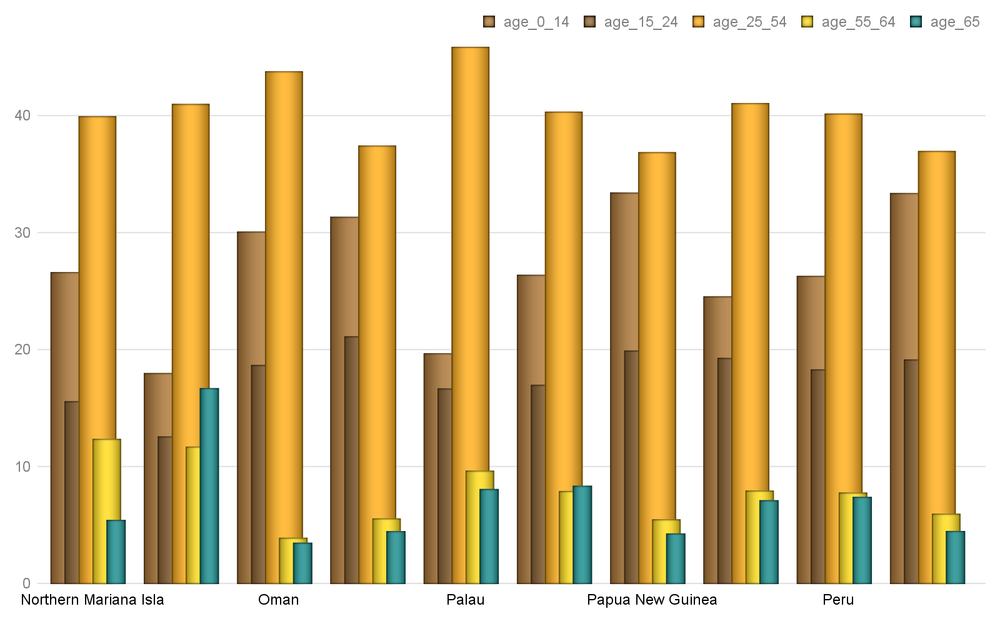

***Hinweis: Alle Text Blöcke wurde vom Python-Dokumentation kopiert!***

**Font color**

Each  object has a **ColorFormat** object that provides access to its color, accessed via its read-only **color** property.

Apply a specific RGB color to a font:

**>>> from** **docx.shared** **import** RGBColor

# Bericht Block №17

## Text Block №17

***Hinweis: Alle Text Blöcke wurde vom Python-Dokumentation kopiert!***

A font can also be set to a theme color by assigning a member of the  enumeration:

**>>> from** **docx.enum.dml** **import** MSO_THEME_COLOR

**>>>** font.color.theme_color = MSO_THEME_COLOR.ACCENT_1

A font’s color can be restored to its default (inherited) value by assigning **None** to either the **rgb** or **theme_color** attribute of **ColorFormat**:

## Tabelle №17

### Altersverteilung für ausgewählte Länder nach WHO: Poland,Portugal,Puerto Rico,Qatar,Romania,Russia,Rwanda,Saint Barthelemy,Saint Helena, Ascension, and Tristan da,Saint Kitts and Nevis

|  | *Gesamt Population* | Altersgruppen | | | | |
| --- | --- | --- | --- | --- | --- | --- |
| Median | 0-14 | 15-24 | 25-54 | 55-64 | 65+ |
| Poland | 40.7 | 14.76 | 10.7 | 43.48 | 14.21 | 16.86 |
| Portugal | 42.2 | 15.34 | 11.36 | 41.72 | 12.18 | 19.4 |
| Puerto Rico | 41.5 | 15.77 | 13.71 | 38.1 | 12.93 | 19.48 |
| Qatar | 33.2 | 12.63 | 12.35 | 70.59 | 3.42 | 1.0 |
| Romania | 41.1 | 14.35 | 10.6 | 46.03 | 12.61 | 16.41 |
| Russia | 39.6 | 17.12 | 9.46 | 44.71 | 14.44 | 14.28 |
| Rwanda | 19.0 | 41.38 | 19.34 | 32.77 | 4.09 | 2.43 |
| Saint Barthelemy | 44.1 | 16.41 | 7.24 | 43.78 | 15.83 | 16.75 |
| Saint Helena, Ascensi | 41.9 | 15.97 | 12.19 | 43.89 | 12.83 | 15.13 |
| Saint Kitts and Nevis | 35.0 | 20.32 | 14.54 | 44.6 | 11.9 | 8.64 |
|  | ***© Dr. Alexander Wagner. All Rights Reserved*** | | | | | |

***Hinweis: Alle Text Blöcke wurde vom Python-Dokumentation kopiert!***

Determining the color of a font begins with determining its color type:

**>>>** font.color.type

RGB (1)

The value of the  property can be a member of the  enumeration or None. *MSO_COLOR_TYPE.RGB* indicates it is an RGB color. *MSO_COLOR_TYPE.THEME* indicates a theme color. *MSO_COLOR_TYPE.AUTO* indicates its value is determined automatically by the application, usually set to black. (This value is relatively rare.) **None** indicates no color is applied and the color is inherited from the style hierarchy; this is the most common case.

## Grafik №17

### Altersverteilung für ausgewählte Länder nach WHO: Poland,Portugal,Puerto Rico,Qatar,Romania,Russia,Rwanda,Saint Barthelemy,Saint Helena, Ascension, and Tristan da,Saint Kitts and Nevis

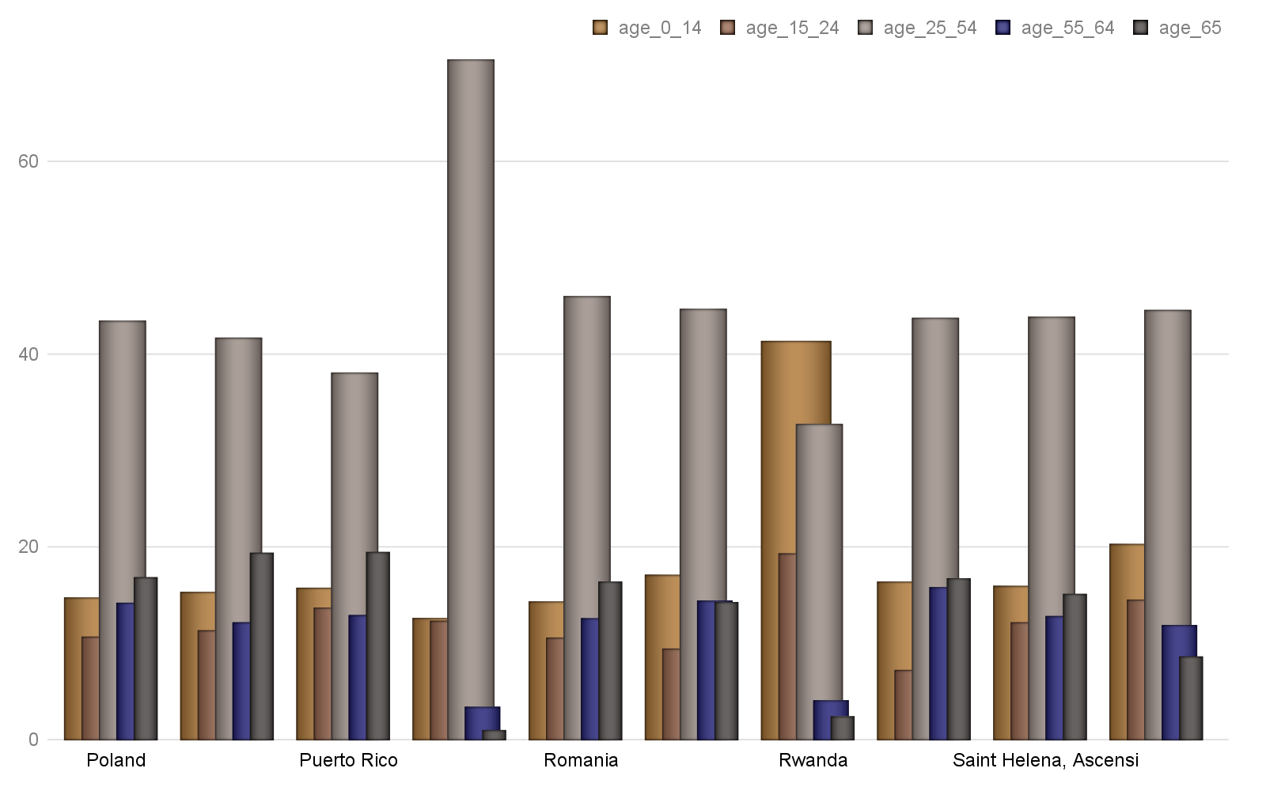

***Hinweis: Alle Text Blöcke wurde vom Python-Dokumentation kopiert!***

**>>>** font.color.rgb

RGBColor(0x42, 0x24, 0xe9)

When the color type is *MSO_COLOR_TYPE.THEME*, the **theme_color** property will be a member of  indicating the theme color:

**>>>** font.color.theme_color

# Bericht Block №18

## Text Block №18

***Hinweis: Alle Text Blöcke wurde vom Python-Dokumentation kopiert!***

**Working with Styles**

This page uses concepts developed in the prior page without introduction. If a term is unfamiliar, consult the prior page  for a definition.

**Access a style**

Styles are accessed using the **Document.styles** attribute:

## Tabelle №18

### Altersverteilung für ausgewählte Länder nach WHO: Saint Lucia,Saint Martin,Saint Pierre and Miquelon,Saint Vincent and the Grenadines,Samoa,San Marino,Sao Tome and Principe,Saudi Arabia,Senegal,Serb

|  | *Gesamt Population* | Altersgruppen | | | | |
| --- | --- | --- | --- | --- | --- | --- |
| Median | 0-14 | 15-24 | 25-54 | 55-64 | 65+ |
| Saint Lucia | 34.8 | 20.02 | 15.37 | 42.97 | 9.99 | 11.65 |
| Saint Martin | 32.5 | 26.22 | 10.35 | 46.67 | 8.74 | 8.02 |
| Saint Pierre and Miqu | 46.5 | 15.29 | 9.05 | 41.79 | 13.54 | 20.33 |
| Saint Vincent and the | 33.6 | 21.3 | 15.97 | 42.66 | 10.64 | 9.42 |
| Samoa | 24.4 | 31.35 | 19.82 | 36.33 | 6.78 | 5.72 |
| San Marino | 44.4 | 15.22 | 11.52 | 40.78 | 12.92 | 19.56 |
| Sao Tome and Principe | 18.4 | 41.85 | 20.68 | 30.82 | 3.81 | 2.83 |
| Saudi Arabia | 27.5 | 26.1 | 18.57 | 46.86 | 5.03 | 3.44 |
| Senegal | 18.8 | 41.51 | 20.33 | 31.19 | 3.98 | 2.98 |
| Serbia | 42.6 | 14.5 | 11.26 | 41.32 | 14.49 | 18.43 |
|  | ***© Dr. Alexander Wagner. All Rights Reserved*** | | | | | |

***Hinweis: Alle Text Blöcke wurde vom Python-Dokumentation kopiert!***

**>>>** styles = document.styles

**>>>** styles

<docx.styles.styles.Styles object at 0x10a7c4f50>

The  object provides dictionary-style access to defined styles by name:

## Grafik №18

### Altersverteilung für ausgewählte Länder nach WHO: Saint Lucia,Saint Martin,Saint Pierre and Miquelon,Saint Vincent and the Grenadines,Samoa,San Marino,Sao Tome and Principe,Saudi Arabia,Senegal,Serb

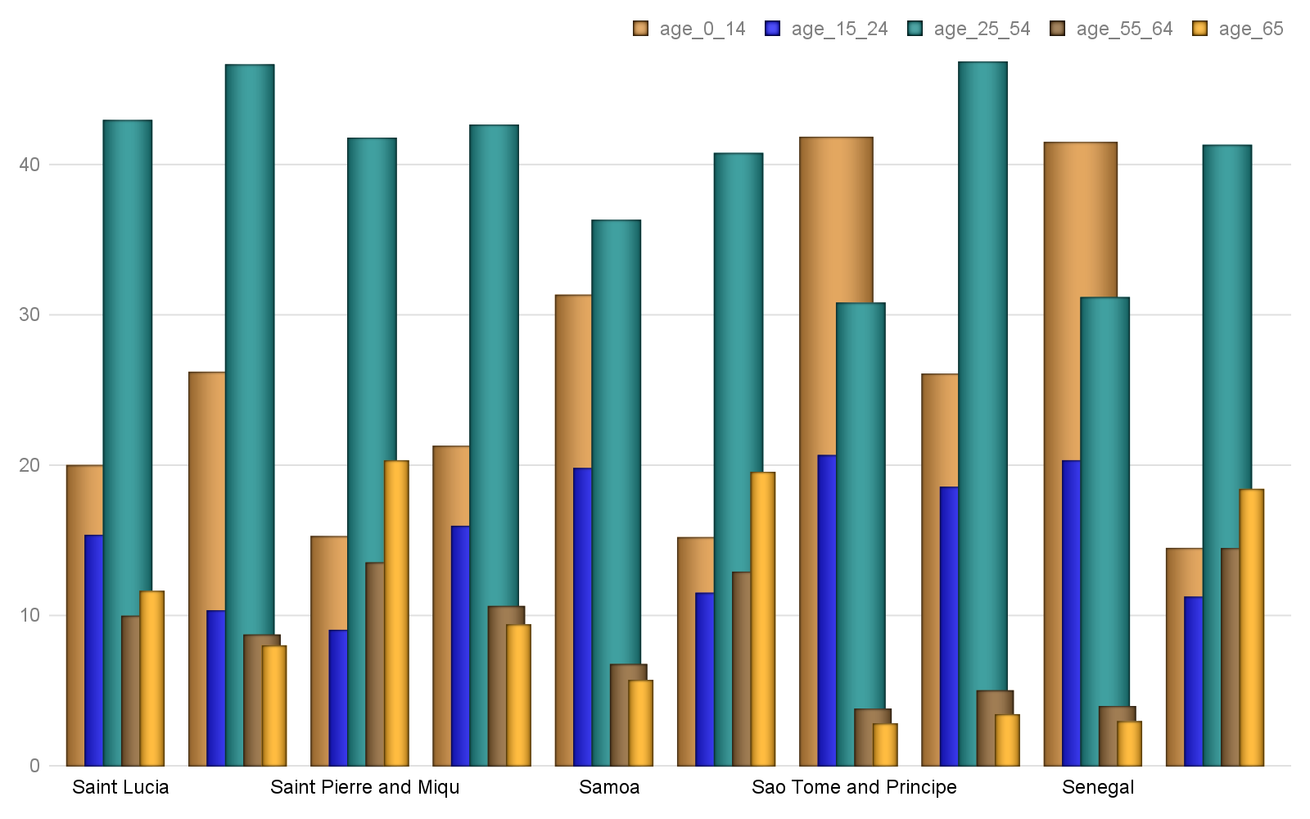

***Hinweis: Alle Text Blöcke wurde vom Python-Dokumentation kopiert!***

<docx.styles.style._ParagraphStyle object at <0x10a7c4f6b>

**Note**

Built-in styles are stored in a WordprocessingML file using their English name, e.g. ‘Heading 1’, even though users working on a localized version of Word will see native language names in the UI, e.g. ‘Kop 1’. Because python-docx operates on the WordprocessingML file, style lookups must use the English name. A document available on this external site allows you to create a mapping between local language names and English style names:

User-defined styles, also known as *custom styles*, are not localized and are accessed with the name exactly as it appears in the Word UI.

# Bericht Block №19

## Text Block №19

***Hinweis: Alle Text Blöcke wurde vom Python-Dokumentation kopiert!***

**>>> from** **docx.enum.style** **import** WD_STYLE_TYPE

**>>>** styles = document.styles

**>>>** paragraph_styles = [

**...**  s **for** s **in** styles **if** s.type == WD_STYLE_TYPE.PARAGRAPH

## Tabelle №19

### Altersverteilung für ausgewählte Länder nach WHO: Seychelles,Sierra Leone,Singapore,Sint Maarten,Slovakia,Slovenia,Solomon Islands,Somalia,South Africa,South Sudan

|  | *Gesamt Population* | Altersgruppen | | | | |
| --- | --- | --- | --- | --- | --- | --- |
| Median | 0-14 | 15-24 | 25-54 | 55-64 | 65+ |
| Seychelles | 35.4 | 19.88 | 13.24 | 49.36 | 9.88 | 7.64 |
| Sierra Leone | 19.0 | 41.82 | 18.56 | 32.16 | 3.7 | 3.76 |
| Singapore | 34.6 | 12.82 | 16.56 | 50.53 | 10.46 | 9.63 |
| Sint Maarten | 41.0 | 18.43 | 14.59 | 41.99 | 15.92 | 9.07 |
| Slovakia | 40.5 | 15.17 | 10.87 | 45.1 | 13.42 | 15.43 |
| Slovenia | 44.5 | 13.32 | 9.45 | 42.9 | 14.83 | 19.51 |
| Solomon Islands | 22.5 | 34.59 | 19.99 | 36.5 | 4.65 | 4.27 |
| Somalia | 18.1 | 43.15 | 19.04 | 31.43 | 4.2 | 2.19 |
| South Africa | 27.1 | 28.27 | 17.61 | 41.78 | 6.66 | 5.68 |
| South Sudan | 17.3 | 44.37 | 20.56 | 29.58 | 3.39 | 2.1 |
|  | ***© Dr. Alexander Wagner. All Rights Reserved*** | | | | | |

***Hinweis: Alle Text Blöcke wurde vom Python-Dokumentation kopiert!***

**>>> for** style **in** paragraph_styles:

**...**  print(style.name)

**...**

Normal

## Grafik №19

### Altersverteilung für ausgewählte Länder nach WHO: Seychelles,Sierra Leone,Singapore,Sint Maarten,Slovakia,Slovenia,Solomon Islands,Somalia,South Africa,South Sudan

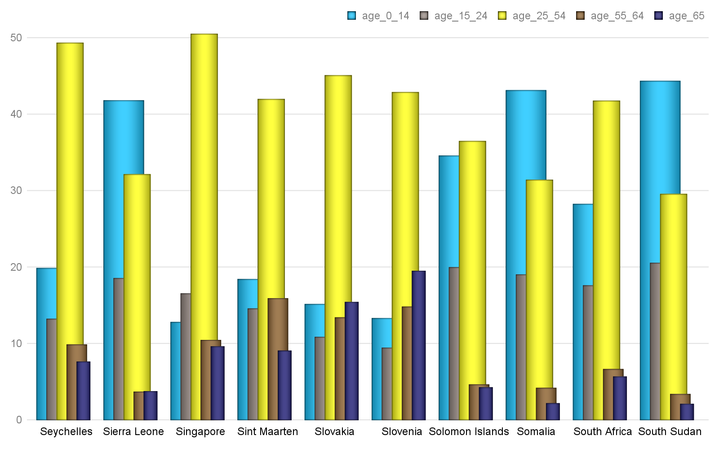

***Hinweis: Alle Text Blöcke wurde vom Python-Dokumentation kopiert!***

List Bullet

**Apply a style**

The , , and  objects each have a **style** attribute. Assigning a style object to this attribute applies that style:

**>>>** document = Document()

# Bericht Block №20

## Text Block №20

***Hinweis: Alle Text Blöcke wurde vom Python-Dokumentation kopiert!***

**>>>** paragraph.style

<docx.styles.style._ParagraphStyle object at <0x11a7c4c50>

**>>>** paragraph.style.name

'Normal'

## Tabelle №20

### Altersverteilung für ausgewählte Länder nach WHO: Spain,Sri Lanka,Sudan,Suriname,Swaziland,Sweden,Switzerland,Syria,Taiwan,Tajikistan

|  | *Gesamt Population* | Altersgruppen | | | | |
| --- | --- | --- | --- | --- | --- | --- |
| Median | 0-14 | 15-24 | 25-54 | 55-64 | 65+ |
| Spain | 42.7 | 15.38 | 9.58 | 44.91 | 12.14 | 17.98 |
| Sri Lanka | 32.8 | 24.06 | 14.63 | 41.58 | 10.06 | 9.67 |
| Sudan | 19.9 | 38.68 | 21.04 | 32.77 | 4.24 | 3.27 |
| Suriname | 29.8 | 24.62 | 17.44 | 44.4 | 7.54 | 6.01 |
| Swaziland | 21.7 | 35.01 | 22.12 | 34.6 | 4.3 | 3.97 |
| Sweden | 41.2 | 17.43 | 11.31 | 39.42 | 11.58 | 20.26 |
| Switzerland | 42.4 | 15.16 | 10.88 | 43.21 | 12.6 | 18.15 |
| Syria | 24.3 | 31.62 | 19.54 | 39.22 | 5.41 | 4.21 |
| Taiwan | 40.7 | 12.88 | 12.88 | 46.41 | 14.12 | 13.72 |
| Tajikistan | 24.5 | 32.33 | 18.61 | 40.12 | 5.62 | 3.32 |
|  | ***© Dr. Alexander Wagner. All Rights Reserved*** | | | | | |

***Hinweis: Alle Text Blöcke wurde vom Python-Dokumentation kopiert!***

**>>>** paragraph.style.name

'Heading 1'

A style name can also be assigned directly, in which case python-docx will do the lookup for you:

**>>>** paragraph.style = 'List Bullet'

## Grafik №20

### Altersverteilung für ausgewählte Länder nach WHO: Spain,Sri Lanka,Sudan,Suriname,Swaziland,Sweden,Switzerland,Syria,Taiwan,Tajikistan

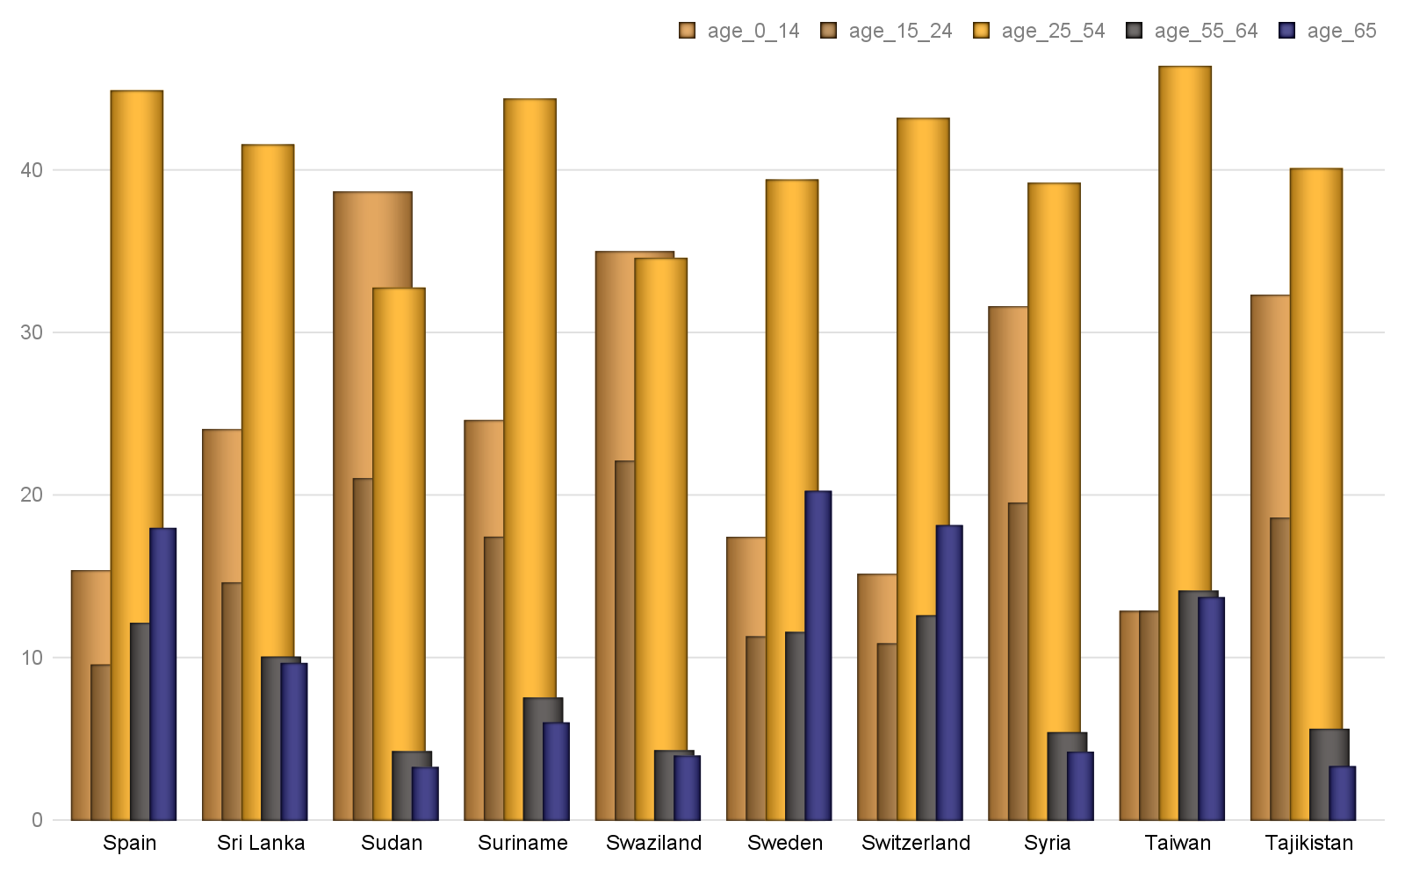

***Hinweis: Alle Text Blöcke wurde vom Python-Dokumentation kopiert!***

<docx.styles.style._ParagraphStyle object at <0x10a7c4f84>

**>>>** paragraph.style.name

'List Bullet'

A style can also be applied at creation time using either the style object or its name:

# Bericht Block №21

## Text Block №21

***Hinweis: Alle Text Blöcke wurde vom Python-Dokumentation kopiert!***

**>>>** paragraph.style.name

'Body Text'

**>>>** body_text_style = document.styles['Body Text']

**>>>** paragraph = document.add_paragraph(style=body_text_style)

## Tabelle №21

### Altersverteilung für ausgewählte Länder nach WHO: Tanzania,Thailand,Timor-Leste,Togo,Tonga,Trinidad and Tobago,Tunisia,Turkey,Turkmenistan,Turks and Caicos Islands

|  | *Gesamt Population* | Altersgruppen | | | | |
| --- | --- | --- | --- | --- | --- | --- |
| Median | 0-14 | 15-24 | 25-54 | 55-64 | 65+ |
| Tanzania | 17.7 | 43.74 | 19.86 | 29.88 | 3.51 | 3.02 |
| Thailand | 37.7 | 16.93 | 14.17 | 46.32 | 12.0 | 10.58 |
| Timor-Leste | 18.9 | 40.91 | 20.32 | 29.95 | 4.94 | 3.87 |
| Togo | 19.8 | 40.29 | 19.2 | 32.79 | 4.31 | 3.41 |
| Tonga | 23.0 | 33.87 | 19.65 | 34.3 | 5.76 | 6.42 |
| Trinidad and Tobago | 36.0 | 19.29 | 11.88 | 45.56 | 12.61 | 10.65 |
| Tunisia | 31.6 | 25.15 | 13.99 | 43.38 | 9.54 | 7.95 |
| Turkey | 30.9 | 24.68 | 15.99 | 43.21 | 8.58 | 7.53 |
| Turkmenistan | 27.9 | 25.79 | 18.39 | 43.18 | 7.9 | 4.74 |
| Turks and Caicos Isla | 33.3 | 21.74 | 13.99 | 53.17 | 6.54 | 4.57 |
|  | ***© Dr. Alexander Wagner. All Rights Reserved*** | | | | | |

***Hinweis: Alle Text Blöcke wurde vom Python-Dokumentation kopiert!***

'Body Text'

**Add or delete a style**

A new style can be added to the document by specifying a unique name and a style type:

**>>> from** **docx.enum.style** **import** WD_STYLE_TYPE

## Grafik №21

### Altersverteilung für ausgewählte Länder nach WHO: Tanzania,Thailand,Timor-Leste,Togo,Tonga,Trinidad and Tobago,Tunisia,Turkey,Turkmenistan,Turks and Caicos Islands

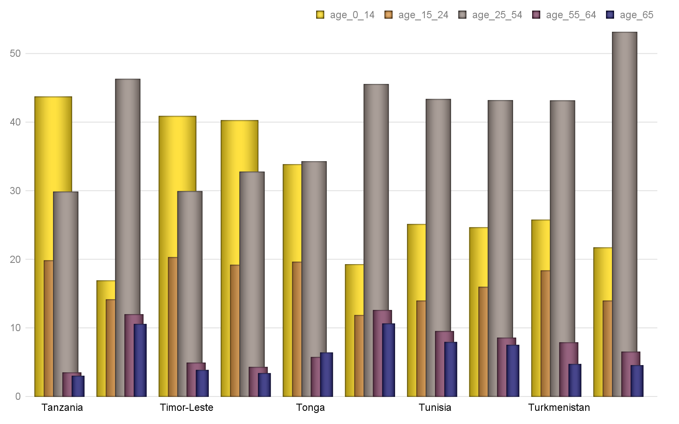

***Hinweis: Alle Text Blöcke wurde vom Python-Dokumentation kopiert!***

**>>>** style = styles.add_style('Citation', WD_STYLE_TYPE.PARAGRAPH)

**>>>** style.name

'Citation'

**>>>** style.type

# Bericht Block №22

## Text Block №22

***Hinweis: Alle Text Blöcke wurde vom Python-Dokumentation kopiert!***

Use the **base_style** property to specify a style the new style should inherit formatting settings from:

**>>>** style.base_style

None

**>>>** style.base_style = styles['Normal']

## Tabelle №22

### Altersverteilung für ausgewählte Länder nach WHO: Tuvalu,Uganda,Ukraine,United Arab Emirates,United Kingdom,United States,Uruguay,Uzbekistan,Vanuatu,Venezuela

|  | *Gesamt Population* | Altersgruppen | | | | |
| --- | --- | --- | --- | --- | --- | --- |
| Median | 0-14 | 15-24 | 25-54 | 55-64 | 65+ |
| Tuvalu | 25.7 | 29.29 | 19.26 | 36.66 | 8.77 | 6.02 |
| Uganda | 15.8 | 48.05 | 21.1 | 26.3 | 2.57 | 1.98 |
| Ukraine | 40.6 | 15.76 | 9.86 | 44.29 | 13.8 | 16.3 |
| United Arab Emirates | 30.3 | 21.01 | 13.51 | 61.14 | 3.27 | 1.07 |
| United Kingdom | 40.5 | 17.53 | 11.9 | 40.55 | 11.98 | 18.04 |
| United States | 38.1 | 18.73 | 13.27 | 39.45 | 12.91 | 15.63 |
| Uruguay | 35.0 | 20.17 | 15.69 | 39.34 | 10.56 | 14.25 |
| Uzbekistan | 28.6 | 23.88 | 18.52 | 44.49 | 7.85 | 5.25 |
| Vanuatu | 22.0 | 35.51 | 20.02 | 35.06 | 5.42 | 3.99 |
| Venezuela | 28.3 | 27.36 | 17.03 | 40.53 | 7.98 | 7.09 |
|  | ***© Dr. Alexander Wagner. All Rights Reserved*** | | | | | |

***Hinweis: Alle Text Blöcke wurde vom Python-Dokumentation kopiert!***

<docx.styles.style._ParagraphStyle object at 0x10a7a9550>

**>>>** style.base_style.name

'Normal'

A style can be removed from the document simply by calling its **delete()** method:

## Grafik №22

### Altersverteilung für ausgewählte Länder nach WHO: Tuvalu,Uganda,Ukraine,United Arab Emirates,United Kingdom,United States,Uruguay,Uzbekistan,Vanuatu,Venezuela

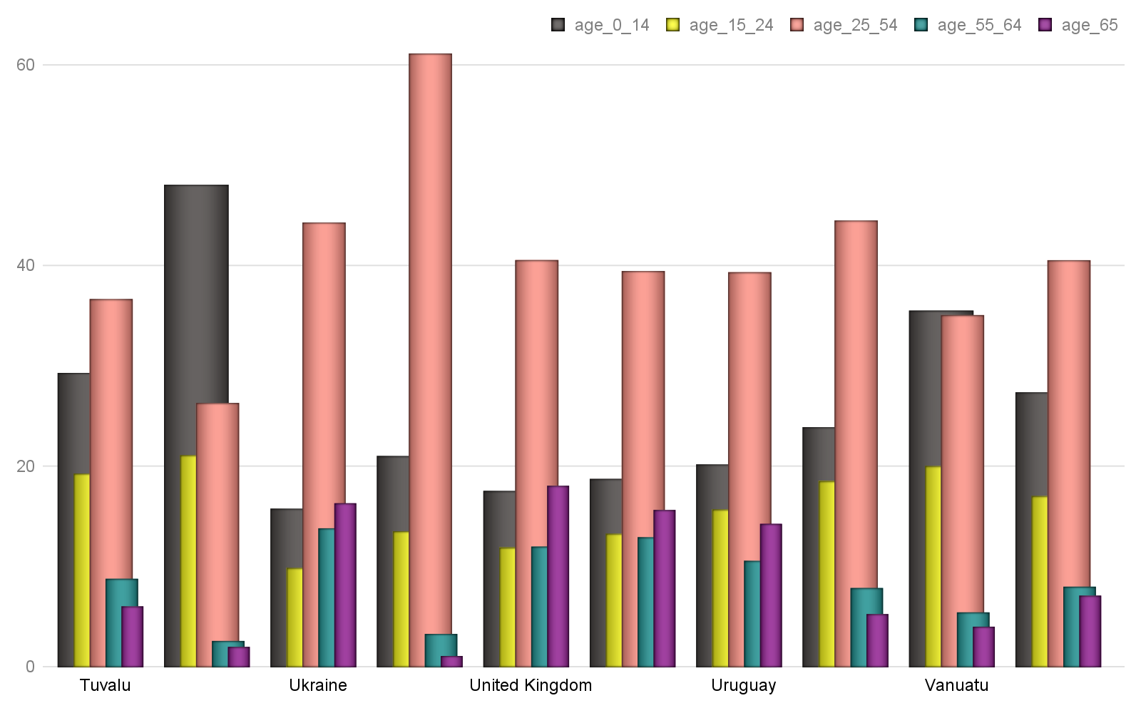

***Hinweis: Alle Text Blöcke wurde vom Python-Dokumentation kopiert!***

**>>>** len(styles)

10

**>>>** styles['Citation'].delete()

**>>>** len(styles)

# Bericht Block №23

### Text Block №23

***Hinweis: Alle Text Blöcke wurde vom Python-Dokumentation kopiert!***

Many font properties are *tri-state*, meaning they can take the values **True**, **False**, and **None**. **True** means the property is “on”, **False** means it is “off”. Conceptually, the **None** value means “inherit”. Because a style exists in an inheritance hierarchy, it is important to have the ability to specify a property at the right place in the hierarchy, generally as far up the hierarchy as possible. For example, if all headings should be in the Arial typeface, it makes more sense to set that property on the *Heading 1* style and have *Heading 2* inherit from *Heading 1*.

Bold and italic are tri-state properties, as are all-caps, strikethrough, superscript, and many others. See the  API documentation for a full list:

**>>>** font.bold, font.italic

(None, None)

### Tabelle №23

Hier wird die Tabelle №23 kopiert!

| **Alcohol consumption (cat.)** | **Stratum time to treatment (raw)** | | | | | | **Total (N=308)** | |
| --- | --- | --- | --- | --- | --- | --- | --- | --- |
| **Stratum <= 12 hours (N=122)** | | **Stratum 12 - 24 hours (N=88)** | | **Stratum > 24 hours (N=98)** | |
| **N** | **%** | **N** | **%** | **N** | **%** | **N** | **%** |
| None | 90 | 73.8 | 72 | 81.8 | 66 | 67.3 | 228 | 74.0 |
| Low level consumption | 15 | 12.3 | 6 | 6.8 | 7 | 7.1 | 28 | 9.1 |
| Substantial consumption | 17 | 13.9 | 10 | 11.4 | 25 | 25.5 | 52 | 16.9 |
| **Total** | 122 | 100.0 | 88 | 100.0 | 98 | 100.0 | 308 | 100.0 |

Die Tabelle №23 wurde erfolgreich kopiert!

### Text Block №24

***Hinweis: Alle Text Blöcke wurde vom Python-Dokumentation kopiert!***

**>>>** font.italic

True

**>>>** font.italic = **False**

**>>>** font.italic

### Tabelle №24

Hier wird die Tabelle №24 kopiert!

| **Alcohol consumption [g per day on average]** | | **Stratum <= 12 hours (N=111)** | **Stratum 12 - 24 hours (N=78)** | **Stratum > 24 hours (N=89)** | **Total (N=278)** |
| --- | --- | --- | --- | --- | --- |
|  | Nvalid | 111 | 78 | 89 | 278 |
| Nmissing | 0 | 0 | 0 | 0 |
| **Mean** | 3.8 | 2.8 | 6.2 | 4.3 |
| SD | 7.6 | 7.5 | 9.5 | 8.3 |
| Minimum | 0 | 0 | 0 | 0 |
| Median | 0.0 | 0.0 | 0.0 | 0.0 |
| Maximum | 24 | 40 | 30 | 40 |

Die Tabelle №24 wurde erfolgreich kopiert!

### Text Block №25

***Hinweis: Alle Text Blöcke wurde vom Python-Dokumentation kopiert!***

**>>>** font.italic = **None**

**>>>** font.italic

None

Underline is a bit of a special case. It is a hybrid of a tri-state property and an enumerated value property. **True** means single underline, by far the most common. **False** means no underline, but more often **None** is the right choice if no underlining is wanted since it is rare to inherit it from a base style. The other forms of underlining, such as double or dashed, are specified with a member of the  enumeration:

### Tabelle №25

Hier wird die Tabelle №25 kopiert!

| **Vaccination against influenza for the coming / current winter season** | **Stratum time to treatment (raw)** | | | | | | **Total (N=308)** | |
| --- | --- | --- | --- | --- | --- | --- | --- | --- |
| **Stratum <= 12 hours (N=122)** | | **Stratum 12 - 24 hours (N=88)** | | **Stratum > 24 hours (N=98)** | |
| **N** | **%** | **N** | **%** | **N** | **%** | **N** | **%** |
| No | 98 | 80.3 | 72 | 81.8 | 87 | 88.8 | 257 | 83.4 |
| Yes | 24 | 19.7 | 16 | 18.2 | 11 | 11.2 | 51 | 16.6 |
| **Total** | 122 | 100.0 | 88 | 100.0 | 98 | 100.0 | 308 | 100.0 |

Die Tabelle №25 wurde erfolgreich kopiert!

### Text Block №26

***Hinweis: Alle Text Blöcke wurde vom Python-Dokumentation kopiert!***

None

**>>>** font.underline = **True**

**>>>** *# or perhaps*

**>>>** font.underline = WD_UNDERLINE.DOT_DASH

### Tabelle №26

Hier wird die Tabelle №26 kopiert!

|  |  |  |  |  |  |  |  |  |  |
| --- | --- | --- | --- | --- | --- | --- | --- | --- | --- |
| Only patients with working status (Self-)Employed | | | | | | | | | |
| **Days of sick leave** | | **Stratum time to treatment (raw)** | | | | | | **Total (N=239)** | |
| **Stratum <= 12 hours (N=94)** | | **Stratum 12 - 24 hours (N=66)** | | **Stratum > 24 hours (N=79)** | |
| **N** | **%** | **N** | **%** | **N** | **%** | **N** | **%** |
| 0 | | 65 | 69.1 | 42 | 63.6 | 54 | 68.4 | 161 | 67.4 |
| 1 | | 4 | 4.3 | 8 | 12.1 | 11 | 13.9 | 23 | 9.6 |
|  | | 4 | 4.3 | 3 | 4.5 | 4 | 5.1 | 11 | 4.6 |
| 3 | | 1 | 1.1 | 2 | 3.0 | 2 | 2.5 | 5 | 2.1 |
| 4 | | 6 | 6.4 | 3 | 4.5 | 2 | 2.5 | 11 | 4.6 |
| 5 | | 2 | 2.1 | 2 | 3.0 | 3 | 3.8 | 7 | 2.9 |
| 6 | | 3 | 3.2 | 1 | 1.5 | 1 | 1.3 | 5 | 2.1 |
| 7 | | 3 | 3.2 | 3 | 4.5 | 0 | 0 | 6 | 2.5 |
| 8 | | 1 | 1.1 | 1 | 1.5 | 1 | 1.3 | 3 | 1.3 |
| 9 | | 3 | 3.2 | 0 | 0 | 0 | 0 | 3 | 1.3 |
| 10 | | 1 | 1.1 | 0 | 0 | 0 | 0 | 1 | 0.4 |
| 11 | | 0 | 0 | 0 | 0 | 1 | 1.3 | 1 | 0.4 |
| 12 | | 1 | 1.1 | 0 | 0 | 0 | 0 | 1 | 0.4 |
| 14 | | 0 | 0 | 1 | 1.5 | 0 | 0 | 1 | 0.4 |
| **Total** | | 94 | 100.0 | 66 | 100.0 | 79 | 100.0 | 239 | 100.0 |

Die Tabelle №26 wurde erfolgreich kopiert!

### Text Block №27

***Hinweis: Alle Text Blöcke wurde vom Python-Dokumentation kopiert!***

Both a paragraph style and a table style allow paragraph formatting to be specified. These styles provide access to a **ParagraphFormat** object via their **paragraph_format** property.

Paragraph formatting includes layout behaviors such as justification, indentation, space before and after, page break before, and widow/orphan control. For a complete list of the available properties, consult the API documentation page for the **ParagraphFormat** object.

Here’s an example of how you would create a paragraph style having hanging indentation of 1/4 inch, 12 points spacing above, and widow/orphan control:

**>>> from** **docx.enum.style** **import** WD_STYLE_TYPE

### Tabelle №27

Hier wird die Tabelle №27 kopiert!

| **Intake of rescue medication** | **Stratum time to treatment (raw)** | | | | | | **Total (N=308)** | |
| --- | --- | --- | --- | --- | --- | --- | --- | --- |
| **Stratum <= 12 hours (N=122)** | | **Stratum 12 - 24 hours (N=88)** | | **Stratum > 24 hours (N=98)** | |
| **N** | **%** | **N** | **%** | **N** | **%** | **N** | **%** |
| No | 103 | 84.4 | 76 | 86.4 | 85 | 86.7 | 264 | 85.7 |
| Yes | 19 | 15.6 | 12 | 13.6 | 13 | 13.3 | 44 | 14.3 |
| **Total** | 122 | 100.0 | 88 | 100.0 | 98 | 100.0 | 308 | 100.0 |

Die Tabelle №27 wurde erfolgreich kopiert!

### Text Block №28

***Hinweis: Alle Text Blöcke wurde vom Python-Dokumentation kopiert!***

**>>>** document = Document()

**>>>** style = document.styles.add_style('Indent', WD_STYLE_TYPE.PARAGRAPH)

**>>>** paragraph_format = style.paragraph_format

**>>>** paragraph_format.left_indent = Inches(0.25)

### Tabelle №28

Hier wird die Tabelle №28 kopiert!

|  | Grade 3 hypertension-sev. | | Isolated syst. hypertension | | Missing | | Overall (non-missing) | | Total | |
| --- | --- | --- | --- | --- | --- | --- | --- | --- | --- | --- |
|  | N | % | N | % | N | % | N | % | N | % |
| Optimal | 0 | 0.0 | 1 | 0.0 | 0 | 0.0 | 23 | 0.3 | 23 | ---- |
| Normal | 0 | 0.0 | 7 | 0.1 | 0 | 0.0 | 76 | 1.0 | 76 | ---- |
| High normal | 0 | 0.0 | 17 | 0.2 | 0 | 0.0 | 216 | 2.9 | 216 | ---- |
| Grade 1 hypertension-mild. | 4 | 0.1 | 138 | 1.9 | 0 | 0.0 | 1.340 | 18.0 | 1.340 | ---- |
| Grade 2 hypertension-mod. | 5 | 0.1 | 551 | 7.4 | 2 | 0.0 | 2.948 | 39.6 | 2.950 | ---- |
| Grade 3 hypertension-sev. | 24 | 0.3 | 324 | 4.4 | 0 | 0.0 | 1.397 | 18.8 | 1.397 | ---- |
| Isolated syst. hypertension | 2 | 0.0 | 325 | 4.4 | 1 | 0.0 | 1.439 | 19.3 | 1.440 | ---- |
| Overall (non-missing) | 35 | 0.5 | 1.363 | 18.3 | 3 | 0.0 | 7.439 | 100.0 | 7.442 | ---- |
| Total | 35 | ---- | 1.363 | ---- | 3 | ---- | 7.439 | ---- | 7.442 | ---- |

Die Tabelle №28 wurde erfolgreich kopiert!

### Text Block №29

***Hinweis: Alle Text Blöcke wurde vom Python-Dokumentation kopiert!***

**>>>** paragraph_format.space_before = Pt(12)

**>>>** paragraph_format.widow_control = **True**

**Use paragraph-specific style properties**

A paragraph style has a **next_paragraph_style** property that specifies the style to be applied to new paragraphs inserted after a paragraph of that style. This is most useful when the style would normally appear only once in a sequence, such as a heading. In that case, the paragraph style can automatically be set back to a body style after completing the heading.

### Tabelle №29

Hier wird die Tabelle №29 kopiert!

|  |  |  |  |  |  |  |  |  |  |  |  |
| --- | --- | --- | --- | --- | --- | --- | --- | --- | --- | --- | --- |
| **Table 4.5 Summary statistics on systolic blood pressure [mmHg] separately by visit and dosage strength (prescribed at previous visit) (OC)** | | | | | | | | | | | |
| **Full Analysis Set (N=7442)** | | | | | | | | | | | |
|  | Grade 3 hypertension-sev. | | Isolated syst. hypertension | | Missing | | Overall (non-missing) | | Total | |
|  | N | % | N | % | N | % | N | % | N | % |
| Optimal | 0 | 0.0 | 1 | 0.0 | 0 | 0.0 | 23 | 0.3 | 23 | ---- |
| Normal | 0 | 0.0 | 7 | 0.1 | 0 | 0.0 | 76 | 1.0 | 76 | ---- |
| High normal | 0 | 0.0 | 17 | 0.2 | 0 | 0.0 | 216 | 2.9 | 216 | ---- |
| Grade 1 hypertension-mild. | 4 | 0.1 | 138 | 1.9 | 0 | 0.0 | 1.340 | 18.0 | 1.340 | ---- |
| Grade 2 hypertension-mod. | 5 | 0.1 | 551 | 7.4 | 2 | 0.0 | 2.948 | 39.6 | 2.950 | ---- |
| Grade 3 hypertension-sev. | 24 | 0.3 | 324 | 4.4 | 0 | 0.0 | 1.397 | 18.8 | 1.397 | ---- |
| Isolated syst. hypertension | 2 | 0.0 | 325 | 4.4 | 1 | 0.0 | 1.439 | 19.3 | 1.440 | ---- |
| Overall (non-missing) | 35 | 0.5 | 1.363 | 18.3 | 3 | 0.0 | 7.439 | 100.0 | 7.442 | ---- |
| Total | 35 | ---- | 1.363 | ---- | 3 | ---- | 7.439 | ---- | 7.442 | ---- |

Die Tabelle №29 wurde erfolgreich kopiert!

### Text Block №30

***Hinweis: Alle Text Blöcke wurde vom Python-Dokumentation kopiert!***

Here’s an example of how you would change the next paragraph style of the *Heading 1* style to *Body Text*:

**>>> from** **docx** **import** Document

**>>>** document = Document()

**>>>** styles = document.styles

### Tabelle №30

Hier wird die Tabelle №30 kopiert!

|  |  |  |  |  |  |
| --- | --- | --- | --- | --- | --- |
| **5. SAFETY** | | | | | |
| **Table 5.1 Frequency distribution on physician’s assessment at each visit regarding the tolerability of investigational product, overall and by dosage strength (prescribed at previous visit)** | | | | | |
| **Safety Set (N=7489)** | | | | | |
|  | | | N | % |
| 4-6 weeks | ArzneiM 30mg/5mg | Very good | 1.824 | 59.0 |
|  |  | Good | 989 | 32.0 |
|  |  | Satisfactory | 82 | 2.7 |
|  |  | Insufficient | 39 | 1.3 |
|  |  | Missing | 158 | 5.1 |
|  |  | Overall (non-missing) | 2.934 | 94.9 |
|  |  | Total | 3.092 | ---- |
|  |  |  |  |  |
|  | ArzneiM 60mg/5mg | Very good | 1.013 | 57.2 |
|  |  | Good | 595 | 33.6 |
|  |  | Satisfactory | 54 | 3.0 |
|  |  | Insufficient | 24 | 1.4 |
|  |  | Missing | 86 | 4.9 |
|  |  | Overall (non-missing) | 1.686 | 95.1 |
|  |  | Total | 1.772 | ---- |
|  |  |  |  |  |
|  | ArzneiM 60mg/10mg | Very good | 626 | 58.4 |
|  |  | Good | 325 | 30.3 |
|  |  | Satisfactory | 41 | 3.8 |
|  |  | Insufficient | 32 | 3.0 |
|  |  | Missing | 48 | 4.5 |
|  |  | Overall (non-missing) | 1.024 | 95.5 |
|  |  | Total | 1.072 | ---- |
|  |  |  |  |  |
|  | Overall (non-missing) | Very good | 3.463 | 58.3 |
|  |  | Good | 1.909 | 32.2 |
|  |  | Satisfactory | 177 | 3.0 |
|  |  | Insufficient | 95 | 1.6 |
|  |  | Missing | 292 | 4.9 |
|  |  | Overall (non-missing) | 5.644 | 95.1 |
|  |  | Total | 5.936 | ---- |
|  |  |  |  |  |
|  | Total | Very good | 3.463 | 58.3 |
|  |  | Good | 1.909 | 32.2 |
|  |  | Satisfactory | 177 | 3.0 |
|  |  | Insufficient | 95 | 1.6 |
|  |  | Missing | 292 | 4.9 |
|  |  | Overall (non-missing) | 5.644 | 95.1 |
|  |  | Total | 5.936 | ---- |
| 8-12 weeks | ArzneiM 30mg/5mg | Very good | 1.423 | 69.2 |
|  |  | Good | 516 | 25.1 |
|  |  | Satisfactory | 30 | 1.5 |
|  |  | Insufficient | 12 | 0.6 |
|  |  | Missing | 75 | 3.6 |
|  |  | Overall (non-missing) | 1.981 | 96.4 |
|  |  | Total | 2.056 | ---- |
|  | ArzneiM 60mg/5mg | Very good | 1.200 | 66.1 |
|  |  | Good | 504 | 27.8 |
|  |  | Satisfactory | 29 | 1.6 |
|  |  | Insufficient | 16 | 0.9 |
|  |  | Missing | 67 | 3.7 |
|  |  | Overall (non-missing) | 1.749 | 96.3 |
|  |  | Total | 1.816 | ---- |
|  |  |  |  |  |
|  | ArzneiM 60mg/10mg | Very good | 815 | 64.6 |
|  |  | Good | 356 | 28.2 |
|  |  | Satisfactory | 30 | 2.4 |
|  |  | Insufficient | 10 | 0.8 |
|  |  | Missing | 51 | 4.0 |
|  |  | Overall (non-missing) | 1.211 | 96.0 |
|  |  | Total | 1.262 | ---- |
|  |  |  |  |  |
|  | Missing | Very good | 25 | 45.5 |
|  |  | Good | 15 | 27.3 |
|  |  | Insufficient | 2 | 3.6 |
|  |  | Missing | 13 | 23.6 |
|  |  | Overall (non-missing) | 42 | 76.4 |
|  |  | Total | 55 | ---- |
|  |  |  |  |  |
|  | Overall (non-missing) | Very good | 3.438 | 67.0 |
|  |  | Good | 1.376 | 26.8 |
|  |  | Satisfactory | 89 | 1.7 |
|  |  | Insufficient | 38 | 0.7 |
|  |  | Missing | 193 | 3.8 |
|  |  | Overall (non-missing) | 4.941 | 96.2 |
|  |  |  |  |  |
|  |  | Total | 5.134 | ---- |
|  | Total | Very good | 3.463 | 66.7 |
|  |  | Good | 1.391 | 26.8 |
|  |  | Satisfactory | 89 | 1.7 |
|  |  | Insufficient | 40 | 0.8 |
|  |  | Missing | 206 | 4.0 |
|  |  | Overall (non-missing) | 4.983 | 96.0 |
|  |  | Total | 5.189 | ---- |
|  |  |  |  |  |
| 12-18 weeks | ArzneiM 30mg/5mg | Very good | 2.043 | 71.3 |
|  |  | Good | 678 | 23.7 |
|  |  | Satisfactory | 28 | 1.0 |
|  |  | Insufficient | 15 | 0.5 |
|  |  | Missing | 101 | 3.5 |
|  |  | Overall (non-missing) | 2.764 | 96.5 |
|  |  | Total | 2.865 | ---- |
|  |  |  |  |  |
|  | ArzneiM 60mg/5mg | Very good | 1.693 | 70.0 |
|  |  | Good | 606 | 25.0 |
|  |  | Satisfactory | 29 | 1.2 |
|  |  | Insufficient | 12 | 0.5 |
|  |  | Missing | 80 | 3.3 |
|  |  | Overall (non-missing) | 2.340 | 96.7 |
|  |  | Total | 2.420 | ---- |
|  |  |  |  |  |
|  | ArzneiM 60mg/10mg | Very good | 1.229 | 66.8 |
|  |  | Good | 502 | 27.3 |
|  |  | Satisfactory | 35 | 1.9 |
|  |  | Insufficient | 14 | 0.8 |
|  |  | Missing | 59 | 3.2 |
|  |  | Overall (non-missing) | 1.780 | 96.8 |
|  |  | Total | 1.839 | ---- |
|  |  |  |  |  |
|  | Missing | Very good | 50 | 59.5 |
|  |  | Good | 19 | 22.6 |
|  |  | Satisfactory | 2 | 2.4 |
|  |  | Insufficient | 6 | 7.1 |
|  |  | Missing | 7 | 8.3 |
|  |  | Overall (non-missing) | 77 | 91.7 |
|  |  | Total | 84 | ---- |
|  |  |  |  |  |
|  | Overall (non-missing) | Very good | 4.965 | 69.7 |
|  |  | Good | 1.786 | 25.1 |
|  |  | Satisfactory | 92 | 1.3 |
|  |  | Insufficient | 41 | 0.6 |
|  |  | Missing | 240 | 3.4 |
|  |  | Overall (non-missing) | 6.884 | 96.6 |
|  |  | Total | 7.124 | ---- |
|  |  |  |  |  |
|  | Total | Very good | 5.015 | 69.6 |
|  |  | Good | 1.805 | 25.0 |
|  |  | Satisfactory | 94 | 1.3 |
|  |  | Insufficient | 47 | 0.7 |
|  |  | Missing | 247 | 3.4 |
|  |  | Overall (non-missing) | 6.961 | 96.6 |
|  |  | Total | 7.208 | ---- |
|  |  |  |  |  |
| Termination | ArzneiM 30mg/5mg | Very good | 2.062 | 69.4 |
|  |  | Good | 694 | 23.3 |
|  |  | Satisfactory | 38 | 1.3 |
|  |  | Insufficient | 56 | 1.9 |
|  |  | Missing | 123 | 4.1 |
|  |  | Overall (non-missing) | 2.850 | 95.9 |
|  |  | Total | 2.973 | ---- |
|  |  |  |  |  |
|  | ArzneiM 60mg/5mg | Very good | 1.702 | 68.5 |
|  |  | Good | 620 | 25.0 |
|  |  | Satisfactory | 36 | 1.4 |
|  |  | Insufficient | 40 | 1.6 |
|  |  | Missing | 86 | 3.5 |
|  |  | Overall (non-missing) | 2.398 | 96.5 |
|  |  | Total | 2.484 | ---- |
|  |  |  |  |  |
|  | ArzneiM 60mg/10mg | Very good | 1.240 | 64.9 |
|  |  | Good | 513 | 26.8 |
|  |  | Satisfactory | 44 | 2.3 |
|  |  | Insufficient | 45 | 2.4 |
|  |  | Missing | 70 | 3.7 |
|  |  | Overall (non-missing) | 1.842 | 96.3 |
|  |  | Total | 1.912 | ---- |
|  |  |  |  |  |
|  | Missing | Very good | 52 | 43.3 |
|  |  | Good | 19 | 15.8 |
|  |  | Satisfactory | 2 | 1.7 |
|  |  | Insufficient | 7 | 5.8 |
|  |  | Missing | 40 | 33.3 |
|  |  | Overall (non-missing) | 80 | 66.7 |
|  |  | Total | 120 | ---- |
|  |  |  |  |  |
|  | Overall (non-missing) | Very good | 5.004 | 67.9 |
|  |  | Good | 1.827 | 24.8 |
|  |  | Satisfactory | 118 | 1.6 |
|  |  | Insufficient | 141 | 1.9 |
|  |  | Missing | 279 | 3.8 |
|  |  | Overall (non-missing) | 7.090 | 96.2 |
|  |  | Total | 7.369 | ---- |
|  | Total | Very good | 5.056 | 67.5 |
|  |  | Good | 1.846 | 24.6 |
|  |  | Satisfactory | 120 | 1.6 |
|  |  | Insufficient | 148 | 2.0 |
|  |  | Missing | 319 | 4.3 |
|  |  | Overall (non-missing) | 7.170 | 95.7 |
|  |  | Total | 7.489 | ---- |