x>0
y>0
x,y both belong to real numbers

let y^2 =t
solution to problem lies in finding a pair (t,x) such that
t^3= x^6 + 8*(x^4) - 6*(x^2) +8

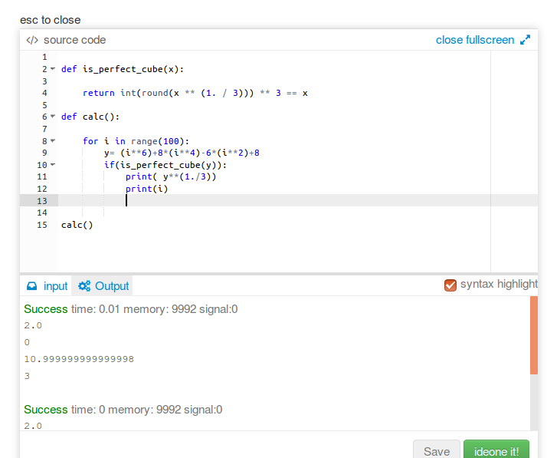

the above code checks for x in range 0 -100 if it satisfies the above equation
and the first solution is found for x=3 and t=11

so answer

3345x + 4321t= 3345*3 + 4321*11=57566

NOTE: ITS GIVEN THAT SOLUTION DOES NOT EXCEED 10^7 SO FEASIBLE RANGE FOR CHECKING (BRUTE – FORCING) FOR THE VALUE OF x WAS TILL 100.

