
Virtual Try-On for Jewellery Accessories using Landmark Tracking and Image Segmentation
Course: Image and Video Processing
Student Name(s): Charvi Kathal & Gunjan Chaurasia
Roll Number(s): H003 & H027
Sap Id: 70472400123 & 70472400396
Programme / Semester / Division: Mbatech(ce) / 5th sem
Faculty Name: Dr Rai Gaurav Mishra
Institute / Department: School of Technology Management & Engineering (STME)
Academic Year: 2026-27

Project repository: https://github.com/av7890/Accessory-Try

1. Abstract
Shoppers cannot see how a piece of jewellery looks on them before buying it online. This project builds a virtual try-on application that takes an ordinary product photo of an earring, necklace, ring or bracelet and shows it on the user, in a still photo or on a live webcam stream. The accessory is first cut out of its background using colour keying, GrabCut or an AI model (rembg), with morphological operations. MediaPipe landmark models then locate the face, hands and shoulders, and the cut-out is rotated, scaled, relit and alpha-blended at the right place, with a One Euro filter to steady the landmarks over time and Gaussian-blurred masks to place hair and skin correctly. A pretrained model also suggests a face shape and matching jewellery styles. On 1,200 labelled test photos the face-shape model was right 66-69% of the time across five shapes (chance is 20%). With the slow hair and skin segmentation moved to a background thread, the live loop needs about 10-45 ms of CPU time per frame. Cut-outs worked on plain backgrounds and failed on busy ones.

2. Introduction

2.1 Background of the problem
When people buy jewellery online they judge it from studio photographs of the product alone. Size, position on the body and the way it sits against their own skin and face are hard to imagine from such a photo. Physical shops solve this with a mirror; online shops have no equivalent. Virtual try-on tools try to close that gap by drawing the product on a picture or video of the customer.

2.2 Why the problem is relevant
Jewellery is small, personal and often bought as a gift, so a wrong choice is disappointing. A try-on that runs in an ordinary web browser, with no special hardware, lets a shopper compare items quickly and decide with more confidence. The same idea applies to in-store mirrors and to social-media filters for brands.

2.3 Role of image and video processing
The problem is solved almost entirely with image and video processing:
- Segmentation: removes the background of the product photo to leave only the jewellery.
- Landmark detection: finds ears, chin, shoulders, finger joints and wrist in every frame.
- Geometric transformation: rotates, scales and warps the product so it follows the person.
- Filtering and blending: soft mask edges, shadows, hair in front of the jewellery, and brightness and colour matching so the product looks part of the scene.
- Temporal filtering: smooths landmark positions across video frames so the jewellery does not shake.

2.4 Motivation for selecting the project
The project combines most topics of the course in one working system (filtering, morphology, segmentation, geometric transforms, colour spaces, video processing) and has an obvious practical use. We first surveyed existing open-source try-on projects (listed in the references) and then built our own pipeline in Python so that every processing step is visible and can be explained.

3. Problem Statement and Objectives

3.1 Problem statement
To let a user see how a jewellery item from a product photo would look on their own face or hand, in a still image or in real time on a webcam, using image and video processing techniques that run on an ordinary laptop.

3.2 Objectives
1. Remove the background from a product photo (uploaded or from a web link) and keep a clean transparent cut-out.
2. Detect the face, hands and shoulders in photos and live video and place earrings, necklaces, rings and bracelets at the correct position, size and angle.
3. Make the result look natural: match brightness and colour to the scene, add a soft shadow, let hair fall in front of the jewellery and keep rings and bracelets on the skin.
4. Keep the live view steady by smoothing landmark positions over time.
5. Add a style advisor that suggests a face shape and jewellery styles, and measure how accurate its face-shape model is on a labelled dataset.

4. Scope of the Project

4.1 What the project covers
- Four accessory types: earrings, necklaces, rings and bracelets.
- Two modes: still photo (upload or camera snapshot) and a live webcam stream in the browser.
- A catalogue that stores cut-outs together with their original photos, so a product can be re-cut with another method, and a split-screen view to compare two items.
- A style advisor: face-shape estimate, neck-length estimate and jewellery suggestions.
- Safe handling of web links and uploaded images.

4.2 What it does not cover
- No 3-D model of the head or hand: the accessory is a flat 2-D image, so it cannot rotate in depth like a real object.
- No automatic measurement of real-world size (for example ring size in millimetres).
- No training of our own detection models; pretrained models are used.
- No payment, shop integration or mobile application.
- No recorded video dataset: the live mode was exercised with a webcam, not with stored clips.

4.3 Type of images and videos used
Still product photographs (PNG, JPEG, WebP), still portraits and hand photographs, and a live webcam stream requested at 1280 x 720 pixels and 30 frames per second. Best results need a frontal face or a fully visible hand in normal lighting.

4.4 Application domain
Online and in-store jewellery retail, fashion e-commerce and brand marketing.

5. Dataset / Input Description
The project uses three kinds of input. No data was collected from other people.

5.1 Product photographs
Product images from public shop pages, supplied by the team and used for demonstration only. Four clean catalogue shots (one per accessory type) are used to test placement. Two difficult photographs, a necklace photographed on stone and a ring worn on a hand, are used to show where background removal fails.
Table 1. Product photographs used for testing
Image | Resolution (px) | Format | Background
Bangle with princess-cut stone | 2000 x 2000 | WebP | Plain off-white
Ring with round stone | 1100 x 1100 | PNG | Plain white
Chain necklace with round pendant | 2000 x 2000 | WebP | Plain white
Round bezel stud earring | 1000 x 1000 | PNG | White with a soft floor shadow
Necklace on stone (difficult) | 387 x 516 | PNG | Busy (stone and wood)
Ring worn on a hand (difficult) | 876 x 876 | WebP | Busy (petals, fabric)

5.2 Person photographs
Six face photographs and two hand photographs from the web were used to check placement and the face-shape output. The faces are small, mostly close-cropped portraits. The hand photographs show the back of a hand against a white background. Face 1 also shows the upper body, with arms crossed.
Table 2. Person photographs used for testing placement
Photo | Content | Resolution (px) | Format
Face 1 | Face and upper body | 728 x 535 | PNG
Face 2 | Face and bare shoulders | 494 x 621 | PNG
Face 3 | Face, close crop | 235 x 353 | PNG
Face 4 | Face and shoulders | 554 x 554 | PNG
Face 5 | Face and shoulders | 447 x 447 | PNG
Face 6 | Face, head and shoulders | 452 x 678 | PNG
Hand 1 | Back of a hand with wrist | 612 x 612 | PNG
Hand 2 | Back of a hand with forearm | 447 x 447 | PNG

5.3 Labelled face-shape dataset (public)
To measure the accuracy of the face-shape model we used the public dataset "Face Shape Classification" (version 1) from Roboflow Universe. It contains 4,002 JPEG photographs of faces in five classes: Heart, Oblong, Oval, Round and Square, split into training, validation and test folders. Image sizes vary widely: the median is about 233 x 305 pixels, widths range from 51 to 3602 pixels and heights from 19 to 4108 pixels. Only the validation and test folders (1,201 photographs) were used, for evaluation; the training folder was not used, because we did not train a model.
Table 3. Face-shape dataset: photographs per split and class
Split | Heart | Oblong | Oval | Round | Square | Total
Train (not used) | 547 | 550 | 548 | 583 | 573 | 2801
Validation | 177 | 164 | 157 | 153 | 150 | 801
Test | 76 | 86 | 92 | 68 | 78 | 400

5.4 Video input
Video comes from the user's webcam through the browser. Its resolution is whatever the camera provides, up to the 1280 x 720 pixels requested.

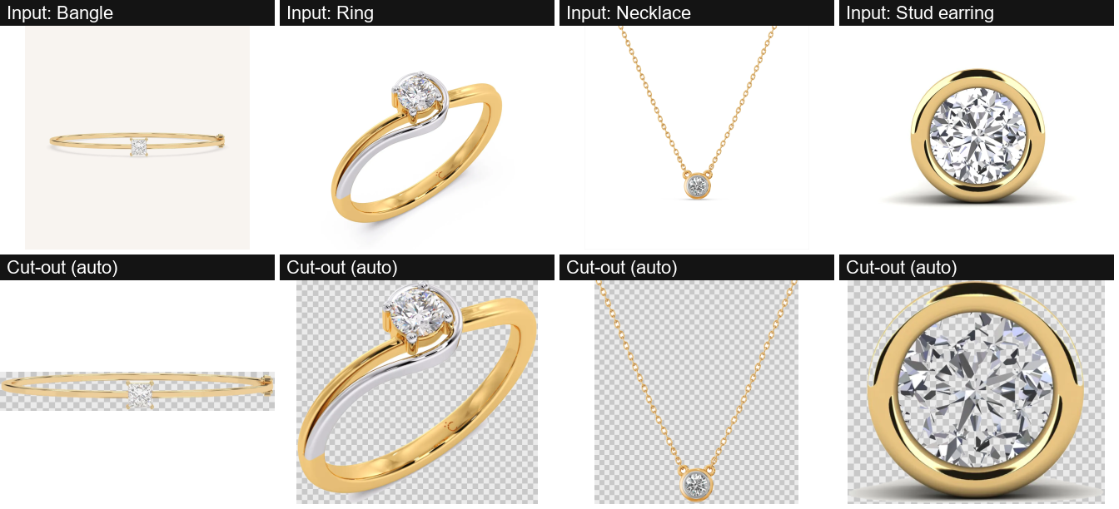
Figure 1. Sample input product photographs (top row) and the cut-outs produced by the automatic method (bottom row).

6. Methodology / Proposed Approach
The application has two branches that meet at the rendering step (Figure 2): a product branch, which turns a photo into a transparent sprite, and a person branch, which finds where to put it.
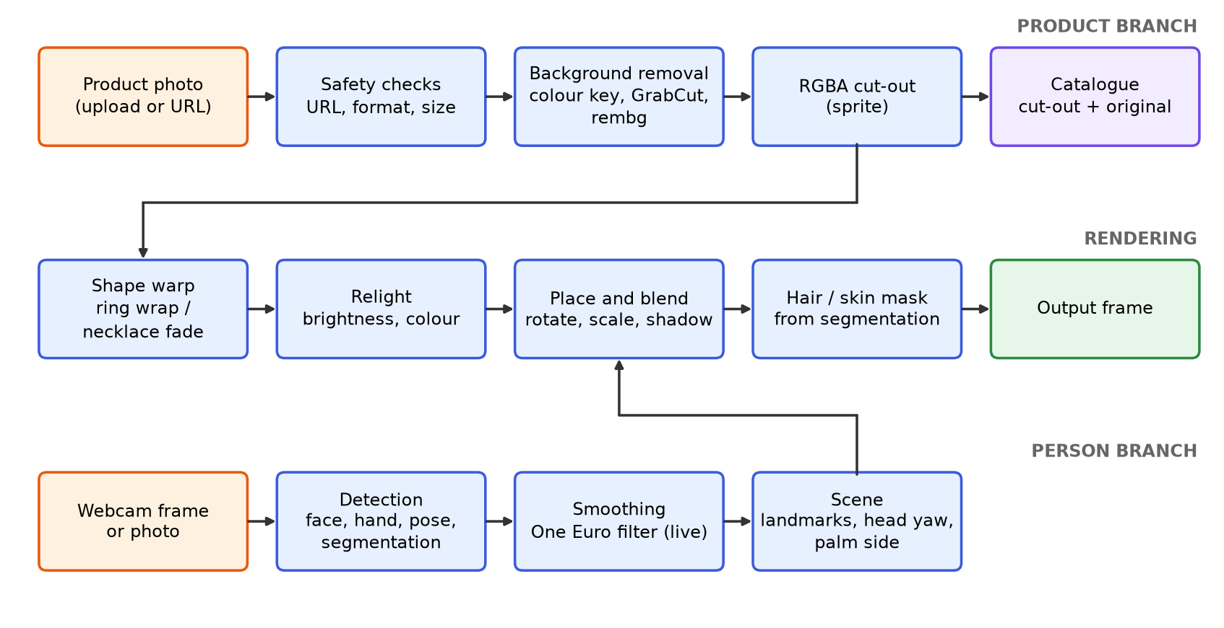
Figure 2. Processing pipeline of the try-on application.

6.1 Product branch
1. The product photo arrives by upload or web link. Web links are checked first (only http/https, public addresses, size limits) and every image is checked for format and size before decoding.
2. The background is removed (Section 7.1) giving a four-channel image with transparency, cropped to the object.
3. The cut-out can be saved with its original photo in the catalogue.

6.2 Person branch
1. Each frame is shrunk to 640 pixels on its long side for detection; landmark positions are normalised, so they scale back to the full-size frame.
2. MediaPipe finds the face (478 points including the irises) for earrings and necklaces, or the hands (21 points each) for rings and bracelets, plus the shoulders for necklaces.
3. In live mode each landmark is smoothed with a One Euro filter.
4. Head turn (yaw) is estimated from the nose position and the face-pose matrix. For hands, whether the palm or the back faces the camera is estimated from the finger-base geometry and the left/right label.

6.3 Rendering
1. Shape warp: the top of a necklace is faded so the chain ends melt into the neck; rings are warped to look wrapped round the finger.
2. Relighting: the product's brightness and colour are scaled toward the scene's.
3. Placement: the sprite is rotated to the head, shoulder or finger direction and alpha-blended with a soft shadow. Earrings are hung from the earlobe, between the two jaw points under the ear, and sized from the face width and the sprite's shape (a round stud is much smaller than a long drop). A necklace is sized to the neck (about the face width) and starts below the chin. A ring is sized to about 1.1 times the finger width, estimated from the knuckle-to-joint length. A bracelet is sized to a little under the palm width, which is about the width of the wrist.
4. Masks: a segmentation model finds hair and skin. Hair pixels are blended back over earrings and necklaces; rings and bracelets are kept only where there is skin.

6.4 Pseudocode of the live loop
for each frame from the browser:
frame = mirror(frame)
scene = analyse(frame) # landmarks, yaw, palm side, shoulders
sprite = shape_warp(product) # drape (necklace) or wrap (ring)
sprite = relight(sprite, frame) # match brightness and colour
for each detected face or hand:
place(sprite, scene) # rotate, scale, shadow, alpha blend
apply hair mask / skin mask # from a background thread
show(frame)

7. Techniques / Algorithms Used

7.1 Image processing
Table 4. Image processing techniques used
Technique | Where it is used
Colour-space conversion (BGR to RGB, BGR to Lab) | Preparing frames for the models; measuring how different a pixel is from the background colour
Colour-distance thresholding (Lab) | Colour-key background removal
Flood fill | Marking the background that touches the image corners
Morphological closing (5 x 5) and dilation (9 x 9) | Filling small gaps in the object mask; growing the skin mask
Connected components | Keeping the largest object; finding enclosed holes such as a ring centre
GrabCut segmentation | Background removal on busy backgrounds
Gaussian filtering (3 x 3, 5 x 5, 7 x 7, and a size-based sigma) | Softening cut-out edges, hair and skin masks, and the shadow
Image segmentation by a neural model | Per-pixel classes (hair, skin, clothes) for hair cover and skin clipping
Feature extraction by landmark models | Face, hand and shoulder points
Affine transformation (bilinear) | Rotating, scaling and positioning the sprite
Remap (bilinear) | Cylindrical wrap of rings
Alpha ramp | Fading the top of a necklace into the neck
Area-averaging and nearest-neighbour resizing | Shrinking images cleanly; scaling the class mask
Alpha blending | Compositing the sprite over the frame
Per-channel gain | Relighting: matching brightness and colour temperature

7.2 Video processing
Table 5. Video processing techniques used
Technique | Where it is used
Frame capture from the browser over WebRTC | Receiving each webcam frame and sending the result back
Per-frame processing in a timestamped video mode | Landmark detection that uses the previous frame for tracking
Temporal filtering (One Euro filter) | Smoothing landmark positions over time; strong smoothing when still, light when moving
Background thread and cached results | Segmentation runs in its own thread and the newest finished mask is reused; pose is refreshed every third frame
Mirroring | Showing the live view like a mirror
Physics simulation (damped pendulum) | Swing of earrings driven by head movement

7.3 Colour keying in detail
The border pixels of the image are assumed to be background. Their median Lab colour is computed, and every pixel whose Lab distance from it exceeds a tolerance (default 28) becomes foreground. A morphological closing joins small gaps, a flood fill from the corners marks the true background, and enclosed background-coloured regions larger than 0.4% of the image (the inside of a ring, the loop of a bracelet) are made transparent. The largest connected object is kept and its edge is softened with a 3 x 3 Gaussian filter. If the result covers more than 85% of the image, the background was not uniform and GrabCut is used instead.

7.4 One Euro filter in detail
The One Euro filter is a low-pass filter whose cut-off frequency rises with the speed of the signal: a still point is smoothed strongly, a fast-moving point is smoothed lightly to limit lag. It is applied to all 478 face points, the 21 points of each hand and the shoulders.

7.5 GrabCut and rembg
GrabCut starts from a rectangle that leaves a 4% margin around the image, models the colours inside and outside it with Gaussian mixtures, and alternates 5 times between labelling pixels and re-estimating the models using a graph cut. The result goes through the same hole clearing, largest-object and edge-softening steps as colour key. rembg runs a small neural network (the u2netp variant of U2-Net) that predicts how likely each pixel is to belong to the main object and uses that as the transparency, which gives soft edges.

8. Implementation
Table 6. Implementation details
Item | Detail
Programming language | Python 3.14
User interface | Streamlit (web application), streamlit-webrtc for the live camera
Image processing | OpenCV, NumPy, Pillow
Detection and segmentation models | MediaPipe Tasks: face landmarker, hand landmarker, pose landmarker (lite), selfie multiclass segmenter
Face-shape model | Pretrained scikit-learn pipeline (scaler, PCA, SVM) from the FaceShapeAI project, MIT licence
Optional AI background removal | rembg with onnxruntime
Hardware | Windows 11 laptop, CPU only (no GPU used)
Testing | pytest: 57 tests passed, 1 skipped

8.1 Important implementation steps
1. Cut-out: colour keying, GrabCut or rembg, with hole clearing and cropping (file segment.py).
2. Detection: all models run inside one engine class that returns a scene of landmarks and masks (engine.py).
3. Placement: one function per accessory type uses the scene to choose position, size and angle, and a common drawing function rotates, scales, shadows and blends the sprite (engine.py, overlay.py).
4. Effects: relighting, ring wrap and necklace drape (effects.py); earring swing (physics.py).
5. Style advisor: landmarks are centred on the eyes, levelled, scaled to the eye distance and passed to the face-shape model (faceshape_model.py); advice text and neck-length rules are in shape.py.
6. Catalogue and safe input: catalog.py stores items on disk; net.py downloads and decodes images with checks.
7. Interface: app.py has the Photo, Live webcam, Catalogue and Style advisor tabs.
The face-shape files are Python pickles from a third party, so they are loaded with a restricted loader that allows only an exact list of scikit-learn and NumPy classes, and their checksums are verified when downloaded. The complete code is in the project repository: https://github.com/av7890/Accessory-Try.

9. Results and Discussion

9.1 Background removal
Figure 1 shows the cut-outs made by the automatic method on four clean catalogue shots. The bangle, ring, necklace chain and stud are isolated with their holes transparent (the inside of the ring and the gaps between chain links). One flaw is visible: around the stud earring a faint arc and part of its floor shadow remain, because they differ little from the white background.
The application offers three ways to remove the background, and the user picks one in the sidebar: colour key, GrabCut, or the rembg AI model. The default, 'auto', tries colour key first and falls back to GrabCut. Figure 3 runs all three on the same photographs, three clean ones and two difficult ones. No single method wins everywhere:
- Plain backgrounds (ring, necklace, stud): colour key and GrabCut both give clean outlines. Around the stud they keep a faint arc and part of the floor shadow, which rembg removes. rembg also fades the white-metal band of the ring and loses most of the thin necklace chain, so on thin chains colour key and GrabCut are better.
- Necklace on stone: colour key fails and rembg keeps the stone. Only GrabCut isolates the pendant cluster, although it loses the thin chain.
- Ring worn on a hand: colour key and GrabCut keep the hand. Only rembg isolates the ring, with soft edges.
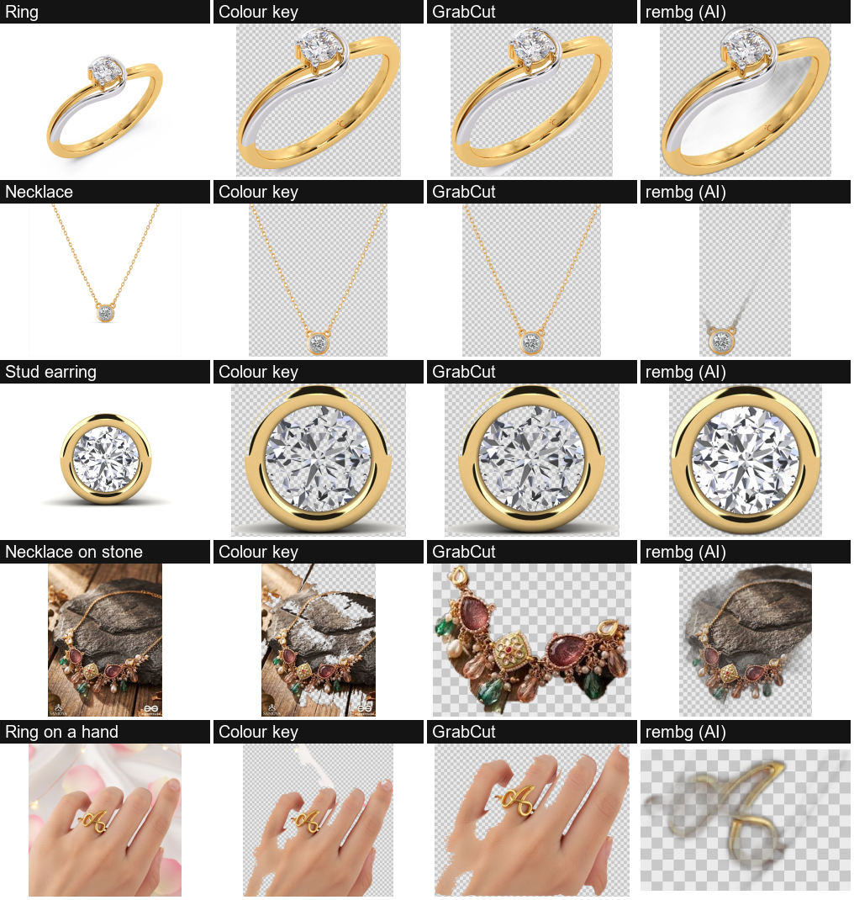
Figure 3. Colour key, GrabCut and rembg (AI) on the same five product photographs.
Table 7. Time per image for each background-removal method (median of 3 runs)
Input | Colour key (ms) | GrabCut (ms) | rembg AI (ms)
Ring | 71 | 1990 | 157
Necklace | 67 | 981 | 154
Stud earring | 55 | 1217 | 151
Necklace on stone | 26 | 2894 | 140
Ring on a hand | 56 | 6297 | 153

The times were measured while another program was using much of the CPU, so the GrabCut times are inflated; the ranking (colour key fastest, GrabCut slowest) is what matters. The rembg time excludes loading its model, which is downloaded on first use. Colour key and GrabCut need no download.
To measure the method where the true outline is known, five drawn product images (rings, a hoop earring, necklace chains on white and grey) with exact masks were used. This is an easy test, so the scores show that the code is correct, not how it performs on real photographs.
Table 8. Cut-out quality on five drawn test images (400 x 400 px)
Method | Mean IoU | Mean time per image (ms)
Automatic (colour key, GrabCut fallback) | 0.999 | 42.6
Colour key | 0.999 | 16.1
GrabCut | 1.000 | 243.8

9.2 Placement on the face and hand
Earrings. Figure 4 shows the round stud earring on six face photographs, cropped from the eyes to the chin. Each stud sits on the earlobe at a realistic size. On Face 3, which already wears a hoop earring, the stud lands on the real earring. The earlobe is found from the two jaw points just under each ear, and the size comes from the sprite's shape. The placement was judged by eye on these six faces; it was not measured.
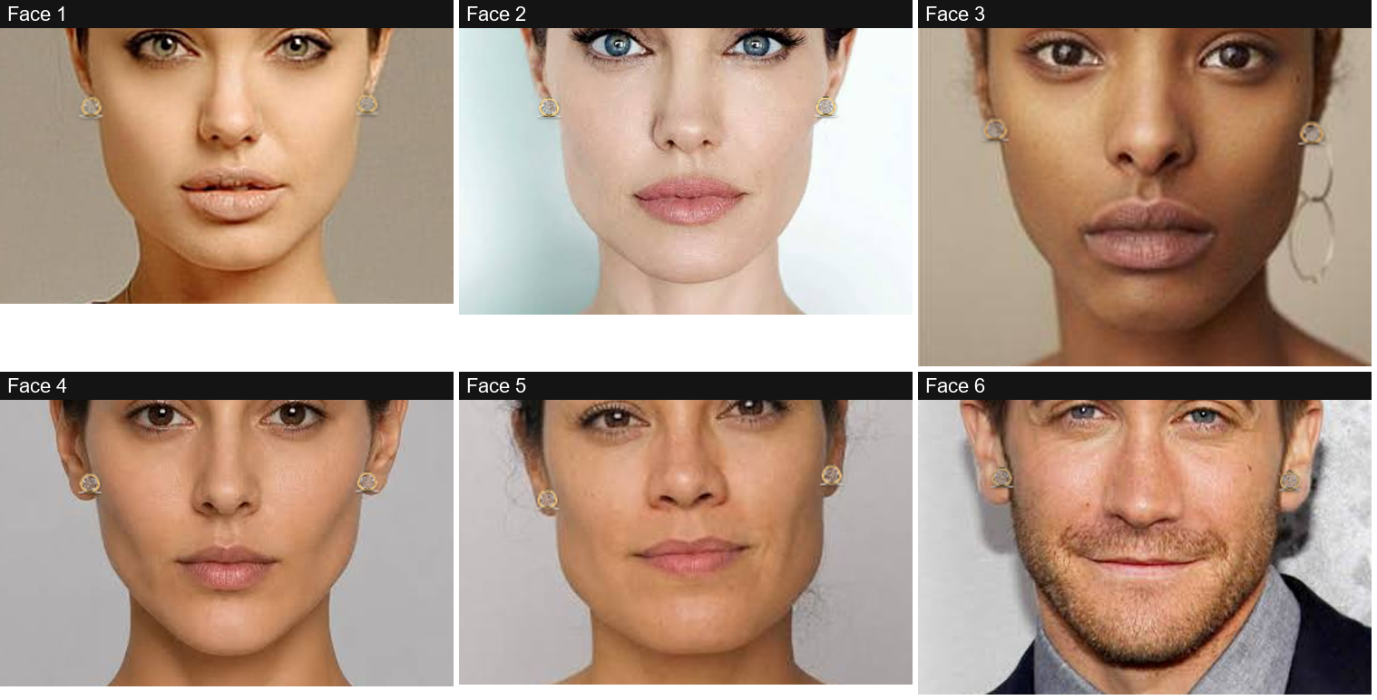
Figure 4. A stud earring placed on six face photographs (crops from the eyes to the chin).
Necklace. Figure 5 shows the chain necklace placed from the shoulder line on a photograph that shows the upper body. The chain spans the width of the neck, follows the tilt of the shoulders and ends in a pendant on the chest. In the tightly cropped portraits (Faces 2 and 4) only the top of the chain is inside the picture. Figure 6 zooms in on the neckline: the left panel is the input, the middle panel is placement only, and the right panel adds relighting, which dims the chain to match the scene, and a contact shadow under the pendant.
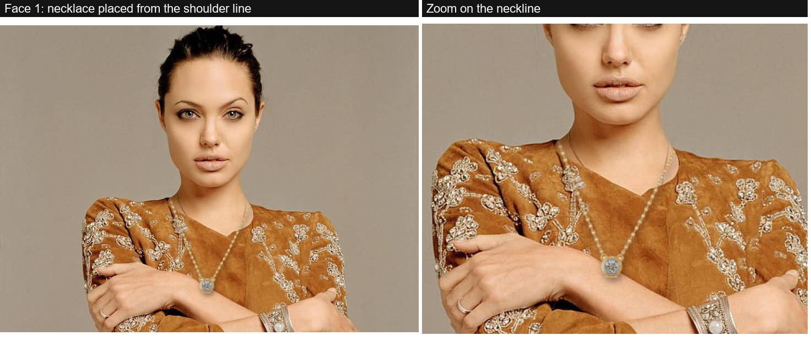
Figure 5. The chain necklace placed on a photograph with the upper body visible, and a zoom on the neckline.
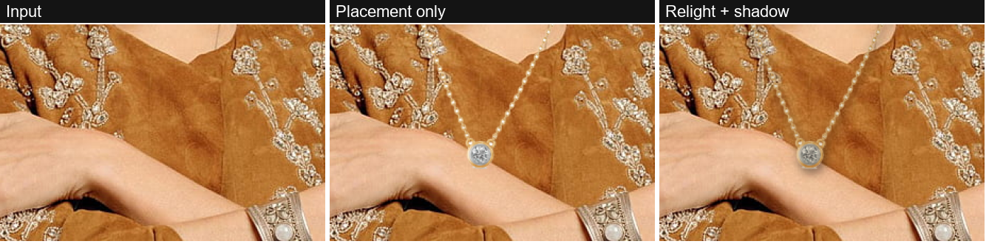
Figure 6. Neckline zoom: input, placement only, and with relighting and shadow.
Ring and bracelet. Figure 7 shows the ring on the ring finger and the bangle at the wrist for two hands. The palm/back check reported the back of the hand for both photographs, which matches the visible fingernails, so the ring is drawn. Both accessories keep the skin tone of the hand underneath and follow the finger and wrist directions. The ring is sized to the finger from the landmarks; very large or chunky rings may still need the size slider.
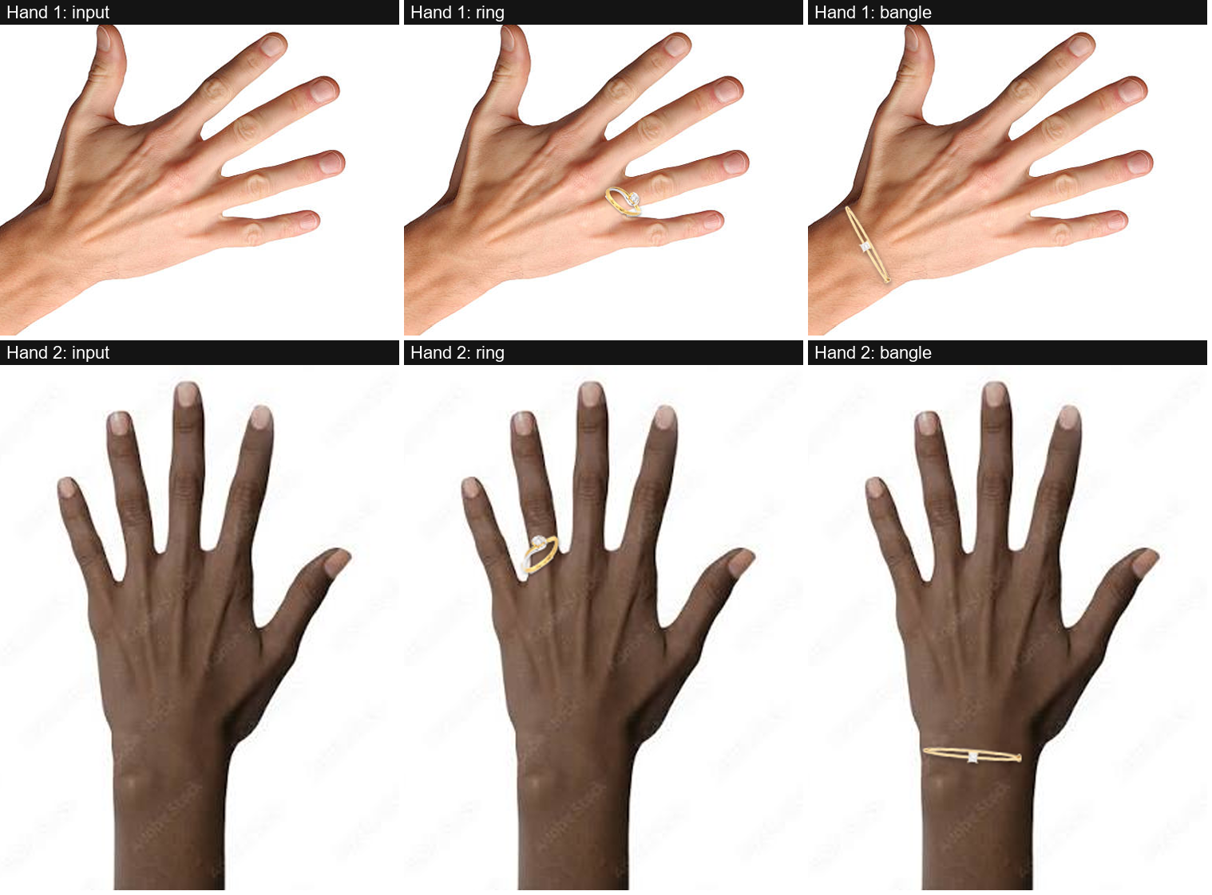
Figure 7. Ring and bangle placed on two hand photographs (crops around the hand).

9.3 Face-shape model
Figure 8 compares the pretrained face-shape model with our own hand-written ratio rules on the test and validation photographs. The model is right about two times in three; the rules, which compared face length, cheekbone, forehead and jaw widths, were close to random guessing and are used only as a fallback if the model files are missing.
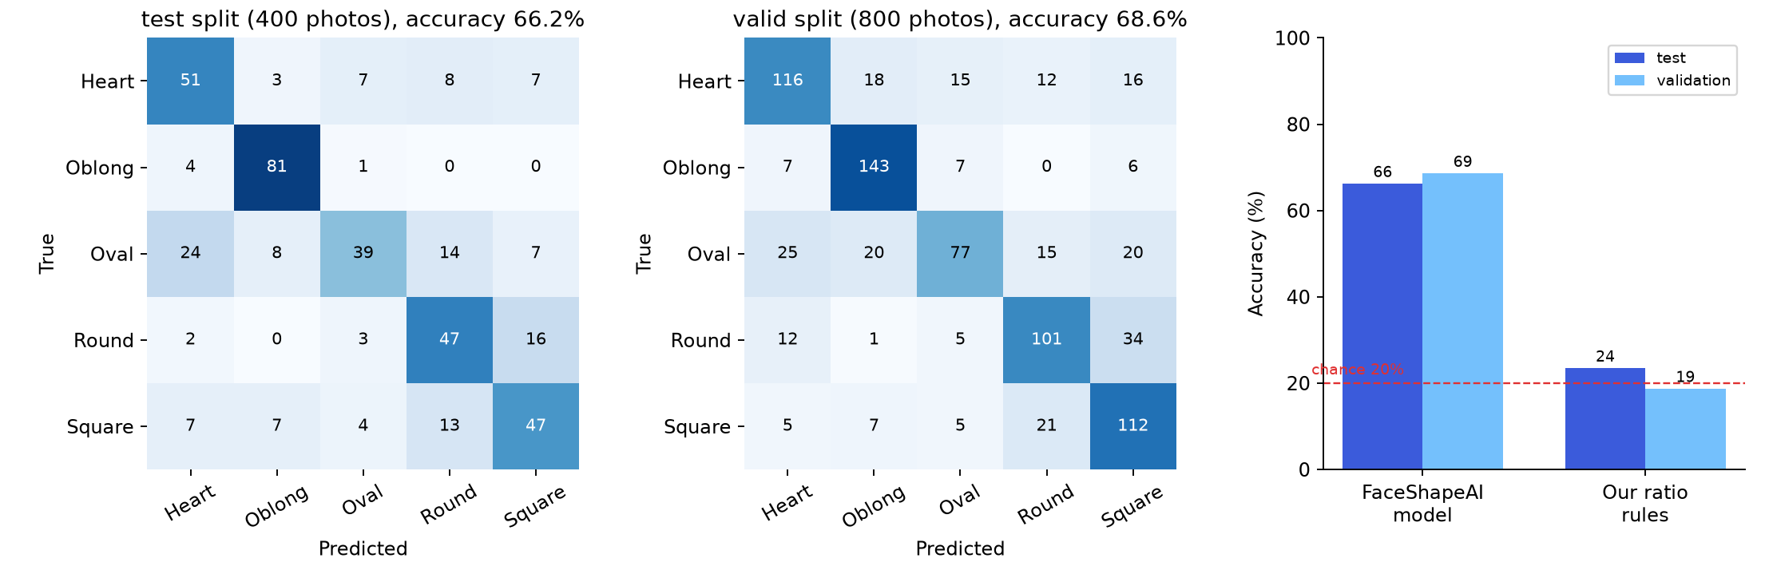
Figure 8. Confusion matrices of the face-shape model (counts) and accuracy of the model versus the fallback rules.
Table 9. Face-shape model: share of each true class predicted correctly (recall)
Split | Heart | Oblong | Oval | Round | Square | Overall accuracy
Test (400) | 67% | 94% | 42% | 69% | 60% | 66.2%
Validation (801; 800 had a detected face) | 66% | 88% | 49% | 66% | 75% | 68.6%

Oblong faces are recognised best and Oval worst (they are often called Heart). On the test photographs, when the model's top probability was at least 70%, it was right in 155 of 190 cases (82%), so the reported probability is a useful sign of reliability. The model has no Diamond class. The dataset's labels are made by people and face shape is partly subjective, so even a perfect system would not score 100%.
Table 10. Model output on six sample faces (no ground-truth label available)
Photo | Most likely shape | Second most likely
Face 1 | Oval 74% | Heart 8%
Face 2 | Oval 38% | Oblong 26%
Face 3 | Heart 48% | Oval 30%
Face 4 | Oval 45% | Oblong 35%
Face 5 | Square 92% | Oval 4%
Face 6 | Oblong 100% | Square 0%

9.4 Smoothing of landmark positions
The One Euro filter was tested on a made-up signal: a point with 1.5-pixel random noise at 30 frames per second, either still or moving sideways (Figure 9). Jitter is measured as the root-mean-square of the second difference of the position (higher means shakier).
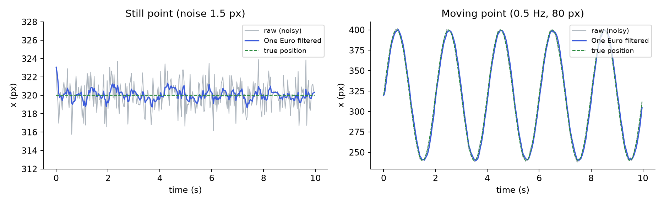
Figure 9. Raw noisy position, filtered position and true position for a still and a moving point.
Table 11. Effect of the One Euro filter on a synthetic signal
Signal | Jitter before | Jitter after | Jitter reduction | Mean position error before / after (px)
Still point | 5.18 | 0.77 | 85% | 1.87 / 0.73
Moving point | 5.31 | 2.29 | 57% | 1.89 / 5.86

For a still point the filter removes most of the shake and also reduces the error. For a moving point the shake is reduced by about half but the filtered position lags behind the true one (error rises from 1.9 to 5.9 pixels). This is the usual trade-off of smoothing. The test used a made-up signal, not real landmarks.

9.5 Speed
The slowest step is the hair/skin segmentation model: it needs about 115 ms per call even on a tiny input on this CPU. In the first version the video loop waited for it every third frame, and measured live speed was only 5.6-7.3 frames per second (earrings 7.3, necklace 5.6, ring 5.7). We then moved segmentation into a background thread: the loop gives it the newest frame when it is idle and uses the latest finished mask. We also limited the hair and skin blending to the small area where jewellery was drawn, and reused the relit sprite while the room lighting stays about the same.
Speed was measured on real input: a sample portrait and the hand photograph were placed on a 1280 x 720 canvas and processed 90 times in live mode. Because another program (a local language-model server) was using about 80% of the laptop's CPU during the tests, wall-clock speed was unreliable. We therefore also report the CPU time the video loop itself uses per frame, which is much less affected, and estimate the speed on an idle CPU as 1000 divided by that time.
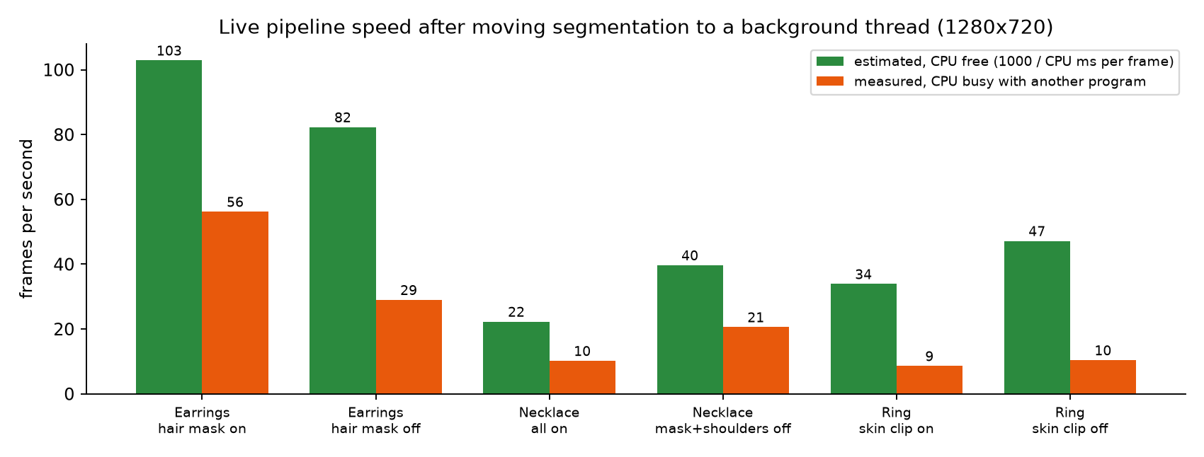
Figure 10. Estimated speed on a free CPU and measured speed on a busy CPU.
Table 12. Live speed after the change, 1280 x 720 input (mean over 90 frames)
Accessory and setting | Video-loop CPU time per frame (ms) | Estimated FPS, CPU free | Measured FPS, CPU busy
Earrings, hair mask on (default) | 9.7 | 103 | 56
Earrings, hair mask off | 12.2 | 82 | 29
Necklace, hair mask and shoulders on (default) | 44.8 | 22 | 10
Necklace, hair mask and shoulders off | 25.2 | 40 | 21
Ring, skin clip on (default) | 29.5 | 34 | 9
Ring, skin clip off | 21.2 | 47 | 10

The estimate assumes the segmentation thread runs on another core, and it was not confirmed on an idle machine. Under a busy CPU the necklace and ring still ran at about 9-10 frames per second. Closing other heavy programs before a live demonstration is recommended.

9.6 Software checks
57 automated tests pass (one is skipped). They cover overlay geometry, effects, cut-out hole clearing, placement and offset sliders, face-shape rules, the pendulum, the One Euro filter, palm and head-turn logic, blocking of unsafe web addresses, safe loading of the model files and the catalogue.

10. Challenges / Limitations

10.1 Problems encountered
- Our own face-shape rules, built from length and width ratios, scored only 19-24% on 1,200 labelled photos (chance is 20%). We replaced them with a pretrained model as the main answer.
- The palm-versus-back check was first inverted. We found it on a hand photograph where the nails were visible but the hand was reported as palm side, and corrected it. It was verified on that one photograph and its mirror image only.
- The first placement was wrong when checked at high zoom: earrings too big and off the earlobe, the necklace about twice the neck width and the ring about twice the finger width. We fixed this by anchoring earrings to the jaw points under the ear and sizing all three from the sprite shape and from neck and finger widths.
- Hair and skin segmentation is slow on a CPU (about 115 ms or more per call). It now runs in a background thread so the video does not wait for it, but the mask can lag a few frames behind fast movement.

10.2 Difficult cases and failures
- Product photos with busy backgrounds, or photos of the product being worn, are not cut out cleanly (Figure 3).
- The product's own shadow is kept as part of a cut-out on a plain background.
- Thin chains can be lost by GrabCut.
- A tightly cropped hand photo was not detected until grey padding was added around it.
- Sizes are estimated from landmarks and from the shape of the product photo. Real jewellery sizes vary, so unusual items (very large hoops, chunky rings) may need the size slider.
- On tightly cropped portraits a necklace lies outside the image.
- Long hair can cover earrings completely; the hair-cover slider reduces this.

10.3 Computational limitations
All models run on the CPU of an ordinary laptop. The segmentation model dominates the cost (about 115 ms or more per call), and live speed drops sharply when other programs use the CPU. A GPU or a smaller segmentation model would make the hair and skin masks follow fast movement more closely.

10.4 Dataset limitations
- No video dataset of our own was recorded, so tracking quality across skin tones, lighting and camera types was not measured.
- The labelled dataset contains faces only; no labelled data was available for hands, rings and bracelets.
- Face-shape labels are subjective, and we do not know whether the model's own training data overlaps with the test photographs, so the accuracy figures could be slightly optimistic.
- Placement was checked by eye on a few photographs and not measured.

11. Conclusion
We implemented a virtual jewellery try-on that works on still photos and a live webcam in the browser. A product photo is cut out with colour keying, morphological operations and GrabCut; MediaPipe landmarks place earrings, necklaces, rings and bracelets at the right position, size and angle; and warping, relighting, Gaussian-blurred masks and alpha blending help them look part of the scene. A One Euro filter steadies the live view, and a catalogue with a split-screen compare mode lets a user evaluate two items.
What we achieved: a working end-to-end application with a face-shape advisor whose model was right about two times in three on 1,200 labelled photographs, a filter that cuts landmark shake by more than half on a test signal, and a test suite that passes. What we did not achieve: a confirmed smooth live speed on a busy CPU with every realism option on, clean cut-outs from busy or worn-product photos, and measured accuracy for hand accessories.
What we learned: how many classical operations (colour spaces, filtering, morphology, geometric warping, blending) are needed in a realistic application; that a simple hand-made rule can be no better than chance until it is measured on labelled data; that speed and realism trade off against each other; and that honest evaluation, including recording failures, is as important as the working demonstration.

12. References
[1] C. Lugaresi et al., "MediaPipe: A Framework for Building Perception Pipelines," arXiv:1906.08172, 2019.
[2] Y. Kartynnik et al., "Real-time Facial Surface Geometry from Monocular Video on Mobile GPUs," arXiv:1907.06724, 2019.
[3] F. Zhang et al., "MediaPipe Hands: On-device Real-time Hand Tracking," arXiv:2006.10214, 2020.
[4] V. Bazarevsky et al., "BlazePose: On-device Real-time Body Pose Tracking," arXiv:2006.10204, 2020.
[5] C. Rother, V. Kolmogorov and A. Blake, "GrabCut: Interactive Foreground Extraction using Iterated Graph Cuts," ACM Transactions on Graphics, vol. 23, no. 3, 2004.
[6] G. Casiez, N. Roussel and D. Vogel, "1 Euro Filter: A Simple Speed-based Low-pass Filter for Noisy Input in Interactive Systems," Proc. ACM CHI, 2012.
[7] X. Qin et al., "U2-Net: Going Deeper with Nested U-Structure for Salient Object Detection," Pattern Recognition, vol. 106, 2020 (model used by the rembg option).
[8] G. Bradski, "The OpenCV Library," Dr. Dobb's Journal of Software Tools, 2000.
[9] F. Pedregosa et al., "Scikit-learn: Machine Learning in Python," Journal of Machine Learning Research, vol. 12, 2011.
[10] Rob4343, "FaceShapeAI," Hugging Face model repository, MIT licence. https://huggingface.co/Rob4343/FaceShapeAI
[11] Roboflow Universe, "Face Shape Classification," dataset version 1 (folder export), accessed October 2026.
[12] "A Comparative Study of Different Face Shape Classification Techniques," 2021 International Conference on Electronic Engineering (ICEEM), 2021.
[13] Related open-source projects: github.com/ShagunDubey1/Virtual-try-on, github.com/RauhanAhmed/GemFit, github.com/AsutoshPati/ARJewelBox, github.com/pranjaykumar926/VIRTUAL-TRY-ON, and the list github.com/minar09/awesome-virtual-try-on.
[14] Streamlit documentation, https://docs.streamlit.io, and streamlit-webrtc, https://github.com/whitphx/streamlit-webrtc.
[15] Project repository: https://github.com/av7890/Accessory-Try

