# Macintosh HD:Users:Amit:Progs:ExcelerateLive:HTML:ml.png Excelerate Lesson Plan

**Number Lines**

**About These Problems**

**A number line is basically a one-dimensional graph. Most problems involve reading data from a number line.**

**Question.** If A and P were multiplied which of the following numbers could their product possibly be?

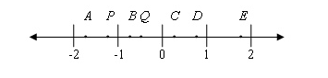

1. Q
2. C
3. D
4. E
5. B

**Answer.** **4**: Since both A and P are below 0 their product must be positive. Since they are both less than one their multiplication must be larger than 1 so E is the only option.