# Macintosh HD:Users:Amit:Progs:ExcelerateLive:HTML:ml.png Excelerate Lesson Plan

**Slope of a Line/Slope Formula**

**About These Problems**

**The slope of a line is also known as rise over run. It is a ratio of how many units the points rise in one unit of increment on the x – axis.**

**Formula = (y2 – y1 ) / (x2 – x1)**

**Question.**  What is the slope of the following line?

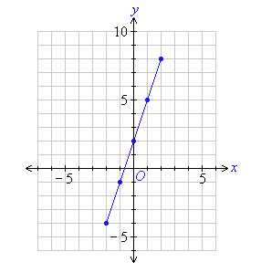

1. 2.5
2. 3
3. 4
4. 5.5
5. 6

**Answer.** **2**: Select two random points. The easiest would be (0,2) and (1,5) which would yield according to the formula. m = (5-2)/(1-0)