# Macintosh HD:Users:Amit:Progs:ExcelerateLive:HTML:ml.png Excelerate Lesson Plan

**X and Y Intercepts**

**About These Problems**

**Intercepts are points where the line or function touches the x or y axis. Correspondingly the x intercept is where the function is 0 for y and touches the x – axis. The y intercept is where the function is 0 for x and touches the y – axis.**

**Question.**  What is the y intercept of the following graph.

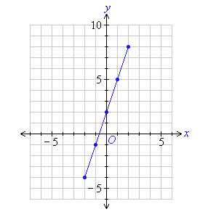

1. (0,2)
2. (1,2)
3. (0,3)
4. (0,2.5)
5. (0,1.2)

**Answer.** **1**: The easiest way to find the y intercept is make x = 0 which in this case yields the point (0,2)