# Macintosh HD:Users:Amit:Progs:ExcelerateLive:HTML:ml.png Excelerate Lesson Plan

**Direct and Inverse Variation**

**About These Problems**

**These problems involve a function with two variables, the input (x) and the output (y). As x increases, if y increases then there is a direct variation. If as x increases, y decreases then there is an inverse variation.**

**Question.**  Describe the variation shown by the scatterplot below.

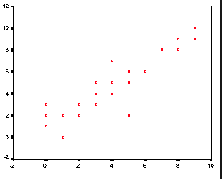

1. Direct
2. Inverse
3. Inconclusive
4. None of the Above
5. Flat

**Answer.** **1**: Almost all the points show the trend that as x increases y increases. The slope is positive. Therefore this is direct variation.