# Macintosh HD:Users:Amit:Progs:ExcelerateLive:HTML:ml.png Excelerate Lesson Plan

**Interior Angles in Polygons**

**About These Problems**

**Interior angles are any given angle on the inside of a polygon. A polygon is any n-sided shape. The sum of all angles in a given n-sided polygon is a function n. For example a triangle which has 3 sides has a sum of interior angles to be 180 degrees. A parallelogram which has 4 sides has a total interior angle sum of 360 degrees. The formula is 180*(n-2)**

**Rules:**

Triangle: 180 degrees

Rectangle: 360 degrees

Pentagon: 540 degrees

Hexagon: 720 degrees

Octagon: 1080 degrees.

**Question.**  Based upon the figure below what is A?

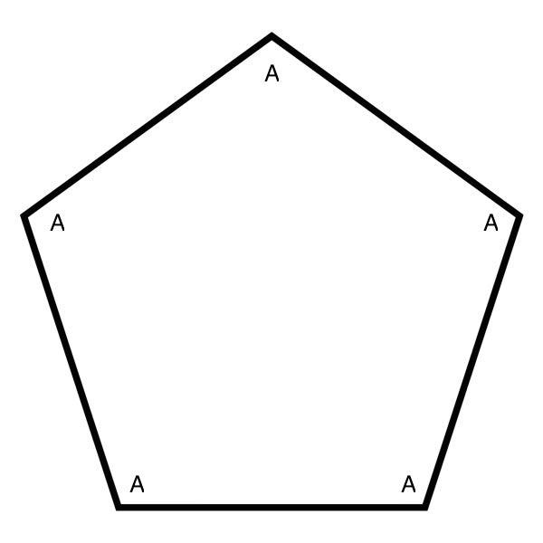

1. 90 degrees
2. 100 degrees
3. 120 degrees
4. 120 degrees
5. 108 degrees

**Answer.** **5**: The sum of interior angles in a pentagon is 540. Dividing that by 5 since all the 5 angles are equal to A, you get 108 degrees.