# Macintosh HD:Users:Amit:Progs:ExcelerateLive:HTML:ml.png Excelerate Lesson Plan

**Angle based Triangles**

**About These Problems**

**There are two main triangles with right angles that are very common in standardized testing. One of these triangles is called a 45-45-90 triangle. The other is a 30-60-90 triangle.**

**45-45-90 Triangle**

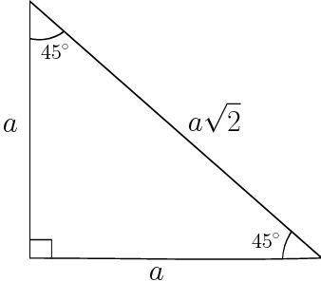

The 45-45-90 triangle is an isosceles right triangle. Isosceles implies that the triangle has two sides of the same length. If the side opposite either of the 45 degree angles is A then the side opposite the 90 degree angle is root(2) times A.

**30-60-90 Triangle**

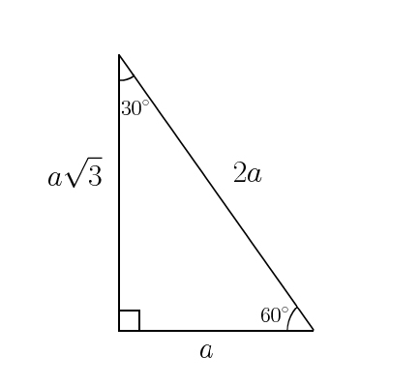

The 30-60-90 triangle above has an interesting ratio with its sides. If the side across the 30 degree angle is A, then the side across the 60 degree angle is A times root(3) and the side opposite the 90 degree angle is 2A.

**Question.**  We have three cities in California. Winchester, Alves, and Verano. Winchester and Verano are separated by a straight highway that is 1414 miles long. Winchester and Alves are also separated by a highway that is 1414 miles long. The three cities form a perfect 45-45-90 degree triangle. How far away is Alves from Verano?

1. 2000 miles
2. 3000 miles
3. 4000 miles
4. 5000 miles
5. 6000 miles

**Answer.** **1**: If the cities form a 45-45-90 triangle we know that "A" is 1414. Multiplying that by root(2) we get around 2000 which is option 1.