# Macintosh HD:Users:Amit:Progs:ExcelerateLive:HTML:ml.png Excelerate Lesson Plan

**Side based Triangles**

**About These Problems**

**There are two main side based triangles with right angles that are very common in standardized testing. One of these triangles is called a 3-4-5 triangle. The other is a 5-12-13 triangle.**

**3-4-5 Triangle**

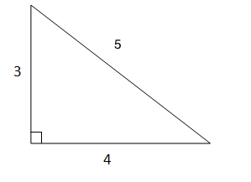

**5-12-13 Triangle**

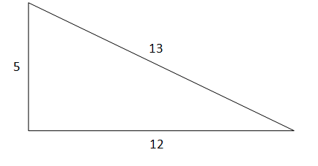

**Question.**  United Airlines Flight 451 has departed San Francisco airport to the north and is about 50 miles north of the airport. A few minutes earlier, American Airlines Flight 3451 departed for Salt Lake City and is 120 miles east of the airport. How far apart are the aircraft?

1. 100 miles
2. 110 miles
3. 120 miles
4. 130 miles
5. 140 miles

**Answer.** **4**: The two aircraft and the airport form a 5-12-13 triangle. The distance between them is 10*13 which is 130.