# Macintosh HD:Users:Amit:Progs:ExcelerateLive:HTML:ml.png Excelerate Lesson Plan

**Isosceles, Scalene, and Equilateral Triangles**

**About These Problems**

**There are three major types of triangles. Scalene triangles are triangles that have no congruent sides. Congruent means two things are equal to each other. Isosceles Triangles have two congruent sides. Equilateral triangles have all three sides the same and have interior angles of 60 degrees.**

**Triangle Types**

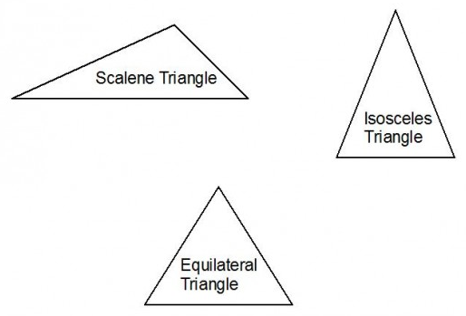

**Question.**  If a triangle has one side of length 15, one side of length 10, and is isosceles, what are its possible perimeters?

1. 20
2. 25
3. 30
4. 35
5. 40

**Answer.** **4**: Since isosceles implies that two of its sides must be the same. The only possible perimeters it can have are 15*2 + 10 which is 40 or 10*2 + 15 which is 35.