# Macintosh HD:Users:Amit:Progs:ExcelerateLive:HTML:ml.png Excelerate Lesson Plan

**Congruent and Similar Triangles**

**About These Problems**

**Congruent triangles are triangles that share all three sides and all three angles. Similar triangles are triangles that share all three angles but the ratio of their sides are scaled by a certain factor.**

**Similar Triangles**

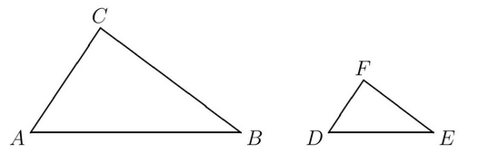

The angles of both triangles are the same yet the one on the right is smaller because it's sides are scaled down. If they were congruent they would both be the same size.

**Question.**  Refer to the figure below. If BC was 8 and FE was 4, what is DE if AB was 12?



1. 4
2. 6
3. 8
4. 10
5. 12

**Answer.** **2**: The triangle on the right is the triangle on the left scaled down by half. We know this because BC/EF = 2. So AB/DE = 2 and we know that AB is 12 so DE must be 6.