# Macintosh HD:Users:Amit:Progs:ExcelerateLive:HTML:ml.png Excelerate Lesson Plan

**Arc Lengths and Areas for Sectors**

**About These Problems**

**Arc Lengths and sector areas are portions of a circle that have been cut out. Your job is to find either the length of the outer part of the circle or the area of the sector. More often than not, the angle of the sector will be given to you.**

**Formulas:**

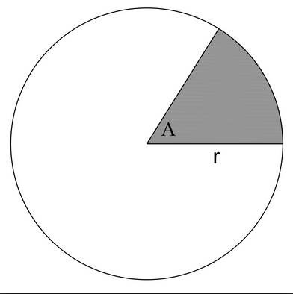

Arc Length of Sector : A/360 degrees * 2*pi*r

Area of a Sector : A/360 degrees * pi * r2

**Question.**  If the radius of a circle is 5 and the angle of a sector is 90 degrees what is the perimeter of the sector?

1. 7.85
2. 17.85
3. 15.75
4. 10
5. 31.4

**Answer.** **2**:

Circumference = 2*5*pi = 31.4

Arc Length = 31.4 * 90 / 360 = 7.85

Perimeter = 5 + 5 + 7.85 = 17.85