# Macintosh HD:Users:Amit:Progs:ExcelerateLive:HTML:ml.png Excelerate Lesson Plan

**Data Analysis**

**About These Problems**

**These problems include steps analyzing tables and graphs, slopes of a plot to analyze trends, and interpreting Venn diagrams.**

**Question.**  Refer to the following figure below. The x axis represents millions of dollars spent in education and the y axis represents how many students out of 10 perform "Proficiently" at standardized testing. If $4 million dollars was spent on education what is the range of students who perform well on standardized testing based upon this data?

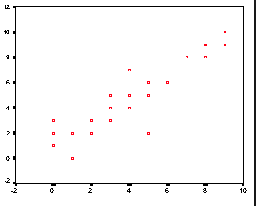

1. 2 – 8 students
2. 3 – 8 students
3. 6 – 7 students
4. 5 – 6 students
5. 4 – 7 students

**Answer.** **5**: At x = 4, there are three points on the plane (4,5,7). Which would make option 5 the only suitable one.