Business Intelligence — Individual Term Project (Technical Report)
Should a New Market Learn from Other Markets?
Cross-market next-destination recommendation on the Booking.com Multi-Destination Trips dataset
Author: Aye Thadar Soe Student ID: 20243540
Course: Business Intelligence (01), Prof. Jason J. Jung, Chung-Ang University, Fall 2026
Code: submitted with this report and at https://github.com/ava-builds/bi-cross-market-recsys (runs in Google Colab)

Summary
When a travel platform suggests the next city of a multi-city trip, should the model for each country learn only from that country's bookings, or from all countries together? I used 288,348 anonymised Booking.com trips from five booker countries and trained the same next-city model on three kinds of data: the country's own trips, all trips pooled, and a blend of the two tuned on validation data. All three reached about 46% Recall@4, compared with 5% for simply recommending the most popular cities. Pooling helped three countries (+0.8 to +3.2 percentage points) but hurt the two whose travellers go to the most unusual places (−2.4 and −3.2 points), because in shared cities the habits of the big markets pushed aside what these travellers actually do next. In a simulated market launch, an unusual market needed other countries' data only until it had about 1,000 trips of its own. The validation-tuned blend gave 547 more correct suggestions on the test trips than one pooled model for everyone.

1. Problem and scenario
Booking.com shows a "next destination" suggestion while people plan a trip with several cities. Its users come from many countries, and some of these markets are big while others are small or new. For each market, the team has to decide what data the recommender learns from. A market's own bookings keep its local preferences, but a small market may not have enough of them. Pooling all markets gives much more data, but the big markets dominate it, and their travellers may behave differently. A blend sits in between.
This is the transfer question from Week 7 of the course: can knowledge move between markets, and who gets worse recommendations when it does?
Research question. For which markets does pooling other markets' data improve next-destination recommendations, and does this depend on the size of the market, on how different its travel behaviour is, or on both?
- H1 (size): markets with less data gain more from pooling.
- H2 (distinctiveness): markets whose destinations are very different from other markets gain less from pooling, and can even lose.
Decision supported. Which data (own, pooled or blended) to train on for each market, and how to change this as a new market grows.

2. Data
I used the Booking.com Multi-Destination Trips dataset (Goldenberg & Levin, 2021) from Booking.com's official GitHub repository. Each row is one hotel booking with its dates, device, booker country, hotel country, city and trip ID. The training file has 1,166,835 bookings in 217,686 trips (December 2015 to February 2017, 39,901 cities). The test file has 70,662 trips whose last city is hidden, and the answers are in ground_truth.csv. I used this official split without changes.
Countries have made-up names such as "Gondal", and cities are numbers. The booker country is where the booking was made, not the traveller's nationality, and the data cannot be matched to real countries or to cultural data such as the World Values Survey. The dataset may only be used non-commercially; this project is coursework, and the data is not shared with my code.
There are only five booker markets (Table 1). To measure how different a market is, I compared the cities its travellers book with the cities everyone else books, using the Jensen-Shannon (JS) divergence (0 = the same, 1 = no overlap).
Market | Train trips | Share | Test trips | Top hotel countries | Distinct. (JS)
Gondal | 100,592 | 46.2% | 32,630 | Gondal, Fook Island, Cobra Island | 0.240
The Devilfire Empire | 51,694 | 23.7% | 16,882 | Cobra Island, Borginia, Fook Island | 0.368
Elbonia | 43,490 | 20.0% | 13,843 | Cobra Island, Fook Island, Elbonia | 0.176
Tcherkistan | 16,291 | 7.5% | 5,459 | Drusselstein, Aldovia, Oceania | 0.579
Bartovia | 5,619 | 2.6% | 1,848 | Bartovia, Fook Island, Cobra Island | 0.333
Table 1. The five booker markets. Tcherkistan travellers mostly visit countries that are not top destinations for any other market.

3. Method

3.1 Task and models
For each trip, the model sees the cities booked so far and suggests 4 cities for the next booking (K = 4, as in the original Booking.com challenge). I kept the model simple on purpose: it counts which cities usually came next after the trip's current city. The counting stays the same and only the training data changes, so any difference in results comes from the data. This is the controlled comparison.
Model | Training data | How it picks the next city
Popularity (baseline) | All markets | The same 4 most-booked cities for everyone
Own market | This market only | Cities that most often came next after the current city; if fewer than 4, filled with popular cities in the same country
Pooled | All markets | Same as Own market
Blend | Both | α × own probability + (1 − α) × pooled probability, with α chosen for each market on validation data
Table 2. Models compared.
The current city can also be suggested again, because about 9% of next bookings are a second hotel in the same city.

3.2 Evaluation
The only setting I tuned, α, was chosen on a validation set made from 10% of the training trips, so the test set was used only once, at the end. The main metric is Recall@4: the share of test trips where the true next city is among the 4 suggestions. The notebook also reports NDCG@4, which gives more credit when the right city is ranked higher, and item coverage. To check that differences are real and not luck, I used 95% bootstrap confidence intervals (1,000 resamples).

3.3 Simulated market entry
In the real data, size and distinctiveness are mixed together, so I also simulated launching in a new market. The other four markets keep all their data, but the target market gets only N of its own trips (N = 250, 1,000, 4,000 and all). I did this for the most distinctive market (Tcherkistan, JS 0.58) and the least distinctive one (Elbonia, JS 0.18), with two random samples for each N below 10,000.

4. Results

4.1 Results by market
Over all 70,662 test trips, the own, pooled and blend models reached a Recall@4 of 46.1%, 46.1% and 46.9%, while the popularity baseline reached only 5.3%. Using the current city makes the suggestions about nine times better. Table 3 shows each market.
Market | Train trips | Popularity | Own market | Pooled | Blend (α)
Gondal | 100,592 | 4.1% | 39.6% | 40.3% | 40.2% (0.4)
The Devilfire Empire | 51,694 | 9.6% | 62.8% | 60.4% | 62.7% (0.6)
Elbonia | 43,490 | 3.4% | 35.1% | 37.2% | 37.3% (0.3)
Tcherkistan | 16,291 | 4.3% | 67.3% | 64.2% | 67.2% (0.9)
Bartovia | 5,619 | 3.5% | 29.6% | 32.7% | 32.3% (0.4)
Table 3. Recall@4 on the official test set (best in bold). NDCG@4, coverage and confidence intervals are in results/exp1_by_market.csv.

4.2 Size or distinctiveness?
Figure 1 plots the gain from pooling against how distinctive each market is. If size were the only thing that mattered (H1), Tcherkistan, the second-smallest market, should gain a lot. Instead it loses the most (−3.2 points), followed by The Devilfire Empire (−2.4). The three less distinctive markets gain: Gondal +0.8, Elbonia +2.1 and Bartovia +3.2. For all five differences, the 95% confidence interval excludes zero. This supports H2, and H1 only for markets that are not very distinctive. With just five markets this is a pattern, not proof, so I tested it again in the simulation.
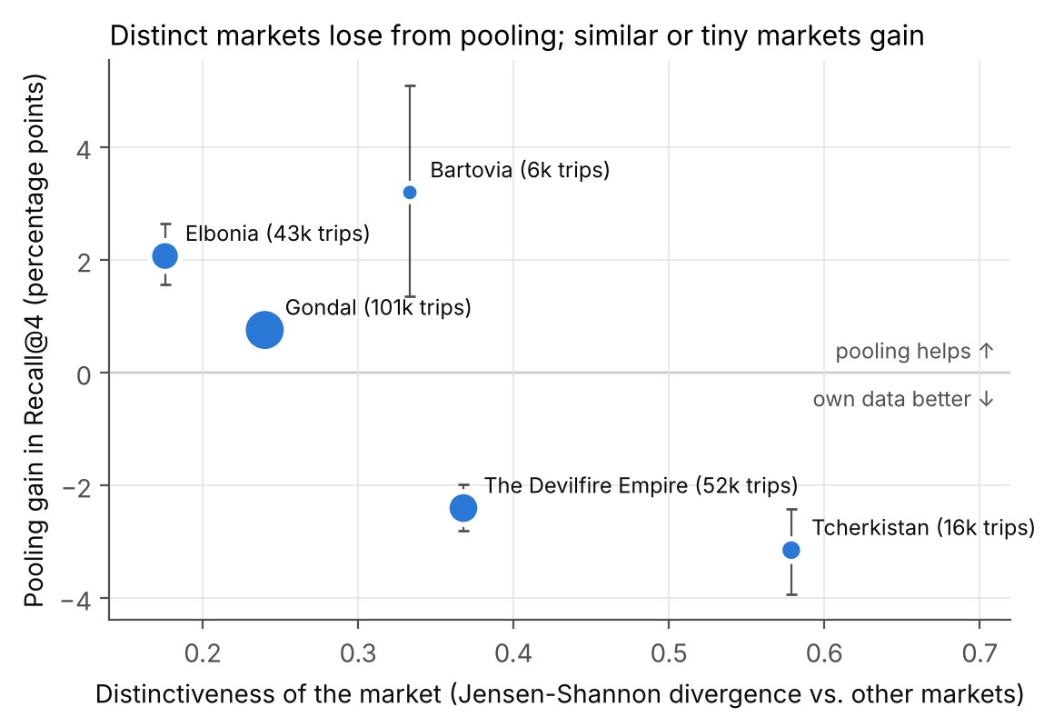
Figure 1. Pooling gain (Pooled − Own, Recall@4) against market distinctiveness. Error bars: 95% confidence intervals; point size: training trips.
The α chosen on validation data followed the same pattern without seeing the test set. It leaned towards own data for the two distinctive markets (0.9 and 0.6) and towards pooled data for the others (0.3–0.4).

4.3 Simulated market entry
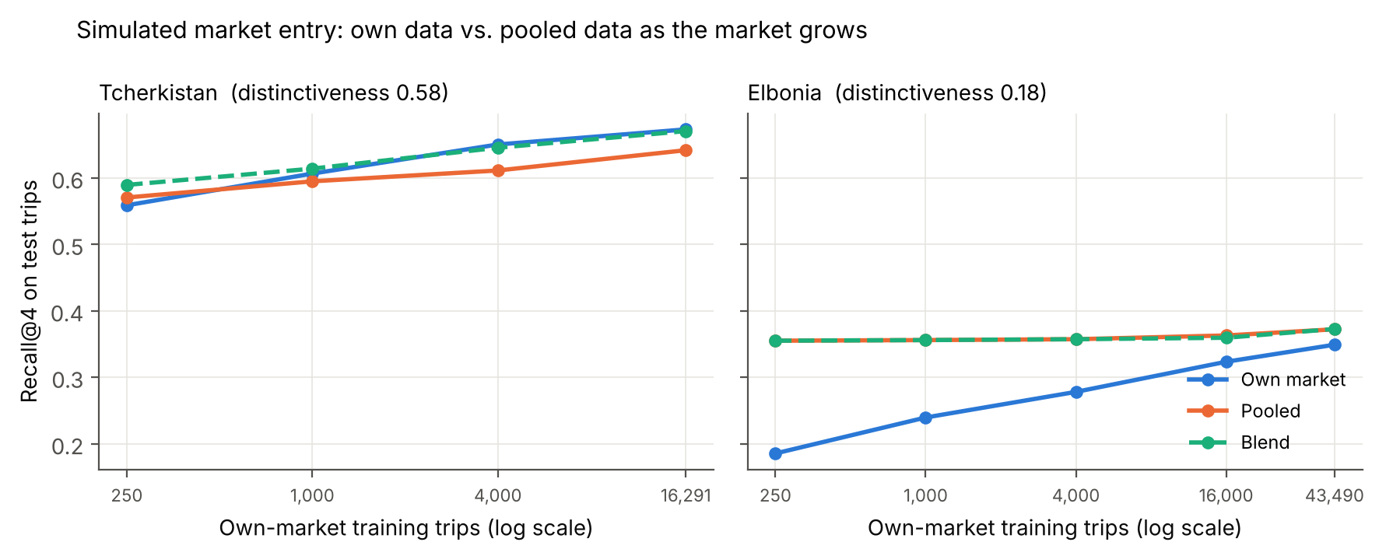
Figure 2. Simulated market entry: Recall@4 as the target market gets more of its own trips.
Elbonia gains from pooling at every size. With only 250 own trips, the pooled model is almost twice as accurate as the own model (35.5% vs 18.6%). Tcherkistan gains from pooling only at the very start: with 250 trips, pooled is better (57.1% vs 55.9%), but from about 1,000 trips its own data wins, and at 4,000 trips the gap is 3.9 points (65.0% vs 61.1%). The blend handled this by itself. Its α moved from 0.2 to 0.8 as Tcherkistan grew, and it was never more than 0.5 points behind the best model.

5. Failure analysis
Crowding out (pooled model). For each test trip, I checked what share of all departures from the current city were made by travellers from the same market. When the market is less than 25% of that traffic, the pooled model does much worse: −9.8 points for The Devilfire Empire (3,048 trips) and −7.1 points for Tcherkistan (2,034 trips). When the market is more than 75% of the traffic, the two models are almost equal for these markets. For example, 47 Tcherkistan test trips end in city 55763, where Tcherkistan travellers make only 17% of the 3,619 departures. They usually go on to cities 36063, 9698 and 45188, but the pooled model suggests 61320, 9161 and 63284, which is what the other markets do.
Too little data (own model). For Bartovia, the smallest market, 14.9% of test trips end in a city that Bartovia travellers never visited in the training data. Pooling did not fix these trips (own 19.6%, pooled 18.9%). The gain came from cities Bartovia had already seen, probably only a few times, where the bigger markets' counts give a more stable ranking.
A hypothesis that did not hold. I expected domestic trips to explain the losses from pooling, but the own–pooled difference on domestic trips was small for every market (−0.4 to +2.4 points). The big gains and losses came from international trips.

6. Business implications
In numbers a manager can use: if each market uses own or pooled data depending on what validation says, the test trips get 578 more correct suggestions than with one pooled model for everyone (+406 for The Devilfire Empire, +172 for Tcherkistan). The blend gets 547 more. Table 4 turns the results into simple rules.
Situation | Train on | Evidence
New market, fewer than about 1,000 own trips | Pooled, or a blend with low own weight | Tcherkistan at 250 trips: blend 58.9%, pooled 57.1%, own 55.9%
Distinctive market with enough data | Own, or a blend with high own weight | Tcherkistan and The Devilfire Empire: +172 and +406 correct suggestions
Typical market | Pooled, at every size | Elbonia and Gondal: pooled wins by 2.1 and 0.8 points
Every market, as it grows | Re-tune α on new validation data; report accuracy per market | α rose from 0.2 to 0.8 as Tcherkistan grew
Table 4. Decision rules from the results.
Checking how distinctive a new market is could tell the team early which rule applies, but I measured distinctiveness on the full data, so how early this works is still untested.

7. Governance and ethics
- Privacy. The data is anonymised by Booking.com, and no personal data was collected or linked.
- Terms. The data is used non-commercially under Booking.com's terms and is not redistributed.
- Fairness. One global model serves small and unusual markets worse, so accuracy should be reported per market, not only as one average.
- Monitoring. The team that owns the recommender should track Recall@4 per market after each retraining and re-tune α as markets grow.

8. Challenges
Data size. The training file has 1.17 million bookings (93 MB), too big for a spreadsheet but fine for Python. The real problem was the number of city pairs: 39,901 cities means about 1.6 billion possible pairs, but only 305,735 of them (0.02%) actually happen. So the counts are stored in dictionaries instead of one huge table, and the bookings are grouped into one row per trip. The whole notebook, including about 60 model fits for the simulation, runs in 3–4 minutes on free Google Colab.
Data quality and fair comparison. Because the countries are anonymised, I could not use cultural data, so the project compares behaviour, not culture. The hidden test city is stored as city 0 and had to be removed before predicting. Two early mistakes were found and fixed during development: the first version never suggested the current city, which missed about 9% of the answers, and the first Own model filled empty slots with pooled data, which secretly mixed in other markets. Tuning α only on validation data kept the test set clean.
Scope and schedule. I worked alone and had to finish by 31 October, so I planned the work in small stages (data, models, experiments, report) and had a working version early. I chose the Booking.com dataset because the Last.fm pages might be unavailable and Foursquare would have needed heavy cleaning of 33 million check-ins. Recommender systems and metrics such as NDCG were new to me, so I studied each method step by step and reran the full notebook myself to check every number.

9. Limitations
- Only five markets. The link between distinctiveness and pooling gain rests on five points.
- Markets are not cultures. The booker country is an anonymised booking origin, so the results describe behaviour, not cultural causes.
- Simple model. It ignores dates, device and longer trip history; stronger models may change the size of the gaps.
- Distinctiveness was measured on the full data. In a real launch it would come from a small early sample.

10. Conclusion
Whether a market should learn from other markets depends less on how much data it has and more on how different its travellers are. Pooling helped the typical markets and the smallest one, but hurt the two most distinctive markets, because the big markets' habits pushed out their own patterns in shared cities. A simple blend tuned on validation data picked the right side for every market and adjusted as a new market grew. For a platform entering new markets, the practical rule is to start with pooled data, watch how different the market is, and let validation data decide when it is ready for its own model.

References
Goldenberg, D., & Levin, P. (2021). Booking.com Multi-Destination Trips Dataset. Proceedings of the 44th International ACM SIGIR Conference on Research and Development in Information Retrieval (SIGIR '21). https://doi.org/10.1145/3404835.3463240
Booking.com. (2021). ml-dataset-mdt: dataset, evaluation notebook and terms and conditions. https://github.com/bookingcom/ml-dataset-mdt (accessed 26 October 2026).
Järvelin, K., & Kekäläinen, J. (2002). Cumulated gain-based evaluation of IR techniques. ACM Transactions on Information Systems, 20(4), 422–446.
Lin, J. (1991). Divergence measures based on the Shannon entropy. IEEE Transactions on Information Theory, 37(1), 145–151.
Jung, J. J. (2026). Cross-Cultural Recommendation Systems Using Public Datasets [Lecture slides]. Business Intelligence, Chung-Ang University.

Appendix: reproducibility and AI use
Reproducibility. All numbers, tables and figures come from analysis.ipynb and are saved in results/ and figures/. The notebook runs in about 3–4 minutes, also in Google Colab, and uses fixed random seeds. README.md explains how to download the dataset and run the code.
AI use. The analysis code was written with an AI assistant (Claude, Anthropic), and the assistant also drafted and edited the text of this report, following the scope and choices I made. I reran the complete notebook myself in Google Colab and confirmed that all results match this report. The interpretation and conclusions are my responsibility.

