This study involved treating 249 mice that had SCC tumor growth with different drug regimens. The researchers observed and measured tumor development over a period of 45 days. The goal of the study was to compare how well Capomulin, a drug of interest developed by Pymaceuticals, performed compared to other treatments.

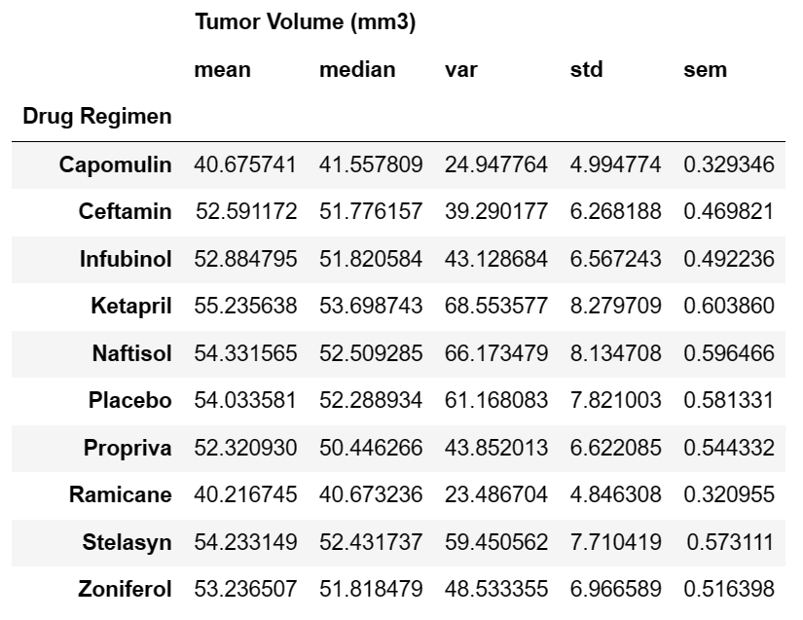

his table shows the average (mean) and middle (median) values of tumor volume for different drugs used in treating tumor growth. It also shows the variation (var), standard deviation (std), and standard error of the mean (sem) for each drug regimen. Based on the table, Capomulin has the lowest mean tumor volume (40.68 mm3), with Ramicane having the second-lowest mean tumor volume (40.22 mm3) while the highest mean tumor volume is associated with Ketapril (55.24 mm3). To help understand the results of the study, the bar chart is created:

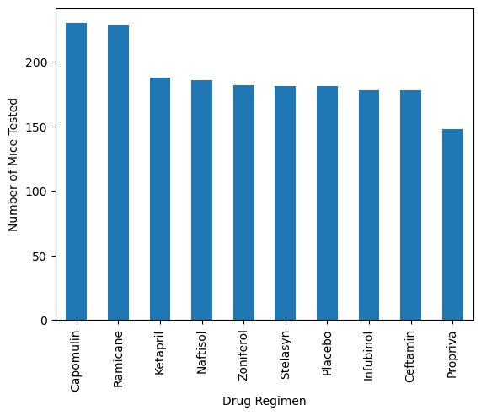

Base on the data and the results obtained from the pi-chart of the sex of the mice, it shows that 51% of the data corresponds to males, while the remaining 49% corresponds to females.

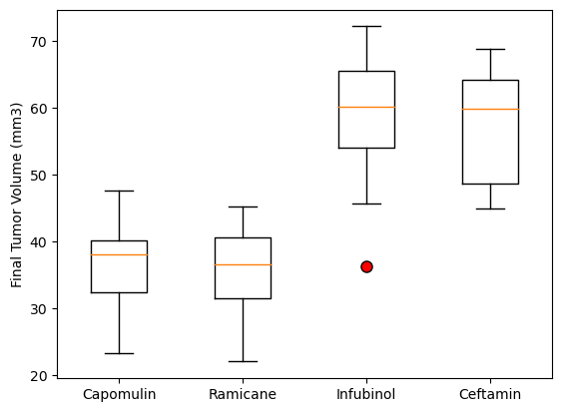

From the above figure, it can be seen that Capomulin , Ramicane and Ceftamin do not have any potential outliers, while Infubinol has one potential outlier with a tumor volume of 36.321346 mm3.

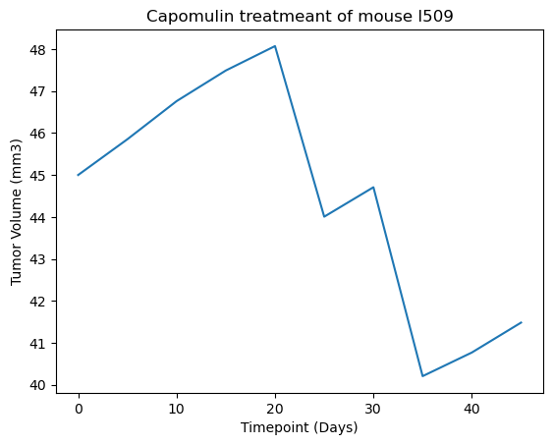

The above line chart indicates that the tumor size is decreasing over time for a sample mouse (n# 1509). This could prove that the Capomulin treatment is effective in reducing the size of the tumor.

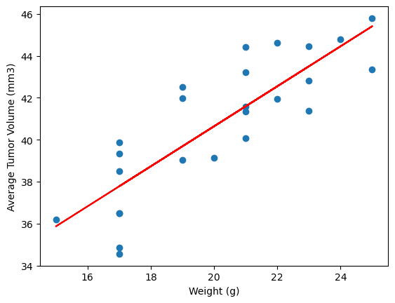

Finally, the correlation between weight(g) factor and Average Tumor volume(mm) is analysed (correlation coefficient =0.84 ) and as it depicted in above figure, it indicates a nearly strong positive correlation between mouse weight and average tumor volume. This means that as the weight of the mouse increases, the average tumor volume tends to increase as well.

