My goal for this project was to gather data about events taking place in New York City via the Ticketmaster and Eventbrite APIs. I collected data about the venues where these upcoming events were taking place. I was able to achieve both of these goals and create a program that prints out the name of the event and the date/start time of it. I was also able to create databases for each website that includes information about the events (event id, name, date/time, and category) and venues (venue name, address, longitude and latitude).

Initially, my goal was to gather this data for specifically New Year’s Eve events, however there were not enough results. Therefore, I decided my search was going to be “music” so that I could gather 100 events for Ticketmaster to meet the requirement. For Eventbrite, I only gathered 50 events because they limit you to 50 responses. Another goal that I didn’t quite achieve was making a word cloud of the categories. While I tried for a long time, it was difficult for me to create and I didn’t have enough of a variety of words since most of the categories were repeated.

I also made a map of the venues using Tableau and the longitude/latitude data I collected. At first, I tried using Google Maps but it wasn’t working with my data, so I decided to switch platforms.

The map I made showed that most of the upcoming music events will take place in downtown Manhattan.

Instructions for running my code:

1. Make sure datetime is installed by “pip install datetime”
2. Everything should print once you run the file “master.py”
3. Open “venue_map.tbw” to see the map.

Pictures of the map:

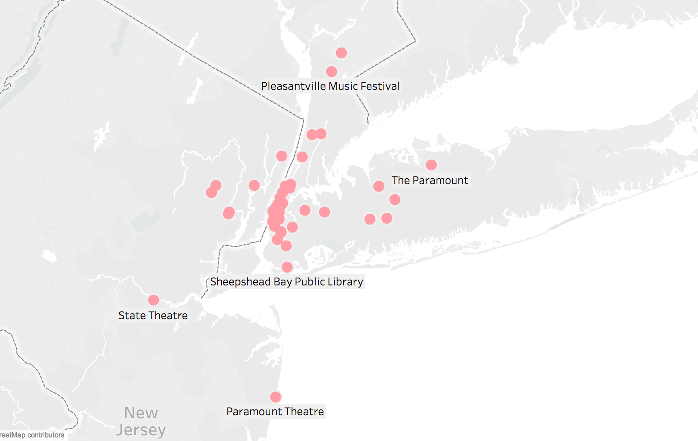

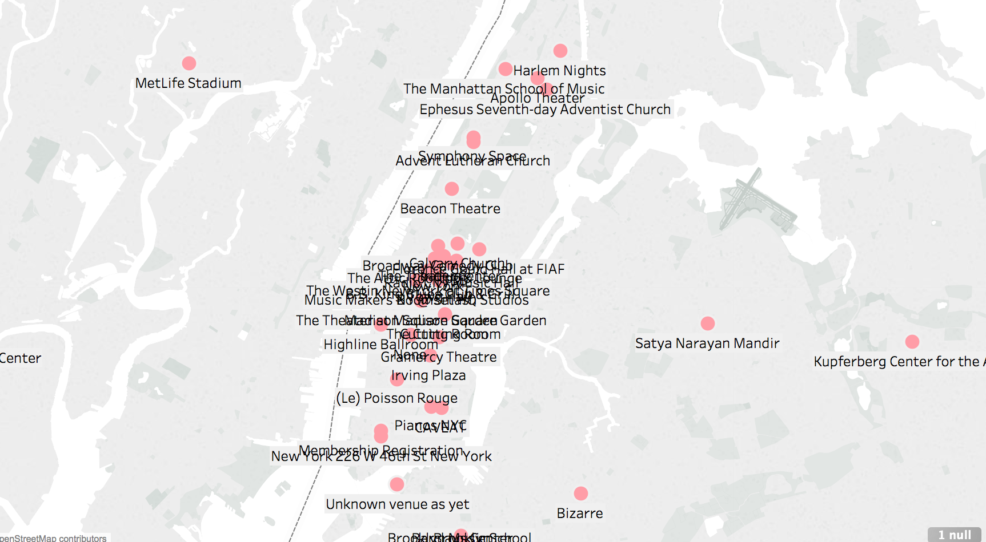

Here is the event report that prints out:

Check out these events taking place on New Years Eve in New York City!!!

via Ticketmaster

Chris Rock: Total Blackout Tour 2017 on Sun, Dec 10, 2017 at 01:00

Chris Rock: Total Blackout Tour 2017 on Fri, Dec 08, 2017 at 01:00

Chris Rock: Total Blackout Tour 2017 on Sat, Dec 09, 2017 at 01:00

PnB Rock on Wed, Dec 27, 2017 at 23:30

The Noise Presents - Pop Evil: Music Over Words Tour on Tue, Mar 20, 2018 at 22:30

"Hello" The Adele Experience & The Music of Amy Winehouse on Tue, Dec 19, 2017 at 01:00

Manhattan School of Music Opera Theater Presents Isouard's Cendrillon on Sat, Dec 09, 2017 at 00:30

Mike Delguidice & Big Shot- Celebrating the Music of Billy Joel on Sun, Jan 21, 2018 at 01:00

Manhattan School of Music Opera Theater Presents Isouard's Cendrillon on Sun, Dec 10, 2017 at 19:30

Kid Rock's Greatest Show On Earth Tour on Sat, Mar 03, 2018 at 00:30

Manhattan School of Music Opera Theater Presents Isouard's Cendrillon on Sun, Dec 10, 2017 at 00:30

The Music of Billy Joel: Cold Spring Harbor on Sun, Jan 14, 2018 at 01:00

Kid Rock's Greatest Show On Earth Tour on Sun, Mar 11, 2018 at 00:30

Billy Joel - In Concert on Sat, Apr 14, 2018 at 00:00

Let It Be: A Celebration of the Music of the Beatles on Sun, Apr 15, 2018 at 19:00

Turtle Dance Music on Sat, Feb 24, 2018 at 20:00

2017 Echo Music Festival - Come Party With Us ft. riceboyliu and more on Fri, Dec 22, 2017 at 23:45

Kid Rock's Greatest Show On Earth Tour on Sat, Mar 10, 2018 at 00:30

Let It Be: A Celebration of the Music of the Beatles on Sun, Apr 15, 2018 at 00:00

The Sound of Music on Sat, Dec 23, 2017 at 19:00

The Sound of Music on Sat, Dec 23, 2017 at 01:00

SCI-FI SPECTACULAR: MUSIC FROM STAR WARS, STAR TREK & BEYOND on Sun, Jan 07, 2018 at 01:00

Turtle Dance Music on Sat, Feb 24, 2018 at 18:00

Apollo Music Café: Tameca Jones on Sat, Dec 09, 2017 at 03:00

The Sound of Music on Sun, Dec 24, 2017 at 01:00

The Rock Pack on Sun, Jan 21, 2018 at 01:00

Panda-monium: Music from the Animal Kingdom on Sat, May 12, 2018 at 18:00

Panda-monium: Music from the Animal Kingdom on Sat, May 12, 2018 at 19:30

Bowzer's Rock & Roll Party on Sun, Jan 14, 2018 at 20:00

Music of BUENA VISTA SOCIAL CLUB - Tribute to the Golden Age of Cuba on Thu, Dec 28, 2017 at 00:00

Apollo Music Café: Brian Owens and the Deacons of Soul on Sun, Dec 10, 2017 at 03:00

GEORGE THOROGOOD and THE DESTROYERS Rock Party Tour 2017 on Sat, Apr 21, 2018 at 00:00

The Music of Edith Piaf feat. Yael & Gabriel on Mon, Dec 25, 2017 at 23:00

Yacht Rock Revue on Sun, Jan 14, 2018 at 01:00

Apollo Music Café: Crystal Monee Hall on Sun, Jan 14, 2018 at 03:00

The Sound of Music on Sun, Dec 24, 2017 at 16:00

Sci-Fi Spectacular: Music from "Star Wars", "Star Trek", & Beyond on Sun, Jan 07, 2018 at 20:00

Music of BUENA VISTA SOCIAL CLUB - Tribute to the Golden Age of Cuba on Thu, Dec 28, 2017 at 02:00

Apollo Music Café: ABIAH Tribute to Nina Simone on Sat, Jan 13, 2018 at 03:00

Bubble Guppies Live! : Ready to Rock on Sat, Apr 14, 2018 at 18:00

Music Of Theresienstadt Holocaust Memorial Concert on Sun, Mar 11, 2018 at 19:00

Sweet Honey In the Rock on Sun, Jan 14, 2018 at 21:00

Pleasantville Music Festival 2018 on Sat, Jul 14, 2018 at 16:00

U2 eXPERIENCE + iNNOCENCE Tour 2018 on Wed, Jun 27, 2018 at 00:00

U2 eXPERIENCE + iNNOCENCE Tour 2018 on Tue, Jun 26, 2018 at 00:00

Bubble Guppies Live! : Ready to Rock on Sun, Apr 15, 2018 at 18:30

Bubble Guppies Live! : Ready to Rock on Sun, Apr 15, 2018 at 15:00

Teksupport: Music On with Marco Carola & Guests on Sat, Feb 17, 2018 at 04:00

For the Love of Music Presents: on Mon, Feb 19, 2018 at 00:00

The Chappaqua Orchestra - Music Is Science! on Sun, Mar 25, 2018 at 19:00

Bubble Guppies Live! : Ready to Rock on Sat, Apr 14, 2018 at 21:30

Manhattan School of Music Opera Theater Presents Isouard's Cendrillon on Sat, Dec 09, 2017 at 19:30

Iridium & Fieldhouse-Music BMG Presents Mondays At the House on Tue, Dec 19, 2017 at 01:30

Steve Conte & Blues Deluxe: the Music of Classic Rod Stewart on Sun, Jan 21, 2018 at 01:00

Iridium & Fieldhouse-Music BMG Presents Mondays At the House on Tue, Jan 30, 2018 at 01:00

Masters of Hawaiian Music featuring George Kahumoku Jr. & Led Kaapana on Fri, Feb 09, 2018 at 00:30

Dropkick Murphys pre-show party with Professional Live Boxing & Music on Sat, Feb 24, 2018 at 20:00

Martin Barre Plays Classic Music of Jethro Tull on Sat, Oct 13, 2018 at 00:00

Martin Barre Plays Classic Music of Jethro Tull on Sun, Oct 14, 2018 at 00:00

U2 eXPERIENCE + iNNOCENCE Tour 2018 on Sat, Jun 30, 2018 at 00:00

Harry Styles Live On Tour on Fri, Jun 22, 2018 at 00:00

Abba: the Concert on Fri, May 04, 2018 at 00:00

The Music of Ella Fitzgerald, Sarah Vaughan & More w/ Emilie Surtees on Sat, Dec 30, 2017 at 18:30

The Music of Louis Armstrong w/ "Hot Lips" Joey Morant & Catfish Stew on Sat, Feb 03, 2018 at 00:30

U2 eXPERIENCE + iNNOCENCE Tour 2018 on Sun, Jun 10, 2018 at 00:00

Z100's Jingle Ball Presented by Capital One on Sat, Dec 09, 2017 at 00:00

Phish on Mon, Jan 01, 2018 at 00:30

Harry Styles Live On Tour on Sat, Jun 23, 2018 at 00:00

A Rock'n Doo Wop Spectacular on Sat, May 05, 2018 at 23:00

Khalid: The Roxy Tour on Sun, Jan 28, 2018 at 01:00

Schoolhouse Rock Live! on Sun, Apr 29, 2018 at 18:00

Yacht Rock Revue on Thu, May 03, 2018 at 23:00

Michael Schenker FEST feat Gary Barden, Graham Bonnet & Robin McAuley on Sun, Mar 11, 2018 at 00:00

Ed Sheeran: 2018 North American Stadium Tour on Sat, Sep 22, 2018 at 23:00

British Rock Xtravaganza on Sun, Feb 18, 2018 at 01:00

Phish on Fri, Dec 29, 2017 at 00:30

Phish on Sat, Dec 30, 2017 at 00:30

John Prine & Sturgill Simpson on Sat, Apr 14, 2018 at 00:00

Phish on Sun, Dec 31, 2017 at 00:30

Billy Joel - In Concert on Thu, Feb 22, 2018 at 01:00

Jake Bugg on Fri, Dec 08, 2017 at 01:00

HOT 4 the Holidays on Fri, Dec 15, 2017 at 01:00

Christmas Spectacular Starring The Radio City Rockettes on Sat, Dec 09, 2017 at 03:00

Christmas Spectacular Starring The Radio City Rockettes on Sat, Dec 09, 2017 at 00:30

Shame of Thrones: The Rock Musical - An Unauthorized Parody on Sun, Dec 10, 2017 at 18:00

Trevor Noah on Sat, Jan 13, 2018 at 00:30

OZUNA "ODISEA SOCIETY TOUR" on Sun, Dec 17, 2017 at 01:00

Christmas Spectacular Starring The Radio City Rockettes on Fri, Dec 08, 2017 at 01:00

Christmas Spectacular Starring The Radio City Rockettes on Wed, Dec 13, 2017 at 22:00

Christmas Spectacular Starring The Radio City Rockettes on Thu, Dec 07, 2017 at 22:00

Hallmark Channel Presents Trans-Siberian Orchestra 2017 on Tue, Dec 26, 2017 at 20:00

Shame of Thrones: The Rock Musical - An Unauthorized Parody on Sat, Dec 09, 2017 at 21:30

A Pentatonix Christmas Tour on Sun, Dec 10, 2017 at 00:00

Christmas Spectacular Starring The Radio City Rockettes on Fri, Dec 08, 2017 at 19:00

Christmas Spectacular Starring The Radio City Rockettes on Sat, Dec 16, 2017 at 03:00

1Music 1 Sound on Sat, Dec 09, 2017 at 00:00

Christmas Spectacular Starring The Radio City Rockettes on Mon, Dec 11, 2017 at 22:00

Shame of Thrones: The Rock Musical - An Unauthorized Parody on Fri, Dec 15, 2017 at 01:30

Christmas Spectacular Starring The Radio City Rockettes on Wed, Dec 13, 2017 at 01:00

Foreigner - Juke Box Heroes Tour on Sat, Jun 16, 2018 at 23:00

Check out these events taking place on New Years Eve in New York City!!!

via Eventbrite

Immersive Music Hackathon on Sat, Dec 09, 2017 at 12:00

Brooklyn Music Week 2018 on Wed, Aug 29, 2018 at 13:00

Power of Music Concert Series on Tue, Dec 12, 2017 at 20:00

Konceptions Music Series  on Tue, Dec 12, 2017 at 21:00

Arab Music Ensemble on Mon, Dec 10, 2018 at 21:00

Class A Music 30th Anniversary on Sat, Dec 09, 2017 at 18:00

Getty Music Worship Summit ― New York on Wed, Dec 20, 2017 at 18:30

Membership in Folk Music Society of NY on Mon, Jan 01, 2007 at 13:00

Heifetz Live Auditions @ The Manhattan School of Music on Fri, Jan 26, 2018 at 16:00

2018 Saturday Night Soirée - Chamber Music America on Sat, Jan 06, 2018 at 18:30

A Toy Story: Powered by 2G Music Group on Fri, Dec 15, 2017 at 19:00

2nd Annual "FANCYSTOCK" Indie Music Festival on Thu, Feb 08, 2018 at 13:00

Monday Nights at the Attic NYC (United By Music) on Mon, Dec 11, 2017 at 23:00

Music Mondays - Orion Weiss & Anna Polonsky, Piano Duo on Mon, Dec 11, 2017 at 19:30

Brooklyn Music School Presents: Little Red Riding Hood  on Fri, Dec 15, 2017 at 19:00

Music at Asbury presents Julia Breanetta Simpson, "How Sweet the Sound" on Sun, Feb 25, 2018 at 15:00

Qi & Yun Music Dream presents Path to Juilliard Piano Concert on Sat, Jan 27, 2018 at 19:30

Ephesus Youth Church Music Ministry - 3rd Annual Holiday Concert on Sat, Dec 16, 2017 at 18:00

Music In Motion PR Launch Party w/ Nitty Scotty, Joe Young, Chase N Cashe, Jay Prezi, Kev Rodgers and Naj Murph on Sun, Dec 10, 2017 at 19:00

The Music Makers NY: 3rd Annual Valentine's "Play" Acoustic Jam & Wine Event for Singles on Thu, Feb 14, 2019 at 18:30

Music Conference on Thu, Mar 30, 2017 at 19:00

BLANK! THE MUSICAL on Sat, Dec 09, 2017 at 20:00

A Christmas Musical on Sat, Dec 30, 2017 at 13:00

KIRTAN MUSIC on Sun, Dec 10, 2017 at 11:00

Hamilton Musical - Rogers Theatre on Wed, Jul 10, 2019 at 19:00

Cruel Intentions - The Musical on Sat, Dec 09, 2017 at 19:15

Cruel Intentions - The Musical on Sat, Dec 09, 2017 at 16:00

"13: the musical" Saturday on Sat, Dec 09, 2017 at 19:30

Cruel Intentions - The Musical on Sun, Dec 10, 2017 at 18:00

The Broadway Musical- The Book Of Mormon on Mon, Oct 14, 2019 at 19:00

Cruel Intentions - The Musical on Mon, Dec 18, 2017 at 18:00

Cruel Intentions - The Musical on Sat, Dec 16, 2017 at 19:15

Cruel Intentions - The Musical on Sun, Dec 10, 2017 at 14:00

Oblivion Music festival  on Fri, Aug 24, 2018 at 10:00

Cruel Intentions - The Musical on Sat, Jan 06, 2018 at 19:15

Cruel Intentions - The Musical on Fri, Jan 19, 2018 at 19:00

Cruel Intentions - The Musical on Sat, Jan 20, 2018 at 16:00

Cruel Intentions - The Musical on Sat, Dec 16, 2017 at 16:00

Musical Broadway Kids Cabaret on Sat, Dec 09, 2017 at 14:00

Cruel Intentions - The Musical on Wed, Dec 20, 2017 at 18:00

Cruel Intentions - The Musical on Fri, Dec 22, 2017 at 19:00

Cruel Intentions - The Musical on Wed, Dec 27, 2017 at 18:00

Cruel Intentions - The Musical on Sun, Dec 17, 2017 at 14:00

Cruel Intentions - The Musical on Sat, Jan 20, 2018 at 19:15

Your Love, Our Musical on Sat, Dec 16, 2017 at 18:30

Cruel Intentions - The Musical on Mon, Jan 08, 2018 at 18:00

Cruel Intentions - The Musical on Sat, Jan 06, 2018 at 16:00

Cruel Intentions - The Musical on Thu, Jan 18, 2018 at 18:00

Cruel Intentions - The Musical on Mon, Jan 29, 2018 at 18:00

Cruel Intentions - The Musical on Sat, Dec 30, 2017 at 16:00

Source Documentation:

|  |  |  |  |
| --- | --- | --- | --- |
| **Date** | **Issue Description** | **Location of Resource** | **Result** |
| 12/5 | Converting longitude/latitude to geodata in Tableau | <https://onlinehelp.tableau.com/current/pro/desktop/en-us/buildexamples_maps.html> | Yes |
| 12/9 | Having the date print out as Sat, Dec 9, 2017 at 13:06 | <https://stackoverflow.com/questions/466345/converting-string-into-datetime>  <https://docs.python.org/3.2/library/datetime.html#strftime-strptime-behavior> | Yes |