An algorithm is a set of instructions to solve a problem. Searching algorithms for searching problems, sorting algorithms for sorting problems, shortest path algorithms for shortest path problems for example.

Author’s first two model choice: hash table, graph

K-nearest neighbors (KNN) – simple machine learning algorithm – used for recommendations & predictions & classifications

a GPS device uses graph algorithms for route operations

performance – there are tradeoffs between algorithms (also data structures)

greedy algorithms – when there is no effcient solution – approximate answer

running time of an algorithm
shows how efficient an algorithm is in certain cases (best & average & worst).
Shows the growth of the number of required operations based on list size (n), not the exact number of operations.
Big O notation is used for the worst-case scenario analysis.
Along with the worst-case run time, it’s also important to look at the average-case run time.
Common big O run times from fastest to slowest:
O(1): constant time, array access
O(logn): logaritmic time, binary search
O(n): linear time, simple search
O(n*logn): quicksort
O(n^2): selection sort
O(2^n)
O(n!): factorial time, travelling salesperson problem
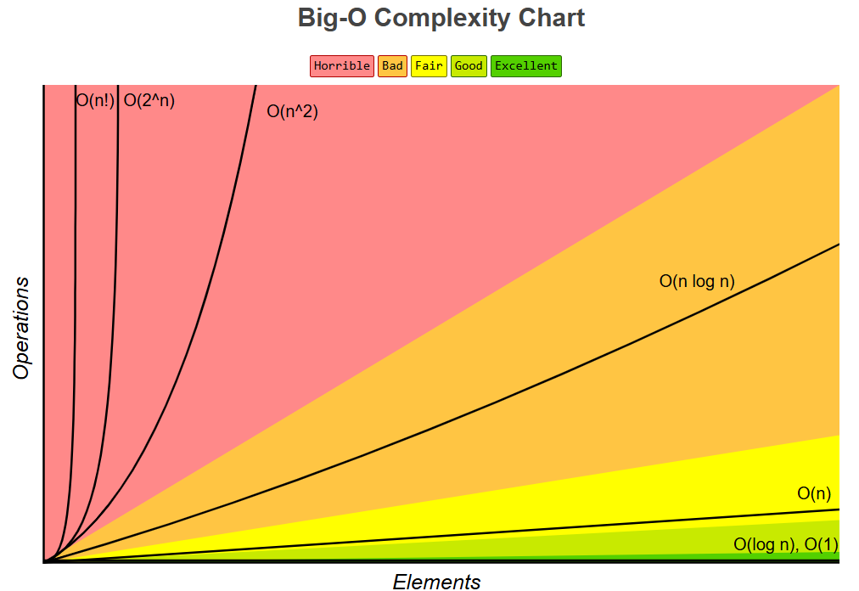
...even though two algorithms have the same big O, their performance in practice might not be the same. Quicksort vs mergesort is one example. İf they are both O(n*logn), quicksort is faster.
Constants are ignored in big O calculations, but sometimes they can make a difference in practice.
O(n*4) = O(n/4) = O(n+4) = O(n-4) = O(n)

binary search – works on sorted list
* binary_srch.py

travelling salesperson problem – finding the shortest path
Given a list of cities and the distances between each pair of cities, what is the shortest possible route that visits each city exactly once and returns to the origin city?
The running time for this problem is O(n!).
this is one of the unsolved problems in computer science. There is no fast known algorithm for it. The best we can do is to come up with an approximate solution.

arrays&linked lists
arrays – accessed with indexes – random access
stored contiguously in memory
has fixed reserved space
keeps a count of the current number of elements
if the space reserved for the array is exceeded, it has to be reallocated and copied, which is an expensive operation. On the other hand, all of the reserved space may not be used at all. But this space is only reserved for the array, so it cannot be used by others. This can also lead to inefficient memory use.
Linked lists – accessed with pointers – sequential access
stored randomly in memory
elements have to keep the reference to the next element, thus they need extra storage for references beside data.
Data structure | Search | Access | Mutate (insert&delete)
 |  |  | beginning | middle | end
Array | O(n) | O(1) | O(n) | O(n) | O(1)*
Linked list | O(n) | O(n) | O(1) | O(n) | O(n)**

* it’s assumed that the reserved space for the array is not exceeded.
** if the element at the end is known, it’s O(1). Otherwise it’s O(n).
arrays are also faster than linked lists in sequential access because arrays make use of caching.
İn general, arrays are used more often than linked lists, but it really depends the nature of the problem. İf the problem requires a lot of mutation operations and a few reads, then linked lists are more suitable. İf the problem involves accessing&reading way more frequent than mutation, then arrays are more appropriate to use.

* selection_srt.py
* example of hybrid use of arrays&linked lists to store usernames

* def func(x, y): ...
func(3, 4)
x,y: parameters
3,4: arguments
arguments are the real values that are passed to the function when the function is called.
Parameters are the variable names where the arguments are processed.

Pseudocode – used to describe the steps of an algorithm using a mix of human language and programming language. İt’s intended for human reading rather than programming.

Recursion
used in many algorithms (for example algorithms with Divide-and-Conquer approach)
happens when a function calls itself.
There might be another way to do the same thing with loops, and sometimes loops are better for performance. Even though, recursion can really make the solution clearer and simpler.
Recursive case: the case when function calls itself
base case: the case when recursive calls stop. if a recursive function involves an array, the base case is often an empty array or an array with one element.

* def func():
..
..
func()
-->program reaches there after returning from func call

* def func():
..
..
return func()
-->program doesn’t reach there after returning from func call

call stack
when you call a function, the frame of memory which has the function, its variables, parameters etc. are pushed into the call stack. Whenever you return from the function at the top of the call stack, or reach the end of this function, the frame of this function is popped off from the call stack. And the next function at the top of the stack continues from where it called the popped off function before.
İf the call stack is too tall, that means your program is saving too much data for function calls. At that point, you can consider to find a way to optimize recursion or rewrite the code using loops. İf you can make recursive calls hit the base case sooner, this will improve the performance.
Each program has a limited amount of space for the call stack. When your program runs out of this space, it will exit with a stack-overflow error.

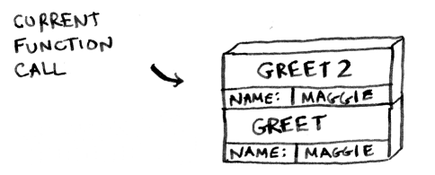

İf this is the current state of the call stack, we can say:
the program is currently running greet2() funtion.
greet() function is called first with the parameter ‘name’ and its argument ‘maggie’
before greet call is finished, greet2() function is called with the parameter ‘name’ and its argument ‘maggie.
When greet2 call is finished, the program will continue from where greet() function called greet2() function.

Divide-and-Conquer (D&C) is not an algorithm by itself. İnstead, it is more like an approach to build an algorithm to solve a problem.
Makes use of recursion.
Quicksort and binary search makes use of D&C approach.
1. step: find the simplest operation that is required to solve the problem.
2. step: find the base case where recursion stops
3.step: divide/decrease the problem size until it becomes the base case.
Pseudocode for find_max(list):
if list.size < 0: return
elif list.size = 1: return list[0]
sub_list_max = find_max(list[1:])
return list[0] if list[0] > sub_list_max else sub_list_max

* recursion_D&C.py
* quick_srt.py

quicksort – choosing the first element (A), the middle element (B) as pivot
in an unsorted, randomized list, performance of A and B is the same
in a sorted list with no duplication, performance of B is significantly higher than A. as the number of duplication of different elements in a sorted list goes up, performance of B decreases, getting closer to the performance of A.
if all items have the same value, performance of A and B is the same, and this is the worst-case.
The worst-case is when for every recursive call, either left or right sub-array is empty.
So in short, A and B don’t make big differences regarding performance unless the array is sorted with very few duplicated different elements.
Quicksort hits the average-case (O(n*logn)) way more often than the worst-case (O(n^2)).

Hash tables
also known as hash maps, dictionaries, and associative arrays.
İt basically maps keys to values.
İt is using a hash function to associate keys and values. This hash function ideally should be able to produce different index (hash code, hash value) for every single key. İt also needs to produce the same index for the same key all the time, so the values that are associated to the key through this index are not lost. The each slot of the bucket array pointed by indexes is where the values are stored.
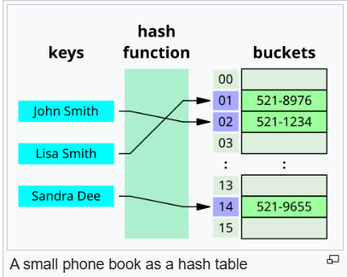
Hash tables are good for :
modeling relationships between to things, filtering out duplicates,
caching&memorizing data instead of making the server do the work.

When a request is sent to the server, the server looks in cache for the request first. İf the request is there, the server doesn’t need to process the request, because it’s already processed before. So, the server already knows what to do. But if the request isn’t there, then the server has to process this request.
With caching, the data is sent faster if it’s cached, and servers do the less work.
The order of k-v pairs in a hash table does not matter.

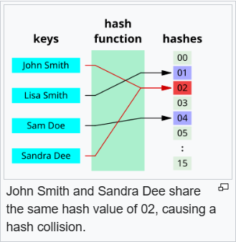
Hash clash/collisions
while hash tables are very useful, they rarely map every different key to a different index perfectly.
A perfect hash function would give each key its own index. This one-to-one mapping is also called injective function. But in reality, you probably won’t get a perfect one-to-one mapping.
Since hash collisions are inevitable, hash tables have mechanisms of dealing with them, known as collision resolutions. Two most common approaches are open addressing and separate chaining.
A good hash function would cause very few collisions.

Time complexity of hash tables
 | search | insert | delete | access
average-case | O(1) | O(1) | O(1) | N/A
worst-case | O(n) | O(n) | O(n) | N/A

Worst-case is when one key is associated with more than one value. İn other words, there are more than one value stored in a bucket. İf all items in a list(n) are hashed into the same key using a linked list or an array, then it will take O(n) time to search, insert or delete on that linked list&array.
Another worst-case is when a hash table has passed its load balance, it has to rehash (create a new bigger table and re-insert each key-value pair).
Accessing is not applicable, it’s not possible to access an arbitrary key-value pair in a hash table.

“you can use the built-in hash table, and assume it will have good performance.” p121. Because probably you won’t need to change internal mechanisms of a built-in hash table, but it’s still good to know what is going on under the hood.

Load balance/factor --> α = n / m
n: the number of entries occupied in the table
m: the number of buckets/slots, the range of index/hash value
when α ↑ performance of the table↓, because the number of hash collisions ↑.
to maintain a good performance, keep α below a certain constant α_{max}.
resize/rehash the table when α = α_{max} or α < α_{max}/4
with lower load factor, there’ll be fewer collisions.
Rules of thumb:
resize when α > 0.7 ( α_{max} = 0.7)
if α = α_{max ,} double the size of the table while resizing/rehashing
CityHash
an example of a good hash function
Abseil library uses this function.
An open source C++ library
provides all kinds of general-purpose C++ functions
a building block for Google’s code

* hash_table.py

network – an environment where there are things that are connected in a way. A set of connections.
A connection can be between anything: cities (distance), words (derived words from another word), people (friendship, family tree, ...) etc.
cityA
cityB
improve
improvement

210 km

improving
John
Susan

Mary
Michael

Graphs – used to model a network
each graph is made up of nodes (vertices) and edges. (sing: vertex, plural: vertices)
nodes are the things on the network
edges are the connections between nodes. These connections can have directions.
Directed graphs – connections have directions
Undirected graphs – connections don’t have directions
Weighted graphs – graphs with numerical values
‘edge-weighted’: weight on edges
‘vertex-weighted’: weight on vertices
Unweighted graphs – doesn’t have weights on vertices or edges.

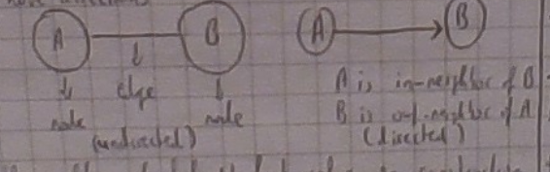
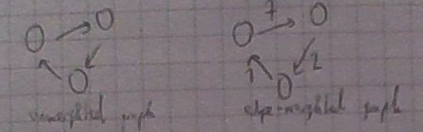
unweighted
edge-unweighted
An undirected connection actually means that both nodes point to each other.
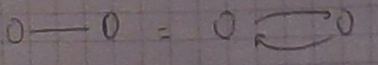

‘bread-first’ search (BFS)
a graph traversing algorithm
from starting node, traverses all the nodes at the same depth level before the nodes at lower depths.
Makes use of queue logic (FIFO: first in, first out).
some use cases: spellchecker, search engine crawler, find the closest path between two things on unweighted graphs.

‘depth-first’ search (DFS)
a graph traversing algorithm
from starting node, traverses all the way down to reach the node that has no further connection.
Makes use of stack logic (LIFO: last in, first out).
Some use cases: finding topological sort

* bfs_dfs.py

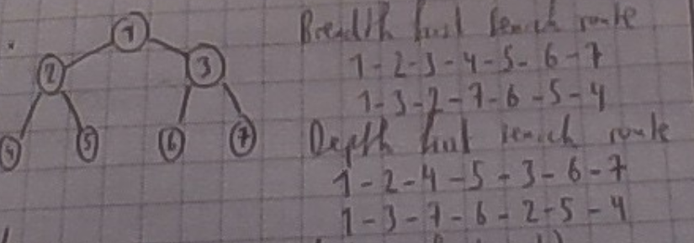

tree
special type of graph (connected acyclic graph)
any two vertices (nodes) are connected by exactly one path. That means there are no cycles/loops.
A vertex/node can have many children vertices/nodes depending on the type of tree, but every vertex must have only one parent node except root node, which has no parent.
Parent node – ‘in-neighbor’ node of a node
child node – ‘out-neighbor’ node of a node
Leaf node – node that doesn’t have any children nodes
File directory is an example of tree structure. A folder is a parent node and the files on this folder are children nodes.
* file_directory.py

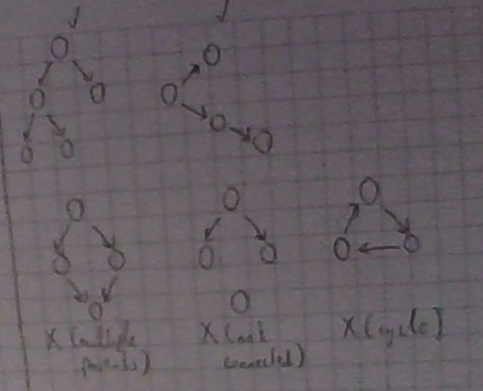
in the example above, three graphs at the bottom are not tree, two graphs at the top are tree.

Huffman coding – foundation of text compression algorithms – make use of binary trees

most database management systems use a balanced tree like ‘B-tree’.

character encoding – how to represent characters in bits – ‘UTF-8’ is one of the character encodings of Unicode standard.

binary tree
very common
a parent node can have two children nodes at most
left child – the child on the left of the parent
right child – the child on the right of the parent

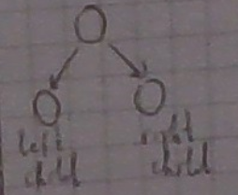

binary search tree (BST)
a binary tree where the key of the left child is <= than the key of the parent, and the key of the right child is > than the key of the parent.
When the height of BST goes up, the performance of BST goes down.
İn the worst-case: BST = singly linked list, thus height is linear with respect to the number of elements on the tree.
in the best-case: height is logaritmic with respect to the number of elements on the tree.
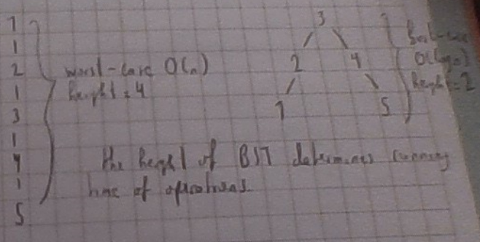
Self-balancing BST
balancing a BST – making tree shorter (decreasing height) to improve the performance.
these trees have some precautionary measures against boundlessly increasing the height, so they automatically keep their height small in the face of arbitrary insertion&deletion operations.
‘height-balanced’ BST
the height is defined to be logaritmic (O(logn)) in the number of n elements. But that does not mean that height is always equal to (logn). İt means when n goes up, the increase of height will be logaritmic to n.
This is the case for AVL trees and ‘red-black’ trees.
Splay trees and treaps are self-balancing but not ‘height-balanced’, as their height is not guarenteed to be logaritmic in the number of elements.

* BST.py

AVL tree
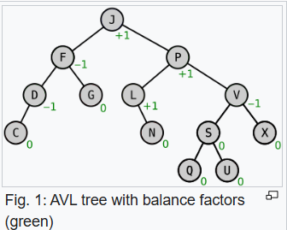
a type of ‘self-balancing’ BST
it’ll maintain a height of O(logn) (height-balanced)
When it is out of balance, it’ll correct itself. (self-balancing)
uses rotations to balance itself.
Uses balance factor (BF) to know if the tree is out of balance or not.
BF of each node = height(sub-right tree) – height(sub-left tree)
if |BF| > 1, then it’s needed to rebalance.
The height of the AVL tree on the right is 4
if it was perfectly balanced, it would be 3.
but this AVL tree is still considered balanced
because there is no node has |BF| that is greater than 1
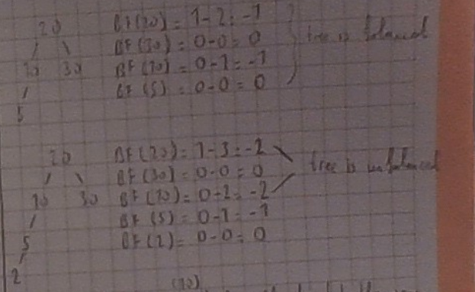
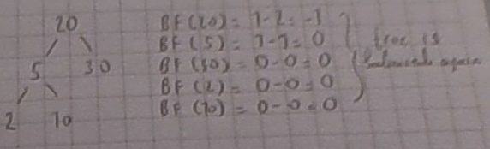
After insertion of element “2”, tree became unbalanced. Because |BF| of “20” and “10” is greater than 1, so it has to rebalance itself through rotations. For further information about rotations, visit: https://en.wikipedia.org/wiki/AVL_tree

an AVL tree would have O(logn) running time while a BST would have O(n) at the worst-case. Because an AVL tree is guarenteed to be balanced but a BST is not guarenteed.

“you will raraly need to implement an AVL tree yourself.” p184

splay tree
a self-balancing BST
frequently accessed nodes would be placed closer to the root, so they can be accessed more quickly.
Not height-balanced, as its height is not guarenteed to be logaritmic in the number of items.

Tree >>> BT >>> BST >>> self-balancing BST (AVL, splay etc.)

‘B-tree’
generalizes BSTs
allows nodes to have more than one key and more than two children.
Each node can have many more keys and children than a BST, so we spend more time to process each node but we seek less because we read more data at one time.
Unlike other ‘self-balancing’ BSTs, the ‘B-tree’ is well suited for storage systems that read&write relatively large blocks of data, such as databases and file systems.
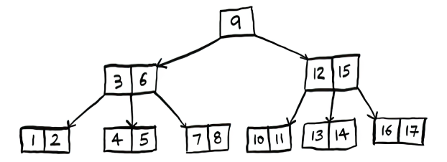

dijkstra algorithm
to find the shortest path between two nodes in a weighted graph with non-negative edges. Because negative weights might cause infinite loops on dijkstra algorithm. (Bellman-Ford algorithm can work with negative edges.)
The shortest path doesn’t have to be physical distance. İt can be generalized to minimize sth. (e.g. minimizing the money you spent)
“dijkstra algorithm only works on graphs with no cycles.” p198. That’s not correct. Dijkstra can be implemented on graphs with cycles.
* dijkstra.py

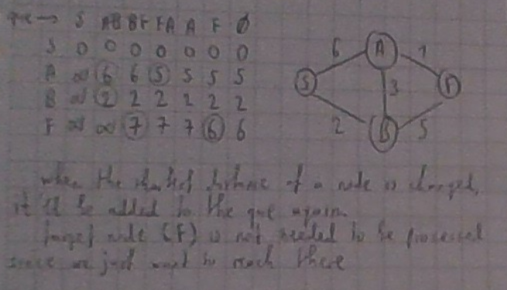
When the shortest distance of a node is changed, it’ll be added to the que again.
Target node (F) is not needed to be processed, since we just want to reach there
que

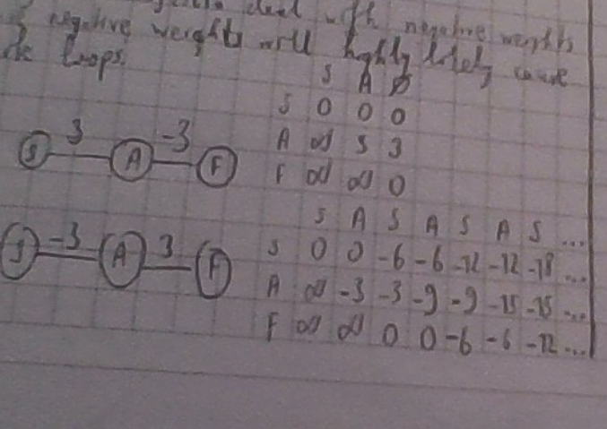
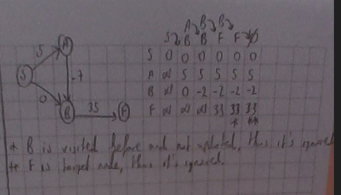
priority queue – built on top of a data structure called heap

‘NP-hard’ problems – problems where there is no exact answer or it takes too long to find it

greedy strategy
to find an approximate answer to ‘NP-hard’ problems
similar approach to what’s done at selection sort
this strategy is based on finding local optimal and repeating this process at each step until an answer is found. Local optimal is the most optimal action to take at current situation. (İt is usually minimum or maximum value per sth like money, time, space etc.)
“sometimes, perfect is the enemy of good” p221
might not find the exact optimal answer but these approximate answers are often good enough. So it optimizes locally and hopes to end up with a global optimum.
* greedy.py

* to find combinations of a list – combinations.py

dynamic programming
a technique to solve a problem by breaking it into sub-problems
it’s often useful to model the problem as a grid
the cells on the grid have the values we try to optimize
the axes of the grid represent the way we break the problem. They are the parameters of the problem

* knapsack problem
you got set of items and a knapsack with 4 lbs space
Find the most valuable item combination that can fit in this knapsack
the cells are the total value of available items for available space
the axes are available items and available space of the knapsack

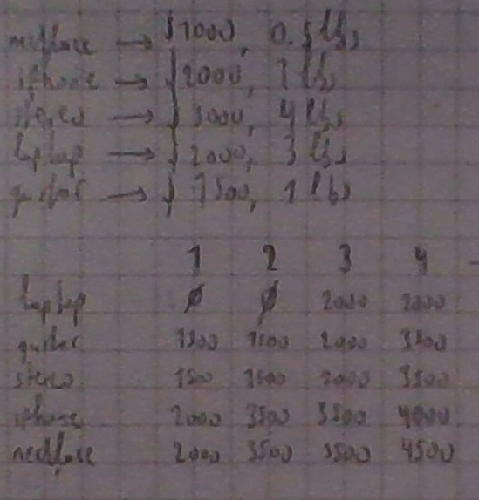
Available Knapsack space
Optimal answer

grid is processed row by row.
At first, only (laptop) is available.
For the second row (laptop, guitar) is available.
For the last row, all items are available and the last cell of the last row would give the optimal answer for the problem.
The order of item selection doesn’t matter.

* vacation problem
suppose you will go to a vacation for two days
you got a list of places where you want to visit
you also got the rating for each place that represents how much you want to visit there.
The cells would be the total rating of places visited
the axes would be the time available, and the places available
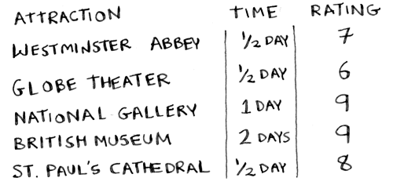
 | 1 | 2
museum | n/a | 9
Gallery | 9 | 9
Cathedral | 9 | 17
Abbey | 15 | 24
Theatre | 15 | 24

? – dynamic programming only works when each subproblem is discrete. Meaning that subproblems don’t depend on other subproblems. p245

levenshtein distance
a string metric to measure the difference between two sequences
the levenshtein distance of two words is the minimum number of single-character edits (insertion, deletion, substitution) required to change one word into the other.
lev(‘kitten’, ‘sitting’) = 3
lev(‘flaw’, ‘lawn’) = 2
* levenshtein.py

longest common substring&subsequence
longest common subsequence is the longest combination in common.
Longest common substring is the longest common sequence whose items occupy consecutive positons within both sequences
* longest_common.py
* s1 = ‘abcwwwbcd’
s2 = ‘abcd’
lc_subsequence = [‘abcd’]
lc_substring = [‘abc’, ‘bcd’]
* s1 = ‘abcd’
s2 = ‘acbad’
lc_subsequence = [‘abd’, ‘acd’]
lc_substring = [‘a’, ‘b’, ‘c’, ‘d’]

? – how to detect copyrighted data in uploaded data

introduction to machine learning
we want to classify elements to make predictions based on these elements. These predictions can be about classifications (predicting the class of an unknown element) or regression (predicting a response).
Elements are represented by a set of features
a vector of an element is an array of numbers showing the measurement of the corresponding feature on the element
transforming an element into a vector is called feature extraction
a vector of an element may yield a result if necessary, and the result is actually the class where the element belongs
some use cases: OCR, speech recognition, face recognition, spam filter
OCR
optical character recognition
processing images to recognize characters in images
measures points&lines&curves
Elements | Features = {f1, f2, f3, ...} | results/classes
Element#0 | (2, 3.24, -5, ...) | class_A
Element#1 | (-2.1, 0, 0.4, ...) | class_B
... | ... | ...

Represented by
yield
So, what’s done here is a mapping/pairing
first, the element is mapped/paired to a vector
second, the vector is mapped/paired to a class if needed
a class/group is abstract, a vector is an implementation, an instance of a class

‘k-nearest’ neighbors (KNN)
given a mapping, by looking its ‘k’ number of nearest/closest neighbors, we can make some predictions about this element based on how close&far this element to other elements
a good rule of thumb is that if you have ‘n’ elements, you should look at ‘√n’ number of the closest/nearest neighbors of the element. ( k = √n )

approaches to determine closeness/similarity
distance formula
measures the distance between vectors
distance between V₁ and V₂ vectors based on {f1, f2, f3, ...} feature set is
distance(V₁, V₂) = √ ( (V₁(f1) – V₂(f1))² + (V₁(f2) – V₂(f2))² + (V₁(f3) – V₂(f3))² + ...)

cosine similarity
a common one used in practice
it doesn’t measure the distance between two vectors
it compares the angles of the vectors
features are the ways to classify elements. For example, to classify fruits, the feaute set might be {size, color, taste}, and a vector of this set would yield a fruit class.
Another example, to classify films, the feature set might be {comedy, horror, drama, action} and a vector of this set would show how much of this film is comedy&horror etc., and would yield the user’s rating or general rating for that film.
Let’s say, after doing some measurements, it is found that movie_A is (0.6, 0, 0.2, 0.2). that means the content of this movie is sixty percent comedy, zero percent horror, twenty percent drama and twenty percent action, and if İts class is rating_2, that means the user rated this movie 2, or the general rating is 2

? – how would we determine the similarity&closeness of movie taste between users
to do that, we need to plot the users on graph, means that we need to represent a user by a vector.
First, a feature set is needed. We can use the same set {comedy, horror, drama, action} and add some weights on the ratings like 5 -> %30, 4 -> %15, 3 -> %10, 2 -> %15, 1 -> %30.
after some calculations, this vector will show how much the user likes comedy, horror, etc. in the end, and then we can use this vector to plot the user on graph.
Based on the films user rated before, to calculate how much the user likes comedy content:
(3/10) * average (rating_5[comedy]) --> look at the movies user have rated 5, get the average number of what percent of these movies are comedy
(1.5/10) * average (rating_4[comedy])
(1/10) * average (rating_3[comedy])
(1.5/10) * average (rating_2[comedy])
(3/10) * average (rating_1[comedy])
by summing up all the numbers above, it will give the number for comedy column on the user vector, and it will show that how much the user likes the comedy content.
By doing the same thing for other features, we would have a complete user vector, and then we can plot the users on graph and compare their movie taste. İf the two user vectors are close, that means their movie taste is similar. İf the two user vectors are far away from each other, that means their movie taste is not similar.
İn this case, we just want to compare user’s movie taste, so it’s not really needed to map these user vectors to classes/groups.

? – how can we build a film recommendation system
possible approaches:
general rating
recommend films with 4 or 5 general rating
the user ratings
based on only the ratings from the user, recommend films that might be in rating_4 or rating_5 rating class for the user (in this case, we are making a prediction. We have a vector that is not plotted by the user yet, and we think that the user will plot this vector close to the vectors from rating_4 or rating_5)
other similar user’s rating
based on only closely plotted users to the user on graph, recommend films that the user’s close neighbors rated high but the user haven’t rated yet
we can use a mix of all, like to recommend 100 films to a user, get 50 from the first approach, get 30 from the second, and get the rest from the third

? – what happens when a vector is mapped with multiple classes
we can make some calculations like taking the average, minimum or maximum value for numerical classes like ratings. But this won’t work for non-numerical classes (fruit classes e.g.). it seems we should update the feature set in a way to prevent collisions in these cases or we can just pick one class and ignore the rest.
An overvies of building an ML model
gather data
clean the data
extract features
pick a model (KNN, SVM’s, neural network etc.)
train the model with %90 of the cleaned data
test&validate the model with %10 of the cleaned data
comparing the predictions the model made with the expected results

the concepts below are briefly explained in chapter 13:
linear regression
inverted indexes
the fourier transform
parallel algorithms
map/reduce
bloom filters&hyperLogLog
HTTPS and the Diffie–Hellman key exchange
locality-sensitive hashing
heaps&priority queues
linear programming

amdahl’s law (from wikipedia)
The law can be stated as: "the overall performance improvement gained by optimizing a single part of a system is limited by the fraction of time that the improved part is actually used"
Amdahl's law is often used in parallel computing to predict the theoretical speedup when using multiple processors. For example, if a program needs 20 hours to complete using a single thread, and a one-hour portion of the program cannot be parallelized, then only the remaining 19 hours' (p = 0.95) execution time can be parallelized. Therefore, regardless of how many threads are devoted to a parallelized execution of this program, the minimum execution time is always more than 1 hour.

Simhash
most hash functions are locality-insensitive. That means the hashes they produce for similar items will be probably very different.
But Simhash is a locality-sensitive hash function, so it produces similar hashes for similar items. Thus, it can be used to check similarity between items.

Priority queue
queues are FIFO (First In First Out)
but priority queues are kept sorted based on a priority parameter, thus in priority queues the first inserted item may not go out first. the item that has the highest priority goes out first even if it is the last inserted item.
Built on heap data structure

heaps (from wikipedia)
In computer science, a heap is a tree-based data structure that satisfies the heap property: In a max heap, for any given node C, if P is a parent node of C, then the key (the value) of P is greater than or equal to the key of C. In a min heap, the key of P is less than or equal to the key of C.
The node at the "top" of the heap (with no parents) is called the root node.
In a heap, the highest (or lowest) priority element is always stored at the root.

Heapsort
similar to selection sort
but unlike selection sort, the unsorted region is maintained in a heap structure to efficiently find the largest&smallest item in each step
so, if we just keep popping a max&min heap until there is no item left in the heap, we would have a sorted array of items

the terms below are briefly explained in appendix B
decision problem
the SAT problem
P- the problem set where problems are quickly solvable
NP – the problem set where solutions are quickly verifiable
P vs NP problem - https://en.wikipedia.org/wiki/P_versus_NP_problem
NP-hard
NP-complete

