**Chapters Covered: Used and Group Management / Files and Directory Permissions**

**AKRISH(RA2311050010015)**

**🔹 Practice Tasks: Files & Directories Permissions**

**Objective:**  
Students will create files, directories, modify permissions, and verify access.

**🛠 Task 1: Create a File and Set Specific Permissions**

1. Create a file named **file1.txt** in your home directory.
2. Set its permissions so that:
   * The **owner** has **read and write** permissions.
   * The **group** has **only read** permission.
   * **Others** have **no permissions**.
3. Verify the permissions using ls -l.  
     
   Attach a output of you:

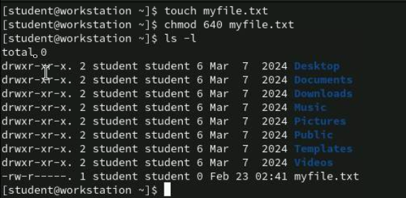

**🛠 Task 2: Create a Directory and Modify Access**

1. Create a directory named **project_dir** in your home directory.
2. Set its permissions so that:
   * The **owner** has **full access** (rwx).
   * The **group** has **read and execute** permissions.
   * **Others** have **no access**.
3. Verify the permissions using ls -ld.

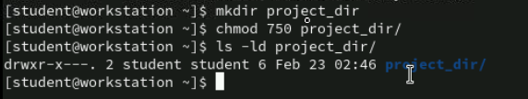

**🛠 Task 3: Create Multiple Users and a Shared Directory**

1. Log in as **root** and create a group named **developers**.
2. Create three users: **dev1, dev2, dev3** and add them to the **developers** group.
3. Set passwords for the users as **atr@te** using the standard input method.
4. Create a shared directory /devprojects and set group ownership to **developers**.
5. Set permissions so that:
   * **Only the owner and group** can read, write, and execute.
   * **Others** should have **no access**.

Attach a output of you:

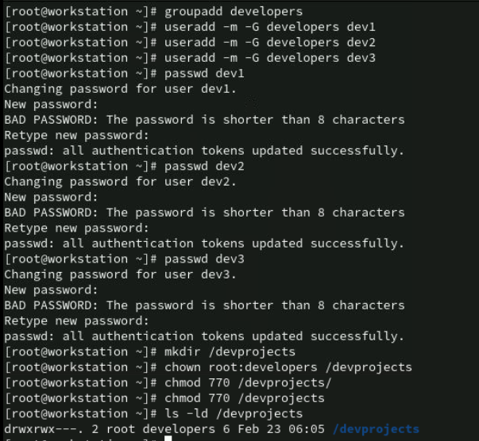

**🛠 Task 4: Verify Access Using su - user**

1. Switch to **dev1** and create a file inside /devprojects named **project1.txt**.
2. Add the content "Project Details" to the **project1.txt** file.
3. Switch to **dev2** and verify if:
   * It can create a file inside /devprojects.
   * It can add content "Adding Notes" to **project1.txt**.
4. Switch to a user not in the **developers** group (e.g., nobody) and try accessing /devprojects.
5. Verify if the output shows "Permission Denied".

Attach a output of you:

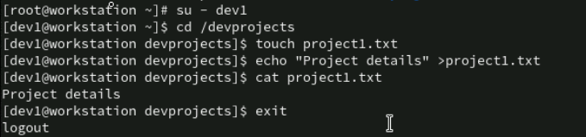

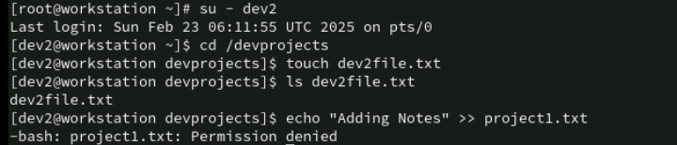  
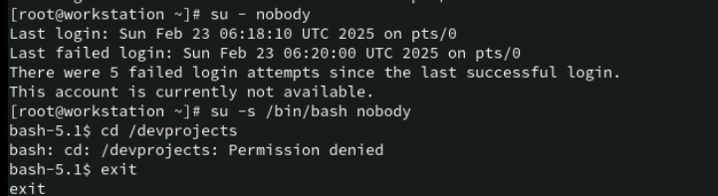

**🛠 Task 5: Remove Write Permission from Group**

1. Change the permissions of /devprojects/project1.txt so that the group can **only read** the file but cannot modify it.
2. Switch to **dev2** and try adding content "Check file able to write" to **project1.txt**.
3. What happens? Explain why.

Attach a output of you:

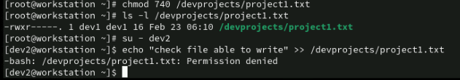

**This happens because dev2 belongs to the developers group, but the file permissions were changed to read-only for the group (r--). Since dev2 is not the owner, they cannot modify the file.**

**🛠 Task 6: Make a Directory Private to Owner**

1. Create a directory named **private_dir** in your home directory.
2. Set its permissions so that:
   * **Only the owner** can access it (read, write, execute).
   * **Group and others** should have **no access**.
3. Verify the permissions.

Attach a output of you:

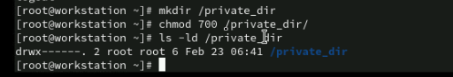

**🛠 Task 7: Understanding Default Permissions (umask)**

1. What are the **steps to change the default file permissions (umask)?**
2. Find the current umask value.
3. Modify umask to ensure newly created **directory's permissions** to drw-rw-r-x
4. Create a new directory and check its default permissions.
5. What is the new permission? Does it match your expected result?

Attach a output of you:

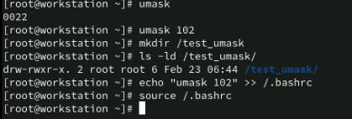

Yes! The expected result was drw-rw-r-x, and the output confirms that the permissions were set correctly.

**Marksheet  
  
Name:**

**Department:**

|  |  |  |
| --- | --- | --- |
| **S.No** | **Task** | **Marks** |
| 1 | Create a File and Set Specific Permissions |  |
| 2 | Create a Directory and Modify Access |  |
| 3 | Create Multiple Users and a Shared Directory |  |
| 4 | Verify Access |  |
| 5 | Remove Write Permission from Group |  |
| 6 | Make a Directory Private to Owner |  |
| 7 | Understanding Default Permissions (umask) |  |

**Remarks:**