NAME: Narola Avadh Shaileshbhai
CLASS: TYBCA DIV: 7 SEMESTER: 5
ROLL NO: 744
SUBJECT: .NET Technology
___________________________________________________
1. Registration page with validation.
Ans:-
Design
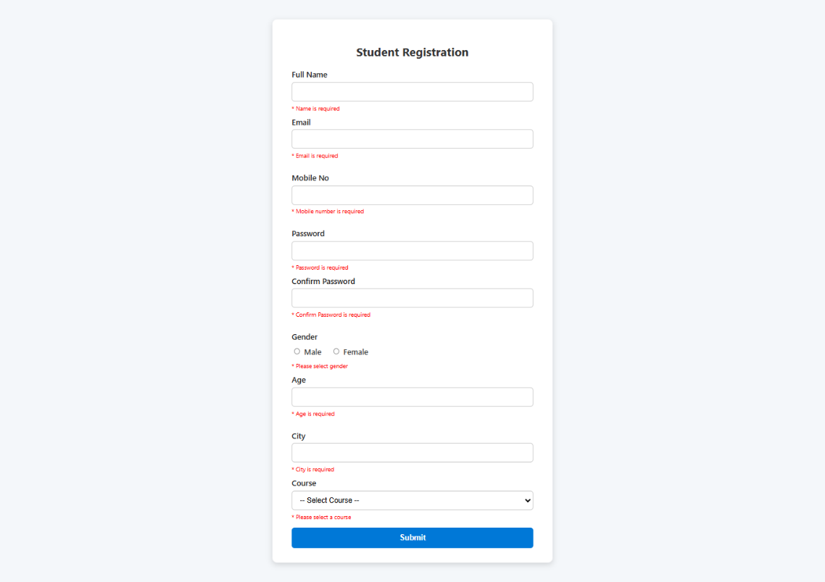

Code Behind
<%@ Page Language="VB" AutoEventWireup="false" CodeFile="formStudent.aspx.vb" Inherits="formStudent" %>

<!DOCTYPE html>
<html xmlns="http://www.w3.org/1999/xhtml">
<head id="Head1" runat="server">
<title>Student Registration Form</title>
<style>
/* General Styling */
body {
margin: 0;
padding: 0;
font-family: 'Segoe UI', Tahoma, Geneva, Verdana, sans-serif;
background-color: #f4f7fa;
}

.container {
max-width: 500px;
margin: 40px auto;
background: #fff;
padding: 30px 40px;
border-radius: 10px;
box-shadow: 0 4px 12px rgba(0, 0, 0, 0.15);
}

h2 {
text-align: center;
color: #333;
margin-bottom: 20px;
font-size: 24px;
}

label {
display: block;
font-weight: 600;
margin-bottom: 6px;
color: #222;
}

/* Input & Dropdown Styling */
.input-box,
.dropdown {
width: 100%;
padding: 10px 12px;
margin-bottom: 14px;
border: 1.8px solid #ccc;
border-radius: 6px;
font-size: 15px;
box-sizing: border-box;
transition: 0.3s ease;
}

.input-box:focus,
.dropdown:focus {
border-color: #0078d7;
box-shadow: 0 0 6px rgba(0, 120, 215, 0.4);
outline: none;
}

/* Gender Styling */
.gender-group {
margin: 10px 0;
}

.gender-options {
display: flex;
gap: 20px;
margin-bottom: 14px;
}

.gender-options label {
cursor: pointer;
font-weight: 500;
color: #444;
}

/* Button Styling */
.btn-submit {
background-color: #0078d7;
color: white;
border: none;
padding: 12px;
font-size: 16px;
border-radius: 6px;
cursor: pointer;
width: 100%;
font-weight: 600;
transition: 0.3s ease;
margin-top: 5px;
}

.btn-submit:hover {
background-color: #005fa3;
}

/* Error Message Styling */
.error {
color: red;
font-size: 12px;
margin-top: -8px;
display: block;
margin-bottom: 10px;
}

/* Success Message */
#<%= LableDis.ClientID %> {
display: block;
margin-top: 15px;
text-align: center;
font-weight: 600;
color: #28a745;
}

/* Link Styling */
#<%= hlViewStudentData.ClientID %> {
display: block;
margin-top: 10px;
text-align: center;
font-weight: 600;
color: #0078d7;
text-decoration: none;
}

#<%= hlViewStudentData.ClientID %>:hover {
text-decoration: underline;
}
</style>
</head>
<body>
<form id="form1" runat="server">
<div class="container">
<h2>Student Registration</h2>
<asp:Label ID="LableDis" runat="server" Text=""></asp:Label>
<asp:HyperLink ID="hlViewStudentData" runat="server" NavigateUrl="viewStudentData.aspx"
Text="View Student Data" Visible="false" />

<!-- Name -->
<label for="txtName">Full Name</label>
<asp:TextBox ID="txtName" runat="server" CssClass="input-box"></asp:TextBox>
<asp:RequiredFieldValidator ID="RequiredFieldValidator1" runat="server"
ControlToValidate="txtName" ErrorMessage="* Name is required" CssClass="error" />

<!-- Email -->
<label for="txtEmail">Email</label>
<asp:TextBox ID="txtEmail" runat="server" CssClass="input-box"></asp:TextBox>
<asp:RequiredFieldValidator ID="RequiredFieldValidator2" runat="server"
ControlToValidate="txtEmail" ErrorMessage="* Email is required" CssClass="error" />
<asp:RegularExpressionValidator ID="RegularExpressionValidator1" runat="server"
ControlToValidate="txtEmail" ErrorMessage="* Invalid Email Format"
ValidationExpression="\w+([-+.']\w+)*@\w+([-.]\w+)*\.\w+([-.]\w+)*"
CssClass="error" />

<!-- Mobile -->
<label for="txtMobile">Mobile No</label>
<asp:TextBox ID="txtMobile" runat="server" CssClass="input-box"></asp:TextBox>
<asp:RequiredFieldValidator ID="RequiredFieldValidator6" runat="server"
ControlToValidate="txtMobile" ErrorMessage="* Mobile number is required"
CssClass="error" />
<asp:RegularExpressionValidator ID="RegularExpressionValidator2" runat="server"
ControlToValidate="txtMobile" ErrorMessage="* Invalid Mobile Number"
ValidationExpression="^(?:\+91|91|0)?[6-9]\d{9}$" CssClass="error" />

<!-- Password -->
<label for="txtPassword">Password</label>
<asp:TextBox ID="txtPassword" runat="server" TextMode="Password" CssClass="input-box"></asp:TextBox>
<asp:RequiredFieldValidator ID="RequiredFieldValidator3" runat="server"
ControlToValidate="txtPassword" ErrorMessage="* Password is required"
CssClass="error" />

<!-- Confirm Password -->
<label for="txtConfPass">Confirm Password</label>
<asp:TextBox ID="txtConfPass" runat="server" TextMode="Password" CssClass="input-box"></asp:TextBox>
<asp:RequiredFieldValidator ID="RequiredFieldValidator8" runat="server"
ControlToValidate="txtConfPass" ErrorMessage="* Confirm Password is required"
CssClass="error" />
<asp:CompareValidator ID="CompareValidator1" runat="server"
ControlToCompare="txtPassword" ControlToValidate="txtConfPass"
ErrorMessage="* Passwords do not match" CssClass="error" />

<!-- Gender -->
<label class="gender-group">Gender</label>
<div class="gender-options">
<label><asp:RadioButton ID="rbMale" runat="server" GroupName="Gender" /> Male</label>
<label><asp:RadioButton ID="rbFemale" runat="server" GroupName="Gender" /> Female</label>
</div>
<asp:CustomValidator ID="GenderValidator" runat="server" CssClass="error"
ErrorMessage="* Please select gender" ClientValidationFunction="validateGender" />

<!-- Age -->
<label for="txtAge">Age</label>
<asp:TextBox ID="txtAge" runat="server" CssClass="input-box"></asp:TextBox>
<asp:RequiredFieldValidator ID="RequiredFieldValidator7" runat="server"
ControlToValidate="txtAge" ErrorMessage="* Age is required" CssClass="error" />
<asp:RangeValidator ID="RangeValidator1" runat="server"
ControlToValidate="txtAge" ErrorMessage="* Must be 18+" MinimumValue="18"
MaximumValue="100" Type="Integer" CssClass="error" />

<!-- City -->
<label for="txtCity">City</label>
<asp:TextBox ID="txtCity" runat="server" CssClass="input-box"></asp:TextBox>
<asp:RequiredFieldValidator ID="RequiredFieldValidator4" runat="server"
ControlToValidate="txtCity" ErrorMessage="* City is required" CssClass="error" />
<!-- Course -->
<label for="ddlCourse">Course</label>
<asp:DropDownList ID="ddlCourse" runat="server" CssClass="dropdown">
<asp:ListItem Text="-- Select Course --" Value="" />
<asp:ListItem Text="BBA" />
<asp:ListItem Text="BCA" />
<asp:ListItem Text="BCOM" />
<asp:ListItem Text="BSc IT" />
</asp:DropDownList>
<asp:RequiredFieldValidator ID="RequiredFieldValidator5" runat="server"
ControlToValidate="ddlCourse" InitialValue="" ErrorMessage="* Please select a course"
CssClass="error" />

<!-- Submit Button -->
<asp:Button ID="btnSubmit" runat="server" Text="Submit" CssClass="btn-submit" />
</div>
</form>

<!-- Gender Validation Script -->
<script type="text/javascript">
function validateGender(sender, args) {
args.IsValid = document.getElementById('<%= rbMale.ClientID %>').checked ||
document.getElementById('<%= rbFemale.ClientID %>').checked;
}
</script>
</body>
</html>

Code
Imports System.Data
Imports System.Data.SqlClient
Partial Class formStudent
Inherits System.Web.UI.Page

Protected Sub btnSubmit_Click(ByVal sender As Object, ByVal e As System.EventArgs) Handles btnSubmit.Click
Dim conn As New SqlConnection(System.Web.Configuration.WebConfigurationManager.ConnectionStrings("studentDBHome").ConnectionString)
Dim gender As String = ""
If rbMale.Checked Then
gender = "Male"
ElseIf rbFemale.Checked Then
gender = "Female"
End If

Dim course As String = ddlCourse.SelectedValue

Dim query As String = "insert into StudentData values ('" & txtName.Text & "','" & txtEmail.Text & "','" & txtMobile.Text & "','" & txtPassword.Text & "','" & gender & "','" & txtAge.Text & "','" & txtCity.Text & "','" & course & "')"
Dim cmd As New SqlCommand(query, conn)
conn.Open()
Dim cnt As Integer = 0
cnt = cmd.ExecuteNonQuery
conn.Close()

If cnt > 0 Then
LableDis.Text = "Registration Successfully"
txtName.Text = ""
txtEmail.Text = ""
txtMobile.Text = ""
txtPassword.Text = ""
txtAge.Text = ""
txtCity.Text = ""

' Clear RadioButtons
rbMale.Checked = False
rbFemale.Checked = False

' Reset DropDownList (if you want to reset to the first/default item)
ddlCourse.SelectedIndex = 0

hlViewStudentData.Visible = True

End If

End Sub

End Class

2. Login Page having implementation of any state management techniques . (SESSION) :
Ans:-
Design

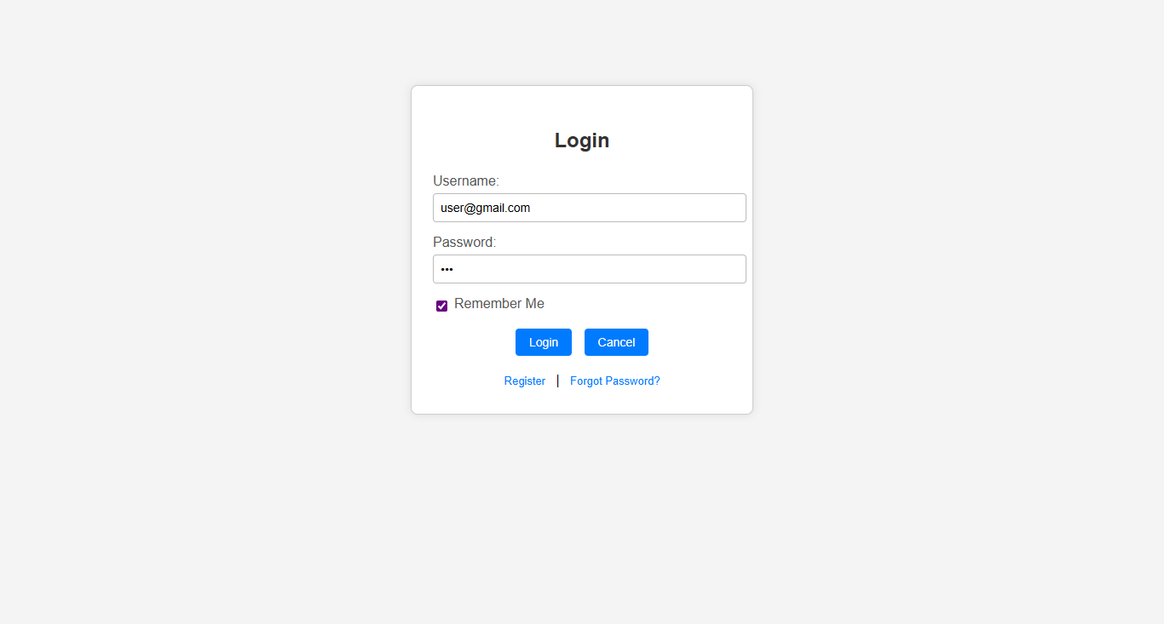

Code behind

<%@ Page Language="VB" AutoEventWireup="false" CodeFile="loginPage.aspx.vb" Inherits="frmLoginDemoty9" %>

<!DOCTYPE html PUBLIC "-//W3C//DTD XHTML 1.0 Transitional//EN" "http://www.w3.org/TR/xhtml1/DTD/xhtml1-transitional.dtd">

<html xmlns="http://www.w3.org/1999/xhtml">
<head id="Head1" runat="server">
<title>Login Page Demo</title>
<style type="text/css">
body {
font-family: Arial, sans-serif;
background-color: #f4f4f4;
margin: 0;
padding: 0;
}

.login-box {
width: 350px;
margin: 100px auto;
background: #fff;
border: 1px solid #ccc;
border-radius: 8px;
padding: 30px 25px;
box-shadow: 0 0 10px rgba(0, 0, 0, 0.1);
}

.login-box h2 {
text-align: center;
margin-bottom: 25px;
color: #333;
}

.row {
margin-bottom: 15px;
}

.row label {
display: block;
margin-bottom: 5px;
color: #555;
}

.asp-input {
width: 100%;
padding: 8px;
border: 1px solid #bbb;
border-radius: 4px;
font-size: 14px;
}

.asp-checkbox {
display: flex;
align-items: center;
color: #555;
}

.asp-checkbox input {
margin-right: 8px;
}

.buttons {
text-align: center;
margin-top: 15px;
}

.buttons input {
padding: 8px 16px;
margin: 0 5px;
border: none;
border-radius: 4px;
background-color: #007bff;
color: white;
cursor: pointer;
font-size: 14px;
}

.buttons input:hover {
background-color: #0056b3;
}

.status-label {
display: block;
text-align: center;
margin-top: 10px;
color: red;
font-weight: bold;
}

.links {
margin-top: 20px;
text-align: center;
}

.links a {
margin: 0 8px;
text-decoration: none;
color: #007bff;
font-size: 13px;
}

.links a:hover {
text-decoration: underline;
}
</style>
</head>
<body>
<form id="form1" runat="server">
<div class="login-box">
<h2>Login</h2>

<div class="row">
<label for="txtUsername">Username:</label>
<asp:TextBox ID="txtUsername" runat="server" CssClass="asp-input" />
</div>

<div class="row">
<label for="txtPassword">Password:</label>
<asp:TextBox ID="txtPassword" runat="server" TextMode="Password" CssClass="asp-input" />
</div>

<div class="row asp-checkbox">
<asp:CheckBox ID="chkRememberMe" runat="server" Text="Remember Me" />
</div>

<div class="buttons">
<asp:Button ID="btnLogin" runat="server" Text="Login" CssClass="asp-button" />
<asp:Button ID="Button1" runat="server" Text="Cancel" CssClass="asp-button" />
<asp:Label ID="Label1" runat="server" CssClass="status-label" Text=""></asp:Label>
</div>

<div class="links">
<asp:HyperLink ID="lnkRegister" runat="server" NavigateUrl="formStudent.aspx">Register</asp:HyperLink>
|
<asp:HyperLink ID="lnkForgot" runat="server" NavigateUrl="ForgotPassword.aspx">Forgot Password?</asp:HyperLink>
</div>
</div>
</form>
</body>
</html>

CODE

Partial Class frmLoginDemoty9
Inherits System.Web.UI.Page

Protected Sub btnLogin_Click(ByVal sender As Object, ByVal e As System.EventArgs) Handles btnLogin.Click
Dim cn As New SqlConnection(System.Web.Configuration.WebConfigurationManager.ConnectionStrings("studentDB").ConnectionString)
Dim cmd As New SqlCommand("select * from StudentData where username='" & txtUsername.Text & "' and password='" & txtPassword.Text & "'", cn)
Dim da As New SqlDataAdapter(cmd)
Dim ds As New DataSet
da.Fill(ds, "tmpStudData")

If ds.Tables(0).Rows.Count > 0 Then
Session("sid") = ds.Tables(0).Rows(0).Item(0).ToString
Response.Redirect("updateStudent.aspx")

Else
Label1.Text = "USERNAME OR PASSWORD INCORRECT"
End If

End Sub
End Class

3. Registered Students Details Page. :
Ans:-
Design

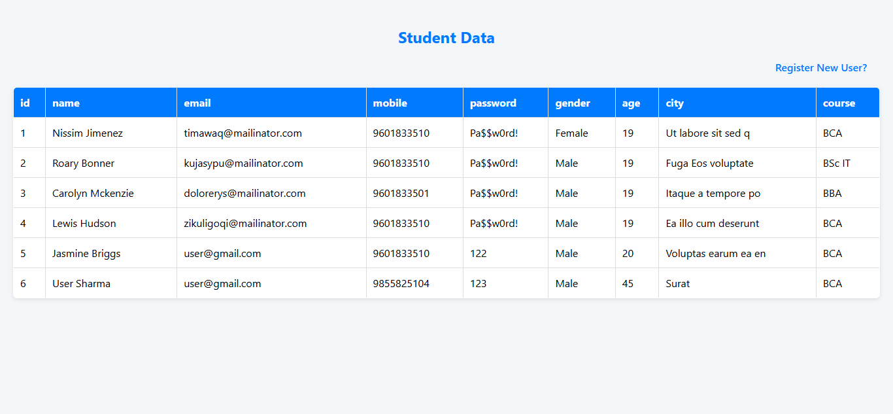

Code behind

<%@ Page Language="VB" AutoEventWireup="true" CodeFile="viewStudentData.aspx.vb" Inherits="viewStudentData" %>

<!DOCTYPE html>
<html xmlns="http://www.w3.org/1999/xhtml">
<head id="Head1" runat="server">
<title>View Student Data</title>
<style>
body {
font-family: 'Segoe UI', Tahoma, Geneva, Verdana, sans-serif;
margin: 20px;
background-color: #f4f7fa;
}
h2 {
color: #007bff;
text-align: center;
}
/* Container for the link */
.link-container {
text-align: end; /* Center the link */
margin-bottom: 20px;
margin-right:20px;
}
a {
color: #007bff;
text-decoration: none;
font-weight: 600;
font-size: 16px;
}
a:hover {
text-decoration: underline;
}

table {
border-collapse: collapse;
width: 100%;
margin-top: 0;
background: #fff;
box-shadow: 0 2px 6px rgba(0,0,0,0.1);
border-radius: 6px;
overflow: hidden;
}
th, td {
border: 1px solid #ddd;
padding: 12px 10px;
text-align: left;
}
th {
background-color: #007bff;
color: white;
}
</style>
</head>
<body>
<form id="form1" runat="server">
<h2>Student Data</h2>

<!-- Link container -->
<div class="link-container">
<asp:HyperLink ID="backRegistration" runat="server" NavigateUrl="formStudent.aspx" Text="Register New User?" />
</div>

<!-- GridView for displaying data -->
<asp:GridView ID="GridView1" runat="server" AutoGenerateColumns="True"></asp:GridView>
</form>
</body>
</html>

CODE

Imports System.Data
Imports System.Data.SqlClient
Partial Class viewStudentData
Inherits System.Web.UI.Page

Protected Sub Page_Load(ByVal sender As Object, ByVal e As System.EventArgs) Handles Me.Load
Dim conn As New SqlConnection(System.Web.Configuration.WebConfigurationManager.ConnectionStrings("StudentDBHome").ConnectionString)
Dim cmd As New SqlCommand("select * from StudentData", conn)
Dim da As New SqlDataAdapter(cmd)
Dim dt As New DataTable
da.Fill(dt)
GridView1.DataSource = dt
GridView1.DataBind()

End Sub

End Class

4. Update Student Profile Page :
Ans:-
Design
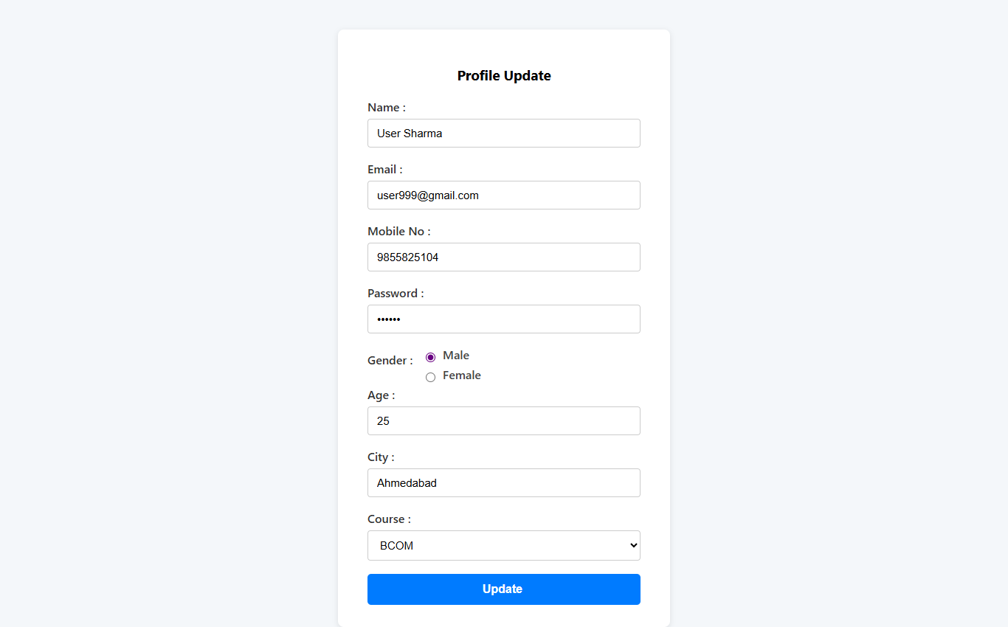

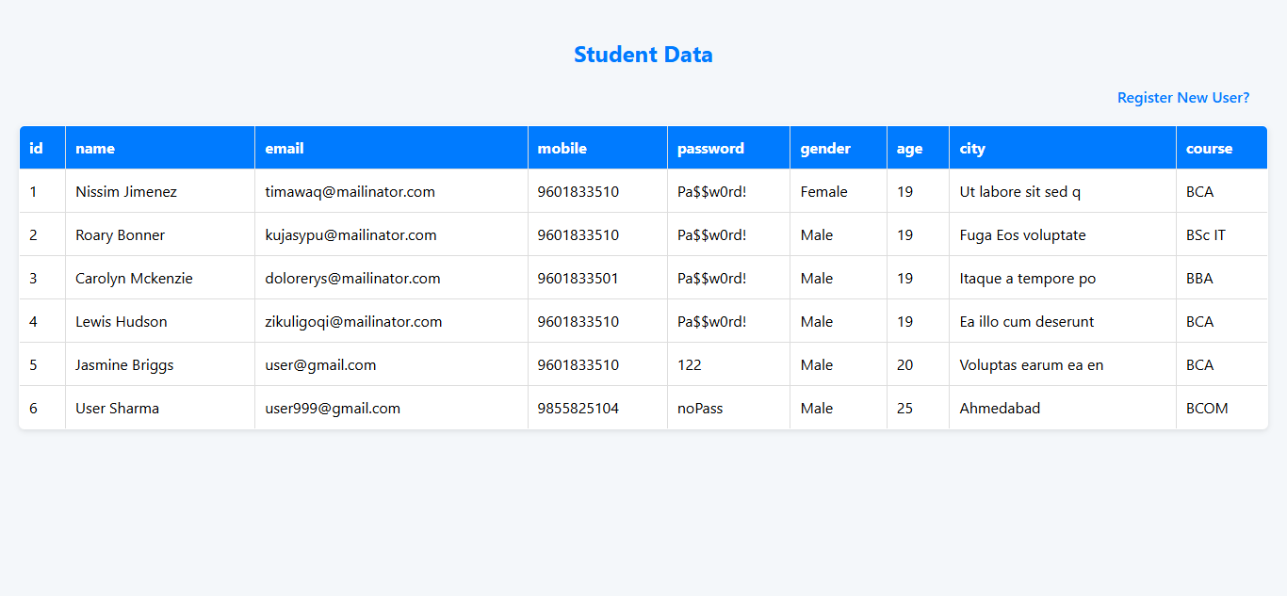
Code behind

<%@ Page Language="VB" AutoEventWireup="false" CodeFile="updateStudent.aspx.vb" Inherits="updateStudent" %>

<!DOCTYPE html PUBLIC "-//W3C//DTD XHTML 1.0 Transitional//EN" "http://www.w3.org/TR/xhtml1/DTD/xhtml1-transitional.dtd">

<html xmlns="http://www.w3.org/1999/xhtml">
<head id="Head1" runat="server">
<title>Student Registration Form</title>
<style>
/* Reset some default browser styles */
body, html {
margin: 0;
padding: 0;
height: 100%;
font-family: 'Segoe UI', Tahoma, Geneva, Verdana, sans-serif;
background-color: #f4f7fa;
}

form {
max-width: 450px;
margin: 40px auto;
background: #fff;
padding: 30px 40px;
border-radius: 8px;
box-shadow: 0 2px 8px rgba(0,0,0,0.1);
box-sizing: border-box;
}

label {
display: block;
font-weight: 600;
margin-bottom: 6px;
color: #333;
}

input[type="text"],
input[type="email"],
input[type="password"],
select {
width: 100%;
padding: 10px 12px;
margin-bottom: 18px;
border: 1.8px solid #ccc;
border-radius: 4px;
font-size: 15px;
box-sizing: border-box;
transition: border-color 0.3s ease;
}

input[type="text"]:focus,
input[type="email"]:focus,
input[type="password"]:focus,
select:focus {
border-color: #007bff;
outline: none;
}

/* Gender label */
.gender-group {
margin-bottom: 18px;
font-weight: 600;
color: #333;
display: inline-block;
vertical-align: middle;
}

/* Container for gender radio buttons inline */
.gender-options {
display: inline-block;
margin-left: 8px;
vertical-align: middle;
}

.gender-options label {
margin-right: 20px;
cursor: pointer;
font-weight: 500;
color: #444;
user-select: none;
}

.gender-options input[type="radio"] {
margin-right: 6px;
cursor: pointer;
vertical-align: middle;
}

.btn-submit {
background-color: #007bff;
color: white;
border: none;
padding: 12px 20px;
font-size: 16px;
border-radius: 5px;
cursor: pointer;
transition: background-color 0.3s ease;
width: 100%;
font-weight: 600;
}

.btn-submit:hover {
background-color: #0056b3;
}

/* Label to display message */
#<%= LableDis.ClientID %> {
display: block;
margin-top: 20px;
font-weight: 600;
text-align: center;
color: #28a745; /* green for success */
}

/* Style for the ViewStudentData link */
#<%= hlViewStudentData.ClientID %> {
display: block;
margin-top: 10px;
text-align: center;
font-weight: 600;
color: #007bff;
text-decoration: none;
}

#<%= hlViewStudentData.ClientID %>:hover {
text-decoration: underline;
}
</style>
</head>
<body>
<form id="form1" runat="server">
<div>
<h3 align="center">Profile Update </h3>
<asp:Label ID="LableDis" runat="server" Text=""></asp:Label>
<asp:HyperLink ID="hlViewStudentData" runat="server" NavigateUrl="viewStudentData.aspx" Text="ViewStudentData" Visible="false" />

<asp:Label ID="Label1" runat="server" Text="Name : " AssociatedControlID="txtName"></asp:Label>
<asp:TextBox ID="txtName" runat="server"></asp:TextBox>

<asp:Label ID="Label2" runat="server" Text="Email : " AssociatedControlID="txtEmail"></asp:Label>
<asp:TextBox ID="txtEmail" runat="server"></asp:TextBox>

<asp:Label ID="Label3" runat="server" Text="Mobile No : " AssociatedControlID="txtMobile"></asp:Label>
<asp:TextBox ID="txtMobile" runat="server"></asp:TextBox>

<asp:Label ID="Label4" runat="server" Text="Password : " AssociatedControlID="txtPass"></asp:Label>
<asp:TextBox ID="txtPass" runat="server" TextMode="Password"></asp:TextBox>

<asp:Label ID="Label5" runat="server" Text="Gender : " CssClass="gender-group"></asp:Label>
<div class="gender-options">
<label>
<asp:RadioButton ID="rbMale" runat="server" GroupName="Gender" Text="" />
Male
</label>
<label>
<asp:RadioButton ID="rbFemale" runat="server" GroupName="Gender" Text="" />
Female
</label>
</div>

<asp:Label ID="Label7" runat="server" Text="Age : " AssociatedControlID="txtAge"></asp:Label>
<asp:TextBox ID="txtAge" runat="server"></asp:TextBox>

<asp:Label ID="Label6" runat="server" Text="City : " AssociatedControlID="txtCity"></asp:Label>
<asp:TextBox ID="txtCity" runat="server"></asp:TextBox>

<asp:Label ID="lblCourse" runat="server" Text="Course :" AssociatedControlID="ddlCourse" CssClass="label"></asp:Label>
<asp:DropDownList ID="ddlCourse" runat="server" CssClass="input-box">
<asp:ListItem Text="-- Select Course --" Value="" />
<asp:ListItem Text="BBA" />
<asp:ListItem Text="BCA" />
<asp:ListItem Text="BCOM" />
<asp:ListItem Text="Bsc IT" />
</asp:DropDownList>

<asp:Button ID="btnUpdate" runat="server" Text="Update "
CssClass="btn-submit" />
</div>
</form>
</body>
</html>

CODE

Imports System.Data
Imports System.Data.SqlClient
Partial Class updateStudent
Inherits System.Web.UI.Page

Protected Sub btnSubmit_Click(ByVal sender As Object, ByVal e As System.EventArgs) Handles btnUpdate.Click
Dim conn As New SqlConnection(System.Web.Configuration.WebConfigurationManager.ConnectionStrings("StudentDBHome").ConnectionString)
Dim gender As String = ""
If rbMale.Checked Then
gender = "Male"
ElseIf rbFemale.Checked Then
gender = "Female"
End If

Dim course As String = ddlCourse.SelectedValue

' Check if Session("sid") is available
If Session("sid") IsNot Nothing Then
Dim query As String = "UPDATE StudentData SET name=@name, email=@email, mobile=@mobile, password=@password, gender=@gender, age=@age, city=@city, course=@course WHERE id=" & Session("sid") & ""

Dim cmd As New SqlCommand(query, conn)
cmd.Parameters.AddWithValue("@name", txtName.Text)
cmd.Parameters.AddWithValue("@email", txtEmail.Text)
cmd.Parameters.AddWithValue("@mobile", txtMobile.Text)
cmd.Parameters.AddWithValue("@password", txtPass.Text)
cmd.Parameters.AddWithValue("@gender", gender)
cmd.Parameters.AddWithValue("@age", txtAge.Text)
cmd.Parameters.AddWithValue("@city", txtCity.Text)
cmd.Parameters.AddWithValue("@course", course)
cmd.Parameters.AddWithValue("@id", Session("sid"))

conn.Open()
Dim cnt As Integer = cmd.ExecuteNonQuery()
conn.Close()

If cnt > 0 Then
LableDis.Text = "Profile updated successfully."

' Optionally clear fields if needed (though it's an edit form)
' txtName.Text = ""
' ...

hlViewStudentData.Visible = True
Else
LableDis.Text = "Update failed."
End If
Else
Response.Redirect("loginPage.aspx")
End If
End Sub

Protected Sub Page_Load(ByVal sender As Object, ByVal e As System.EventArgs) Handles Me.Load

If Not IsPostBack Then
If Session("sid") IsNot Nothing Then
Dim conn As New SqlConnection(System.Web.Configuration.WebConfigurationManager.ConnectionStrings("StudentDBHome").ConnectionString)
Dim cmd As New SqlCommand("SELECT * FROM StudentData WHERE id = " & Session("sid") & " ", conn)
Dim da As New SqlDataAdapter(cmd)
Dim dt As New DataTable()
da.Fill(dt)

If dt.Rows.Count > 0 Then
Dim dr As DataRow = dt.Rows(0)
txtName.Text = dr("name").ToString()
txtEmail.Text = dr("email").ToString()
txtMobile.Text = dr("mobile").ToString()
txtPass.Text = dr("password").ToString()
txtAge.Text = dr("age").ToString()
txtCity.Text = dr("city").ToString()

' Gender radio buttons
Dim gender As String = dr("Gender").ToString()
If gender = "Male" Then
rbMale.Checked = True
ElseIf gender = "Female" Then
rbFemale.Checked = True
End If

' Course dropdown
Dim course As String = dr("course").ToString()
If ddlCourse.Items.FindByValue(course) IsNot Nothing Then
ddlCourse.SelectedValue = course
End If
End If
Else
' If session expired or no session found, redirect to login
Response.Redirect("loginPage.aspx")
End If
End If
End Sub

End Class

6. Web.config:
<?xml version="1.0"?>
<configuration>
<appSettings />
<connectionStrings>
<add name="studentDBHome" connectionString="Data Source=.\SQLEXPRESS;AttachDbFilename=D:\TYBCA744\AllProjectData\App_Data\Student44.mdf;Integrated Security=True;User Instance=True"/>

</connectionStrings>
<system.web>
<!--
Visual Basic options:
Set strict="true" to disallow all data type conversions
where data loss can occur.
Set explicit="true" to force declaration of all variables.
-->
<compilation debug="true" strict="false" explicit="true" targetFramework="4.0">
</compilation>
<!--
The <authentication> section enables configuration
of the security authentication mode used by
ASP.NET to identify an incoming user.
-->
<authentication mode="Windows"/>
<!--
The <customErrors> section enables configuration
of what to do if/when an unhandled error occurs
during the execution of a request. Specifically,
it enables developers to configure html error pages
to be displayed in place of a error stack trace.

<customErrors mode="RemoteOnly" defaultRedirect="GenericErrorPage.htm">
<error statusCode="403" redirect="NoAccess.htm" />
<error statusCode="404" redirect="FileNotFound.htm" />
</customErrors>
-->
<pages controlRenderingCompatibilityVersion="3.5" clientIDMode="AutoID">
<namespaces>
<clear/>
<add namespace="System.Data"/>
<add namespace="System.Data.SqlClient"/>
<add namespace="System"/>
<add namespace="System.Collections"/>
<add namespace="System.Collections.Generic"/>
<add namespace="System.Collections.Specialized"/>
<add namespace="System.Configuration"/>
<add namespace="System.Text"/>
<add namespace="System.Text.RegularExpressions"/>
<add namespace="System.Web"/>
<add namespace="System.Web.Caching"/>
<add namespace="System.Web.SessionState"/>
<add namespace="System.Web.Security"/>
<add namespace="System.Web.Profile"/>
<add namespace="System.Web.UI"/>
<add namespace="System.Web.UI.WebControls"/>
<add namespace="System.Web.UI.WebControls.WebParts"/>
<add namespace="System.Web.UI.HtmlControls"/>
</namespaces>
</pages>
</system.web>
</configuration>

7. Global.aspx :
<%@ Application Language="VB" %>

<script runat="server">

Sub Application_Start(ByVal sender As Object, ByVal e As EventArgs)
' Code that runs on application startup
' MsgBox("WELCOME TO MY WEBSITE")
Application("OnlineUsers") = 1000
End Sub

Sub Application_End(ByVal sender As Object, ByVal e As EventArgs)
' Code that runs on application shutdown
'MsgBox("BYE BYE")
End Sub

Sub Application_Error(ByVal sender As Object, ByVal e As EventArgs)
' Code that runs when an unhandled error occurs
End Sub

Sub Session_Start(ByVal sender As Object, ByVal e As EventArgs)
' Code that runs when a new session is started
'MsgBox("NEW USER ARRIVED")

Application("OnlineUsers") = Int(Application("OnlineUsers")) + 1
End Sub

Sub Session_End(ByVal sender As Object, ByVal e As EventArgs)
' Code that runs when a session ends.
Application("OnlineUsers") = Int(Application("OnlineUsers")) - 1
'MsgBox("USER LEFT WEBSITE")
' Note: The Session_End event is raised only when the sessionstate mode
' is set to InProc in the Web.config file. If session mode is set to StateServer
' or SQLServer, the event is not raised.
End Sub

</script>

