**OUTPUT**

**Importing library**

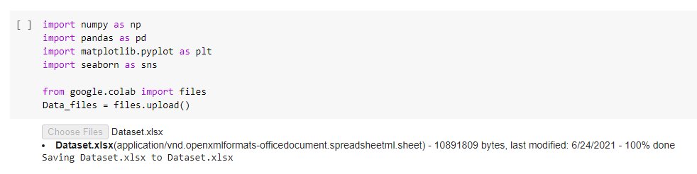

Reading sheets

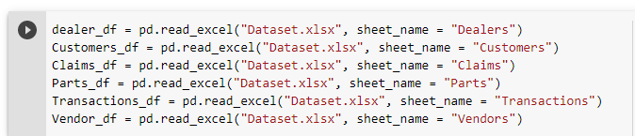

Output of Dealer_ID Sheet

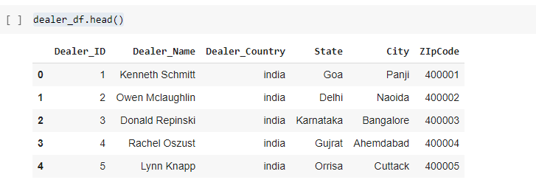

Output of Customers Sheet

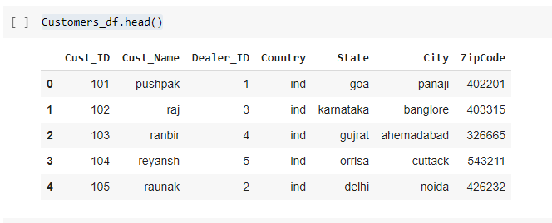

Output Of Parts Sheet

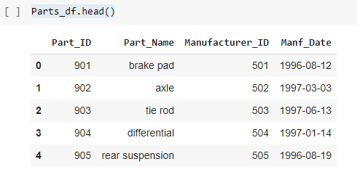

Output of Claims Sheet

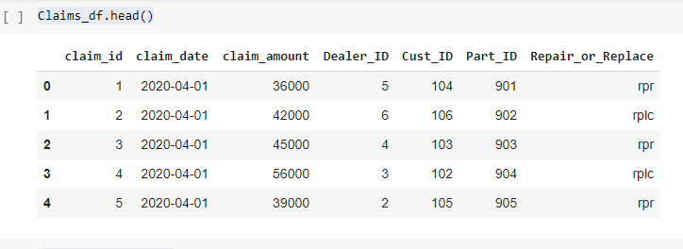

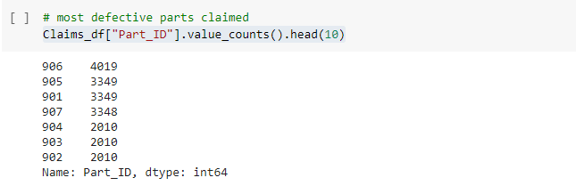

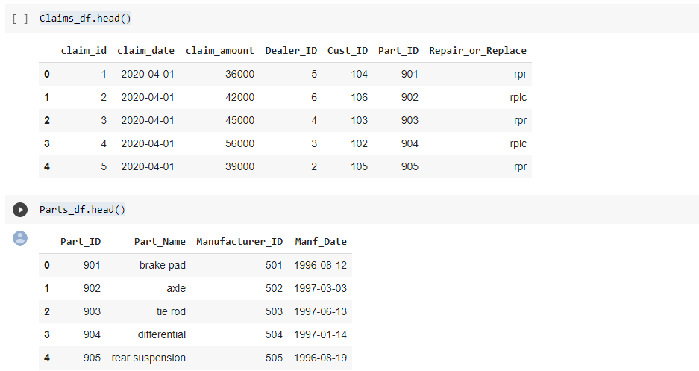

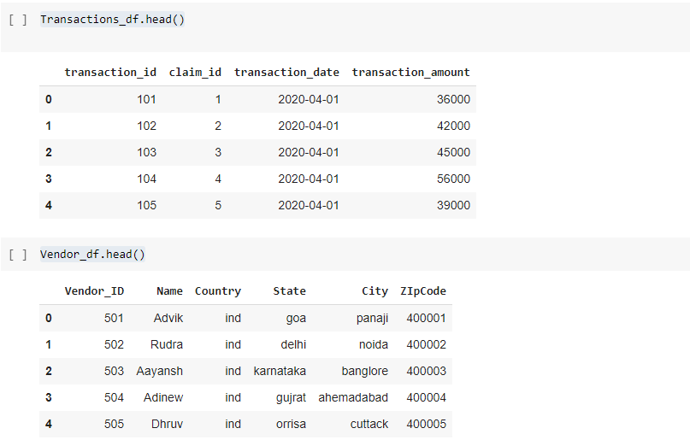

2) Predict the parts that may fail according to the location, mileage and age:

- In this case, by analyzing the historical data, we need to predict the parts that can be expected to fail according to the age, km driven and location of the vehicle.

- This data helps the company to understand the manufacturing requirements of the part i.e. which part is to be manufactured in what quantity so as to avoid unavailability of the parts when claim is raised for that part.

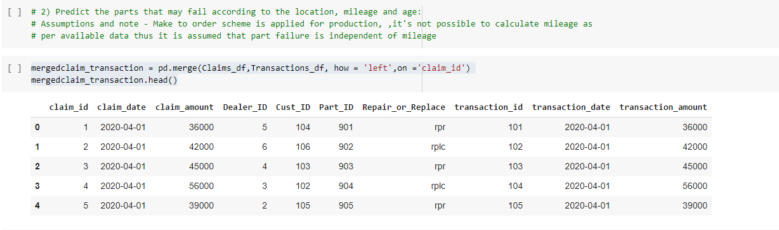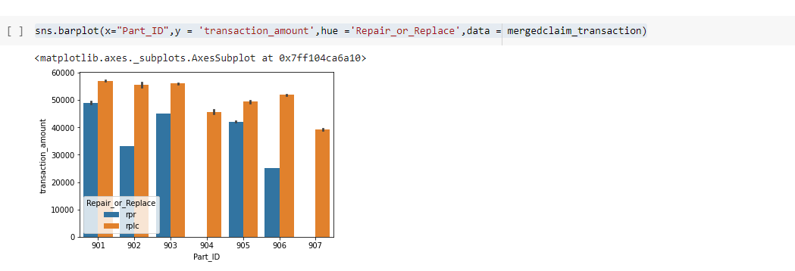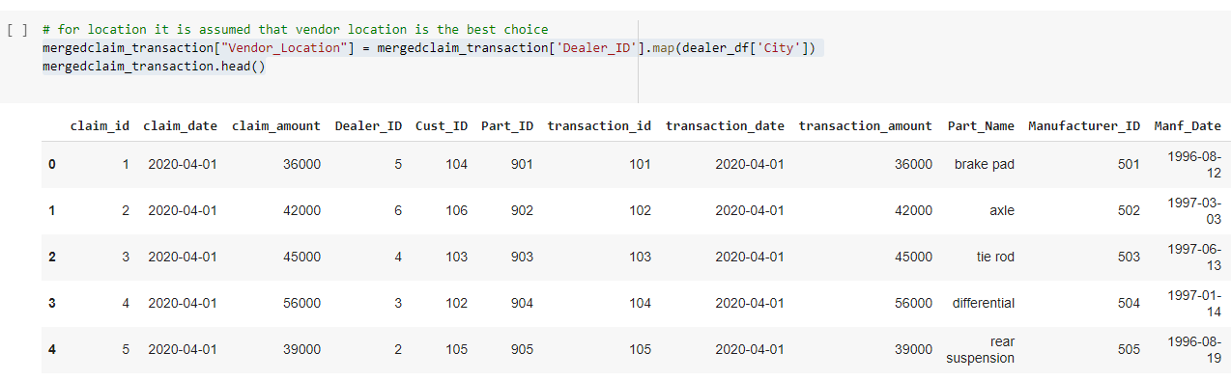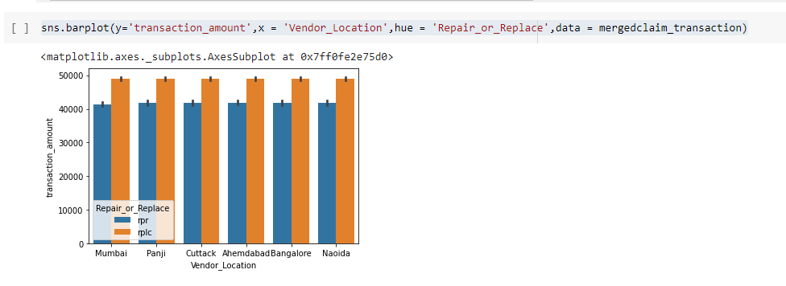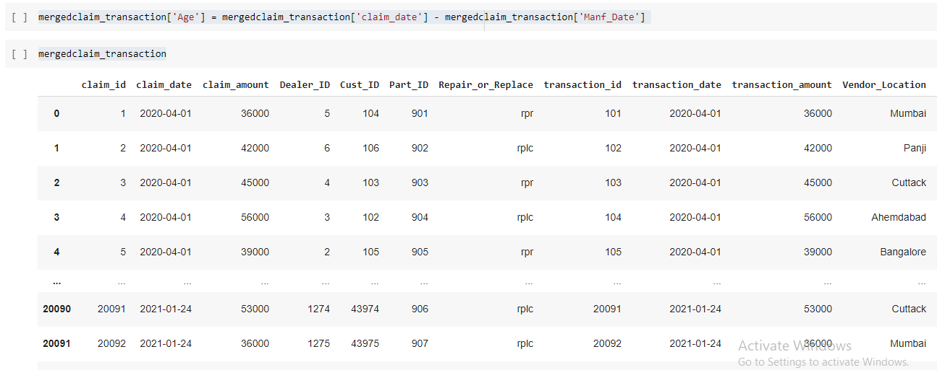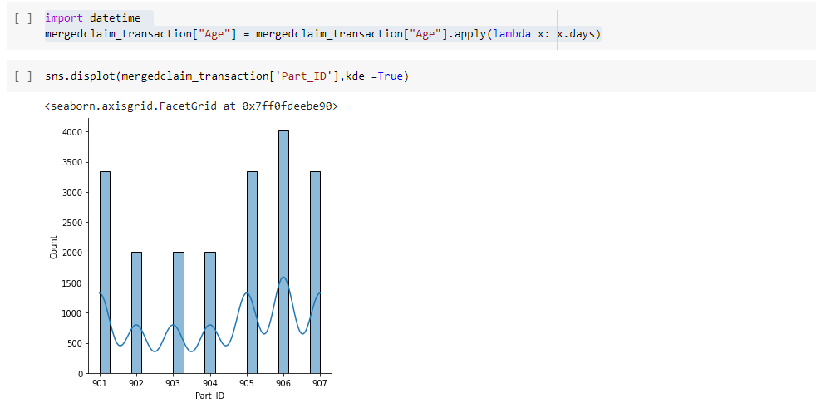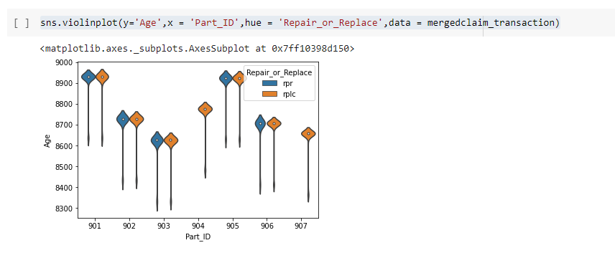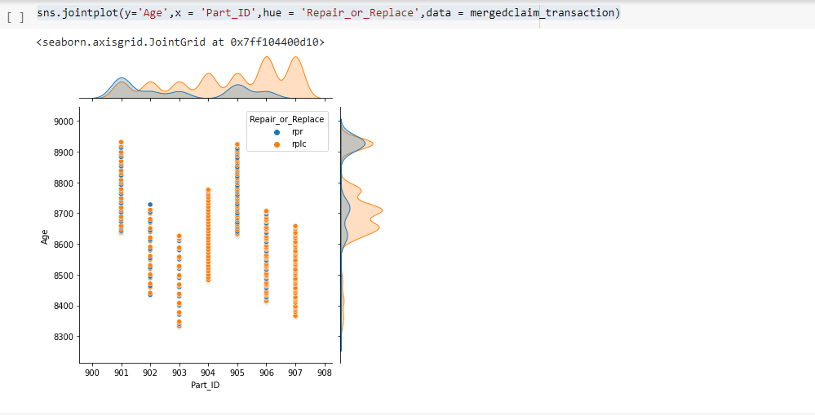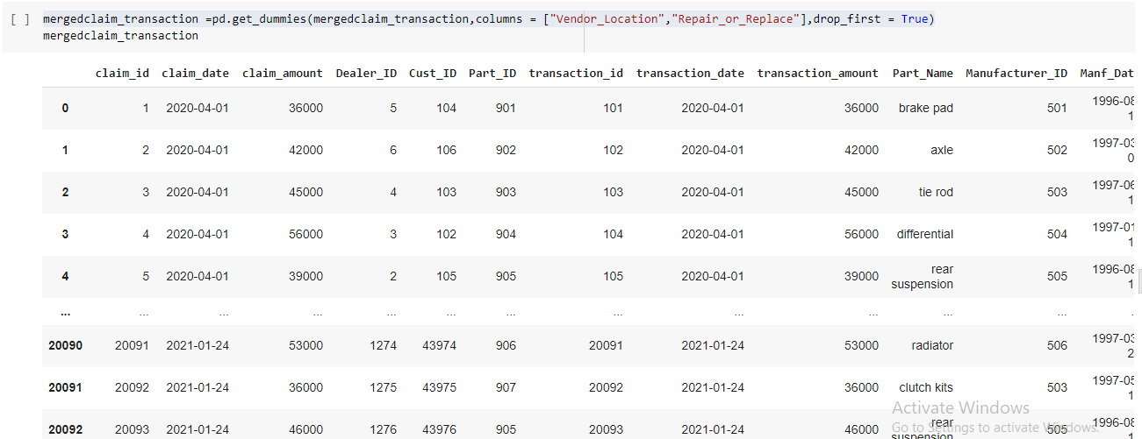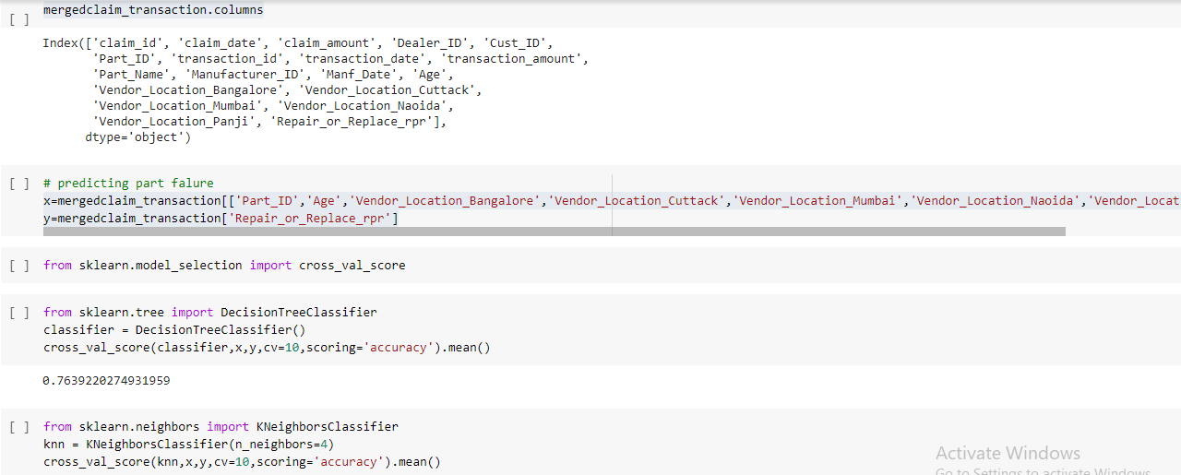

3) To determine whether the defective part is to be replaced or repaired:

- The model was developed to decide whether the failed part has to be repaired or replaced with the new one.

- For this, we had the last claimed data of the company.

- As this is the binary classification problem, Decision tree and Random Forest algorithms are used to build the model.

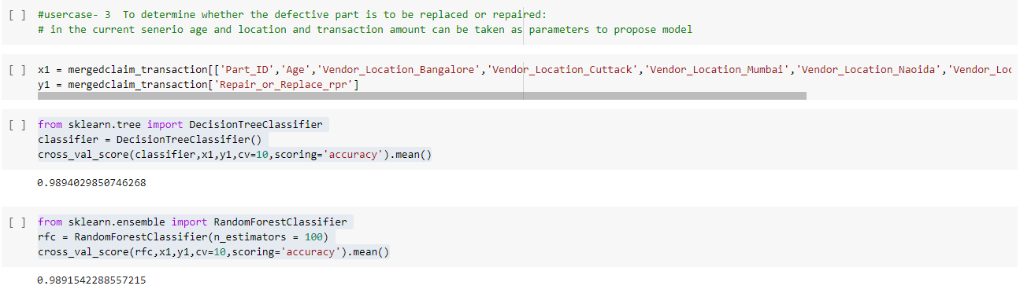

5) Processing of variety of data: - The data were coming from various locations like US, Canada, China, India in huge amount with varying data-types. - It was required to club the data and then process it further for the analyzing.

