**Supplementary Material 2 for**

A methodology to explore historical groundwater level trends and their origin: the case of Quebec, Canada.

**Authors:** Adoubi Vincent De Paul Adombi1,**\***, Romain Chesnaux1, Marie-Amélie Boucher2

1. Research Group R2Eau, Centre d’études sur les ressources minérales, Université du Québec à Chicoutimi, 555 boulevard de l’Université, Chicoutimi, Québec G7H 2B1, Canada. **Email*:** [avadombi@etu.uqac.ca](mailto:avadombi@etu.uqac.ca) | ORCID id: 0000-0001-8063-6444
2. Department of Civil Engineering, Université de Sherbrooke, 2500 Boul. de l’Université, Sherbrooke, Québec, Canada.

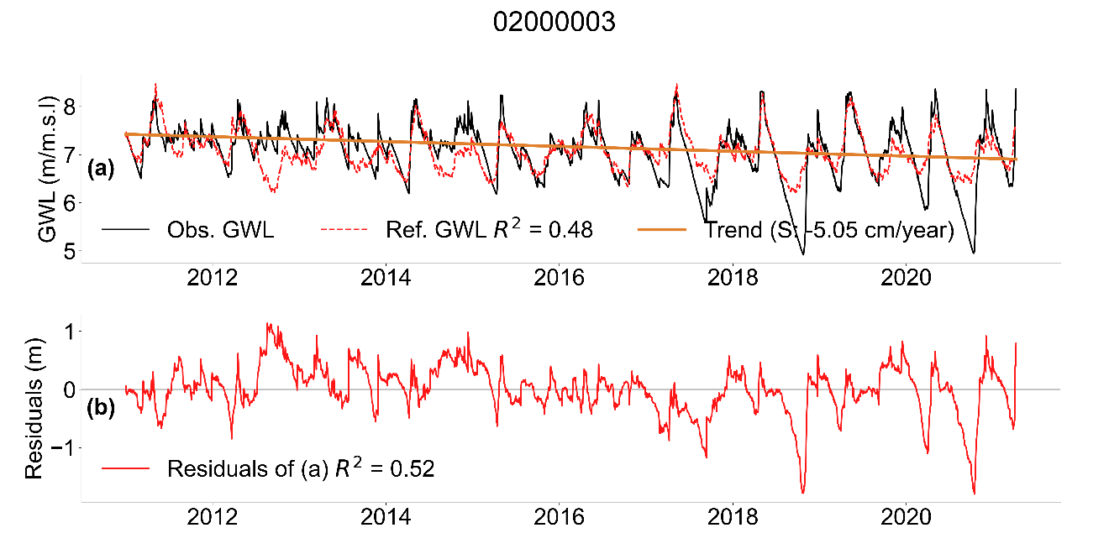

**Fig. 1** (a) Time series of GWL and reference hydrograph for well 02000003. (b) Time series of residuals. The correlation of the observed series with the reference hydrograph and with the residuals is given by R2. The trend line and slope of the trend are also shown.

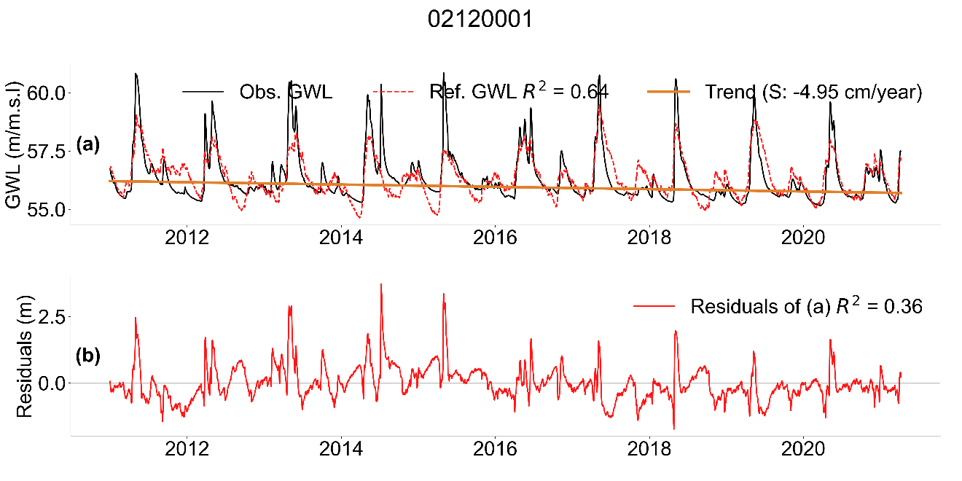

**Fig. 2** (a) Time series of GWL and reference hydrograph for well 02120001. (b) Time series of residuals. The correlation of the observed series with the reference hydrograph and with the residuals is given by R2. The trend line and slope of the trend are also shown.

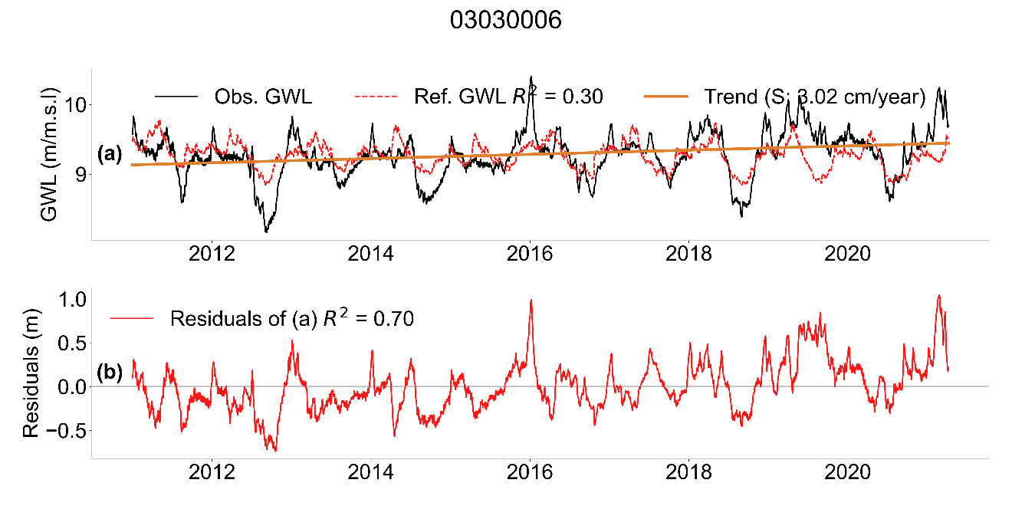

**Fig. 3** (a) Time series of GWL and reference hydrograph for well 03030006. (b) Time series of residuals. The correlation of the observed series with the reference hydrograph and with the residuals is given by R2. The trend line and slope of the trend are also shown.

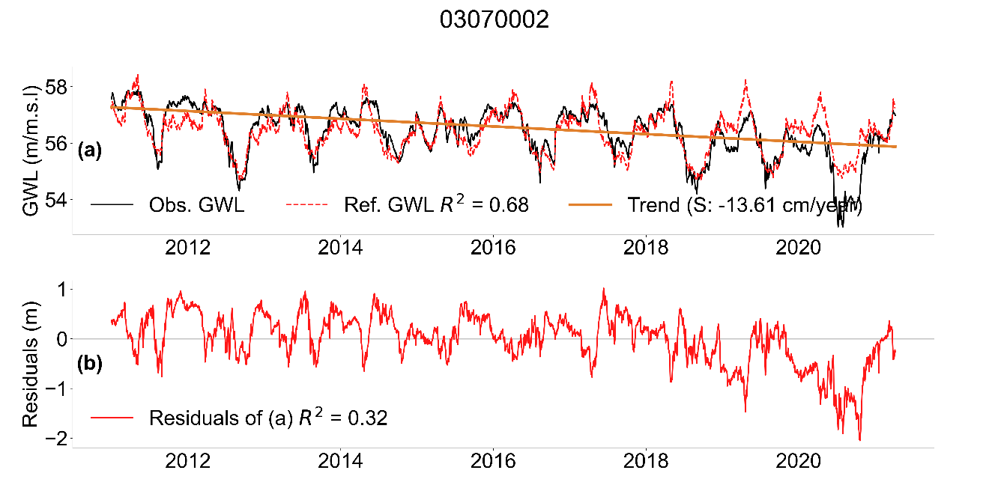

**Fig. 4** (a) Time series of GWL and reference hydrograph for well 03070002. (b) Time series of residuals. The correlation of the observed series with the reference hydrograph and with the residuals is given by R2. The trend line and slope of the trend are also shown.

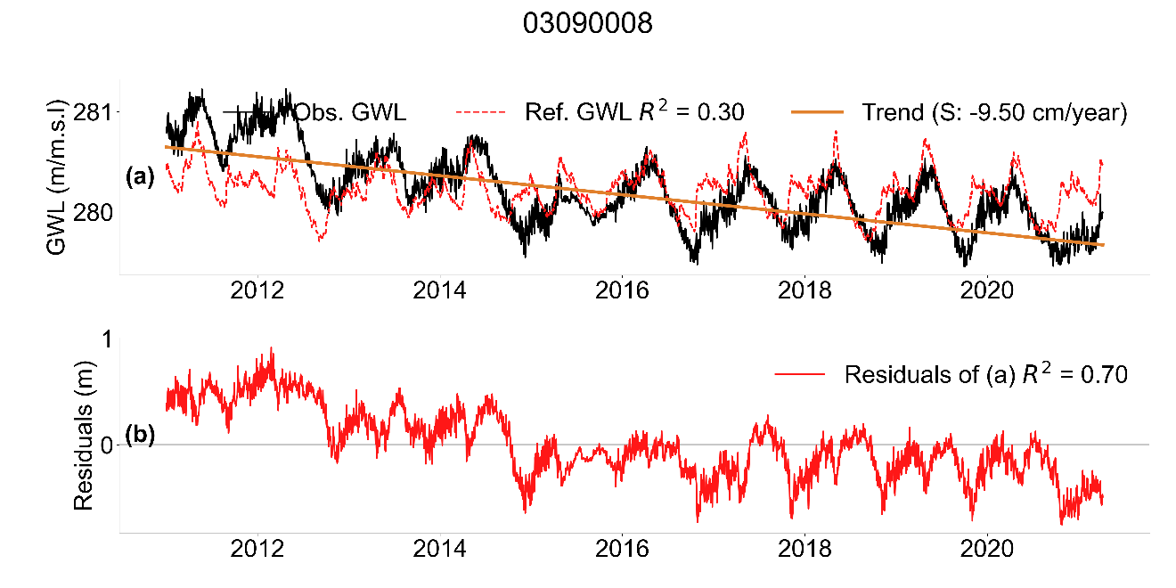

**Fig. 5** (a) Time series of GWL and reference hydrograph for well 03090008. (b) Time series of residuals. The correlation of the observed series with the reference hydrograph and with the residuals is given by R2. The trend line and slope of the trend are also shown.

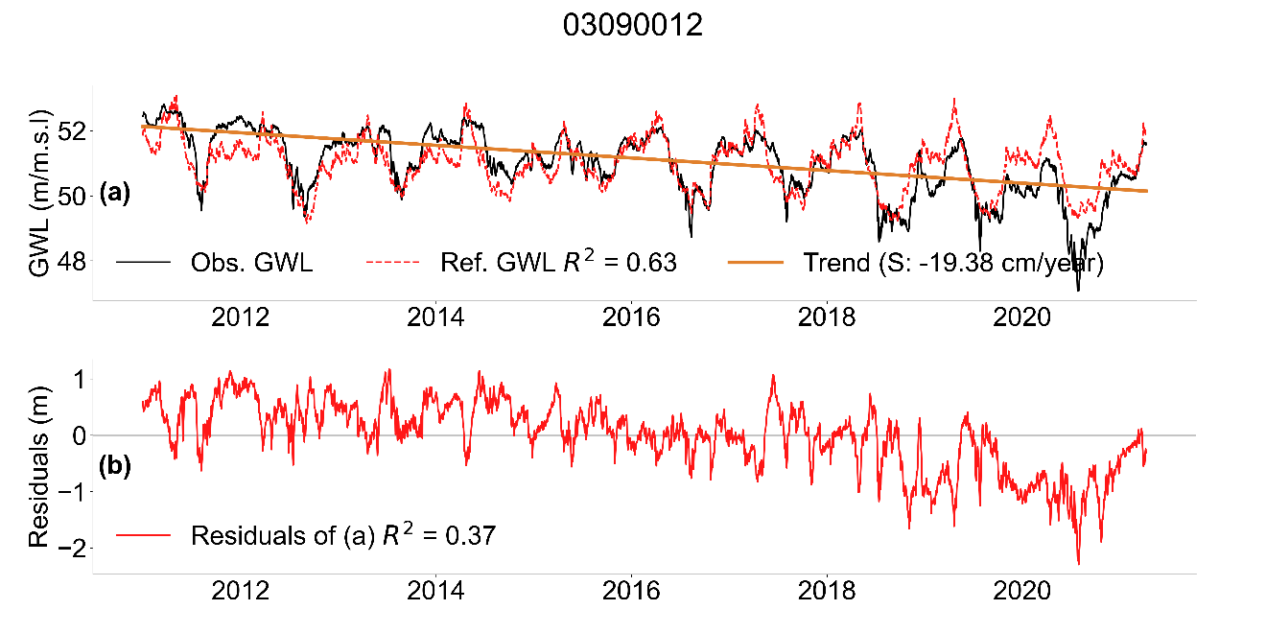

**Fig. 6** (a) Time series of GWL and reference hydrograph for well 03090012. (b) Time series of residuals. The correlation of the observed series with the reference hydrograph and with the residuals is given by R2. The trend line and slope of the trend are also shown.

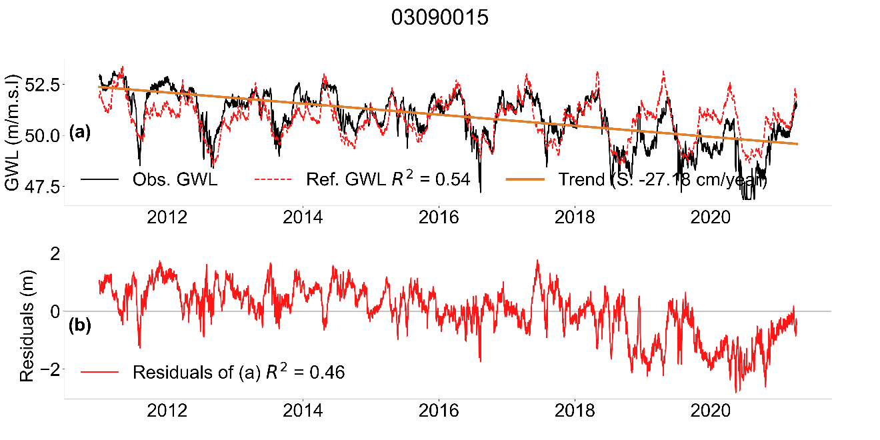

**Fig. 7** (a) Time series of GWL and reference hydrograph for well 03090015. (b) Time series of residuals. The correlation of the observed series with the reference hydrograph and with the residuals is given by R2. The trend line and slope of the trend are also shown.

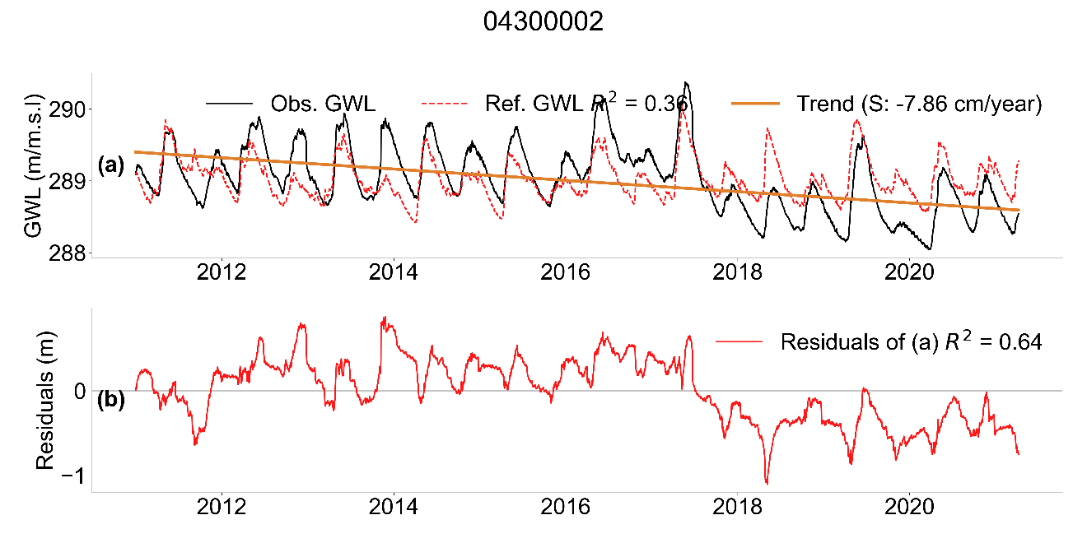

**Fig. 8** (a) Time series of GWL and reference hydrograph for well 04300002. (b) Time series of residuals. The correlation of the observed series with the reference hydrograph and with the residuals is given by R2. The trend line and slope of the trend are also shown.

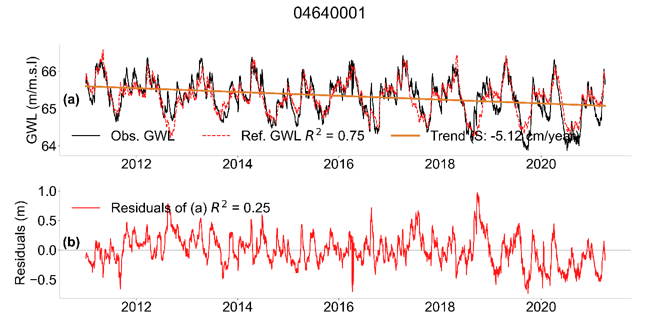

**Fig. 9** (a) Time series of GWL and reference hydrograph for well 04640001. (b) Time series of residuals. The correlation of the observed series with the reference hydrograph and with the residuals is given by R2. The trend line and slope of the trend are also shown.

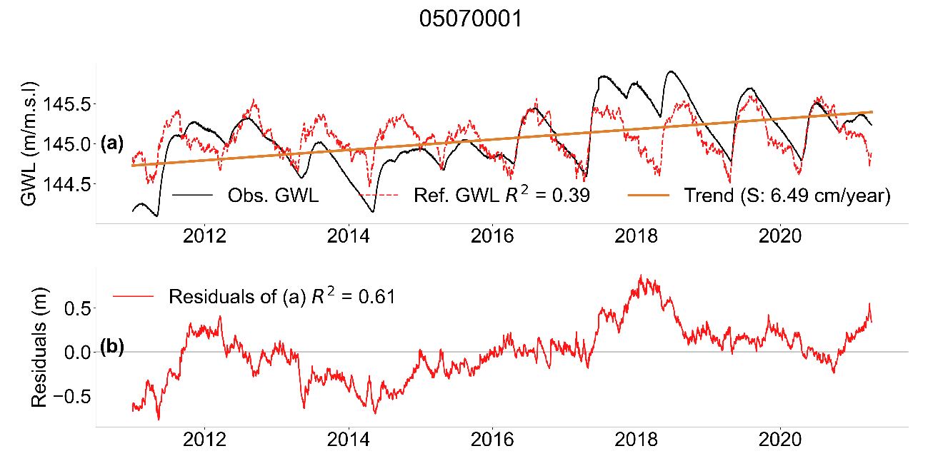

**Fig. 10** (a) Time series of GWL and reference hydrograph for well 05070001. (b) Time series of residuals. The correlation of the observed series with the reference hydrograph and with the residuals is given by R2. The trend line and slope of the trend are also shown.

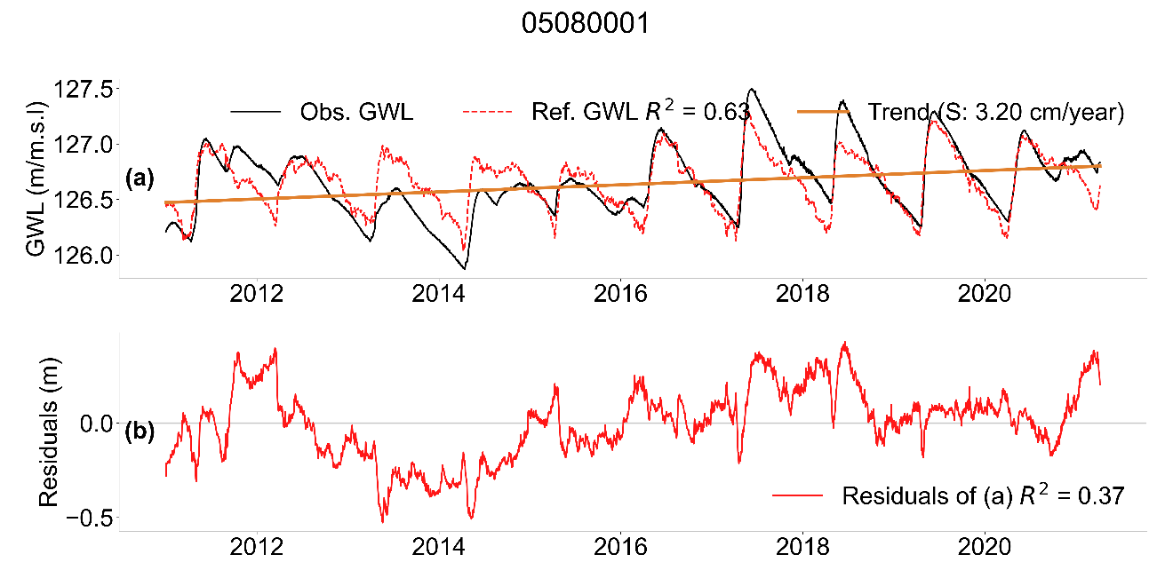

**Fig. 11** (a) Time series of GWL and reference hydrograph for well 05080001. (b) Time series of residuals. The correlation of the observed series with the reference hydrograph and with the residuals is given by R2. The trend line and slope of the trend are also shown.

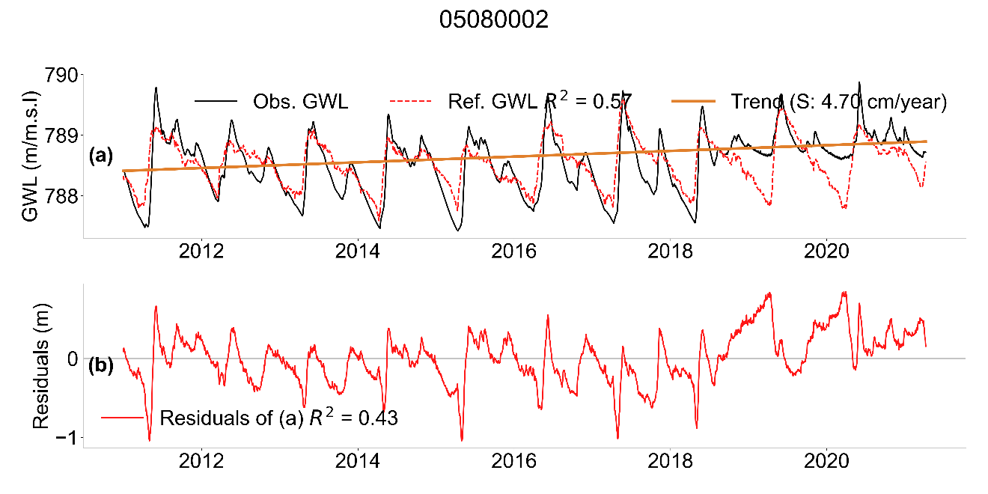

**Fig. 12** (a) Time series of GWL and reference hydrograph for well 05080002. (b) Time series of residuals. The correlation of the observed series with the reference hydrograph and with the residuals is given by R2. The trend line and slope of the trend are also shown.

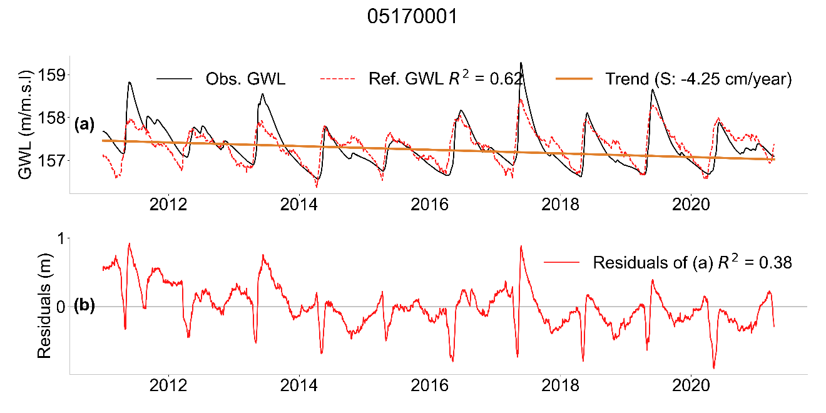

**Fig. 13** (a) Time series of GWL and reference hydrograph for well 05170001. (b) Time series of residuals. The correlation of the observed series with the reference hydrograph and with the residuals is given by R2. The trend line and slope of the trend are also shown.

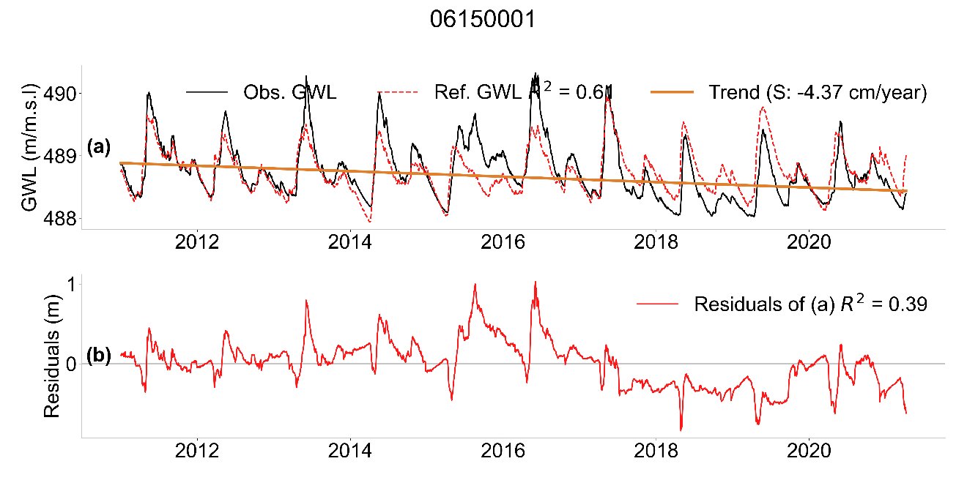

**Fig. 14** (a) Time series of GWL and reference hydrograph for well 06150001. (b) Time series of residuals. The correlation of the observed series with the reference hydrograph and with the residuals is given by R2. The trend line and slope of the trend are also shown.

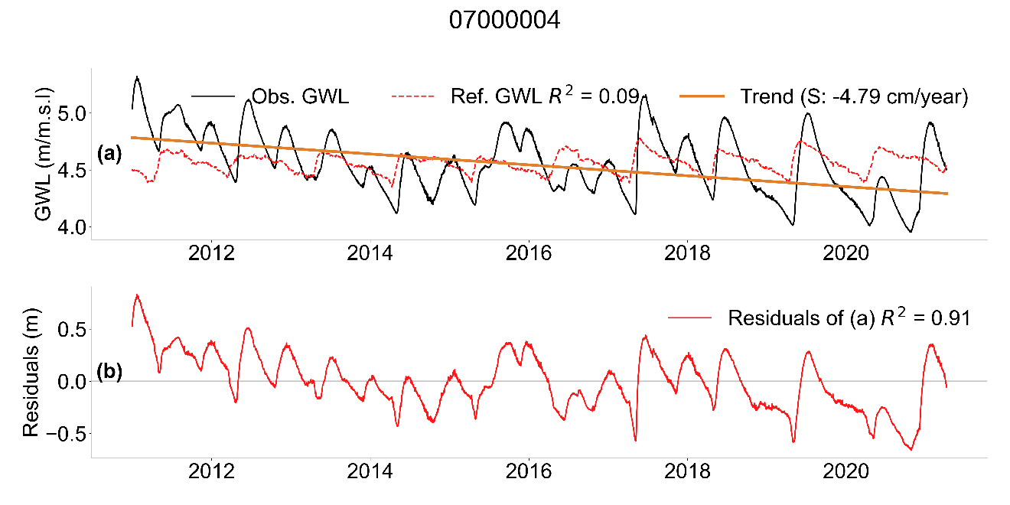

**Fig. 15** (a) Time series of GWL and reference hydrograph for well 07000004. (b) Time series of residuals. The correlation of the observed series with the reference hydrograph and with the residuals is given by R2. The trend line and slope of the trend are also shown.

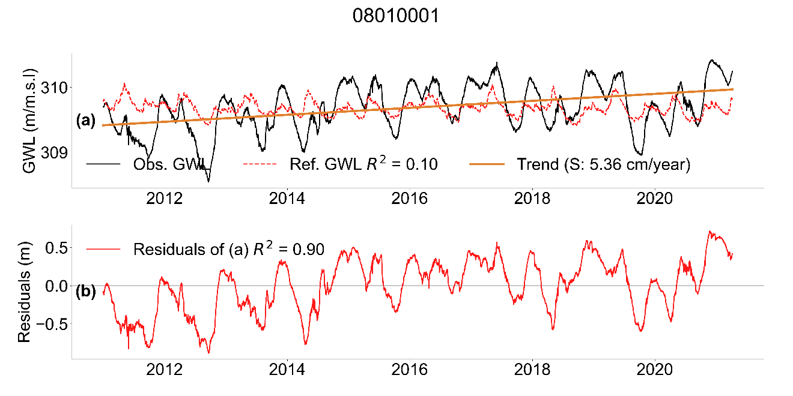

**Fig. 16** (a) Time series of GWL and reference hydrograph for well 08010001. (b) Time series of residuals. The correlation of the observed series with the reference hydrograph and with the residuals is given by R2. The trend line and slope of the trend are also shown.

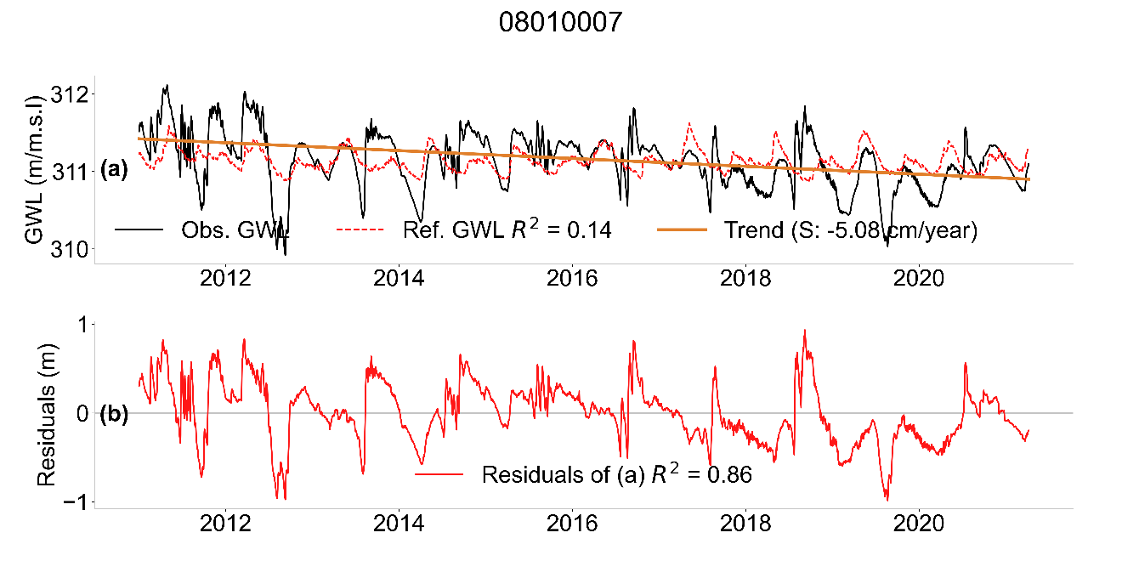

**Fig. 17** (a) Time series of GWL and reference hydrograph for well 08010007. (b) Time series of residuals. The correlation of the observed series with the reference hydrograph and with the residuals is given by R2. The trend line and slope of the trend are also shown.

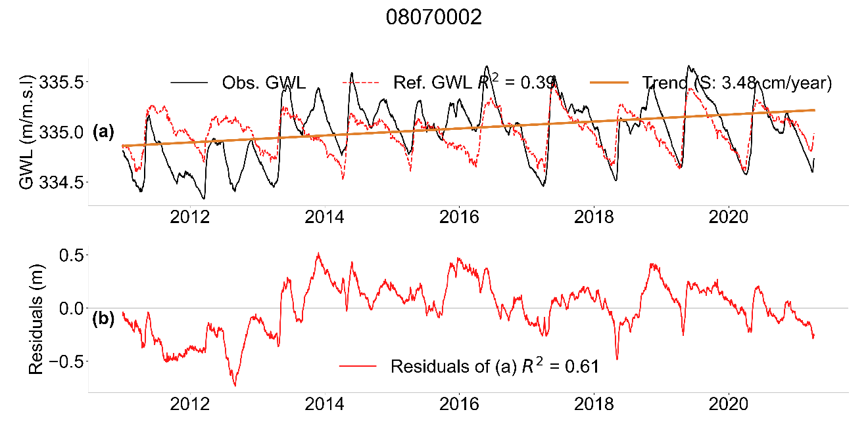

**Fig. 18** (a) Time series of GWL and reference hydrograph for well 08070002. (b) Time series of residuals. The correlation of the observed series with the reference hydrograph and with the residuals is given by R2. The trend line and slope of the trend are also shown.