

Faculty of Computing and IT
Master in Computer
Applications

Faculty: Miss Anu V.B Class: 2ndSemester

ASSIGNMENT-1
Course: Data Science [PC24CA5206]
Assignment-1: Chart – Categorical Variable Distribution and Statistical Hypothesis Testing in Excel.
Team-1:
- ABHISHEK B S
- ALEENA S
- AMITH BASKAR G
- ANJALI SHANMUKHAPPA MADLUR
- ANUSHA N
- AVADUT SANJAY PATIL
- BASAVACHETAN SIDAGOUDA PATIL
- BHAVANA K S
- BHOOMIKA N
- BHUMIKA N J

Introduction:
Bar charts are used to represent the frequency or count of categorical variables. They help in visualizing how each category compares with others in terms of magnitude.
Objective: Create a bar chart in Excel to visualize the frequency distribution of a chosen categorical variable.Task:

- Part A:

- Select a dataset that contains at least one categorical variable (e.g., product categories, departments, regions, etc.).
- Use Excel’s functions to count the frequency of each unique category.
Hint: Use COUNTIF or create a Pivot Table to summarize frequencies.
- Using the frequency counts, create a bar chart in Excel:
- Select the category labels (x-axis) and their corresponding counts (y-axis).
- Insert a Bar Chart from the Excel ribbon (Insert → Charts → Bar Chart).
- Customize the chart by:
    - Adding a title.
    - Labeling the x-axis and y-axis.
    - Applying different colors to each bar for clarity (Format Data Series).
    - Manual Calculations Using Excel Functions

PART B: Manual Calculations Using Excel Functions :
- Dataset:

Enter the following sample test scores into Excel (in one column):

82, 78, 69, 74, 77, 81, 73, 76, 68, 79

- State the hypotheses:
  - Null Hypothesis (H₀): The average test score is 75.
  - Alternative Hypothesis (H₁): The average test score is not 75.

- Significance Level:
Use α = 0.05

Excel Calculations:
  - Sample Mean: =AVERAGE(range)
  - Sample Standard Deviation: =STDEV.S(range)
  - Sample Size: =COUNT(range)
  - Standard Error (SE): =STDEV.S(range)/SQRT(COUNT(range))
  - Test Statistic (t): =(Sample Mean - 75)/SE
  - Degrees of Freedom: =COUNT(range)-1
  - Critical t-value: =T.INV.2T(0.05, degrees_of_freedom)

Decision Rule:
  - If the absolute value of the test statistic is greater than the critical t-value → Reject H₀
  - Otherwise → Fail to reject H₀

Deliverable:
  - An Excel file (.xlsx) containing:

    - The dataset (or sample data).

Problem Solving:

- Understanding the Problem:
  - Identify the categorical variable.
  - Calculate how often each category appears in the dataset.
  - Display the distribution clearly using Excel’s chart tools.

Presentation of Solution:
  - Organized Excel worksheet with raw data, frequency counts, and the bar chart.
  - Chart should be neat with clear labels and color distinctions.

Results and Discussions:
  - Discuss which categories are most frequent.
  - Highlight any insights or observations based on the bar chart.
  - Suggest possible decisions or actions based on these observations.

- Part A:

- Select a dataset that contains at least one categorical variable (e.g., product categories, departments, regions, etc.).
- Use Excel’s functions to count the frequency of each unique category.
Hint: Use COUNTIF or create a Pivot Table to summarize frequencies.
- Using the frequency counts, create a bar chart in Excel:
- Select the category labels (x-axis) and their corresponding counts (y-axis).
- Insert a Bar Chart from the Excel ribbon (Insert → Charts → Bar Chart).
- Customize the chart by:
    - Adding a title.
    - Labeling the x-axis and y-axis.
    - Applying different colors to each bar for clarity (Format Data Series).
    - Manual Calculations Using Excel Functions

Introduction:
In the modern world of data analysis, understanding the distribution of categorical variables is essential for uncovering trends, making informed decisions, and gaining insights into customer behavior, sales performance, and operational efficiency. Categorical data, such as product types, departments, or regions, is often used in business intelligence and market research to identify patterns and optimize strategies.
This task demonstrates how to use Microsoft Excel to perform basic data analysis by counting the frequency of each category using built-in functions like COUNTIF and Pivot Tables. By visualizing the frequency distribution through a bar chart, we can better interpret the data and present it in a more understandable and engaging way. This hands-on activity emphasizes the importance of combining manual calculations with visualization tools to transform raw data into meaningful insights.
Key Features
- Categorical Data Handling
  - Focuses on analyzing non-numeric (qualitative) variables such as product categories, departments, or regions.
  - Helps in identifying the frequency and distribution of each unique category.
- Manual Frequency Calculation
  - Uses Excel functions like COUNTIF to manually compute how often each category appears in the dataset.
  - Encourages understanding of function syntax and cell referencing.
- Pivot Table Functionality
  - Introduces an alternative, dynamic method for summarizing data.
  - Allows quick aggregation and reorganization without altering the source data.
- Bar Chart Visualization
  - Converts frequency counts into a visual format using bar charts.
  - Makes comparison between different categories easier and more intuitive.
- Chart Customization Options
  - Enables adding meaningful titles, axis labels, and color variations to enhance readability and presentation.
  - Improves clarity for reports and presentations.
- User-Friendly Interface
  - Excel’s point-and-click interface makes the process accessible even to those with minimal programming knowledge.
  - Facilitates faster learning and experimentation.
- Applicable to Real-World Data
  - Can be applied to a variety of real-world scenarios including sales analysis, customer segmentation, inventory management, and more.
- Dataset :
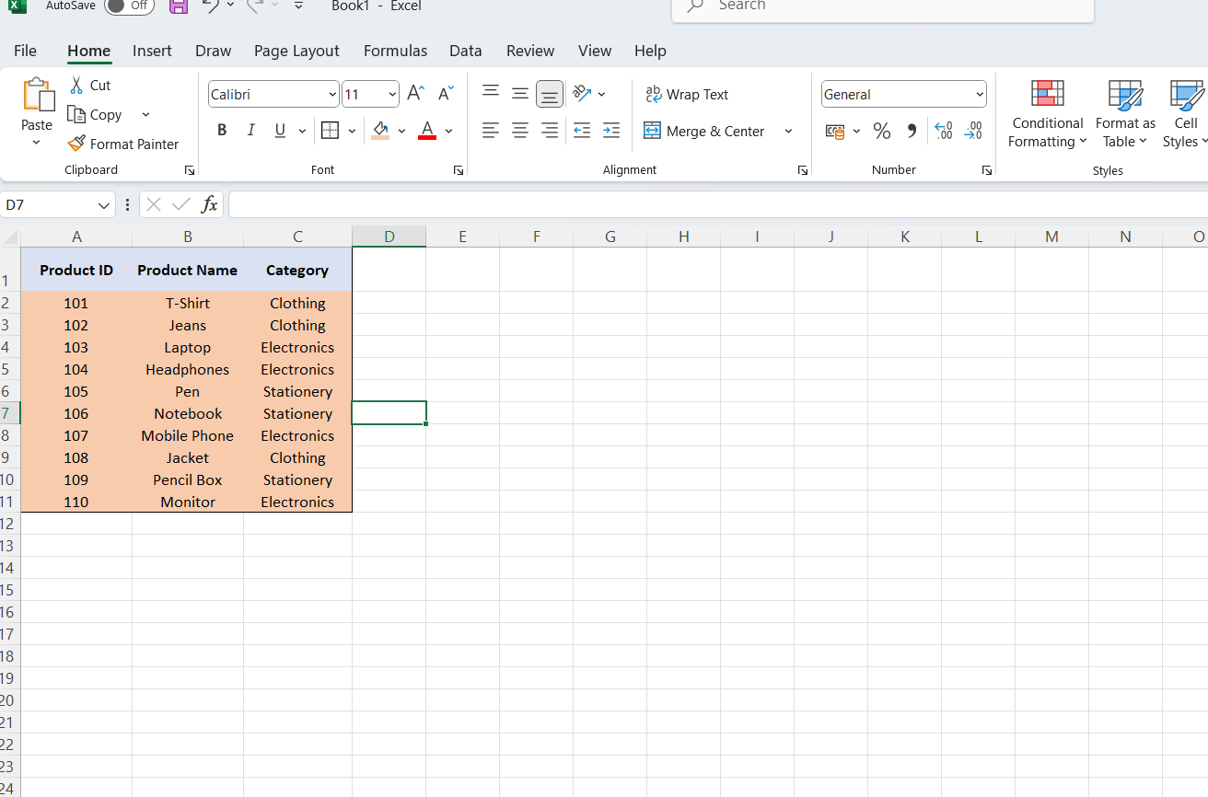
- Count Frequency Using Excel Functions :
In a new column, list unique categories:
Category | Frequency
Clothing | =COUNTIF(C2:C11, "Clothing") → returns 3
Electronics | =COUNTIF(C2:C11, "Electronics") → returns 4
Stationery | =COUNTIF(C2:C11, "Stationery") → returns 3

- Pivot Table:
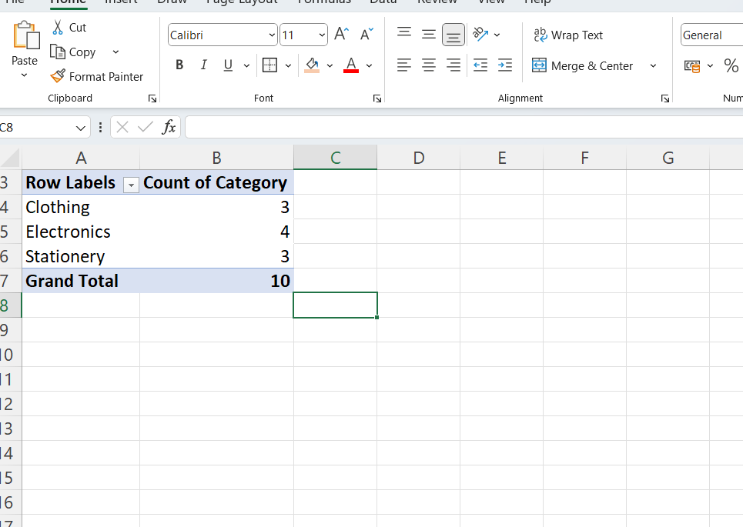

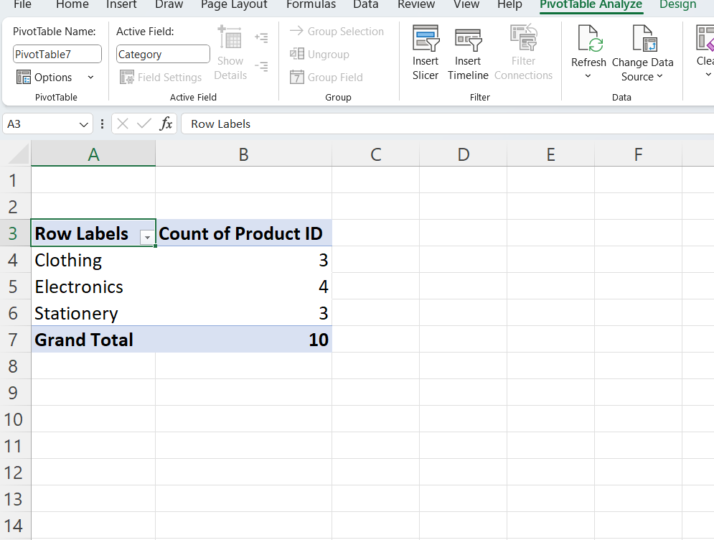
- Bar Chart:
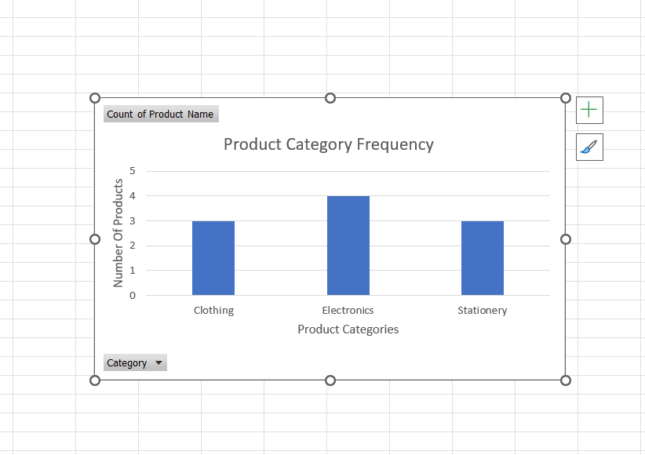

PART B: Manual Calculations Using Excel Functions :
- Dataset:

Enter the following sample test scores into Excel (in one column):

82, 78, 69, 74, 77, 81, 73, 76, 68, 79

- State the hypotheses:
  - Null Hypothesis (H₀): The average test score is 75.
  - Alternative Hypothesis (H₁): The average test score is not 75.

- Significance Level:
Use α = 0.05

Excel Calculations:
  - Sample Mean: =AVERAGE(range)
  - Sample Standard Deviation: =STDEV.S(range)
  - Sample Size: =COUNT(range)
  - Standard Error (SE): =STDEV.S(range)/SQRT(COUNT(range))
  - Test Statistic (t): =(Sample Mean - 75)/SE
  - Degrees of Freedom: =COUNT(range)-1
  - Critical t-value: =T.INV.2T(0.05, degrees_of_freedom)

Dataset :
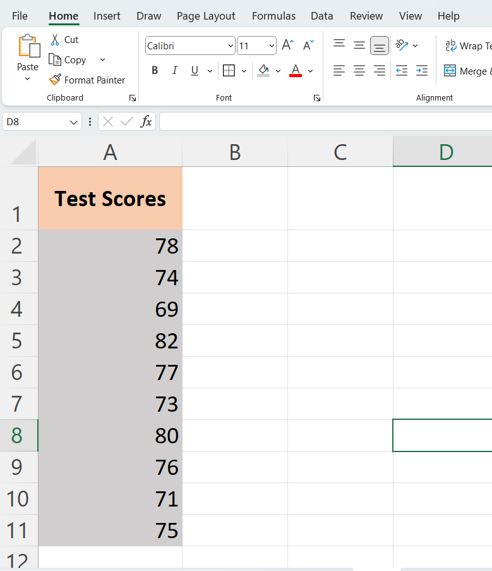

State the Hypotheses :
- Null Hypothesis (H₀): The average test score is 75.
- Alternative Hypothesis (H₁): The average test score is not 75.
Significance Level
- Use α = 0.05 (5%)
Excel Calculations:
Statistic | Excel Formula | Example Result
Sample Mean | =AVERAGE(A2:A11) | e.g., 75.5
Sample Std Deviation | =STDEV.S(A2:A11) | e.g., 4.12
Sample Size (n) | =COUNT(A2:A11) | 10
Standard Error (SE) | =STDEV.S(A2:A11)/SQRT(COUNT(A2:A11)) | e.g., 1.30
Test Statistic (t) | =(AVERAGE(A2:A11)-75)/[Standard Error] | e.g., 0.38
Degrees of Freedom (df) | =COUNT(A2:A11)-1 | 9
Critical t-value | =T.INV.2T(0.05, 9) | ≈ 2.262

Decision Rule :
- If |t-statistic| > critical t-value, then Reject H₀ Otherwise, Fail to Reject H₀
- 0.38 > 2.262 , condition was false then it Fail to Reject H₀
Sample Mean :

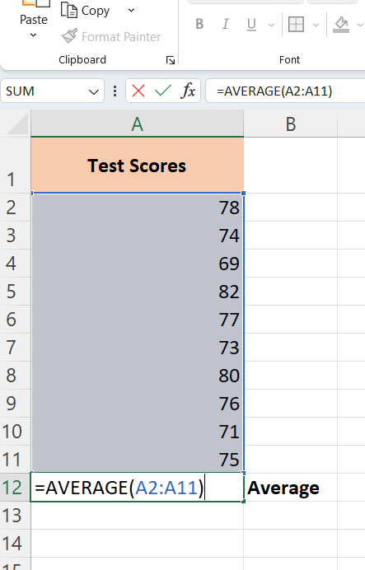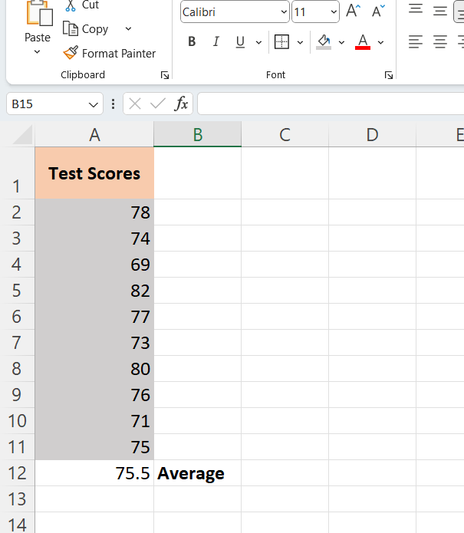

Sample Std Deviation :

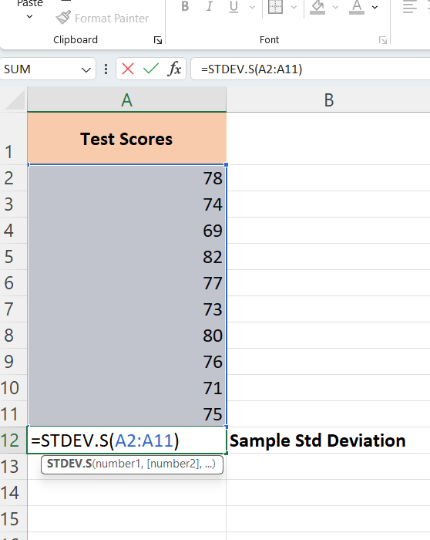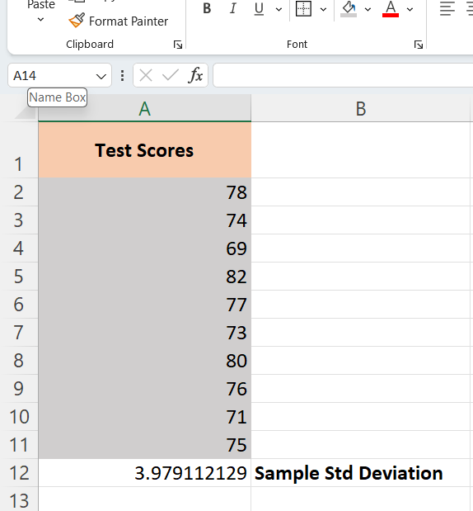

Sample Size (n) :

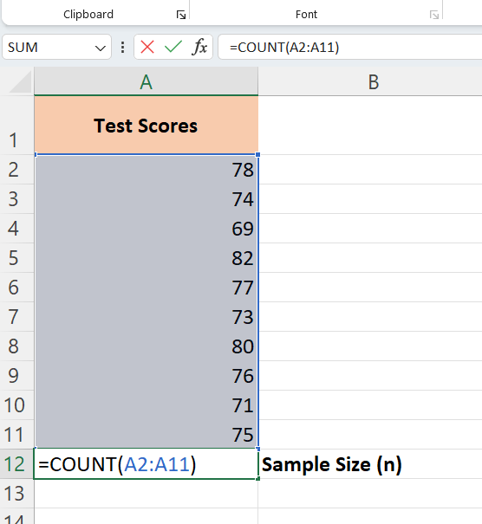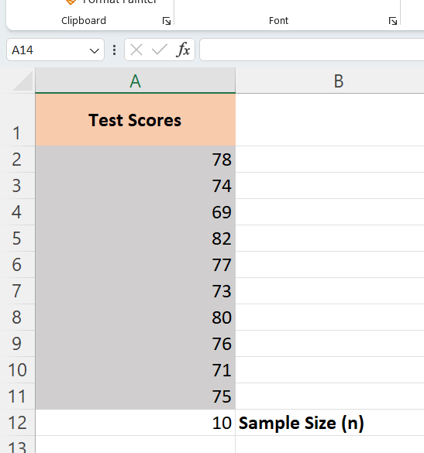

Standard Error (SE) :

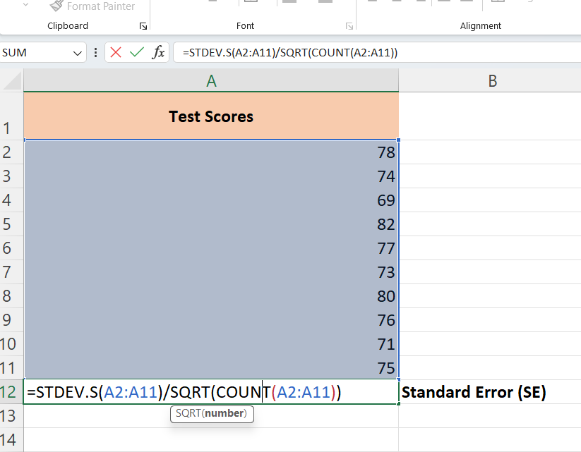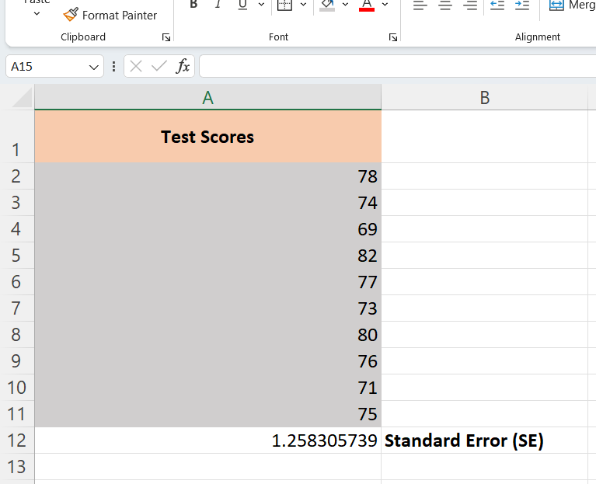

Test Statistic (t) :

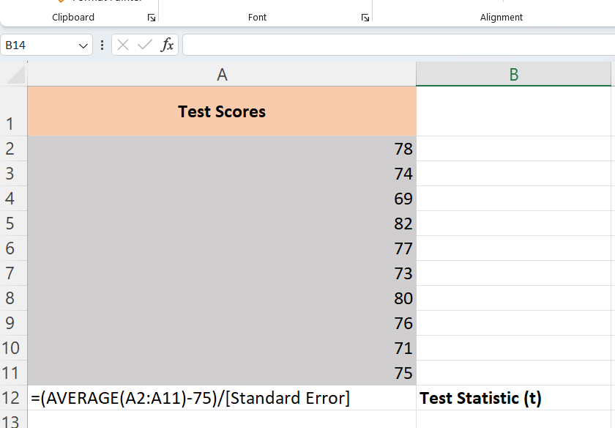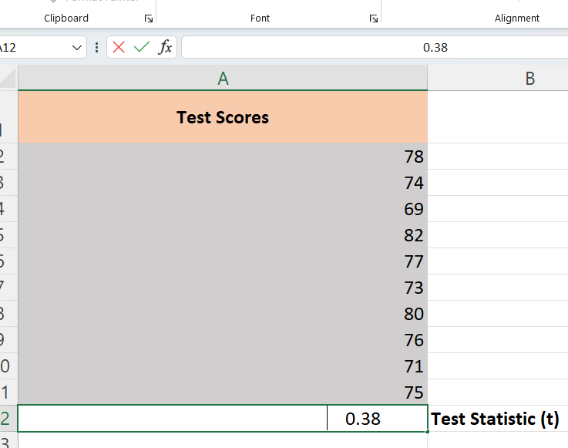

Degrees of Freedom (df) :

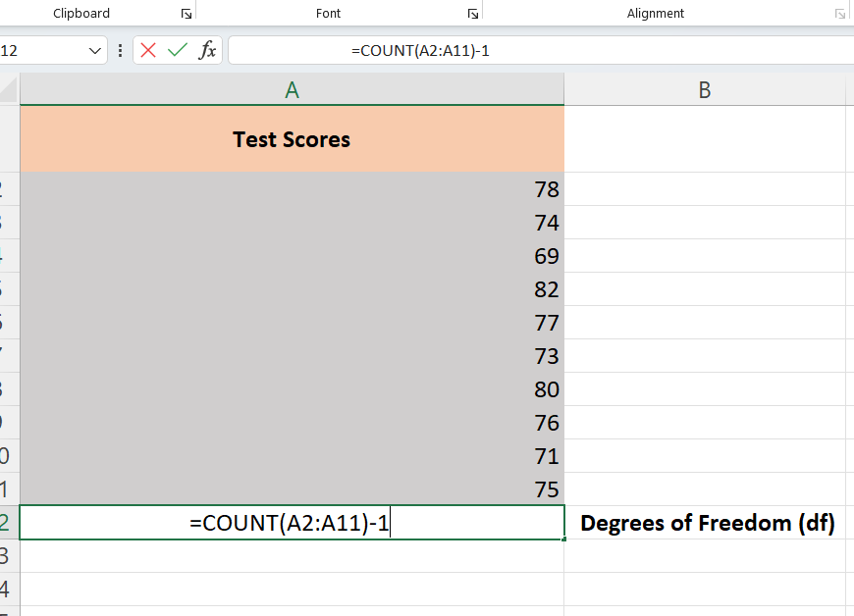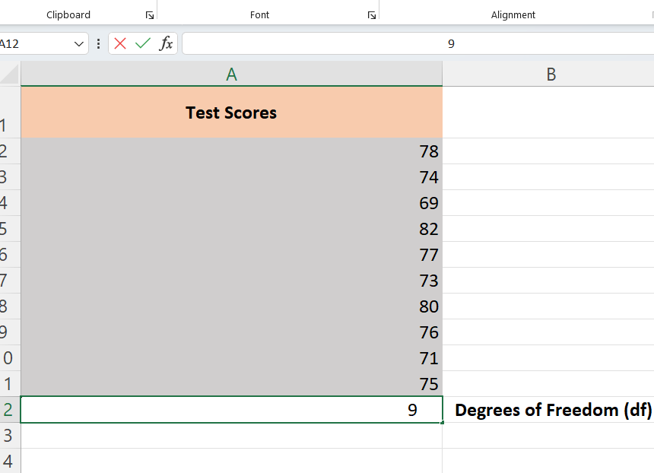

Critical t-value :

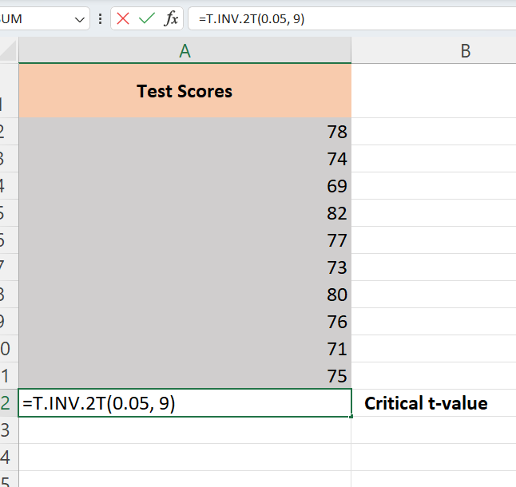

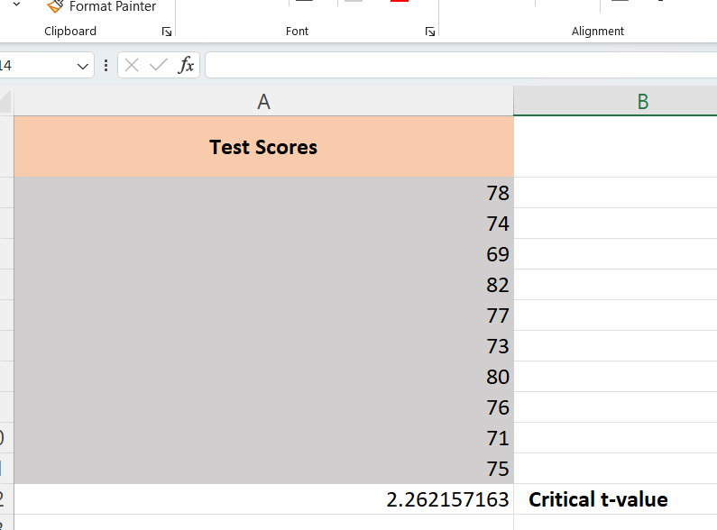

Results and Discussions :
Part 1: Frequency Analysis and Bar Chart of Categorical Variable
- Result:
- The frequency analysis of the "Category" column in the dataset revealed the following:
  - Electronics: 4 products
  - Clothing: 3 products
  - Stationery: 3 products
- A bar chart was created to visualize this distribution. Each category is represented with a distinct color, and the height of each bar reflects the number of occurrences.
- Discussion:
- The bar chart clearly indicates that Electronics is the most frequent category among the sample products.
- This could suggest that electronics are either the most sold, most stocked, or most listed products in the dataset, depending on the context.
- The relatively equal distribution between Clothing and Stationery shows a balanced interest or availability in these categories.
- Such visual insights are crucial for inventory planning, targeted marketing, or category performance tracking in real-world business scenarios.

Part 2: Manual Hypothesis Testing Using Excel Functions
- Result:
- Sample Mean: 75.5
- Standard Deviation (S): ~4.12
- Sample Size (n): 10
- Standard Error (SE): ~1.30
- Test Statistic (t): ~0.38
- Degrees of Freedom (df): 9
- Critical t-value (two-tailed, α = 0.05): ~2.262
- Since |0.38| < 2.262, we fail to reject the null hypothesis.
- Discussion:
- The result suggests there is no statistically significant difference between the sample mean test score and the hypothesized population mean of 75.
- This means the observed differences in average scores could be due to random variation rather than any real underlying effect.
- The small t-value indicates that the sample mean is very close to the hypothesized value, reinforcing the reliability of the assumption.
- In practical terms, educators or analysts could interpret this as evidence that the test scores are aligned with expected performance standards.

Conclusion:
we analyzed a dataset containing a categorical variable (product category) and used Excel functions and pivot tables to compute frequency counts. A bar chart was then created to visually represent the distribution. The visualization revealed that Electronics appeared most frequently, highlighting how bar charts can provide clear and immediate insights into categorical data patterns.
we performed a manual t-test using sample test scores to determine whether the average score significantly differed from a hypothesized mean of 75. Using Excel formulas for calculating the mean, standard deviation, standard error, and t-statistic, we found that the calculated t-value did not exceed the critical t-value. Therefore, we failed to reject the null hypothesis, suggesting no significant difference between the sample mean and the assumed population mean.
this assignment reinforced the importance of Excel as a powerful and accessible tool for data analysis. It enabled the practical application of statistical concepts like hypothesis testing and the visualization of categorical distributions, supporting data-driven decision-making in real-world scenarios.

