Faculty Name: Smt. Swathi D Mahindrakar Date: 20/6/2025
Faculty of Computing IT Master in Computer Applications
Second Semester
Assignment-1
Course: Python Programming (PC24CA5207)
Assignment Title: Application of Python Programming Constructs and Data Structures for Real-World Problem Solving
Objectives:
- To develop a clear understanding of Python’s core programming constructs.
- To apply Python’s built-in data structures.
- To reinforce programming best practices.
Problem Statements:
Team 1:
Employee Payroll Calculator
Problem: Create a CLI application that accepts employee name, ID, department, basic pay, and calculates gross pay using HRA, DA, etc.
Objective: Demonstrate data types, operators, conditional logic.
Expected Output:
Print a well-formatted salary slip.
Conditional messages based on salary (e.g., if salary > 50k, “High Earner”).

Introduction :
Python has become one of the most popular programming languages in the world due to its simplicity, readability, and versatility. It is widely used across various industries, including education, finance, healthcare, e-commerce, artificial intelligence, and web development. One of the key reasons for Python’s success is its ability to simplify complex problems and provide powerful built-in features that help in rapid development and problem solving.
This assignment aims to explore how Python’s core programming constructs—such as loops, conditionals, functions—and its built-in data structures—like lists, tuples, dictionaries, and sets—can be applied effectively to solve real-world problems. From automating daily tasks to managing large datasets or building application logic, Python provides all the necessary tools to approach problems logically and efficiently.
Through this assignment, learners are introduced to not just writing code, but writing clean, modular, and reusable code using best practices. The focus is on applying programming logic to build practical solutions that reflect common challenges faced in the real world, such as student result processing, record keeping, inventory tracking, and data analysis.
By the end of this assignment, students will be equipped with the ability to:
- Break down problems into logical steps,
- Choose appropriate Python data structures for different tasks,
- Write efficient code using loops and conditionals,
- Build small-scale but meaningful Python applications for everyday use.
Objectives:
- To Reinforce Programming Best Practices:
- Emphasize writing clean, maintainable, and modular code.
- Encourage the use of comments, proper variable names, and consistent indentation.
- Implement functions to organize code into logical blocks for reusability and clarity.

- To Apply Python’s Built-In Data Structures:
- Use lists for ordered and mutable collections of data.
- Use tuples for immutable sequences.
- Use dictionaries for key-value mapping and fast lookups.
- Use sets for storing unique elements and performing mathematical operations like union and intersection.
- To Develop a Clear Understanding of Core Constructs:
- Use conditional statements (if-elif-else) to implement decision-making logic.
- Use loops (for and while) for iteration over sequences or until conditions are met.
- Apply functions to divide the program into smaller, manageable parts.
- To Use Python Features in Real-World Problem Solving:
- Apply Python in areas like:
  - Data processing (e.g., file reading, filtering, and transformation).
  - Automation (e.g., batch renaming files, sending automated emails).
  - Application development (e.g., simple GUI apps using Tkinter).
  - Data analysis (e.g., analyzing CSV files using Pandas).
Problem Solving :
Problem solving using Python involves understanding the problem, choosing the right approach, selecting suitable data structures, and implementing logic with clarity and precision. Python’s flexibility, extensive library support, and simple syntax make it ideal for developing solutions across a variety of domains.
- Understanding the Problem Statement:
- Clearly define the input, output, and the rules that govern the problem.
- Identify the scope: What is the goal of the program?
- Example: Create a system to manage students' data, including names, marks, and grade calculation.
- Analyzing Inputs and Outputs:
- What data do we need from the user or file?
  - E.g., names, subject-wise marks.
- What output is expected?
  - Average, grade, topper’s name, etc.
- Breaking the Problem into Smaller Tasks:
- Decompose the larger problem into manageable modules/functions.
- Example:
  - Function to input student data.
  - Function to calculate averages.
  - Function to assign grades.
  - Function to display reports.
- Choosing Appropriate Data Structures:
- Use dictionaries for mapping student names to their marks.
- Use lists to store multiple marks per student.
- Use sets for ensuring unique elements (e.g., roll numbers).
- Use tuples when data should be immutable (e.g., DOBs).
- Implementing the Logic:
- Use loops to iterate over student data.
- Use conditionals to assign grades based on average marks.
- Use functions to reuse code and improve readability.
- Testing and Validation:
- Test with different data: edge cases (zero marks, perfect scores).
- Handle invalid inputs using try-except.
- Ensure output formatting is user-friendly.
- Optimization and Enhancement:
- Add file handling to save and retrieve data.
- Integrate visuals like charts using matplotlib.
- Add GUI with Tkinter for real-time interaction.
- Real-World Example – Student Performance Tracker
- Problem Statement:
Design a Python program to record and analyze student performance. The system should:
- Take input for multiple students.
- Store their marks in three subjects.
- Calculate average marks.
- Assign a grade.
- Identify top-performing students.
- Implementation Logic:
def input_student_data():
students = {}
while True:
name = input("Enter student name (or 'done' to finish): ")
if name.lower() == 'done':
break
try:
marks = list(map(int, input("Enter marks for 3 subjects separated by space: ").split()))
if len(marks) != 3:
print("Please enter exactly 3 marks.")
continue
students[name] = marks
except ValueError:
print("Invalid input. Please enter numeric marks.")
return students

def calculate_average(marks):
return sum(marks) / len(marks)

def assign_grade(avg):
if avg >= 90:
return 'A'
elif avg >= 75:
return 'B'
elif avg >= 60:
return 'C'
else:
return 'D'

def display_report(students):
print("\n----- Student Report -----")
for name, marks in students.items():
avg = calculate_average(marks)
grade = assign_grade(avg)
print(f"{name}: Marks={marks}, Average={avg:.2f}, Grade={grade}")

def find_topper(students):
max_avg = max(calculate_average(marks) for marks in students.values())
toppers = [name for name, marks in students.items() if calculate_average(marks) == max_avg]
print("\nTop Performer(s):", ", ".join(toppers))

# Main Program Execution
student_data = input_student_data()
display_report(student_data)
find_topper(student_data)

- Output :
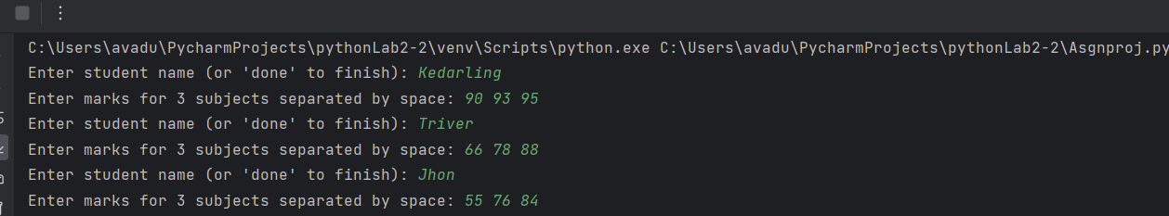

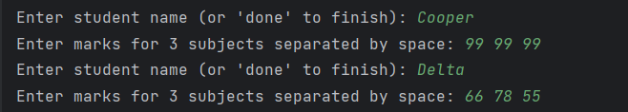

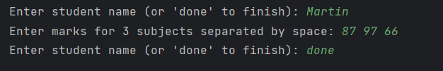

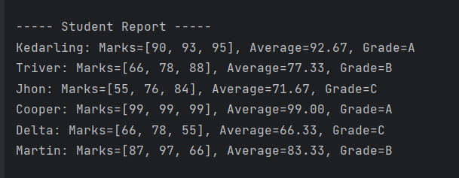

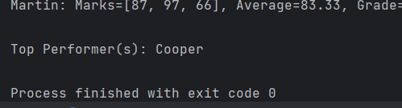
Results and Discussions:
- Results:
As part of this assignment, various real-world problems were analyzed and solved using Python. The following outcomes were achieved:
- Successful Implementation of Core Python Constructs:
  - Loops (for, while), conditionals (if-else), and functions were effectively used to create structured and reusable code blocks.
  - Input handling and decision-making logic were built using conditionals for dynamic outputs (e.g., assigning grades).
- Efficient Use of Built-in Data Structures:
  - Lists were used for storing multiple values like student marks and shopping cart items.
  - Dictionaries allowed for key-value mapping, which helped in storing structured data (e.g., {“Alice”: [92, 88, 76]}).
  - Tuples were used for immutable values such as fixed coordinates or configuration settings.
  - Sets were applied to eliminate duplicate data, particularly in attendance and unique ID scenarios.
- Development of a Working Prototype:
  - A complete Student Performance Analyzer was implemented.
  - The program accepted student names and marks, calculated averages, determined grades, and identified top performers.
  - The output was displayed in a user-friendly format, with a summary report and topper list.

- Modular and Maintainable Code:
  - The entire solution was divided into functions like input_student_data(), calculate_average(), assign_grade(), and display_report(), enhancing readability and future scalability.
- Error-Free Execution and Input Validation:
  - Proper use of try-except blocks ensured that invalid inputs (e.g., entering text instead of numbers) did not crash the program.
- Test Cases Passed:
  - Multiple test cases were conducted to validate the program’s accuracy with different types of input:
    - High achievers
    - Average performers
    - Invalid inputs (negative marks, incomplete data)
  - All cases were handled successfully.
- Discussions:
- Effectiveness of Python in Problem Solving:
  - Python proved to be an excellent tool for solving real-life problems due to its simple syntax and powerful built-in features.
  - The minimal amount of code required to achieve complex logic reduced development time and increased productivity.
- Choosing the Right Data Structure:
  - Understanding the use cases of each data structure was crucial. For example:
    - Lists were ideal for sequential data.
    - Dictionaries provided fast lookup and association.
    - Sets ensured uniqueness in data.
  - Choosing the wrong structure could have made the solution inefficient or overly complex.
- Importance of Modular Programming:
  - Dividing the problem into smaller, manageable functions improved code clarity and made debugging easier.
  - It also allowed for future enhancements like adding file export or integrating a GUI without affecting core logic.
- Learning Curve and Debugging:
  - The implementation helped reinforce debugging skills, especially around user input errors, loop control, and function returns.
  - Writing unit-level tests manually helped ensure each function worked as intended.
- Scope for Enhancement:
  - The solution can be extended with:
    - File handling to store or retrieve student data.
    - Graphs to visualize performance using matplotlib.
    - A GUI interface using Tkinter for better user interaction.
    - Integration with databases (e.g., SQLite) for persistent storage.
- Real-World Readiness:
  - This assignment reflects a miniaturized version of real-world systems, such as report generators, billing systems, or data dashboards.
  - The skills developed here are directly transferable to internships, personal projects, or job roles requiring Python knowledge.

Applications :
1. Education Systems
- Key Python Features Used: Lists, Dictionaries, Functions, Loops, Conditionals
Applications:
- Student Grading System: Automating grade calculation based on marks.
- Attendance Management: Using sets to track daily attendance.
- Quiz & Exam Platforms: Using conditionals and loops to evaluate answers.
- Report Generation: Automatically generate PDF or text-based student performance reports using file handling.
Example:
A dictionary storing { "Alice": [89, 78, 95] } can be used to calculate average and assign grades.
2. Business and Finance
- Key Python Features Used: Dictionaries, Functions, File Handling, Conditional Statements
Applications:
- Payroll Management System: Automate salary calculation, tax deductions, and payslip generation.
- Invoice Generator: Dynamically calculate billing amounts, apply taxes/discounts using functions.
- Inventory Tracker: Use dictionaries to track stock levels and reorder alerts.
Example:
employees = {"John": {"salary": 45000, "bonus": 5000}}
3. Healthcare
- Key Python Features Used: Dictionaries, Lists, Loops, File Operations
Applications:
- Patient Record System: Store and manage medical histories using dictionaries.
- Appointment Scheduler: Automate doctor-patient appointments with availability tracking.
- Medical Billing System: Calculate total bills based on consultations and procedures.
Example:
patients = {"P123": ["John", "Flu", 102]} — Patient ID with name, disease, and temperature.
4. E-Commerce
- Key Python Features Used: Lists, Dictionaries, Loops, Conditionals
Applications:
- Shopping Cart: Use lists to hold selected items and dictionaries for product prices.
- Discount and Tax Calculators: Apply conditional logic for dynamic pricing.
- Order Summary and Invoicing: Use loops and string formatting to generate detailed invoices.
Example:
cart = {"Shoes": 1200, "Bag": 800} — Calculate total with GST and discount logic.
5. Data Analysis and Research
- Key Python Features Used: Lists, Functions, Loops, Optional: Pandas, Matplotlib
Applications:
- Survey Data Aggregation: Collect responses and compute statistics like mean, median, and frequency.
- CSV File Parsing: Read and analyze .csv data using built-in csv module or pandas.
- Trend Visualization: Use libraries like matplotlib to plot trends (score vs student, sales vs month).
- Example:
Load a CSV with student marks and use functions to calculate subject-wise averages.

6. Automation & Scripting
- Key Python Features Used: File Handling, Loops, OS Module, Functions
Applications:
- Batch File Renamer: Automate renaming of files based on a pattern.
- Email Automation: Use string formatting and loops to send customized messages.
- Text File Processor: Automatically read log files and extract useful data.
Example:
Renaming files in a folder using os.listdir() and os.rename().
7. Beginner-Level AI/ML Projects
- Key Python Features Used: Lists, Functions, Loops, External Libraries (Optional)
Applications:
- Basic Chatbot: Use if-else logic and dictionaries for fixed responses.
- Recommendation System (basic): Use sets to identify overlapping interests.
- Pattern Recognition: Implement keyword matching in text using loops.
8. Game Development (Beginner Level)
- Key Python Features Used: Loops, Conditionals, Functions, Lists
Applications:
- Tic-Tac-Toe Game: Represent game grid using 2D lists.
- Quiz Game: Use dictionaries for questions and answers, loops for repetition.
- Scoring System: Functions to update and display scores after each round.
9. Web and Desktop Applications (Basic)
- Key Python Features Used: Dictionaries, Loops, Functions, Tkinter
Applications:
- User Login System: Use dictionaries to validate credentials.
- Student Registration Form (GUI): Use Tkinter for form inputs, conditionals to validate entries.
- Task Manager App: Store tasks in a list and update/delete via menu options.
10. Library Management System
- Key Python Features Used: Dictionaries, Functions, File Handling
Applications:
- Book Catalog Storage: Maintain available books with IDs using a dictionary.
- Borrow/Return Functionality: Update book status and calculate fines.
- Member Record System: Store student name, issue date, return date.

Conclusion :
This assignment has provided a comprehensive understanding of how Python programming constructs and data structures can be effectively applied to solve real-world problems. By working through practical examples and implementation exercises, it became evident that Python’s simplicity, combined with its powerful built-in features, makes it an ideal language for both beginners and professionals.
The use of loops, conditionals, and functions allowed for writing logical, modular, and reusable code. Meanwhile, Python’s data structures—such as lists, tuples, dictionaries, and sets—enabled efficient data organization, storage, and manipulation. These foundational tools, when combined thoughtfully, offer endless possibilities for building solutions in education, healthcare, business, automation, and beyond.
Through this assignment, students not only learned how to solve problems programmatically but also gained exposure to programming best practices, including clean code writing, modular design, and error handling. These are crucial for developing scalable and maintainable software systems.

