SVM – Classification – Confusion Report

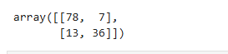

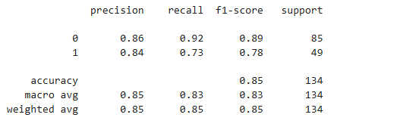
1. What are total number of customer : 134
2. How many customers did not purchase = 85 ( support 0)
3. How many customers actually purchased = 49 (support 1)
4. Out of all customer what is percentage of customer who purchased = 73 (Recall 1)
6. Out of all customer what is percentage of customer who not purchased = 92 (Recall 0)
5. Percentage of prediction that customer will buy = 84 (Precision 1)
7. Percentage of prediction that customer will not buy = 84 (Precision 0)
9. Over all accuracy of the model: 85 (Accuracy)

Decision Tree Clasificatoin-Confusion Report

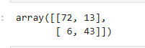

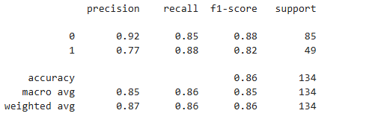

1. What are total number of customer : 134
2. How many customers did not purchase = 85 ( support 0)
3. How many customers actually purchased = 49 (support 1)
4. Out of all customer what is percentage of customer who purchased = 88 (Recall 1)
6. Out of all customer what is percentage of customer who not purchased = 88 (Recall 0)
5. Percentage of prediction that customer will buy = 77 (Precision 1)
7. Percentage of prediction that customer will not buy = 92 (Precision 0)
9. Over all accuracy of the model: 86 (Accuracy)

Random Forest Classification – Confusion Report

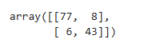

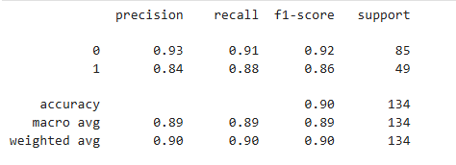
1. What are total number of customer : 134
2. How many customers did not purchase = 85 ( support 0)
3. How many customers actually purchased = 49 (support 1)
4. Out of all customer what is percentage of customer who purchased = 88 (Recall 1)
6. Out of all customer what is percentage of customer who not purchased = 88 (Recall 0)
5. Percentage of prediction that customer will buy = 77 (Precision 1)
7. Percentage of prediction that customer will not buy = 92 (Precision 0)
9. Over all accuracy of the model: 86 (Accuracy)

