1. PROBLEM STATEMENT:
Predict the Chronic Kidney Disease (CKD)

2. 3-STAGES:
- Machine Learning
- Supervised Learning
- Classification

3. ALGORITHMS:
3.1. SUPPORT VECTOR MACHINE:
Parameters:
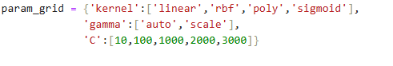
Confusion Matrix, Confusion Report and ROC_AUC score
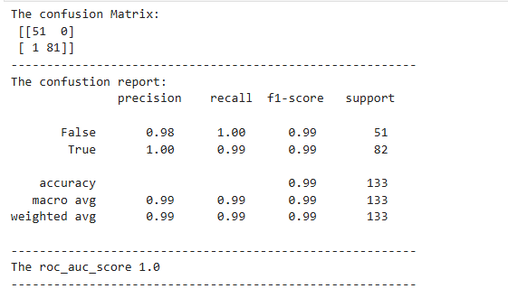

The SVM classification {'C': 10, 'gamma': 'auto', 'kernel': 'sigmoid'}

3.2. DECISION TREE:
Parameters:
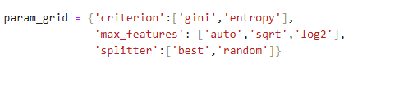
Confusion Matrix, Confusion Report and ROC_AUC score
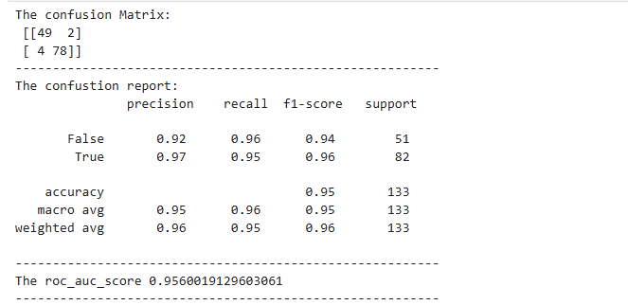
The Decision Tree Classification {'criterion': 'gini', 'max_features': 'log2', 'splitter': 'best'}

3.4. RANDOM FOREST:
Parameters:
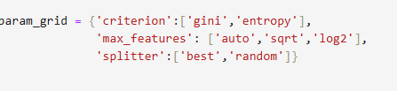
Confusion Matrix, Confusion Report and ROC_AUC score
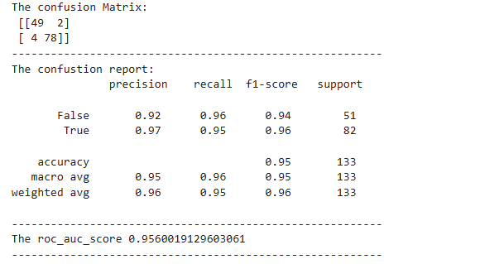
The Decision Tree classification 'criterion': 'gini', 'max_features': 'log2', 'n_estimators': 100

