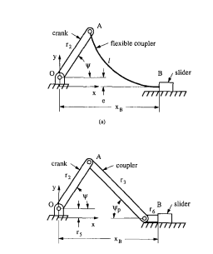

Plot the slides displacement, $x_{B}$, and the required crank input torque, $T_{in}$ with the crank input angle $α$
Flexible Segment Length $L$ | 5
Crank Length $r_{2}$ | 3
Offset $e$ | 5

Assumptions:
- The slider always remains in contact with the ground
- No frictional resistance to slider motion
- Flexible segment is initially straight
- Slider does not support horizontal force, so the force on the end of the flexible coupler is vertical ($n=0$).

Derivation

For the compliant beam, the coordinates of the tip are approximated as:
$$x=l\left[1-γ\left(1-\cos{Θ}\right)\right]$$
$$y=γl\sin{Θ}$$
For a transverse end force, $γ≈0.85.$

Coupler length $r_{3}=γl$
Fixed Link Offset $r_{5}=\left(1-γ\right)l$
The PRB model is a standard four-bar slider-crank mechanism. We define the position of the slider $x_{B}$ by summing the horizontal components of the vector loop:
$$x_{B}=r_{2}\cos\left(ϕ\right)+r_{3}\cos\left(ϕ_{p}\right)+r_{5}$$
Where $r_{2}$ is the crank length, $ϕ$ is the input crank angle, and $ϕ_{p}$ is the pseudo-rigid body angle (the angle of the rigid coupler $r_{3}$).
The vertical constraint, assuming the slider moves along the x-axis with an offset $e$, is:
$$r_{2}\sin\left(ϕ\right)-r_{3}\sin\left(ϕ_{p}\right)=c$$
Where $c$ is the vertical distance from the origin to the slider path.
The compliance of the flexible couples is simulated by a torsional spring placed at the virtual pivot (point A). The spring constant $K$ is derived from the beam’s material and geometric properties:
$$K=γK_{Θ}\frac{EI}{l}$$
Where $E$ is Young’s modulus, $I$ is the moment of inertia, and $K_{Θ}$ is the stiffness coefficient (standard value for this loading is $≈2.25$).

