HAND-HYGIENE COMPLIANCE TIMER WITH DROPOUT TOLERANCE AND WASH LOGGING
Project Work for Integrated Skill Enhancement-1
Submitted in partial fulfilment of the requirements for the award of the degree of
BACHELOR OF TECHNOLOGY
IN
ELECTRONICS AND COMMUNICATION ENGINEERING
By
Student Name | Roll Number
Srujana | 24EG104E33

Department of Electronics and Communication Engineering
ANURAG UNIVERSITY SCHOOL OF ENGINEERING
Venkatapur (V), Ghatkesar (M), Medchal-Malkajgiri Dist-500088
2026-2027

ANURAG UNIVERSITY SCHOOL OF ENGINEERING
Venkatapur (V), Ghatkesar (M), Medchal-Malkajgiri Dist-500088
DEPARTMENT OF ELECTRONICS AND COMMUNICATION ENGINEERING

CERTIFICATE
This is to certify that the project report entitled “Hand-Hygiene Compliance Timer with Dropout Tolerance and Wash Logging” being submitted by
Srujana 24EG104E33
in partial fulfilment for the award of the Degree of Bachelor of Technology in Electronics & Communication Engineering to the Anurag University, Hyderabad, is a record of bonafide work carried out by the above student in the Department of Electronics and Communication Engineering. The results embodied in this project report have not been submitted to any other University or Institute for the award of any Degree or Diploma.

Dr. Harikrishna Kamatham
Professor, HOD
ECE & ECM
External Examiner

DECLARATION
I hereby declare that the project report entitled “Hand-Hygiene Compliance Timer with Dropout Tolerance and Wash Logging”, submitted in partial fulfilment of the requirements for the award of the degree of Bachelor of Technology in Electronics and Communication Engineering at Anurag University School of Engineering, is a record of original work carried out by me.
The work has not been submitted to any other university or institute for the award of any degree or diploma. Where I used an AI assistant to help with code skeletons and explanations, I reviewed, linted, simulated and understood every module, and the results reported here come from tools that I ran myself.

Srujana 24EG104E33
Date: 24/10/2026
Place: Hyderabad

ACKNOWLEDGEMENTS
I am grateful to Dr. Harikrishna Kamatham, Head of the Department of Electronics and Communication Engineering, for providing the facilities and encouragement I needed, and to all the faculty members of the department for what they have taught me over the years.
I also thank the open-source community behind Icarus Verilog, Verilator, Yosys, OpenROAD, OpenLane, KLayout and the SkyWater SKY130 PDK. Without these free tools, taking a design all the way to a GDS layout would not have been possible for a student.
Finally, I thank my family and friends for their support and for putting up with me while I waited for simulations and place-and-route runs to finish.

ABSTRACT
Incomplete hand washing is one of the cheapest infection risks to fix and one of the hardest to notice. People cut washes short, nobody is watching, and manual audits catch only a small share of what happens at the sink. This project designs a small digital chip that sits at a sink or sanitiser station and times every wash. The chip reads one hand-presence sensor signal, cleans it with a two-flip-flop synchronizer and a debounce counter, and runs a six-state finite state machine that starts a wash, counts seconds, shows progress in thirds, tolerates short dropouts through a grace period, and decides whether the wash was long enough. It offers three selectable durations (20, 30 and 40 seconds), raises a done or too-short indication with a buzzer signal, and keeps two eight-bit saturating counters of good and bad washes for auditing.
The design is written in synthesizable Verilog and verified with a self-checking testbench in which all 16 checks pass. Yosys reports 457 generic cells, 65 flip-flops and no latches. Using the open-source OpenLane flow on the SkyWater 130 nm process, the design was taken to a final GDS layout of about 104 µm × 115 µm. Static timing analysis at nine corners (three PVT conditions with three parasitic extremes each) shows positive setup and hold slack everywhere at a 20 ns clock, with a worst setup slack of 6.346 ns and a worst hold slack of 0.105 ns. DRC, LVS and antenna checks are clean. The work shows the complete path from a real-world problem to a verified, signed-off layout.
Keywords: hand hygiene, finite state machine, RTL to GDS, SKY130, OpenLane, multi-corner static timing analysis.

TABLE OF CONTENTS
CHAPTER 1: INTRODUCTION 1
1.1 Introduction 1
1.2 Problem Statement 1
1.3 Objectives 2
1.4 Literature Survey 2
1.5 Organisation of the Report 3
CHAPTER 2: METHODOLOGY 4
2.1 System Overview 4
2.2 Software and Hardware Requirements 4
2.3 Design Specification 5
2.4 Block Diagram 6
2.5 Module Description 7
2.6 FSM and Flowchart 8
2.7 Design Decisions 9
2.8 Verification Methodology 9
2.9 RTL-to-GDS Implementation Flow 10
2.10 Use of AI Assistance 10
CHAPTER 3: RESULTS AND DISCUSSION 12
3.1 Functional Simulation Results 12
3.2 Synthesis Results 13
3.3 Physical Design Results 13
3.4 Multi-Corner Static Timing Analysis 15
3.5 Sign-off Checks 16
3.6 Discussion 16
3.7 Cost Analysis 17
3.8 Usefulness to Society 17
3.9 Environmental Safety 17
CHAPTER 4: CONCLUSION AND FUTURE SCOPE 18
4.1 Conclusion 18
4.2 Future Scope 18
REFERENCES 19
APPENDIX A: wash_fsm.v (RTL listing) 21
APPENDIX B: OpenLane configuration and SDC 23
APPENDIX C: Commands to reproduce the results 22

LIST OF FIGURES
Figure 2.1: Block diagram of the hand-hygiene compliance timer 6
Figure 2.2: State diagram of the wash FSM 8
Figure 2.3: RTL-to-GDS design flow 10
Figure 3.1: Simulated waveform of a compliant wash 13
Figure 3.2: Final GDS layout of the design (full die) 14
Figure 3.3: Zoomed view of the layout showing cell rows and routing 15

LIST OF TABLES
Table 2.1: Software tools used in the project 4
Table 2.2: Off-chip components the chip is designed to work with 5
Table 2.3: Design parameters 5
Table 2.4: Port description 6
Table 2.5: FSM state table 8
Table 2.6: OpenLane configuration and timing constraints 10
Table 3.1: Testbench checks and results 12
Table 3.2: Generic Yosys synthesis cell summary 13
Table 3.3: Physical design summary (SKY130, sky130_fd_sc_hd) 13
Table 3.4: Setup and hold timing at all nine corners (all values in ns) 15

LIST OF ABBREVIATIONS
Abbreviation | Full form
AI | Artificial Intelligence
ASIC | Application-Specific Integrated Circuit
CTS | Clock Tree Synthesis
DRC | Design Rule Check
FF | Flip-Flop
FSM | Finite State Machine
GDS | Graphic Data System (GDSII layout format)
HAI | Healthcare-Associated Infection
LED | Light-Emitting Diode
LVS | Layout Versus Schematic
PDK | Process Design Kit
PVT | Process, Voltage and Temperature
RC | Resistance–Capacitance (interconnect parasitics)
RTL | Register Transfer Level
SDC | Synopsys Design Constraints
STA | Static Timing Analysis
TNS | Total Negative Slack
VLSI | Very Large Scale Integration
WHO | World Health Organization
WNS | Worst Negative Slack (worst slack)
tt / ss / ff | Typical / slow / fast process corner

LIST OF SYMBOLS
Symbol | Meaning | Unit
f_clk | System clock frequency | Hz
T_clk | Clock period | ns
DIV | Clocks per one-second tick | clocks
t_target | Selected wash duration (20, 30 or 40) | s
t_grace | Grace period for sensor dropout | ticks
N_good / N_bad | Good-wash and bad-wash counts (good_cnt, bad_cnt) | count
WNS | Worst slack at a timing corner | ns
TNS | Sum of all negative slacks | ns
V_DD | Supply voltage | V
µm | Micrometre (layout dimensions) | µm

CHAPTER 1

INTRODUCTION

1.1 INTRODUCTION
Washing your hands properly is the cheapest and most effective way to slow the spread of infection in a hospital, and almost everybody agrees on that. What people do not always manage is to wash for long enough. A quick rinse under the tap feels like a wash, but soap and friction need time to do their work. The World Health Organization recommends 20 to 30 seconds for an alcohol-based hand rub and 40 to 60 seconds for washing with soap and water [1].
Healthcare-associated infections (HAIs) are infections that patients pick up while being treated for something else. Systematic reviews show that their burden is large, and larger in low-resource settings [2]. Studies of hand-hygiene compliance keep finding that real-world compliance falls well short of what the guidelines ask for [3]. The usual way hospitals find this out is by sending a trained observer to watch and count, but being watched changes behaviour, and one study found that compliance measured by observers was clearly higher than compliance measured electronically [4].
In this project I look at the problem from the electronics side. At a sink or a sanitiser dispenser, a sensor can tell us whether hands are present. A small digital circuit can use that single signal to time the wash, give live feedback with lights and a buzzer, decide at the end whether the wash was long enough, and keep a running count of good and bad washes. That circuit is what I designed.
I took the design all the way from an idea to a manufacturable layout: a written specification, synthesizable Verilog, a self-checking testbench, logic synthesis, place and route, static timing analysis at every corner, physical verification and a final GDSII file. Everything was done with open-source tools and the SkyWater 130 nm process design kit (PDK).

1.2 PROBLEM STATEMENT
People cut hand washing short for ordinary reasons: they are busy, nobody is watching, and the sink gives no feedback about how long they have been at it. Posters remind people but do not measure anything. Manual audits measure only a small sample of all washes and, as noted above, change the behaviour they are trying to observe. Microcontroller-based or networked monitoring systems do work, but they bring software, power draw and cost that a plain sink dispenser may not justify.
The problem addressed: to design a compact, always-on, low-power digital circuit that takes a single hand-presence signal, times every wash, tolerates brief interruptions, reports compliance immediately, and records how many washes were good and how many were too short; and to carry that design through to a verified GDS layout.

1.3 OBJECTIVES
- Define one specific function for the chip, with its ports, wash durations and grace period, before writing any RTL.
- Write synthesizable Verilog for the synchronizer, debouncer, tick generator, wash controller and event counters.
- Verify the design with a self-checking testbench that covers normal operation, reset behaviour, boundary conditions and corner cases.
- Synthesize the design with Yosys and confirm there are no unintended latches.
- Complete floorplanning, placement, clock-tree synthesis and routing with OpenLane on the SKY130 process and produce a GDS file.
- Sign off timing (setup and hold) at all PVT and parasitic corners, together with DRC, LVS and antenna checks.
- Document every design decision so that it can be explained and defended.

1.4 LITERATURE SURVEY
Hand-hygiene guidance and burden. The WHO guidelines on hand hygiene in health care set out when and how long staff should clean their hands, and give separate durations for alcohol-based rub and for soap and water [1]. Allegranzi et al. reviewed the evidence on endemic healthcare-associated infection and found that the burden is considerably higher in developing countries than in high-income ones [2]. These two sources give the project its reason to exist and its choice of wash durations.
Measuring compliance. Erasmus et al. reviewed studies of compliance with hand-hygiene guidelines in hospitals and reported average compliance of only about 40 per cent in the studies they covered [3]. Srigley et al. compared direct observation with an electronic monitoring system and showed a clear Hawthorne effect: people washed more often when they knew an observer was present [4]. Together they argue for measurement that is automatic and does not depend on a person watching.
Digital design practice used in the chip. A signal that arrives from outside the clock domain, such as a hand sensor, must be passed through at least two flip-flops before it is used, otherwise a metastable value can spread into the logic [5]. Mechanical or noisy inputs also need debouncing, which in digital form means accepting a change only after it has been stable for a minimum time [6]. For timing, I follow the common practice of generating a one-cycle enable pulse instead of a slower derived clock, which keeps the whole design in one clock domain and makes static timing analysis simpler [5]. Timing concepts such as setup, hold and corner analysis are standard textbook material [11].
Open-source implementation flow. Yosys provides logic synthesis [7], OpenROAD provides floorplanning, placement, clock-tree synthesis, routing and timing analysis [8], and OpenLane 2 ties these together into one RTL-to-GDS flow [12] on top of the SkyWater SKY130 PDK [9]. This made it possible to complete the entire journey without any commercial licence.
In the material I reviewed, most work on hand-hygiene monitoring is about measuring and reporting compliance across a whole institution. This project sits at the very last step of that chain: the small circuit at the sink that actually does the timing and judging.

1.5 ORGANISATION OF THE REPORT
Chapter 2 explains the methodology: the specification, the tools, the architecture, each module, the verification plan and the implementation flow. Chapter 3 presents the results of simulation, synthesis, physical design and multi-corner timing analysis, and discusses cost, usefulness to society and environmental safety. Chapter 4 concludes the report and lists future work. The RTL listing, configuration files and commands needed to reproduce the results are in the appendices.
CHAPTER 2

METHODOLOGY

2.1 SYSTEM OVERVIEW
The chip is a controller. It does not contain the sensor, the lights or the buzzer; it reads one digital sensor signal and drives the outputs that those parts would use. In normal use the sequence of events is as follows.
- The sensor input is first passed through a two-flip-flop synchronizer so that it is safe to use with the system clock.
- A debounce counter ignores very short glitches, so only genuine hand presence is accepted.
- When a stable “hands present” signal arrives, the controller starts a wash and latches the selected duration (20, 30 or 40 seconds). Changing the setting during the wash has no effect.
- A tick generator produces one pulse per second, and a seconds counter counts up while hands are present. Three progress outputs switch on at about one third, two thirds and the full time.
- If the sensor drops out, the controller moves to a paused state and starts a grace timer of about two seconds. If hands return in time, the wash carries on from where it stopped.
- If the full time is reached, the controller raises the “done” output and the buzzer and adds one to the good-wash counter.
- If the grace period runs out first, it raises the “too short” alarm and the buzzer and adds one to the bad-wash counter.
- After the indication, the controller waits for the sensor to go low and returns to idle, ready for the next person.

2.2 SOFTWARE AND HARDWARE REQUIREMENTS
Because this is an ASIC design project, the “hardware” is the target silicon process, and almost all of the work is done with software tools. Table 2.1 lists the tools I used and what each one was for.
Table 2.1: Software tools used in the project
Tool | Version | Purpose
Verilog HDL | IEEE 1364-2005 [10] | Describing the synthesizable RTL and the testbench
Icarus Verilog | 12.0 | Compiling and simulating the design and testbench
Verilator | 5.020 | Linting the RTL for latches, width mismatches and style problems
Yosys | 0.33 | Generic logic synthesis and cell-count check
OpenLane | 2.3.10 | Complete RTL-to-GDS flow, run inside Docker
OpenROAD / OpenSTA | bundled with OpenLane | Floorplan, placement, CTS, routing and multi-corner STA
Magic, KLayout, Netgen | bundled with OpenLane | DRC, layout generation and LVS
KLayout (viewer) | 0.30.12 | Viewing the final GDS and taking layout screenshots
Docker | 29.8.0 | Running the OpenLane tool container
Python | 3.12 (virtual environment) | Running OpenLane and rendering scripts
Git and GitHub Codespaces | cloud | Version control and the Linux development environment
Target technology. The design is implemented in the SkyWater SKY130 130 nm process using the high-density standard-cell library (sky130_fd_sc_hd) at a nominal supply of 1.8 V [9].
Off-chip components. The chip is meant to sit between a sensor and some simple indicators. I did not build this hardware; Table 2.2 lists what the chip would be connected to and why each part matters to the design.
Table 2.2: Off-chip components the chip is designed to work with
Component | Connected to | Why it is relevant
Hand-presence or water-flow sensor (digital output) | sensor_in | Tells the chip when washing is happening. It is asynchronous and can be noisy, which is why the synchronizer and debouncer exist.
Three LEDs (progress) | led_progress[2:0] | Show the person how far through the wash they are.
Green LED | led_done | Confirms a full-length wash.
Red LED | alarm_short | Warns that the wash ended too early.
Piezo buzzer | buzzer | Gives an audible result at the end of each wash.
Mode switch (2 bits) | mode_sel[1:0] | Selects 20, 30 or 40 second washes.
Push button | clear_log | Lets an authorised person clear the good and bad counters.
32.768 kHz watch crystal | clk | A very low-power clock that divides exactly to one second.
Small display or logger | good_cnt, bad_cnt | Shows or records the compliance counts.

2.3 DESIGN SPECIFICATION
I fixed the specification before writing any RTL. Table 2.3 gives the main design parameters and Table 2.4 gives the ports.
Table 2.3: Design parameters
Parameter | Value
System clock (intended) | 32.768 kHz
One-second tick divider | 32768 clocks (8 clocks in simulation)
Debounce time | 2^11 = 2048 clocks, about 62.5 ms (4 clocks in simulation)
Wash durations (mode_sel) | 00 = 20 s, 01 = 30 s, 10 = 40 s, 11 = 20 s (default)
Progress thresholds (20 s mode) | 6 s, 13 s and 20 s
Grace period for sensor dropout | 2 ticks (effective 1 to 2 s)
Result indication time | 2 ticks
Log counters | two 8-bit saturating counters (hold at 255)
Reset | active-low, asynchronous
Table 2.4: Port description
Signal | Dir | Width | Description
clk | in | 1 | System clock
rst_n | in | 1 | Active-low asynchronous reset
sensor_in | in | 1 | Hands or water detected (asynchronous)
mode_sel | in | 2 | Selects the wash duration
clear_log | in | 1 | Clears the good and bad counters
led_progress | out | 3 | Wash progress in thirds
led_done | out | 1 | High when a wash was completed properly
alarm_short | out | 1 | High when a wash ended too early
buzzer | out | 1 | High during the result indication
good_cnt | out | 8 | Number of compliant washes
bad_cnt | out | 8 | Number of non-compliant washes

2.4 BLOCK DIAGRAM
Figure 2.1 shows how the blocks fit together. The sensor passes through the synchronizer and debouncer to the wash FSM. The tick generator gives the FSM its one-second timebase, and the FSM in turn holds the tick generator at zero while idle so that every wash starts with a full first second. The FSM sends a one-cycle pulse to one of the two saturating counters at the end of each wash.
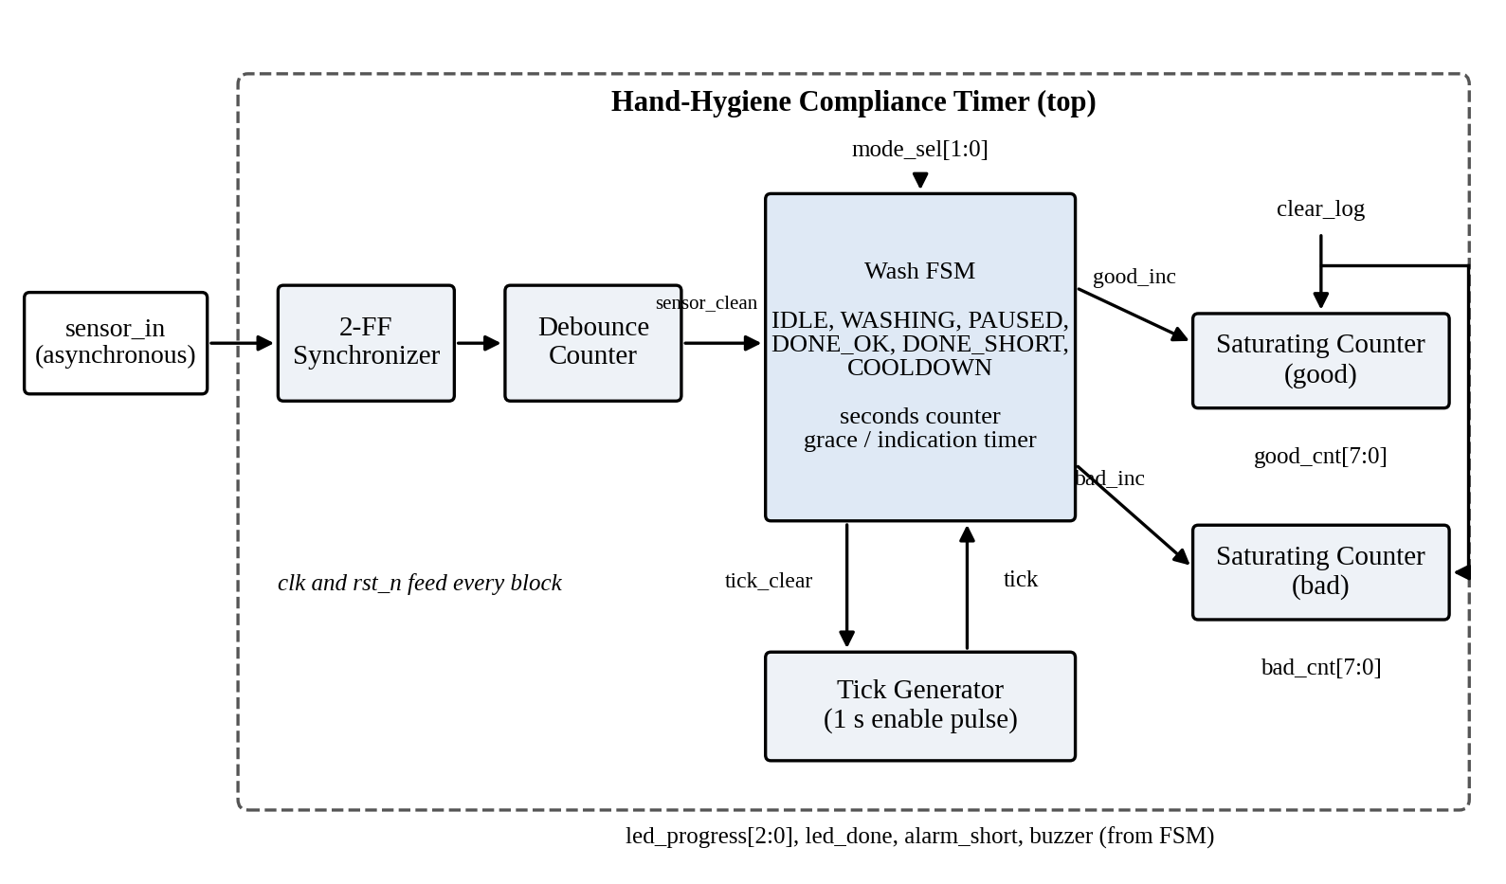
Figure 2.1: Block diagram of the hand-hygiene compliance timer

2.5 MODULE DESCRIPTION

2.5.1 Synchronizer
The sensor is not aligned to the system clock, so its edges can arrive at any moment, including exactly when a flip-flop is sampling. The first flip-flop may then settle to an unpredictable value (metastability). The second flip-flop samples the first one a full clock cycle later, by which time the value has almost certainly resolved. Both flip-flops reset to zero.

2.5.2 Debounce
The debouncer compares its input with its current output. While they are equal, its counter stays at zero. While they differ, the counter counts up, and only when it reaches its maximum does the output take the new value. If the input flips back before that, the counter is cleared, so short glitches never get through. At the intended 32.768 kHz clock a change has to be stable for about 62.5 ms. A pulse only a few clocks long is ignored completely.

2.5.3 Tick Generator
The tick generator counts clock cycles and raises a one-cycle-wide enable pulse once every DIV clocks. I deliberately made this an enable pulse rather than a divided clock. A derived clock would be a second clock domain that has to be constrained and balanced; an enable keeps one clock for the whole design. Its clear input is driven by the FSM and holds the counter at zero while the FSM is idle.

2.5.4 Wash FSM
The wash FSM is the heart of the design. It has six states (IDLE, WASHING, PAUSED, DONE_OK, DONE_SHORT, COOLDOWN), a six-bit seconds counter, and a second six-bit timer that is reused for the grace period and for the length of the result indication. In IDLE it latches mode_sel into an internal register, so that the target time cannot change in the middle of a wash. The target and the two progress thresholds are looked up from the latched mode. Outputs such as led_done, alarm_short and buzzer are decoded directly from the state, while good_inc and bad_inc are registered one-cycle pulses sent to the counters.

2.5.5 Saturating Counter
Each log counter is an eight-bit register that increments when its inc input is high and stops at 255 instead of wrapping to zero. The clear input has priority over inc. Two instances are used, one for good washes and one for bad washes, and both share the same clear_log input.

2.5.6 Top Level
The top module only connects the blocks. It exposes the tick divider and the debounce width as parameters. The hardware defaults are 32768 and 11, and the testbench overrides them with small values so that a complete wash simulates in a few hundred clock cycles instead of millions.

2.6 FSM AND FLOWCHART
Figure 2.2 shows the state diagram and Table 2.5 gives the behaviour of each state.
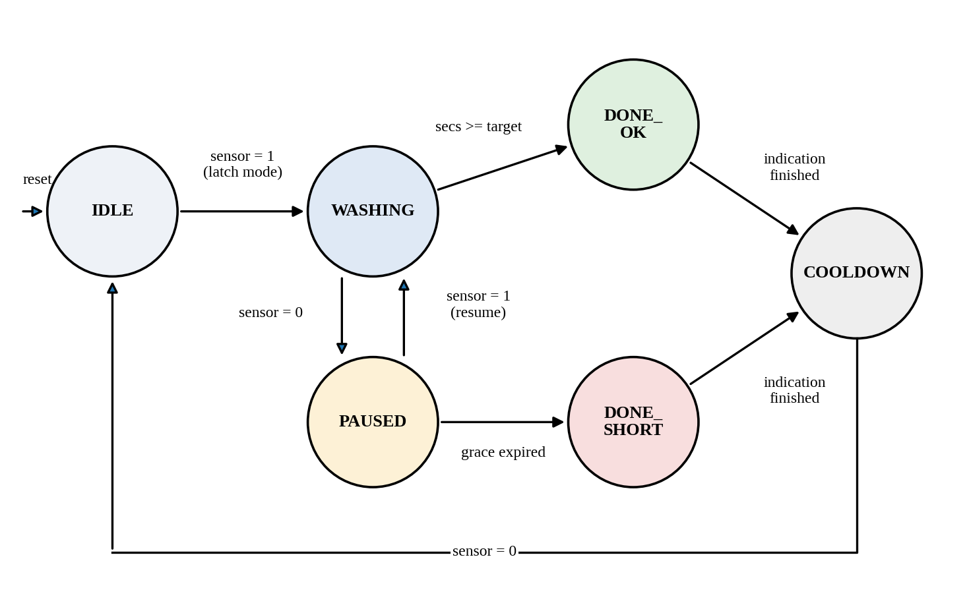
Figure 2.2: State diagram of the wash FSM
Table 2.5: FSM state table
State | Condition | Next state | Action / outputs
IDLE | sensor = 1 | WASHING | Latch mode_sel; timers are held at zero while idle
WASHING | sensor = 0 | PAUSED | Start grace timer
WASHING | secs >= target | DONE_OK | Pulse good_inc
WASHING | tick | WASHING | secs = secs + 1; progress outputs update
PAUSED | sensor = 1 | WASHING | Resume; seconds already counted are kept
PAUSED | grace ticks reached | DONE_SHORT | Pulse bad_inc
DONE_OK | indication finished | COOLDOWN | led_done and buzzer on
DONE_SHORT | indication finished | COOLDOWN | alarm_short and buzzer on
COOLDOWN | sensor = 0 | IDLE | All indications off

2.7 DESIGN DECISIONS
A few decisions shaped the design, and each one has a reason behind it.
- One clock domain. Everything runs on one clock. The only asynchronous input that matters is the sensor, and it goes through the synchronizer.
- Tick enable instead of a divided clock. This avoids gated or derived clocks, which makes clock-tree synthesis and timing analysis simpler.
- Mode latched at the start of a wash. A person leaning on the mode switch cannot extend or shorten a wash that is already running.
- Grace period. Hands naturally leave the sensor for a moment while soap is applied or the tap is adjusted. Without a grace period every such moment would count as a failed wash.
- Saturating counters. A log that wraps from 255 back to 0 would hide a lot of bad washes. Holding at 255 is the safer failure.
- Parameterised timing. The one-second divider and the debounce width are parameters so that simulation stays fast while the hardware keeps its real values.
- Asynchronous reset. The reset is asserted asynchronously and treated as a false path in timing analysis. Synchronising its release is listed as future work.

2.8 VERIFICATION METHODOLOGY
I wrote a self-checking testbench that drives sensor_in like a person at a sink and compares the outputs with expected values automatically, printing PASS or FAIL for each check. One simulated “second” is 8 clock cycles and the debounce time is 4 clock cycles. The expected values come from the specification, not from watching what the RTL does, otherwise a bug in the RTL would simply be copied into the test.
The testbench covers a full compliant wash in each mode, a too-short wash, dropouts shorter and longer than the grace period, sensor glitches, a mode change in the middle of a wash, the progress outputs, reset in the middle of a wash, the clear_log input and two washes back to back. Two continuous assertions run throughout: led_done and alarm_short are never high together, and the counters never decrease except on reset or clear_log. A watchdog stops the simulation if it ever hangs.

2.9 RTL-TO-GDS IMPLEMENTATION FLOW
Figure 2.3 summarises the flow. After the RTL passed lint and simulation, I ran Yosys to check the cell count and look for latches. I then ran the full OpenLane flow, which performs synthesis, floorplanning, placement, clock-tree synthesis, routing, parasitic extraction, multi-corner timing analysis, DRC, LVS and antenna checks, and finally writes the GDS.
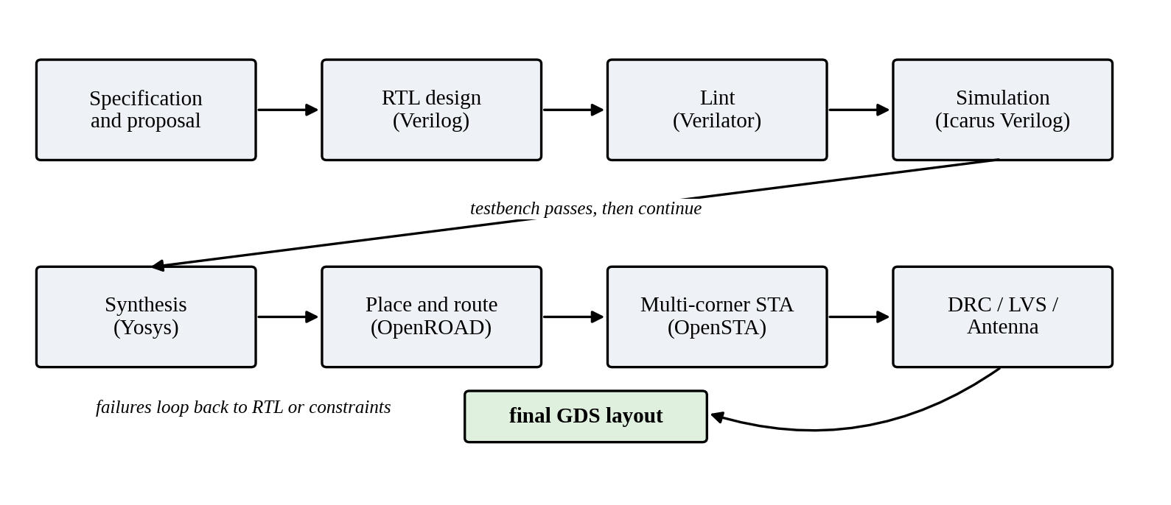
Figure 2.3: RTL-to-GDS design flow
The first OpenLane run used a relaxed 50 ns clock, only to confirm that the design could reach GDS. I then wrote my own constraints file and tightened the clock to 20 ns (50 MHz). Table 2.6 lists the main configuration settings and the constraints used.
Table 2.6: OpenLane configuration and timing constraints
Item | Setting
Design name / clock port | top / clk
Clock period | 20 ns (50 MHz)
Clock uncertainty / transition | 0.25 ns / 0.15 ns
Input delay (sensor_in, mode_sel, clear_log) | 10 ns relative to clk
Output delay (all outputs) | 10 ns relative to clk
rst_n | false path (asynchronous reset)
Core utilisation / placement density | 40 % / 50 %
Timing corners analysed | 3 PVT (tt 25 °C 1.80 V, ss 100 °C 1.60 V, ff −40 °C 1.95 V) × 3 RC (nom, min, max) = 9

2.10 USE OF AI ASSISTANCE
I used an AI assistant as a helper, not as a replacement for understanding. The proposal, ports and state table were finalised first, and RTL was requested one small module at a time. Each module was read line by line and linted with Verilator, which caught real issues: missing end-of-file newlines and width mismatches in the tick generator (WIDTHEXPAND and WIDTHTRUNC), which I fixed. The testbench expectations were checked against my own specification. Simulation, synthesis and physical-design results in this report come from tools I ran myself.
CHAPTER 3

RESULTS AND DISCUSSION

3.1 FUNCTIONAL SIMULATION RESULTS
All 16 checks in the self-checking testbench passed with 0 failures, and neither continuous assertion fired. Table 3.1 lists the checks.
Table 3.1: Testbench checks and results
ID | Test | Stimulus | Expected | Result
T1 | Reset state | Reset applied | Counters 0, no indications | PASS
T2 | Full wash, 20 s | Sensor high for 23 s | good_cnt + 1, bad_cnt unchanged | PASS
T3 | Too-short wash | 8 s, then leave for 5 s | bad_cnt + 1, good_cnt unchanged | PASS
T4 | Brief dropout | Drop for 6 clocks (below grace), return | Wash completes, good_cnt + 1 | PASS
T5 | Sensor glitch | 2-clock pulse | Ignored, no progress | PASS
T6a | 30 s mode, early | 25 s of washing | Not yet done | PASS
T6b | 30 s mode, complete | After 30 s | good_cnt + 1 | PASS
T7a | 40 s mode, early | 35 s of washing | Not yet done | PASS
T7b | 40 s mode, complete | After 40 s | good_cnt + 1 | PASS
T8 | Mode change mid-wash | Switch to 40 s after 5 s | Wash still ends at 20 s | PASS
T9a | Progress, one third | About 8 s | led_progress = 001 | PASS
T9b | Progress, two thirds | About 14 s | led_progress = 011 | PASS
T10 | Reset mid-wash | Reset after 6 s | Counters 0, progress 000 | PASS
T11a | Before clear | After a good wash | good_cnt nonzero | PASS
T11b | clear_log | Pulse clear_log | Both counters 0 | PASS
T12 | Back-to-back washes | Two full washes | good_cnt + 2 exactly | PASS
Figure 3.1 shows the simulated waveform of a complete wash.
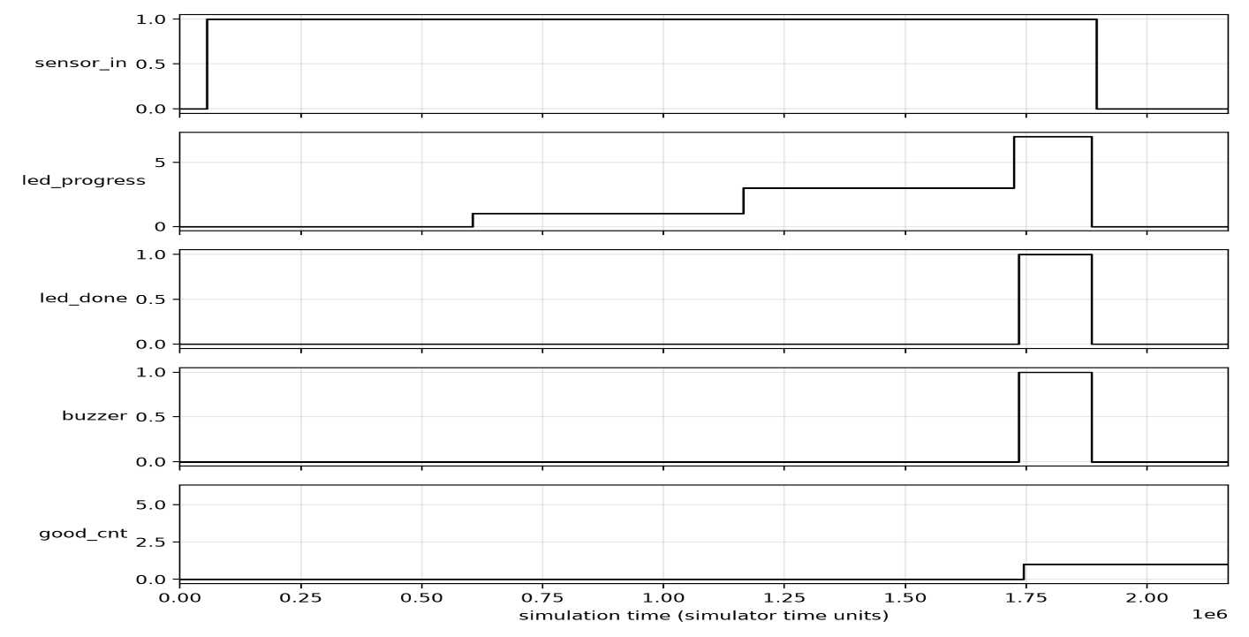
Figure 3.1: Simulated waveform of a compliant wash

3.2 SYNTHESIS RESULTS
Yosys synthesised the complete design into 457 generic cells. No latches were inferred, no memories were used, and the design contains 65 flip-flops (34 with an enable and 31 without). Table 3.2 gives the breakdown.
Table 3.2: Generic Yosys synthesis cell summary
Cell type | Count | Cell type | Count
$_ANDNOT_ | 155 | $_NOR_ | 13
$_AND_ | 16 | $_NOT_ | 15
$_DFFE_PN0P_ (flip-flop with enable) | 34 | $_ORNOT_ | 19
$_DFF_PN0_ (flip-flop) | 31 | $_OR_ | 70
$_MUX_ | 1 | $_XNOR_ | 28
$_NAND_ | 41 | $_XOR_ | 34
Total cells | 457 | Total flip-flops | 65
The flip-flop count matches what I expected from the architecture: 2 in the synchronizer, 11 in the debouncer plus its output, about 20 in the tick generator and about 19 in the FSM, and 16 in the two log counters.

3.3 PHYSICAL DESIGN RESULTS
The OpenLane flow completed all 78 stages in about two minutes on a two-core cloud machine. Table 3.3 summarises the result.
Table 3.3: Physical design summary (SKY130, sky130_fd_sc_hd)
Item | Result
Flow | OpenLane 2.3.10, 78 / 78 stages complete
Clock period | 20 ns (50 MHz)
Devices and nets in layout (Netgen) | 364 devices, 364 nets (includes tap, fill and decap cells)
Flip-flops (sky130_fd_sc_hd__dfrtp) | 65 (52 × _1, 9 × _2, 4 × _4)
Hold-fix delay cells (dlygate4sd3_1) | 39, inserted automatically
Die size | about 104.29 µm × 115.01 µm (about 0.012 mm²)
Setup / hold violations | None
Max slew / max capacitance violations | None
DRC / LVS / Antenna | Passed / Passed / Passed
LVS result | Circuits match uniquely
The 39 delay cells are worth a comment. Many paths in this design are short (a flip-flop feeding a flip-flop through a little logic), and at the fast corner they arrive so early that they threaten the hold requirement. The tool therefore added delay buffers on its own to fix this.
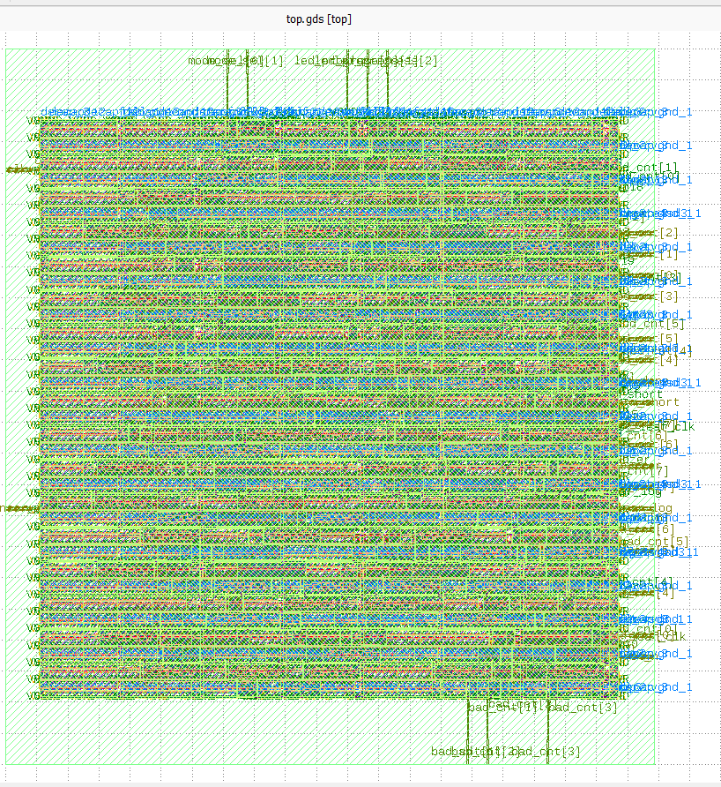
Figure 3.2: Final GDS layout of the design (full die)
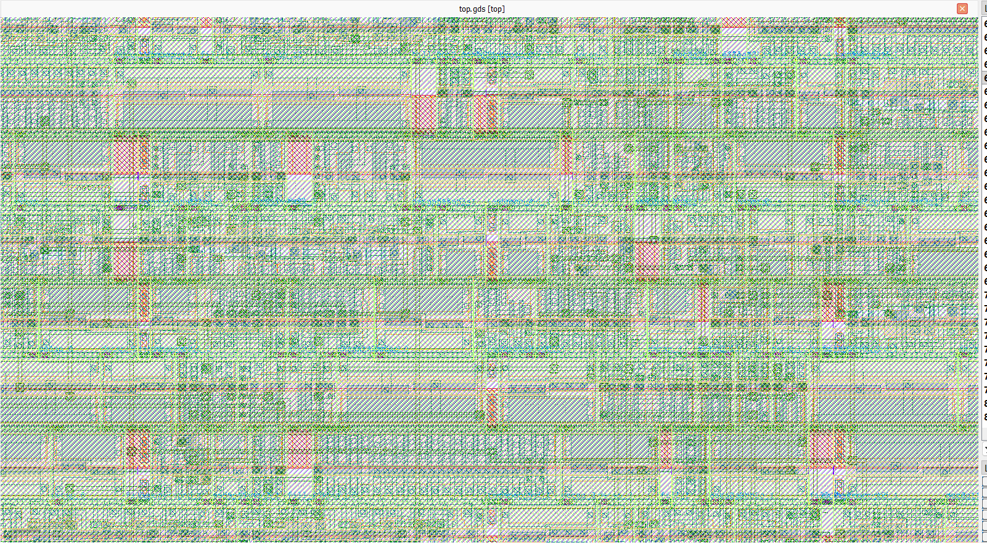
Figure 3.3: Zoomed view of the layout showing cell rows and routing

3.4 MULTI-CORNER STATIC TIMING ANALYSIS
Timing was checked at nine corners: three process/voltage/temperature (PVT) conditions, each with nominal, minimum and maximum interconnect parasitics. Slow-corner (ss) analysis is the one that matters for setup, because gates are slowest there. Fast-corner (ff) analysis matters for hold, because data moves fastest and may arrive before the capturing flip-flop is ready. Table 3.4 gives the worst setup and hold slack and the total negative slack (TNS) at every corner.
Table 3.4: Setup and hold timing at all nine corners (all values in ns)
Corner | Setup WNS | Setup TNS | Hold WNS | Hold TNS
nom_tt_025C_1v80 | 8.018 | 0 | 0.314 | 0
nom_ss_100C_1v60 | 6.389 | 0 | 0.885 | 0
nom_ff_n40C_1v95 | 8.645 | 0 | 0.106 | 0
min_tt_025C_1v80 | 8.026 | 0 | 0.312 | 0
min_ss_100C_1v60 | 6.414 | 0 | 0.883 | 0
min_ff_n40C_1v95 | 8.660 | 0 | 0.105 | 0
max_tt_025C_1v80 | 8.006 | 0 | 0.316 | 0
max_ss_100C_1v60 | 6.346 | 0 | 0.887 | 0
max_ff_n40C_1v95 | 8.626 | 0 | 0.107 | 0
Overall worst | 6.346 (max_ss) | 0 | 0.105 (min_ff) | 0
Every corner has positive setup and hold slack and a TNS of zero. As expected, setup slack is smallest at the slow corner (6.346 ns, max_ss) and hold slack is smallest at the fast corner (0.105 ns, min_ff). The hold margin is small but positive, which is exactly why the flow inserted the delay cells.

3.5 SIGN-OFF CHECKS
- DRC: the final layout has no design-rule violations.
- LVS: the layout and the synthesized netlist match uniquely, with the same number of devices and nets in both.
- Antenna: no antenna violations.
- Electrical: no maximum-slew or maximum-capacitance violations.

3.6 DISCUSSION
Real clock versus analysis clock. The chip is intended to run from a 32.768 kHz crystal, which gives an exact one-second tick, a clock period of about 30.5 µs. Timing was signed off at 50 MHz, about 1500 times faster. Passing at 50 MHz with more than 6 ns of setup slack in the slowest corner means the circuit has a very large margin at its real operating frequency. I chose the faster clock so that the timing report would be a meaningful test and not a trivial pass.
Wash duration against the WHO figures. The 20 s and 30 s modes match the WHO range for alcohol-based hand rub, and the 40 s mode matches the lower end of the WHO range for soap and water [1]. A 60 s mode would be a sensible addition for full soap-and-water washing.
Known limitations. I found several things worth being honest about.
- The grace period is accurate only to within about a second. The tick counter keeps running while the sensor is low, so the first grace tick can arrive early. A two-tick grace therefore lasts between one and two seconds.
- If the sensor drops in the very same cycle that the seconds counter reaches its target, the sensor check has priority and the FSM moves to PAUSED. The wash is then only completed if hands return within the grace period.
- The counters are ordinary registers and lose their values when power is removed. A real product would need non-volatile storage or an external logger.
- The reset is asynchronous on release as well as on assertion. A reset synchroniser would make it more robust.
- Power was not analysed in detail in this project.

3.7 COST ANALYSIS
Every tool I used is free and open source, so the design cost no licence fees. The silicon itself is extremely small (about 0.012 mm²), so at volume the cost of the chip would be a very small part of a dispenser. The bill of materials would be dominated by the sensor, the buzzer and LEDs, the housing and the battery. I have not obtained a fabrication quote; for prototypes, low-cost multi-project shuttles on open PDKs would be the natural route.

3.8 USEFULNESS TO SOCIETY
Healthcare-associated infections cause avoidable suffering and cost [2], and poor hand-hygiene compliance is a well-documented contributor [3]. A cheap device at the sink that gives instant feedback and keeps an honest count could help in hospitals and clinics, and also in school toilets, kitchens and food-processing plants. Because it measures automatically, it avoids the observer bias seen in manual audits [4]. Because it needs no software or operating system, it can be very cheap, reliable and long-lasting.

3.9 ENVIRONMENTAL SAFETY
The circuit is tiny and runs at a low supply voltage (1.8 V for the core), so it can be powered for a long time from a small battery, which reduces battery waste. It has no radio, no moving parts and no mains connection, so it adds no electromagnetic or electrical-shock concerns of its own. A small die uses very little silicon. Encouraging complete hand washing does not require any extra chemicals beyond what is already used.
CHAPTER 4

CONCLUSION AND FUTURE SCOPE

4.1 CONCLUSION
I designed a hand-hygiene compliance timer as a small digital circuit and took it from a written specification to a signed-off GDS layout. The design synchronises and debounces a sensor input, times a wash in three selectable durations, tolerates short interruptions, signals the result with progress, done and alarm outputs, and keeps saturating counts of good and bad washes.
The testbench passed all 16 checks. Yosys found no latches and 65 flip-flops. The OpenLane flow produced a layout of about 104 µm × 115 µm that passes DRC, LVS and antenna checks, and static timing analysis at all nine corners shows positive setup and hold slack with zero total negative slack: the worst setup slack is 6.346 ns and the worst hold slack is 0.105 ns at a 20 ns clock.
The project also taught me that passing simulation is only the start. The linter, the hold-fix cells and the corner-by-corner timing report each showed me something that simulation alone would never have revealed.

4.2 FUTURE SCOPE
- Add the full six-to-eight step WHO hand-wash technique as a step indicator that changes every few seconds.
- Add a 60 s mode and make the durations configurable through a small register interface (SPI or I²C).
- Add non-volatile or externally readable logging (a UART or SPI output), and timestamps from a real-time clock.
- Add staff identification so washes can be linked to individuals, with appropriate privacy safeguards.
- Add a reset synchroniser, and run gate-level simulation with timing back-annotation and a detailed power analysis.
- Prototype the design on an FPGA with a real sensor, and submit it to a multi-project shuttle for fabrication.

REFERENCES
[1] World Health Organization – ‘WHO Guidelines on Hand Hygiene in Health Care: First Global Patient Safety Challenge, Clean Care Is Safer Care’, Publisher: WHO Press, Place: Geneva, Country: Switzerland, Year: 2009.
[2] B. Allegranzi, S. Bagheri Nejad, C. Combescure, W. Graafmans, H. Attar, L. Donaldson, D. Pittet – ‘Burden of endemic health-care-associated infection in developing countries: systematic review and meta-analysis’, The Lancet, Year: 2011, Vol. 377, Iss. 9761, pp. 228 to 241.
[3] V. Erasmus, T. J. Daha, H. Brug, J. H. Richardus, M. D. Behrendt, M. W. Vos, E. F. van Beeck – ‘Systematic review of studies on compliance with hand hygiene guidelines in hospital care’, Infection Control & Hospital Epidemiology, Year: 2010, Vol. 31, Iss. 3, pp. 283 to 294.
[4] J. A. Srigley, C. D. Furness, G. R. Baker, M. Gardam – ‘Quantification of the Hawthorne effect in hand hygiene compliance monitoring using an electronic monitoring system: a retrospective cohort study’, BMJ Quality & Safety, Year: 2014, Vol. 23, Iss. 12, pp. 974 to 980.
[5] C. E. Cummings – ‘Clock Domain Crossing (CDC) Design & Verification Techniques Using SystemVerilog’, Synopsys Users Group (SNUG) Conference, Boston, USA, Year: 2008.
[6] J. Ganssle – ‘A Guide to Debouncing’, The Ganssle Group, Year: 2004 (revised 2008).
[7] C. Wolf, J. Glaser – ‘Yosys – A Free Verilog Synthesis Suite’, Proceedings of the 21st Austrian Workshop on Microelectronics (Austrochip), Year: 2013.
[8] T. Ajayi, D. Blaauw, T.-B. Chan, C.-K. Cheng, et al. – ‘Toward an Open-Source Digital Flow: First Learnings from the OpenROAD Project’, Proceedings of the 56th ACM/IEEE Design Automation Conference (DAC), Year: 2019.
[9] SkyWater Technology and Google – ‘SkyWater Open Source PDK (SKY130) Documentation’, https://skywater-pdk.readthedocs.io.
[10] IEEE – ‘IEEE Standard for Verilog Hardware Description Language’, IEEE Std 1364-2005, Publisher: IEEE, Year: 2006.
[11] N. H. E. Weste, D. M. Harris – ‘CMOS VLSI Design: A Circuits and Systems Perspective’, 4th Edition, Publisher: Addison-Wesley, Country: USA, Year: 2011.
[12] OpenLane Project – ‘OpenLane 2 Documentation’, https://openlane2.readthedocs.io.

APPENDIX A
wash_fsm.v (main control module)
// Wash FSM: times a hand wash, tolerates short dropouts, reports result.
module wash_fsm #(
parameter [5:0] GRACE_S = 6'd2, // allowed sensor dropout (seconds)
parameter [5:0] BEEP_S = 6'd2 // result indication time (seconds)
) (
input wire clk,
input wire rst_n,
input wire sensor, // debounced hands-present signal
input wire tick, // 1-cycle pulse once per second
input wire [1:0] mode_sel,
output wire tick_clear,
output reg [2:0] led_progress,
output wire led_done,
output wire alarm_short,
output wire buzzer,
output reg good_inc,
output reg bad_inc
);
localparam [2:0] IDLE = 3'd0,
WASHING = 3'd1,
PAUSED = 3'd2,
DONE_OK = 3'd3,
DONE_SHORT = 3'd4,
COOLDOWN = 3'd5;

reg [2:0] state;
reg [1:0] mode_r; // mode latched at wash start
reg [5:0] secs; // seconds washed
reg [5:0] aux; // grace / indication timer

// Target and progress thresholds for the latched mode
reg [5:0] target, t1, t2;
always @* begin
case (mode_r)
2'b01: begin target = 6'd30; t1 = 6'd10; t2 = 6'd20; end
2'b10: begin target = 6'd40; t1 = 6'd13; t2 = 6'd26; end
default: begin target = 6'd20; t1 = 6'd6; t2 = 6'd13; end
endcase
end

// State register and timers
always @(posedge clk or negedge rst_n) begin
if (!rst_n) begin
state <= IDLE;
mode_r <= 2'b00;
secs <= 6'd0;
aux <= 6'd0;
good_inc <= 1'b0;
bad_inc <= 1'b0;
end else begin
good_inc <= 1'b0;
bad_inc <= 1'b0;
case (state)
IDLE: begin
secs <= 6'd0;
aux <= 6'd0;
if (sensor) begin
mode_r <= mode_sel;
state <= WASHING;
end
end

WASHING: begin
if (!sensor) begin
aux <= 6'd0;
state <= PAUSED;
end else if (secs >= target) begin
aux <= 6'd0;
good_inc <= 1'b1;
state <= DONE_OK;
end else if (tick) begin
secs <= secs + 6'd1;
end
end

PAUSED: begin
if (sensor) begin
state <= WASHING;
end else if (tick) begin
if ((aux + 6'd1) >= GRACE_S) begin
aux <= 6'd0;
bad_inc <= 1'b1;
state <= DONE_SHORT;
end else begin
aux <= aux + 6'd1;
end
end
end

DONE_OK, DONE_SHORT: begin
if (tick) begin
if ((aux + 6'd1) >= BEEP_S) state <= COOLDOWN;
else aux <= aux + 6'd1;
end
end

COOLDOWN: begin
if (!sensor) state <= IDLE;
end

default: state <= IDLE;
endcase
end
end

// Outputs
assign tick_clear = (state == IDLE);
assign led_done = (state == DONE_OK);
assign alarm_short = (state == DONE_SHORT);
assign buzzer = (state == DONE_OK) || (state == DONE_SHORT);

always @* begin
if (state == IDLE || state == COOLDOWN)
led_progress = 3'b000;
else
led_progress = {(secs >= target), (secs >= t2), (secs >= t1)};
end
endmodule

APPENDIX B
OpenLane configuration (config/config.json)
{
"DESIGN_NAME": "top",
"VERILOG_FILES": [
"dir::../src/synchronizer.v",
"dir::../src/debounce.v",
"dir::../src/tick_gen.v",
"dir::../src/sat_counter.v",
"dir::../src/wash_fsm.v",
"dir::../src/top.v"
],
"CLOCK_PORT": "clk",
"CLOCK_PERIOD": 20,
"PNR_SDC_FILE": "dir::top.sdc",
"SIGNOFF_SDC_FILE": "dir::top.sdc",
"FP_SIZING": "relative",
"FP_CORE_UTIL": 40,
"PL_TARGET_DENSITY_PCT": 50,
"RUN_LINTER": true,
"DESIGN_IS_CORE": false
}

Timing constraints (config/top.sdc)
set clk_port clk
create_clock -name clk -period 20 [get_ports $clk_port]
set_clock_uncertainty 0.25 [get_clocks clk]
set_clock_transition 0.15 [get_clocks clk]

set_input_delay 10 -clock clk [get_ports {sensor_in mode_sel[*] clear_log}]
set_output_delay 10 -clock clk [get_ports {led_progress[*] led_done buzzer alarm_short good_cnt[*] bad_cnt[*]}]
set_false_path -from [get_ports rst_n]

APPENDIX C
Commands to reproduce the results
# Lint
verilator --lint-only -Wall --top-module top src/*.v

# Simulate
iverilog -g2012 -o test/tb_top.out test/tb_top.v src/*.v
vvp test/tb_top.out

# Generic synthesis
yosys -p "read_verilog -sv src/*.v; hierarchy -check -top top; synth -top top -flatten; check; stat"

# RTL-to-GDS (inside the Python virtual environment)
python -m openlane --dockerized config/config.json

# Per-corner timing metrics
grep -E "timing__(setup|hold)__(ws|tns)" docs/results/metrics_final.csv

