{{ cohort }} Leadership Lab
The Connection 101 Workshop

Strengthen your relationships to thrive in all contexts.

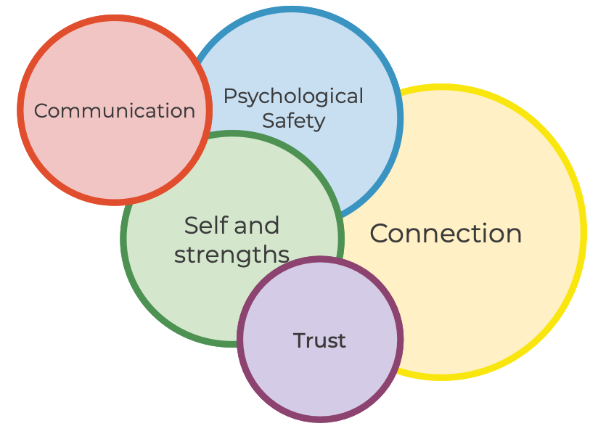

Prepared for: {{ name }}
{{ date }}

