**{{ cohort }} Connection Lab**

**The Connection 101 Workshop**

*Strengthen your relationships to thrive in all contexts.*

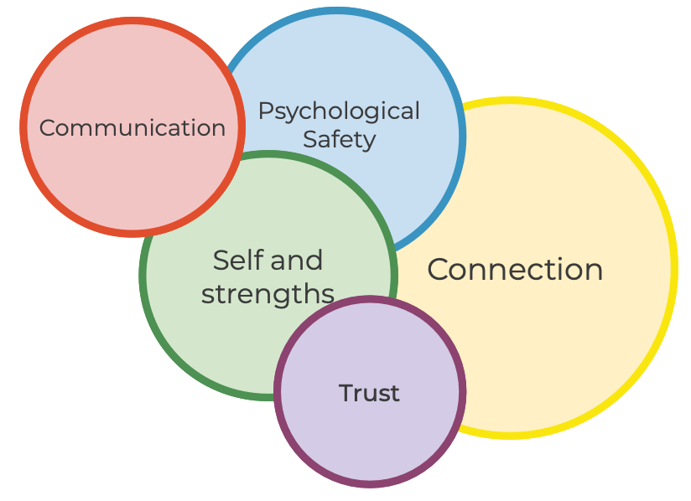

Prepared for: {{ name }}

{{ date }}