**Database diagram:**

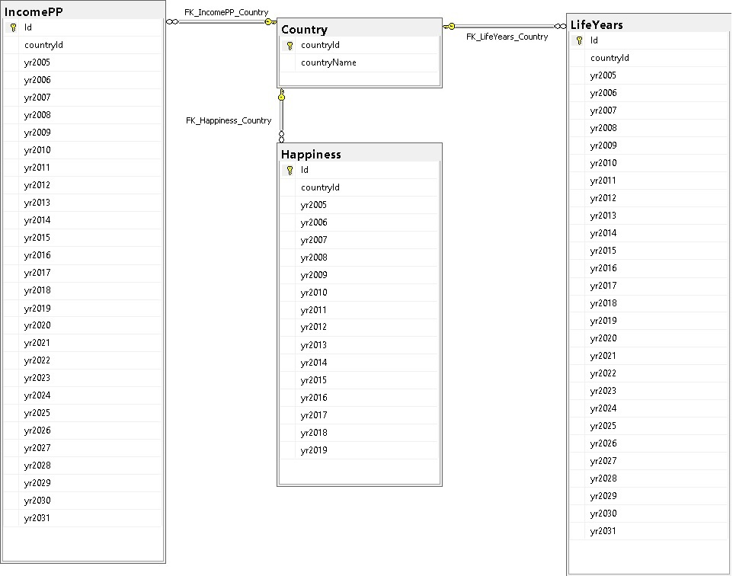

|  |  |
| --- | --- |
| **Main data tables:**   1. IncomePP (Income per person for year and country) 2. LifeYears (Life expectancy of each country) 3. Happiness (Rate of happiness of each country) | **Secondary table:**   1. Country |

**Queries (Report):**

Are wealthy people happier?

1. Does wealth equal happiness?  - Analyze happiness and income to show happiness of top 5 countries with highest and lowest incomes.
   1. Get top 5 countries with highest income
   2. Get top 5 countries with lowest income
   3. Calculate Avg happiness score of each country

**Filters on:**

* + 1. Countries Count Top (1-countries count) for high & low incomes

1. Do happy people live longer? - Relate happiness with life expectancy. Analyze if more happy people live longer.
   1. Find Avg of happiness score for each countryId (for specific period if any)
   2. Find Avg Age of life for each countryID (for specific period if any)
   3. Show top X happy country’s with their avg life age

**Filters on:**

1. Happiness Score **>=** (0.1 – 1.0)
2. Country
3. Are wealthier people expected to live longer?
4. Do wealthier people live longer? - Show estimated income per person and life expectancy of up to next 10 years.
   1. Grab the estimated Income & Life for next **X** years

**Filters on:**

* + 1. Next **X** years (1-10)
    2. Income >= **Y** (user input)