## 患者列表信息

来源his中医生所有权限的患者。医生可以根据权限、病区、病人就诊状态、时间等过滤病人列表信息。

住院医师登录后操作

## 住院医师首页

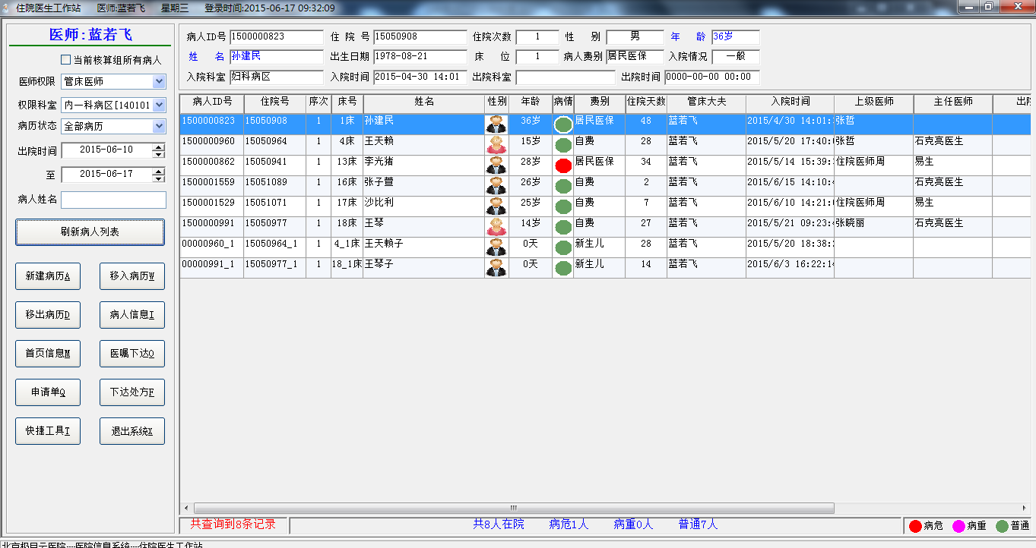

### 业务流程：

医生登录后加载首页过滤条件和医生所属患者列表信息。列表点击行可以查看患者详细信息。

### 涉及数据：

#### 医生组信息?核算组

-----------------------------根据医生id查询医生组信息--------------------

select nvl ( Order_Group , '*' ) from DOCTOR_GROUP where DOCTOR_USER ='000LRF'

#### 在院和出院数据

----------------查询该医生组下的在院和7天内出院数据-------------

select pat_type , patient_id , bed_no ,

decode(bed_label , '出院' , '出院' , bed_label||'床') as bed_label ,

visit_id ,

inp_no ,

name ,

sex ,

inp_days ,

admission_date_time ,

request_doctor_id ,

dept_code ,

super_doctor_id ,

parent_doctor_id ,

discharge_date_time ,

date_of_birth ,

'000LRF' ,

charge_type ,

body_height ,

body_weight,

pat_condition,

name_phonetic,

pat_identity,

prepayment

from (select '在院' as pat_type,

b.patient_id as patient_id,

c.bed_no as bed_no,

c.bed_label as bed_label,

b.visit_id as visit_id,

a.inp_no as inp_no,

a.name as name,

a.sex as sex,

(trunc(sysdate) - trunc(d.admission_date_time)) as inp_days,

d.admission_date_time as admission_date_time,

e.request_doctor_id as request_doctor_id,

b.dept_code as dept_code,

e.super_doctor_id as super_doctor_id,

e.parent_doctor_id as parent_doctor_id,

d.discharge_date_time as discharge_date_time,

a.date_of_birth as date_of_birth,

d.charge_type as charge_type,

d.body_height as body_height ,

d.body_weight as body_weight,

a.name_phonetic as name_phonetic,

d.identity as pat_identity,

nvl(b.PREPAYMENTS , 0) - nvl(b.TOTAL_CHARGES, 0) as prepayment,

b.PATIENT_CONDITION as pat_condition

from pat_master_index a,

pats_in_hospital b,

bed_rec c,

pat_visit d,

mr_on_line e

where a.patient_id = b.patient_id

and b.patient_id = d.patient_id

and b.visit_id = d.visit_id

and b.patient_id = e.patient_id

and b.visit_id = e.visit_id

and b.ward_code(+) = c.ward_code

and b.bed_no(+) = c.bed_no

and e.status = '0'

and (e.request_doctor_id in (select DOCTOR_USER from DOCTOR_GROUP where order_group = '*') or '0' = 0)

and (e.request_doctor_id = '000LRF' or '000LRF' = '*')

and (e.parent_doctor_id = '*' or '*' = '*')

and (e.super_doctor_id = '*' or '*' = '*')

and b.dept_code = '140101'

union all

select '已出院' as pat_type,

d.patient_id as patient_id,

0 as bed_no,

'出院' as bed_label,

d.visit_id as visit_id,

a.inp_no as inp_no,

a.name as name,

a.sex as sex,

(trunc(d.discharge_date_time) - trunc(d.admission_date_time)) as inp_days,

d.admission_date_time as admission_date_time,

e.request_doctor_id as request_doctor_id,

d.dept_discharge_from as dept_code,

e.super_doctor_id as super_doctor_id,

e.parent_doctor_id as parent_doctor_id,

d.discharge_date_time as discharge_date_time,

a.date_of_birth as date_of_birth,

d.charge_type as charge_type,

d.body_height as body_height ,

d.body_weight as body_weight,

a.name_phonetic as name_phonetic,

d.identity as pat_identity,

0 as prepayment,

d.pat_adm_condition as pat_condition

from pat_master_index a , pat_visit d , mr_on_line e

where a.patient_id = d.patient_id

and d.patient_id = e.patient_id

and d.visit_id = e.visit_id

and e.status = '0'

and (e.request_doctor_id in (select DOCTOR_USER from DOCTOR_GROUP where order_group = '*') or '0' = 0)

and (e.request_doctor_id = '000LRF' or '000LRF' = '*')

and (e.parent_doctor_id = '*' or '*' = '*')

and (e.super_doctor_id = '*' or '*' = '*')

and d.dept_discharge_from = '140101'

and d.discharge_date_time >= '2015-06-10 00:00:00'

and d.discharge_date_time <= '2015-06-17 23:59:59')

#### 出生日期和入院日期

------------------根据住院id和住院次数查询患者出生日期和入院日期---------------------

select a.date_of_birth , b.admission_date_time from pat_master_index a , pat_visit b where a.patient_id =b.patient_id and b.patient_id ='1500000823'and b.visit_id =1278214145

#### 患者详细信息

-----------------根据患者id和住院次数查询患者详细信-------------------

select b.patient_id,

b.inp_no,

b.sex,

b.name,

b.date_of_birth,

a.charge_type,a.identity,

a.pat_adm_condition,

a.visit_id,

a.dept_admission_to,

a.admission_date_time,

a.dept_discharge_from,

a.discharge_date_time,

c.ward_code,c.dept_code,b.unit_in_contract,

(select bed_label from bed_rec where bed_no = c.bed_no and ward_code = c.ward_code) bed_label

From pat_visit a,

pat_master_index b,

pats_in_hospital c

where a.patient_id = b.patient_id

and a.patient_id = c.patient_id(+)

and a.visit_id = c.visit_id(+)

and a.patient_id = '1500000823'

and a.visit_id = '1'

注：上面省略计算年龄SQL，计算年龄可以放页面去计算，计算年龄截至当天还是入院日期（新生儿）

#### 查询医生当前核算组病人?

--------------------------------------查询医生所属组-----------------------------------------------

**select** nvl ( Order_Group , '*' ) **from** DOCTOR_GROUP **where** DOCTOR_USER ='000LRF'

**-------------------查询核算组内患者--------------------------**

**select** pat_type ,

patient_id ,

bed_no ,

decode(bed_label , '出院' , '出院' , bed_label||'床') as bed_label ,

visit_id ,

inp_no ,

name ,

sex ,

inp_days ,

admission_date_time ,

request_doctor_id ,

dept_code ,

super_doctor_id ,

parent_doctor_id ,

discharge_date_time ,

date_of_birth ,

'000LRF' ,

charge_type ,

body_height ,

body_weight,

pat_condition,

name_phonetic,

pat_identity,

prepayment

**from** (**select**'在院' as pat_type,

b.patient_id as patient_id,

c.bed_no as bed_no,

c.bed_label as bed_label,

b.visit_id as visit_id,

a.inp_no as inp_no,

a.name as name,

a.sex as sex,

(trunc(sysdate) - trunc(d.admission_date_time)) as inp_days,

d.admission_date_time as admission_date_time,

e.request_doctor_id as request_doctor_id,

b.dept_code as dept_code,

e.super_doctor_id as super_doctor_id,

e.parent_doctor_id as parent_doctor_id,

d.discharge_date_time as discharge_date_time,

a.date_of_birth as date_of_birth,

d.charge_type as charge_type,

d.body_height as body_height ,

d.body_weight as body_weight,

a.name_phonetic as name_phonetic,

d.identity as pat_identity,

nvl(b.PREPAYMENTS , 0) - nvl(b.TOTAL_CHARGES, 0) as prepayment,

b.PATIENT_CONDITION as pat_condition

**from** pat_master_index a,

pats_in_hospital b,

bed_rec c,

pat_visit d,

mr_on_line e

**where** a.patient_id = b.patient_id

and b.patient_id = d.patient_id

and b.visit_id = d.visit_id

and b.patient_id = e.patient_id

and b.visit_id = e.visit_id

and b.ward_code(+) = c.ward_code

and b.bed_no(+) = c.bed_no

and e.status = '0'

and (e.request_doctor_id **in** (**select** DOCTOR_USER **from** DOCTOR_GROUP **where** order_group = '140302') or '1' = 0)

and (e.request_doctor_id = '*' or '*' = '*')

and (e.parent_doctor_id = '*' or '*' = '*')

and (e.super_doctor_id = '*' or '*' = '*')

and b.dept_code = '140101'

**unionall**

**select**'已出院' as pat_type,

d.patient_id as patient_id,

0 as bed_no,

'出院' as bed_label,

d.visit_id as visit_id,

a.inp_no as inp_no,

a.name as name,

a.sex as sex,

(trunc(d.discharge_date_time) - trunc(d.admission_date_time)) as inp_days,

d.admission_date_time as admission_date_time,

e.request_doctor_id as request_doctor_id,

d.dept_discharge_from as dept_code,

e.super_doctor_id as super_doctor_id,

e.parent_doctor_id as parent_doctor_id,

d.discharge_date_time as discharge_date_time,

a.date_of_birth as date_of_birth,

d.charge_type as charge_type,

d.body_height as body_height ,

d.body_weight as body_weight,

a.name_phonetic as name_phonetic,

d.identity as pat_identity,

0 as prepayment,

d.pat_adm_condition as pat_condition

**from** pat_master_index a , pat_visit d , mr_on_line e

**where** a.patient_id = d.patient_id

and d.patient_id = e.patient_id

and d.visit_id = e.visit_id

and e.status = '0'

and (e.request_doctor_id **in** (**select** DOCTOR_USER **from** DOCTOR_GROUP **where** order_group = '140302') or '1' = 0)

and (e.request_doctor_id = '*' or '*' = '*')

and (e.parent_doctor_id = '*' or '*' = '*')

and (e.super_doctor_id = '*' or '*' = '*')

and d.dept_discharge_from = '140101'

and d.discharge_date_time >= '2015-06-10 00:00:00'

and d.discharge_date_time <= '2015-06-17 23:59:59')

:as_doctor=['000LRF']医生id

:as_order_group=['140302']所在组

:ai_hsz=['1']

:as_id=['*']

:as_parent_id=['*']

:as_super_id=['*']

:as_dept_code=['140101']所在科室

:adt_start_out=['2015-06-10 00:00:00']

:adt_end_out=['2015-06-17 23:59:59']

注：患者详细信息加载，以及年龄计算同上

#### 查询出院病历

**select** pat_type ,

patient_id ,

bed_no ,

decode(bed_label , '出院' , '出院' , bed_label||'床') as bed_label ,

visit_id ,

inp_no ,

name ,

sex ,

inp_days ,

admission_date_time ,

request_doctor_id ,

dept_code ,

super_doctor_id ,

parent_doctor_id ,

discharge_date_time ,

date_of_birth ,

'000LRF' ,

charge_type ,

body_height ,

body_weight,

pat_condition,

name_phonetic,

pat_identity,

prepayment

**from** (**select**'在院' as pat_type,

b.patient_id as patient_id,

c.bed_no as bed_no,

c.bed_label as bed_label,

b.visit_id as visit_id,

a.inp_no as inp_no,

a.name as name,

a.sex as sex,

(trunc(sysdate) - trunc(d.admission_date_time)) as inp_days,

d.admission_date_time as admission_date_time,

e.request_doctor_id as request_doctor_id,

b.dept_code as dept_code,

e.super_doctor_id as super_doctor_id,

e.parent_doctor_id as parent_doctor_id,

d.discharge_date_time as discharge_date_time,

a.date_of_birth as date_of_birth,

d.charge_type as charge_type,

d.body_height as body_height ,

d.body_weight as body_weight,

a.name_phonetic as name_phonetic,

d.identity as pat_identity,

nvl(b.PREPAYMENTS , 0) - nvl(b.TOTAL_CHARGES, 0) as prepayment,

b.PATIENT_CONDITION as pat_condition

**from** pat_master_index a,

pats_in_hospital b,

bed_rec c,

pat_visit d,

mr_on_line e

**where** a.patient_id = b.patient_id

and b.patient_id = d.patient_id

and b.visit_id = d.visit_id

and b.patient_id = e.patient_id

and b.visit_id = e.visit_id

and b.ward_code(+) = c.ward_code

and b.bed_no(+) = c.bed_no

and e.status = '0'

and (e.request_doctor_id **in** (**select** DOCTOR_USER **from** DOCTOR_GROUP **where** order_group = '*') or '0' = 0)

and (e.request_doctor_id = '*' or '*' = '*')

and (e.parent_doctor_id = '000LRF' or '000LRF' = '*')

and (e.super_doctor_id = '*' or '*' = '*')

and b.dept_code = '140302'

**unionall**

**select**'已出院' as pat_type,

d.patient_id as patient_id,

0 as bed_no,

'出院' as bed_label,

d.visit_id as visit_id,

a.inp_no as inp_no,

a.name as name,

a.sex as sex,

(trunc(d.discharge_date_time) - trunc(d.admission_date_time)) as inp_days,

d.admission_date_time as admission_date_time,

e.request_doctor_id as request_doctor_id,

d.dept_discharge_from as dept_code,

e.super_doctor_id as super_doctor_id,

e.parent_doctor_id as parent_doctor_id,

d.discharge_date_time as discharge_date_time,

a.date_of_birth as date_of_birth,

d.charge_type as charge_type,

d.body_height as body_height ,

d.body_weight as body_weight,

a.name_phonetic as name_phonetic,

d.identity as pat_identity,

0 as prepayment,

d.pat_adm_condition as pat_condition

**from** pat_master_index a , pat_visit d , mr_on_line e

**where** a.patient_id = d.patient_id

and d.patient_id = e.patient_id

and d.visit_id = e.visit_id

and e.status = '0'

and (e.request_doctor_id **in** (**select** DOCTOR_USER **from** DOCTOR_GROUP **where** order_group = '*') or '0' = 0)

and (e.request_doctor_id = '*' or '*' = '*')

and (e.parent_doctor_id = '000LRF' or '000LRF' = '*')

and (e.super_doctor_id = '*' or '*' = '*')

and d.dept_discharge_from = '140302'

and d.discharge_date_time >= '2015-06-10 00:00:00'

and d.discharge_date_time <= '2015-06-17 23:59:59')

:as_doctor=['000LRF']

:as_order_group=['*']

:ai_hsz=['0']

:as_id=['*']

:as_parent_id=['000LRF']

:as_super_id=['*']

:as_dept_code=['140302']

:adt_start_out=['2015-06-10 00:00:00']

:adt_end_out=['2015-06-17 23:59:59']

注：其它列表数据，页面详细信息同1

#### 查询会诊病历

**select** pat_type ,

patient_id ,

bed_no ,

decode(bed_label , '出院' , '出院' , bed_label||'床') as bed_label ,

visit_id ,

inp_no ,

name ,

sex ,

inp_days ,

admission_date_time ,

request_doctor_id ,

dept_code ,

super_doctor_id ,

parent_doctor_id ,

discharge_date_time ,

date_of_birth ,

'000LRF' ,

charge_type ,

body_height ,

body_weight,

pat_condition,

name_phonetic,

pat_identity,

prepayment

**from** (**select**'在院' as pat_type,

b.patient_id as patient_id,

c.bed_no as bed_no,

c.bed_label as bed_label,

b.visit_id as visit_id,

a.inp_no as inp_no,

a.name as name,

a.sex as sex,

(trunc(sysdate) - trunc(d.admission_date_time)) as inp_days,

d.admission_date_time as admission_date_time,

e.request_doctor_id as request_doctor_id,

b.dept_code as dept_code,

e.super_doctor_id as super_doctor_id,

e.parent_doctor_id as parent_doctor_id,

d.discharge_date_time as discharge_date_time,

a.date_of_birth as date_of_birth,

d.charge_type as charge_type,

d.body_height as body_height ,

d.body_weight as body_weight,

a.name_phonetic as name_phonetic,

d.identity as pat_identity,

nvl(b.PREPAYMENTS , 0) - nvl(b.TOTAL_CHARGES, 0) as prepayment,

b.PATIENT_CONDITION as pat_condition

**from** pat_master_index a,

pats_in_hospital b,

bed_rec c,

pat_visit d,

mr_on_line e

**where** a.patient_id = b.patient_id

and b.patient_id = d.patient_id

and b.visit_id = d.visit_id

and b.patient_id = e.patient_id

and b.visit_id = e.visit_id

and b.ward_code(+) = c.ward_code

and b.bed_no(+) = c.bed_no

and e.status = '0'

and (e.request_doctor_id **in** (**select** DOCTOR_USER **from** DOCTOR_GROUP **where** order_group = '140302') or '1' = 0)

and (e.request_doctor_id = '*' or '*' = '*')

and (e.parent_doctor_id = '*' or '*' = '*')

and (e.super_doctor_id = '*' or '*' = '*')

and b.dept_code = '140101'

**unionall**

**select**'已出院' as pat_type,

d.patient_id as patient_id,

0 as bed_no,

'出院' as bed_label,

d.visit_id as visit_id,

a.inp_no as inp_no,

a.name as name,

a.sex as sex,

(trunc(d.discharge_date_time) - trunc(d.admission_date_time)) as inp_days,

d.admission_date_time as admission_date_time,

e.request_doctor_id as request_doctor_id,

d.dept_discharge_from as dept_code,

e.super_doctor_id as super_doctor_id,

e.parent_doctor_id as parent_doctor_id,

d.discharge_date_time as discharge_date_time,

a.date_of_birth as date_of_birth,

d.charge_type as charge_type,

d.body_height as body_height ,

d.body_weight as body_weight,

a.name_phonetic as name_phonetic,

d.identity as pat_identity,

0 as prepayment,

d.pat_adm_condition as pat_condition

**from** pat_master_index a , pat_visit d , mr_on_line e

**where** a.patient_id = d.patient_id

and d.patient_id = e.patient_id

and d.visit_id = e.visit_id

and e.status = '0'

and (e.request_doctor_id **in** (**select** DOCTOR_USER **from** DOCTOR_GROUP **where** order_group = '140302') or '1' = 0)

and (e.request_doctor_id = '*' or '*' = '*')

and (e.parent_doctor_id = '*' or '*' = '*')

and (e.super_doctor_id = '*' or '*' = '*')

and d.dept_discharge_from = '140101'

and d.discharge_date_time >= '2015-06-10 00:00:00'

and d.discharge_date_time <= '2015-06-17 23:59:59')

:as_doctor=['000LRF']

:as_order_group=['140302']

:ai_hsz=['1']

:as_id=['*']

:as_parent_id=['*']

:as_super_id=['*']

:as_dept_code=['140101']

:adt_start_out=['2015-06-10 00:00:00']

:adt_end_out=['2015-06-17 23:59:59']

注：列表显示，页面详细信息同1，列表无数据时页面详细信息也需要显示？

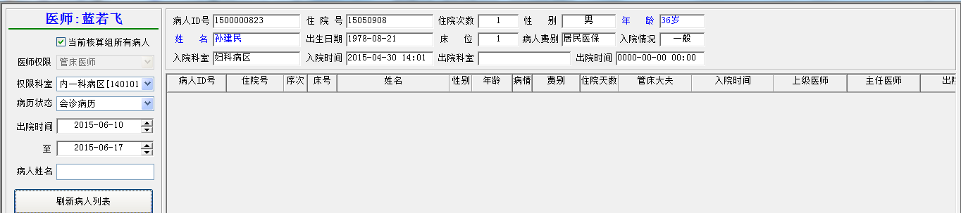

## 新建病历操作

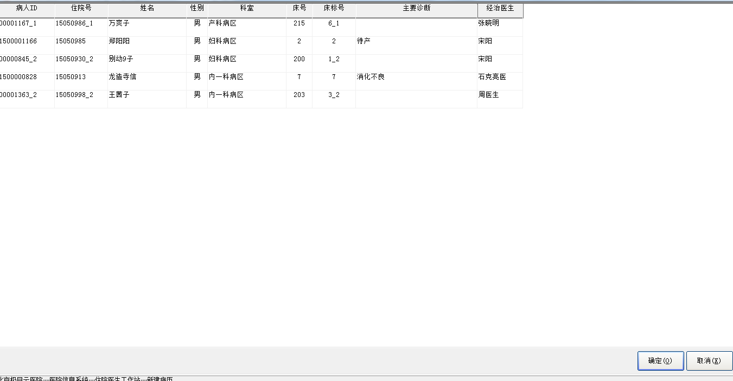

### 业务流程：

点击新建病历查询病人信息，根据病人信息循环判断是否有病历如果没有列表显示。

### 查询病人数据

--------------------------------------查询病人数据结果66条---------------------------------------------------

**SELECT** "PAT_MASTER_INDEX"."PATIENT_ID" ,

"PAT_MASTER_INDEX"."INP_NO" ,

"PATS_IN_HOSPITAL"."VISIT_ID" ,

"PAT_MASTER_INDEX"."SEX" ,

"PATS_IN_HOSPITAL"."BED_NO" ,

"PATS_IN_HOSPITAL"."DIAGNOSIS" ,

"PATS_IN_HOSPITAL"."DOCTOR_IN_CHARGE" ,

"PAT_MASTER_INDEX"."NAME_PHONETIC" ,

"PAT_MASTER_INDEX"."DATE_OF_BIRTH" ,

"PAT_MASTER_INDEX"."CHARGE_TYPE" ,

"PATS_IN_HOSPITAL"."PATIENT_CONDITION" ,

"DEPT_DICT"."DEPT_NAME" ,

"PATS_IN_HOSPITAL"."DEPT_CODE" ,

"INPADM"."BED_REC"."BED_LABEL" ,

"PAT_MASTER_INDEX"."NAME"

**FROM** "PAT_MASTER_INDEX" ,

"PATS_IN_HOSPITAL" ,

"DEPT_DICT" ,

"INPADM"."BED_REC"

**WHERE** ( "PAT_MASTER_INDEX"."PATIENT_ID" = "PATS_IN_HOSPITAL"."PATIENT_ID" ) and

( "PATS_IN_HOSPITAL"."DEPT_CODE" = "DEPT_DICT"."DEPT_CODE" ) and

( "PATS_IN_HOSPITAL"."BED_NO" = "INPADM"."BED_REC"."BED_NO" ) and

( "PATS_IN_HOSPITAL"."WARD_CODE" = "INPADM"."BED_REC"."WARD_CODE" ) and

( (( "PATS_IN_HOSPITAL"."WARD_CODE" **in** ( '2001','2002','2003','2012','2007','2008','220201' )) and

( "PATS_IN_HOSPITAL"."DEPT_CODE" **in** ( '140101','140102','140201','140302','210101','210201','220102' ))) or

("PATS_IN_HOSPITAL"."DEPT_CODE_LEND" **in** ( '140101','140102','140201','140302','210101','210201','220102' ) ) and

( "PATS_IN_HOSPITAL"."BED_NO" is **not** null ) )

### 住院次数查询病历数

--------------------------------------根据病人id和住院次数查询病历数---------------------------------------

**Select** count ( *) **From** mr_on_line **Where** patient_id ='1500001258' And visit_id =1

### 查询病人床号

--------------------------------------------确定操作------查询病人床号---------------------------------------------

SELECT bed_no FROM PATS_IN_HOSPITAL where patient_id ='1500000828'

-----------------------------------------确定操作------病历文件存储位置------------------------------------------

Select mr_path From mr_work_path

### 查询主管医生

----------------------确定操作---------查询主管医生---------------------

select super_doctor_id , parent_doctor_id from orders_group_rec where patient_id ='1500000828'and visit_id =69074945

### 查询病历数量

----------------------确定操作---------查询病历数量---------------------

**select** count ( *) **from** mr_on_line **where** patient_id ='1500000828' and visit_id =1

### 写入病历

----------------------确定操作---------写入病历---------------------

**InsertInto** mr_on_line ( patient_id , visit_id , status , request_doctor_id , request_date_time , super_doctor_id , parent_doctor_id ) Values ( '1500000828' , 69074945 , '0' , '000LRF' , '2015-06-17 11:21:35' , '0SKLYS' , NULL )

### 查询病案数

----------------------确定操作--------查询病案数量---------------------

SELECTCount ( *) FROM MR_Index Where Patient_ID ='1500000828'And Visit_ID =1278214145

### 写入病案信息

----------------------确定操作--------写入病案信息---------------------

**InsertInto** mr_index ( patient_id , visit_id , mr_status , access_path , last_access_date_time ) Values ( '1500000828' , 69074945 , 'O' , 'D:\MR' , '2015-06-17 11:21:35' )

### 更新患者主治医生

-------------------确定操作--------更新患者主治医生------------------

**update** pats_in_hospital set doctor_in_charge ='蓝若飞' **where** patient_id ='1500000828'

-------------------确定操作--------------------------

select dept_code , order_group from doctor_group where doctor_user ='000LRF'

### 更新病人对应科室等信息

-------------------确定操作--------更新病人对应科室等信息----------------

UpdateORDERS_GROUP_REC set ORDER_DOCTOR ='蓝若飞' , DEPT_CODE ='140302' , ORDER_GROUP ='140302' , DOCTOR_USER ='000LRF'where patient_id ='1500000828'

## 移入病历操作

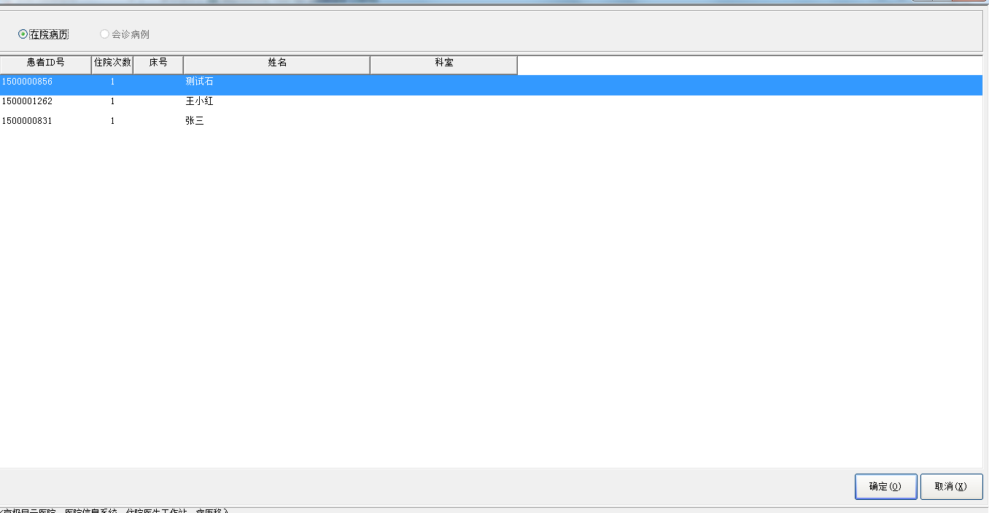

### 业务流程：

移入病历分为在院病历和会诊病历

### ？

-------------------------------无查询结果-----------------------------

SELECT "MR_ON_LINE"."PATIENT_ID",

"MR_ON_LINE"."VISIT_ID",

"MEDREC"."PAT_MASTER_INDEX"."NAME",

"MEDREC"."PAT_MASTER_INDEX"."SEX",

"MR_ON_LINE"."STATUS",

"MR_ON_LINE"."REQUEST_DOCTOR_ID",

"MR_ON_LINE"."REQUEST_DATE_TIME",

"MEDREC"."PAT_MASTER_INDEX"."NAME_PHONETIC",

"MEDREC"."PAT_MASTER_INDEX"."DATE_OF_BIRTH",

"MEDREC"."PAT_VISIT"."CHARGE_TYPE"

FROM "MEDREC"."PAT_MASTER_INDEX",

"MR_ON_LINE",

"MEDREC"."PAT_VISIT"

WHERE ( ( "MR_ON_LINE"."REQUEST_DOCTOR_ID" = '000LRF' ) AND

( "MR_ON_LINE"."STATUS" = '1' ) ) And

( "MR_ON_LINE"."PATIENT_ID" = "MEDREC"."PAT_MASTER_INDEX"."PATIENT_ID"(+) ) and

( "MR_ON_LINE"."PATIENT_ID" = "MEDREC"."PAT_VISIT"."PATIENT_ID"(+) ) and

( "MR_ON_LINE"."VISIT_ID" = "MEDREC"."PAT_VISIT"."VISIT_ID"(+) )

### 查询科室信息

-----------查询科室信息-----------------------------------

**SELECT** "COMM"."DEPT_DICT"."DEPT_CODE" , "COMM"."DEPT_DICT"."DEPT_NAME" **FROM** "COMM"."DEPT_DICT"

### ？

--------------------------------查询结果对应列表信息------------------------------------------------------

SELECT "MR_ON_LINE"."PATIENT_ID",

"MR_ON_LINE"."VISIT_ID",

"PAT_MASTER_INDEX"."NAME",

"PAT_MASTER_INDEX"."SEX",

"MR_ON_LINE"."STATUS",

"MR_ON_LINE"."REQUEST_DOCTOR_ID",

"MR_ON_LINE"."REQUEST_DATE_TIME",

"PAT_MASTER_INDEX"."NAME_PHONETIC",

"PAT_MASTER_INDEX"."DATE_OF_BIRTH",

"PAT_VISIT"."CHARGE_TYPE",

(select BED_label from bed_rec where ward_code=PATS_IN_HOSPITAL.ward_code and bed_no = PATS_IN_HOSPITAL.bed_no) bed_label,

"PATS_IN_HOSPITAL"."DEPT_CODE"

FROM "PAT_MASTER_INDEX",

"PATS_IN_HOSPITAL" ,

"MR_ON_LINE",

"PAT_VISIT"

WHERE ( "MR_ON_LINE"."STATUS" = '*' ) And

("PATS_IN_HOSPITAL"."WARD_CODE" ISNULLOR "PATS_IN_HOSPITAL"."WARD_CODE" in ('2001','2002','2003','2012','2007','2008','220201') ) and

("MR_ON_LINE"."PATIENT_ID"="PATS_IN_HOSPITAL"."PATIENT_ID") AND

( "MR_ON_LINE"."PATIENT_ID" = "PAT_MASTER_INDEX"."PATIENT_ID"(+) ) and

( "MR_ON_LINE"."PATIENT_ID" = "PAT_VISIT"."PATIENT_ID"(+)) and

( "MR_ON_LINE"."VISIT_ID" = "PAT_VISIT"."VISIT_ID" )

union

SELECT "MR_ON_LINE"."PATIENT_ID",

"MR_ON_LINE"."VISIT_ID",

"PAT_MASTER_INDEX"."NAME",

"PAT_MASTER_INDEX"."SEX",

"MR_ON_LINE"."STATUS",

"MR_ON_LINE"."REQUEST_DOCTOR_ID",

"MR_ON_LINE"."REQUEST_DATE_TIME",

"PAT_MASTER_INDEX"."NAME_PHONETIC",

"PAT_MASTER_INDEX"."DATE_OF_BIRTH",

"PAT_VISIT"."CHARGE_TYPE",

(select BED_label from bed_rec where ward_code=PATS_IN_HOSPITAL.ward_code and bed_no = PATS_IN_HOSPITAL.bed_no) bed_label,

"PATS_IN_HOSPITAL"."DEPT_CODE"

FROM "PAT_MASTER_INDEX",

"PATS_IN_HOSPITAL" ,

"MR_ON_LINE",

"PAT_VISIT"

WHERE ( "MR_ON_LINE"."STATUS" = '*' ) And

("PATS_IN_HOSPITAL"."LEND_INDICATOR" = 1AND "PATS_IN_HOSPITAL"."DEPT_CODE_LEND" IN ('140101','140102','140201','140302','210101','210201','220102')) AND

("MR_ON_LINE"."PATIENT_ID"="PATS_IN_HOSPITAL"."PATIENT_ID") AND

( "MR_ON_LINE"."PATIENT_ID" = "PAT_MASTER_INDEX"."PATIENT_ID"(+) ) and

( "MR_ON_LINE"."PATIENT_ID" = "PAT_VISIT"."PATIENT_ID"(+)) and

( "MR_ON_LINE"."VISIT_ID" = "PAT_VISIT"."VISIT_ID" )

### ？

--------------------------------------------无查询结果----------------------------------------------------------------

SELECT "ORDADM"."CONSULTATION_DOCTOR_MASTER"."PATIENT_ID",

"ORDADM"."CONSULTATION_DOCTOR_MASTER"."VISIT_ID",

"MEDREC"."PAT_MASTER_INDEX"."NAME",

"MEDREC"."PAT_MASTER_INDEX"."SEX",

'' status,

"ORDADM"."CONSULTATION_DOCTOR_DETAIL"."CONSULTATION_DOCTOR",

"ORDADM"."CONSULTATION_DOCTOR_MASTER"."CONSULTATION_DATE_TIME",

"MEDREC"."PAT_MASTER_INDEX"."NAME_PHONETIC",

"MEDREC"."PAT_MASTER_INDEX"."DATE_OF_BIRTH",

"PAT_VISIT"."CHARGE_TYPE",

"PATS_IN_HOSPITAL"."DEPT_CODE",

(SELECT BED_LABEL FROM BED_REC WHERE BED_NO = "PATS_IN_HOSPITAL"."BED_NO" AND WARD_CODE = "PATS_IN_HOSPITAL"."WARD_CODE") BED_NO,

"ORDADM"."CONSULTATION_DOCTOR_DETAIL"."CONSULTATION_DEPT"

FROM "ORDADM"."CONSULTATION_DOCTOR_DETAIL",

"MEDREC"."PAT_MASTER_INDEX",

"MEDREC"."PAT_VISIT",

"ORDADM"."CONSULTATION_DOCTOR_MASTER",

"PATS_IN_HOSPITAL"

WHERE ( "MEDREC"."PAT_MASTER_INDEX"."PATIENT_ID" = "MEDREC"."PAT_VISIT"."PATIENT_ID" ) and

"PATS_IN_HOSPITAL"."PATIENT_ID" = "PAT_VISIT"."PATIENT_ID" AND

"PATS_IN_HOSPITAL"."VISIT_ID" = "PAT_VISIT"."VISIT_ID" AND

( medrec.pat_visit.patient_id = ordadm.consultation_doctor_master.patient_id (+)) and

( medrec.pat_visit.visit_id = ordadm.consultation_doctor_master.visit_id (+)) and

( "ORDADM"."CONSULTATION_DOCTOR_DETAIL"."CONSULTATION_ID" = "ORDADM"."CONSULTATION_DOCTOR_MASTER"."CONSULTATION_ID" ) and

(("ORDADM"."CONSULTATION_DOCTOR_DETAIL"."CONSULTATION_DOCTOR" = '000LRF') OR

("ORDADM"."CONSULTATION_DOCTOR_DETAIL"."CONSULTATION_DOCTOR" ISNULLAND

"ORDADM"."CONSULTATION_DOCTOR_DETAIL"."CONSULTATION_DEPT" in ('140101','140102','140201','140302','210101','210201','220102'))) AND

("ORDADM"."CONSULTATION_DOCTOR_MASTER"."END_DATE_TIME" ISNULL) and

("ORDADM"."CONSULTATION_DOCTOR_DETAIL"."CONSULTATION_COMMIT" <>2)

## 移出病历操作

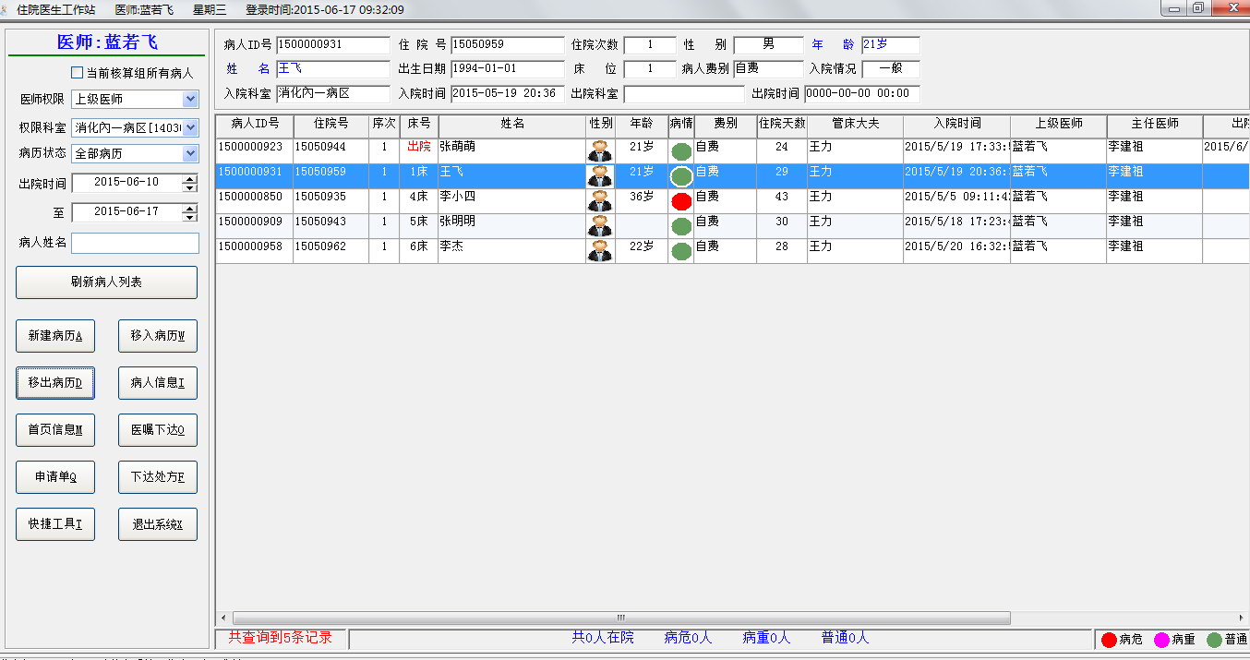

### 业务流程：

选中未出院的病人记录，点击移出病历，验证用户名密码，确认后完成操作。

### 验证密码

----------------------------------------------------根据用户名查询密码----------------------------------

**select** password **from** staff_dict **where** upper ( user_name ) =upper ( '000LRF' )

### ？

**SELECT** APP_GRANTS.CAPABILITY **FROM** APP_GRANTS , USERS **WHERE** ( APP_GRANTS.USER_ID =USERS.USER_ID ) and ( UPPER ( RTRIM ( APP_GRANTS.APPLICATION ) ) ='DOCTWS' ) and ( UPPER ( RTRIM ( USERS.DB_USER ) ) ='000LRF' )

### 医生工作组

------------------------------根据人员编号组代码查询数量----------------

selectcount ( *) from staff_vs_group where emp_no ='0028'and group_code ='140302'

------------------------------根据用户名查找用户id----------------

select user_id from users where db_user =upper ( '000LRF' )

### 查询用户权限

--------------------------根据程序名和用户id查询用户权限----------------

SELECT capability FROM APP_GRANTS where application ='DOCTWS'AND user_id ='0028'

### 更新病历状态

----------------------根据病人id和住院次数更新病历状态---------------

update mr_on_line Set status ='*' , request_doctor_id ='*'Where patient_id ='1500000931'And visit_id =65537

## 查看病人信息

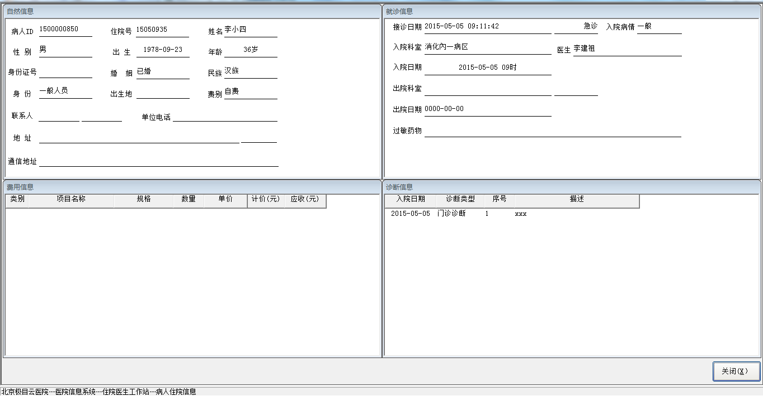

### 业务流程：

**选中病人点击查看病人信息，跳转到病人信息页面，显示病人基本信息、就诊信息、费用信息及诊断信息。**

### 出生日期及入院日期

-------------------------------------根据病人id查询出生日期及入院日期---------------------------

**select** a.date_of_birth , b.admission_date_time **from** pat_master_index a , pat_visit b **where** a.patient_id =b.patient_id and b.patient_id ='1500000850' and b.visit_id =1

### 病人基本信息

--------------------查询病人基本信息-------------------------------

select b.patient_id,

b.inp_no,

b.sex,

b.name,

b.date_of_birth,

a.charge_type,a.identity,

a.pat_adm_condition,

a.visit_id,

a.dept_admission_to,

a.admission_date_time,

a.dept_discharge_from,

a.discharge_date_time,

c.ward_code,c.dept_code,b.unit_in_contract,

(select bed_label from bed_rec where bed_no = c.bed_no and ward_code = c.ward_code) bed_label

From pat_visit a,

pat_master_index b,

pats_in_hospital c

where a.patient_id = b.patient_id

and a.patient_id = c.patient_id(+)

and a.visit_id = c.visit_id(+)

and a.patient_id = '1500000850'

and a.visit_id = '1'

SELECT "MEDREC"."PAT_MASTER_INDEX"."PATIENT_ID" , "MEDREC"."PAT_MASTER_INDEX"."SEX" , "MEDREC"."PAT_MASTER_INDEX"."DATE_OF_BIRTH" , "MEDREC"."PAT_MASTER_INDEX"."NATION" , "MEDREC"."PAT_MASTER_INDEX"."IDENTITY" , "MEDREC"."PAT_MASTER_INDEX"."CHARGE_TYPE" , "MEDREC"."PAT_VISIT"."MARITAL_STATUS" , "MEDREC"."PAT_MASTER_INDEX"."ID_NO" , "MEDREC"."PAT_MASTER_INDEX"."MAILING_ADDRESS" , "MEDREC"."PAT_MASTER_INDEX"."ZIP_CODE" , "MEDREC"."PAT_MASTER_INDEX"."NEXT_OF_KIN" , "MEDREC"."PAT_MASTER_INDEX"."NEXT_OF_KIN_ADDR" , "MEDREC"."PAT_MASTER_INDEX"."NEXT_OF_KIN_PHONE" , "COMM"."RELATIONSHIP_DICT"."RELATIONSHIP_NAME" , "COMM"."AREA_DICT"."AREA_NAME" , "MEDREC"."PAT_MASTER_INDEX"."NEXT_OF_KIN_ZIP_CODE" , "MEDREC"."PAT_MASTER_INDEX"."PHONE_NUMBER_BUSINESS" , "MEDREC"."PAT_MASTER_INDEX"."PHONE_NUMBER_HOME" , "MEDREC"."PAT_MASTER_INDEX"."NAME" , "MEDREC"."PAT_MASTER_INDEX"."INP_NO" FROM "MEDREC"."PAT_MASTER_INDEX" , "MEDREC"."PAT_VISIT" , "COMM"."RELATIONSHIP_DICT" , "COMM"."AREA_DICT" WHERE ( "MEDREC"."PAT_MASTER_INDEX"."RELATIONSHIP" = "COMM"."RELATIONSHIP_DICT"."RELATIONSHIP_CODE" (+)) and ( "MEDREC"."PAT_MASTER_INDEX"."BIRTH_PLACE" = "COMM"."AREA_DICT"."AREA_CODE" (+)) and ( "MEDREC"."PAT_MASTER_INDEX"."PATIENT_ID" = "MEDREC"."PAT_VISIT"."PATIENT_ID" ) and ( ( MEDREC."PAT_VISIT"."PATIENT_ID" = '1500000850' ) and ( MEDREC."PAT_VISIT"."VISIT_ID" = '1' ) )

---------------------------------转院原因-------------------------

SELECT "COMM"."DISCHARGE_DISPOSITION_DICT"."DISCHARGE_DISPOSITION_CODE" , "COMM"."DISCHARGE_DISPOSITION_DICT"."DISCHARGE_DISPOSITION_NAME" FROM "COMM"."DISCHARGE_DISPOSITION_DICT"

### 病区部门入院类型字典

**--------------------------------------------------病区---------------------------------------------------**

SELECT "COMM"."DEPT_DICT"."DEPT_CODE" , "COMM"."DEPT_DICT"."DEPT_NAME" FROM "COMM"."DEPT_DICT" WHERE ( COMM."DEPT_DICT"."CLINIC_ATTR" = 0 ) and ( COMM."DEPT_DICT"."OUTP_OR_INP" = 1 )

---------------------------------部门-----------------------

SELECT "COMM"."DEPT_DICT"."DEPT_NAME" , "COMM"."DEPT_DICT"."DEPT_CODE" FROM "COMM"."DEPT_DICT"

---------------------------入院类型-------------------------

SELECT "COMM"."PATIENT_CLASS_DICT"."PATIENT_CLASS_CODE" , "COMM"."PATIENT_CLASS_DICT"."PATIENT_CLASS_NAME" FROM "COMM"."PATIENT_CLASS_DICT"

### 就诊信息

---------------------------------就诊信息---------------------

SELECT "MEDREC"."PAT_VISIT"."ADMISSION_DATE_TIME" , "MEDREC"."PAT_VISIT"."PAT_ADM_CONDITION" , "MEDREC"."PAT_VISIT"."PATIENT_CLASS" , "MEDREC"."PAT_VISIT"."DISCHARGE_DISPOSITION" , "MEDREC"."PAT_VISIT"."DISCHARGE_DATE_TIME" , "MEDREC"."PAT_VISIT"."DEPT_ADMISSION_TO" , "MEDREC"."PAT_VISIT"."DEPT_DISCHARGE_FROM" , "MEDREC"."PAT_VISIT"."CONSULTING_DATE" , "MEDREC"."PAT_VISIT"."CONSULTING_DOCTOR" , "MEDREC"."PAT_VISIT"."ALERGY_DRUGS" FROM "MEDREC"."PAT_VISIT" WHERE ( MEDREC."PAT_VISIT"."PATIENT_ID" = '1500000850' ) and ( MEDREC."PAT_VISIT"."VISIT_ID" = '1' )

### 费用信息

--------------------------费用信息--------------------------------

SELECT "INP_BILL_DETAIL"."ITEM_CLASS" ,

"INP_BILL_DETAIL"."ITEM_NAME" ,

"INP_BILL_DETAIL"."ITEM_SPEC" ,

"INP_BILL_DETAIL"."AMOUNT" ,

"INP_BILL_DETAIL"."UNITS" ,

"INP_BILL_DETAIL"."ITEM_PRICE" ,

"INP_BILL_DETAIL"."CHARGES" ,

"INP_BILL_DETAIL"."COSTS"

FROM "INP_BILL_DETAIL"

WHERE ( patient_id = '1500000850' ) and ( visit_id = '1' )

SELECT prepayments , total_charges FROM pats_in_hospital Where patient_id ='1500000850'And visit_id =5963777

## 查看病人首页信息

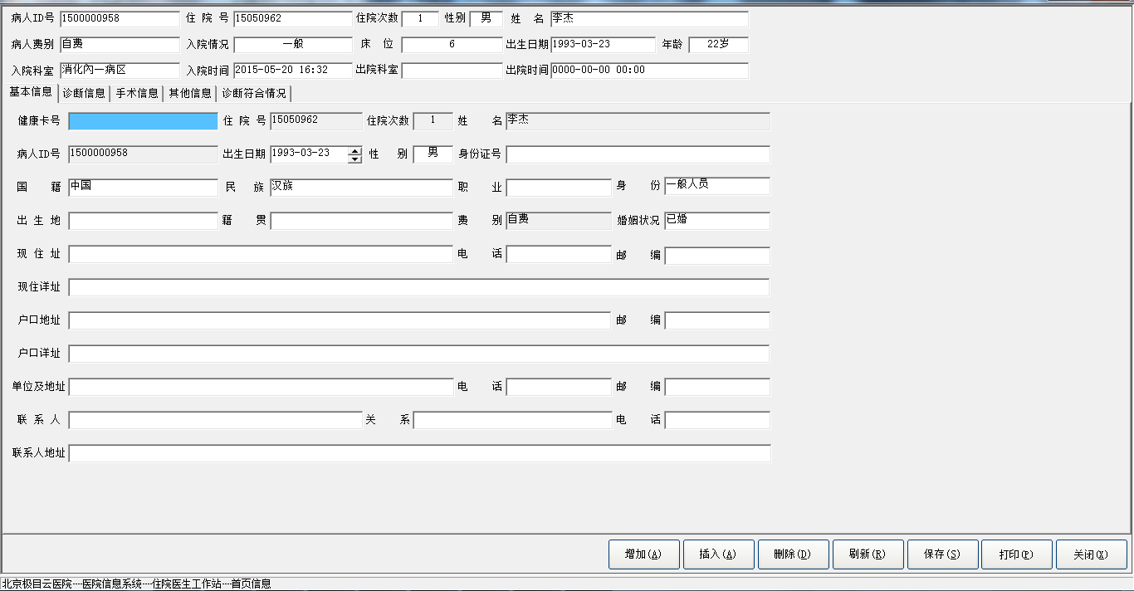

### 业务流程：

**选中病人后点击查看首页信息，跳转病人综合信息页面。页面包含基本信息，诊断信息，手术信息，其它信息等，可以进行信息维护。**

### 判断是否新生儿-

--------------------------------判断是否新生儿---------------------------------------------------

SELECTcount ( *) FROM newborn_rec where patient_id ='1500000958'

### 查询诊断类型

--------------------------------查询诊断类型---------------------------------------------------

selectcount ( *) from DIAGNOSIS_TYPE_DICT where is_visible =1and DIAGNOSIS_TYPE_CODE ='9'

### 应用参数设置表

select PARAMETER_VALUE from app_configer_parameter where app_name ='DOCTOR'and PARAMETER_NAME ='MRCLSFY_DIAG_CODE'

**select** PARAMETER_VALUE **from** app_configer_parameter **where** app_name ='DOCTOR' and PARAMETER_NAME ='MRCLSFY_DIAG_CODE_HARM'

**select** PARAMETER_VALUE **from** app_configer_parameter **where** app_name ='DOCTOR' and PARAMETER_NAME ='MRCLSFY_DIAG_CODE_M'

**select** PARAMETER_VALUE **from** app_configer_parameter **where** app_name ='DOCTOR' and PARAMETER_NAME ='MRCLSFY_OPER_CODE'

**select** PARAMETER_VALUE **from** app_configer_parameter **where** app_name ='DOCTOR' and PARAMETER_NAME ='MRCLSFY_OPER_DESC'

**select** PARAMETER_VALUE **from** app_configer_parameter **where** app_name ='DOCTOR' and PARAMETER_NAME ='MRCLSFY_OPER_SCALAE'

**select** PARAMETER_VALUE **from** app_configer_parameter **where** app_name ='DOCTOR' and PARAMETER_NAME ='MRCLSFY_DIAG_NUM'

**select** PARAMETER_VALUE **from** app_configer_parameter **where** app_name ='DOCTOR' and PARAMETER_NAME ='MRCLSFY_BASE_NOT_NULL'

**select** PARAMETER_VALUE **from** app_configer_parameter **where** app_name ='DOCTOR' and PARAMETER_NAME ='MRCLSFY_CODE_NOT_NULL'

**select** PARAMETER_VALUE **from** app_configer_parameter **where** app_name ='DOCTOR' and PARAMETER_NAME ='MRCLSFY_DIAG_INPUT'

### 输入法配置

**select** count ( *) **from** input_setting **where** dict_type ='首页诊断'

**select** PARAMETER_VALUE **from** app_configer_parameter **where** app_name ='DOCTOR' and PARAMETER_NAME ='MRCLSFY_NEW'

**select** PARAMETER_VALUE **from** app_configer_parameter **where** app_name ='DOCTOR' and PARAMETER_NAME ='MRCLSFY_MR_QUALITY'

**select** count ( *) **from** newborn_rec **where** patient_id ='1500000958'

**select** dept_name,dept_code **From** dept_dict

### 病人住院记录

**select** b.patient_id,

b.inp_no,

b.sex,

b.name,

b.date_of_birth,

b.charge_type,

a.pat_adm_condition,

a.visit_id,

a.dept_admission_to,

a.admission_date_time,

a.dept_discharge_from,

a.discharge_date_time,

c.ward_code,

(**select** bed_label **from** bed_rec **where** bed_no = c.bed_no and ward_code = c.ward_code) bed_label

**From** pat_visit a,

pat_master_index b,

pats_in_hospital c

**where** a.patient_id = b.patient_id

and a.patient_id = c.patient_id(+)

and a.visit_id = c.visit_id(+)

and a.patient_id = '1500000958'

and a.visit_id = '1'

select nation_name, nation_code from nation_dict

SELECT "AREA_DICT"."AREA_CODE", "AREA_DICT"."AREA_NAME" FROM "AREA_DICT"

select * From OCCUPATION_DICT

**select** b.identity_code,b.identity_name **From** identity_dict b

**select** * **From** MARITAL_STATUS_DICT

**select** * **from** RELATIONSHIP_DICT

### 国家字典

**SELECT** "COUNTRY_DICT"."COUNTRY_NAME" , "COUNTRY_DICT"."COUNTRY_CODE" **FROM** "COUNTRY_DICT" ORDER BY "COUNTRY_DICT"."SERIAL_NO" ASC

### 病人基本信息

**select** b.healthy_card_no,

a.patient_id,

a.visit_id,

b.inp_no,

b.name,b.sex,

b.date_of_birth,

b.citizenship,

b.nation,

b.id_no,

b.birth_place,

b.native_place,

a.occupation,

a.identity,

a.charge_type,

a.marital_status,

a.patient_area,a.PATIENT_AREA_ADDRESS,

a.pat_phone,

a.pat_zip,

b.mailing_address_code,b.mailing_address,

b.zip_code,

a.service_agency,

a.phone_number_business,

a.business_zip_code,

a.next_of_kin,

a.relationship,

a.next_of_kin_addr,

a.next_of_kin_phone

**from** pat_visit a,

pat_master_index b

**where** a.patient_id = b.patient_id

and a.patient_id = '1500000958'

and a.visit_id = '1'

### 诊断类别字典

**SELECT** "DIAGNOSIS_TYPE_DICT"."DIAGNOSIS_TYPE_CODE", "DIAGNOSIS_TYPE_DICT"."DIAGNOSIS_TYPE_NAME" **FROM** "DIAGNOSIS_TYPE_DICT" **where** is_visible = 1 ORDER BY "DIAGNOSIS_TYPE_DICT"."DIAGNOSIS_TYPE_CODE" ASC

### ？

select * From admission_condition_dict

select diagnosis_code,diagnosis_name From diagnosis_dict

### 诊断记录

select PATIENT_ID,

VISIT_ID,

DIAGNOSIS_TYPE,

DIAGNOSIS_NO,

DIAGNOSIS_DESC,

DIAGNOSIS_DATE,

TREAT_DAYS,

TREAT_RESULT,

OPER_TREAT_INDICATOR,

DIAGNOSIS_CODE,

INSERT_INDICATOR,

DIAGNOSIS_CODE2,

ADMISSION_CONDITION,PATHOLOGY_NO

From diagnosis

where patient_id = '1500000958'

and visit_id = '1'

### 用户表

**select**'' USER_NAME,'' NAME **From** dual **unionallselect** USER_NAME,NAME **From** STAFF_DICT **where** user_name is **not** null

### ANAESTHESIA_DICT哪个字典？

**select** ANAESTHESIA_CODE,ANAESTHESIA_NAME **from** ( **select**''ANAESTHESIA_CODE,'' ANAESTHESIA_NAME **from** dual **unionallselect** ANAESTHESIA_DICT.ANAESTHESIA_CODE,ANAESTHESIA_DICT.ANAESTHESIA_NAME **from** ANAESTHESIA_DICT )

### 切口愈合字典

**select** heal_code,heal_name **From** heal_dict **unionallselect**'' heal_code,'' heal_name **from** dual

### 切口等级字典

**select** wound_grade_code,wound_grade_name **From** wound_grade_dict **unionallselect**'' wound_grade_code , '' wound_grade_name **From** dual

**select** * **From** COMM.operation_scale_dict

**select**

PATIENT_ID,

VISIT_ID,

OPERATION_NO,

OPERATION_DESC,

OPERATION_CODE,

HEAL,

WOUND_GRADE,

OPERATING_DATE,

ANAESTHESIA_METHOD,

OPERATOR ,

FIRST_ASSISTANT ,

SECOND_ASSISTANT,

ANESTHESIA_DOCTOR,

STATISTICS_FLAG,

STATISTICS_CODE ,

OPERATION_DEPT,

OPERATION_NUM,

OPERATION_SCALE

**From** operation

**where** patient_id = '1500000958'

and visit_id = '1'

**select** * **From** MR_MEDICAL_PAY_WAY

**select** * **From** blood_type_rh_dict

**select** * **From** blood_type_dict

**select**'' USER_NAME,'' NAME **From** dual **unionallselect** USER_NAME,NAME **From** STAFF_DICT **where** user_name is **not** null

**select** a.patient_id,

a.visit_id,

a.patient_class,

'' is_ALERGY_DRUGS,

a.ALERGY_DRUGS,

a.AUTOPSY_INDICATOR,

a.blood_type,

a.blood_type_rh,

a.DIRECTOR,

a.CHIEF_DOCTOR,

a.ATTENDING_DOCTOR,

a.DOCTOR_IN_CHARGE,

a.ADVANCED_STUDIES_DOCTOR,

a.duty_nurse,

a.practice_doctor,

a.mr_quality,

a.doctor_of_control_quality,

a.nurse_of_control_quality,

a.date_of_control_quality,

a.medical_pay_way,

a.diagnose_date,

a.EMER_TREAT_TIMES,

a.ESC_EMER_TIMES,

a.discharge_disposition,

a.trans_hospital,

a.trans_community,

a.reason_31_admission,a.plan_31_admission,

COMA_TIMES_B0,COMA_TIMES_B1,COMA_TIMES_B2,

COMA_TIMES_A0,COMA_TIMES_A1,COMA_TIMES_A2

**from** pat_visit a

**where** a.patient_id = '1500000958'

and a.visit_id = '1'

**select** *

**From** diag_comparing

**where** patient_id = '1500000958'

and visit_id = '1'

**select** catalog_status **From** pat_visit **where** patient_id ='1500000958' and visit_id =36831233

### 保存患者基本信息

**update** pat_master_index set healthy_card_no ='2323322' , sex ='男' , date_of_birth ='1993-03-23 00:00:00' , citizenship ='CN' , nation ='汉族' , id_no ='610431199105242219' , birth_place ='431122' , native_place ='431122' , mailing_address_code ='433122' , mailing_address ='湖南湘西土家族苗族自治州泸溪县' , zip_code =NULL **where** patient_id ='1500000958'

**UPDATE** "PAT_VISIT" SET "OCCUPATION" = '21', "PATIENT_AREA" = '431122', "PATIENT_AREA_ADDRESS" = '湖南永州东安县'**WHERE** "PATIENT_ID" = '1500000958' AND "VISIT_ID" = '1' AND "OCCUPATION" IS NULL AND "IDENTITY" = '一般人员' AND "CHARGE_TYPE" = '自费' AND "MARITAL_STATUS" = '已婚' AND "PATIENT_AREA" IS NULL AND "PATIENT_AREA_ADDRESS" IS NULL AND "PAT_PHONE" IS NULL AND "PAT_ZIP" IS NULL AND "SERVICE_AGENCY" IS NULL AND "PHONE_NUMBER_BUSINESS" IS NULL AND "BUSINESS_ZIP_CODE" IS NULL AND "NEXT_OF_KIN" IS NULL AND "RELATIONSHIP" IS NULL AND "NEXT_OF_KIN_ADDR" IS NULL AND "NEXT_OF_KIN_PHONE" IS NULL

### 保存诊断信息

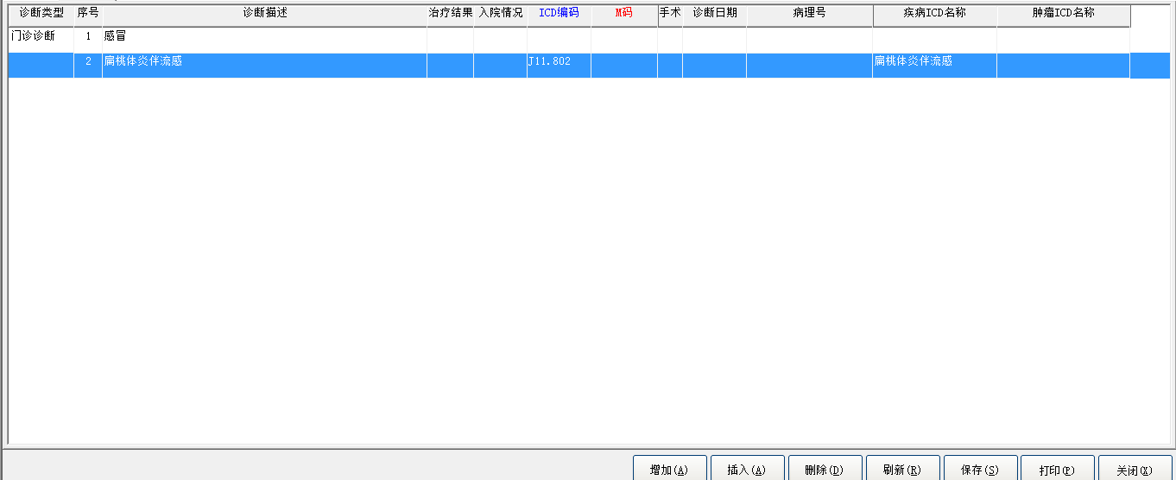

**INSERTINTO** "DIAGNOSIS" ( "PATIENT_ID", "VISIT_ID", "DIAGNOSIS_TYPE", "DIAGNOSIS_NO", "DIAGNOSIS_DESC", "DIAGNOSIS_DATE", "TREAT_DAYS", "TREAT_RESULT", "OPER_TREAT_INDICATOR", "DIAGNOSIS_CODE", "INSERT_INDICATOR", "DIAGNOSIS_CODE2", "ADMISSION_CONDITION", "PATHOLOGY_NO" ) VALUES ( '1500000958', '1', '1', '2', '扁桃体炎伴流感', '2015-05-20 00:00:00', NULL, NULL, NULL, 'J11.802', NULL, NULL, NULL, NULL )

:1=['1500000958']

:2=['1']

:3=['1']

:4=['2']

:5=['扁桃体炎伴流感']

:6=['2015-05-20 00:00:00']

:7=[NULL]

:8=[NULL]

:9=[NULL]

:10=['J11.802']

:11=[NULL]

:12=[NULL]

:13=[NULL]

:14=[NULL]

### 保存手术记录

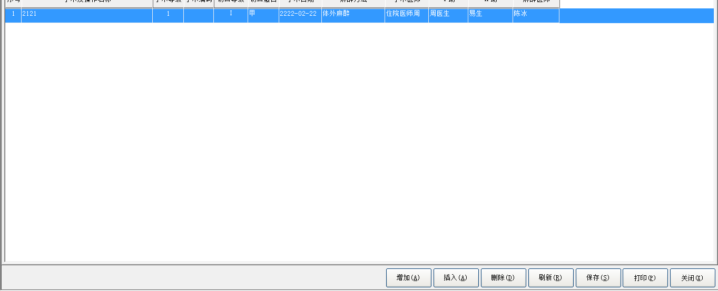

**INSERTINTO** "OPERATION" ( "PATIENT_ID", "VISIT_ID", "OPERATION_NO", "OPERATION_DESC", "OPERATION_CODE", "HEAL", "WOUND_GRADE", "OPERATING_DATE", "ANAESTHESIA_METHOD", "OPERATOR", "FIRST_ASSISTANT", "SECOND_ASSISTANT", "ANESTHESIA_DOCTOR", "STATISTICS_FLAG", "STATISTICS_CODE", "OPERATION_DEPT", "OPERATION_NUM", "OPERATION_SCALE" ) VALUES ( '1500000958', '1', '1', '2121', NULL, '甲', 'Ⅰ', '2222-02-22 00:00:00', 'M', '000016', '000005', '000020', '0000CB', NULL, NULL, NULL, NULL, '1' )

### 保存其它信息

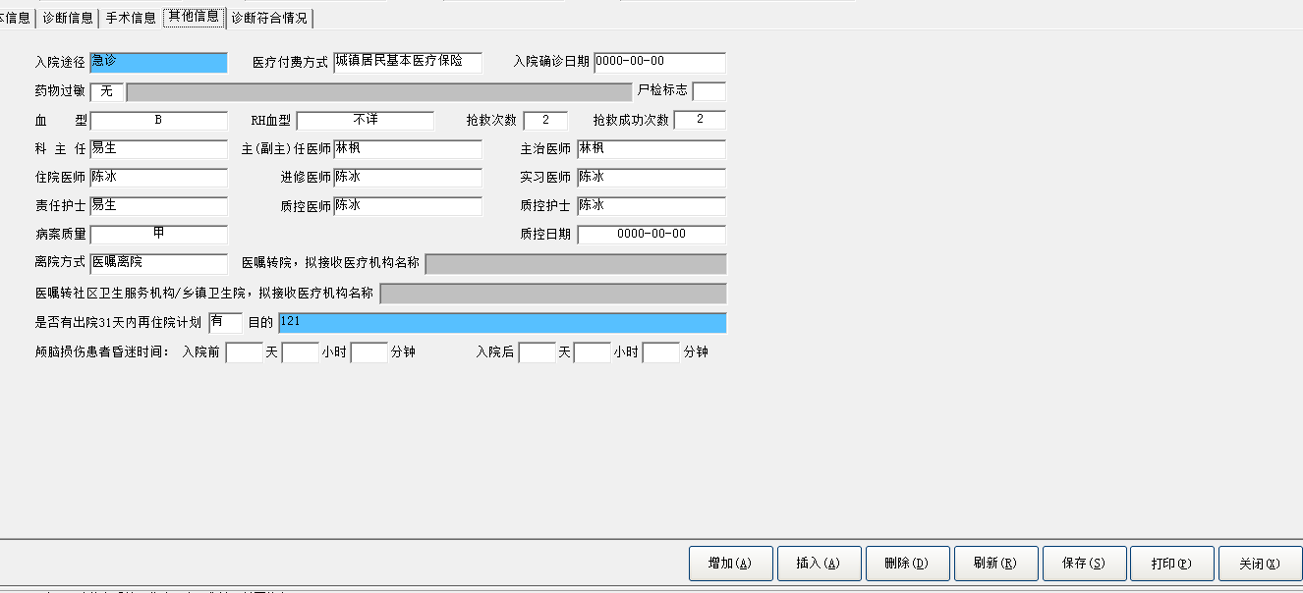

**DELETEFROM** "OPERATION" **WHERE** "PATIENT_ID" = '1500000958' AND "VISIT_ID" = '1' AND "OPERATION_NO" = '1' AND "OPERATION_DESC" = '2121' AND "OPERATION_CODE" IS NULL AND "HEAL" = '甲' AND "WOUND_GRADE" = 'Ⅰ' AND "OPERATING_DATE" = '2222-02-22 00:00:00' AND "ANAESTHESIA_METHOD" = 'M' AND "OPERATOR" = '000016' AND "FIRST_ASSISTANT" = '000005' AND "SECOND_ASSISTANT" = '000020' AND "ANESTHESIA_DOCTOR" = '0000CB' AND "STATISTICS_FLAG" IS NULL AND "STATISTICS_CODE" IS NULL AND "OPERATION_DEPT" IS NULL AND "OPERATION_NUM" IS NULL AND "OPERATION_SCALE" = '1'

**INSERTINTO** "OPERATION" ( "PATIENT_ID", "VISIT_ID", "OPERATION_NO", "OPERATION_DESC", "OPERATION_CODE", "HEAL", "WOUND_GRADE", "OPERATING_DATE", "ANAESTHESIA_METHOD", "OPERATOR", "FIRST_ASSISTANT", "SECOND_ASSISTANT", "ANESTHESIA_DOCTOR", "STATISTICS_FLAG", "STATISTICS_CODE", "OPERATION_DEPT", "OPERATION_NUM", "OPERATION_SCALE" ) VALUES ( '1500000958', '1', '1', '2121', NULL, '甲', 'Ⅰ', '2222-02-22 00:00:00', 'M', '000016', '000005', '000020', '0000CB', NULL, NULL, NULL, NULL, '1' )

**UPDATE** "PAT_VISIT" SET "BLOOD_TYPE" = 'B', "BLOOD_TYPE_RH" = '不详', "DIRECTOR" = '000020', "CHIEF_DOCTOR" = '0000LF', "ATTENDING_DOCTOR" = '0000LF', "DOCTOR_IN_CHARGE" = '0000CB', "ADVANCED_STUDIES_DOCTOR" = '0000CB', "DUTY_NURSE" = '000020', "PRACTICE_DOCTOR" = '0000CB', "DOCTOR_OF_CONTROL_QUALITY" = '0000CB', "NURSE_OF_CONTROL_QUALITY" = '0000CB', "MEDICAL_PAY_WAY" = '2', "EMER_TREAT_TIMES" = '2', "ESC_EMER_TIMES" = '2', "REASON_31_ADMISSION" = '121', "PLAN_31_ADMISSION" = '2'**WHERE** "PATIENT_ID" = '1500000958' AND "VISIT_ID" = '1' AND "PATIENT_CLASS" = '1' AND "ALERGY_DRUGS" IS NULL AND "AUTOPSY_INDICATOR" IS NULL AND "BLOOD_TYPE" IS NULL AND "BLOOD_TYPE_RH" IS NULL AND "DIRECTOR" IS NULL AND "CHIEF_DOCTOR" IS NULL AND "ATTENDING_DOCTOR" IS NULL AND "DOCTOR_IN_CHARGE" IS NULL AND "ADVANCED_STUDIES_DOCTOR" IS NULL AND "DUTY_NURSE" IS NULL AND "PRACTICE_DOCTOR" IS NULL AND "MR_QUALITY" = '甲' AND "DOCTOR_OF_CONTROL_QUALITY" IS NULL AND "NURSE_OF_CONTROL_QUALITY" IS NULL AND "DATE_OF_CONTROL_QUALITY" IS NULL AND "MEDICAL_PAY_WAY" IS NULL AND "DIAGNOSE_DATE" IS NULL AND "EMER_TREAT_TIMES" IS NULL AND "ESC_EMER_TIMES" IS NULL AND "DISCHARGE_DISPOSITION" = '1' AND "TRANS_HOSPITAL" IS NULL AND "TRANS_COMMUNITY" IS NULL AND "REASON_31_ADMISSION" IS NULL AND "PLAN_31_ADMISSION" IS NULL AND "COMA_TIMES_B0" IS NULL AND "COMA_TIMES_B1" IS NULL AND "COMA_TIMES_B2" IS NULL AND "COMA_TIMES_A0" IS NULL AND "COMA_TIMES_A1" IS NULL AND "COMA_TIMES_A2" IS NULL

### 保存诊断符合情况

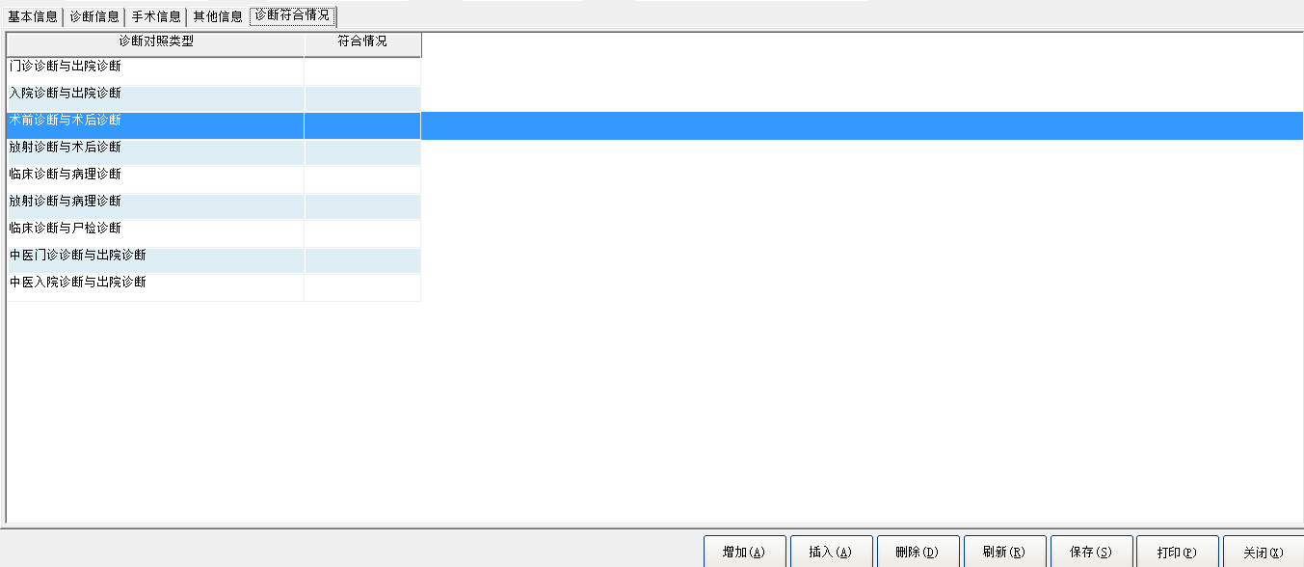

**DELETEFROM** "OPERATION" **WHERE** "PATIENT_ID" = '1500000958' AND "VISIT_ID" = '1' AND "OPERATION_NO" = '1' AND "OPERATION_DESC" = '2121' AND "OPERATION_CODE" IS NULL AND "HEAL" = '甲' AND "WOUND_GRADE" = 'Ⅰ' AND "OPERATING_DATE" = '2222-02-22 00:00:00' AND "ANAESTHESIA_METHOD" = 'M' AND "OPERATOR" = '000016' AND "FIRST_ASSISTANT" = '000005' AND "SECOND_ASSISTANT" = '000020' AND "ANESTHESIA_DOCTOR" = '0000CB' AND "STATISTICS_FLAG" IS NULL AND "STATISTICS_CODE" IS NULL AND "OPERATION_DEPT" IS NULL AND "OPERATION_NUM" IS NULL AND "OPERATION_SCALE" = '1'

**INSERTINTO** "OPERATION" ( "PATIENT_ID", "VISIT_ID", "OPERATION_NO", "OPERATION_DESC", "OPERATION_CODE", "HEAL", "WOUND_GRADE", "OPERATING_DATE", "ANAESTHESIA_METHOD", "OPERATOR", "FIRST_ASSISTANT", "SECOND_ASSISTANT", "ANESTHESIA_DOCTOR", "STATISTICS_FLAG", "STATISTICS_CODE", "OPERATION_DEPT", "OPERATION_NUM", "OPERATION_SCALE" ) VALUES ( '1500000958', '1', '1', '2121', NULL, '甲', 'Ⅰ', '2222-02-22 00:00:00', 'M', '000016', '000005', '000020', '0000CB', NULL, NULL, NULL, NULL, '1' )

**UPDATE** "DIAG_COMPARING" SET "DIAG_CORRESPONDENCE" = '1'**WHERE** "PATIENT_ID" = '1500000958' AND "VISIT_ID" = '1' AND "DIAG_COMPARE_GROUP" = '1' AND "DIAG_CORRESPONDENCE" IS NULL AND "STATISTICS_CORRESPONDENCE" IS NULL

**UPDATE** "DIAG_COMPARING" SET "DIAG_CORRESPONDENCE" = '1'**WHERE** "PATIENT_ID" = '1500000958' AND "VISIT_ID" = '1' AND "DIAG_COMPARE_GROUP" = '2' AND "DIAG_CORRESPONDENCE" IS NULL AND "STATISTICS_CORRESPONDENCE" IS NULL

**UPDATE** "DIAG_COMPARING" SET "DIAG_CORRESPONDENCE" = '1'**WHERE** "PATIENT_ID" = '1500000958' AND "VISIT_ID" = '1' AND "DIAG_COMPARE_GROUP" = '3' AND "DIAG_CORRESPONDENCE" IS NULL AND "STATISTICS_CORRESPONDENCE" IS NULL

**UPDATE** "DIAG_COMPARING" SET "DIAG_CORRESPONDENCE" = '3'**WHERE** "PATIENT_ID" = '1500000958' AND "VISIT_ID" = '1' AND "DIAG_COMPARE_GROUP" = '4' AND "DIAG_CORRESPONDENCE" IS NULL AND "STATISTICS_CORRESPONDENCE" IS NULL

**UPDATE** "DIAG_COMPARING" SET "DIAG_CORRESPONDENCE" = '0'**WHERE** "PATIENT_ID" = '1500000958' AND "VISIT_ID" = '1' AND "DIAG_COMPARE_GROUP" = '5' AND "DIAG_CORRESPONDENCE" IS NULL AND "STATISTICS_CORRESPONDENCE" IS NULL

**UPDATE** "DIAG_COMPARING" SET "DIAG_CORRESPONDENCE" = '0'**WHERE** "PATIENT_ID" = '1500000958' AND "VISIT_ID" = '1' AND "DIAG_COMPARE_GROUP" = '6' AND "DIAG_CORRESPONDENCE" IS NULL AND "STATISTICS_CORRESPONDENCE" IS NULL

**UPDATE** "DIAG_COMPARING" SET "DIAG_CORRESPONDENCE" = '0'**WHERE** "PATIENT_ID" = '1500000958' AND "VISIT_ID" = '1' AND "DIAG_COMPARE_GROUP" = '7' AND "DIAG_CORRESPONDENCE" IS NULL AND "STATISTICS_CORRESPONDENCE" IS NULL

**UPDATE** "DIAG_COMPARING" SET "DIAG_CORRESPONDENCE" = '0'**WHERE** "PATIENT_ID" = '1500000958' AND "VISIT_ID" = '1' AND "DIAG_COMPARE_GROUP" = '8' AND "DIAG_CORRESPONDENCE" IS NULL AND "STATISTICS_CORRESPONDENCE" IS NULL

**UPDATE** "DIAG_COMPARING" SET "DIAG_CORRESPONDENCE" = '0'**WHERE** "PATIENT_ID" = '1500000958' AND "VISIT_ID" = '1' AND "DIAG_COMPARE_GROUP" = '9' AND "DIAG_CORRESPONDENCE" IS NULL AND "STATISTICS_CORRESPONDENCE" IS NULL

## 医嘱下达页面、

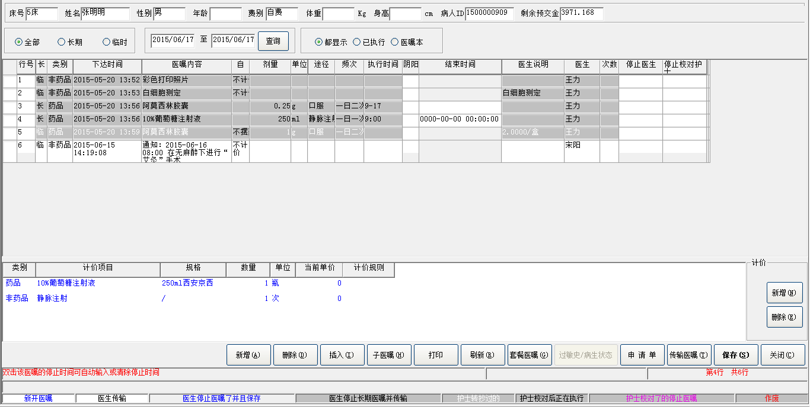

业务流程：患者列表页面，选择患者，点击医嘱下达，跳转到医嘱信息页面，医嘱信息页面包含5部分，1、病人基本信息 2、医嘱信息过滤条件 3、医嘱列表 4、医嘱明细

5、操作按钮。

### 患者基本信息

-----------------------------------------------患者基本信息----------------------------------------------

select b.patient_id,

b.inp_no,

b.sex,

b.name,

b.date_of_birth,

a.charge_type,a.identity,

a.pat_adm_condition,

a.visit_id,

a.dept_admission_to,

a.admission_date_time,

a.dept_discharge_from,

a.discharge_date_time,

c.ward_code,c.dept_code,b.unit_in_contract,

(select bed_label from bed_rec where bed_no = c.bed_no and ward_code = c.ward_code) bed_label

From pat_visit a,

pat_master_index b,

pats_in_hospital c

where a.patient_id = b.patient_id

and a.patient_id = c.patient_id(+)

and a.visit_id = c.visit_id(+)

and a.patient_id = '1500000909'

and a.visit_id = '1'

**select** sum ( amount ) **from** prepayment_rcpt **where** patient_id ='1500000909' and visit_id =1 and transact_type <>'作废'

### 药品单位信息

--------------------------------------------药品单位信息------------------------------------------------

SELECT "DOSAGE_UNITS_DICT"."DOSAGE_UNITS" , "DOSAGE_UNITS_DICT"."SERIAL_NO" , "DOSAGE_UNITS_DICT"."INPUT_CODE" FROM "DOSAGE_UNITS_DICT"

### 项目类型

----------------------项目类型---------------------------------

SELECT ADMINISTRATION_NAME, SERIAL_NO , ADMINISTRATION_CODE, INPUT_CODE FROM ADMINISTRATION_DICT WHERE INP_OUTP_FLAG ='1'OR INP_OUTP_FLAG ISNULL

### 服用类型字典

------------------------服用类型字典-----------------------------------

SELECT "PERFORM_FREQ_DICT"."SERIAL_NO" , "PERFORM_FREQ_DICT"."FREQ_DESC" , "PERFORM_FREQ_DICT"."FREQ_COUNTER" , "PERFORM_FREQ_DICT"."FREQ_INTERVAL" , "PERFORM_FREQ_DICT"."FREQ_INTERVAL_UNITS" FROM "PERFORM_FREQ_DICT"

### 医嘱列表

-----------------------医嘱列表--------------------------------

SELECT "ORDERS"."START_DATE_TIME",

"ORDERS"."ORDER_TEXT",

"ORDERS"."DOSAGE",

"ORDERS"."DOSAGE_UNITS",

"ORDERS"."ADMINISTRATION",

"ORDERS"."DURATION",

"ORDERS"."DURATION_UNITS",

"ORDERS"."FREQUENCY",

"ORDERS"."FREQ_COUNTER",

"ORDERS"."FREQ_INTERVAL",

"ORDERS"."FREQ_INTERVAL_UNIT",

substr("ORDERS"."DOCTOR",1,8) DOCTOR,

substr("ORDERS"."NURSE",1,8) NURSE,

substr("ORDERS"."STOP_DOCTOR",1,8) STOP_DOCTOR,

"ORDERS"."ORDER_CLASS",

"ORDERS"."REPEAT_INDICATOR",

"ORDERS"."STOP_DATE_TIME",

"ORDERS"."ORDER_CODE",

"ORDERS"."ORDER_STATUS",

"ORDERS"."ENTER_DATE_TIME",

"ORDERS"."FREQ_DETAIL",

"ORDERS"."PATIENT_ID",

"ORDERS"."VISIT_ID",

"ORDERS"."ORDER_NO",

"ORDERS"."ORDER_SUB_NO",

"ORDERS"."PERFORM_SCHEDULE",

"ORDERS"."BILLING_ATTR",

'9',

"ORDERS"."LAST_ACCTING_DATE_TIME",

"ORDERS"."PERFORM_RESULT",

"ORDERS"."LAST_PERFORM_DATE_TIME",

"ORDERS"."ORDERING_DEPT",

substr("ORDERS"."STOP_NURSE",1,8) STOP_NURSE,

"ORDERS"."DRUG_BILLING_ATTR",

substr("ORDERS"."CURRENT_PRESC_NO",1,5) CURRENT_PRESC_NO,

"ORDERS"."DOCTOR_USER",

"ORDERS"."VERIFY_DATA_TIME"

FROM "ORDERS"

WHERE ( ORDERS.PATIENT_ID = '1500000909' ) AND

( ORDERS.VISIT_ID = '1' )

**SELECT** "ORDERS"."START_DATE_TIME",

"ORDERS"."ORDER_TEXT",

"ORDERS"."DOSAGE",

"ORDERS"."DOSAGE_UNITS",

"ORDERS"."ADMINISTRATION",

"ORDERS"."DURATION",

"ORDERS"."DURATION_UNITS",

"ORDERS"."FREQUENCY",

"ORDERS"."FREQ_COUNTER",

"ORDERS"."FREQ_INTERVAL",

"ORDERS"."FREQ_INTERVAL_UNIT",

"ORDERS"."DOCTOR",

"ORDERS"."NURSE",

"ORDERS"."STOP_DOCTOR",

"ORDERS"."ORDER_CLASS",

"ORDERS"."REPEAT_INDICATOR",

"ORDERS"."STOP_DATE_TIME",

"ORDERS"."ORDER_CODE",

"ORDERS"."ORDER_STATUS",

"ORDERS"."ENTER_DATE_TIME",

"ORDERS"."FREQ_DETAIL",

"ORDERS"."PATIENT_ID",

"ORDERS"."VISIT_ID",

"ORDERS"."ORDER_NO",

"ORDERS"."ORDER_SUB_NO",

"ORDERS"."PERFORM_SCHEDULE",

"ORDERS"."BILLING_ATTR",

'9',

"ORDERS"."LAST_ACCTING_DATE_TIME",

"ORDERS"."PERFORM_RESULT",

"ORDERS"."LAST_PERFORM_DATE_TIME",

"ORDERS"."ORDERING_DEPT",

"ORDERS"."STOP_NURSE",

"ORDERS"."DRUG_BILLING_ATTR",

"ORDERS"."DOCTOR_USER",

"ORDERS"."VERIFY_DATA_TIME",

"ORDERS"."ORDER_PRINT_INDICATOR",

"ORDERS"."PROCESSING_DATE_TIME",

"ORDERS"."PROCESSING_NURSE",

"ORDERS"."STOP_PROCESSING_NURSE",

"ORDERS"."STOP_PROCESSING_DATE_TIME",

"ORDERS"."CANCEL_DATE_TIME",

"ORDERS"."CANCEL_DOCTOR",

"ORDERS"."CURRENT_PRESC_NO",

"ORDERS"."DEGREE" ,

"ORDERS"."APP_NO" ,

"ORDERS"."STOP_FLAG" ,

"CLINIC_ITEM_NAME_DICT"."EXPAND1",

"CLINIC_ITEM_NAME_DICT"."EXPAND2",

"CLINIC_ITEM_NAME_DICT"."EXPAND3",

"CLINIC_ITEM_NAME_DICT"."EXPAND4",

"CLINIC_ITEM_NAME_DICT"."EXPAND5",

0 as nwarn,

"ORDERS"."CONTINUE_ORDER_NO",

(**casewhen** ORDER_CLASS = 'A' or ORDER_CLASS = 'B' then 'A' else 'B'**end**) aa,

0.00 bb

**FROM** "ORDERS","CLINIC_ITEM_NAME_DICT"

**WHERE** ( ORDERS.PATIENT_ID = '1500000909' ) AND

( ORDERS.VISIT_ID = '1' ) AND

( ORDERS.ORDER_CODE = CLINIC_ITEM_NAME_DICT.ITEM_CODE(+) ) AND

( ( CLINIC_ITEM_NAME_DICT.STD_INDICATOR = 1) or CLINIC_ITEM_NAME_DICT.STD_INDICATOR is null)

### 查看医嘱明细

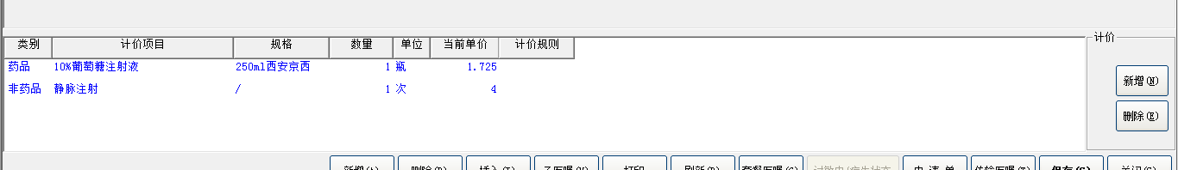

**SELECT** "PRICE_LIST"."ITEM_CODE" , "PRICE_LIST"."UNITS" , "PRICE_LIST"."PRICE" **FROM** "PRICE_LIST" **WHERE** "PRICE_LIST"."ITEM_CLASS" ='A' and "PRICE_LIST"."ITEM_CODE" ='W010501IJO' AND sysdate >= "START_DATE" and "PRICE_LIST"."ITEM_SPEC" ='250ml西安京西' and ( "PRICE_LIST"."STOP_DATE" IS NULL or SYSDATE <= "STOP_DATE" )

**SELECT** "PRICE_LIST"."ITEM_CODE" , "PRICE_LIST"."UNITS" , "PRICE_LIST"."PRICE" **FROM** "PRICE_LIST" **WHERE** "PRICE_LIST"."ITEM_CLASS" ='E' and "PRICE_LIST"."ITEM_CODE" ='120400002' AND sysdate >= "START_DATE" and "PRICE_LIST"."ITEM_SPEC" ='/' and ( "PRICE_LIST"."STOP_DATE" IS NULL or SYSDATE <= "STOP_DATE" )

### 删除医嘱明细

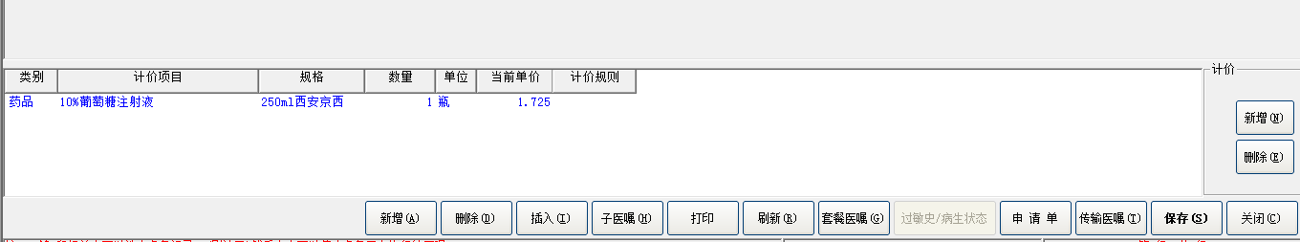

**DELETEFROM** "ORDERS_COSTS" **WHERE** "ITEM_NO" = '2' AND "ORDER_NO" = '4' AND "VISIT_ID" = '1' AND "PATIENT_ID" = '1500000909'

**DELETEFROM** "ORDERS_COSTS" **WHERE** "ITEM_NO" = '1' AND "ORDER_NO" = '4' AND "VISIT_ID" = '1' AND "PATIENT_ID" = '1500000909'

**INSERTINTO** "ORDERS_COSTS" ( "ITEM_NAME", "AMOUNT", "UNITS", "ITEM_CODE", "ITEM_CLASS", "ITEM_NO", "ORDER_SUB_NO", "ORDER_NO", "VISIT_ID", "PATIENT_ID", "COSTS", "ITEM_SPEC", "BACKBILL_RULE" ) VALUES ( '10%葡萄糖注射液', '1', '瓶', 'W010501IJO', 'A', '1', '1', '4', '1', '1500000909', NULL, '250ml西安京西', NULL )

### 新增医嘱

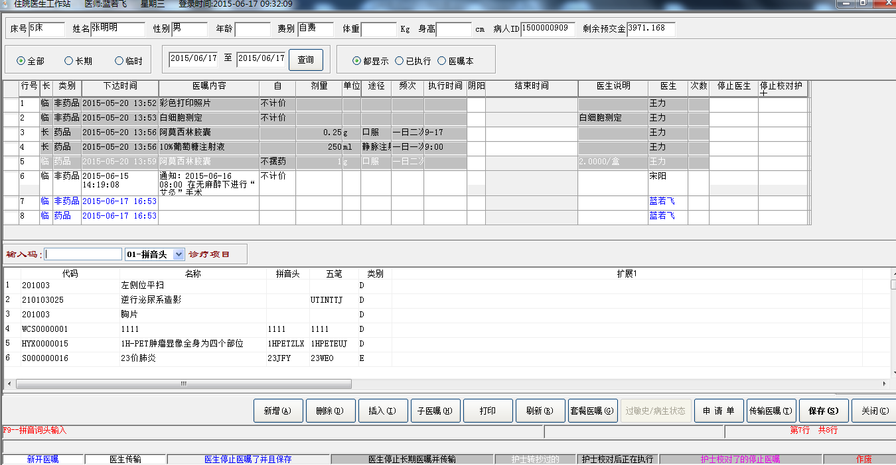

----------------------查询药品属性------------------------------

SELECT DRUG_DICT.DOSE_PER_UNIT , DRUG_DICT.UNITS , DRUG_DICT.DOSE_UNITS FROM DRUG_DICT , DRUG_PRICE_LIST WHERE DRUG_PRICE_LIST.DRUG_CODE =DRUG_DICT.DRUG_CODE AND DRUG_PRICE_LIST.DRUG_SPEC =DRUG_DICT.DRUG_SPEC AND DRUG_PRICE_LIST.DRUG_CODE ='T030004IJ0'AND DRUG_PRICE_LIST.DRUG_SPEC || DRUG_PRICE_LIST.FIRM_ID ='10mg浙江海正'

### 查询单位价格

-------------------------------查询单位价格--------------------

select administration , frequency , freq_interval_unit , max_dosage , freq_counter , freq_interval from DRUG_RATIONAL_DOSAGE where drug_code ='T030004IJ0'and drug_spec ='10mg'

SELECT "DRUG_STOCK"."STORAGE",

"DRUG_STOCK"."DRUG_CODE",

"DRUG_STOCK"."DRUG_SPEC",

"DRUG_STOCK"."UNITS",

"DRUG_STOCK"."BATCH_NO",

"DRUG_STOCK"."EXPIRE_DATE",

"DRUG_STOCK"."FIRM_ID",

"DRUG_STOCK"."PURCHASE_PRICE",

"DRUG_STOCK"."DISCOUNT",

"DRUG_STOCK"."PACKAGE_SPEC",

"DRUG_STOCK"."QUANTITY",

"DRUG_STOCK"."PACKAGE_UNITS",

"DRUG_STOCK"."SUB_PACKAGE_1",

"DRUG_STOCK"."SUB_PACKAGE_UNITS_1",

"DRUG_STOCK"."SUB_PACKAGE_SPEC_1",

"DRUG_STOCK"."SUB_PACKAGE_2",

"DRUG_STOCK"."SUB_PACKAGE_UNITS_2",

"DRUG_STOCK"."SUB_PACKAGE_SPEC_2",

"DRUG_STOCK"."SUB_STORAGE",

"DRUG_STOCK"."DOCUMENT_NO",

"DRUG_STOCK"."SUPPLY_INDICATOR"

FROM "DRUG_STOCK"

WHERE ( "DRUG_STOCK"."STORAGE" in ('150501','150502','150520','150521','') ) AND

( "DRUG_STOCK"."DRUG_CODE" like'T030004IJ0' ) AND

( "DRUG_STOCK"."SUPPLY_INDICATOR" = 1 )

### 添加医嘱保存

**INSERTINTO** "ORDERS_COSTS" ( "ITEM_NAME", "AMOUNT", "UNITS", "ITEM_CODE", "ITEM_CLASS", "ITEM_NO", "ORDER_SUB_NO", "ORDER_NO", "VISIT_ID", "PATIENT_ID", "COSTS", "ITEM_SPEC", "BACKBILL_RULE" ) VALUES ( '逆行泌尿系造影', '1.0000', '次', '210103025', 'D', '1', '1', '7', '1', '1500000909', '160.00', '/', NULL )

**INSERTINTO** "ORDERS" ( "START_DATE_TIME", "ORDER_TEXT", "DOSAGE", "DOSAGE_UNITS", "ADMINISTRATION", "DURATION", "DURATION_UNITS", "FREQUENCY", "FREQ_COUNTER", "FREQ_INTERVAL", "FREQ_INTERVAL_UNIT", "DOCTOR", "NURSE", "STOP_DOCTOR", "ORDER_CLASS", "REPEAT_INDICATOR", "STOP_DATE_TIME", "ORDER_CODE", "ORDER_STATUS", "ENTER_DATE_TIME", "FREQ_DETAIL", "PATIENT_ID", "VISIT_ID", "ORDER_NO", "ORDER_SUB_NO", "PERFORM_SCHEDULE", "BILLING_ATTR", "PERFORM_RESULT", "ORDERING_DEPT", "STOP_NURSE", "DRUG_BILLING_ATTR", "DOCTOR_USER", "VERIFY_DATA_TIME", "ORDER_PRINT_INDICATOR", "PROCESSING_DATE_TIME", "PROCESSING_NURSE", "STOP_PROCESSING_NURSE", "STOP_PROCESSING_DATE_TIME", "CANCEL_DATE_TIME", "CANCEL_DOCTOR", "DEGREE", "APP_NO", "STOP_FLAG", "CONTINUE_ORDER_NO" ) VALUES ( '2015-06-17 17:11:36', '逆行泌尿系造影', NULL, NULL, NULL, NULL, NULL, '', '1', '1', '日', '蓝若飞', NULL, NULL, 'D', '0', '2015-06-17 17:11:36', '210103025', '5', NULL, NULL, '1500000909', '1', '7', '1', NULL, '1', NULL, '140302', NULL, '1', '000LRF', NULL, NULL, NULL, NULL, NULL, NULL, NULL, NULL, NULL, NULL, NULL, NULL )

## 申请单

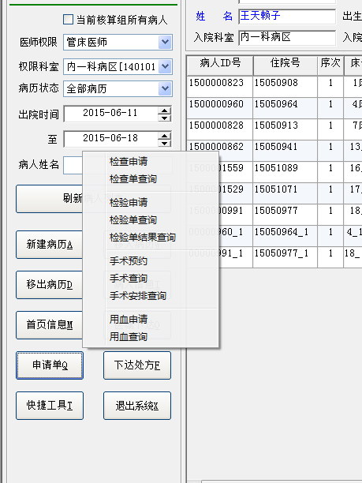

### 检查申请

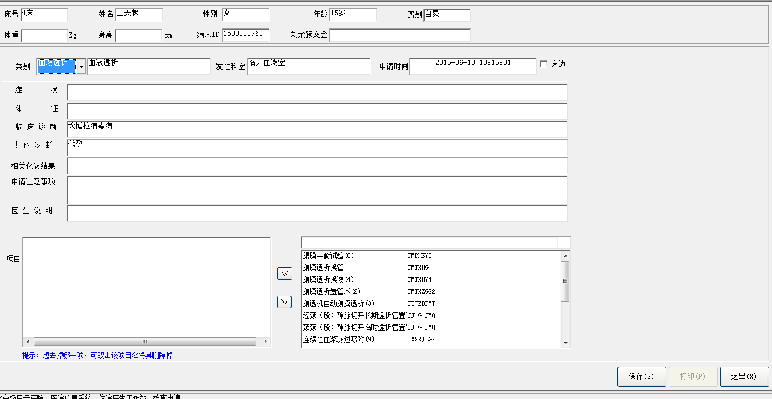

功能描述：选中病人点击检查申请，选择需要检查项目，点击保存。

#### 应用参数设置表

**SELECT** "APP_CONFIGER_PARAMETER"."APP_NAME",

"APP_CONFIGER_PARAMETER"."DEPT_CODE",

"APP_CONFIGER_PARAMETER"."EMP_NO",

"APP_CONFIGER_PARAMETER"."PARAMETER_NAME",

"APP_CONFIGER_PARAMETER"."PARAMETER_VALUE",

"APP_CONFIGER_PARAMETER"."POSITION"

**FROM** "APP_CONFIGER_PARAMETER"

**WHERE** Upper("APP_CONFIGER_PARAMETER"."PARAMETER_NAME") = upper('IS_FUZZY_FILTER')

**SELECT** "APP_CONFIGER_PARAMETER"."APP_NAME",

"APP_CONFIGER_PARAMETER"."DEPT_CODE",

"APP_CONFIGER_PARAMETER"."EMP_NO",

"APP_CONFIGER_PARAMETER"."PARAMETER_NAME",

"APP_CONFIGER_PARAMETER"."PARAMETER_VALUE",

"APP_CONFIGER_PARAMETER"."POSITION"

**FROM** "APP_CONFIGER_PARAMETER"

**WHERE** Upper("APP_CONFIGER_PARAMETER"."PARAMETER_NAME") = upper('OVERDRAFT_WAY')

**SELECT** "APP_CONFIGER_PARAMETER"."APP_NAME",

"APP_CONFIGER_PARAMETER"."DEPT_CODE",

"APP_CONFIGER_PARAMETER"."EMP_NO",

"APP_CONFIGER_PARAMETER"."PARAMETER_NAME",

"APP_CONFIGER_PARAMETER"."PARAMETER_VALUE",

"APP_CONFIGER_PARAMETER"."POSITION"

**FROM** "APP_CONFIGER_PARAMETER"

**WHERE** Upper("APP_CONFIGER_PARAMETER"."PARAMETER_NAME") = upper('PAYPERMENT_CHARGE')

#### ？

**SELECT** PBD_FHGT,PBD_FWGT,PBD_FITL,PBD_FUNL,PBD_FCHR,PBD_FPTC,PBD_FFCE,PBH_FHGT,PBH_FWGT,PBH_FITL,PBH_FUNL,PBH_FCHR,PBH_FPTC,PBH_FFCE,PBL_FHGT,PBL_FWGT,PBL_FITL,PBL_FUNL,PBL_FCHR,PBL_FPTC,PBL_FFCE,PBT_CMNT **FROM** SYSTEM.PBCATTBL **WHERE** PBT_OWNR = 'COMM' AND PBT_TNAM = 'INPUT_SETTING'

#### ？

**SELECT** COLUMN_NAME, DATA_TYPE, DATA_LENGTH, DATA_PRECISION, DATA_SCALE, NULLABLE, COLUMN_ID, DATA_DEFAULT **FROM** SYS.ALL_TAB_COLUMNS **WHERE** TABLE_NAME = 'INPUT_SETTING' AND OWNER = 'COMM' ORDER BY COLUMN_ID

**SELECT** PBC_CNAM,PBC_TNAM,PBC_OWNR,PBC_LABL,PBC_LPOS,PBC_HDR,PBC_HPOS,PBC_JTFY,PBC_MASK,PBC_CASE,PBC_HGHT,PBC_WDTH,PBC_PTRN,PBC_BMAP,PBC_INIT,PBC_EDIT,PBC_CMNT **FROM** SYSTEM.PBCATCOL **WHERE** (PBC_TNAM = 'INPUT_SETTING' AND PBC_OWNR = 'COMM')

**SELECT** COLUMN_NAME **FROM** SYS.ALL_IND_COLUMNS **WHERE** INDEX_NAME = 'PK_INPUT_SETTING' AND INDEX_OWNER = 'COMM' AND TABLE_OWNER = 'COMM' AND TABLE_NAME = 'INPUT_SETTING'

#### 输入法配置

**select** * **from** comm.input_setting **where** dict_type='科室' order by show_sort

**SELECT** OWNER, TABLE_NAME, TABLE_TYPE **FROM** SYS.ALL_CATALOG **WHERE** TABLE_TYPE **IN** ('TABLE','VIEW')AND OWNER = 'JMYUSERHIS' AND TABLE_NAME = 'DEPT_DICT'

**SELECT** PBD_FHGT,PBD_FWGT,PBD_FITL,PBD_FUNL,PBD_FCHR,PBD_FPTC,PBD_FFCE,PBH_FHGT,PBH_FWGT,PBH_FITL,PBH_FUNL,PBH_FCHR,PBH_FPTC,PBH_FFCE,PBL_FHGT,PBL_FWGT,PBL_FITL,PBL_FUNL,PBL_FCHR,PBL_FPTC,PBL_FFCE,PBT_CMNT **FROM** SYSTEM.PBCATTBL **WHERE** PBT_OWNR = 'PUBLIC' AND PBT_TNAM = 'DEPT_DICT'

**SELECT** PBC_CNAM,PBC_TNAM,PBC_OWNR,PBC_LABL,PBC_LPOS,PBC_HDR,PBC_HPOS,PBC_JTFY,PBC_MASK,PBC_CASE,PBC_HGHT,PBC_WDTH,PBC_PTRN,PBC_BMAP,PBC_INIT,PBC_EDIT,PBC_CMNT **FROM** SYSTEM.PBCATCOL **WHERE** (PBC_TNAM = 'DEPT_DICT' AND PBC_OWNR = 'JMYUSERHIS')

#### 记录病人医嘱的锁定情况

**INSERTINTO** "ORDADM"."ORDER_OPEN" ( "PATIENT_ID" , "VISIT_ID" , "USER_NAME" , "USER_ID" , "COMPUTER" , "OPEN_TIME" , "DEPT_NAME" ) VALUES ( '1500000862' , 1 , '蓝若飞' , '000LRF' , '极目云' , '2015-06-18 10:27:20' , '140101' )

#### 检查报告模板

**SELECT** 0 aa,

"COMM"."EXAM_RPT_PATTERN"."DESCRIPTION",

"COMM"."EXAM_RPT_PATTERN"."DESCRIPTION_CODE",

"COMM"."EXAM_RPT_PATTERN"."INPUT_CODE"

**FROM** "COMM"."EXAM_RPT_PATTERN"

**WHERE** ( "COMM"."EXAM_RPT_PATTERN"."EXAM_SUB_CLASS" = '血液透析') AND

( "COMM"."EXAM_RPT_PATTERN"."DESC_ITEM" = '检查项目' ) AND

( "COMM"."EXAM_RPT_PATTERN"."DOCTOR_TESHU" IS NULL )

**unionall**

**SELECT** 0 aa,

"COMM"."EXAM_RPT_PATTERN"."DESCRIPTION",

"COMM"."EXAM_RPT_PATTERN"."DESCRIPTION_CODE",

"COMM"."EXAM_RPT_PATTERN"."INPUT_CODE"

**FROM** "COMM"."EXAM_RPT_PATTERN"

**WHERE** ( "COMM"."EXAM_RPT_PATTERN"."DOCTOR_TESHU" **like**'%0028%' ) AND

( "COMM"."EXAM_RPT_PATTERN"."DESC_ITEM" = '检查项目' )

#### 检查预约记录

**INSERTINTO** "EXAM_APPOINTS" ( "EXAM_NO", "PATIENT_ID", "NAME", "NAME_PHONETIC", "SEX", "DATE_OF_BIRTH", "BIRTH_PLACE", "IDENTITY", "CHARGE_TYPE", "MAILING_ADDRESS", "ZIP_CODE", "PHONE_NUMBER", "EXAM_CLASS", "EXAM_SUB_CLASS", "CLIN_SYMP", "PHYS_SIGN", "RELEVANT_LAB_TEST", "RELEVANT_DIAG", "CLIN_DIAG", "EXAM_MODE", "EXAM_GROUP", "PERFORMED_BY", "PATIENT_SOURCE", "FACILITY", "REQ_DATE_TIME", "REQ_DEPT", "REQ_PHYSICIAN", "VISIT_ID", "DOCTOR_USER", "NOTICE", "WARD_CODE" ) VALUES ( '101167', '1500000862', '李光猪', 'LI GUANG ZHU', '男', '1987-01-01 00:00:00', NULL, '一般人员', '居民医保', NULL, NULL, NULL, '血液透析', '血液透析', 'gdg', 'gdgfd', 'gg', '。', 'dfg', NULL, NULL, '180305', '2', NULL, '2015-06-18 10:33:17', '140302', '蓝若飞', '1', '000LRF', 'g', '2001' )

#### 检查项目记录

**INSERTINTO** EXAM."EXAM_ITEMS" ( "EXAM_NO", "EXAM_ITEM_NO", "EXAM_ITEM", "EXAM_ITEM_CODE" ) VALUES ( '101167', '1', '腹膜透析换管', 'X000000005' )

**INSERTINTO** EXAM."EXAM_ITEMS" ( "EXAM_NO", "EXAM_ITEM_NO", "EXAM_ITEM", "EXAM_ITEM_CODE" ) VALUES ( '101167', '2', '腹膜透析换液(4)', 'X000000004' )

**INSERTINTO** EXAM."EXAM_ITEMS" ( "EXAM_NO", "EXAM_ITEM_NO", "EXAM_ITEM", "EXAM_ITEM_CODE" ) VALUES ( '101167', '3', '腹透机自动腹膜透析(3)', 'X000000003' )

**INSERTINTO** EXAM."EXAM_ITEMS" ( "EXAM_NO", "EXAM_ITEM_NO", "EXAM_ITEM", "EXAM_ITEM_CODE" ) VALUES ( '101167', '4', '经颈（股）静脉切开长期透析管置管术(13)', 'X000000013' )

#### 医嘱

**insertinto** orders ( patient_id , visit_id , order_no , order_sub_no , start_date_time , repeat_indicator , order_class , order_text , order_code , order_status , ordering_dept , doctor , doctor_user , enter_date_time , billing_attr , drug_billing_attr , app_no , freq_detail ) values ( '1500000862' , 67829761 , 1 , 1 , '2015-06-18 10:33:18' , 0 , 'D' , '腹膜透析换管' , 'X000000005' , '6' , '140302' , '蓝若飞' , '000LRF' , '2015-06-18 10:33:18' , 3 , 858783747 , '101167' , '' )

**insertinto** orders ( patient_id , visit_id , order_no , order_sub_no , start_date_time , repeat_indicator , order_class , order_text , order_code , order_status , ordering_dept , doctor , doctor_user , enter_date_time , billing_attr , drug_billing_attr , app_no , freq_detail ) values ( '1500000862' , 67829761 , 2 , 1 , '2015-06-18 10:33:18' , 0 , 'D' , '腹膜透析换液(4)' , 'X000000004' , '6' , '140302' , '蓝若飞' , '000LRF' , '2015-06-18 10:33:18' , 3 , -65533 , '101167' , '' )

**insertinto** orders ( patient_id , visit_id , order_no , order_sub_no , start_date_time , repeat_indicator , order_class , order_text , order_code , order_status , ordering_dept , doctor , doctor_user , enter_date_time , billing_attr , drug_billing_attr , app_no , freq_detail ) values ( '1500000862' , 67829761 , 3 , 1 , '2015-06-18 10:33:18' , 0 , 'D' , '腹透机自动腹膜透析(3)' , 'X000000003' , '6' , '140302' , '蓝若飞' , '000LRF' , '2015-06-18 10:33:18' , 3 , 3 , '101167' , '' )

**insertinto** orders ( patient_id , visit_id , order_no , order_sub_no , start_date_time , repeat_indicator , order_class , order_text , order_code , order_status , ordering_dept , doctor , doctor_user , enter_date_time , billing_attr , drug_billing_attr , app_no , freq_detail ) values ( '1500000862' , 67829761 , 4 , 1 , '2015-06-18 10:33:18' , 0 , 'D' , '经颈（股）静脉切开长期透析管置管术(13)' , 'X000000013' , '6' , '140302' , '蓝若飞' , '000LRF' , '2015-06-18 10:33:18' , 3 , 3 , '101167' , '' )

### 查询检查申请单

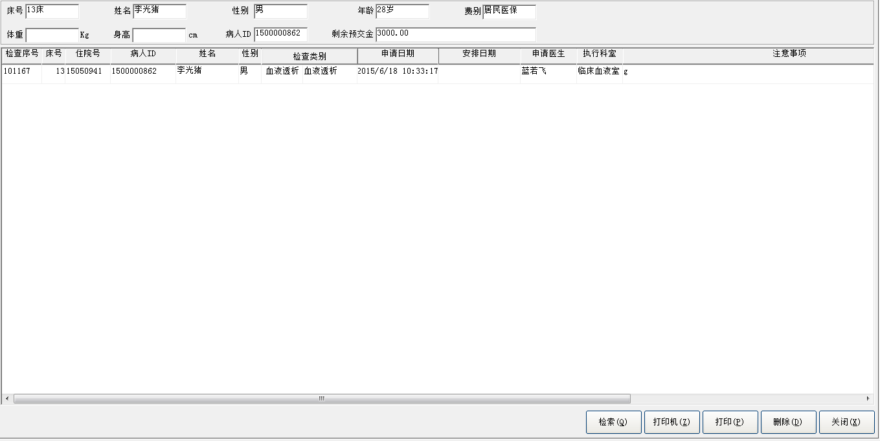

业务流程：选中病人点击查看检验单，可以查询给该病人已开出的检验单，进行打印操作。

#### 应用参数设置表

**SELECT** "APP_CONFIGER_PARAMETER"."APP_NAME",

"APP_CONFIGER_PARAMETER"."DEPT_CODE",

"APP_CONFIGER_PARAMETER"."EMP_NO",

"APP_CONFIGER_PARAMETER"."PARAMETER_NAME",

"APP_CONFIGER_PARAMETER"."PARAMETER_VALUE",

"APP_CONFIGER_PARAMETER"."POSITION"

**FROM** "APP_CONFIGER_PARAMETER"

**WHERE** Upper("APP_CONFIGER_PARAMETER"."PARAMETER_NAME") = upper('OVERDRAFT_WAY')

#### 检查预约记录

**SELECT** DISTINCT "INPADM"."PATS_IN_HOSPITAL"."BED_NO",

"MEDREC"."PAT_MASTER_INDEX"."INP_NO",

"INPADM"."PATS_IN_HOSPITAL"."PATIENT_ID",

"MEDREC"."PAT_MASTER_INDEX"."SEX",

"EXAM"."EXAM_APPOINTS"."EXAM_CLASS",

"EXAM"."EXAM_APPOINTS"."EXAM_SUB_CLASS",

"EXAM"."EXAM_APPOINTS"."REQ_DATE_TIME",

"EXAM"."EXAM_APPOINTS"."SCHEDULED_DATE",

"EXAM"."EXAM_APPOINTS"."REQ_PHYSICIAN",

"EXAM"."EXAM_APPOINTS"."NOTICE",

"EXAM"."EXAM_APPOINTS"."EXAM_NO",

"INPADM"."PATS_IN_HOSPITAL"."DEPT_CODE",

"EXAM"."EXAM_APPOINTS"."CLIN_SYMP",

"EXAM"."EXAM_APPOINTS"."PHYS_SIGN",

"EXAM"."EXAM_APPOINTS"."RELEVANT_LAB_TEST",

"EXAM"."EXAM_APPOINTS"."RELEVANT_DIAG",

"EXAM"."EXAM_APPOINTS"."CLIN_DIAG",

"EXAM"."EXAM_APPOINTS"."PERFORMED_BY",

"MEDREC"."PAT_MASTER_INDEX"."NAME"

**FROM** "EXAM"."EXAM_APPOINTS",

"INPADM"."PATS_IN_HOSPITAL",

"MEDREC"."PAT_MASTER_INDEX"

**WHERE** ( "EXAM"."EXAM_APPOINTS"."PATIENT_ID" = "INPADM"."PATS_IN_HOSPITAL"."PATIENT_ID" ) and

( "INPADM"."PATS_IN_HOSPITAL"."PATIENT_ID" = "MEDREC"."PAT_MASTER_INDEX"."PATIENT_ID" ) and

EXAM."EXAM_APPOINTS"."PATIENT_ID" = '1500001559'

### 检验申请

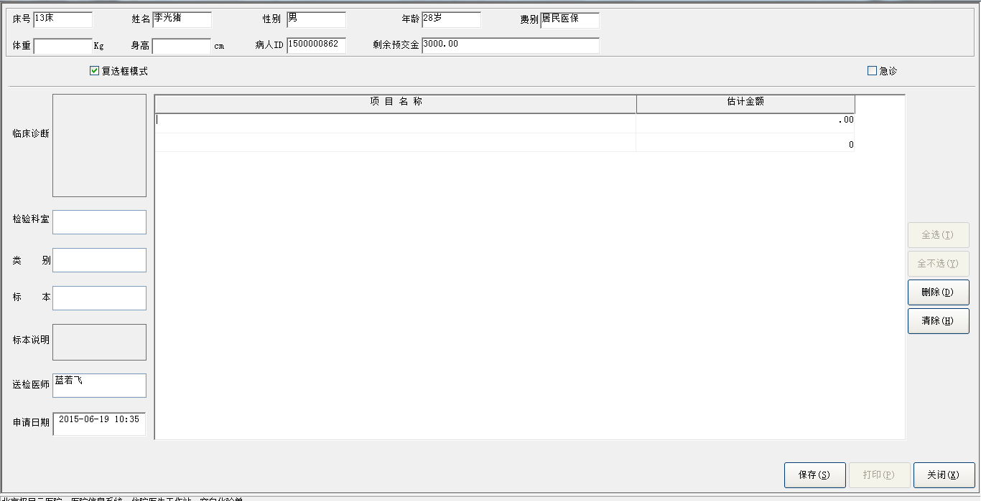

业务流程：选中病人点击检验申请，可以进入检验申请页面开具检验单。

#### 记录病人医嘱的锁定情况

**INSERTINTO** "ORDADM"."ORDER_OPEN" ( "PATIENT_ID" , "VISIT_ID" , "USER_NAME" , "USER_ID" , "COMPUTER" , "OPEN_TIME" , "DEPT_NAME" ) VALUES ( '1500001559' , 1 , '蓝若飞' , '000LRF' , '极目云' , '2015-06-18 10:45:20' , '140101' )

#### 检验主记录

**INSERTINTO** lab_test_master ( test_no , priority_indicator , patient_id , visit_id , name , sex , age , relevant_clinic_diag , specimen , notes_for_spcm , requested_date_time , ordering_dept , ordering_provider , performed_by , name_phonetic , charge_type , result_status ) VALUES ( '1506182526' , 12058624 , '1500001559' , 909246465 , '张子萱' , '男' , 26 , '' , '血' , NULL , sysdate , '140302' , '000LRF' , '180301' , 'ZHANG ZI XUAN' , '自费' , '0' )

#### 检验项目

**INSERTINTO** "LAB_TEST_ITEMS" ( "TEST_NO", "ITEM_NO", "ITEM_NAME", "ITEM_CODE" ) VALUES ( '1506182526', '1', '血清肌钙蛋白T测定', '250306008' )

#### 医嘱

**insertinto** orders ( patient_id , visit_id , order_no , order_sub_no , start_date_time , repeat_indicator , order_class , order_text , order_code , order_status , ordering_dept , doctor , doctor_user , enter_date_time , billing_attr , drug_billing_attr , app_no , freq_detail ) values ( '1500001559' , 69206017 , 4 , 1 , '2015-06-18 10:47:07' , 0 , 'C' , '血清肌钙蛋白T测定' , '250306008' , '6' , '140302' , '蓝若飞' , '000LRF' , '2015-06-18 10:47:07' , 69009411 , 3 , '1506182526' , '血清肌钙蛋白T测定' )

### 检验单查询

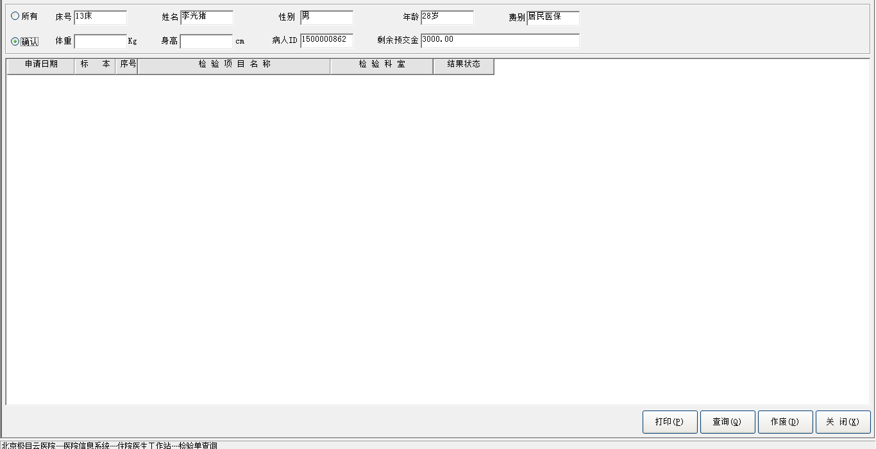业务流程：选中病人点击检验单查询，可以查询到该病人已开具的检验单，可以进行打印、作废等操作。

#### 查询检验单

**SELECT** "LAB_TEST_ITEMS"."ITEM_NO" ,

"LAB_TEST_ITEMS"."ITEM_NAME" ,

"LAB_TEST_MASTER"."SPECIMEN" ,

"LAB_TEST_ITEMS"."ITEM_CODE" ,

"LAB_TEST_ITEMS"."TEST_NO" ,

"DEPT_DICT"."DEPT_NAME" ,

"LAB_TEST_MASTER"."RESULT_STATUS" ,

"LAB_TEST_MASTER"."REQUESTED_DATE_TIME" ,

"LAB_TEST_MASTER"."BILLING_INDICATOR" ,

"LAB_TEST_MASTER"."PRIORITY_INDICATOR" ,

"LAB_TEST_MASTER"."CHARGE_TYPE" ,

"LAB_TEST_MASTER"."NOTES_FOR_SPCM" ,

"LAB_TEST_MASTER"."PERFORMED_BY" ,

"LAB_TEST_MASTER"."RELEVANT_CLINIC_DIAG" ,

"LAB_TEST_MASTER"."NAME" ,

"LAB_TEST_MASTER"."SEX" ,

"LAB_TEST_MASTER"."AGE" ,

"LAB_TEST_MASTER"."ORDERING_DEPT" ,

"LAB_TEST_MASTER"."PATIENT_ID" ,

"LAB_TEST_MASTER"."ORDERING_PROVIDER" ,

"LAB_TEST_MASTER"."TEST_NO"

**FROM** "LAB_TEST_ITEMS" ,

"LAB_TEST_MASTER" ,

"DEPT_DICT"

**WHERE** ( "LAB_TEST_MASTER"."TEST_NO" = "LAB_TEST_ITEMS"."TEST_NO" ) and

( "LAB_TEST_MASTER"."PERFORMED_BY" = "DEPT_DICT"."DEPT_CODE" ) and

( "LAB_TEST_MASTER"."PATIENT_ID" = '1500001559' ) and

("LAB_TEST_MASTER"."VISIT_ID" = '1' )

### 检验结果查询

#### 业务流程同检验单查询

**SELECT** "LAB_TEST_MASTER"."TEST_NO" ,

"LAB_TEST_MASTER"."PATIENT_ID" ,

"LAB_TEST_MASTER"."VISIT_ID" ,

"LAB_TEST_MASTER"."WORKING_ID" ,

"LAB_TEST_MASTER"."EXECUTE_DATE" ,

"LAB_TEST_MASTER"."NAME" ,

"LAB_TEST_MASTER"."CHARGE_TYPE" ,

"LAB_TEST_MASTER"."SEX" ,

"LAB_TEST_MASTER"."AGE" ,

"LAB_TEST_MASTER"."TEST_CAUSE" ,

"LAB_TEST_MASTER"."RELEVANT_CLINIC_DIAG" ,

"LAB_TEST_MASTER"."SPECIMEN" ,

"LAB_TEST_MASTER"."NOTES_FOR_SPCM" ,

"LAB_TEST_MASTER"."SPCM_RECEIVED_DATE_TIME" ,

"LAB_TEST_MASTER"."SPCM_SAMPLE_DATE_TIME" ,

"LAB_TEST_MASTER"."REQUESTED_DATE_TIME" ,

"LAB_TEST_MASTER"."ORDERING_DEPT" ,

"LAB_TEST_MASTER"."ORDERING_PROVIDER" ,

"LAB_TEST_MASTER"."PERFORMED_BY" ,

"LAB_TEST_MASTER"."RESULT_STATUS" ,

"LAB_TEST_MASTER"."RESULTS_RPT_DATE_TIME" ,

"LAB_TEST_MASTER"."TRANSCRIPTIONIST" ,

"LAB_TEST_MASTER"."VERIFIED_BY" ,

"LAB_TEST_MASTER"."COSTS" ,

"LAB_TEST_MASTER"."CHARGES" ,

"LAB_TEST_MASTER"."BILLING_INDICATOR" ,

"LAB_TEST_MASTER"."PRINT_INDICATOR" ,

"LAB_TEST_MASTER"."SUBJECT"

**FROM** "LAB_TEST_MASTER"

**where** "LAB_TEST_MASTER"."RESULT_STATUS" ='4' and

"LAB_TEST_MASTER"."PATIENT_ID" = '1500001559' and

"LAB_TEST_MASTER"."VISIT_ID" = '1'

### 手术申请

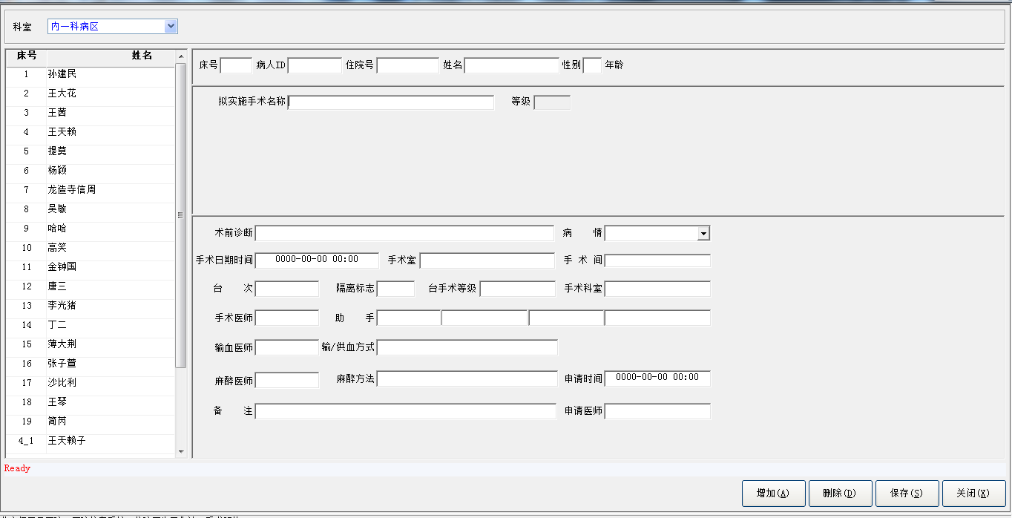

业务流程： 选择手术申请进入手术申请界面，左侧选择需要手术的人，右边选择手术项目及时间等信息，点击保存。

#### 安排手术名称

**INSERTINTO** "SCHEDULED_OPERATION_NAME" ( "PATIENT_ID", "VISIT_ID", "SCHEDULE_ID", "OPERATION_NO", "OPERATION", "OPERATION_SCALE", "OPERATION_CODE" ) VALUES ( '1500001363', '1', '2', '1', '9块椎骨融合', NULL, '81.64001' )

#### 手术安排

**INSERTINTO** "OPERATION_SCHEDULE" ( "PATIENT_ID", "VISIT_ID", "SCHEDULE_ID", "DEPT_STAYED", "BED_NO", "SCHEDULED_DATE_TIME", "OPERATING_ROOM", "DIAG_BEFORE_OPERATION", "PATIENT_CONDITION", "OPERATION_SCALE", "ISOLATION_INDICATOR", "OPERATING_DEPT", "SURGEON", "FIRST_ASSISTANT", "SECOND_ASSISTANT", "THIRD_ASSISTANT", "FOURTH_ASSISTANT", "BLOOD_TRAN_DOCTOR", "NOTES_ON_OPERATION", "REQ_DATE_TIME", "SEQUENCE", "ANESTHESIA_METHOD", "ENTERED_BY", "OPERATING_ROOM_NO", "ACK_INDICATOR", "DOCTOR_USER", "PROVIDE_WAY", "ANESTHESIA_DOCTOR", "ANESTHESIA_ASSISTANT" ) VALUES ( '1500001363', '1', '2', '140101', '3', '2015-06-19 08:00:00', '2210', '待产', '病重', '2', '2', '140101', '0008', '0002', '0004', '0008', '0008', '0008', NULL, '2015-06-18 10:55:02', NULL, 'B', '0028', '4', '0', '000LRF', '亲属供血', '0027', NULL )

#### 医嘱

**INSERTINTO** "ORDERS" ( "START_DATE_TIME", "ORDER_TEXT", "DOSAGE", "DOSAGE_UNITS", "ADMINISTRATION", "DURATION", "DURATION_UNITS", "FREQUENCY", "FREQ_COUNTER", "FREQ_INTERVAL", "FREQ_INTERVAL_UNIT", "DOCTOR", "NURSE", "STOP_DOCTOR", "ORDER_CLASS", "REPEAT_INDICATOR", "STOP_DATE_TIME", "ORDER_CODE", "ORDER_STATUS", "ENTER_DATE_TIME", "FREQ_DETAIL", "PATIENT_ID", "VISIT_ID", "ORDER_NO", "ORDER_SUB_NO", "PERFORM_SCHEDULE", "BILLING_ATTR", "LAST_ACCTING_DATE_TIME", "PERFORM_RESULT", "LAST_PERFORM_DATE_TIME", "ORDERING_DEPT", "STOP_NURSE", "DRUG_BILLING_ATTR", "DOCTOR_USER", "VERIFY_DATA_TIME", "ORDER_PRINT_INDICATOR", "PROCESSING_DATE_TIME", "PROCESSING_NURSE", "STOP_PROCESSING_NURSE", "STOP_PROCESSING_DATE_TIME", "CURRENT_PRESC_NO", "CANCEL_DATE_TIME", "CANCEL_DOCTOR", "DEGREE" ) VALUES ( '2015-06-18 10:56:22', '通知：2015-06-19 08:00 在B下进行“9块椎骨融合”手术', NULL, NULL, NULL, NULL, NULL, NULL, NULL, NULL, NULL, '蓝若飞', NULL, NULL, 'F', '0', '2015-06-18 10:56:22', '81.64001', '6', '2015-06-18 10:56:22', NULL, '1500001363', '1', '28', '1', NULL, '3', NULL, NULL, NULL, '140101', NULL, '3', '000LRF', NULL, NULL, NULL, NULL, NULL, NULL, NULL, NULL, NULL, NULL )

### 手术预约查询

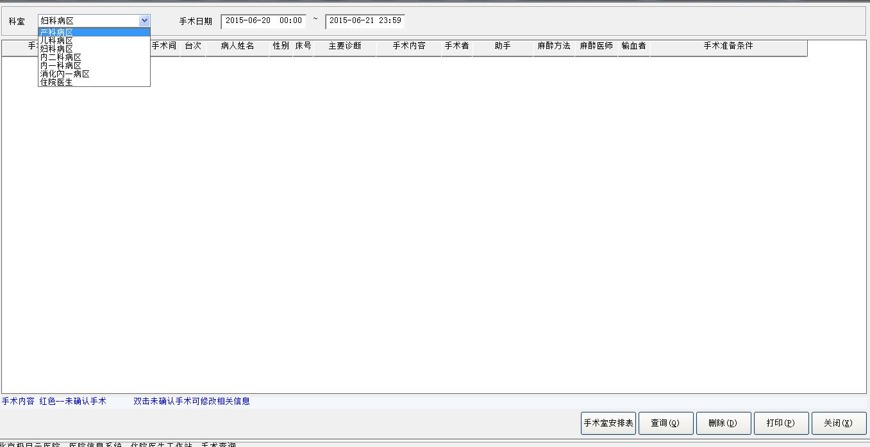

业务流程：点击手术预约查询可以进入手术预约查询界面。

#### 手术预约记录

**SELECT** "OPERATION_SCHEDULE"."SCHEDULED_DATE_TIME" ,

"OPERATION_SCHEDULE"."OPERATING_ROOM_NO" ,

"OPERATION_SCHEDULE"."SEQUENCE" ,

"OPERATION_SCHEDULE"."PATIENT_ID" ,

"PAT_MASTER_INDEX"."INP_NO" ,

"PAT_MASTER_INDEX"."NAME" ,

Months_Between(Sysdate,

"PAT_MASTER_INDEX"."DATE_OF_BIRTH"),

"OPERATION_SCHEDULE"."DEPT_STAYED" ,

"OPERATION_SCHEDULE"."DIAG_BEFORE_OPERATION" ,

"SCHEDULED_OPERATION_NAME"."OPERATION_NO" ,

"SCHEDULED_OPERATION_NAME"."OPERATION" ,

"OPERATION_SCHEDULE"."ISOLATION_INDICATOR" ,

"OPERATION_SCHEDULE"."SURGEON" ,

"OPERATION_SCHEDULE"."FIRST_ASSISTANT" ,

"OPERATION_SCHEDULE"."SECOND_ASSISTANT" ,

"OPERATION_SCHEDULE"."THIRD_ASSISTANT" ,

"OPERATION_SCHEDULE"."FOURTH_ASSISTANT" ,

"OPERATION_SCHEDULE"."ANESTHESIA_METHOD" ,

"OPERATION_SCHEDULE"."ANESTHESIA_DOCTOR" ,

"OPERATION_SCHEDULE"."ANESTHESIA_ASSISTANT" ,

"OPERATION_SCHEDULE"."BLOOD_TRAN_DOCTOR" ,

"OPERATION_SCHEDULE"."BED_NO" ,

"OPERATION_SCHEDULE"."VISIT_ID" ,

"OPERATION_SCHEDULE"."SCHEDULE_ID" ,

"OPERATION_SCHEDULE"."OPERATING_ROOM" ,

"PAT_MASTER_INDEX"."SEX" ,

"OPERATION_SCHEDULE"."NOTES_ON_OPERATION" ,

"OPERATION_SCHEDULE"."ACK_INDICATOR"

**FROM** "PAT_MASTER_INDEX" ,

"OPERATION_SCHEDULE" ,

"SCHEDULED_OPERATION_NAME",

"PATS_IN_HOSPITAL"

**WHERE** ( "OPERATION_SCHEDULE"."PATIENT_ID" = "SCHEDULED_OPERATION_NAME"."PATIENT_ID" ) and

( "OPERATION_SCHEDULE"."VISIT_ID" = "SCHEDULED_OPERATION_NAME"."VISIT_ID" ) and

( "OPERATION_SCHEDULE"."SCHEDULE_ID" = "SCHEDULED_OPERATION_NAME"."SCHEDULE_ID" ) and

( "SCHEDULED_OPERATION_NAME"."PATIENT_ID" = "PAT_MASTER_INDEX"."PATIENT_ID" ) and

( "SCHEDULED_OPERATION_NAME"."PATIENT_ID" = "PATS_IN_HOSPITAL"."PATIENT_ID" ) and

( (( "OPERATION_SCHEDULE"."DEPT_STAYED" = '220102' ) or ( "PATS_IN_HOSPITAL"."DEPT_CODE_LEND" = '220102' ))and

( "OPERATION_SCHEDULE"."SCHEDULED_DATE_TIME" >= '2015-06-19 00:00:00' ) and

( "OPERATION_SCHEDULE"."SCHEDULED_DATE_TIME" <= '2015-06-20 23:59:00' ) )

ORDER BY "OPERATION_SCHEDULE"."SCHEDULED_DATE_TIME" ASC,

"OPERATION_SCHEDULE"."OPERATING_ROOM_NO" ASC,

"OPERATION_SCHEDULE"."SEQUENCE" ASC

### 用血申请

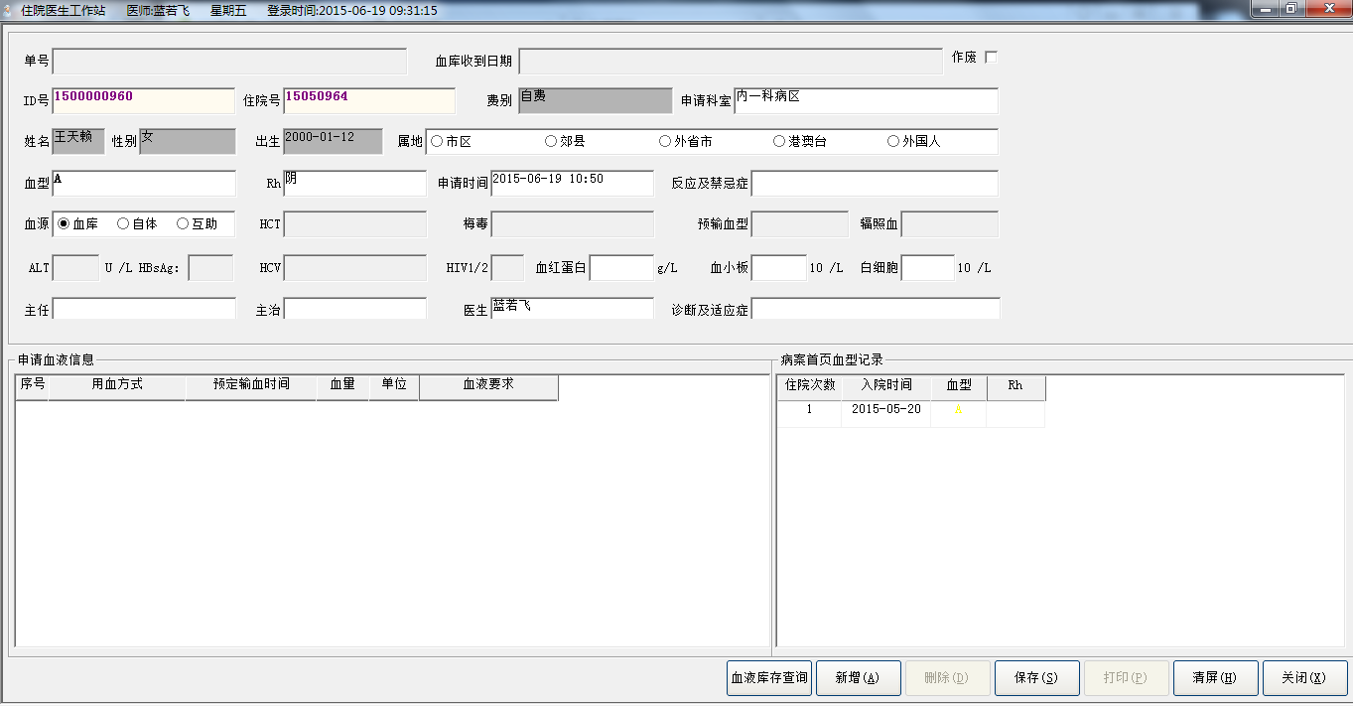

业务流程：选中患者列表，点击用血申请，进入用血申请界面，输入信息点击保存，可以保存用血信息，点击血液库查询，可以查询血库存量。

#### 在院病人记录

**SELECT** count ( *) **FROM** pats_in_hospital **Where** patient_id ='1500000960' And visit_id =1953759233 and dept_code is **not** null

**SELECT** "APP_CONFIGER_PARAMETER"."APP_NAME",

"APP_CONFIGER_PARAMETER"."DEPT_CODE",

"APP_CONFIGER_PARAMETER"."EMP_NO",

"APP_CONFIGER_PARAMETER"."PARAMETER_NAME",

"APP_CONFIGER_PARAMETER"."PARAMETER_VALUE",

"APP_CONFIGER_PARAMETER"."POSITION"

**FROM** "APP_CONFIGER_PARAMETER"

**WHERE** Upper("APP_CONFIGER_PARAMETER"."PARAMETER_NAME") = upper('IS_FUZZY_FILTER')

**select** WARD_CODE **from** pats_in_hospital **where** patient_id ='1500000960' and visit_id =50397185

#### 工作人员分组情况

**SELECT** distinct "COMM"."STAFF_DICT"."NAME" **FROM** "COMM"."STAFF_DICT", "COMM"."STAFF_VS_GROUP" **WHERE** ( "COMM"."STAFF_VS_GROUP"."EMP_NO" = "COMM"."STAFF_DICT"."EMP_NO" ) and ( ( "STAFF_VS_GROUP"."GROUP_CLASS" = '病区医生' ) )

#### 预交金记录

**select** sum ( amount ) **from** prepayment_rcpt **where** patient_id ='1500000960' and visit_id =1 and transact_type <> '作废'

#### 病人主索引

**select** charge_type **from** pat_master_index **where** patient_id ='1500000960'

**select** count ( *) , sum ( TOTAL_SANCTIFIED_AMOUNT ) **from** INP_OVERDRAFT_REG_MASTER **where** patient_id ='1500000960' and visit_id =57409537 and charge_type ='*' and dept_code ='*'

#### ？

**select** count ( *) , sum ( TOTAL_SANCTIFIED_AMOUNT ) **from** INP_OVERDRAFT_REG_MASTER **where** patient_id ='*' and visit_id =0 and charge_type ='自费' and dept_code ='*'

**select** count ( *) , sum ( TOTAL_SANCTIFIED_AMOUNT ) **from** INP_OVERDRAFT_REG_MASTER **where** patient_id ='*' and visit_id =0 and charge_type ='*' and dept_code ='2001'

**select** count ( *) , sum ( TOTAL_SANCTIFIED_AMOUNT ) **from** INP_OVERDRAFT_REG_MASTER **where** patient_id ='*' and charge_type ='*' and dept_code ='*'

**SELECT** "APP_CONFIGER_PARAMETER"."APP_NAME",

"APP_CONFIGER_PARAMETER"."DEPT_CODE",

"APP_CONFIGER_PARAMETER"."EMP_NO",

"APP_CONFIGER_PARAMETER"."PARAMETER_NAME",

"APP_CONFIGER_PARAMETER"."PARAMETER_VALUE",

"APP_CONFIGER_PARAMETER"."POSITION"

**FROM** "APP_CONFIGER_PARAMETER"

**WHERE** Upper("APP_CONFIGER_PARAMETER"."PARAMETER_NAME") = upper('OVERDRAFT_WAY')

#### 应用配置

**SELECT** PARAMETER_VALUE **FROM** app_configer_parameter **where** upper ( parameter_name ) ='PREPAYMENT_ADD'

#### 病人住院主记录

**select** charge_type **from** pat_visit **where** patient_id ='1500000960' and visit_id =1

#### 应用参数设置表

**SELECT** "APP_CONFIGER_PARAMETER"."APP_NAME",

"APP_CONFIGER_PARAMETER"."DEPT_CODE",

"APP_CONFIGER_PARAMETER"."EMP_NO",

"APP_CONFIGER_PARAMETER"."PARAMETER_NAME",

"APP_CONFIGER_PARAMETER"."PARAMETER_VALUE",

"APP_CONFIGER_PARAMETER"."POSITION"

**FROM** "APP_CONFIGER_PARAMETER"

**WHERE** Upper("APP_CONFIGER_PARAMETER"."PARAMETER_NAME") = upper('PAYPERMENT_CHARGE')

#### 初始化参数表

**SELECT** price , match_metch **FROM** count_table

工作人员分组情况

**SELECT** DISTINCT "STAFF_DICT"."NAME" , "STAFF_DICT"."TITLE" **FROM** "STAFF_DICT" , "STAFF_VS_GROUP" **WHERE** ( "STAFF_DICT"."EMP_NO" = "STAFF_VS_GROUP"."EMP_NO" ) and ( ( group_class = '病区医生' ) and (STAFF_DICT.TITLE = '主任医师' or ( STAFF_DICT.TITLE = '副主任医师') ) )

#### 血型字典

**SELECT** "BLOOD_TYPE_DICT"."SERIAL_NO", "BLOOD_TYPE_DICT"."BLOOD_TYPE_CODE", "BLOOD_TYPE_DICT"."BLOOD_TYPE_NAME" **FROM** "BLOOD_TYPE_DICT"

#### 费别字典

**SELECT** "COMM"."CHARGE_TYPE_DICT"."CHARGE_TYPE_NAME" , "COMM"."CHARGE_TYPE_DICT"."CHARGE_TYPE_CODE" **FROM** "COMM"."CHARGE_TYPE_DICT"

**SELECT** "COMM"."DEPT_DICT"."DEPT_NAME" , "COMM"."DEPT_DICT"."DEPT_CODE" **FROM** "COMM"."DEPT_DICT"

**SELECT** a.inp_no , a.name , a.sex , a.date_of_birth , a.charge_type , b.ward_code , b.dept_code , b.doctor_in_charge , b.diagnosis , b.visit_id , c.blood_type , c.blood_type_rh **FROM** pat_master_index a , pats_in_hospital b , pat_visit c **WHERE** a.patient_id ='1500000960' AND a.patient_id =b.patient_id ( + ) AND b.patient_id =c.patient_id ( + ) AND b.visit_id =c.visit_id ( + )

#### 病人住院主记录

**SELECT** "PAT_VISIT"."VISIT_ID" , "PAT_VISIT"."ADMISSION_DATE_TIME" , "PAT_VISIT"."BLOOD_TYPE" , "PAT_VISIT"."BLOOD_TYPE_RH" , "PAT_VISIT"."PATIENT_ID" **FROM** "PAT_VISIT" **WHERE** ( "PAT_VISIT"."BLOOD_TYPE" is **not** null ) and ( "PAT_VISIT"."PATIENT_ID" = '1500000960' )

**SELECT** OWNER, TABLE_NAME, TABLE_TYPE **FROM** SYS.ALL_CATALOG **WHERE** TABLE_TYPE **IN** ('TABLE','VIEW')AND OWNER = 'COMM' AND TABLE_NAME = 'INPUT_SETTING'

**SELECT** PBD_FHGT,PBD_FWGT,PBD_FITL,PBD_FUNL,PBD_FCHR,PBD_FPTC,PBD_FFCE,PBH_FHGT,PBH_FWGT,PBH_FITL,PBH_FUNL,PBH_FCHR,PBH_FPTC,PBH_FFCE,PBL_FHGT,PBL_FWGT,PBL_FITL,PBL_FUNL,PBL_FCHR,PBL_FPTC,PBL_FFCE,PBT_CMNT **FROM** SYSTEM.PBCATTBL **WHERE** PBT_OWNR = 'COMM' AND PBT_TNAM = 'INPUT_SETTING'

**SELECT** COLUMN_NAME, DATA_TYPE, DATA_LENGTH, DATA_PRECISION, DATA_SCALE, NULLABLE, COLUMN_ID, DATA_DEFAULT **FROM** SYS.ALL_TAB_COLUMNS **WHERE** TABLE_NAME = 'INPUT_SETTING' AND OWNER = 'COMM' ORDER BY COLUMN_ID

**SELECT** PBC_CNAM,PBC_TNAM,PBC_OWNR,PBC_LABL,PBC_LPOS,PBC_HDR,PBC_HPOS,PBC_JTFY,PBC_MASK,PBC_CASE,PBC_HGHT,PBC_WDTH,PBC_PTRN,PBC_BMAP,PBC_INIT,PBC_EDIT,PBC_CMNT **FROM** SYSTEM.PBCATCOL **WHERE** (PBC_TNAM = 'INPUT_SETTING' AND PBC_OWNR = 'COMM')

**SELECT** INDEX_NAME, UNIQUENESS **FROM** SYS.ALL_INDEXES **WHERE** TABLE_OWNER = 'COMM' AND TABLE_NAME = 'INPUT_SETTING'

**SELECT** COLUMN_NAME **FROM** SYS.ALL_IND_COLUMNS **WHERE** INDEX_NAME = 'PK_INPUT_SETTING' AND INDEX_OWNER = 'COMM' AND TABLE_OWNER = 'COMM' AND TABLE_NAME = 'INPUT_SETTING'

**select** * **from** comm.input_setting **where** dict_type='科室' order by show_sort

**SELECT** OWNER, TABLE_NAME, TABLE_TYPE **FROM** SYS.ALL_CATALOG **WHERE** TABLE_TYPE **IN** ('TABLE','VIEW')AND OWNER = 'JMYUSERHIS' AND TABLE_NAME = 'DEPT_DICT'

**SELECT** OWNER, SYNONYM_NAME **FROM** SYS.ALL_SYNONYMS **WHERE** OWNER = 'JMYUSERHIS' AND SYNONYM_NAME = 'DEPT_DICT'

**SELECT** OWNER, SYNONYM_NAME **FROM** SYS.ALL_SYNONYMS **WHERE** OWNER = 'PUBLIC' AND SYNONYM_NAME = 'DEPT_DICT'

**SELECT** PBD_FHGT,PBD_FWGT,PBD_FITL,PBD_FUNL,PBD_FCHR,PBD_FPTC,PBD_FFCE,PBH_FHGT,PBH_FWGT,PBH_FITL,PBH_FUNL,PBH_FCHR,PBH_FPTC,PBH_FFCE,PBL_FHGT,PBL_FWGT,PBL_FITL,PBL_FUNL,PBL_FCHR,PBL_FPTC,PBL_FFCE,PBT_CMNT **FROM** SYSTEM.PBCATTBL **WHERE** PBT_OWNR = 'PUBLIC' AND PBT_TNAM = 'DEPT_DICT'

**SELECT** PBC_CNAM,PBC_TNAM,PBC_OWNR,PBC_LABL,PBC_LPOS,PBC_HDR,PBC_HPOS,PBC_JTFY,PBC_MASK,PBC_CASE,PBC_HGHT,PBC_WDTH,PBC_PTRN,PBC_BMAP,PBC_INIT,PBC_EDIT,PBC_CMNT **FROM** SYSTEM.PBCATCOL **WHERE** (PBC_TNAM = 'DEPT_DICT' AND PBC_OWNR = 'JMYUSERHIS')

**SELECT** INDEX_NAME, UNIQUENESS **FROM** SYS.ALL_INDEXES **WHERE** TABLE_OWNER = 'JMYUSERHIS' AND TABLE_NAME = 'DEPT_DICT'

**SELECT** TABLE_OWNER, TABLE_NAME **FROM** SYS.ALL_SYNONYMS **WHERE** OWNER = 'JMYUSERHIS' AND SYNONYM_NAME = 'DEPT_DICT' AND (DB_LINK IS NULL OR DB_LINK = '')

**SELECT** TABLE_OWNER, TABLE_NAME **FROM** SYS.ALL_SYNONYMS **WHERE** OWNER = 'PUBLIC' AND SYNONYM_NAME = 'DEPT_DICT' AND (DB_LINK IS NULL OR DB_LINK = '')

**SELECT** INDEX_NAME, UNIQUENESS **FROM** SYS.ALL_INDEXES **WHERE** TABLE_OWNER = 'COMM' AND TABLE_NAME = 'DEPT_DICT'

**SELECT** COLUMN_NAME **FROM** SYS.ALL_IND_COLUMNS **WHERE** INDEX_NAME = 'PK_DEPT_DICT' AND INDEX_OWNER = 'COMM' AND TABLE_OWNER = 'COMM' AND TABLE_NAME = 'DEPT_DICT'

**select** DEPT_CODE,DEPT_NAME,INPUT_CODE,CLINIC_ATTR,OUTP_OR_INP **from** dept_dict order by INPUT_CODE asc

**SELECT** OWNER, TABLE_NAME, TABLE_TYPE **FROM** SYS.ALL_CATALOG **WHERE** TABLE_TYPE **IN** ('TABLE','VIEW')AND OWNER = 'COMM' AND TABLE_NAME = 'INPUT_TYPE'

**SELECT** PBD_FHGT,PBD_FWGT,PBD_FITL,PBD_FUNL,PBD_FCHR,PBD_FPTC,PBD_FFCE,PBH_FHGT,PBH_FWGT,PBH_FITL,PBH_FUNL,PBH_FCHR,PBH_FPTC,PBH_FFCE,PBL_FHGT,PBL_FWGT,PBL_FITL,PBL_FUNL,PBL_FCHR,PBL_FPTC,PBL_FFCE,PBT_CMNT **FROM** SYSTEM.PBCATTBL **WHERE** PBT_OWNR = 'COMM' AND PBT_TNAM = 'INPUT_TYPE'

**SELECT** COLUMN_NAME, DATA_TYPE, DATA_LENGTH, DATA_PRECISION, DATA_SCALE, NULLABLE, COLUMN_ID, DATA_DEFAULT **FROM** SYS.ALL_TAB_COLUMNS **WHERE** TABLE_NAME = 'INPUT_TYPE' AND OWNER = 'COMM' ORDER BY COLUMN_ID

**SELECT** PBC_CNAM,PBC_TNAM,PBC_OWNR,PBC_LABL,PBC_LPOS,PBC_HDR,PBC_HPOS,PBC_JTFY,PBC_MASK,PBC_CASE,PBC_HGHT,PBC_WDTH,PBC_PTRN,PBC_BMAP,PBC_INIT,PBC_EDIT,PBC_CMNT **FROM** SYSTEM.PBCATCOL **WHERE** (PBC_TNAM = 'INPUT_TYPE' AND PBC_OWNR = 'COMM')

**SELECT** INDEX_NAME, UNIQUENESS **FROM** SYS.ALL_INDEXES **WHERE** TABLE_OWNER = 'COMM' AND TABLE_NAME = 'INPUT_TYPE'

**SELECT** COLUMN_NAME **FROM** SYS.ALL_IND_COLUMNS **WHERE** INDEX_NAME = 'PK_INPUT_TYPE' AND INDEX_OWNER = 'COMM' AND TABLE_OWNER = 'COMM' AND TABLE_NAME = 'INPUT_TYPE'

**select** * **from** comm.input_type **where** input_code<>'00' order by input_code

**SELECT** distinct blood_type **FROM** pat_visit **WHERE** patient_id ='1500000960'

**SELECT** apply_num.NEXTVAL **FROM** DUAL

#### 用血预约申请单

**INSERT** **INTO** BLDBANK."BLOOD_APPLY" ( "APPLY_NUM", "INP_NO", "PATIENT_ID", "DEPT_CODE", "PAT_NAME", "PAT_SEX", "BIRTHDAY", "FEE_TYPE", "PAT_SOURCE", "BLOOD_PAPER", "BLOOD_INUSE", "BLOOD_TABOO", "HEMATIN", "PLATELET", "LEUCOCYTE", "PAT_BLOOD_GROUP", "RH", "BLOOD_SUM", "APPLY_DATE", "GATHER_DATE", "DIRECTOR", "PHYSICIAN", "DOCTOR", "BLOOD_DIAGNOSE", "PRICE", "HCT", "ALT", "HBSAG", "HCV", "HIV", "ANTI_MD", "SHINE_BLOOD", "PRE_BLOOD_TYPE" ) VALUES ( '09976', '15050964', '1500000960', '140101', '王天赖', '女', '20100-01-12 00:00:00', '自费', '1', NULL, '血库', NULL, '10', NULL, NULL, 'A', '阴', '200', '2015-06-19 11:03:58', NULL, '崔小玺', '李建祖', '蓝若飞', NULL, NULL, NULL, NULL, NULL, NULL, NULL, NULL, NULL, NULL )

#### 申请用血量表

**INSERT** **INTO** "BLOOD_CAPACITY" ( "FAST_SLOW", "MATCH_SUB_NUM", "TRANS_DATE", "TRANS_CAPACITY", "OPERATOR", "APPLY_NUM", "BLOOD_TYPE", "UNIT" ) VALUES ( '1', '1', '2222-02-22 11:00:00', '200', NULL, '09976', 'QXRHYX', '毫升' )

**select** max ( visit_id ) **from** pat_visit **where** patient_id ='1500000960'

**select** blood_type_name **from** BLOOD_COMPONENT **where** blood_type ='QXRHYX'

**select** sysdate **from** dual

**select** max ( order_no ) **from** orders **where** patient_id ='1500000960' and visit_Id =57278465

**insert** **into** orders ( patient_id , visit_id , order_no , order_sub_no , start_date_time , repeat_indicator , order_class , order_text , order_code , order_status , ordering_dept , doctor , doctor_user , enter_date_time , billing_attr , drug_billing_attr , app_no ) values ( '1500000960' , 85458945 , 6 , 1 , '2015-06-19 11:05:44' , 0 , 'Z' , '输全血Rh(-)200毫升' , '' , '6' , '140101' , '蓝若飞' , '000LRF' , '2015-06-19 11:05:44' , -322174973 , 825229315 , '09976' )

### 用血记录查询

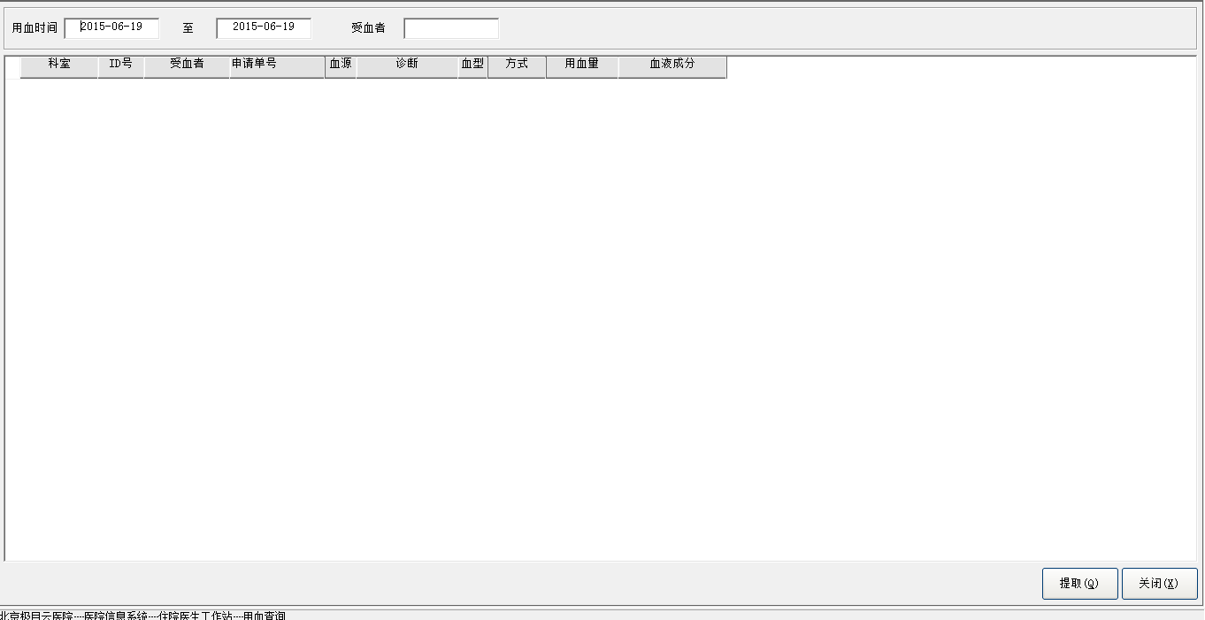

#### 患者主信息

#### 科室字典

**SELECT** "COMM"."DEPT_DICT"."DEPT_NAME" , "COMM"."DEPT_DICT"."DEPT_CODE" **FROM** "COMM"."DEPT_DICT"

#### 血液成分字典

**SELECT** "BLDBANK"."BLOOD_COMPONENT"."BLOOD_TYPE_NAME" , "BLDBANK"."BLOOD_COMPONENT"."BLOOD_TYPE" **FROM** "BLDBANK"."BLOOD_COMPONENT" **WHERE** ( BLDBANK."BLOOD_COMPONENT"."STOP_DATE" is null )

#### 用血预约申请单

**SELECT** "BLDBANK"."BLOOD_APPLY"."APPLY_NUM" , "BLDBANK"."BLOOD_APPLY"."PATIENT_ID" , "BLDBANK"."BLOOD_APPLY"."DEPT_CODE" , "BLDBANK"."BLOOD_APPLY"."PAT_NAME" , "BLDBANK"."BLOOD_APPLY"."BLOOD_INUSE" , "BLDBANK"."BLOOD_APPLY"."BLOOD_DIAGNOSE" , "BLDBANK"."BLOOD_APPLY"."PAT_BLOOD_GROUP" , "BLDBANK"."BLOOD_APPLY"."RH" , "BLDBANK"."BLOOD_APPLY"."BLOOD_SUM" , "BLDBANK"."BLOOD_APPLY"."APPLY_DATE" , "BLDBANK"."BLOOD_APPLY"."PRICE" , "BLDBANK"."BLOOD_CAPACITY"."FAST_SLOW" , "BLDBANK"."BLOOD_CAPACITY"."TRANS_DATE" , "BLDBANK"."BLOOD_CAPACITY"."TRANS_CAPACITY" , "BLDBANK"."BLOOD_CAPACITY"."BLOOD_TYPE" **FROM** "BLDBANK"."BLOOD_APPLY" , "BLDBANK"."BLOOD_CAPACITY" **WHERE** ( "BLDBANK"."BLOOD_APPLY"."APPLY_NUM" = "BLDBANK"."BLOOD_CAPACITY"."APPLY_NUM" ) and ( ( to_char(BLDBANK."BLOOD_CAPACITY"."TRANS_DATE",'yyyy-mm-dd') between '2015-06-19' and '2015-06-19' ) or ( BLDBANK."BLOOD_APPLY"."PAT_NAME" = '' ) )