- 门诊处方
- 处方接口
- 功能描述：
医师可以针对所下诊断开具处方子处方等数据
处方表数据流：处方表—收费—> 待发药 —发药—> 处方主记录
- 输入输出：
(依赖的字典perform_freq_dict ADMINISTRATION_DICT drug_info )
输入 | 输出
DRUG_DICT（药品字典） | OUTP_PRESC（处方医嘱明细记录）
DRUG_NAME_DICT（药品名称字典） | OUTP_ORDERS_COSTS（门诊医生收费明细）
DRUG_PRICE_LIST（药品价格列表） | OUTP_ORDERS（门诊医嘱主记录）
DRUG_STOCK （药品库存）
DRUG_STORAGE_DEPT（药品库存科室）

该判断在mpa中没有加

医师开处方
1、列表所有的药品信息
选中药 | | 西药
点选特定药品
加载相关的价格信息
药理信息（处方用药合理性）
本次诊疗已经有诊断结果了
是
提示医师先填写诊断信息
否
4、保存
- 接口定义：
- 判断是否已有诊断信息 [ 该步骤在本系统中没有进行验证 ]
参数就诊时间、就诊序号
select * from OUTP_MR_DIAG_DESC o
where o.visit_date = to_date('2015-06-17 00:00:00', 'YYYY-MM-DD HH24:MI:SS')
and o.visit_no = '637'
- 根据所选药局列表药品信息
Drug_dict、drug_stock、current_price_list表（名称、规格、库存、包装单位、库房、单次剂量、单次剂量单位、输入码、医保类别）
- 加载所选药品相关的价格信息
Select item_spec , units , price From current_price_list Where item_code ='P0405188TAO' And item_spec ='0.2g*10中美史克' And units ='盒' And item_class ='A'
价格表中item_class为A为药品
- 药理信息加载（毒理分类）?
不同类的要开在一个处方里会有提示依据是什么？
Select TOXI_PROPERTY from DRUG_DICT
- 保存
（每条药品添加一条）
insert OUTP_ORDERS_COSTS门诊医生收费明细、
insert OUTP_PRESC 处方医嘱明细记录
(子处方说明，子处方涉及两个字段order_no以及sub_order_no..
是子处方的话sub_order_no =‘递增’同时子处方的order_no = 父处方的order_no 否则 sub_order_no = 1（起始值）
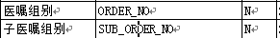
（一次处方添加一条记录）
insert outp_orders 门诊医嘱主记录
添加门诊医生收费明细
INSERT INTO "OUTP_ORDERS_COSTS" ( "PATIENT_ID", "VISIT_DATE", "VISIT_NO", "SERIAL_NO", "ORDER_CLASS", "ORDER_NO", "ORDER_SUB_NO", "ITEM_NO", "ITEM_CLASS", "ITEM_NAME", "ITEM_CODE", "ITEM_SPEC", "UNITS", "REPETITION", "AMOUNT", "ORDERED_BY_DEPT", "ORDERED_BY_DOCTOR", "PERFORMED_BY", "CLASS_ON_RCPT", "COSTS", "CHARGES", "RCPT_NO", "BILL_DESC_NO", "BILL_ITEM_NO", "CHARGE_INDICATOR", "CLASS_ON_RECKONING", "SUBJ_CODE", "PRICE_QUOTIETY", "ITEM_PRICE", "BILL_DATE", "BILL_NO", "WARD_CODE" ) VALUES ( '15001159', '2015-06-17 00:00:00', '637', '2500401', 'A', '2', '1', '1', 'A', '补血颗粒', 'A0201KL00', '4mg*10万达', '袋', '1', '3.0000', '210102', '张晓明', '150520', NULL, '73.5000', '73.5000', NULL, NULL, NULL, '0', NULL, NULL, NULL, NULL, NULL, NULL, '' )
添加处方医嘱明细记录
INSERT INTO "OUTP_PRESC" ( "VISIT_DATE", "VISIT_NO", "SERIAL_NO", "PRESC_NO", "ITEM_NO", "ITEM_CLASS", "DRUG_CODE", "DRUG_NAME", "DRUG_SPEC", "FIRM_ID", "UNITS", "AMOUNT", "DOSAGE", "DOSAGE_UNITS", "ADMINISTRATION", "FREQUENCY", "PROVIDED_INDICATOR", "COSTS", "CHARGES", "CHARGE_INDICATOR", "DISPENSARY", "REPETITION", "ORDER_NO", "SUB_ORDER_NO", "FREQ_DETAIL", "GETDRUG_FLAG", "PRESC_ATTR", "ABIDANCE", "SKIN_FLAG" ) VALUES ( '2015-06-17 00:00:00', '637', '2500401', '711', '1', 'A', 'A0201KL00', '补血颗粒', '4mg*10', '万达', '袋', '3.0000', '4.0000', 'mg', '冲服', '3/日', '0', '73.5000', '73.5000', '0', '150520', '1', '2', '1', NULL, '1', '门诊处方', '20', NULL )
添加门诊医嘱主记录
Insert INTO outp_orders ( patient_id , visit_date , visit_no , serial_no , ordered_by , doctor , clinic_no , doctor_no ) values ( '15001159' , '2015-06-17 00:00:00' , 637 , '2500401' , '210102' , '张晓明' , '2015061700637' , '000ZXM' )
注：新增处方信息OUTP_PRESC中 presc_no 从同此诊断中其他处方累加1
OUTP_PRESC中presc _no
select max ( presc_no ) from OUTP_PRESC where visit_date =to_date('2015-06-17 00:00:00','YYYY-MM-DD HH24:MI:SS') and visit_no =637
其他相关sql
1）获取同次诊断中已有处方
SELECT DISTINCT "OUTP_PRESC"."VISIT_DATE",
"OUTP_PRESC"."VISIT_NO",
"OUTP_PRESC"."SERIAL_NO",
"OUTP_PRESC"."PRESC_NO",
"OUTP_PRESC"."ITEM_CLASS",
"OUTP_PRESC"."CHARGE_INDICATOR",
"OUTP_PRESC"."DISPENSARY",
"OUTP_PRESC"."PRESC_ATTR"
FROM "OUTP_PRESC",
"CLINIC_MASTER"
WHERE ( "OUTP_PRESC"."VISIT_DATE" = "CLINIC_MASTER"."VISIT_DATE" ) and
( "OUTP_PRESC"."VISIT_NO" = "CLINIC_MASTER"."VISIT_NO" ) and
( "CLINIC_MASTER"."VISIT_DATE" = '2015-06-17 00:00:00' ) AND
( "CLINIC_MASTER"."VISIT_NO" = '637' )
5)删除
DELETE FROM "OUTP_ORDERS_COSTS"
WHERE "SERIAL_NO" = '2500520' AND "ORDER_CLASS" = 'A' AND "ORDER_NO" = '5' AND "ORDER_SUB_NO" = '1' AND "ITEM_NO" = '1'
DELETE FROM "OUTP_PRESC"
WHERE "SERIAL_NO" = '2500520' AND "PRESC_NO" = '811' AND "ITEM_NO" = '1' AND "SKIN_FLAG" IS NULL
- 功能实现
新方、添加、删除、子处方、保存、就诊完毕（因为考虑到，一般的门诊开完药整个诊疗过程基本就结束了，因而加了改功能按钮在处方页面）
1、新方；所谓新方就是重新开具一个处方
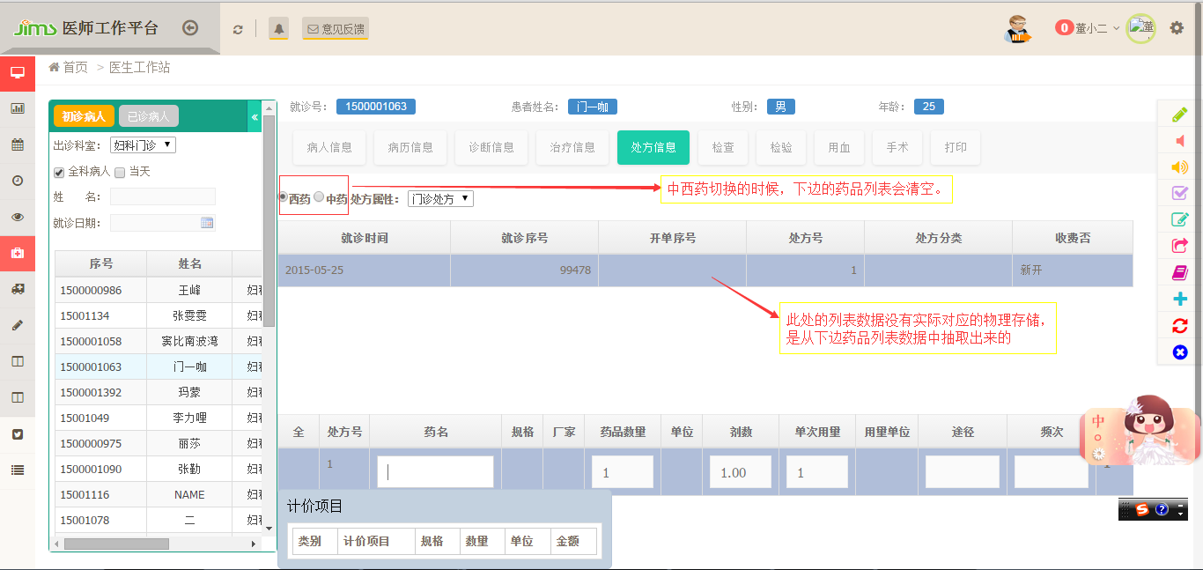
2、添加；在已选处方下新加一条药品信息
3、子处方；将已选的非第一条处方药品设置为上一条药品的子药品，绑定药品关系
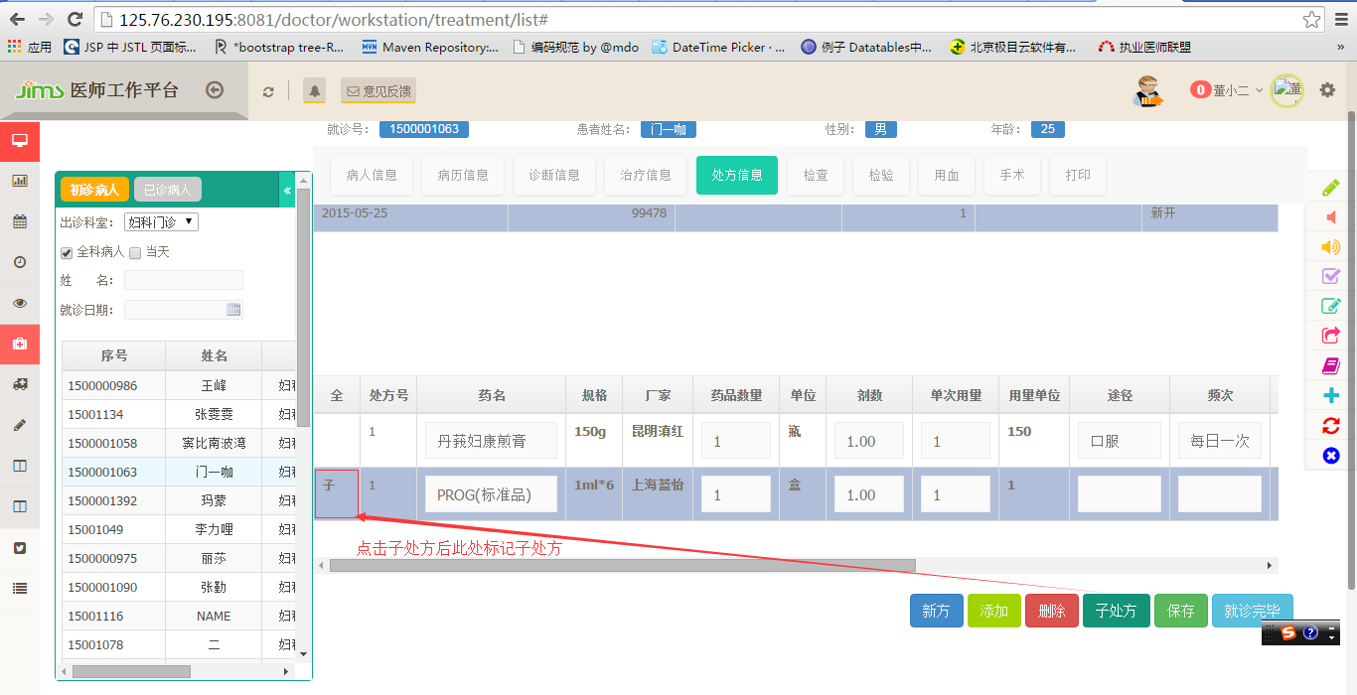
4、保存；保存药品列表，也就是生成一条处方
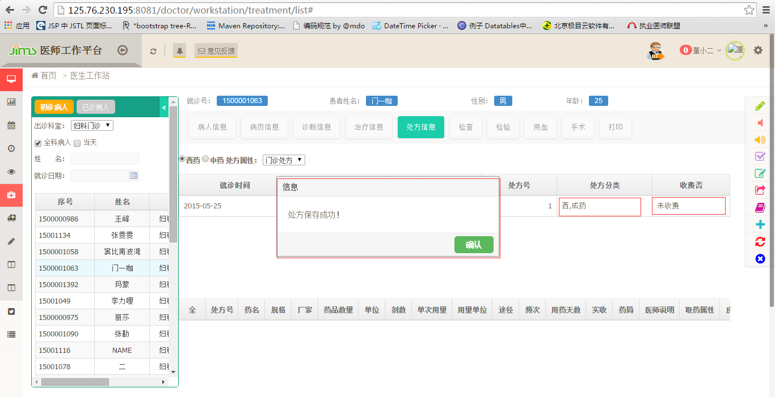
页面提示“处方保存成功”，同时页面第一个列表 开单序号、处方分类、收费否的值都改为对应的值。
5、删除；
只能删除选定的药品，不能删除第一个table列表的数据，也就是没有根据处方号或开单序号删除处方的功能。
6、就诊完毕；
如果已有病历或诊断，则会更改患者此次就诊信息，接着改病人会进入医师的已诊患者列表。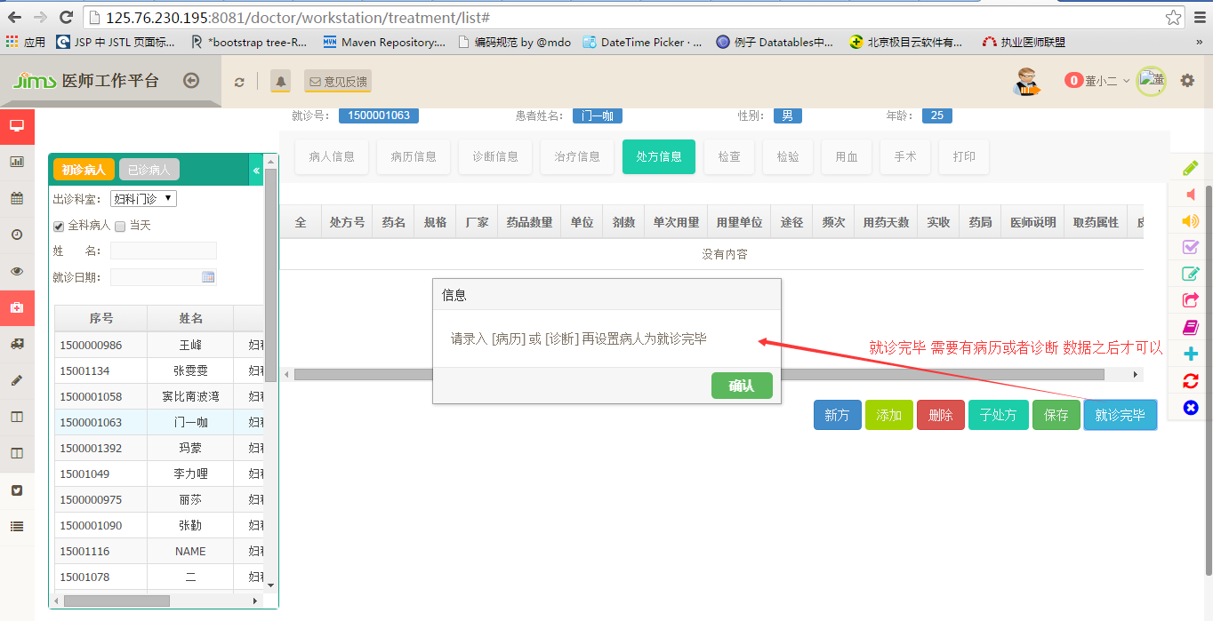
- 住院处方
- 处方接口
- 功能描述
下达处方:
医师可以针对所下诊断开具处方子处方等数据
处方退药:
针对已收费药品，可进行退药。
退药查询:
查询已退药品。
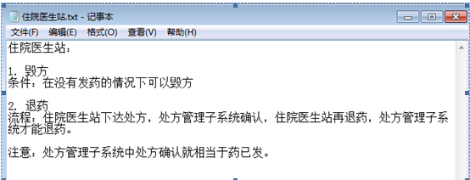
所谓发药，就等同于已收费
- 输入输出
输入 | 输出
DRUG_DICT（药品字典） | DOCT_DRUG_PRESC_DETAIL（待发药住院处方明细记录）
DRUG_NAME_DICT（药品名称字典） | DOCT_DRUG_PRESC_MASTER（待发药住院处方主记录）
DRUG_PRICE_LIST（药品价格列表） | ORDERS（医嘱）
DRUG_STOCK （药品库存） | ORDER_OPEN (类医嘱锁表) 在下达处方的时候该表没有插入数据
DRUG_STORAGE_DEPT（药品库存科室）
- 接口定义
【下达处方】 （前三步与门诊处方数据依赖相同 ）
- 根据所选药局列表药品信息
Drug_dict、drug_stock、current_price_list表（名称、规格、库存、包装单位、库房、单次剂量、单次剂量单位、输入码、医保类别）
- 加载所选药品相关的价格信息
Select item_spec , units , price From current_price_list Where item_code ='P0405188TAO' And item_spec ='0.2g*10中美史克' And units ='盒' And item_class ='A'
价格表中item_class为A为药品
- 药理信息加载（毒理分类）?
不同类的要开在一个处方里会有提示依据是什么？
Select TOXI_PROPERTY from DRUG_DICT
- 药品价格、处方号
价格查询
select price , prefer_price , foreigner_price from current_price_list where item_class ='A' and item_code ='P080530WE0' and upper ( item_spec ) =upper ( '1贴*100沪强生制药' ) and units ='盒'
查询处方号
SELECT nvl ( Max ( order_no ) , 0 ) From orders where patient_id ='1500000846' And visit_id =1
- （每条药品添加一条）
insert ORDERS 医嘱、
insert DOCT_DRUG_PRESC_DETAIL待发药住院处方明细记录
(子处方说明，子处方涉及两个字段order_no以及sub_order_no..
是子处方的话sub_order_no =‘递增’同时子处方的order_no = 父处方的order_no 否则 sub_order_no = 1（起始值）
（一次处方添加一条记录）
insert DOCT_DRUG_PRESC_MASTER 待发药住院处方主记录
sql 语句：
INSERT INTO "ORDADM"."ORDER_OPEN" ( "PATIENT_ID" , "VISIT_ID" , "USER_NAME" , "USER_ID" , "COMPUTER" , "OPEN_TIME" , "DEPT_NAME" ) VALUES ( '1500000846' , 1 , '李建祖' , '000LJZ' , '极目云' , '2015-07-22 17:22:36' , '140101' )
[INSERT INTO ORDER_OPEN 未做]
添加医嘱
INSERT INTO "ORDERS" ( "START_DATE_TIME", "ORDER_TEXT", "DOSAGE", "DOSAGE_UNITS", "ADMINISTRATION", "DURATION", "DURATION_UNITS", "FREQUENCY", "FREQ_COUNTER", "FREQ_INTERVAL", "FREQ_INTERVAL_UNIT", "DOCTOR", "NURSE", "STOP_DOCTOR", "ORDER_CLASS", "REPEAT_INDICATOR", "STOP_DATE_TIME", "ORDER_CODE", "ORDER_STATUS", "ENTER_DATE_TIME", "FREQ_DETAIL", "PATIENT_ID", "VISIT_ID", "ORDER_NO", "ORDER_SUB_NO", "PERFORM_SCHEDULE", "BILLING_ATTR", "LAST_ACCTING_DATE_TIME", "PERFORM_RESULT", "LAST_PERFORM_DATE_TIME", "ORDERING_DEPT", "STOP_NURSE", "DRUG_BILLING_ATTR", "DOCTOR_USER", "VERIFY_DATA_TIME", "ORDER_PRINT_INDICATOR", "PROCESSING_DATE_TIME", "PROCESSING_NURSE", "STOP_PROCESSING_NURSE", "STOP_PROCESSING_DATE_TIME", "CURRENT_PRESC_NO", "CANCEL_DATE_TIME", "CANCEL_DOCTOR", "DEGREE" ) VALUES ( '2015-07-22 17:24:22', '苯扎氯铵贴', '1.0000', '贴', '外用', NULL, NULL, NULL, NULL, NULL, NULL, '李建祖', NULL, NULL, 'A', '0', NULL, 'P080530WE0', '6', '2015-07-22 17:24:22', '1.0000/盒', '1500000846', '1', '50', '1', NULL, '4', NULL, NULL, NULL, '140101', NULL, '4', '000LJZ', NULL, NULL, NULL, NULL, NULL, NULL, '3158', NULL, NULL, NULL )
INSERT INTO "ORDERS" ( "START_DATE_TIME", "ORDER_TEXT", "DOSAGE", "DOSAGE_UNITS", "ADMINISTRATION", "DURATION", "DURATION_UNITS", "FREQUENCY", "FREQ_COUNTER", "FREQ_INTERVAL", "FREQ_INTERVAL_UNIT", "DOCTOR", "NURSE", "STOP_DOCTOR", "ORDER_CLASS", "REPEAT_INDICATOR", "STOP_DATE_TIME", "ORDER_CODE", "ORDER_STATUS", "ENTER_DATE_TIME", "FREQ_DETAIL", "PATIENT_ID", "VISIT_ID", "ORDER_NO", "ORDER_SUB_NO", "PERFORM_SCHEDULE", "BILLING_ATTR", "LAST_ACCTING_DATE_TIME", "PERFORM_RESULT", "LAST_PERFORM_DATE_TIME", "ORDERING_DEPT", "STOP_NURSE", "DRUG_BILLING_ATTR", "DOCTOR_USER", "VERIFY_DATA_TIME", "ORDER_PRINT_INDICATOR", "PROCESSING_DATE_TIME", "PROCESSING_NURSE", "STOP_PROCESSING_NURSE", "STOP_PROCESSING_DATE_TIME", "CURRENT_PRESC_NO", "CANCEL_DATE_TIME", "CANCEL_DOCTOR", "DEGREE" ) VALUES ( '2015-07-22 17:24:22', '注射用表柔比星', '10.0000', 'mg', '静脉注射', NULL, NULL, '一日二次', NULL, NULL, NULL, '李建祖', NULL, NULL, 'A', '0', NULL, 'T030004IJ0', '6', '2015-07-22 17:24:22', '1.0000/支', '1500000846', '1', '51', '1', NULL, '4', NULL, NULL, NULL, '140101', NULL, '4', '000LJZ', NULL, NULL, NULL, NULL, NULL, NULL, '3158', NULL, NULL, NULL )
待发药住院处方主记录
INSERT INTO "DOCT_DRUG_PRESC_MASTER" ( "PATIENT_ID", "VISIT_ID", "NAME", "NAME_PHONETIC", "PRESC_DATE", "IDENTITY", "CHARGE_TYPE", "ORDERED_BY", "PRESCRIBED_BY", "PRESC_ATTR", "DISPENSARY", "PRESC_SOURCE", "UNIT_IN_CONTRACT", "PRESC_NO", "PRESC_TYPE", "REPETITION", "COSTS", "PAYMENTS", "ENTERED_BY", "PRESC_STATUS", "DISPENSING_PROVIDER", "COUNT_PER_REPETITION", "USAGE", "BINDING_PRESC_TITLE", "DISCHARGE_TAKING_INDICATOR", "DOCTOR_USER", "DECOCTION", "NEWLY_PRINT", "DIAGNOSIS_NAME" ) VALUES ( '1500000846', '1', '金钟国', 'JIN ZHONG GUO', '2015-07-22 17:22:43', '一般人员', '自费', '140101', '李建祖', NULL, '150501', '1', '', '3158', '0', '1', '185.5180', '185.5180', '李建祖', '0', NULL, NULL, NULL, NULL, NULL, '000LJZ', NULL, NULL, '蜘蛛痣血管瘤' )
待发药住院处方明细记录
INSERT INTO "DOCT_DRUG_PRESC_DETAIL" ( "PRESC_DATE", "PRESC_NO", "ITEM_NO", "ORDER_NO", "ORDER_SUB_NO", "DRUG_CODE", "DRUG_SPEC", "DRUG_NAME", "FIRM_ID", "PACKAGE_SPEC", "PACKAGE_UNITS", "QUANTITY", "COSTS", "PAYMENTS", "ADMINISTRATION", "DOSAGE", "DOSAGE_UNITS", "AMOUNT_PER_PACKAGE", "FREQUENCY", "DOSAGE_EACH", "FREQ_DETAIL" ) VALUES ( '2015-07-22 17:22:43', '3158', '1', '50', '1', 'P080530WE0', '1贴*100沪强生制药', '苯扎氯铵贴', '沪强生制药', '1贴*100', '盒', '1.00', '24.1500', '24.1500', '外用', NULL, '贴', NULL, NULL, '1.0000', '1.0000/盒' )
INSERT INTO "DOCT_DRUG_PRESC_DETAIL" ( "PRESC_DATE", "PRESC_NO", "ITEM_NO", "ORDER_NO", "ORDER_SUB_NO", "DRUG_CODE", "DRUG_SPEC", "DRUG_NAME", "FIRM_ID", "PACKAGE_SPEC", "PACKAGE_UNITS", "QUANTITY", "COSTS", "PAYMENTS", "ADMINISTRATION", "DOSAGE", "DOSAGE_UNITS", "AMOUNT_PER_PACKAGE", "FREQUENCY", "DOSAGE_EACH", "FREQ_DETAIL" ) VALUES ( '2015-07-22 17:22:43', '3158', '2', '51', '1', 'T030004IJ0', '10mg浙江海正', '注射用表柔比星', '浙江海正', '10mg', '支', '1.00', '138.0000', '138.0000', '静脉注射', '0.0000', 'mg', NULL, '一日二次', '10.0000', '1.0000/支' )
[毁方：]
1：DELETE FROM "DOCT_DRUG_PRESC_MASTER" WHERE "PRESC_DATE" = '2015-07-15 10:24:05' AND "PRESC_NO" = '3251'
2:DELETE FROM "DOCT_DRUG_PRESC_DETAIL" WHERE "PRESC_DATE" = '2015-07-15 10:24:05' AND "PRESC_NO" = '3251' // AND "ITEM_NO" = '1'
3:UPDATE "ORDERS" SET "STOP_DOCTOR" = '000LJZ', "ORDER_STATUS" = '8' WHERE "PATIENT_ID" = '1500000846' AND "VISIT_ID" = '1' AND "ORDER_NO" = '9' AND "ORDER_SUB_NO" = '1'
[ 处方退药]
1：【查询】 已收费药品
SELECT PATIENT_ID, VISIT_ID, ITEM_NO, ITEM_CLASS, ITEM_NAME, ITEM_CODE, ITEM_SPEC, AMOUNT,
UNITS, ORDERED_BY, PERFORMED_BY, COSTS, CHARGES, BILLING_DATE_TIME, OPERATOR_NO,
RCPT_NO, ORDER_GROUP, ORDER_DOCTOR, PERFORM_GROUP, PERFORM_DOCTOR, 0 check_box,
'' LBATCH_NO, 0.00 as back_amount
FROM INP_BILL_DETAIL
WHERE (PATIENT_ID = '1500001167') AND (VISIT_ID = 1) and (PERFORMED_BY in ('150520'))
and BILLING_DATE_TIME >= to_date('2013-07-27', 'yyyy-mm-dd')
and BILLING_DATE_TIME <= to_date('2015-07-27', 'yyyy-mm-dd') + 1
and (ITEM_CLASS = 'A')
and (RCPT_NO is null)
and (AMOUNT > 0)

- 查询可退药数量
SELECT DOCT_DRUG_PRESC_MASTER.PATIENT_ID,
DOCT_DRUG_PRESC_MASTER.VISIT_ID,
DOCT_DRUG_PRESC_DETAIL.DRUG_CODE,
DOCT_DRUG_PRESC_DETAIL.DRUG_SPEC,
DOCT_DRUG_PRESC_DETAIL.DRUG_NAME,
DOCT_DRUG_PRESC_DETAIL.FIRM_ID,
sum(DOCT_DRUG_PRESC_DETAIL.QUANTITY)
FROM DOCT_DRUG_PRESC_DETAIL, DOCT_DRUG_PRESC_MASTER
WHERE (DOCT_DRUG_PRESC_DETAIL.PRESC_NO = DOCT_DRUG_PRESC_MASTER.PRESC_NO)
and (DOCT_DRUG_PRESC_DETAIL.PRESC_DATE =
DOCT_DRUG_PRESC_MASTER.PRESC_DATE)
and ((DOCT_DRUG_PRESC_MASTER.PATIENT_ID = '1500001167') AND
(DOCT_DRUG_PRESC_MASTER.VISIT_ID = 1) AND
(DOCT_DRUG_PRESC_MASTER.DISPENSARY in ('150502')) AND
(DOCT_DRUG_PRESC_MASTER.PRESC_TYPE = 0) AND
(DOCT_DRUG_PRESC_MASTER.PRESC_STATUS = 3))
GROUP BY DOCT_DRUG_PRESC_MASTER.PATIENT_ID,
DOCT_DRUG_PRESC_MASTER.VISIT_ID,
DOCT_DRUG_PRESC_DETAIL.DRUG_CODE,
DOCT_DRUG_PRESC_DETAIL.DRUG_SPEC,
DOCT_DRUG_PRESC_DETAIL.DRUG_NAME,
DOCT_DRUG_PRESC_DETAIL.FIRM_ID
- 退药
生成主记录 和 detal详情
INSERT INTO PHARMACY."DOCT_DRUG_PRESC_MASTER" ( "PRESC_DATE", "PRESC_NO", "DISPENSARY", "PATIENT_ID", "VISIT_ID", "NAME", "NAME_PHONETIC", "IDENTITY", "CHARGE_TYPE", "UNIT_IN_CONTRACT", "PRESC_TYPE", "PRESC_ATTR", "PRESC_SOURCE", "DISCHARGE_TAKING_INDICATOR", "BINDING_PRESC_TITLE", "REPETITION", "COUNT_PER_REPETITION", "COSTS", "PAYMENTS", "ORDERED_BY", "PRESCRIBED_BY", "ENTERED_BY", "PRESC_STATUS", "DISPENSING_PROVIDER", "USAGE", "DOCTOR_USER", "NEWLY_PRINT" ) VALUES ( '2015-07-28 10:53:38', '3218', '150520', '1500001167', '1', '万爽', '', '一般人员', '自费', NULL, '0', NULL, '1', NULL, NULL, '1', NULL, '-9.0060', '-9.0060', '21020101', '张晓明', '张晓明', '3', NULL, NULL, '000ZXM', NULL )
INSERT INTO PHARMACY."DOCT_DRUG_PRESC_DETAIL" ( "PRESC_DATE", "PRESC_NO", "ITEM_NO", "ORDER_NO", "ORDER_SUB_NO", "DRUG_CODE", "DRUG_SPEC", "DRUG_NAME", "FIRM_ID", "PACKAGE_SPEC", "PACKAGE_UNITS", "QUANTITY", "DOSAGE", "DOSAGE_UNITS", "ADMINISTRATION", "COSTS", "PAYMENTS", "MEMO", "AMOUNT_PER_PACKAGE", "FREQUENCY", "DOSAGE_EACH", "BATCH_NO" ) VALUES ( '2015-07-28 10:53:38', '3218', '1', NULL, NULL, 'I051520CAO', '0.25g*20', '阿莫西林胶囊', '哈药总厂', '0.25g*20', '盒', '-2.0000', '-2.0000', NULL, NULL, '-9.0060', '-9.0060', NULL, NULL, NULL, NULL, NULL )
【退药查询】
1、(master)
SELECT "DOCT_DRUG_PRESC_MASTER"."PATIENT_ID",
"DOCT_DRUG_PRESC_MASTER"."VISIT_ID",
"DOCT_DRUG_PRESC_MASTER"."NAME",
"DOCT_DRUG_PRESC_MASTER"."NAME_PHONETIC",
"DOCT_DRUG_PRESC_MASTER"."PRESC_DATE",
"DOCT_DRUG_PRESC_MASTER"."IDENTITY",
"DOCT_DRUG_PRESC_MASTER"."CHARGE_TYPE",
"DOCT_DRUG_PRESC_MASTER"."ORDERED_BY",
"DOCT_DRUG_PRESC_MASTER"."PRESCRIBED_BY",
"DOCT_DRUG_PRESC_MASTER"."PRESC_ATTR",
"DOCT_DRUG_PRESC_MASTER"."DISPENSARY",
"DOCT_DRUG_PRESC_MASTER"."PRESC_SOURCE",
"DOCT_DRUG_PRESC_MASTER"."UNIT_IN_CONTRACT",
"DOCT_DRUG_PRESC_MASTER"."PRESC_NO",
"DOCT_DRUG_PRESC_MASTER"."PRESC_TYPE",
"DOCT_DRUG_PRESC_MASTER"."REPETITION",
"DOCT_DRUG_PRESC_MASTER"."COSTS",
"DOCT_DRUG_PRESC_MASTER"."PAYMENTS",
"DOCT_DRUG_PRESC_MASTER"."ENTERED_BY",
"DOCT_DRUG_PRESC_MASTER"."PRESC_STATUS",
"DOCT_DRUG_PRESC_MASTER"."DISPENSING_PROVIDER",
"DOCT_DRUG_PRESC_MASTER"."COUNT_PER_REPETITION",
"DOCT_DRUG_PRESC_MASTER"."USAGE",
"PATS_IN_HOSPITAL"."BED_NO",
nvl(prepayments,0) - nvl(total_charges, 0) prepayment,
"PATS_IN_HOSPITAL"."DIAGNOSIS",
"DOCT_DRUG_PRESC_MASTER"."BINDING_PRESC_TITLE",
"DOCT_DRUG_PRESC_MASTER"."DISCHARGE_TAKING_INDICATOR",
"DOCT_DRUG_PRESC_MASTER"."DOCTOR_USER",
"DOCT_DRUG_PRESC_MASTER"."NEWLY_PRINT"
FROM "DOCT_DRUG_PRESC_MASTER",
"PATS_IN_HOSPITAL"
WHERE ( "DOCT_DRUG_PRESC_MASTER"."PATIENT_ID" = "PATS_IN_HOSPITAL"."PATIENT_ID" ) and
( "DOCT_DRUG_PRESC_MASTER"."VISIT_ID" = "PATS_IN_HOSPITAL"."VISIT_ID" ) and
(PRESC_STATUS in(1,3)) AND
( DOCT_DRUG_PRESC_MASTER.PATIENT_ID = #{patientId} ) and
<![CDATA[("DOCT_DRUG_PRESC_MASTER"."COSTS" < 0 ) ]]>
2、(detail)
SELECT "DOCT_DRUG_PRESC_DETAIL"."PRESC_DATE",
"DOCT_DRUG_PRESC_DETAIL"."PRESC_NO",
"DOCT_DRUG_PRESC_DETAIL"."ITEM_NO",
"DOCT_DRUG_PRESC_DETAIL"."ORDER_NO",
"DOCT_DRUG_PRESC_DETAIL"."ORDER_SUB_NO",
"DOCT_DRUG_PRESC_DETAIL"."DRUG_CODE",
"DOCT_DRUG_PRESC_DETAIL"."DRUG_SPEC",
"DOCT_DRUG_PRESC_DETAIL"."DRUG_NAME",
"DOCT_DRUG_PRESC_DETAIL"."FIRM_ID",
"DOCT_DRUG_PRESC_DETAIL"."PACKAGE_SPEC",
"DOCT_DRUG_PRESC_DETAIL"."PACKAGE_UNITS",
"DOCT_DRUG_PRESC_DETAIL"."QUANTITY",
"DOCT_DRUG_PRESC_DETAIL"."COSTS",
"DOCT_DRUG_PRESC_DETAIL"."PAYMENTS",
"DOCT_DRUG_PRESC_MASTER"."PRESC_STATUS",
"DOCT_DRUG_PRESC_DETAIL"."ADMINISTRATION",
"DOCT_DRUG_PRESC_DETAIL"."DOSAGE",
"DOCT_DRUG_PRESC_DETAIL"."DOSAGE_UNITS",
"DOCT_DRUG_PRESC_MASTER"."PRESC_TYPE",
"DOCT_DRUG_PRESC_DETAIL"."AMOUNT_PER_PACKAGE",
"DOCT_DRUG_PRESC_DETAIL"."FREQUENCY",
"DOCT_DRUG_PRESC_DETAIL"."DOSAGE_EACH",
0 sub_order
FROM "DOCT_DRUG_PRESC_DETAIL",
"DOCT_DRUG_PRESC_MASTER"
WHERE ( "DOCT_DRUG_PRESC_DETAIL"."PRESC_NO" = "DOCT_DRUG_PRESC_MASTER"."PRESC_NO" ) and
( "DOCT_DRUG_PRESC_DETAIL"."PRESC_DATE" = "DOCT_DRUG_PRESC_MASTER"."PRESC_DATE" ) and
( ( DOCT_DRUG_PRESC_DETAIL.PRESC_DATE = '2015-07-28 10:53:38' ) AND
( DOCT_DRUG_PRESC_DETAIL.PRESC_NO = '3218' ) )
【退药查询中的毁方：】
DELETE FROM "DOCT_DRUG_PRESC_DETAIL" WHERE "PRESC_DATE" = '2015-07-28 11:00:15' AND "PRESC_NO" = '3219' // AND "ITEM_NO" = '1' 删除所有详情

2、功能实现
新方、添加、毁方、子处方、刷新、保存
1、新方；所谓新方就是重新开具一个处方

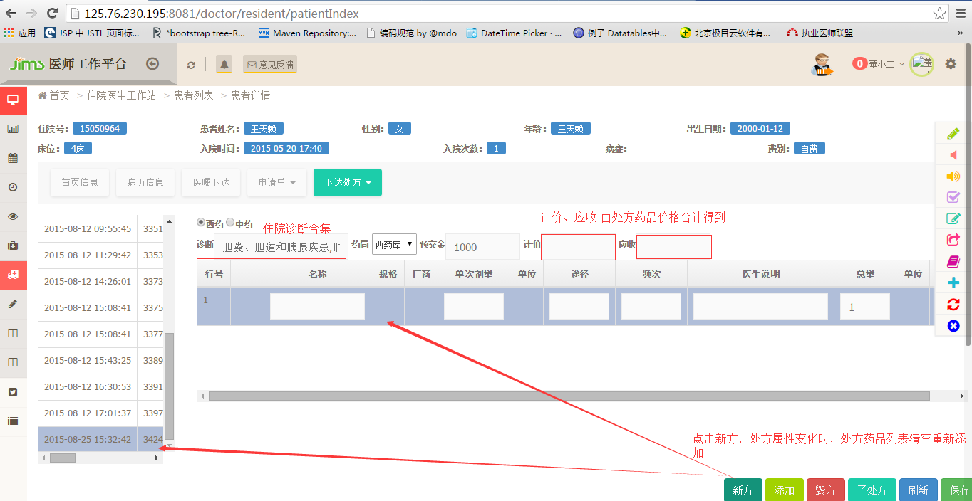
在点击新方的时候处方号生成方式：select presc_no_seq.nextval from dual
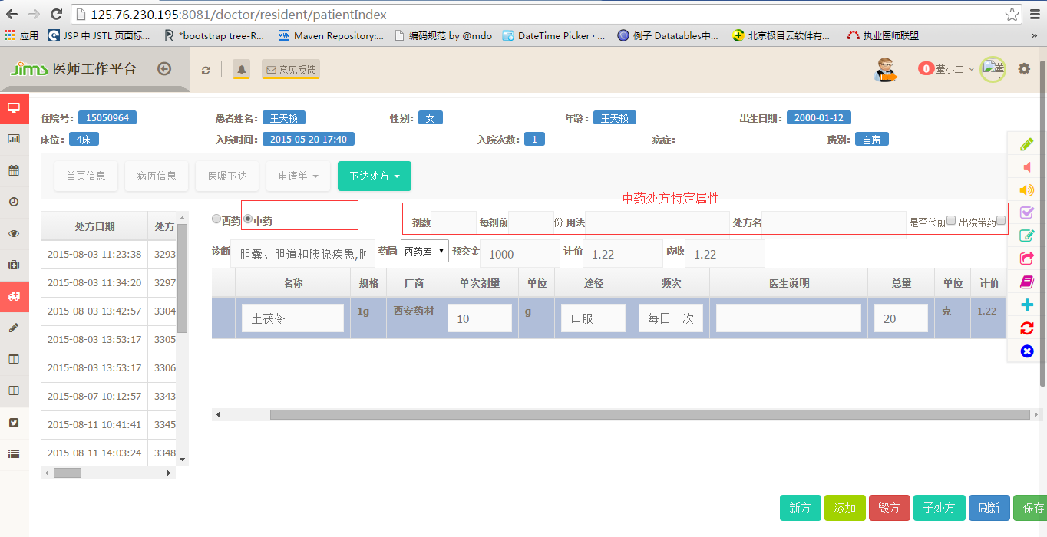
2、添加：在已选处方下添加一条药品信息
3、毁方：即删除处方，此处毁方针对的是整个处方，而非处方下的药品 ，此处跟门诊处方不同
4、子处方：子处方如同门诊处方
5、刷新：在做更新的时候，点击刷新放弃修改，添加等操作
6、保存：保存处方

