

RPS Digital – Configuration Document (Draft)

To assist you with filling this document, the **Appendix** sections has the steps visualised with examples. Please refer to this when required to help you fill out this form.

Contents

Market Appraisal Plugin 2

Valuer Diaries 2

Notification Events 2

Global Settings 4

Viewing Request Plugin 5

Viewer Diaries 5

Viewing Notification Events 5

Pre-Requisites/Advisories 7

Appendix 8

Web Integration Methods 8

Market Appraisal Booking Example 9

Viewing Request Booking Example 16

## Market Appraisal Plugin

The Market Appraisal plugin allows the ability to book in an appointment directly into RPS from a pool of available timeslots. The appointment process has the ability to create a contact if one does not already exist (it will de-duplicate using the email address used for the registration). This section will cover all the configuration options available for this plugin and the expected interactions.

### Valuer Diaries

The appointment diary allows specific negotiators/valuers to be pre-configured and included in the pool that is presented to a client on the website for a Market Appraisal to be booked in. There are currently two options available options that you to change valuer diaries:

1. Job Title(s) – the diary is made up of individuals with specific job title(s).
2. Specified Negs - Diary is preconfigured with specific Negotiators/Valuers.

Please use the table below to specify the option required ensuring any names are spelt accurately.

**Sales**

|  |  |  |  |
| --- | --- | --- | --- |
| **Option** | | **Default Sales Value** | **Requirement** |
| a) | Job Title(s) | Valuer, Negotiator, Property Consultant, Senior Property Consultant, Sales Negotiator, Sales Associate, | Click or tap here to enter text. |
| b) | Specific Negs | Please list all negotiators. Please use **full names** and ensure you have at least one person from each your offices. | Click or tap here to enter text. |

**Lettings**

|  |  |  |  |
| --- | --- | --- | --- |
| **Option** | | **Default Lettings Value** | **Requirement** |
| a) | Job Title(s) | Valuer, Negotiator, Property Consultant, Senior Property Consultant, Lettings Negotiator, Lettings Associate, | Click or tap here to enter text. |
| b) | Specific Negs | Please list all negotiators. Please use **full names** and ensure you have at least one person from each your offices. | Click or tap here to enter text. |

### Notification Events

When an appointment is being booked, the following notification events are triggered:

|  |  |  |  |
| --- | --- | --- | --- |
| **Option** | **Default Text/Option** | **Owner** | **Requirement** |
| On Screen Notification | *“To book a valuation, please enter your e-mail and postcode below.”* | Web company | Please review with your web company. |
| Email Sent – Subject Line: | ***SALES:*** *“Your Valuation Request”*  ***LETTINGS:*** *“Your Lettings Valuation Request”* | Reapit | Keep Default  Custom Text (enter below)  Click or tap here to enter text. |
| Email Sent – Reply Address: | [no-reply@client-website.co.uk](mailto:no-reply@client-website.co.uk)  Note: We will provide technical details to your web company/mail provider to allow emails to be sent on behalf of your domain. | Reapit | Please specify the default email address:  Click or tap here to enter text. |
| Email Sent – Content of email: | ***“<<Vendor>>***  *Your valuation has been booked for hh:mm on DD MMMM at <<Property Full Address>>.*  *If you have any queries or need to rearrange, please call me on <<Property Valuer>> or e-mail <<valuer email address>>*  *We've also created an account for you which you can log into here.*  *Kind regards*  ***<<Property Negotiator>>”*** | Reapit | Keep Default  Custom Text (enter below)  Click or tap here to enter text.  Note: Reapit will by default use your existing email template layout (including headers & footers) and update the text accordingly.  2nd paragraph is subject to the availability of the Vendor Tracker once fully configured. |
| Email Sent - Recipients | In Addition to the email notification being sent to the client, the email also gets sent as a BCC (Blind Carbon Copy) to the valuer. There is a config option to also send this to the **branch manager**. | Reapit | Email Office Manager too. |
| SMS Text Message | ***SALES:*** *“Your valuation with {{ negotiator }} has been booked for {{ date }} at {{ location }}. To rearrange this appointment, please call {{ telephone }}”*  ***LETTINGS:*** *“Your lettings valuation with {{ negotiator }} has been booked for {{ date }} at {{ location }}. To rearrange this appointment, please call {{ telephone }}”* | Reapit | Keep Default  Custom Text (enter text below)  Click or tap here to enter text.  *please note the limit on SMS text message limit |

### Global Settings

|  |  |  |
| --- | --- | --- |
| **Option** | **Default Option** | **Requirement** |
| Appointment Lead Time – A lead time can be set before an appointment can be made. This is to ensure an appointment cannot be booked immediately. | 6 hours | Keep Default  Custom Time (select option below)  6 hours |
| Appointment Buffer: There is a buffer of 30 minutes applied prior and after a pre-existing appointment to ensure travel time is accommodated. | 30 min | Keep Default  Custom Time (select option below)  30 minutes |
| Default Office - A default office needs to be set if a registration postcode cannot be identified or falls outside an offices catchment area. If no postcodes are found please specify which office should the enquiry go to (via AppImp)? | Please enter the default office -> | Default office:  Click or tap here to enter text. |
| National Holidays and Company holidays/event days can be set to prevent appointments from being made on these days. | England & Wales | England & Wales  Scotland  Northern Ireland  -----------------------------------------  Please specify any additional dates you want reserved:  Click or tap to enter a date. |
| Specify office opening times:  *Please be advised that this setting is currently a global setting across your offices. |  | Monday:  Tuesday:  Wednesday:  Thursday:  Friday:  Saturday:  Sunday: |

## Viewing Request Plugin

### Viewer Diaries

The Viewing plugin allows the option to create viewing appointment requests directly into RPS for a specific property.

The diary can be setup in the follow three methods:

1. Property Negotiator – The property manager diary is presented with available slots in their diary.
2. Job Title(s) – the diary is made up of individuals with specific job title(s).
3. Specified Negs - Diary is preconfigured with a pool of specific Negotiators.

Please use the table below to specify the option required ensuring any names are spelt accurately.

|  |  |  |  |
| --- | --- | --- | --- |
| **Option** | | **Default Value** | **Requirement** |
| a) | Property Negotiator | Property Negotiator | Keep Default |
| b) | Job Title(s) | Valuer, Negotiator, Property Consultant, Senior Property Consultant, Sales Negotiator, Sales Associate, | Click or tap here to enter text. |
| c) | Specific Negs | Please list all negotiators. Please use **full names** and ensure you have at least one person from each your offices. | Click or tap here to enter text. |

### Viewing Notification Events

When an appointment is being booked, the following notification events are triggered:

|  |  |  |  |
| --- | --- | --- | --- |
| **Option** | **Default Text/Option** | **Owner** | **Requirement** |
| On Screen Notification | *“To book a viewing, please enter your e-mail below.”* | Web company | Please review with your web company. |
| Email Sent – Subject Line: | *“Your Viewing Request for {{ location }}”* | Reapit | Keep Default  Custom Text (enter below)  Click or tap here to enter text. |
| Email Sent – Reply Address: | [no-reply@client-website.co.uk](mailto:no-reply@client-website.co.uk)  Note: We will provide technical details to your web company/mail provider to allow emails to be sent on behalf of your domain. | Reapit | Please specify the default email address:  Click or tap here to enter text. |
| Email Sent – Content of email: | ***Your viewing at <<Property Full Address>>has been booked for***  *hh:mm on DD MMMM.*  *If you have any queries or need to rearrange, please call me on <<Property Manager Number>> or e-mail <<Property Manager Email Address>>*  *We've also created an account for you which you can log into here.*  *Kind regards*  ***<<Property Negotiator>>”*** | Reapit | Keep Default  Custom Text (enter below)  Click or tap here to enter text.  Note: Reapit will by default use your existing email template layout (including headers & footers) and update the text accordingly.  2nd paragraph is subject to the availability of the Applicant Tracker once fully configured. |
| Email Sent - Recipients | In Addition to the email notification being sent to the client, the email also gets sent as a BCC (Blind Carbon Copy) to the valuer. There is a config option to also send this to the **branch manager**. | Reapit | Email Office Manager too. |
| SMS Text Message | *“Your viewing at {{ location }} has been booked with {{ negotiator }} for {{ date }}. To rearrange this appointment, please call {{ telephone }}.”* | Reapit | Keep Default  Custom Text (enter text below)  Click or tap here to enter text.  *please note the limit on SMS text message limit |

## Pre-Requisites/Advisories

**RPS Digital Pre-requisites:**

* **Hosting -** RPS data must be hosted on Reapit Servers in order to use the RPS Digital offering.
* **jQuery version** – a minimum of Version 1.9 of the jQuery library is required.
* **Workflow** – Any RPS workflow will need to be reviewed and ensure client acceptance is received.
* **Privacy Policy** - As part of the RPS Digital implementation, it is recommended to review your Website Privacy Policy to ensure you are adhering to DPA requirements. RPS Digital will allow the processing of the following pieces of information:
* Name
* Address
* Email Address
* Telephone Number

## Appendix

### Web Integration Methods

There are two available methods for website integration. Options and links to documentation are available as follows.

|  |  |  |
| --- | --- | --- |
| **Option** | **Example/Documentation URL** | **Notes** |
| jQuery Plugin | Valuation Plugin:  <https://tracker.reapit.net/demo/_demo/valuation/documentation>  Viewing Plugin: <https://tracker.reapit.net/demo/_demo/viewing/documentation> | To test out the ‘Book a Valuation’ link on the demo page, please use the following postcode when registering to ensure a full cycle of registration takes place:  **MK1 1DF**  Please note that any data added to this form will be overwritten on a daily/weekly basis. |
| API Endpoints | Diary Extension Packs:  <https://tracker.reapit.net/demo/_doc/web-service/diary-extension-pack/> |  |

### Market Appraisal Booking Example

Integration Documentation that will be needed by your Web Company can be found on the following location: <https://tracker.reapit.net/demo/_demo/valuation/#documentation>

The below screen prints show the series of steps when creating a new “Market Appraisal” request:

1. **Book a valuation button** – your web company can amend the text displayed within the button.



When the ‘Book a Valuation’ button is selected, the following default screens are displayed:

1. **Booking a valuation**

When the button is pressed, the following screen is presented (*the text can be altered by your web company):

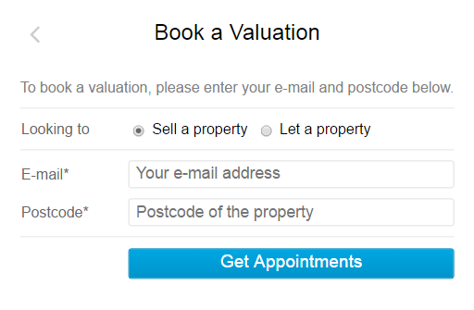

Note: The postcode entered here determines which office diary is displayed. If the postcode is not recognised, the enquiry will be sent to a default office setup to catch all exceptions as an AppImp enquiry.

Enter Email address & Postcode:

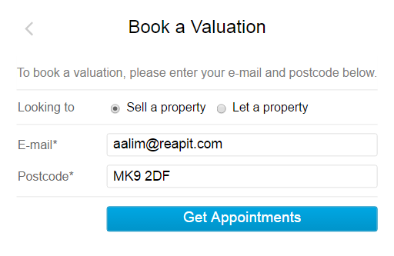

Once ‘Get Appointments’ is selected, subject to a valid post code match against the agency offices, the user is presented with a similar diary screen: (unavailable times are not visible).

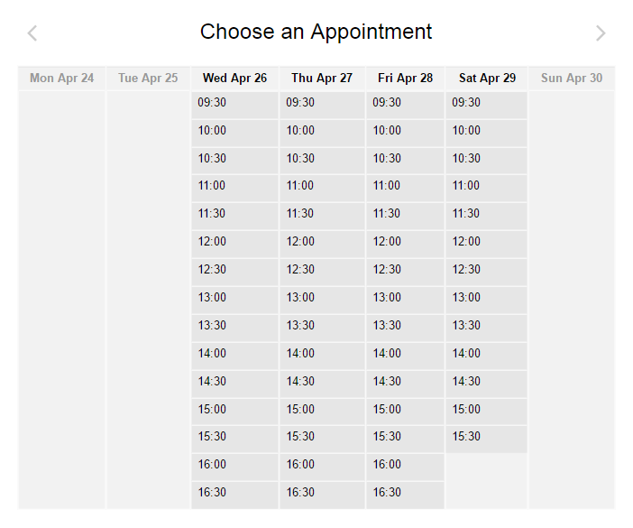

National holidays and company event days can be booked out by default to ensure appointments are not made on these days.

Upon selection of a suitable and available appointment slot, a request for more details will be displayed to provide further contact and property details:

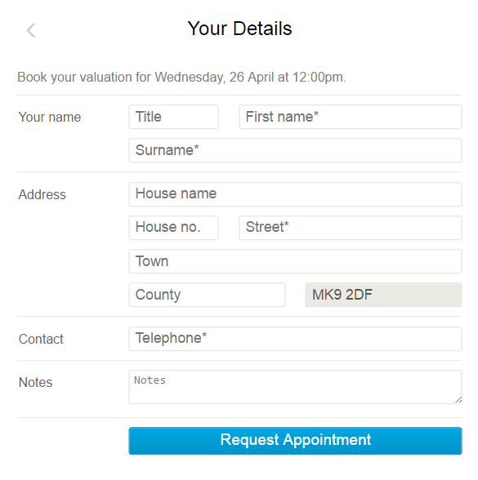

Filled out form example:

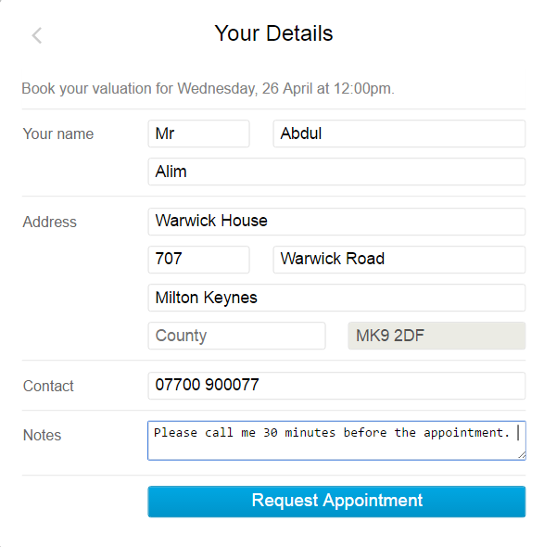

Upon a successful appointment creation, the following dialogue box will be presented: 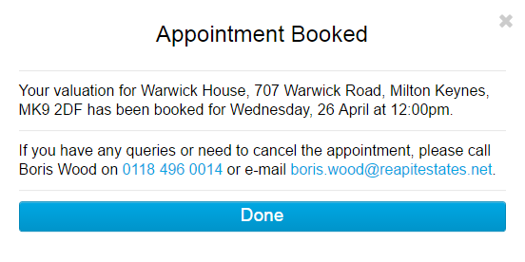

1. **Notifications**

A number of notification events are triggered once a successful appointment has been created:

1. Email Message Notification
   * **Recipients:**
     + Prospective Vendor, **BCC:** Property Negotiator, **BCC:** Office Manager (subject to configuration)

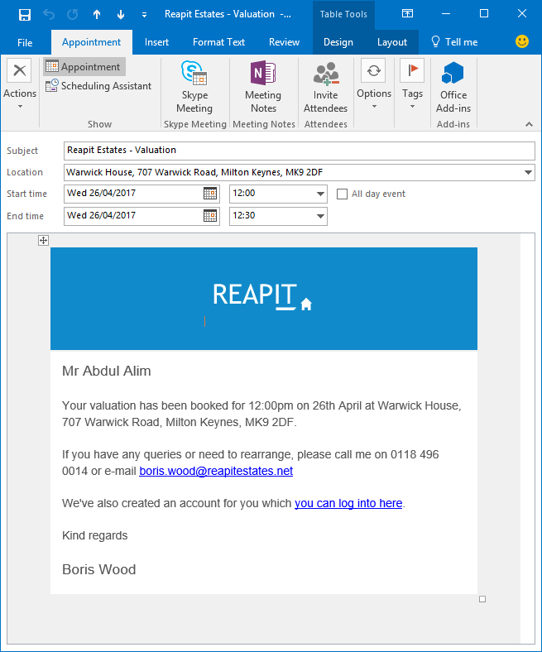

1. Text Message Alert (subject to availability of SMS Speedway already configured).

Example of a message received on a phone:

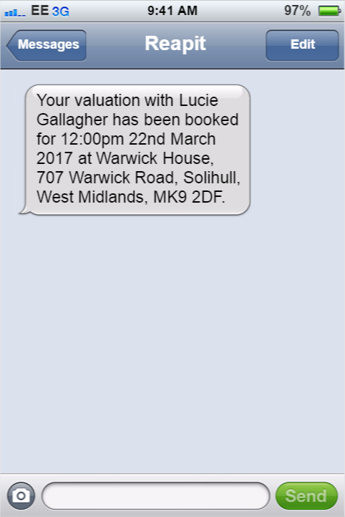

1. **RPS Interactions**

There are a number of interactions that occur on RPS following a successful appointment creation:

1. Contact/Property Record gets created. If a contact does exist it will de-dupe on the telephone number entered.
2. RPS Task gets created and assigned to the valuer assigned.
3. Diary entry gets created
4. Property Record with associated contact record. If a contact already exist, it will create a property record from the existing contact.

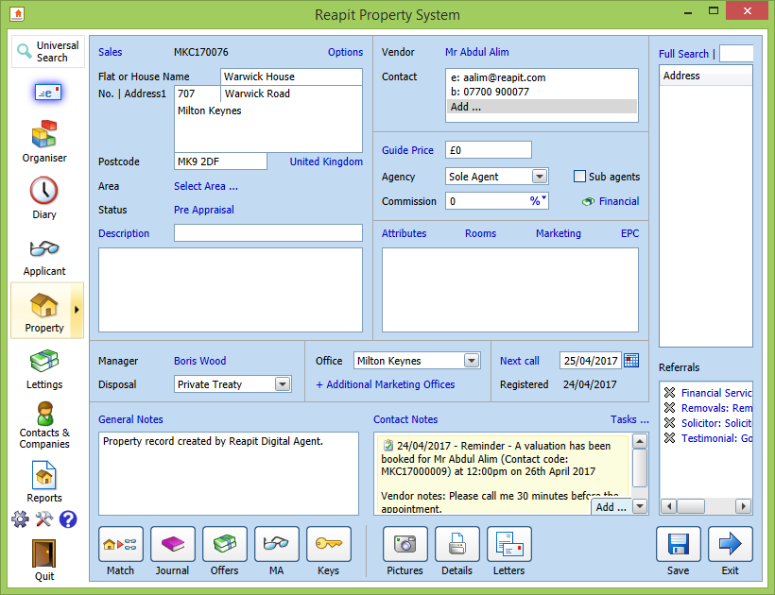

1. Task created and alerted on the organiser screen:

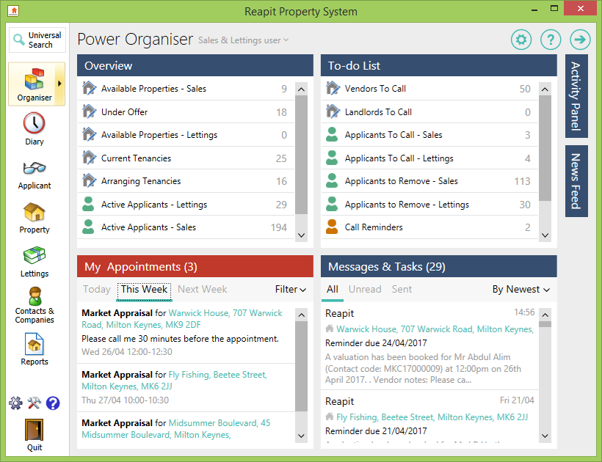

Content of Task created:

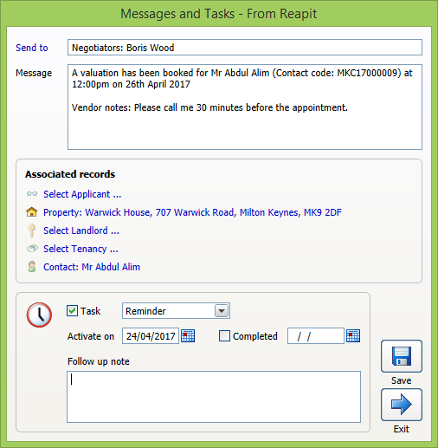

1. Diary entry created:

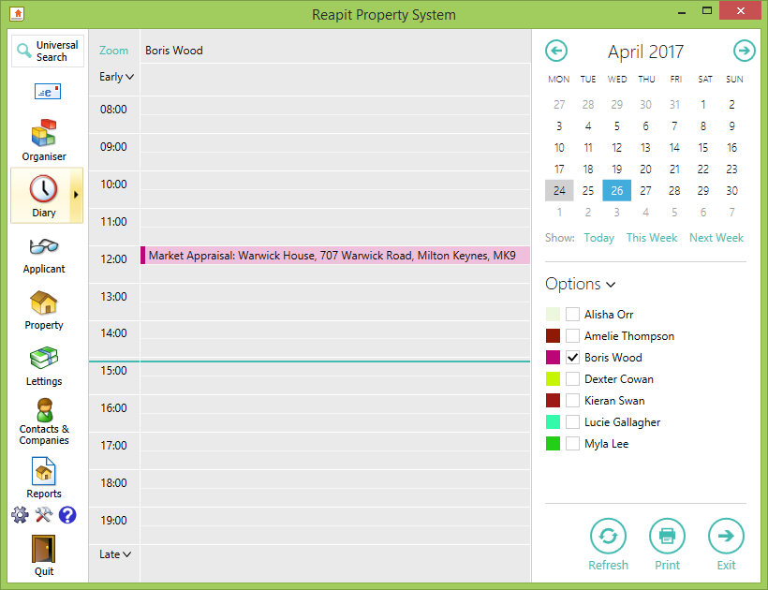

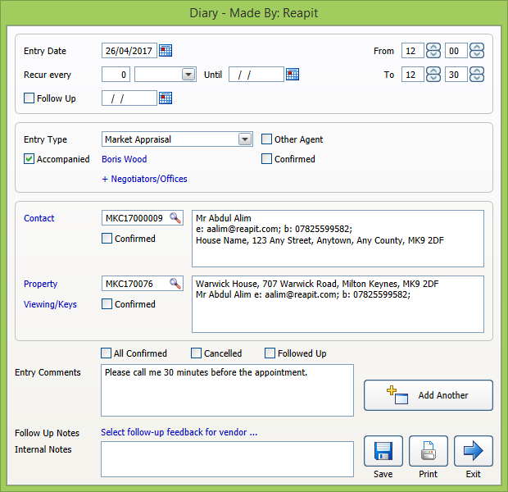

### Viewing Request Booking Example

Integration Documentation that will be needed by your Web Company can be found on the following location: <https://tracker.reapit.net/demo/_demo/viewing/#documentation>

Link configured to appear against each property on website:

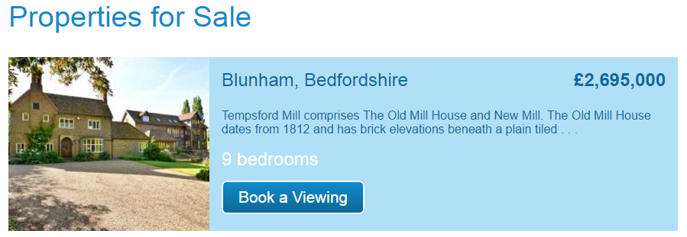

Selecting ‘Book a Viewing’ presents option to specify email address:

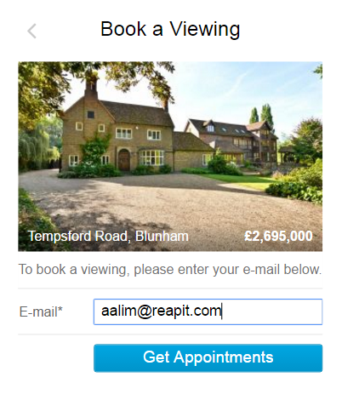

Available diary entries shown based on configuration (Only property manager, job title specific negs, specific negs).

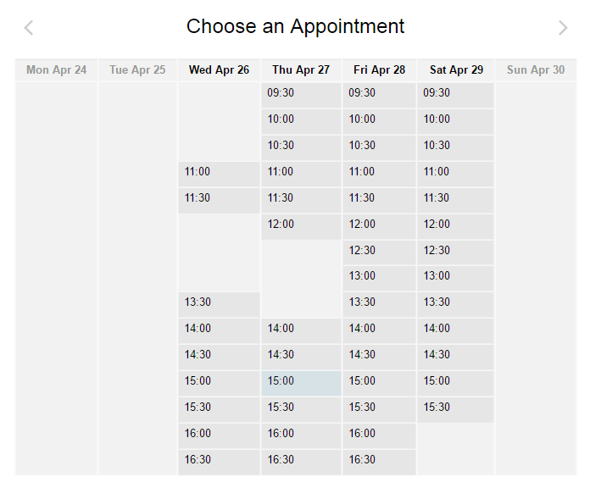

Option to fill out full details of the prospective applicant.

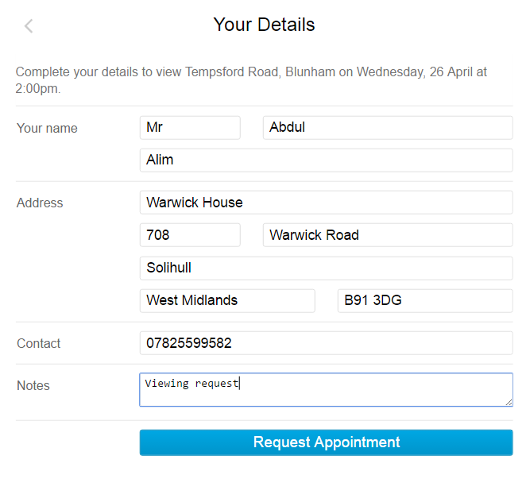

Confirmation screen confirming the appointment request and who the point of contact is for any further queries or changes.

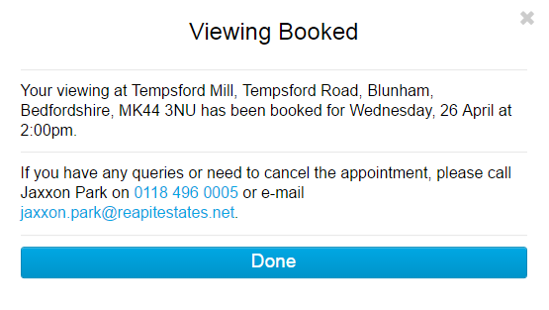

Confirmation email received by the prospective applicant:

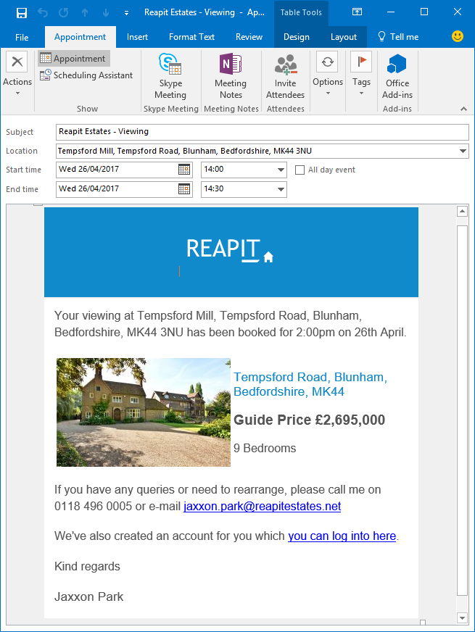

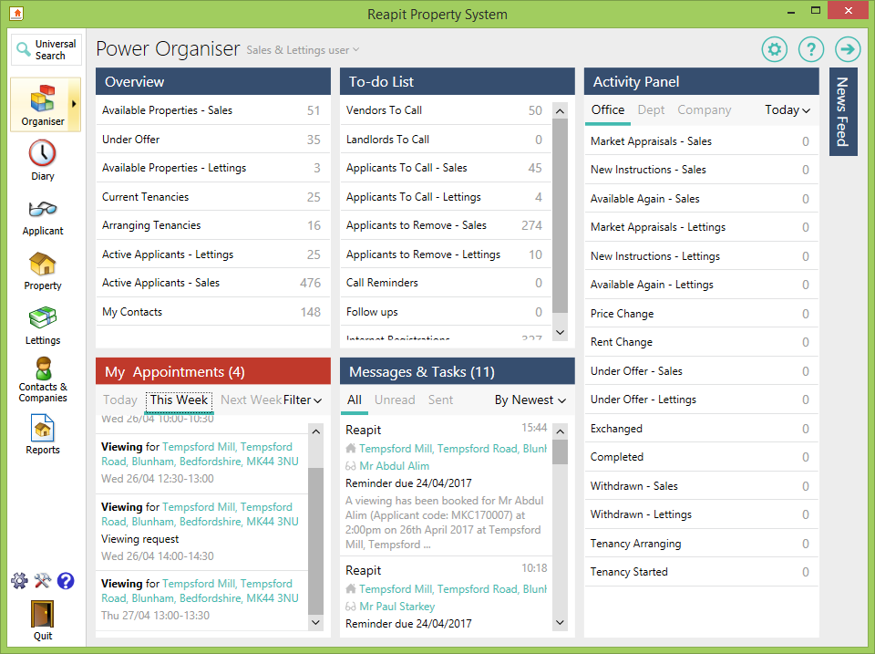

Viewing shown in the ‘My Appointments’ and Task generated which can be seen under ‘Messages & Tasks’.

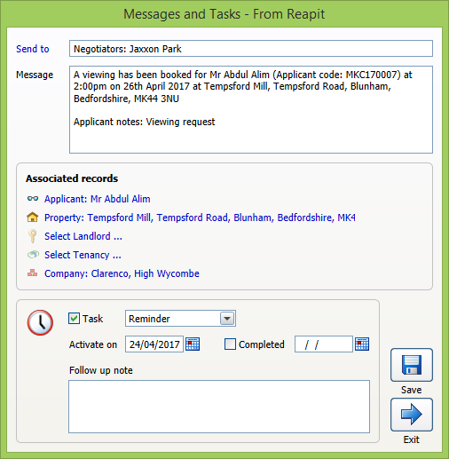

Task generated within RPS and associated to the respective negotiator.

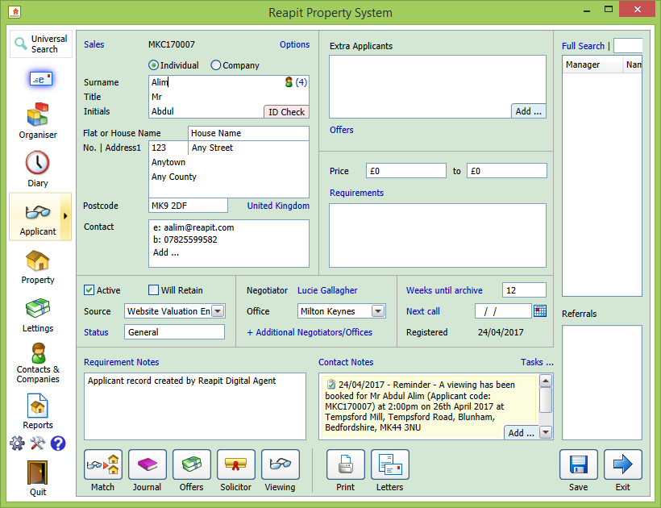

Applicant record created within RPS.

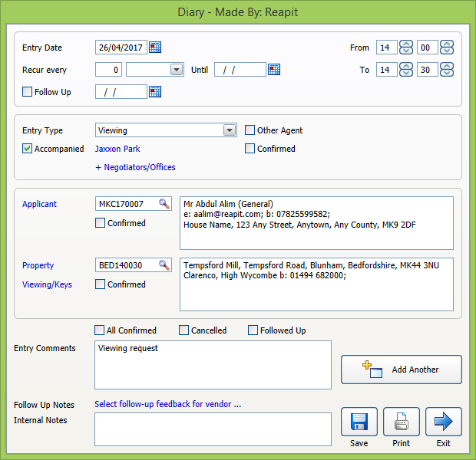

Content of Diary entry within RPS.