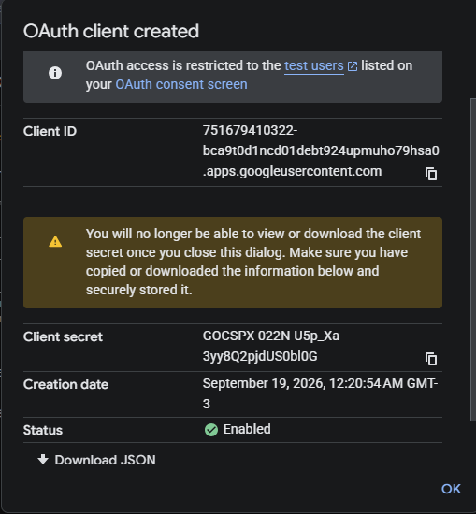
groq: 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
render: rnd_N40u3TTsVxWAX2fE1DWAE9J8JfIe

