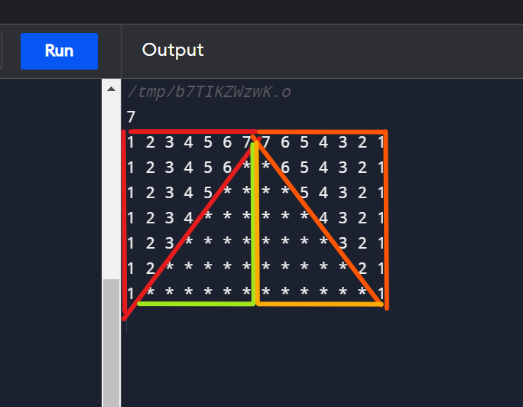

#include <iostream>
using namespace std;
int main() {
int n;
cin>>n;
int row=1;
while(row<=n){
int col=1;
int count=1;
/* first triangle*/
while(col<=n-row+1){
cout<<count<<" ";
count++;
col++;
}
/* second triangle*/
int star=1;
while(star<=row-1){
cout<<"*"<<" ";
star++;
}
/*third triangle*/
int star1=1;
while(star1<=row-1){
cout<<"*"<<" ";
star1++;
}
/* fourth triangle*/
int col1=1;
int count1=n-row+1;

while(col1<=n-row+1){
cout<<count1<<" ";
count1--;
col1++;
}
cout<<endl;
row++;
}
}

