The Well

**Preparing the game**: Place one card face-up in the middle of the table. Shuffle and deal the remaining cards face-down to all the players. These cards form their personal draw piles.

**Object of the game**: To be the first player to get rid of all your cards.

**Playing the game**: At the same time, players flip their entire draw piles over so they are face-up. If you are the first player to spot the identical symbol on both your top card and the center card, call it out (example: “Lightbulb!”) and place your card on top of the center card. Use the new card revealed on your personal pile to find a match with the center card. Play continues until one player runs out of cards.

**Winning the game**: The first player to run out of cards wins the game.

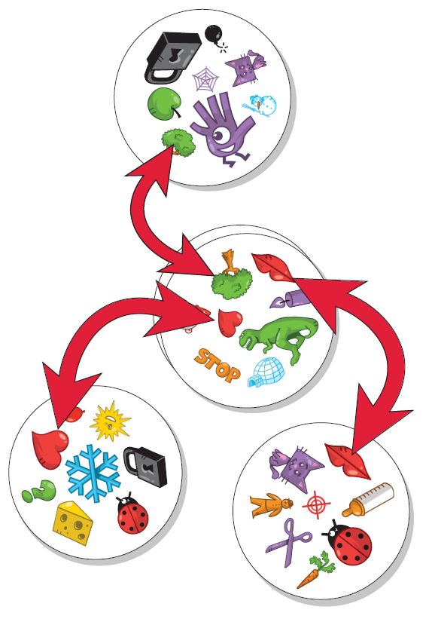

*For The Well, The Tower, & The Poisoned Gift*

The Tower

**Preparing the game**: Shuffle the cards and deal one card face-down to each player. Place the remaining cards face-up in the middle of the table to form the draw pile.

**Object of the game**: To collect the most cards

**Playing the game**: At the same time, players flip over their cards. They try to spot the one symbol that appears both on the center card and on their own card. If you are the first player to do so call it out (example: “Microscope!”). Then take the center card and place it face-up on top of your flipped card, building a personal pile. Now use the new top card on your personal pile to find a match with the center card. Repeat this process each time a new center card is revealed. Play continues until no cards remain in the draw pile.

**Winning the game**: The player with the most cards wins.

The Poisoned Gift

**Preparing the game:** Shuffle the cards and deal one card face-down to each player. Place the remaining cards face-up in the middle of the table to form the draw pile.

**Object of the game:** To have the least number of cards.

**Playing the game:** At the same time, players flip over their cards. Players look for a match between the center card and any of the other players’ cards. If you spot a match, call it out (example: “Fish!”). Take the center card and place it on top of the other player’s card on which you found the match. This is the “Poisoned Gift” because you give an unwanted card to an opponent. The revealed card on the center stack becomes the new card that players use to find a match. Continue playing until the draw pile is gone.

**Winning the game**: The player with the least number of cards wins the game.

Hot Potato

(played in multiple rounds)

**Preparing the game**: Shuffle the cards and deal one card face-down to each player. Set aside the remaining cards to use later. Decide how many rounds you wish to play (five minimum).

**Object of the game**: To have the least amount of cards after all the rounds have been played. This is accomplished by getting rid of your cards during each round.

**Playing the game**: At the same time, players turn over the card in their hands. The card must be held flat in the palm of a steady hand. If you spot a matching symbol between your card and another player’s card, call it out (example: “Magnet!”). Place your card face-up on top of the other player’s card. If you have two or more cards in your hand look only at your top card for a match. When you spot it, give all your cards to the player who has the match. Repeat play in this manner until one player has all the cards. That player loses the round and creates a personal discard pile with those cards. A new round starts.

**Winning the game**: At the end of

the final round, the player with the least amount of cards wins the game.

|  |  |
| --- | --- |
|  |  |
| *For Hot Potato* | *For Triplet* |

Triplet

**Preparing the game**: Place all the cards face-down in a pile.

**Object of the game**: To collect the most cards.

**Playing the game:** One player takes the first 9 cards and places them face-up on the table in a 3x3 grid. Then, at the same time, all players try to find a matching symbol on any 3 cards. The same symbol must be present on all 3 cards to make a matching set. As soon as you find the matching symbol, call it out (example: “Robot!”), take the 3 cards you’ve won, and reload with 3 new cards.

**Winning the game:** When there are fewer than 9 cards left in the game and no more sets of matching cards, the game ends and the player with the most cards wins

Game rules and

List of icons