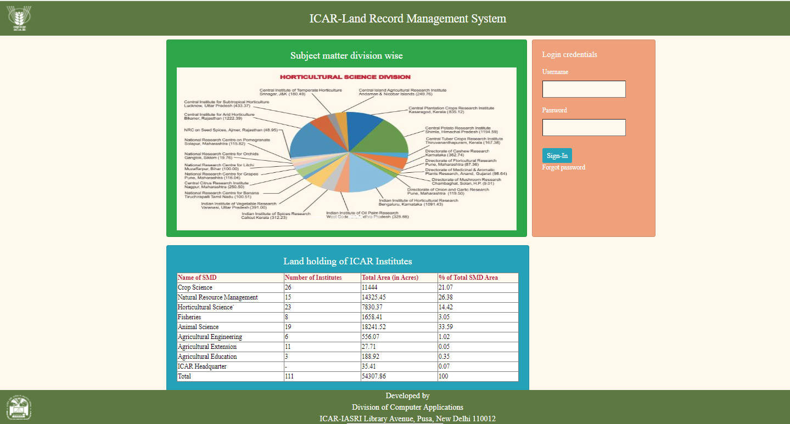 **Admin User Manual LRMS**

1. **Admin login**

**I Click on Username in text box**

**II Click on Password in text box**

1. **Admin can enter his username and password.**

**I Enter Username in text box**

**II Enter Password in text box**

**III Click in Sign-In button**

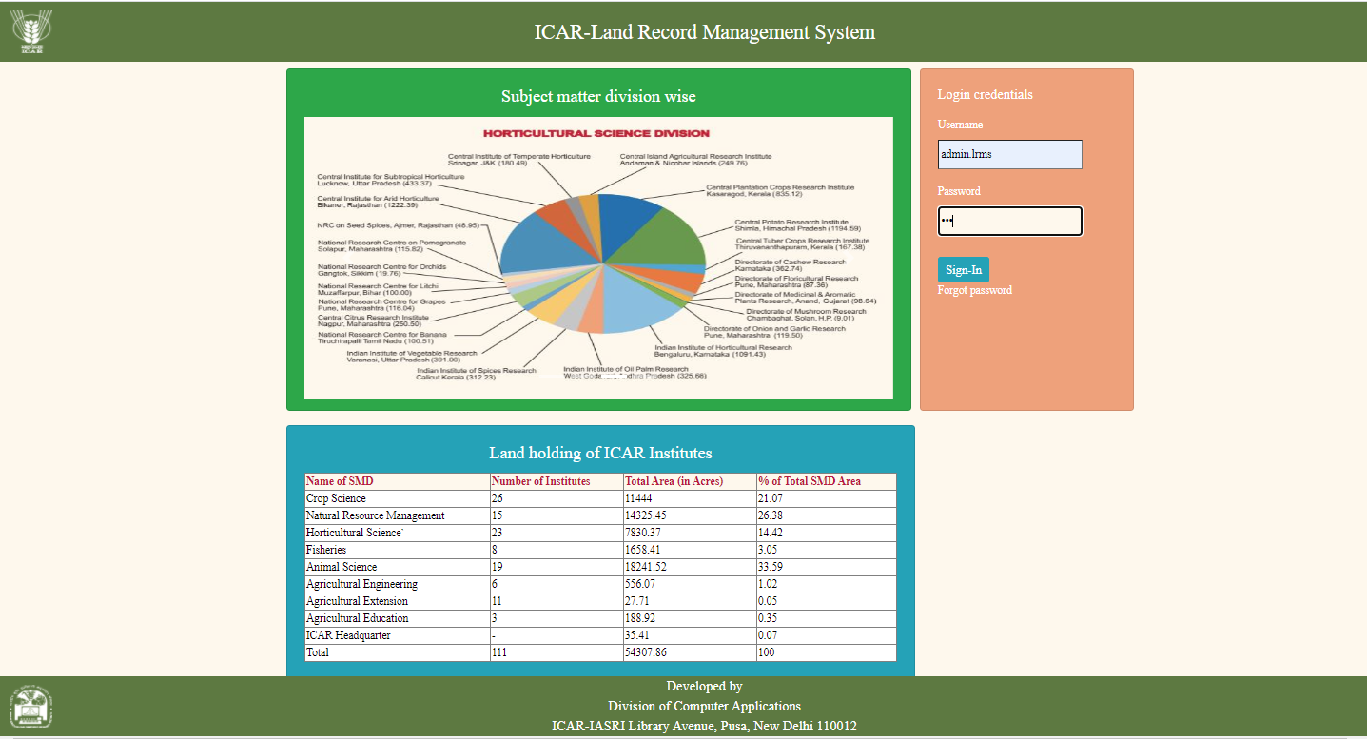

1. After login, Admin profile page opens.

**I Click on Add User**

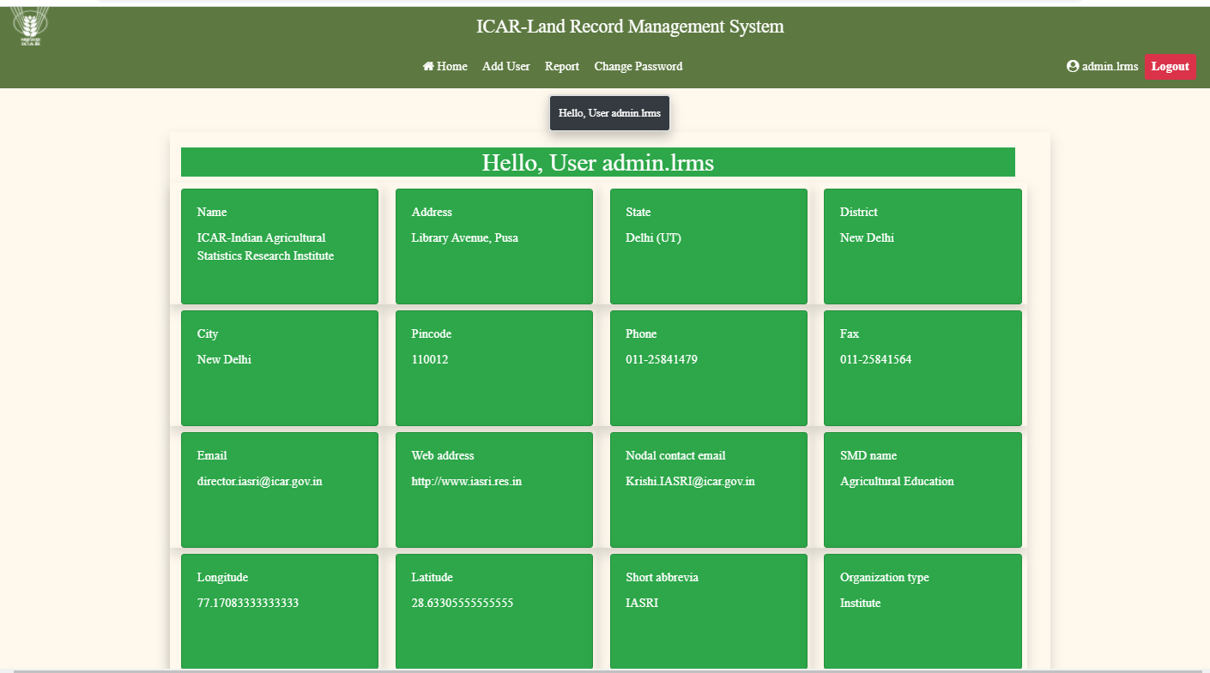

1. Admin can add user by clicking on Add User option in menu.

**Enter user name and password, website, email, phone, fax & select organization from dropdown list and select organizationtype from dropdownlist then click on submit button.**

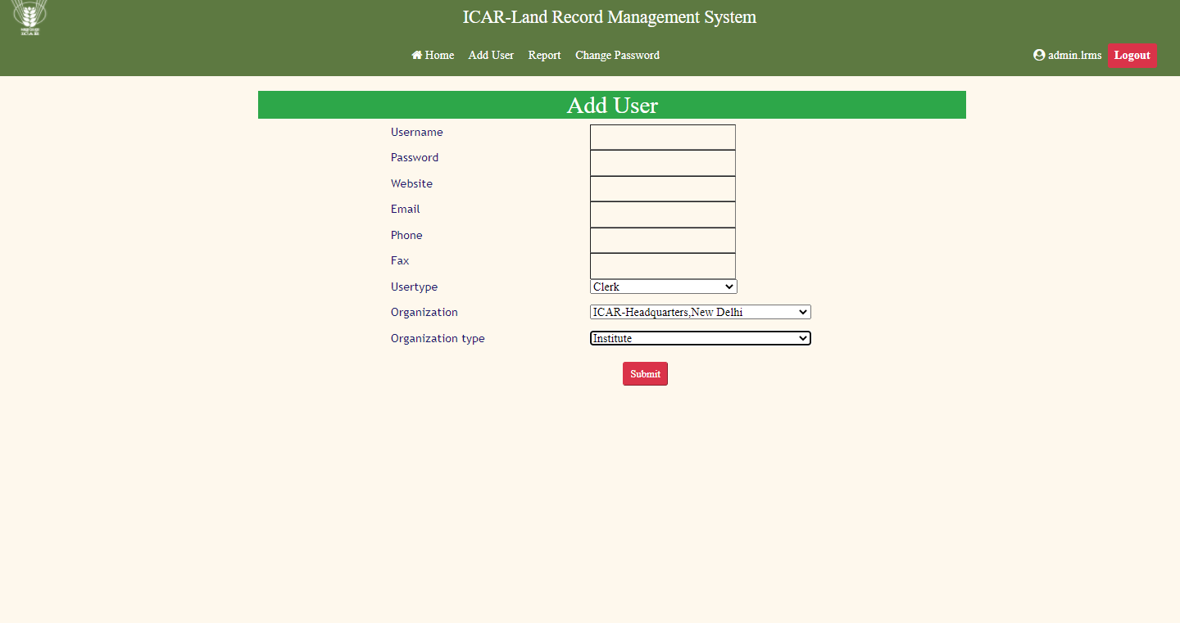

1. Admin can change his password by clicking on change password option in menu.

**I Enter new password in text box and then click on submit button.**

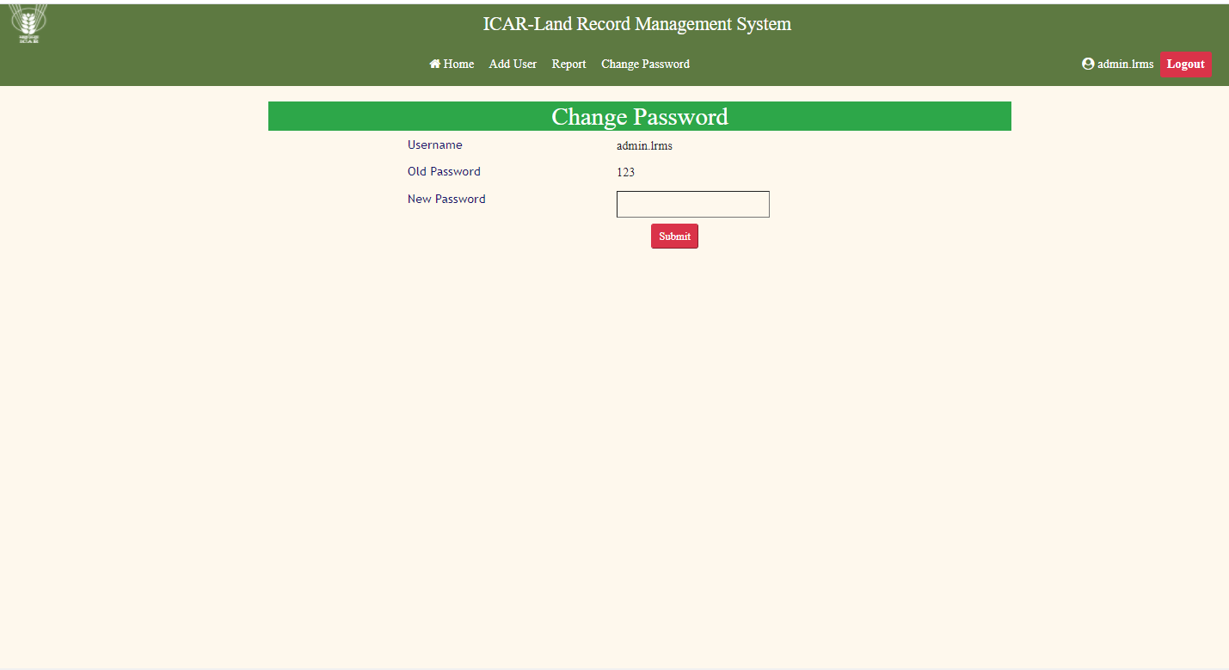

**User Manual LRMS**

1. User can enter his username and password.

**I Click on Username text box**

**II Click on Password text box**

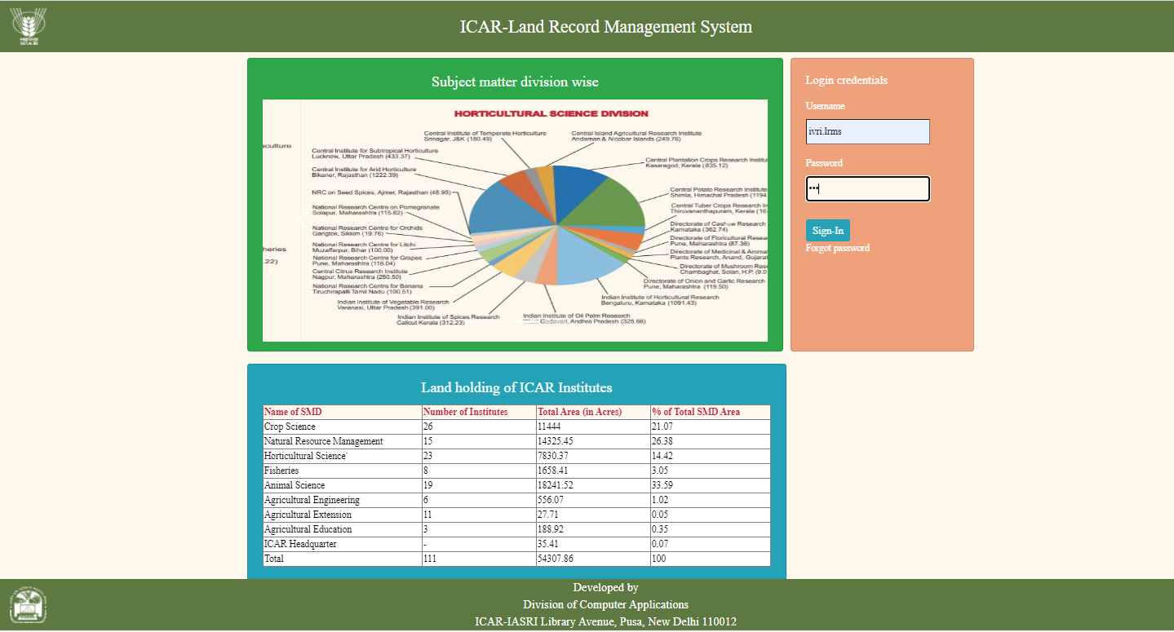

1. After login, the user/institute profile page opens.

**I Click on Fill form to add land performa record.**

**II Click on Edit Upload details to change the details in user/institute page.**

**III Click on View Form to view previous filled land performa record.**

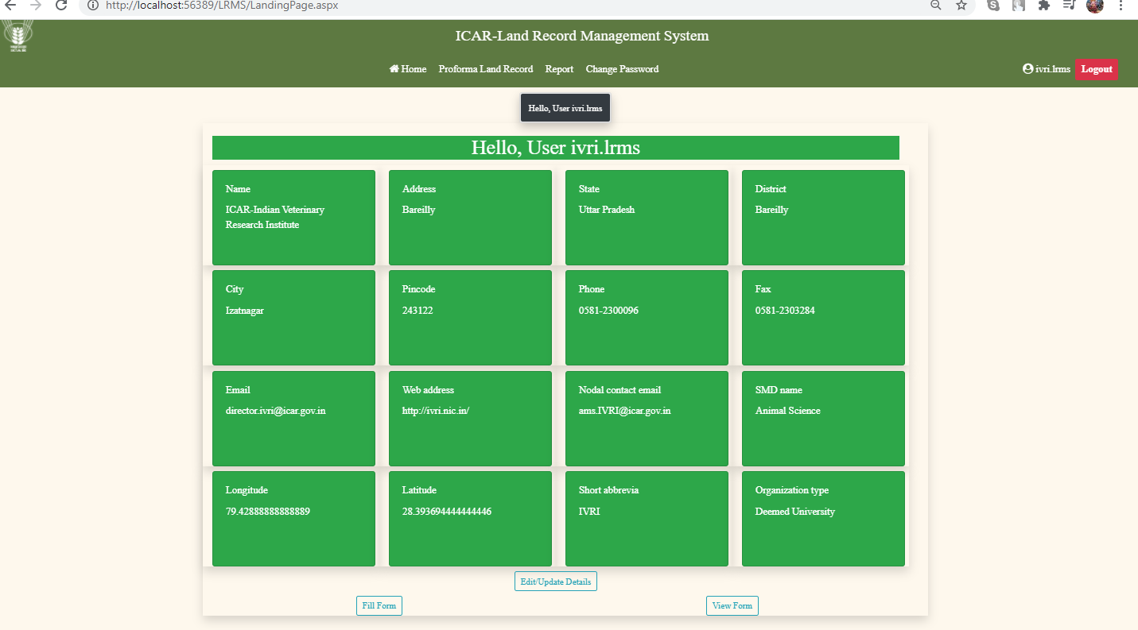

1. User can enter land performa data by clicking on Performa Land Record in menu.

**I All fields should be filled by user/institute.**

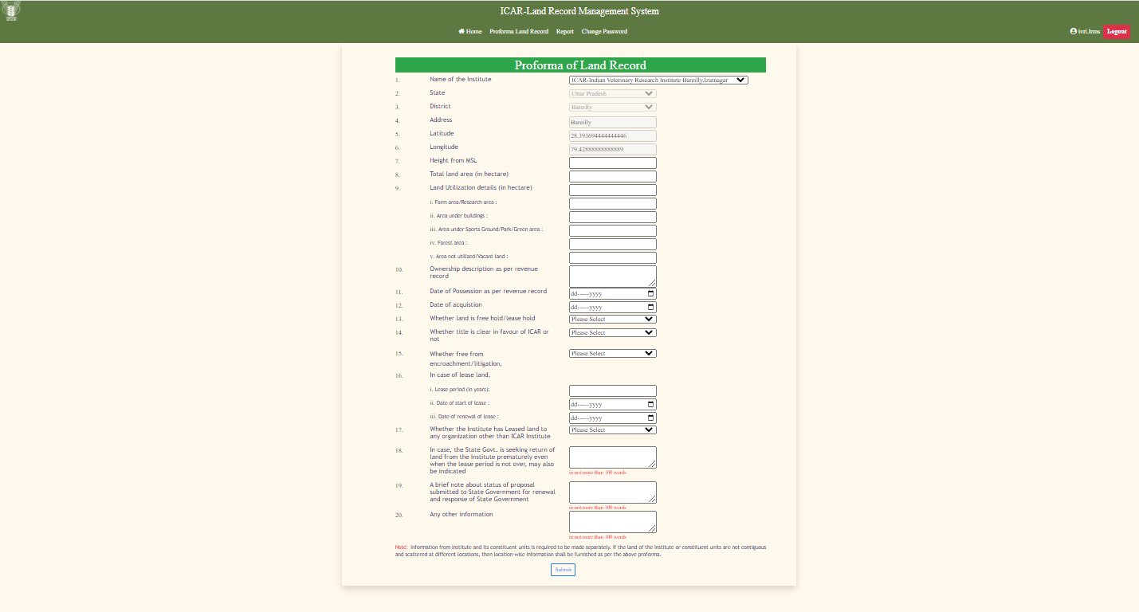

1. User can view currently filled land performa report by clicking on Report option in menu.

* **Select institute or regional station from dropdownlist and click on submit button.**
* **After that record will be shown in table. User/institute can view the report by clicking on View link in table. The land performa report will open.**

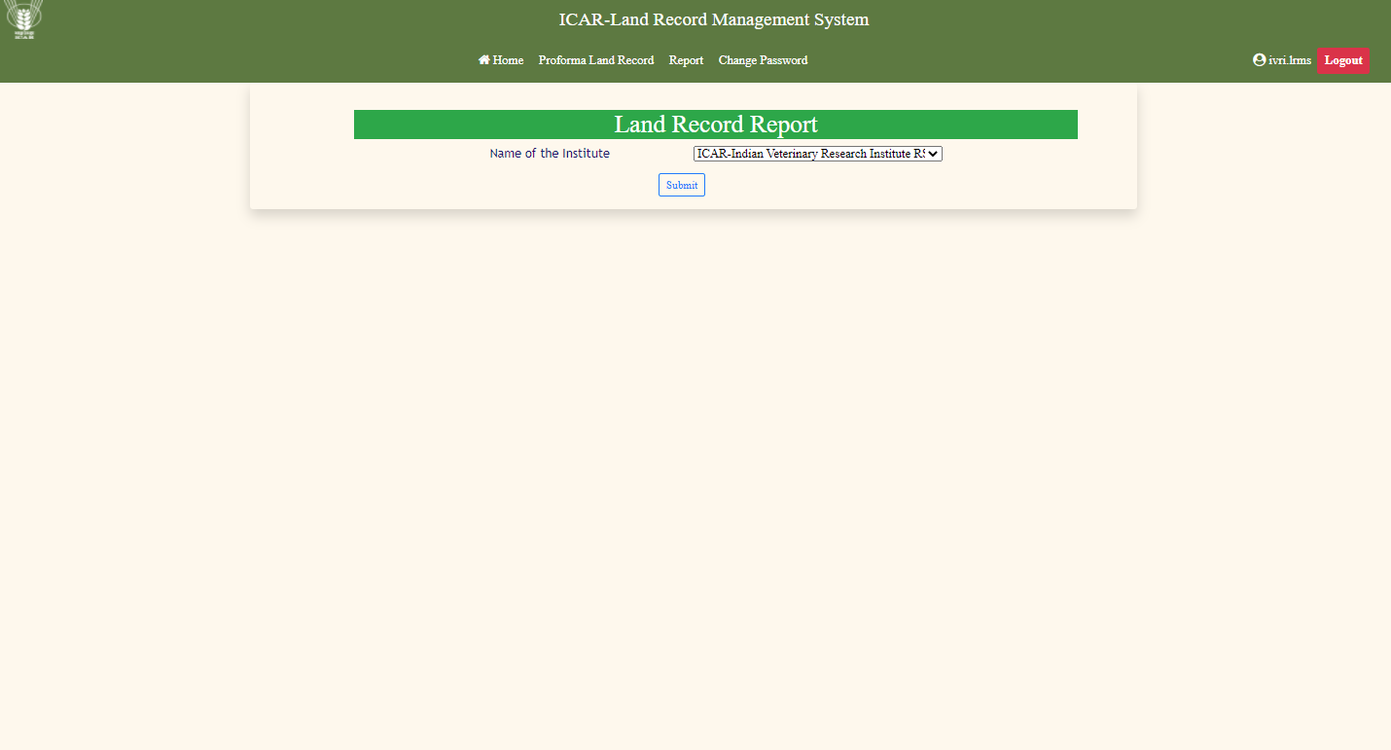

1. User can change password by clicking on change password option in menu.

**I Enter new password in text box and then click on submit button.**

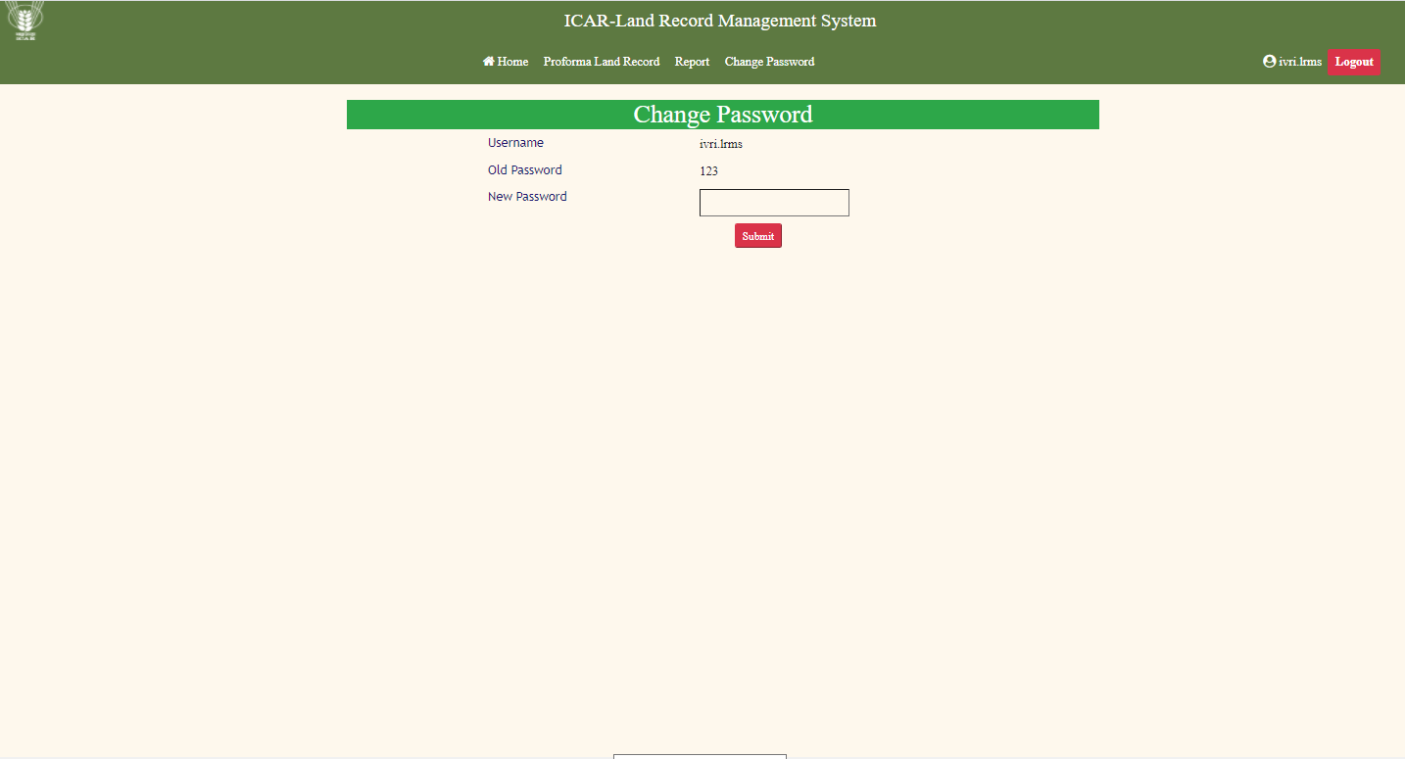

**Lastly Admin and User can recover the account details by clicking on forgot password option in login credentials section.**

**Forgot Password click in Email text box.**

