**TERM PROJECT**

**CECS 323 - DATABASE**

**“AIRPORTS”**

**GROUP MEMBERS:**

**JONATHAN CORCHADO RANDY LAO**

**JAIRO NUÑEZ ANDY VAN**

# **CLASS DIAGRAM**

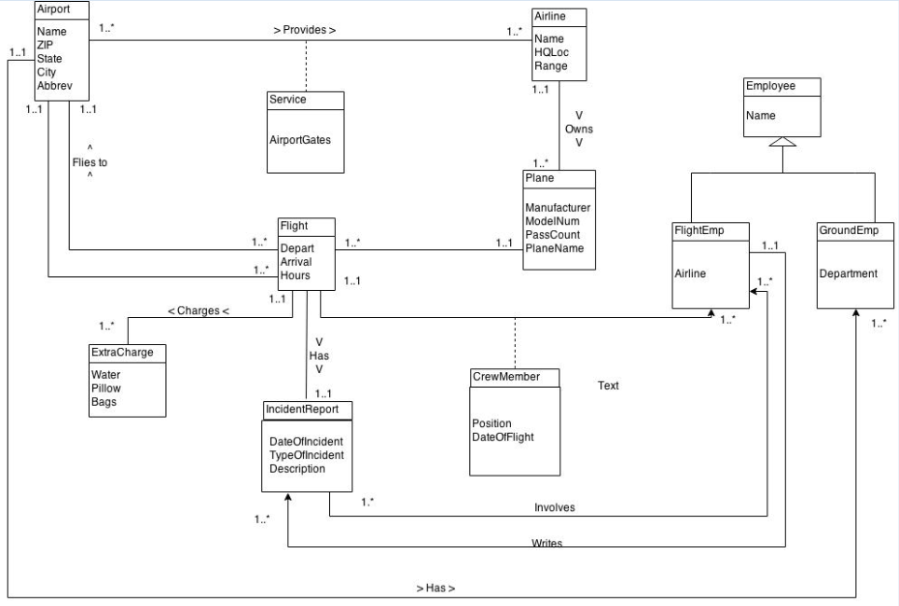

# **RELATION SCHEME**

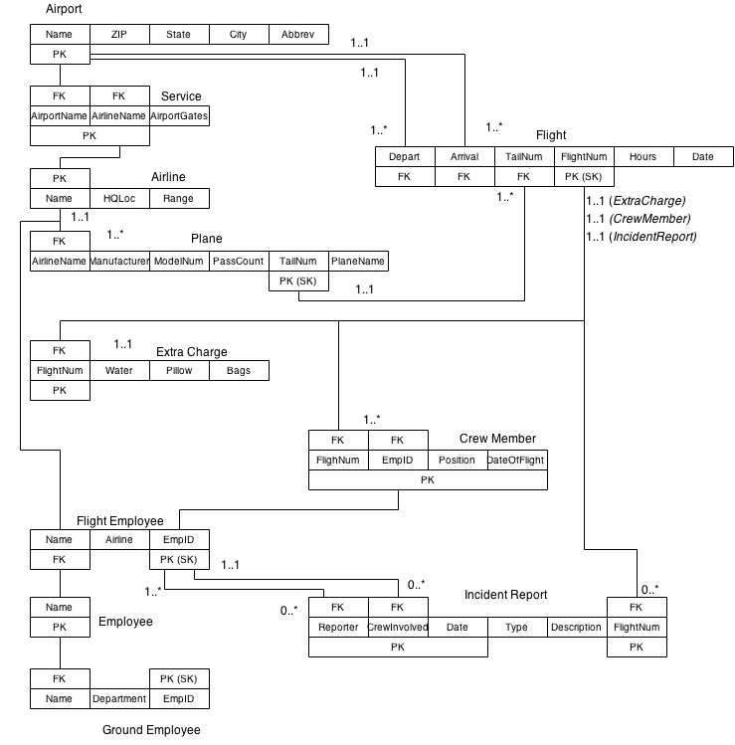

# **CLASS DEFINITIONS**

An *airport* is defined as a structure that provides people with the ability to board planes with the purpose of traveling to another airport at a distant location. Airports schedule many flights which are communicated between all airports.

An *airline* is a company that provides flights for customers through the airport. Airlines have individual charges and may offer different flights than other airlines. Some airlines may only fly locally/domestically while some may fly internationally.

A *service* is an association class that connects many *airports* to many *airlines*. It allows an airport to serve multiple airlines, and an airline to be serviced by multiple airports. Each airline has a specific set of gates at each airport it is serviced at.

A *plane* is a vehicle that moves through the air at high speeds. It may carry cargo or customers, depending on the purpose of the plane. Planes provided by airlines typically carry both.

A *flight* is a scheduled trip that a plane and crew take part in along with customers. It provides details for the trip and will always have a start and end location.

An *extra charge* holds three distinct values that tell whether or not a specific luxury has an extra cost. Each attribute is defined separately as to whether or not there will be a charge for that service. For example, *pillows* may be free but *excessive luggage* may have a charge.

An *incident report* is a detailed report that describes any incident that occurs onboard a plane during a flight. It may involve passengers, members of the crew, and will always have a crew member that reports the incident. Along with the people involved, the following are also reported: date, type of incident, brief description.

*Employee* is a superclass that broadly describes all workers associated with an airline or an airport. At any given time, an employee may be one of the two subclasses, but not both. Employees are not limited to being a ground employee or a flight employee.

*GroundEmployee* is a subclass of *Employee* which represents a worker who that stays at a specific airport. They do not board any flights and do not change airports.

*FlightEmployees* is a subclass of *Employee* which represents a worker who attends to passengers on flights. *FlightEmployees* are not limited to the number of flights that they embark on but cannot be on two flights that have overlapping flight times or origin/destination airports. *FlightEmployees* should be aboard flights that fly out of their current city before departing from another arbitrary airport.

A *CrewMember* is an association class that relates many *flights* to many *flightEmployees.*

# **ATTRIBUTE DEFINITIONS**

AIRPORT

NAME Name for each airport

ZIP ZIP code where the airport is located

STATE State where the airport is located

CITY City where the airport is located

ABBREV FAA approved abbreviation for the airport;

external key

AIRLINE

NAME Name for the airline  
 HQLOC Location of the airline’s headquarters

RANGE Where the airline flies

Is either Local | Domestic | International

SERVICE

AIRPORT GATE The range of gates provided for an airline

It is automatically assumed that an airline receives all of the gates within the range to keep the airport organized

PLANE

MANUFACTURER Company that built the plane

MODELNUM Plane’s model number; shared by planes of

same design; external key provided by manufacturer

PASSCOUNT Number of passengers the plane can hold

TAILNUM Tail number of each plane; a distinct value;

PLANENAME Nickname for the plane; default NULL

FLIGHT

DEPART Trip’s departure airport *name*

ARRIVAL Trip’s destination airport *name*

FLIGHTNUM Flight’s specific number; surrogate key

EXTRACHARGE

WATERPRICE Extra cost for water

PILLOWPRICE Extra cost for pillows

BAGSPRICE Extra cost for bags

A cost of 0 for any values implies that it

is free

INCIDENTREPORT

DATEOFINCIDENT Date of the specified incident

TYPEOFINCIDENT General classification, is not limited

DESCRIPTION Short description of the incident

CREWMEMBER

POSITION Member’s current role on the flight

DATEOFFLIGHT Date of the specific flight the member is

on; acts as a discriminator attribute as the relationship between FLIGHT and FLIGHTEMP may occur multiple times

# **DE-NORMALIZATIONS**

The denormalization that we used in our database is the ZIP attribute. With the ZIP attribute, you know the State and City. Denormalization allows us to not create another class for the ZIP to store those attributes and just letting us keep it there.

# **ASSOCIATION DESCRIPTIONS**

An airport provides 1 to many services. A service is provided by 1 and only 1 airport.

An airline provides 1 to many services. A service is provided by 1 and only 1 airline.

An airport receives 1 to many flights. A flight flies to 1 and only 1 airport.

An airport sends out 1 to many flights. A flight flies from 1 and only 1 airport.

A plane takes 1 to many flights. A flight is taken by 1 and only 1 plane.

A flight has 1 and only 1 list of extra charges. A list of extra charges is for 1 and only 1 flight.

A flight is described by 0 to many incident reports. An incident report describes 1 and only 1 flight.

An incident report is recorded by 1 and only 1 reporter (*flight employee*). A reporter records 0 to many incident reports.

An incident report involves 0 to many flight employees. A flight employee is involved in 0 to many incident reports.

A flight has 1 to many crew members. A crew member goes on 1 and only 1 flight.

A flight employee represents 1 to many crew members. A crew member is represented by 1 and only 1 flight employee.

(*A crew member is defined as one’s current job on a specific flight. Therefore it may change as a flight employee may have different roles throughout their career. The current job has a discriminator attribute which define which day the employee was on the given flight)*

# **DATA DESCRIPTION LANGUAGE [DDL]/DATA MANIPULATION LANGUAGE [DML]**

1. SELECT * FROM Plane WHERE passengerCount = (SELECT MAX(passengerCount) FROM Plane);

2a. SELECT flightNum, airlineName, depart, arrival, hours FROM Flight NATURAL JOIN Airline where airlineName = 'Dora The Explora' ORDER BY depart;

b. SELECT flightNum, airlineName, depart, arrival, hours FROM Flight NATURAL JOIN Airline where airlineName = 'Dora The Explora' ORDER BY arrival;

c. SELECT flightNum, airlineName, depart, arrival, hours FROM Flight NATURAL JOIN Airline where (airlineName = 'Dora The Explora' AND hours = (SELECT MAX(hours) FROM Flight)) ORDER BY depart;

d. SELECT flightNum, airlineName, depart, arrival, hours FROM Flight NATURAL JOIN Airline where (airlineName = 'Dora The Explora' AND hours = (SELECT MIN(hours) FROM Flight)) ORDER BY depart;

3. SELECT flightNum, waterPrice, pillowPrice, bagPrice FROM Flight NATURAL JOIN Charge;

4. SELECT employeeID, employeeName, flightNum, position FROM Airline NATURAL JOIN Plane NATURAL JOIN Flight NATURAL JOIN CrewMember NATURAL JOIN FlightEmployee NATURAL JOIN Employee ORDER BY flightNum;

5. SELECT * from flight

6a. SELECT flightNum, arrival, city FROM Flight INNER JOIN Airport ON Flight.arrival = Airport.abb ORDER BY city;

b. SELECT flightNum, depart, city FROM Flight INNER JOIN Airport ON Flight.depart = Airport.abb ORDER BY city;

c. SELECT airlineName, rang from Airline order by rang;

d. SELECT distinct empID from (SELECT NONDISTINCT DATE from Flight NATURAL JOIN CrewMember)

7. SELECT flightNum, airlineName AS 'Airline', author,memberInvolved, inType AS 'Type', description FROM IncidentReport NATURAL JOIN Flight NATURAL JOIN Plane NATURAL JOIN Airline;

8. SELECT * FROM Plane WHERE passengerCount = (SELECT MAX(passengerCount) FROM Plane);

SELECT manufacturer, airlineName FROM Airline NATURAL JOIN Plane;

SELECT airlineName, tailNum, planeName FROM Plane WHERE planeName = 'Speedy Gonzalez';

SELECT flightNum, waterPrice FROM Flight NATURAL JOIN Charge WHERE waterPrice = (SELECT MAX(waterPrice) FROM Charge);

# **SAMPLE OUTPUT FOR QUERIES**

1

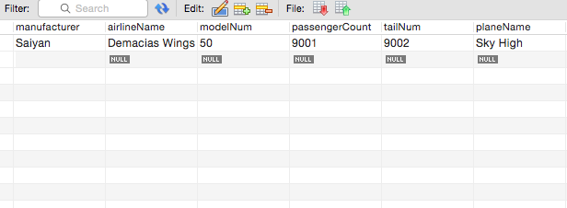

2a

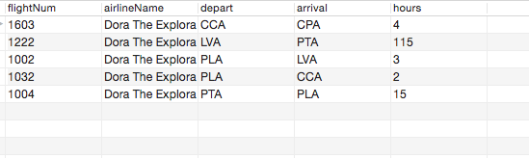

b

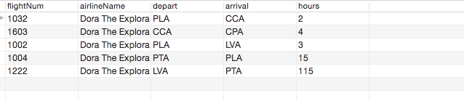

c

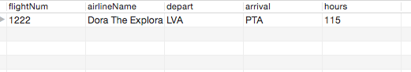

d

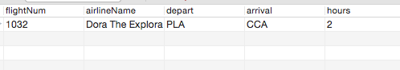

3

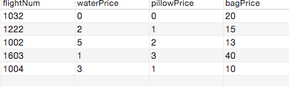

4

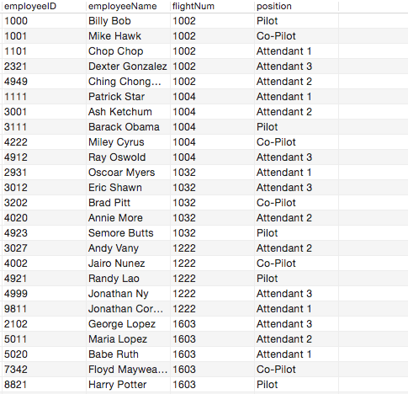

5

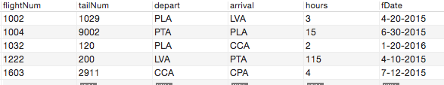

6a

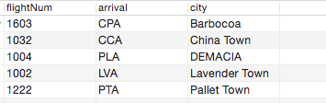

b

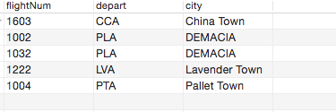

c

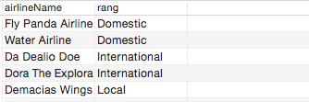

7



8a

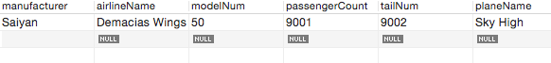

b

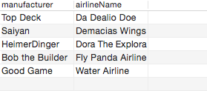

c

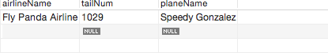

d

