BABU BANARASI DAS
UNIVERSITY
2026-2027
SCHOOL OF COMPUTER APPLICATIONS
NoSQL Project On
Hospital and Healthcare Management System Using MongoDB
Submitted to: Submitted by:
Mr. Harendra Singh Avni Singh
Department: BCA (DS & AI) Roll no: ()
Date: 1250258153

1. CREATE DATABASE
MongoDB Query:
use HospitalDB
Explanation: Creates or switches to the HospitalDB database.
Output Screenshot:
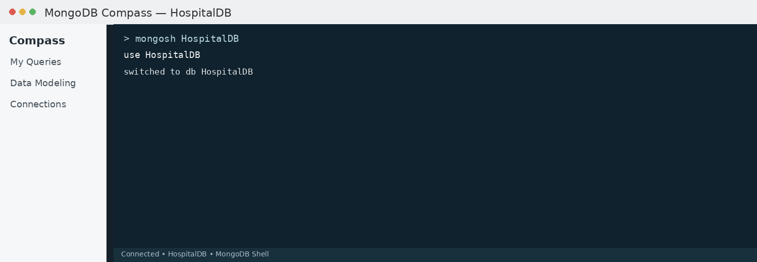

2. CREATE COLLECTION
MongoDB Query:
db.createCollection("patients")
Explanation: Creates a collection named patients.
Output Screenshot:
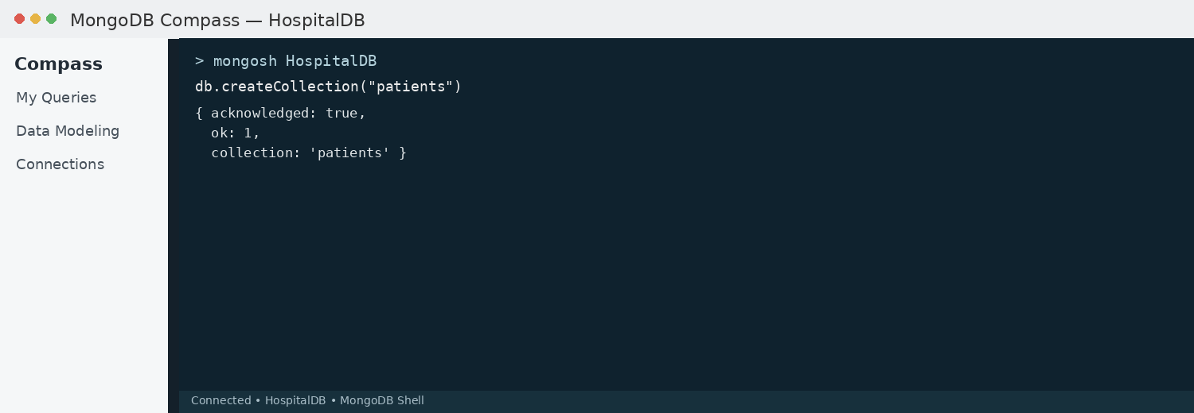

3. INSERT 50 PATIENTS
MongoDB Query:
db.patients.insertMany([
{patientId:1, name:"Aarav", age:24, billAmount:6200, department:"Cardiology"},
{patientId:2, name:"Ananya", age:42, billAmount:6000, department:"Neurology"},
{patientId:3, name:"Aditya", age:35, billAmount:4700, department:"Orthopedics"},
{patientId:4, name:"Aditi", age:32, billAmount:4450, department:"Pediatrics"},
{patientId:5, name:"Arjun", age:29, billAmount:7800, department:"Dermatology"},
{patientId:6, name:"Bhavna", age:33, billAmount:8300, department:"General Medicine"},
{patientId:7, name:"Chirag", age:41, billAmount:3100, department:"ENT"},
{patientId:8, name:"Divya", age:50, billAmount:8000, department:"Cardiology"},
{patientId:9, name:"Dev", age:21, billAmount:7600, department:"Emergency"},
{patientId:10, name:"Esha", age:28, billAmount:4800, department:"Orthopedics"},
{patientId:11, name:"Farhan", age:29, billAmount:6300, department:"Neurology"},
{patientId:12, name:"Gauri", age:54, billAmount:4950, department:"General Medicine"},
{patientId:13, name:"Harsh", age:26, billAmount:9200, department:"Cardiology"},
{patientId:14, name:"Ishita", age:35, billAmount:3600, department:"Pediatrics"},
{patientId:15, name:"Jatin", age:41, billAmount:8000, department:"Orthopedics"},
{patientId:16, name:"Kavya", age:25, billAmount:6600, department:"Dermatology"},
{patientId:17, name:"Karan", age:53, billAmount:5750, department:"Neurology"},
{patientId:18, name:"Lakshmi", age:52, billAmount:9300, department:"Cardiology"},
{patientId:19, name:"Manish", age:50, billAmount:7950, department:"General Medicine"},
{patientId:20, name:"Neha", age:26, billAmount:9100, department:"Emergency"},
{patientId:21, name:"Om", age:47, billAmount:5600, department:"ENT"},
{patientId:22, name:"Pallavi", age:18, billAmount:5300, department:"Pediatrics"},
{patientId:23, name:"Rahul", age:26, billAmount:9400, department:"Cardiology"},
{patientId:24, name:"Riya", age:16, billAmount:6350, department:"Emergency"},
{patientId:25, name:"Sahil", age:47, billAmount:8800, department:"Orthopedics"},
{patientId:26, name:"Simran", age:40, billAmount:7050, department:"General Medicine"},
{patientId:27, name:"Tarun", age:31, billAmount:4000, department:"Neurology"},
{patientId:28, name:"Tanvi", age:46, billAmount:6950, department:"Dermatology"},
{patientId:29, name:"Uday", age:39, billAmount:9000, department:"Cardiology"},
{patientId:30, name:"Vansh", age:55, billAmount:6600, department:"General Medicine"},
{patientId:31, name:"Varun", age:39, billAmount:4400, department:"ENT"},
{patientId:32, name:"Yash", age:27, billAmount:8400, department:"Cardiology"},
{patientId:33, name:"Zoya", age:22, billAmount:8600, department:"Pediatrics"},
{patientId:34, name:"Abhishek", age:55, billAmount:4700, department:"Neurology"},
{patientId:35, name:"Bhumi", age:59, billAmount:4700, department:"Orthopedics"},
{patientId:36, name:"Chetan", age:58, billAmount:2900, department:"General Medicine"},
{patientId:37, name:"Diya", age:23, billAmount:3700, department:"Emergency"},
{patientId:38, name:"Gopal", age:47, billAmount:8000, department:"Cardiology"},
{patientId:39, name:"Heena", age:21, billAmount:6350, department:"Dermatology"},
{patientId:40, name:"Imran", age:25, billAmount:5550, department:"ENT"},
{patientId:41, name:"Jyoti", age:16, billAmount:6000, department:"Neurology"},
{patientId:42, name:"Kunal", age:24, billAmount:6950, department:"Pediatrics"},
{patientId:43, name:"Meera", age:29, billAmount:3950, department:"Cardiology"},
{patientId:44, name:"Nikhil", age:45, billAmount:5200, department:"Orthopedics"},
{patientId:45, name:"Pooja", age:20, billAmount:2500, department:"General Medicine"},
{patientId:46, name:"Rohan", age:42, billAmount:4400, department:"Emergency"},
{patientId:47, name:"Sakshi", age:47, billAmount:3950, department:"Neurology"},
{patientId:48, name:"Tushar", age:55, billAmount:8400, department:"Cardiology"},
{patientId:49, name:"Urvi", age:55, billAmount:6250, department:"General Medicine"},
{patientId:50, name:"Vikas", age:22, billAmount:4350, department:"Orthopedics"}
Explanation: Inserts multiple patient documents into the collection.
Explanation: Inserts multiple booking documents into the collection.
Output Screenshot:
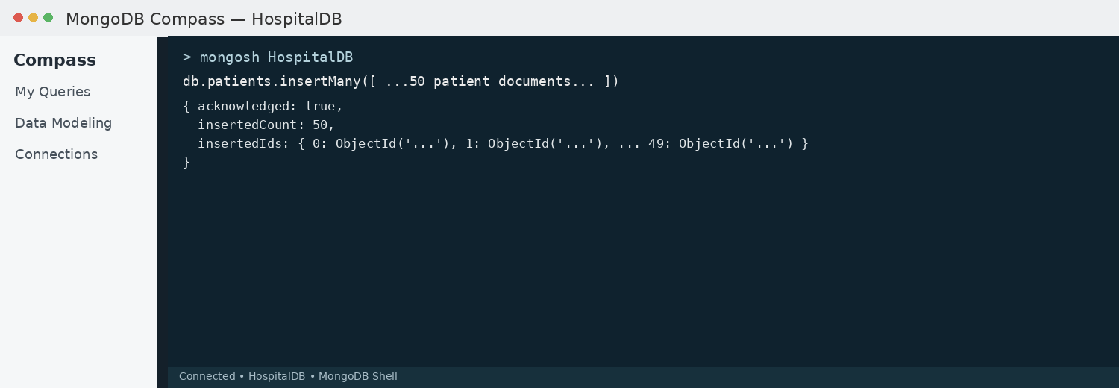

4. DISPLAY ALL BOOKINGS
MongoDB Query:
db.patients.find()
Explanation: Retrieves all documents from the patients collection.
Output Screenshot:
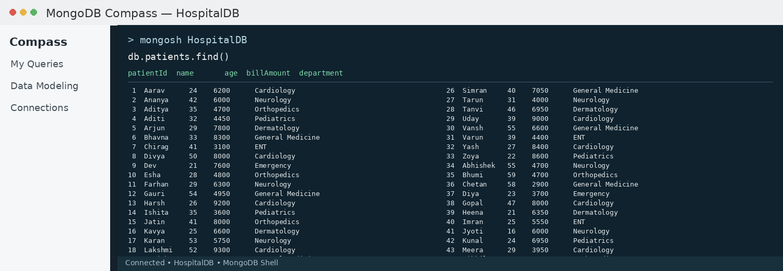

5. EQUAL TO — $eq
MongoDB Query:
db.patients.find({billAmount: {$eq: 6200}})
Explanation: Finds patients whose bill amount is exactly 6200.
Output Screenshot:
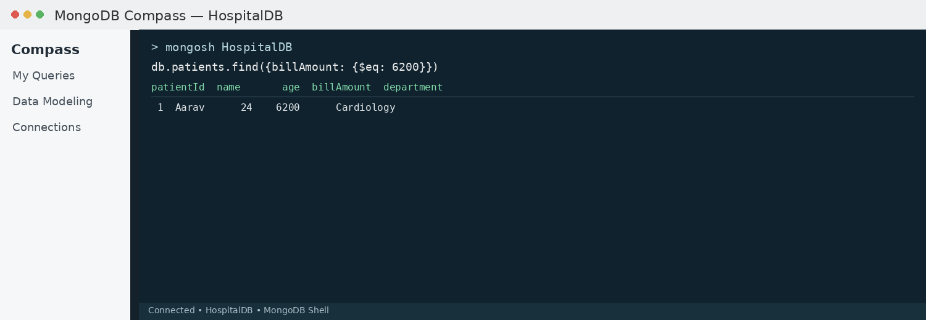

6. GREATER THAN — $gt
MongoDB Query:
db.patients.find({billAmount: {$gt: 8500}})
Explanation: Finds patients whose bill amount is greater than 8500.
Output Screenshot:
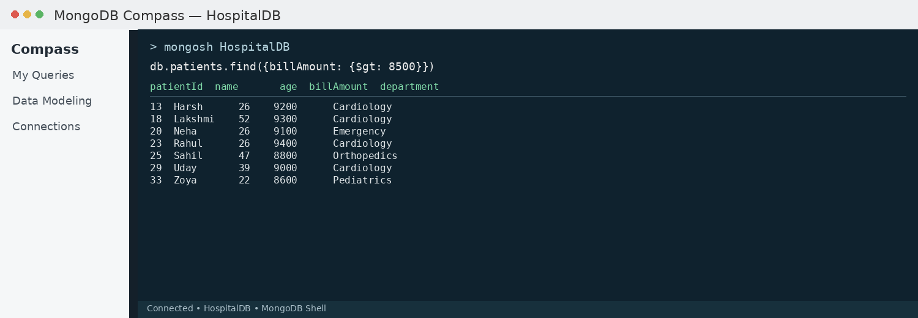

7. LESS THAN — $lt
MongoDB Query:
db.patients.find({billAmount: {$lt: 3500}})
Explanation: Finds patients whose bill amount is less than 3500.
Output Screenshot:
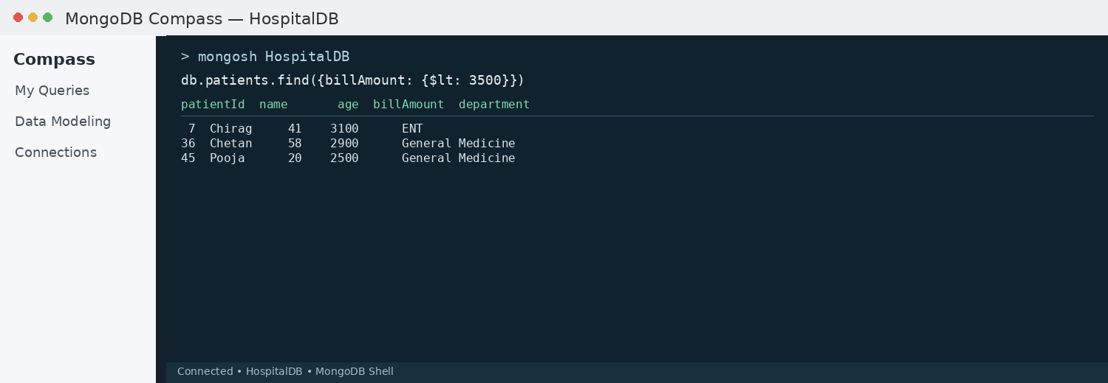

8. GREATER THAN OR EQUAL TO — $gte
MongoDB Query:
db.patients.find({billAmount: {$gte: 9000}})
Explanation: Finds patients whose bill amount is 9000 or above.
Output Screenshot:
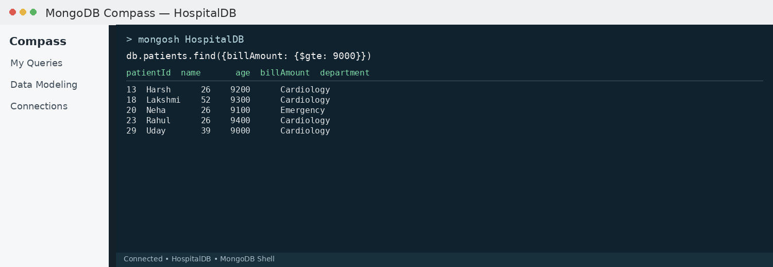

9. LESS THAN OR EQUAL TO — $lte
MongoDB Query:
db.patients.find({billAmount: {$lte: 4000}})
Explanation: Finds patients whose bill amount is 4000 or below.
Output Screenshot:
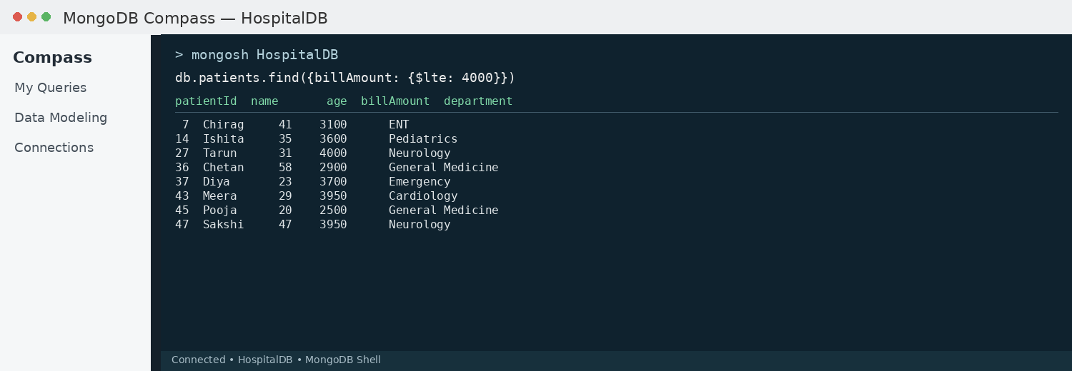

10. UPDATE OPERATION
MongoDB Query:
db.patients.updateOne(
{patientId:5},
{$set:{billAmount:9500}}
)
Explanation: Updates the bill amount to 9500 of the patient with patientId 5.
Output Screenshot:
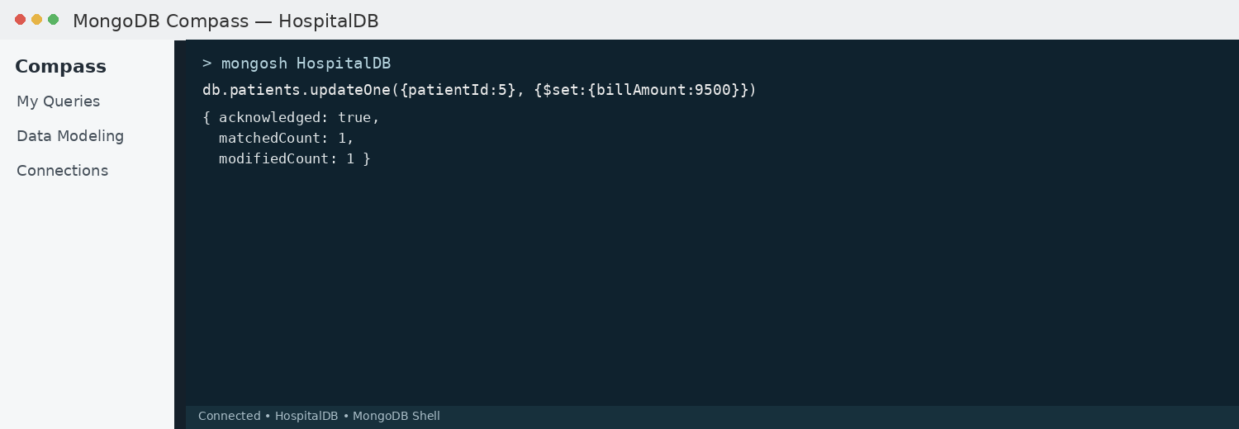

11. DELETE ONE OPERATION
MongoDB Query:
db.patients.deleteOne({patientId:10})
Explanation: Deletes one document matching patientId 10.
Output Screenshot:
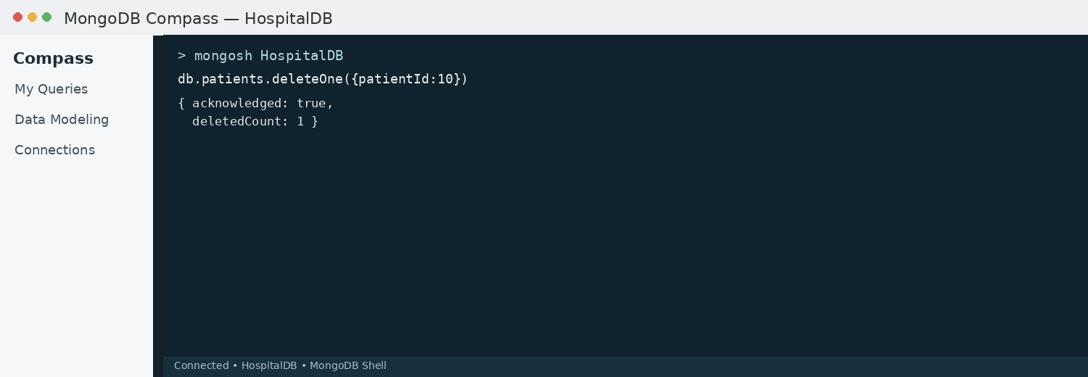

12. DELETE MANY OPERATION
MongoDB Query:
db.patients.deleteMany({
billAmount: {$lt:3500}
})
Explanation: Deletes all patients having a bill amount below 3500.
Output Screenshot:
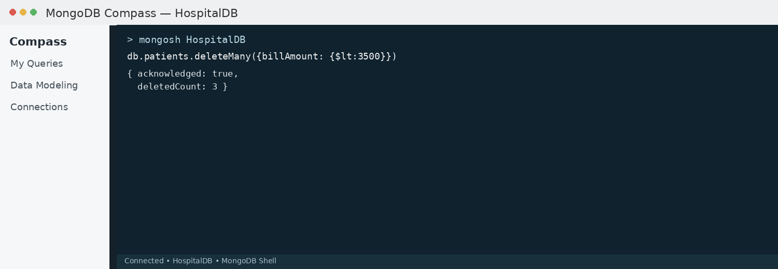

13. AND OPERATION — $and
MongoDB Query:
db.patients.find({
$and:[
{billAmount:{$gt:8000}},
{age:26}
]
})
Explanation: Finds patients satisfying both conditions.
Output Screenshot:
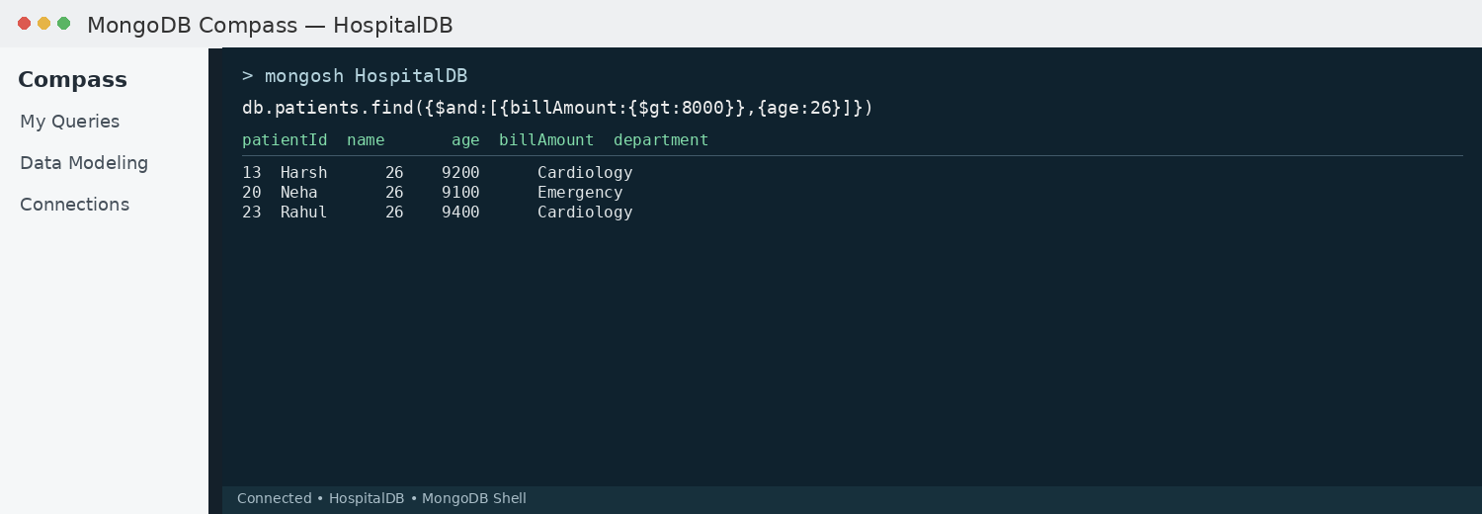

14. OR OPERATION — $or
MongoDB Query:
db.patients.find({
$or:[
{department:"Cardiology"},
{department:"Neurology"}
]
})
Explanation: Finds patients who visited the Cardiology or Neurology department.
Output Screenshot:
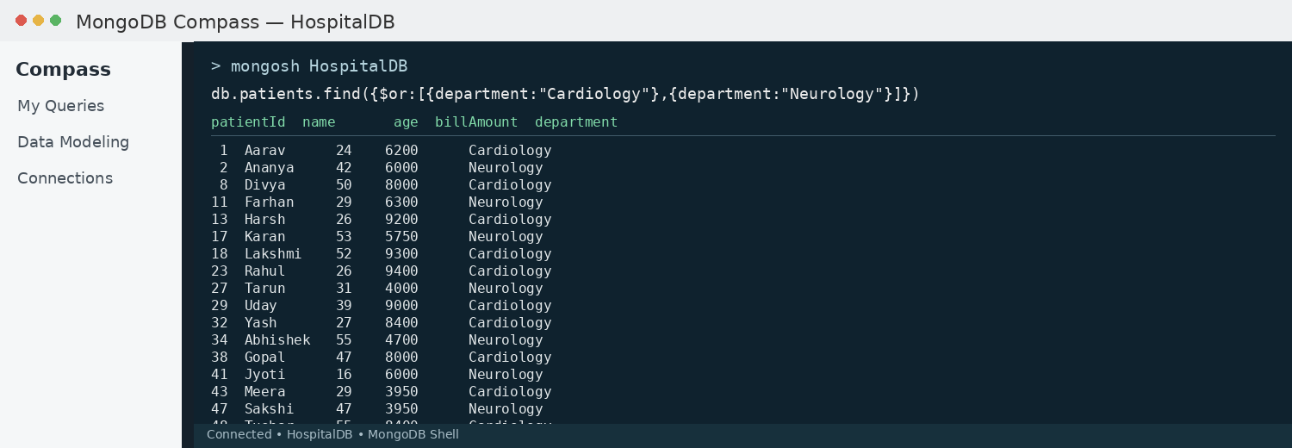

15. SORT OPERATION
A. MongoDB Query:
db.patients.find().sort({billAmount: 1})
Explanation: Sorts patients by bill amount from lowest to highest. Use 1 for ascending order.
Output Screenshot:
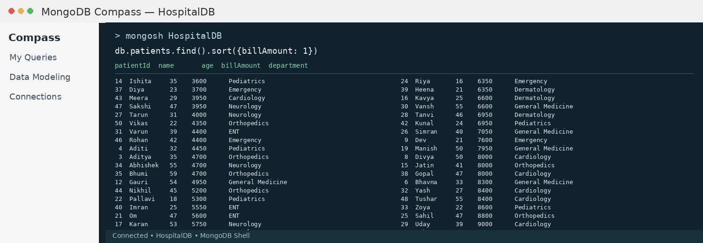
B. MongoDB Query:
db.patients.find().sort({billAmount: -1})
Explanation: Sorts patients by bill amount from highest to lowest. Use -1 for descending order.
Output Screenshot:
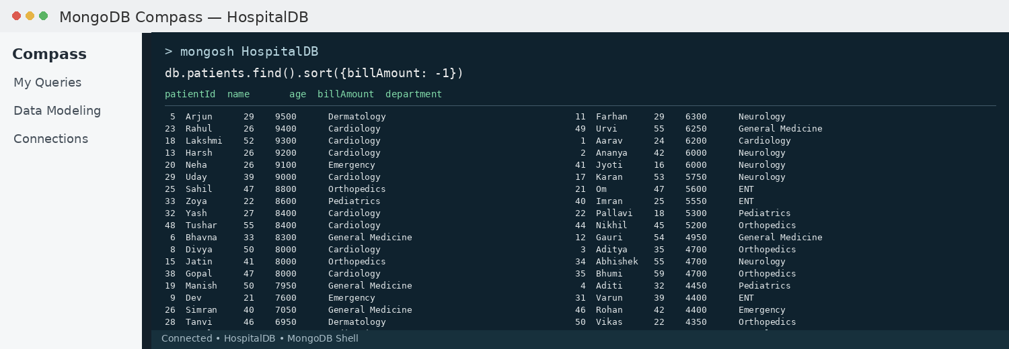

16. LIMIT OPERATION
MongoDB Query:
db.patients.find().limit(5)
Explanation: Displays only the first five patient documents.
Output Screenshot:
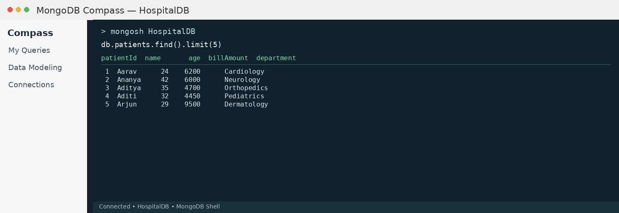

17. SEARCH BY DEPARTMENT
MongoDB Query:
db.patients.find({department:"Cardiology"})
Explanation: Finds all patients who visited the Cardiology department.
Output Screenshot:
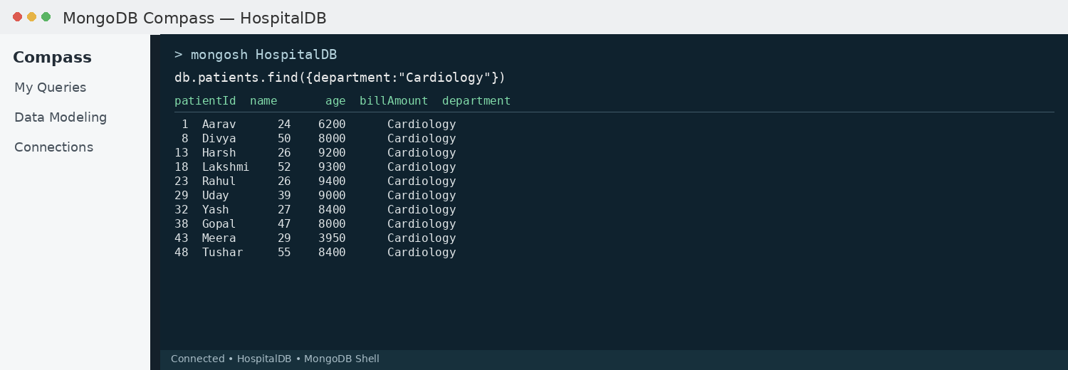

18. COUNT DOCUMENTS
MongoDB Query:
db.patients.countDocuments()
Explanation: Counts documents currently present in the collection (performed after the delete operations).
Output Screenshot:
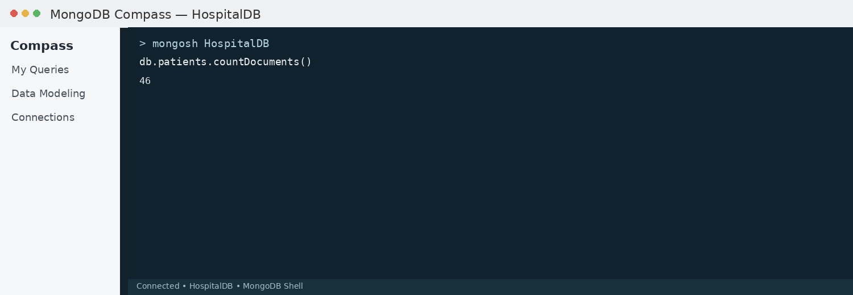

MONGODB OPERATORS USED
Operator | Meaning | Example
$eq | Equal to | billAmount: {$eq:6200}
$gt | Greater than | billAmount: {$gt:8500}
$lt | Less than | billAmount: {$lt:3500}
$gte | Greater than or equal to | billAmount: {$gte:9000}
$lte | Less than or equal to | billAmount: {$lte:4000}
$and | All conditions true | $and:[...]
$or | At least one condition true | $or:[...]

CONCLUSION
This project provided practical knowledge of NoSQL databases using MongoDB. A Hospital and Healthcare Management System containing patient information was created and different MongoDB operations were performed on the data.
Through this project, I learned how to insert, retrieve, update, and delete documents. I also learned how to arrange data in ascending and descending order, how comparison operators such as $eq, $gt, $lt, $gte, and $lte work, along with logical operators such as $and and $or.
Overall, this project helped me understand how MongoDB can be used to manage and query healthcare patient data efficiently.

