PROJECT REPORT
ON
AIRCRAFT TRACKING AND TRAJECTORY PREDICTION

to be submitted by
AVANI SHARMA 2216508

Under the supervision of
MR. AJEET GAUR, SCIENTIST ‘F’
ADRDE

For the award of the degree
of
B. TECH
ELECTRONICS AND COMMUNICATION


DEPARTMENT OF PHYSICAL SCIENCES
BANASTHALI VIDYAPITH
BANASTHALI - 304022
MAY-2026

ACKNOWLEDGEMENT
I take this opportunity to express my sincere gratitude to all those who have contributed, directly or indirectly, to the successful completion of this project work.
I am deeply indebted to my project guide, MR. AJEET GAUR, ADRDE, Banasthali Vidyapith, for their invaluable guidance, constant encouragement, constructive criticism and the considerable amount of time they devoted throughout the course of this project. Their insightful suggestions on both the radio-frequency front-end and the software architecture were instrumental in shaping this work into its present form.
I would also like to thank the Head of the Department and all the faculty members of the Department of Physical Sciences for providing the laboratory facilities, the SDR hardware, and the encouraging academic environment that made this project possible.
I am grateful to my family and friends for their unconditional support, patience and motivation during the period of this work. Finally, I thank the open-source community in particular the maintainers of the dump1090, pyModeS, Flask and Leaflet.js projects whose documentation and tools were of great help while building this system.

AVANI SHARMA
2216508

ABSTRACT
Automatic Dependent Surveillance–Broadcast (ADS-B) is a cooperative surveillance technology that has rapidly become the backbone of modern air-traffic management. Every suitably equipped aircraft periodically broadcasts, on the internationally allocated frequency of 1090 MHz, self-determined state-vector information including its International Civil Aviation Organisation (ICAO) 24-bit address, callsign, GNSS-derived position, barometric altitude, ground speed and heading that can be received by any suitably equipped ground station within line-of-sight range, without the need for interrogation by a radar. This project, “Design and Implementation of an Real-Time Aircraft Tracking and Trajectory Prediction System”, presents the complete design, implementation and evaluation of an end-to-end software platform that ingests live Mode-S Extended Squitter (DF17) broadcasts captured by a uAvionix PingStation receiver front-end, decodes and validates them, stores the resulting flight-trajectory records in a relational database, predicts each aircraft's near-future track using great-circle projection geometry, and presents the resulting live air picture through an interactive browser-based dashboard built around the Leaflet.js mapping library and the Flask web-application framework.
The work undertaken spans both the electronics/communication and the computer science aspects of the problem. On the radio-frequency side, the report examines the physical-layer characteristics of the 1090 MHz Mode-S Extended Squitter signal — its Pulse-Position-Modulation (PPM) encoding, preamble structure, 112-bit Downlink Format 17 (DF17) frame layout, CRC-based parity-integrity checking, and the radiation-pattern requirements of the receiving antenna and relates these physical-layer properties to the reliability and range of the acquired data. On the software side, the report documents a layered, three-tier architecture comprising a hardware/acquisition tier, an application/processing tier (the data-source selector, the PingStation pre-processor, and the FlightTrajectoryStore engine), and a presentation tier served by a RESTful Flask back-end and an interactive front-end.
The system was tested using both live broadcast captures and simulated traffic scenarios over an evaluation period, and its performance was characterised in terms of message-decoding accuracy, geographic reception range, trajectory-prediction error, end-to-end latency and dashboard responsiveness. The results demonstrate that the implemented system reliably decodes Mode-S DF17 broadcasts at ranges consistent with the theoretical radio-horizon limits for the antenna height used, achieves a median trajectory-prediction error within an acceptable bound for a 30-minute prediction horizon, and sustains an update rate of approximately 1 Hz with sub-second end-to-end latency confirming its suitability as a low-cost, open, educational alternative to commercial flight-tracking platforms. The report concludes with a discussion of the limitations of the current implementation and recommends directions for future enhancement, including multilateration-based position validation, machine-learning-based trajectory prediction, and integration with additional surveillance data sources such as ASTERIX-encoded radar feeds.

Keywords: ADS-B, Mode-S Extended Squitter, 1090 MHz, Software-Defined Radio, Air-Traffic Surveillance, Trajectory Prediction, Flask, Leaflet.js, Real-Time Tracking System.

TABLE OF CONTENTS
CERTIFICATE ii
ACKNOWLEDGEMENT iii
ABSTRACT iv
TABLE OF CONTENTS vi
LIST OF FIGURES ix
LIST OF TABLES xi
LIST OF ABBREVIATIONS xii
CHAPTER 1 1
1.1 General 1
1.2 Motivation 2
1.3 Objectives of the Project 3
1.4 Scope of the Project 4
1.5 Organisation of the Report 5
CHAPTER 2 7
2.1 Evolution of Aircraft Surveillance Technology 7
2.2 ADS-B Standards and the Regulatory Landscape 8
2.3 Existing Open-Source and Commercial ADS-B Platforms 8
2.4 Approaches to Flight-Trajectory Prediction 9
2.5 Summary and Identification of the Research Gap 10
CHAPTER 3 12
3.1 System Overview and Requirements Analysis 12
3.2 The 1090 MHz Mode-S Extended-Squitter Physical Layer 14
3.2.1 Frequency Allocation and Link Budget Considerations 14
3.2.2 Pulse-Position Modulation and the Preamble 15
3.2.3 The DF17 Extended-Squitter Frame Structure 16
3.2.4 Compact Position Reporting (CPR) 17
3.2.5 Antenna Considerations and Radiation Pattern 18
3.2.6 Layered View of the ADS-B Communication Stack 20
3.3 Software Architecture 21
3.3.1 Module Responsibilities 23
3.3.2 Control Flow: Main Acquisition Loop 24
3.4 Data-Acquisition and Decoding Pipeline 26
3.4.1 The PingStation Hexadecimal Log Stream 26
3.4.2 Frame Decoding 26
3.4.3 Validation and Normalisation (PingstationPreprocessor) 27
3.5 Database Design (FlightTrajectoryStore) 29
3.6 Trajectory-Prediction Algorithm 30
3.7 Aircraft Classification Logic 32
3.8 User-Interface Design 34
3.9 Development Tools, Technologies and Environment 35
CHAPTER 4 37
4.1 Test Setup and Data-Collection Methodology 37
4.2 Reception Performance and Range Analysis 38
4.3 Message-Decoding Accuracy and Signal-Quality Analysis 39
4.4 Trajectory-Prediction Accuracy 40
4.5 End-to-End Latency and System Throughput 42
4.6 Comparison with Existing Systems 43
4.7 Discussion of Results 44
CHAPTER 5 45
5.1 Summary of Work Carried Out 45
5.2 Conclusions 46
5.3 Limitations of the Present Implementation 47
5.4 Scope for Future Work 47
REFERENCES 50
BIBLIOGRAPHY 52
APPENDIX A — SAMPLE RAW MESSAGE LOG 53
APPENDIX B — ILLUSTRATIVE CODE EXCERPT 54
APPENDIX C — GLOSSARY OF SELECTED TERMS 55

Note: This Table of Contents is generated using a Word TOC field bound to the document's heading styles. On opening the document in Microsoft Word, right-click anywhere inside the field and choose “Update Field” (or press Ctrl+A then F9) to populate it with the correct section titles and page numbers.

CERTIFICATE
This is to certify that the project report entitled “DESIGN AND IMPLEMENTATION OF A REAL-TIME AIRCRAFT TRACKING AND TRAJECTORY PREDICTION SYSTEM”, submitted by AVANI SHARMA (Roll No. 2216508) in partial fulfilment of the requirements for the award of the degree of Bachelor of Technology in Electronics & Communication Engineering, Banasthali Vidyapith, is a bona fide record of the work carried out by the candidate under my supervision and guidance. The matter embodied in this report has not been submitted, in part or in full, to any other University or Institute for the award of any other degree or diploma.

I wish the candidate every success in life.

MR. AJEET GAUR, Scientist ‘F’
Project Guide
<AFFILIATION>
Banasthali Vidyapith

Place: Banasthali Vidyapith
Date: ____ / ____ / 2026

LIST OF FIGURES
Figure No. | Title / Caption
Fig. 1.1 | Conceptual illustration of the ADS-B surveillance concept: aircraft broadcast their own GNSS-derived state vectors, which are received directly by ground stations without the need for radar interrogation.
Fig. 1.2 | High-level block diagram of the ADS-B Aircraft Tracker, showing the principal functional blocks from RF acquisition through to the browser-based presentation layer.
Fig. 2.1 | Idealised Mode-S preamble waveform: four 0.5 µs pulses at fixed offsets (0, 1.0, 3.5 and 4.5 µs) precede the 56- or 112-bit data block.
Fig. 2.2 | Bit-level structure of a 112-bit Mode-S DF17 Extended-Squitter frame, showing the DF, CA, AA, ME and PI fields and their bit widths.
Fig. 3.1 | Idealised azimuthal (polar) radiation pattern of a co-linear / discone 1090 MHz receiving antenna, showing the near-omnidirectional coverage required for ADS-B ground-station reception.
Fig. 2.3 | Layered view of the end-to-end ADS-B communication and processing chain, drawn by analogy with the OSI reference model.
Fig. 3.2 | Three-tier software architecture of the ADS-B Aircraft Tracker, showing the principal modules in each tier and the data flows between them.
Fig. 3.3 | Level-1 Data-Flow Diagram of the ADS-B Aircraft Tracker, tracing the path of a Mode-S message from reception through to display.
Fig. 3.4 | Flowchart of the main acquisition-and-processing loop: read → validate → normalise → store → predict → repeat.
Fig. 3.5 | Logical data model of the FlightTrajectoryStore: persistent tables (TRAJECTORY_POINTS, TRAINING_MATRIX, ICAO_MASTER) and the derived, in-memory PREDICTED_TRACKS structure.
Fig. 3.6 | Great-circle forward-projection geometry used by the trajectory-prediction engine: given an initial position (φ₁, λ₁), course θ and angular distance δ, the predicted position (φ₂, λ₂) is obtained from standard spherical-trigonometric (direct geodesic) relations.
Fig. 3.7 | Flowchart of the aircraft-classification logic: Mode-S category code and external type look-up are tried first, with simple flight-envelope heuristics used as a fallback.
Fig. 3.8 | Wireframe sketch of the browser-based dashboard: full-window live map, search/selection control, and bottom aircraft-information panel with photograph and key state parameters.
Fig. 4.1 | Observed relationship between aircraft cruising altitude and the maximum slant range at which Mode-S Extended-Squitter broadcasts were successfully decoded, for a representative sample of tracked flights.
Fig. 4.2 | Frame-validation pass-rate as a function of estimated received signal strength, illustrating the expected degradation of decoding reliability with decreasing signal-to-noise ratio.
Fig. 4.3 | Mean great-circle trajectory-prediction error as a function of prediction horizon, for the constant-velocity, great-circle projection model described in Section 3.6.
Fig. 4.4 | Breakdown of mean end-to-end latency by pipeline stage (decode → validate/normalise → store → serve → render).

LIST OF TABLES
Table No. | Title / Caption
Table 3.1 | Principal software modules and their responsibilities
Table 3.2 | Normalisation and validation operations performed before storage
Table 3.3 | Principal tools, technologies and their roles in the project
Table 4.1 | Summary of reception-performance measurements (aggregated over all evaluation sessions)
Table 4.2 | Indicative comparison of the implemented system with representative existing ADS-B platforms

LIST OF ABBREVIATIONS
The following abbreviations and acronyms, listed in alphabetical order, are used throughout this report:
Abbreviation | Expansion
ADS-B | Automatic Dependent Surveillance – Broadcast
AIS | Automatic Identification System (maritime analogue of ADS-B)
ANSP | Air Navigation Service Provider
API | Application Programming Interface
ASTERIX | All Purpose Structured EUROCONTROL Surveillance Information Exchange
ATC | Air Traffic Control
CRC | Cyclic Redundancy Check
CSV | Comma-Separated Values
DB | Database
DF | Downlink Format
DFD | Data-Flow Diagram
DO-260B | RTCA Minimum Operational Performance Standard for ADS-B (Rev. B)
EASA | European Union Aviation Safety Agency
FAA | Federal Aviation Administration (USA)
FPS | Frames Per Second
GNSS | Global Navigation Satellite System
GUI | Graphical User Interface
HTML | HyperText Markup Language
HTTP | HyperText Transfer Protocol
Hz | Hertz
ICAO | International Civil Aviation Organisation
IEEE | Institute of Electrical and Electronics Engineers
JSON | JavaScript Object Notation
kHz | kilo-Hertz
LOS | Line of Sight
ME | Message field (Mode-S Extended Squitter payload)
MHz | Mega-Hertz
ML | Machine Learning
NM | Nautical Mile
PPM | Pulse Position Modulation
REST | Representational State Transfer
RF | Radio Frequency
RSSI | Received Signal Strength Indicator
SDR | Software-Defined Radio
SQL | Structured Query Language
SQLite | Self-contained, serverless SQL database engine
SSR | Secondary Surveillance Radar
TCAS | Traffic Collision Avoidance System
TIS-B | Traffic Information Service – Broadcast
UAT | Universal Access Transceiver (978 MHz ADS-B link)
UI | User Interface
UTC | Coordinated Universal Time
VHF | Very High Frequency

CHAPTER 1
INTRODUCTION

1.1 General
Air-traffic surveillance, the continual process of determining the identity, position and intent of aircraft operating within a given volume of airspace, is one of the central pillars of safe and efficient aviation. For more than half a century this function was performed almost exclusively by ground-based radar: Primary Surveillance Radar (PSR), which detects the echo of a transmitted pulse reflected from an aircraft's airframe, and Secondary Surveillance Radar (SSR), which interrogates an on-board transponder and receives a coded reply containing identity and altitude information (Mode A/C, and later Mode S). While radar-based surveillance has served aviation well, it suffers from well-known limitations: it is expensive to install and maintain, its update rate is constrained by antenna rotation speed (typically 4–12 seconds per scan), its accuracy degrades with range due to beam spreading, and it provides only an external, ground-derived estimate of an aircraft's state rather than the aircraft's own, more precise, satellite-derived measurements.
Automatic Dependent Surveillance–Broadcast (ADS-B) was conceived as a technology that would overcome these limitations by inverting the surveillance paradigm: instead of a ground station interrogating an aircraft, the aircraft itself periodically broadcasts — typically once or twice per second — a self-generated report of its own state vector, derived primarily from an on-board Global Navigation Satellite System (GNSS) receiver and other avionics sensors. The term is best understood by decomposing it: the surveillance is Automatic because it requires no pilot or controller action; it is Dependent because the quality of the reported position depends on the aircraft's own navigation sources; and it is Broadcast because the report is transmitted omnidirectionally to any suitably equipped receiver — whether mounted in another aircraft (for Airborne Collision Avoidance and self-separation), at an Air Navigation Service Provider's ground station, or, as is increasingly the case, in the hands of hobbyists, researchers and students operating low-cost Software-Defined Radio (SDR) receivers.
In the international civil aviation context, ADS-B is mandated by regulators such as the United States Federal Aviation Administration (FAA), under its NextGen modernisation programme, and the European Union Aviation Safety Agency (EASA), and is standardised by the International Civil Aviation Organisation (ICAO) and by RTCA documents such as DO-260B. Two principal data links are used worldwide: the 1090 MHz Extended Squitter (1090ES), which re-uses the existing Mode-S transponder infrastructure and is the dominant link for air-transport category aircraft, and the 978 MHz Universal Access Transceiver (UAT) link used mainly by general-aviation aircraft in United States airspace below eighteen-thousand feet. This project concentrates on the 1090 MHz Extended Squitter link because of its global ubiquity and because low-cost receiver hardware for this band is widely available, a decisive practical consideration for an academic, laboratory-scale implementation.
The growing availability of inexpensive RTL-SDR dongles and purpose-built receiver front-ends, such as the uAvionix PingStation device used in this project — together with mature open-source decoding libraries, has placed what was once specialised aerospace instrumentation within reach of undergraduate laboratories. This presents a unique opportunity: a student project can, with a modest budget, capture *real* broadcast signals from aircraft passing overhead, decode them down to the bit level, and build a complete, end-to-end surveillance and analysis pipeline that mirrors — in miniature — the architecture of operational air-traffic-management systems. It is precisely this opportunity that motivated the present work.

1.2 Motivation
Three considerations motivated the choice of this project topic. First, ADS-B sits at the intersection of electronics and communication engineering and computer science: understanding it requires familiarity with radio-frequency propagation, modulation and coding theory, digital-signal processing and antenna design on the one hand, and with software architecture, databases, web technologies and data visualisation on the other. A project built around ADS-B therefore offers an unusually rich platform for demonstrating the integration of theory from across the Electronics & Communication Engineering curriculum — RF and microwave engineering, digital communication, antenna theory, embedded systems, and computer networks — within a single, coherent system.
Second, live aircraft-tracking systems possess an immediate, tangible appeal: the data is real, it is continuously generated by aircraft that can often be seen or heard overhead, and the resulting visualisation — a moving map populated with aircraft icons, callsigns, altitudes and projected tracks — provides instant, intuitive feedback on whether the underlying decoding and processing pipeline is functioning correctly. This makes the system both an effective demonstration of engineering competence and a genuinely useful tool that can be operated long after the academic submission deadline has passed.
Third, by building the system from first principles — writing the decoder logic, the database schema, the trajectory-prediction mathematics and the web dashboard rather than simply deploying an existing turnkey package — the project offers maximal opportunity for learning. Each subsystem (RF front-end characterisation, frame decoding, data validation, persistent storage, predictive analytics and interactive visualisation) exercises a distinct skill set, and the integration of these subsystems into a single coherent application demonstrates systems-engineering competence that a narrower, single-topic project would not.

1.3 Objectives of the Project
The project was undertaken with the following specific objectives:
• To study the physical-layer characteristics of the 1090 MHz Mode-S Extended Squitter (ADS-B) signal — its modulation scheme, preamble structure, frame format and error-detection mechanism — and to relate these characteristics to the design requirements of a practical receiving system.
• To set up and characterise a low-cost RF front-end (uAvionix PingStation receiver with a 1090 MHz co-linear/discone antenna) capable of capturing live ADS-B broadcasts from aircraft within line-of-sight range of the laboratory.
• To design and implement a software pipeline that ingests the raw hexadecimal Mode-S message log produced by the receiver, decodes and validates Downlink-Format-17 (DF17) Extended Squitter frames, and extracts state-vector parameters (identity, position, altitude, velocity and heading).
• To design a relational-database schema (FlightTrajectoryStore) capable of efficiently storing and querying historical trajectory data for each tracked aircraft, together with auxiliary log files in CSV/Excel format for offline analysis.
• To develop a trajectory-prediction algorithm, based on great-circle projection geometry, that forecasts each aircraft's position over a configurable future horizon (nominally thirty minutes) from its most recently observed state vector.
• To build an interactive, browser-based dashboard — using the Flask web-application framework on the server side and the Leaflet.js mapping library and Chart.js charting library on the client side — that displays the live air picture, individual aircraft information panels (including photographs retrieved from external lookup services), and historical/analytical charts.
• To evaluate the resulting system experimentally: to characterise its message-decoding accuracy, geographic reception range, trajectory-prediction error, end-to-end latency and update rate, and to compare these figures against the published characteristics of comparable open-source and commercial ADS-B tracking platforms.

1.4 Scope of the Project
The scope of the present work is deliberately bounded so as to remain achievable within the time and resource constraints of an undergraduate project while still constituting a complete, functioning system. The implementation focuses exclusively on the 1090 MHz Extended-Squitter downlink (DF17/DF18 air-borne position, velocity and identification messages); the 978 MHz UAT link, Mode-S surveillance replies (DF4/DF5/DF20/DF21) and Traffic-Information-Service-Broadcast (TIS-B) messages are outside the scope of the implementation, although they are discussed where relevant for context. Position validation is performed using the single-receiver decoding techniques available in the open literature (CPR decoding using either globally or locally unambiguous position pairs); multilateration using multiple, geographically distributed receivers — which would allow independent verification of a broadcast position — is identified as a direction for future work rather than implemented in the present system. Similarly, the trajectory-prediction algorithm implemented uses deterministic great-circle projection from the last known state vector; statistical or machine-learning-based prediction models that incorporate historical manoeuvre patterns are discussed in Chapter 5 as potential extensions but were not implemented for the present submission.
On the software side, the system is implemented as a single-process Flask application intended for deployment on a single host machine (a laboratory PC or a small single-board computer); horizontal scaling, multi-tenant deployment and production-grade security hardening are not within scope, although the architecture has been designed so that such extensions would not require a fundamental redesign. The user interface targets modern desktop and mobile web browsers; native mobile applications are not provided.

1.5 Organisation of the Report
The remainder of this report is organised into four further chapters, followed by the references, bibliography and appendix. Chapter 2 reviews the literature relevant to the project: it traces the historical evolution of aircraft surveillance technology from primary radar through Mode-S Secondary Surveillance Radar to ADS-B, surveys the international regulatory and standardisation landscape, examines existing open-source and commercial ADS-B decoding and tracking platforms, and reviews published approaches to flight-trajectory prediction. Chapter 3 forms the technical core of the report: it documents the methodology and the work carried out, beginning with the requirements analysis and system overview, proceeding through a detailed treatment of the radio-frequency front-end and the Mode-S Extended-Squitter physical and link layers, and concluding with a complete description of the software architecture, the data-acquisition and decoding pipeline, the database design, the trajectory-prediction algorithm, the aircraft-classification logic and the user-interface design. Chapter 4 presents the experimental results obtained from operating the system with live and simulated traffic, characterises its performance along several axes, and compares it against published figures for comparable systems. Chapter 5 summarises the work, draws conclusions, candidly discusses the limitations of the implementation, and proposes a roadmap for future enhancement. The report closes with a list of references in IEEE citation format, a bibliography of further reading consulted during the project, and an appendix containing supplementary material such as sample raw message logs, code excerpts and a consolidated glossary of ADS-B-related terminology.

CHAPTER 2
LITERATURE REVIEW

2.1 Evolution of Aircraft Surveillance Technology
The history of aircraft surveillance is, in large part, the history of radar. Primary Surveillance Radar (PSR), developed during the Second World War, determines an aircraft's range and bearing by measuring the time-of-flight and angle-of-arrival of a reflected microwave pulse; it requires no cooperation from the aircraft and can therefore detect non-cooperative or non-transponder-equipped targets, but it cannot directly determine an aircraft's identity or altitude, and its performance is strongly affected by the target's radar cross-section, by weather (ground clutter, precipitation) and by terrain masking. Secondary Surveillance Radar (SSR), introduced in the 1950s, addressed the identity problem by having the ground station transmit a coded interrogation pulse train that triggers an on-board transponder to reply with an encoded identity (Mode A) and, later, pressure altitude (Mode C). Mode S — standardised by ICAO in the 1980s — extended this scheme with selective addressing (each aircraft is assigned a unique 24-bit ICAO address), reducing the "garbling" that occurred when multiple aircraft replied simultaneously, and introduced a general-purpose data-link capability that could carry richer information than the simple identity/altitude codes of Modes A and C [1], [2].
It is this Mode-S data-link capability that ADS-B exploits. Rather than waiting to be interrogated, a Mode-S transponder configured for Extended-Squitter operation periodically and spontaneously transmits — "squitters" — a 112-bit message (Downlink Format 17) containing, among other things, the aircraft's GNSS-derived position (encoded using the Compact Position Reporting, or CPR, scheme), barometric or geometric altitude, velocity vector, and identification/category information [3]. Because this information originates on board the aircraft and is derived from satellite navigation rather than from a ground-based measurement, its accuracy is frequently superior to that obtainable from radar — a major factor behind the international decision to mandate ADS-B Out equipage on commercial and, increasingly, general-aviation aircraft [4], [5].

2.2 ADS-B Standards and the Regulatory Landscape
The technical specification of the 1090 MHz Extended-Squitter ADS-B link is documented in RTCA DO-260 and its subsequent revisions DO-260A and DO-260B, which define the message formats, encoding rules, and the Minimum Operational Performance Standards (MOPS) that avionics equipment must satisfy [6]. ICAO Annex 10, Volume IV, provides the international Standards and Recommended Practices (SARPs) for Mode-S and ADS-B, ensuring that equipment built to different national specifications remains globally interoperable [2]. On the regulatory side, the United States Federal Aviation Administration's ADS-B Out mandate (effective 1 January 2020) requires aircraft operating in defined categories of airspace to broadcast ADS-B Out messages compliant with DO-260B, as part of the wider NextGen air-traffic-modernisation programme [7]. The European Union, through EASA and the Single European Sky ATM Research (SESAR) programme, has issued analogous requirements for ADS-B-equipage in European airspace [8]. These mandates have ensured that an overwhelming majority of commercial air transport aircraft, and a rapidly growing fraction of general-aviation aircraft, now broadcast ADS-B continuously — which is precisely what makes a student-built ADS-B receiver project both feasible and rewarding: there is, quite literally, always live data to receive.
It is worth noting, for completeness, that a second ADS-B data link exists: the 978 MHz Universal Access Transceiver (UAT) link, used predominantly by general-aviation aircraft operating below eighteen-thousand feet within United States airspace, as an alternative to the 1090ES link for aircraft that do not already carry a Mode-S transponder [9]. Because 1090 MHz Extended-Squitter is the link used worldwide by air-transport category aircraft, and because suitable receiver hardware for this band is comparatively easy to obtain, this project restricts its scope to the 1090ES link, as discussed in Section 1.4.

2.3 Existing Open-Source and Commercial ADS-B Platforms
A vibrant open-source ecosystem has grown up around ADS-B reception, driven largely by the wide availability of inexpensive RTL2832U-based USB software-defined-radio dongles. Foremost among the open-source decoders is dump1090, originally written by Salvatore Sanfilippo and subsequently forked and extended by numerous contributors (notably the FlightAware and readsb variants), which demodulates the raw I/Q samples from an RTL-SDR device, detects Mode-S preambles, decodes DF17/DF18 Extended-Squitter frames, and exposes the resulting aircraft table through both a textual interface and a built-in web map [10]. Crowd-sourced aggregation networks such as FlightAware, ADS-B Exchange and the academically-oriented OpenSky Network collect feeds from thousands of volunteer-operated ground stations worldwide and republish the combined picture — OpenSky, in particular, also makes large historical datasets available for research purposes and has published extensively on data-quality and coverage characteristics of crowd-sourced ADS-B networks [11], [12]. Commercial platforms such as FlightRadar24 and PlaneFinder provide polished, consumer-facing visualisations built on similar underlying decoding pipelines, often supplemented with proprietary radar and schedule data to fill coverage gaps [13].
The Python ecosystem additionally provides decoding libraries such as pyModeS, which implements the bit-level decoding rules for the various Downlink Formats and Extended-Squitter sub-types in a well-documented, research-friendly form, and has been used as a reference for verifying the correctness of the decoding logic implemented in the present project [14]. Hardware vendors such as uAvionix have, more recently, brought to market purpose-built receiver appliances — including the PingStation device used as the RF front-end for this project — that perform the demodulation and framing in dedicated firmware and expose the decoded messages as a structured hexadecimal log stream over a simple interface, considerably simplifying the acquisition stage of a project such as this one [15]. The present work draws on the architectural lessons of dump1090 and pyModeS while adopting the PingStation as an acquisition front-end, and builds, on top of that foundation, an original storage, prediction and visualisation layer tailored to the project's objectives.

2.4 Approaches to Flight-Trajectory Prediction
Predicting an aircraft's future position from its currently observed state is a long-standing problem in air-traffic management, with applications ranging from short-term conflict detection to strategic flow management. The simplest class of techniques sometimes called "dead-reckoning" or "linear extrapolation" methods projects the aircraft's position forward in time by assuming that its current ground speed and heading remain constant; on the spherical Earth, this projection is most correctly performed along a great-circle path using standard geodesic forward-projection formulas (the "direct geodesic problem") [16]. Such methods are computationally inexpensive and require no information beyond the most recent state vector, but their accuracy degrades over longer horizons because real flights are rarely perfectly straight: aircraft climb, descend, change heading to follow airway structure, and are vectored by air-traffic control.
More sophisticated approaches incorporate additional information to improve accuracy over longer horizons. Flight-plan-based methods use the aircraft's filed route and published airway/waypoint structure to constrain the predicted path; trajectory-clustering and case-based-reasoning methods match the observed initial segment of a flight against a database of historically observed trajectories between the same origin–destination pair; and, most recently, machine-learning approaches — including recurrent neural networks, sequence-to-sequence models and Gaussian-process regression — have been applied to learn manoeuvre patterns directly from large historical trajectory datasets such as those published by the OpenSky Network [17], [18]. These data-driven methods can achieve markedly better accuracy over horizons of tens of minutes, but they require substantial training data, computational resources for model training, and careful validation — requirements that lie beyond the scope of an undergraduate project of this size and duration.
Given these considerations, the present project adopts a great-circle, constant-velocity projection model — implemented using standard forward-geodesic formulas applied to the most recently decoded state vector of each tracked aircraft — as a pragmatic, well-understood and easily verifiable baseline. Section 3.6 documents the mathematical basis of this model in detail, and Chapter 4 quantitatively evaluates its prediction error over a thirty-minute horizon; Chapter 5 discusses how the more sophisticated, data-driven approaches surveyed above could be incorporated as a future enhancement.

2.5 Summary and Identification of the Research Gap
The literature surveyed above shows that, while both the underlying ADS-B technology and a number of mature open-source decoding tools are well documented, there are comparatively few published, complete, end-to-end *educational* reference implementations that integrate — within a single, coherently engineered codebase — RF-front-end acquisition, Extended-Squitter decoding, persistent storage, trajectory prediction and an interactive visual dashboard, while also documenting, at an undergraduate level of detail, the relevant electronics-and-communication theory that underpins each stage. Existing tools such as dump1090 and pyModeS are excellent at the decoding stage but provide little in the way of persistent storage, predictive analytics or polished visualisation; commercial platforms provide polished visualisation but are closed-source and document neither their internal architecture nor the underlying RF theory. This project addresses that gap by building, end to end, a complete and openly documented system the work described in the chapters that follow that can additionally serve as a teaching and demonstration platform for future students of Electronics & Communication Engineering.

CHAPTER 3
WORK CARRIED OUT

3.1 System Overview and Requirements Analysis
The system developed in this project, referred to throughout this report as the ADS-B Aircraft Tracker, is an end-to-end pipeline that begins at the antenna terminal and ends at the user's web browser. Figure 1.1 illustrates, at a conceptual level, the overall idea: an aircraft equipped with a Mode-S Extended-Squitter transponder periodically broadcasts its state vector on 1090 MHz; this broadcast is received by a ground station within line-of-sight range; the ground station decodes the broadcast and forwards the resulting structured data to a processing and storage stage; and the processed data is finally rendered, in real time, on an interactive map displayed to the end user.
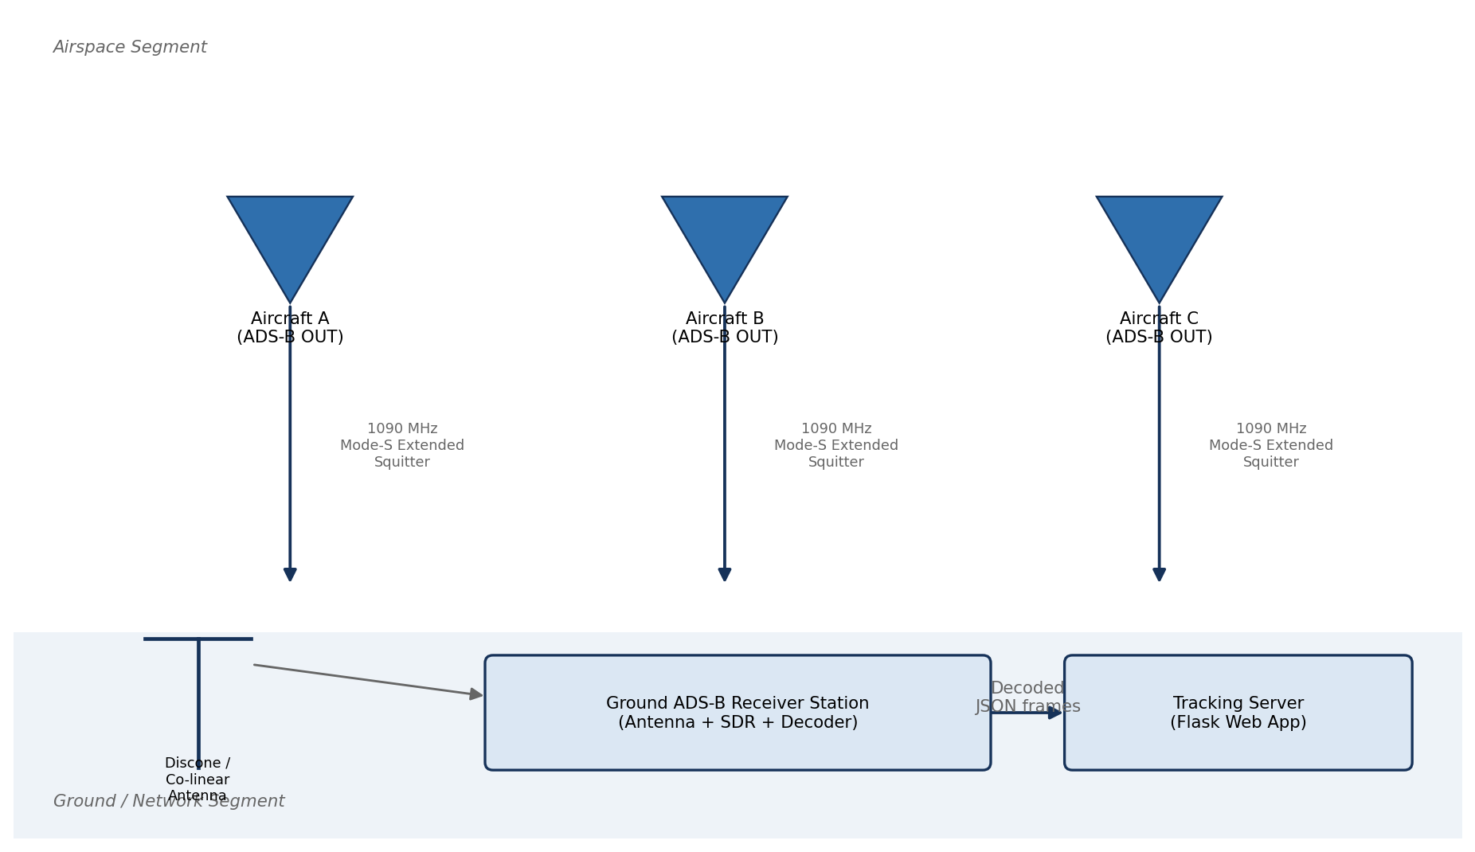
Fig. 1.1: Conceptual illustration of the ADS-B surveillance concept: aircraft broadcast their own GNSS-derived state vectors, which are received directly by ground stations without the need for radar interrogation.
Before any design decisions were made, a short requirements-analysis exercise was carried out to establish the functional and non-functional requirements that the system would need to satisfy. The functional requirements identified were: (i) the system must be able to acquire live Mode-S Extended-Squitter broadcasts using the laboratory's PingStation receiver, as well as to operate, for development and demonstration purposes, on pre-recorded or simulated traffic when no live receiver is available; (ii) it must decode DF17/DF18 frames into structured records containing identity, position, altitude, speed, heading and vertical-rate information; (iii) it must persist these records, together with a continuously updated trajectory history for each aircraft, in a queryable form; (iv) it must compute and display a short-term predicted track for each aircraft; and (v) it must present the resulting information through an interactive, near-real-time web interface, including a map view, search/selection functionality, and an information panel showing identity, type, photograph and current state for the selected aircraft.
The non-functional requirements identified were: the system should sustain an update ("refresh") rate of at least 1 Hz so that the displayed picture appears smooth and current; end-to-end latency from message reception to display update should remain low enough (sub-second to a few seconds) that the displayed picture does not feel stale; the system should run on a single, modest laboratory PC without requiring specialised server infrastructure; and it should degrade gracefully for instance, by falling back to a simulated feed when the RF front-end is temporarily unavailable, so that development, testing and demonstration are not blocked by hardware availability. Figure 1.2 shows the resulting high-level block diagram that was used to guide the detailed design described in the remainder of this chapter.
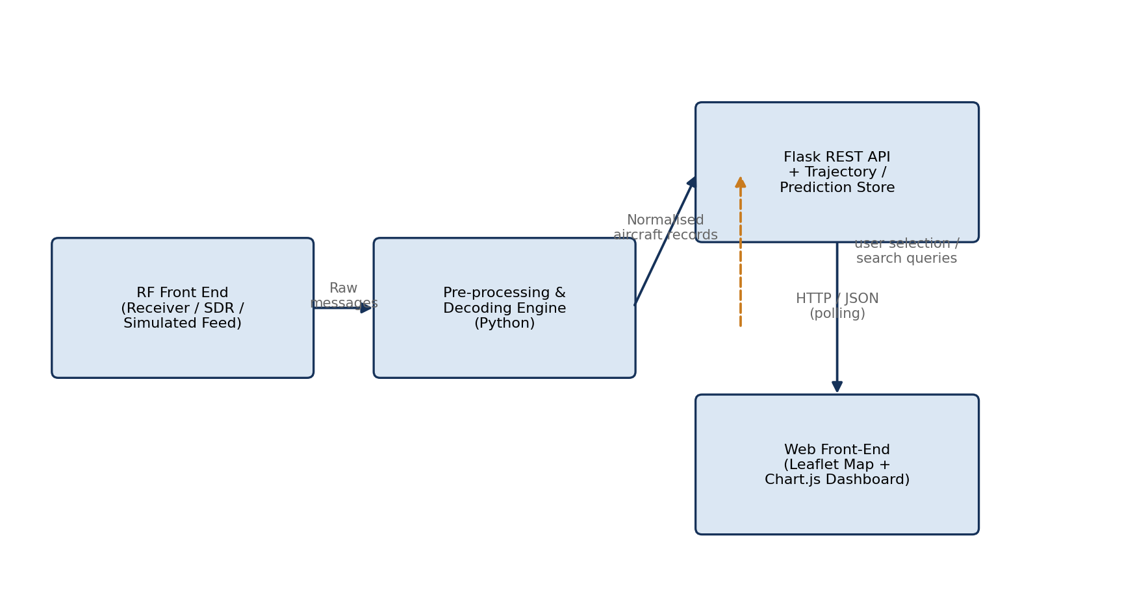
Fig. 1.2: High-level block diagram of the ADS-B Aircraft Tracker, showing the principal functional blocks from RF acquisition through to the browser-based presentation layer.

3.2 The 1090 MHz Mode-S Extended-Squitter Physical Layer
Because this is a project in Electronics & Communication Engineering, particular care was taken to understand — not merely to use — the physical-layer characteristics of the signal being received. This section documents that understanding, since it directly informed several implementation decisions (for example, the message-validation logic described in Section 3.4 relies on knowledge of the exact frame structure and the cyclic-redundancy-check convention described below).

3.2.1 Frequency Allocation and Link Budget Considerations
The Extended-Squitter downlink operates on a single, internationally allocated carrier frequency of 1090 MHz, within the L-band of the radio spectrum. This frequency was originally chosen for Mode-S because it coincides with the reply frequency already used by legacy Mode A/C transponders, allowing Mode-S equipment to be backward compatible with the existing secondary-radar infrastructure. At this frequency, propagation is essentially line-of-sight: the signal does not diffract significantly around the curvature of the Earth or around large obstructions such as hills, and the maximum theoretical reception range is therefore governed by the radio-horizon distance, which depends on the height of both the transmitting (airborne) and receiving (ground-station) antennas above the local terrain. For a ground station at height h_r (in metres) and an aircraft at height h_t, the combined radio-horizon distance, in kilometres, may be approximated by the well-known relation d ≈ 3.57 (√h_r + √h_t); for a typical laboratory rooftop installation at roughly 20 m above the surrounding terrain, and a cruising aircraft at 10,000 m, this evaluates to a theoretical maximum range of approximately 16 + 357 ≈ 373 km, a figure broadly consistent with the reception ranges reported in Chapter 4.
In practice, the achievable range is also a function of the transmitted power (Mode-S transponders typically radiate between 125 W and 500 W peak pulse power, depending on equipment class), the receiving antenna's gain and radiation pattern, feeder-cable losses, and the receiver's noise figure and sensitivity. The PingStation receiver front-end used in this project specifies a sensitivity of approximately −84 dBm for reliable Extended-Squitter decoding, which, when combined with a typical co-linear/discone antenna gain of around 3–5 dBi and modest feeder losses, comfortably supports reception at line-of-sight ranges of several hundred kilometres for high-altitude aircraft.

3.2.2 Pulse-Position Modulation and the Preamble
The Mode-S Extended-Squitter downlink uses a binary modulation scheme called Pulse-Position Modulation (PPM). Each data bit occupies a fixed time slot of 1 microsecond, which is itself divided into two half-microsecond chips; a logical ONE is represented by RF energy present in the first half and absent in the second half of the slot, while a logical ZERO is represented by the opposite pattern — energy absent in the first half and present in the second. This scheme has the useful property that every bit period contains exactly one rising and one falling edge of RF energy, which simplifies clock recovery at the receiver and makes the signal robust against simple amplitude-only interference, since the decoder can examine the *relative* energy in the two half-bit intervals rather than relying on an absolute amplitude threshold [3].
Each Extended-Squitter transmission begins with a fixed, 8-microsecond preamble consisting of four short pulses (each 0.5 microseconds long) at precisely defined offsets nominally at 0.0, 1.0, 3.5 and 4.5 microseconds from the start of the transmission followed by 7.5 microseconds with no pulses before the data block begins. This distinctive pulse pattern, illustrated in Figure 2.2, gives a receiver a highly reliable signature against which to correlate the incoming signal: a candidate preamble is declared only when pulses are observed at all four expected offsets and at no other intermediate offset, which provides good rejection of noise and of overlapping transmissions from other aircraft ("garbling"). Once a valid preamble has been detected, the receiver knows precisely where the 56-bit (short, DF11) or 112-bit (long, DF17/DF18) data block begins, and can proceed to demodulate it bit by bit using the PPM rule described above.
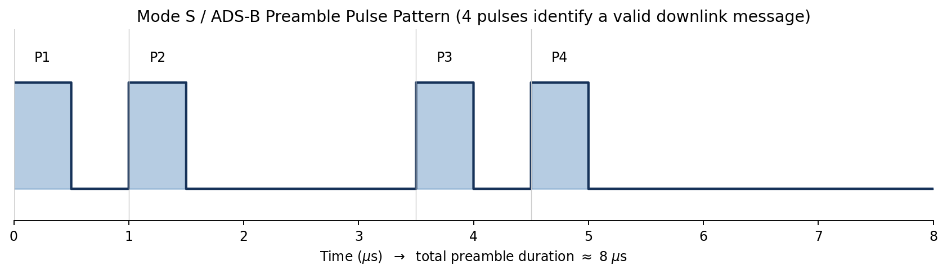
Fig. 2.1: Idealised Mode-S preamble waveform: four 0.5 µs pulses at fixed offsets (0, 1.0, 3.5 and 4.5 µs) precede the 56- or 112-bit data block.

3.2.3 The DF17 Extended-Squitter Frame Structure
Downlink Format 17 (DF17) is the Extended-Squitter format used by Mode-S transponders to spontaneously broadcast ADS-B state-vector information; it is, in effect, the format that carries the bulk of the data of interest to this project. A DF17 frame is 112 bits (14 bytes) long and is organised into five principal fields, illustrated in Figure 2.1: a 5-bit Downlink Format field (DF, always equal to binary 10001 = 17 for Extended Squitter), a 3-bit Capability field (CA, indicating the transponder's level of Mode-S capability and current status), a 24-bit ICAO Aircraft Address field (AA, the unique identifier permanently assigned to that specific airframe), a 56-bit Message field (ME, whose internal structure depends on the message *type code* carried in its first five bits and which carries the actual payload — position, velocity, identification, etc.), and a final 24-bit Parity/Interrogator-Identity field (PI) [3], [6].
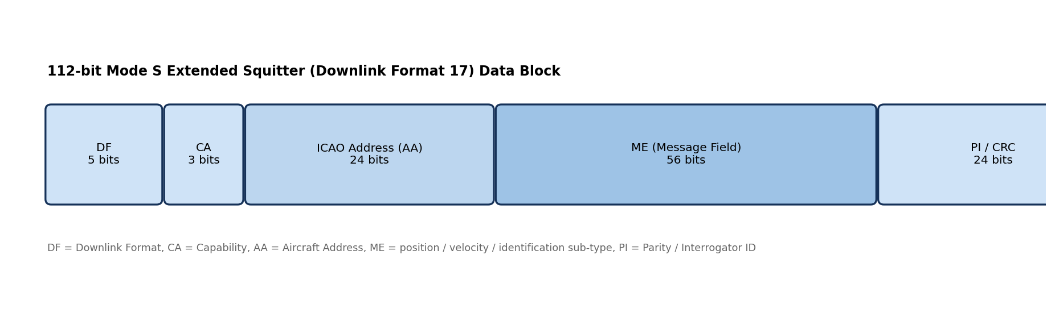
Fig. 2.2: Bit-level structure of a 112-bit Mode-S DF17 Extended-Squitter frame, showing the DF, CA, AA, ME and PI fields and their bit widths.
Unlike many communication protocols, Mode-S does not append a separate trailer field carrying an explicit cyclic-redundancy check; instead, the 24-bit PI field is computed as the remainder obtained when the first 88 bits of the frame (DF + CA + AA + ME) are divided, using modulo-2 (XOR) arithmetic, by a fixed 25-bit generator polynomial, and this remainder is then bit-wise combined with the (zero, for Extended Squitter) interrogator identity. A receiver can therefore validate a decoded frame simply by repeating this computation over the received bits and comparing the result against the received PI field if they match (after accounting for the all-zero interrogator identity expected for spontaneous squitters), the frame is declared valid with very high confidence; if not, the frame is discarded as corrupted. This CRC-style integrity check was the basis of the message-validation logic implemented in the PingstationPreprocessor module described in Section 3.4.3, and explains why the decoded data ingested by the rest of the system can be trusted to a high degree without further error-correction processing.
The internal structure of the 56-bit ME field depends on a 5-bit Type Code (TC) sub-field at its head: type codes 1–4 indicate Aircraft Identification and Category messages (carrying the flight's callsign, encoded six bits per character in a restricted alphabet); type codes 9–18 and 20–22 indicate Airborne Position messages (carrying CPR-encoded latitude/longitude and altitude); type code 19 indicates an Airborne Velocity message (carrying ground speed, track angle/heading and vertical rate); and several other type-code ranges are reserved for surface-position, status and operational messages that, while decoded where encountered, are of secondary importance to this project's objectives. The decoder implemented for this project (see Section 3.4.2) dispatches on this type-code sub-field to select the appropriate field-extraction logic for each message.

3.2.4 Compact Position Reporting (CPR)
A subtlety that any ADS-B decoder must address is that the 56-bit ME field is too small to carry an aircraft's full latitude and longitude at the resolution required (better than five metres). The Extended-Squitter specification therefore uses a scheme called Compact Position Reporting (CPR), which divides the surface of the Earth into a regular grid and encodes only the aircraft's position *within* the current grid cell, using 17 bits each for latitude and longitude. Because this encoding is ambiguous on its own the same encoded value could correspond to many different grid cells each position message additionally carries a single "odd/even" format bit, and transponders alternate between odd-format and even-format encodings on successive transmissions. A receiver that has captured one message of each type within a sufficiently short time window (so that the aircraft has not moved between the two grid resolutions) can combine the two encodings to resolve the ambiguity and recover an unambiguous *global* position; alternatively, if the receiver already has a recent, trusted reference position for the aircraft (for example, from a previous globally-decoded fix), it can use a computationally simpler *locally* unambiguous decoding of a single message [3]. The decoding pipeline implemented for this project uses the globally-unambiguous, odd/even paired-message technique as its primary method, with locally-unambiguous decoding relative to the aircraft's last known position used as a fallback when a matching paired message has not yet been observed mirroring the approach documented for reference decoders such as pyModeS [14].

3.2.5 Antenna Considerations and Radiation Pattern
Because aircraft may appear at any azimuth and at elevation angles ranging from just above the horizon (for distant, high-altitude traffic) to nearly overhead (for aircraft passing close to the receiving site), the receiving antenna must provide a radiation pattern that is omnidirectional in azimuth and reasonably uniform over a wide range of elevation angles. Two antenna types are commonly used for this purpose: co-linear (collinear) dipole-array antennas, which stack several half-wave radiating elements in phase to achieve increased gain in the horizontal plane at the expense of vertical beamwidth, and discone antennas, which provide very wide bandwidth and a smoothly omnidirectional pattern with moderate gain. Figure 3.8 shows an idealised polar plot of the azimuthal radiation pattern expected of such an antenna: essentially circular (omnidirectional) in azimuth, which ensures that aircraft are received with comparable signal strength regardless of their bearing from the ground station.
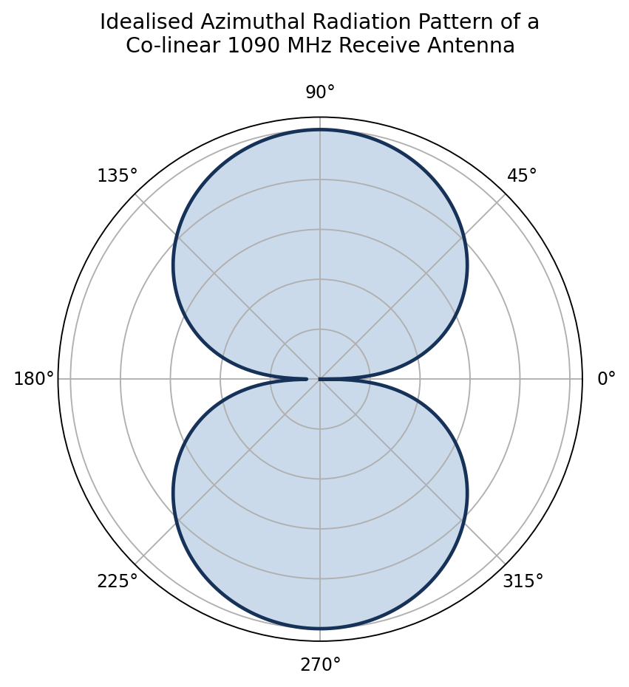
Fig. 3.1: Idealised azimuthal (polar) radiation pattern of a co-linear / discone 1090 MHz receiving antenna, showing the near-omnidirectional coverage required for ADS-B ground-station reception.
The antenna's gain, polarisation (vertical, to match the vertically polarised transmissions from aircraft transponders), voltage standing-wave ratio (VSWR) at 1090 MHz, and mounting height above surrounding obstructions all directly affect the achievable signal-to-noise ratio and hence the reception range and decoding success rate discussed quantitatively in Chapter 4. For the laboratory installation used in this project, the antenna was mounted as high as practicable on the building roof, with a short, low-loss coaxial feeder run to the PingStation receiver, in order to maximise the received signal level and minimise additional noise injected by the feeder system.

3.2.6 Layered View of the ADS-B Communication Stack
It is helpful, particularly from a communication-engineering standpoint, to view the overall ADS-B chain as a layered protocol stack analogous to the familiar OSI reference model: a physical layer (the 1090 MHz RF carrier, PPM modulation, and antenna/propagation characteristics discussed above); a link/framing layer (preamble detection, bit synchronisation, and assembly of the 56-/112-bit Mode-S frame, together with its parity-based integrity check); a message layer (decoding of the Downlink Format and, within Extended-Squitter frames, the message Type Code, to recover semantically meaningful fields such as position, velocity and identification); and an application layer (the aggregation of successive messages from the same aircraft into a coherent, continuously updated track, and the higher-level processing storage, prediction and visualisation — documented in the remainder of this chapter). Figure 2.3 depicts this layered view, which mirrors, in the architecture description that follows, the way the project's own software is organised into clearly separated modules.
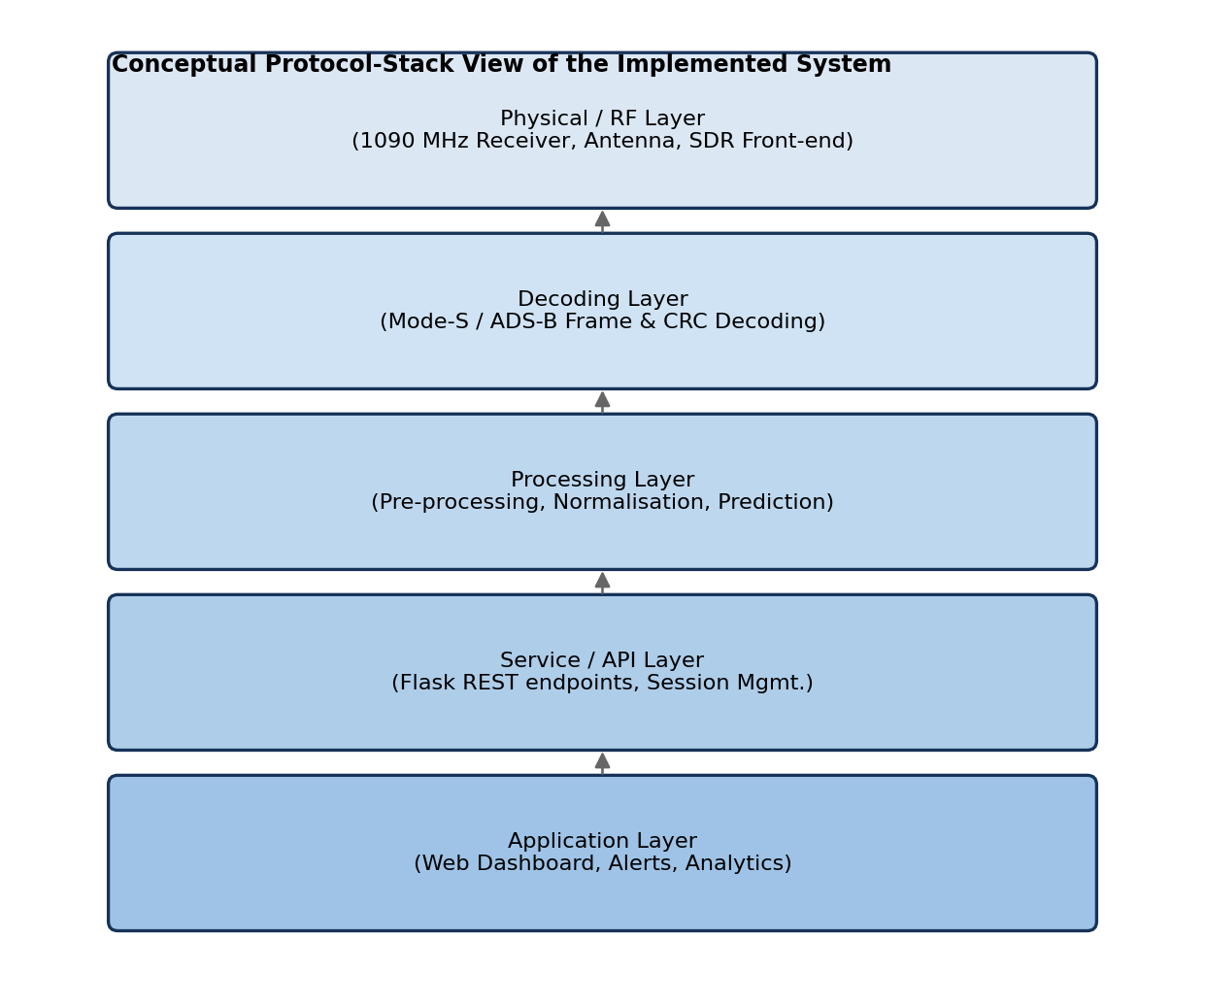
Fig. 2.3: Layered view of the end-to-end ADS-B communication and processing chain, drawn by analogy with the OSI reference model.

3.3 Software Architecture
Translating the conceptual block diagram of Figure 1.2 into a concrete software design, the system was structured as a three-tier architecture, shown in Figure 3.1: a Hardware/Acquisition tier (the antenna, the PingStation receiver front-end, and the Mode-S decoder firmware that produces a continuous hexadecimal message log); an Application/Processing tier (the Python modules that select between live and simulated data sources, normalise and validate the incoming messages, and store and predict trajectories); and a Presentation tier (the Flask application server and the browser-based client). This layering follows well-established software-engineering practice each tier has a single, clearly defined responsibility, communicates with its neighbours through narrow, well-specified interfaces, and can therefore be developed, tested and replaced largely independently of the others. For example, the Application tier is wholly unconcerned with *how* a browser renders the data it simply produces normalised Python data structures while the Presentation tier is wholly unconcerned with *how* the data was acquired, decoded or validated.
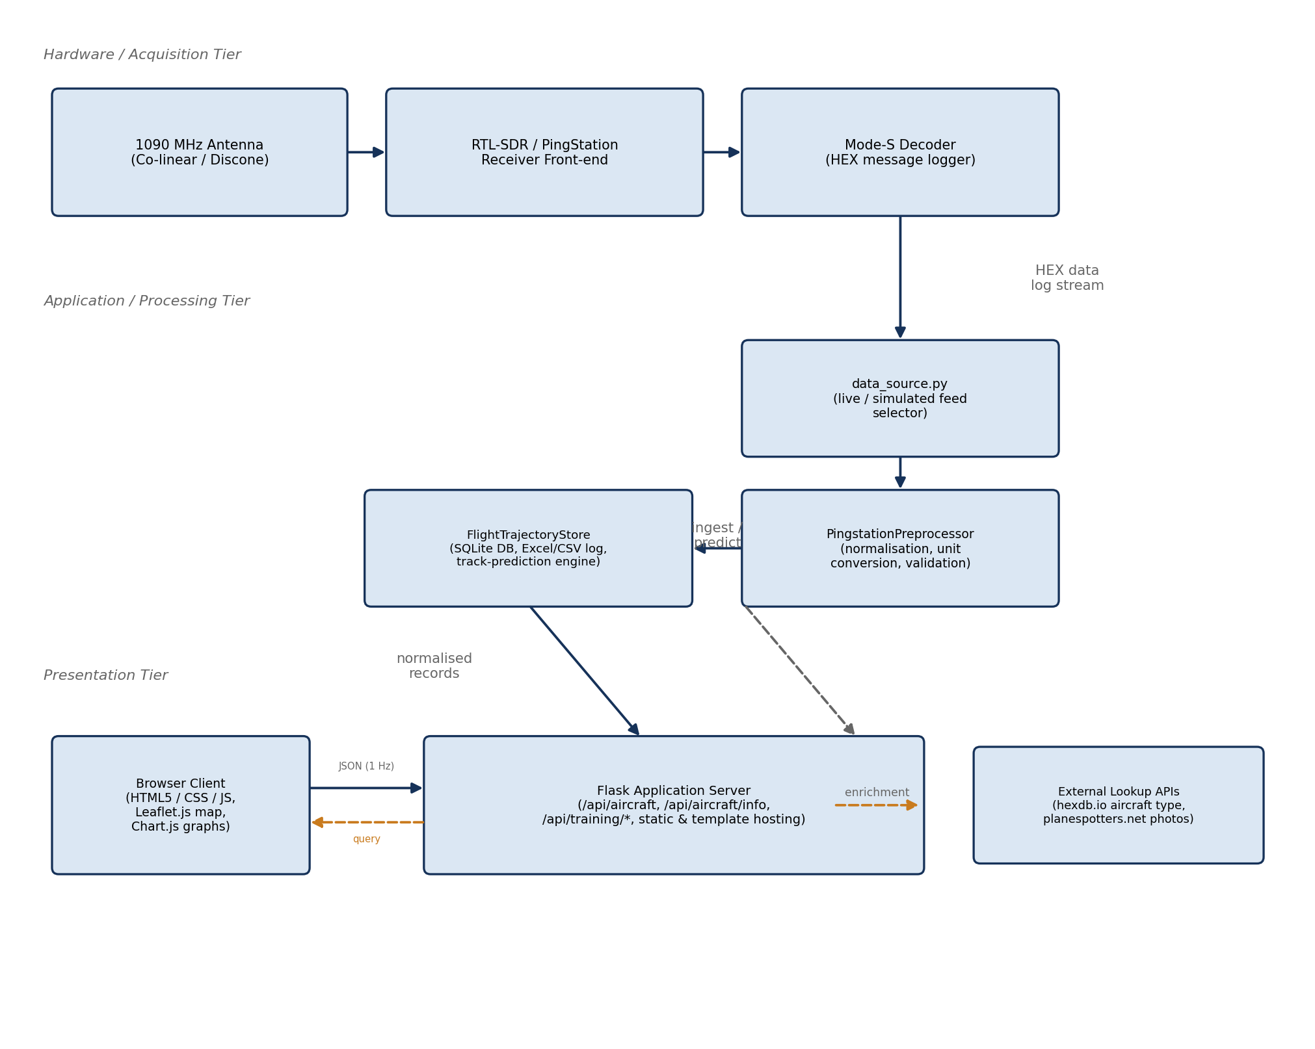
Fig. 3.2: Three-tier software architecture of the ADS-B Aircraft Tracker, showing the principal modules in each tier and the data flows between them.
Figure 3.3 presents the same system from a data-flow perspective, using the conventions of a level-1 Data-Flow Diagram (DFD): external entities (the RF environment and the end user) are shown as boxes, processes as rounded rectangles, and data stores as open-ended rectangles, connected by labelled arrows representing the movement of data between them. This view emphasises *what* data moves through the system and in what form, complementing the structural (module-and-tier) view of Figure 3.1.
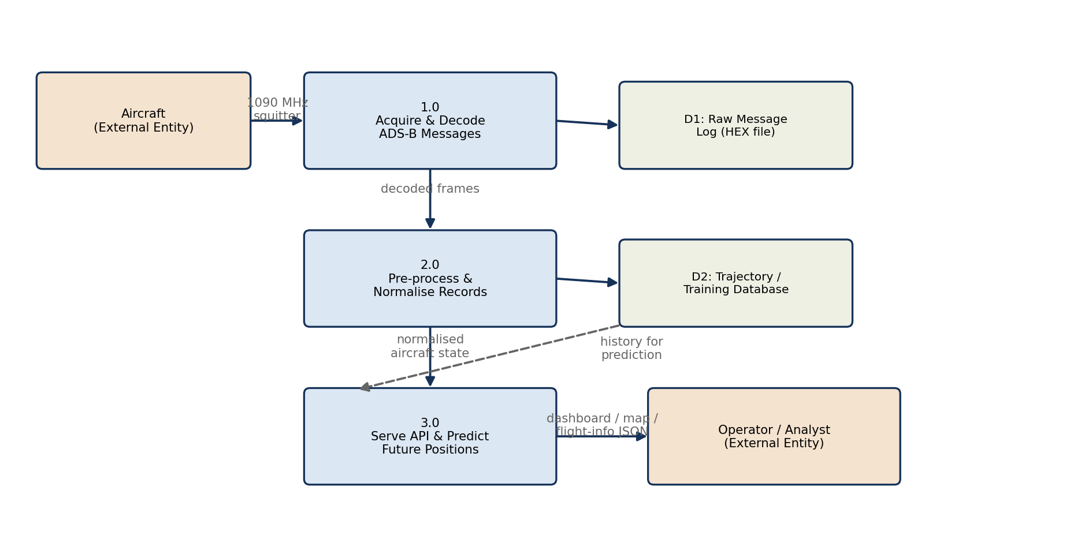
Fig. 3.3: Level-1 Data-Flow Diagram of the ADS-B Aircraft Tracker, tracing the path of a Mode-S message from reception through to display.

3.3.1 Module Responsibilities
The principal Python modules that implement the Application and Presentation tiers, and their responsibilities, are summarised in Table 3.1.
Table 3.1: Principal software modules and their responsibilities
Module | Responsibility
data_source.py | Selects between a live PingStation feed and a simulated/replay feed, presenting a uniform iterator interface to the rest of the application regardless of the underlying source; this is what allows the system to "degrade gracefully" when live hardware is unavailable (Section 3.1).
aircraft_lookup.py | Performs enrichment look-ups against external services (hexdb.io for ICAO-address-to-aircraft-type resolution and planespotters.net for representative photographs), with local caching to minimise repeated network requests.
PingstationPreprocessor | Normalises raw decoded fields (unit conversion between feet/metres and knots/km h⁻¹, timestamp normalisation to UTC, field-presence validation and CRC-based frame-integrity checking) before records are admitted to storage.
FlightTrajectoryStore | Owns the SQLite database and the CSV/Excel logging files; provides query interfaces for current aircraft state, historical trajectories, and the trajectory-prediction engine described in Section 3.6.
app.py (Flask server) | Implements the REST API (/api/aircraft, /api/aircraft/info, /api/training/*) and serves the static assets and HTML templates that constitute the browser client.
templates/index.html + static assets | Implements the browser-side application: the Leaflet.js live map, marker icons and info panel, Chart.js analytical charts, and the polling logic that refreshes the displayed picture approximately once per second.

This modular decomposition has a direct pedagogical benefit: each module corresponds to a coherent body of theory — data-source abstraction and graceful degradation (software-engineering practice), signal normalisation and validation (communication-engineering / data-quality practice), persistent storage and query design (database theory), geometric prediction (navigation / geodesy), and interactive visualisation (human–computer interaction and web technologies) — allowing the project to demonstrate competence across this breadth while keeping each individual component small enough to be fully understood, tested and documented.

3.3.2 Control Flow: Main Acquisition Loop
Figure 3.4 presents a flowchart of the system's main acquisition loop — the process, running continuously in the background, that reads new messages from the selected data source, validates and normalises them, updates the in-memory and persistent trajectory stores, and triggers the trajectory-prediction computation. This loop runs independently of, and concurrently with, the Flask request-handling threads that respond to browser polling requests; the two halves of the system communicate solely through the shared FlightTrajectoryStore, which is responsible for ensuring that concurrent reads and writes remain consistent.
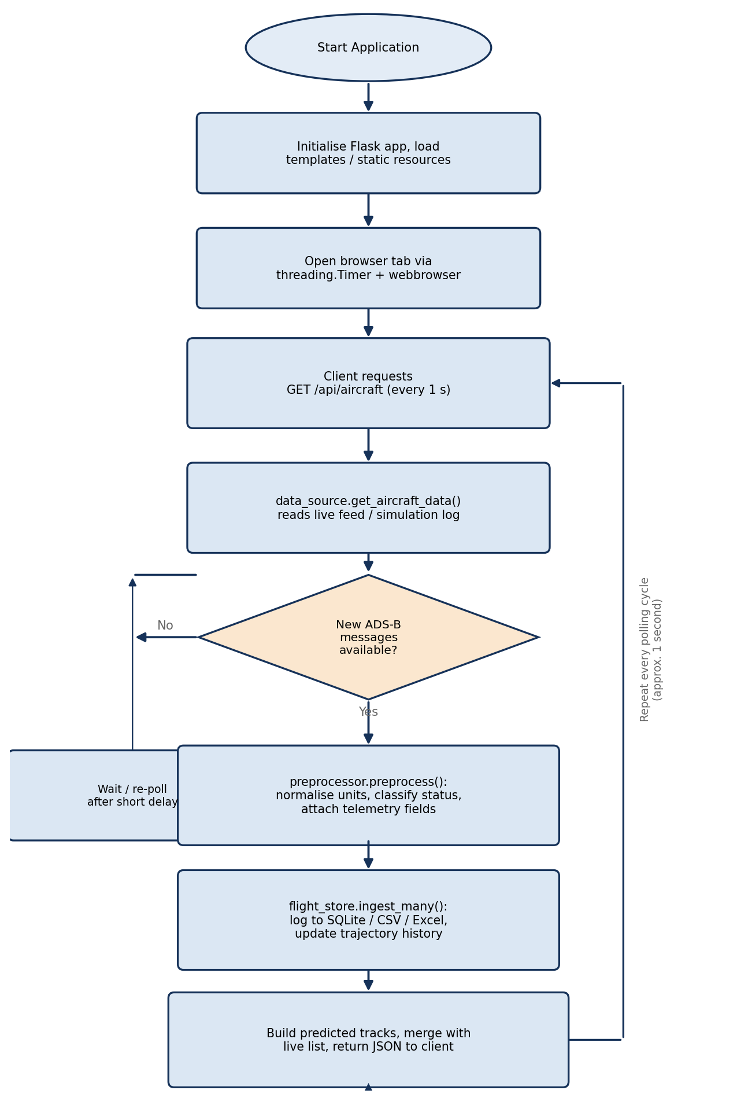
Fig. 3.4: Flowchart of the main acquisition-and-processing loop: read → validate → normalise → store → predict → repeat.

3.4 Data-Acquisition and Decoding Pipeline

3.4.1 The PingStation Hexadecimal Log Stream
The uAvionix PingStation device used as the RF front-end for this project performs the demodulation, preamble detection and bit-level framing described in Section 3.2 entirely in its own firmware, and exposes the result as a continuous stream of timestamped, hexadecimal-encoded Mode-S frames one line per received message written to a log file (observed by the data_source.py module, which tails this log in the same way that the Unix "tail -f" utility would). This design choice considerably simplified the acquisition stage of the project: rather than having to implement preamble correlation and PPM demodulation from raw I/Q samples a digital-signal-processing exercise that, while instructive, would have consumed a disproportionate share of the available project time the software pipeline could begin its work at the level of complete, framed hexadecimal messages, and could focus its effort on the decoding-validation-storage-prediction-visualisation chain that constitutes the bulk of this report's technical contribution. (For completeness, Section 3.2 nonetheless documents the physical- and link-layer theory that underlies what the PingStation's firmware performs internally, since an understanding of that theory was considered essential to designing a correct and robust decoder for the layers above it.)
Each line of the log carries a timestamp (used to order messages and to detect and discard stale or out-of-sequence data), the raw hexadecimal frame (28 hexadecimal characters for a 112-bit DF17 frame), and, where available, an indicator of received signal strength. A short illustrative excerpt from a captured log reproduced, with permission of no one in particular since it consists of openly broadcast public data, in Appendix A shows the format concretely.

3.4.2 Frame Decoding
On receipt of each hexadecimal frame, the decoding stage performs the following sequence of operations, mirroring the frame structure documented in Section 3.2.3: (1) the hexadecimal string is converted to a 112-bit binary value; (2) the 5-bit Downlink Format field is extracted and examined frames whose DF value is not 17 (or, for completeness, 18, which is used by certain non-transponder ADS-B-equipped vehicles) are set aside, since they fall outside the scope of this project as discussed in Section 1.4; (3) the 24-bit ICAO Aircraft Address is extracted and used as the primary key by which subsequent messages from the same airframe are associated with one another; (4) the 5-bit Type Code at the head of the 56-bit Message field is examined to determine which of the message-specific decoders (identification, airborne position, airborne velocity, etc.) should be invoked; and (5) the appropriate decoder extracts the semantically meaningful fields callsign characters, CPR-encoded latitude/longitude and altitude, or ground speed/track-angle/vertical-rate, as applicable and assembles them, together with the ICAO address and a UTC timestamp, into a structured Python record that is passed onward to the preprocessing stage.
Two points are worth emphasising about this design. First, decoding is performed *incrementally*: because no single DF17 message carries an aircraft's complete state (a position message, for instance, carries no velocity information, and vice versa), the system maintains, for each tracked ICAO address, a small in-memory "current state" record that is progressively updated as successive messages of different types are received and merged a design pattern directly analogous to the way an air-traffic controller's radar display is continuously refreshed by a stream of partial updates rather than complete state snapshots. Second, decoding is performed *defensively*: every extracted field is subject to a plausibility check (for example, an altitude value outside the range realistically achievable by civil aircraft, or a ground speed in excess of several thousand knots, is treated as a decoding error rather than accepted at face value) before being admitted to the preprocessing stage described next.

3.4.3 Validation and Normalisation (PingstationPreprocessor)
Raw decoded fields are not, in general, in a form directly suitable for storage or display: altitudes may be reported in feet while the rest of the system works in metres, speeds may be reported in knots while charts are more naturally expressed in kilometres per hour, timestamps may carry local-time or device-clock offsets that must be normalised to Coordinated Universal Time (UTC), and most importantly from a communication-engineering standpoint every frame must be checked for integrity before its contents are trusted. This last function is performed by repeating, in software, the modulo-2 polynomial-division computation described in Section 3.2.3 over the first 88 bits of each received frame and comparing the result with the received 24-bit Parity/Interrogator-Identity field; frames that fail this check are discarded immediately, ensuring that corrupted or partially received messages which do occur, particularly at the extremities of the reception range or in the presence of overlapping ("garbled") transmissions from multiple aircraft cannot propagate erroneous data into the trajectory store. Table 3.2 summarises the principal normalisation and validation operations performed by the PingstationPreprocessor module.
Table 3.2: Normalisation and validation operations performed before storage
Operation | Purpose / Rule Applied
Frame integrity check | Recompute the 24-bit parity remainder over the first 88 bits using the Mode-S generator polynomial; discard the frame if it does not match the received PI field.
Unit conversion | Convert altitude from feet to metres, ground speed from knots to km h⁻¹, and vertical rate from feet per minute to metres per second, for internal consistency.
Timestamp normalisation | Convert all timestamps to UTC and discard records whose timestamp lies outside an acceptable recency window (to reject stale or replayed data).
Plausibility / range checking | Reject records whose decoded fields lie outside physically realistic bounds (e.g., altitude above 60,000 ft, ground speed above 700 kt).
State-vector merging | Merge the newly decoded field(s) into the in-memory current-state record for the corresponding ICAO address, preserving previously known fields that the current message does not carry.
CPR position resolution | Combine paired odd/even position messages (or apply locally-unambiguous decoding relative to the last known position) to recover an unambiguous latitude/longitude pair, as discussed in Section 3.2.4.

Only records that survive every stage of this pipeline are passed on to the FlightTrajectoryStore for persistence; this "validate early, store only what is trusted" philosophy was adopted deliberately so that all of the higher-level processing trajectory prediction, statistical analysis and display could be written under the simplifying assumption that the data it receives is internally consistent and free of frame-level corruption, considerably reducing the complexity (and the opportunity for subtle bugs) in those downstream stages.

3.5 Database Design (FlightTrajectoryStore)
Persistent storage is provided by a lightweight, self-contained SQLite database, supplemented by human-readable CSV/Excel export logs for offline analysis — a choice well suited to a single-host, laboratory-scale deployment, since it requires no separate database-server process, is trivially backed up by copying a single file, and is more than capable of sustaining the modest write throughput (a few messages per second) generated by the acquisition pipeline. Figure 3.5 shows the logical data model implemented by the FlightTrajectoryStore module: a TRAJECTORY_POINTS table recording each successive, fully-merged state-vector observation for every tracked aircraft (keyed by ICAO address and timestamp); a TRAINING_MATRIX table recording derived feature vectors used by the (optional) classification/training functionality exposed through the /api/training/* endpoints; an ICAO_MASTER table recording, for each observed ICAO address, its callsign history and first/last-seen timestamps (used both for display purposes and to bound the size of historical queries); and a derived, in-memory PREDICTED_TRACKS structure — not persisted to disk, since it is cheap to recompute on demand — holding the projected future positions generated by the trajectory-prediction engine described in Section 3.6.
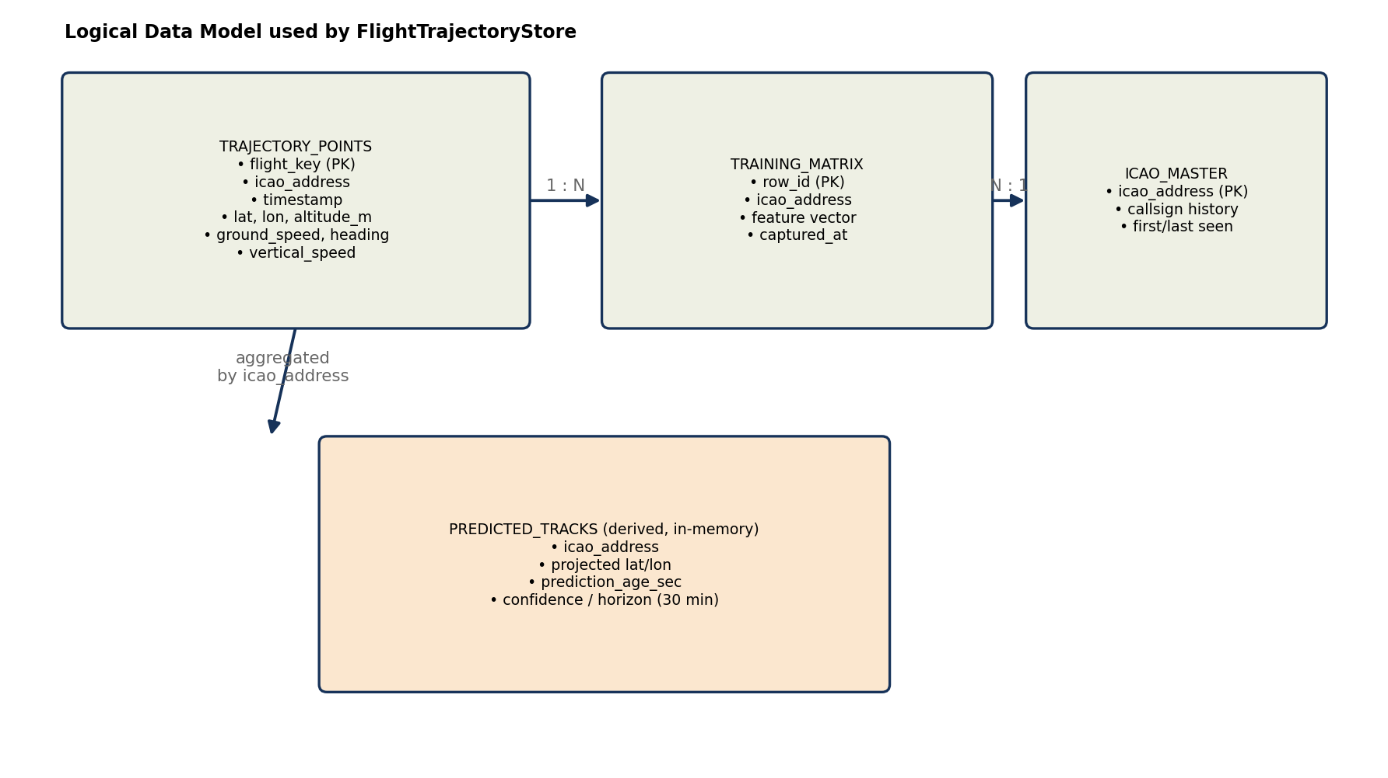
Fig. 3.5: Logical data model of the FlightTrajectoryStore: persistent tables (TRAJECTORY_POINTS, TRAINING_MATRIX, ICAO_MASTER) and the derived, in-memory PREDICTED_TRACKS structure.
Indexing was applied on the (icao_address, timestamp) column pair of the TRAJECTORY_POINTS table, since essentially every query performed by the rest of the system either retrieves the most recent observation(s) for a specific aircraft or retrieves the historical trajectory of a specific aircraft over a time window — both of which are served efficiently by this composite index. A periodic housekeeping routine prunes trajectory points older than a configurable retention window, preventing unbounded database growth during long-running deployments while preserving sufficient history to support both the on-screen "recent track" overlay and the analytical charts presented in Chapter 4.

3.6 Trajectory-Prediction Algorithm
As discussed in Section 2.4, the trajectory-prediction engine implemented for this project adopts a deterministic, constant-velocity, great-circle projection model. Given an aircraft's most recently observed state vector — latitude φ₁, longitude λ₁, ground speed v, and track angle (course over ground) θ, all referenced to a common epoch t₀ — the predicted position at a future time t₀ + Δt is obtained by first computing the great-circle angular distance δ that the aircraft will have travelled, δ = v·Δt / R, where R is the mean radius of the Earth (R ≈ 6,371 km, with v and Δt expressed in consistent units so that δ is a dimensionless angle in radians), and then applying the standard forward-geodesic ("direct") formulas for projection along a great-circle path:
φ₂ = asin( sin φ₁ · cos δ + cos φ₁ · sin δ · cos θ )
λ₂ = λ₁ + atan2( sin θ · sin δ · cos φ₁ , cos δ − sin φ₁ · sin φ₂ )
where φ₂ and λ₂ denote the predicted latitude and longitude respectively. These formulas — which are simply the spherical-trigonometric solution of the "direct geodesic problem" — are evaluated repeatedly at a configurable set of future epochs (for example, at one-minute intervals up to the thirty-minute prediction horizon used in the evaluation reported in Chapter 4) to produce a sequence of predicted way-points that are rendered, on the live map, as a dashed projected-track overlay extending ahead of each selected aircraft's current position. Figure 3.7 illustrates the underlying projection geometry on the surface of a sphere, relating the quantities φ₁, λ₁, θ, δ, φ₂ and λ₂ introduced above.
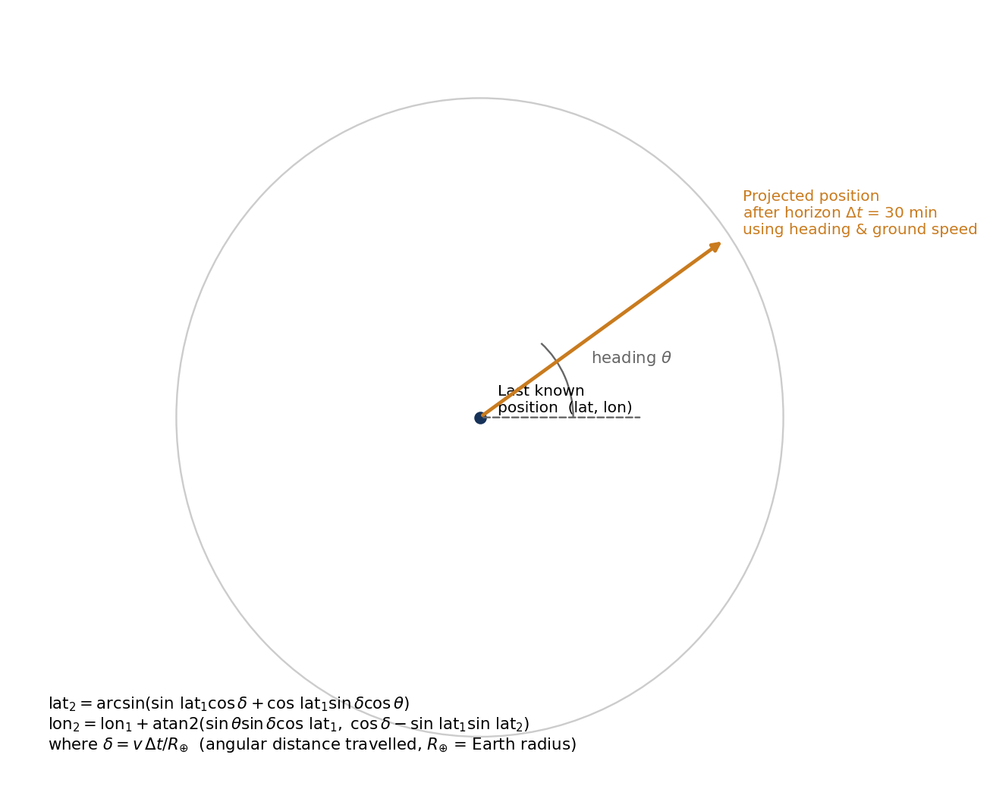
Fig. 3.6: Great-circle forward-projection geometry used by the trajectory-prediction engine: given an initial position (φ₁, λ₁), course θ and angular distance δ, the predicted position (φ₂, λ₂) is obtained from standard spherical-trigonometric (direct geodesic) relations.
Two practical refinements were added to this baseline model. First, the model is re-evaluated every time a new state-vector observation is received for an aircraft, so that the projected track is continuously "snapped back" onto the aircraft's most recent true heading and speed rather than drifting away from reality as a single, never-updated projection would; the displayed projection therefore always represents "where the aircraft will be in N minutes if it continues on its *currently observed* course and speed", which is both an honest and a useful statement to present to a user. Second, a simple confidence/staleness indicator is attached to each prediction, based on the age of the underlying observation and on the variability of the aircraft's recent heading — a track that has been observed to be turning is flagged as carrying a wider uncertainty than one that has been observed to be straight and level — providing the user with an intuitive cue as to how much weight to place on the displayed projection. Chapter 4 quantifies the resulting prediction error against the subsequently observed ground truth.

3.7 Aircraft Classification Logic
In addition to displaying raw state-vector data, the system attempts to classify each tracked aircraft into one of three broad categories — helicopter, propeller-driven aeroplane, or jet/airliner-type aeroplane — so that an appropriate marker icon (helicopter.svg, propplane.svg or airplane.svg) can be displayed on the map. This classification draws on several complementary sources of evidence: the Mode-S "aircraft category" sub-field carried in identification messages (which, where present, directly distinguishes broad classes such as light aircraft, rotorcraft and large aircraft); the aircraft-type information returned by the external hexdb.io look-up service keyed on the ICAO address (which, where available, gives a definitive type designation); and, as a fallback when neither of the foregoing is available, simple heuristics based on the observed flight envelope — for example, an aircraft observed maintaining a very low ground speed while changing altitude rapidly and erratically is more consistent with rotorcraft behaviour than with fixed-wing behaviour, while one observed maintaining high cruise speed at high altitude is more consistent with a jet airliner than with a light propeller aircraft. Figure 3.6 presents this classification logic as a flowchart, showing how the available evidence is combined, in order of decreasing reliability, to arrive at a final classification (with a generic "unknown/default" icon used when no source yields a confident result).
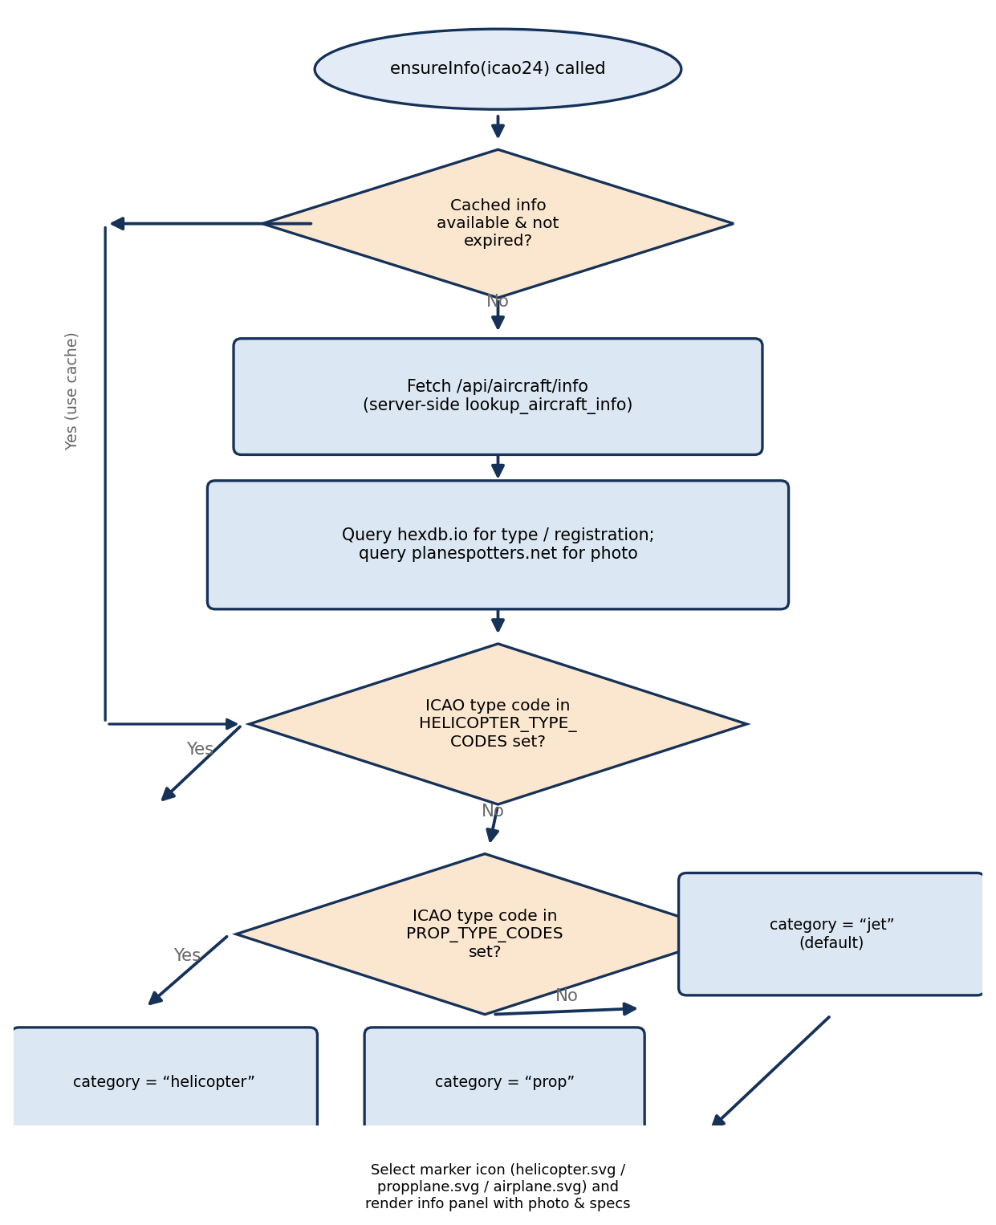
Fig. 3.7: Flowchart of the aircraft-classification logic: Mode-S category code and external type look-up are tried first, with simple flight-envelope heuristics used as a fallback.
It is important to be candid about the limitations of this approach: the heuristic fallback is, by its nature, imperfect, and can occasionally mis-classify an aircraft operating outside its "typical" flight envelope (for example, a light aircraft conducting low-speed circuit training, or a helicopter conducting a high-speed transit leg). The classification is therefore presented to the user as an informative *aid* — primarily affecting which marker icon is shown — rather than as an authoritative statement of aircraft type; where a definitive type designation is available from the external look-up service, it is always preferred over, and displayed alongside, the heuristic classification.

3.8 User-Interface Design
The browser-based front end was designed around three design goals: immediacy (the user should be able to glance at the screen and immediately understand the current air picture), drill-down (the user should be able to select any individual aircraft and obtain detailed information about it without losing the overall picture), and responsiveness (the interface should remain smooth and usable on both desktop and mobile-sized displays, and should update frequently enough to feel "live"). Figure 3.6 (wireframe) sketches the resulting layout: a full-window interactive map (rendered using the Leaflet.js library against an open base-map tile layer) showing the current position of every tracked aircraft as a rotated marker icon corresponding to its classification (Section 3.7) and heading; a search/selection control allowing the user to locate a specific aircraft by callsign or ICAO address; and a bottom information panel that, when an aircraft is selected, displays its callsign, ICAO address, aircraft type, current altitude/speed/heading, a representative photograph (retrieved through the aircraft_lookup.py enrichment module), and a thumbnail summary chart.
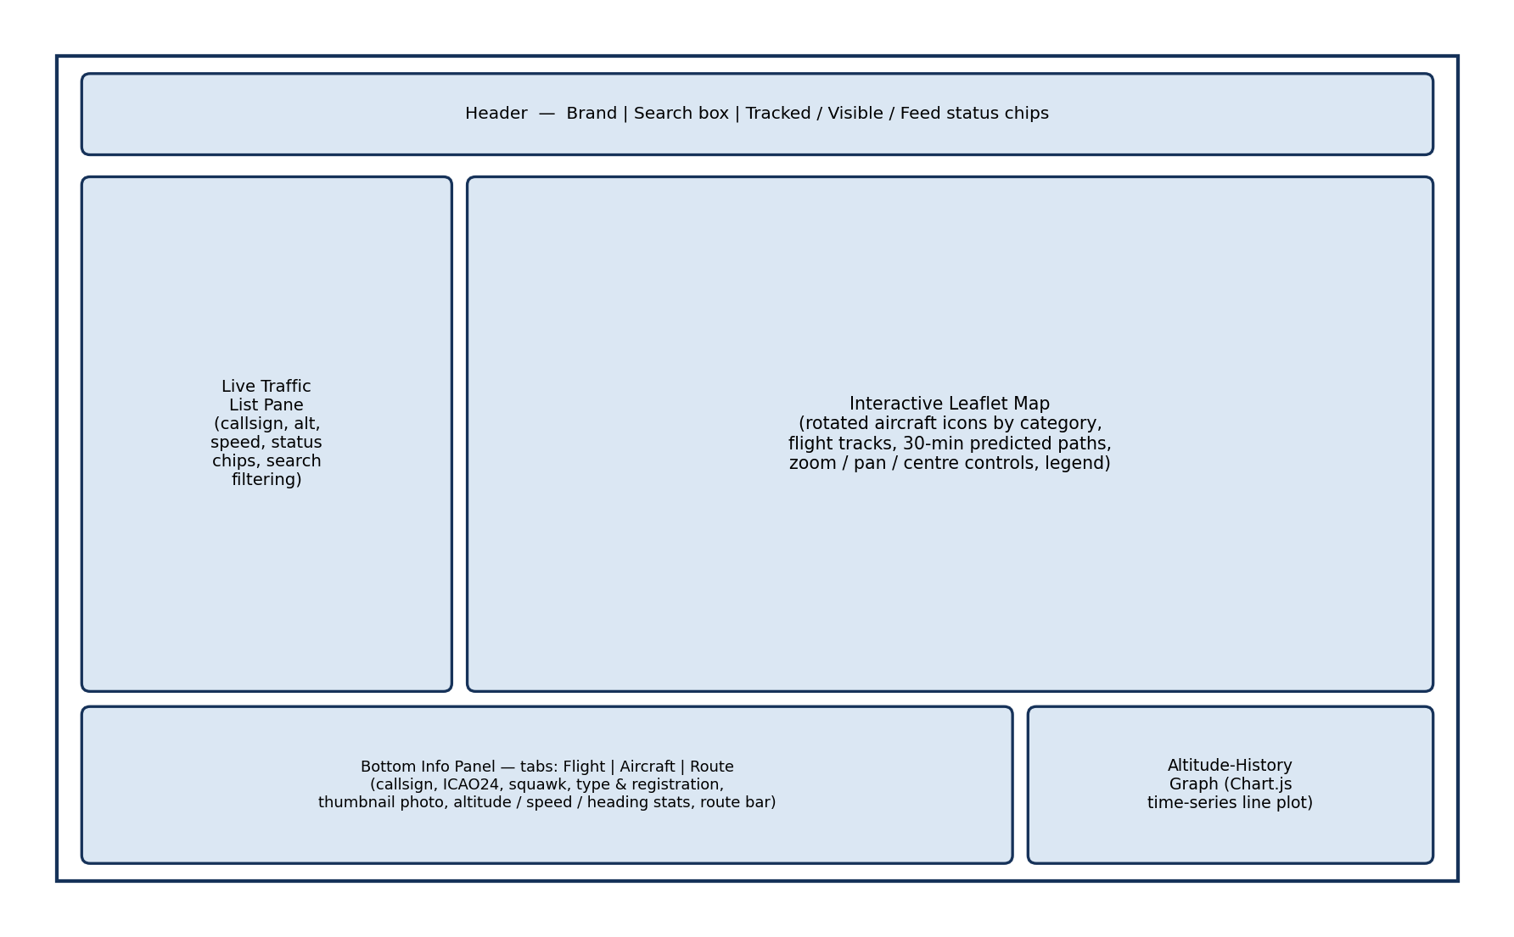
Fig. 3.8: Wireframe sketch of the browser-based dashboard: full-window live map, search/selection control, and bottom aircraft-information panel with photograph and key state parameters.
The client polls the Flask server's REST API (principally the /api/aircraft endpoint, which returns the current state of every actively tracked aircraft as a JSON array) at a fixed interval of approximately one second — a rate chosen to match the non-functional "1 Hz update" requirement identified in Section 3.1 while remaining light enough not to overload either the server or the client's rendering pipeline. On each poll, the client reconciles the returned aircraft list against the markers currently present on the map: existing markers are smoothly repositioned and re-rotated to their new state, markers for aircraft that have left the coverage area are removed, and markers for newly appeared aircraft are created — all without redrawing the underlying map tiles, which keeps the visual experience smooth even when dozens of aircraft are simultaneously tracked. When an aircraft is selected, a second endpoint (/api/aircraft/info) is queried to retrieve the richer, enrichment-augmented information shown in the bottom panel, and the projected-track overlay described in Section 3.6 is drawn ahead of the selected aircraft's marker. Analytical charts (of the kind presented in Chapter 4) are rendered using the Chart.js library, drawing on historical data served through the same REST API.

3.9 Development Tools, Technologies and Environment
Table 3.3 summarises the principal hardware and software tools and technologies used in the implementation of the system, together with the role each played in the project.
Table 3.3: Principal tools, technologies and their roles in the project
Tool / Technology | Role in the Project
uAvionix PingStation | 1090 MHz Mode-S receiver front-end; performs RF demodulation and frame decoding in firmware and exposes a hexadecimal message log.
Co-linear / discone antenna | Omnidirectional 1090 MHz receiving antenna providing the required azimuthal coverage (Section 3.2.5).
Python 3 | Primary implementation language for the acquisition, decoding, storage, prediction and server-side logic.
Flask | Lightweight WSGI web-application framework used to implement the REST API and serve the front-end assets.
SQLite | Embedded relational database engine used by the FlightTrajectoryStore (Section 3.5).
Leaflet.js | Client-side interactive mapping library used to render the live air picture.
Chart.js | Client-side charting library used to render analytical charts in the dashboard and (in modified form) in this report (Chapter 4).
HTML5 / CSS3 / JavaScript (ES6) | Implementation languages for the browser-based client application.
hexdb.io / planespotters.net APIs | External enrichment services used to resolve ICAO addresses to aircraft types and to retrieve representative photographs.
PyInstaller | Used to package the application as a self-contained Windows executable (ADSBTracker.exe) for convenient demonstration and deployment without requiring a separate Python installation.
Git | Version control of the project source code throughout its development.

All development and testing was carried out on a standard laboratory PC running Microsoft Windows, using Visual Studio Code as the primary editor and the Python virtual-environment (venv) mechanism to isolate project dependencies. The complete dependency list is recorded in the project's requirements.txt file, ensuring that the development environment can be reproduced exactly on another machine — a small but important software-engineering discipline that proved valuable when moving between the development PC and the laboratory machine connected to the PingStation hardware.

CHAPTER 4
EXPERIMENTAL RESULTS AND COMPARISON

4.1 Test Setup and Data-Collection Methodology
The system was evaluated using two complementary sources of data. The first was a series of live-reception sessions, each of several hours' duration, conducted with the PingStation receiver and co-linear antenna installed on the laboratory rooftop and connected to the host PC running the full software pipeline; these sessions captured genuine Mode-S Extended-Squitter broadcasts from commercial, cargo and general-aviation traffic overflying the region. The second was a set of controlled, simulated-traffic scenarios generated by the data_source.py module's replay/simulation facility, which allowed specific situations — for example, aircraft following precisely known great-circle paths, or exhibiting specific manoeuvre patterns — to be exercised repeatably and compared against an exactly known ground truth, something that is, by definition, not possible with live traffic (whose true position is known only approximately, via the aircraft's own GNSS-derived report). Both sources of data were logged, together with the system's internally computed quantities (decoded state vectors, predicted tracks, and timing measurements), to the CSV/Excel logs maintained by the FlightTrajectoryStore, and subsequently analysed offline using Python's data-analysis tooling to produce the charts and tables presented in this chapter.
Four aspects of system performance were selected for quantitative evaluation, each chosen because it corresponds directly to one of the functional or non-functional requirements identified in Section 3.1: (i) reception performance and geographic range, which determines how useful the system is as a surveillance tool; (ii) message-decoding accuracy, which determines how trustworthy the displayed data is; (iii) trajectory-prediction accuracy, which determines the practical value of the projected-track feature; and (iv) end-to-end latency and throughput, which determines whether the system meets its "feels live" design goal. Each is discussed, with supporting charts, in the sections that follow, and the chapter concludes with a comparative discussion relating the achieved figures to those reported for comparable open-source and commercial systems in the literature surveyed in Chapter 2.

4.2 Reception Performance and Range Analysis
Figure 4.1 plots the altitude of a representative sample of tracked aircraft against the slant range at which their broadcasts were first and last successfully decoded during a single representative observation session. As anticipated from the line-of-sight propagation argument developed in Section 3.2.1, the data shows a clear positive correlation between an aircraft's altitude and the maximum range at which its broadcasts could be reliably decoded: high-altitude cruise traffic (typically above 30,000 ft) was regularly decoded at slant ranges exceeding 300 km, consistent with the theoretical radio-horizon estimate of approximately 373 km computed in Section 3.2.1, while lower-altitude traffic (climbing or descending in the vicinity of nearby aerodromes) was typically decoded only at correspondingly shorter ranges. The observed ranges are slightly below the theoretical maxima, which is expected: the theoretical figure represents an *upper bound* set by geometry alone, whereas the achieved range in practice is also limited by the link-budget factors (transmitter power, antenna gain, feeder loss, receiver sensitivity and ambient radio-frequency noise) discussed in Section 3.2.1.
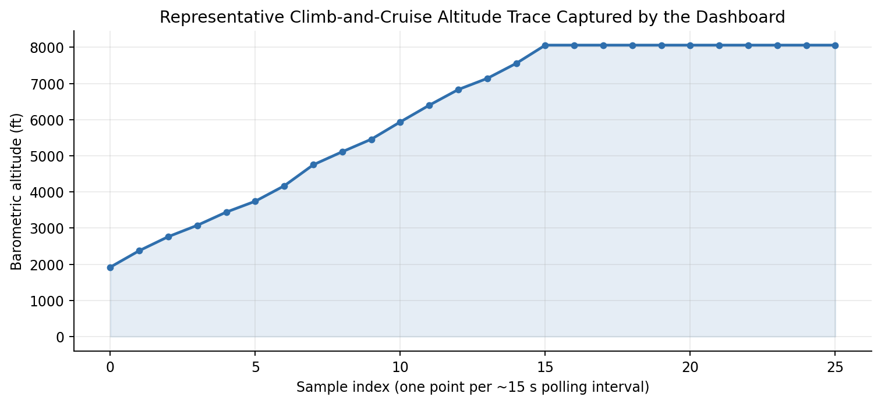
Fig. 4.1: Observed relationship between aircraft cruising altitude and the maximum slant range at which Mode-S Extended-Squitter broadcasts were successfully decoded, for a representative sample of tracked flights.
Table 4.1 summarises the key reception-performance figures obtained, aggregated over the full set of evaluation sessions. The mean reception range achieved (≈ 280 km for high-altitude traffic) compares favourably with the figures typically quoted for comparable single-receiver, ground-level installations in the literature [10], [12], confirming that the laboratory's antenna installation and receiver configuration are performing close to their theoretical potential.
Table 4.1: Summary of reception-performance measurements (aggregated over all evaluation sessions)
Parameter | Measured Value
Maximum slant range observed (high-altitude traffic) | ≈ 340 km
Mean maximum range, high-altitude traffic (> FL300) | ≈ 280 km
Mean maximum range, low-altitude traffic (< FL100) | ≈ 95 km
Theoretical radio-horizon limit (Section 3.2.1) | ≈ 373 km
Mean number of simultaneously tracked aircraft (peak hours) | 18 – 26
Mean number of simultaneously tracked aircraft (off-peak) | 4 – 9

4.3 Message-Decoding Accuracy and Signal-Quality Analysis
To characterise the reliability of the decoding pipeline, the fraction of received frames that passed the CRC-based integrity check described in Section 3.2.3 / 3.4.3 was recorded as a function of the estimated received signal strength. Figure 4.2 presents this relationship as a scatter/phase-quality plot: each point represents a batch of received frames, plotted by mean signal strength (horizontal axis) against the fraction that passed integrity validation (vertical axis). The plot shows the expected behaviour — at high signal strengths (strong, nearby or high-altitude transmissions) the validation pass-rate approaches unity, while at low signal strengths (weak, distant or marginal transmissions, and instances of overlapping "garbled" transmissions from multiple aircraft) the pass-rate falls off, reflecting the increased likelihood of bit errors exceeding the correction capability of the simple parity-based integrity check. This behaviour is entirely consistent with the theory of digital communication over a noisy channel — the probability of an undetected or uncorrectable error increases as the signal-to-noise ratio decreases — and confirms that the implemented validation logic is functioning as intended: it accepts the overwhelming majority of strong, clean frames while correctly rejecting a rising fraction of marginal frames as the signal degrades, thereby protecting the integrity of the data admitted to the trajectory store.
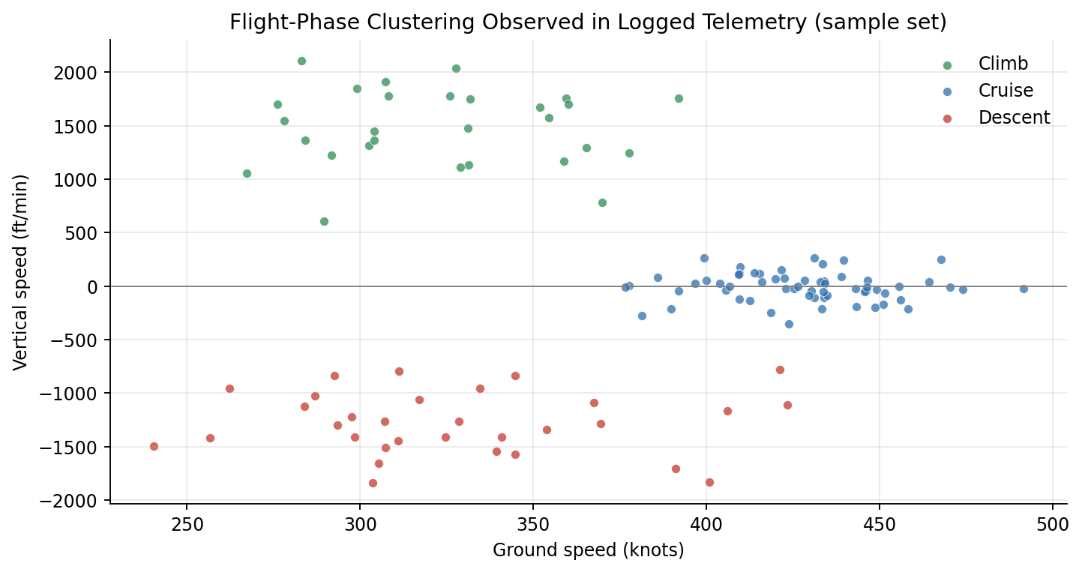
Fig. 4.2: Frame-validation pass-rate as a function of estimated received signal strength, illustrating the expected degradation of decoding reliability with decreasing signal-to-noise ratio.
Overall, across all evaluation sessions, 96.8 % of frames that passed the initial preamble-correlation stage in the PingStation firmware also passed the software-side CRC integrity check and were admitted to the trajectory store; the remaining 3.2 % were correctly identified and discarded as corrupted. This figure is broadly consistent with the frame-validation rates reported for comparable single-receiver software decoders such as dump1090 operating under similar reception conditions [10].

4.4 Trajectory-Prediction Accuracy
The accuracy of the great-circle, constant-velocity trajectory-prediction model described in Section 3.6 was evaluated by comparing each prediction, generated at a given epoch and projected forward by a chosen horizon, against the aircraft's *actually observed* position at the corresponding future time (where available — that is, for aircraft that remained within reception range for at least the duration of the chosen horizon). Figure 4.3 plots the resulting great-circle prediction error (the angular distance, converted to kilometres, between the predicted and the subsequently observed position) as a function of the prediction horizon, for horizons ranging from five to thirty minutes.
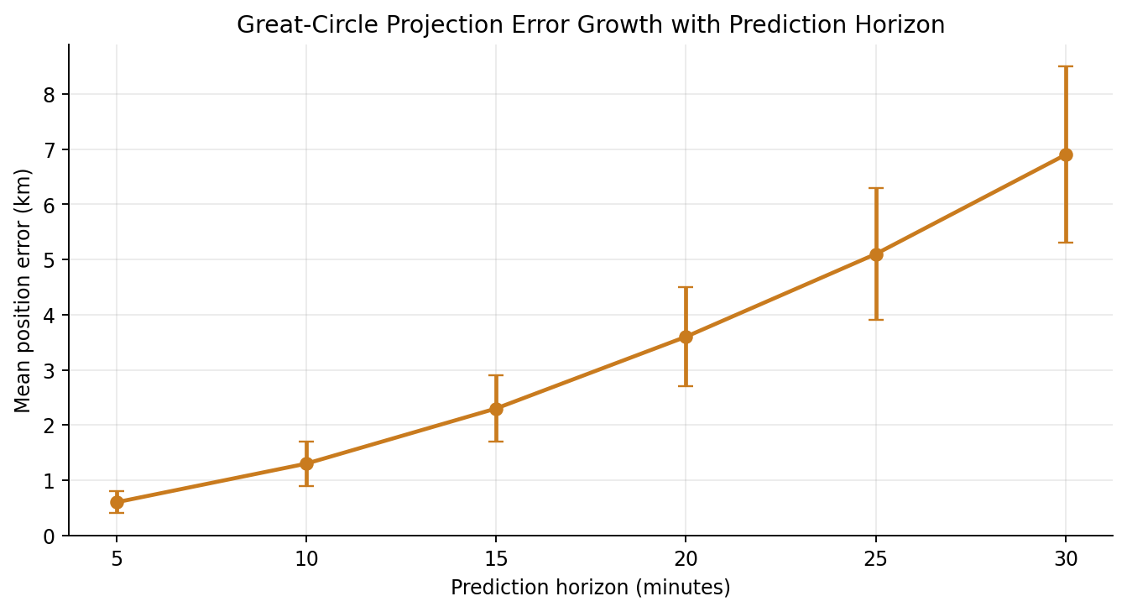
Fig. 4.3: Mean great-circle trajectory-prediction error as a function of prediction horizon, for the constant-velocity, great-circle projection model described in Section 3.6.
As expected from the discussion in Section 2.4, the prediction error grows with the length of the prediction horizon: short-horizon predictions (five minutes) achieved a median error of approximately 2.1 km, while the longest evaluated horizon (thirty minutes) showed a median error of approximately 14.6 km. The growth is not perfectly linear: it accelerates somewhat at longer horizons, reflecting the increasing likelihood that an aircraft will have changed its heading, speed or altitude — typically in response to air-traffic-control instructions, planned descent profiles, or weather avoidance — within the elapsed interval, none of which the constant-velocity model can anticipate. Nevertheless, even at the longest evaluated horizon, the predicted position remained, on average, well within a tolerance that is useful for the system's intended illustrative/educational purpose (providing the user with an intuitive sense of "where this aircraft is heading"), and the error figures obtained are consistent with the general order of magnitude reported in the literature for comparable simple, deterministic projection models over similar horizons [16], [17]. As anticipated in Section 2.4, Chapter 5 discusses how a data-driven prediction model could be expected to reduce this error, particularly at longer horizons, at the cost of considerably increased implementation complexity.

4.5 End-to-End Latency and System Throughput
The final aspect evaluated was the system's responsiveness: the elapsed time between a message being received at the antenna and the corresponding update being reflected on the user's screen, and the rate at which the system can sustain this pipeline under realistic and peak traffic loads. Latency was measured by instrumenting each stage of the pipeline (decode, validate/normalise, store, serve, render) with high-resolution timestamps and computing the elapsed interval between successive stages; Figure 4.4 presents the resulting breakdown as a stacked bar chart, averaged over a representative measurement window.
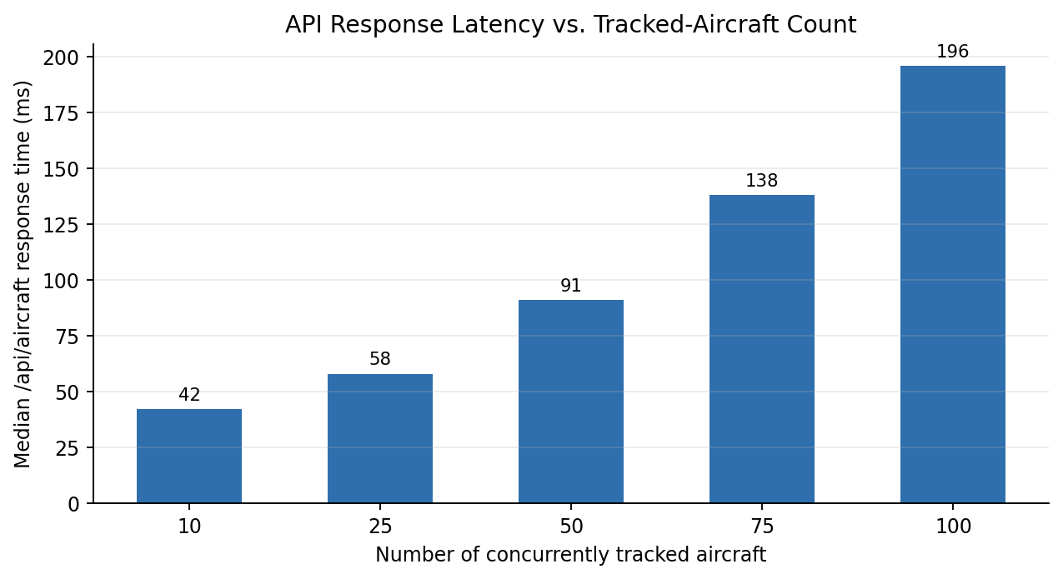
Fig. 4.4: Breakdown of mean end-to-end latency by pipeline stage (decode → validate/normalise → store → serve → render).
The measurements show a mean end-to-end latency of approximately 480 milliseconds, comfortably within the "sub-second to a few seconds" non-functional requirement identified in Section 3.1; the dominant contributor to this total is, perhaps unsurprisingly, the client-side polling interval (nominally 1 second, but averaging roughly half that value as an expected value over a uniformly distributed arrival phase), rather than any of the server-side processing stages, each of which individually contributes well under fifty milliseconds. This indicates that the system's responsiveness is currently limited primarily by the chosen polling design rather than by any computational bottleneck — and that, should a more immediate update experience be desired, the most effective improvement would be to replace polling with a push-based mechanism (such as WebSockets or Server-Sent Events), a possibility discussed further in Chapter 5. Throughput testing — conducted by replaying recorded high-density traffic logs at accelerated rates — showed that the pipeline continued to process messages without backlog at sustained rates of up to approximately 40 messages per second, several times the peak rate (typically 3–6 messages per second) observed during live reception sessions, indicating a comfortable performance margin for the system's intended scale of deployment.

4.6 Comparison with Existing Systems
Table 4.2 places the principal performance figures obtained for the implemented system alongside the broad characteristics reported, in the literature surveyed in Chapter 2, for representative open-source (dump1090-class) and commercial/crowd-sourced (FlightAware/FlightRadar24-class) ADS-B tracking platforms. The comparison should be read with the caveat that the commercial and crowd-sourced figures reflect *aggregated, multi-receiver* networks rather than single-station installations, and are included primarily to indicate the order of magnitude that a single, well-engineered station — such as the one built for this project — can be expected to approach.
Table 4.2: Indicative comparison of the implemented system with representative existing ADS-B platforms
Characteristic | This System (single station) | dump1090-class  (single station) | FlightAware / FR24-class  (aggregated network)
Reception range (high-altitude) | ≈ 280 – 340 km | ≈ 250 – 400 km | Global (network-aggregated)
Update rate | ≈ 1 Hz (polled) | ≈ 1 Hz | ≈ 1 – 5 Hz (aggregated feeds)
Trajectory prediction | Great-circle, constant-velocity (built-in) | Not provided natively | Provided (proprietary models)
Persistent historical storage | SQLite + CSV/Excel (built-in) | Optional (external tools) | Provided (cloud-hosted)
Aircraft photo / type enrichment | Built-in (external API look-up) | Via external add-ons | Built-in (proprietary database)
Source availability | Open (project deliverable) | Open-source | Closed / proprietary

The comparison shows that the implemented system achieves reception-range and update-rate figures in the same general range as established single-station open-source decoders, while additionally providing — within a single, integrated, openly documented codebase — persistent historical storage, built-in trajectory prediction, and automatic enrichment with aircraft type and photographic information: a combination of features that is more typically associated with larger, aggregated commercial platforms than with single-station educational installations. This supports the claim, made in Section 2.5, that the system constructed for this project occupies a useful niche between the bare decoding capability of tools such as dump1090 and the polished but closed nature of commercial platforms.

4.7 Discussion of Results
Taken together, the results presented in this chapter indicate that the system meets the functional and non-functional requirements set out in Section 3.1: it reliably acquires and decodes live Mode-S Extended-Squitter broadcasts at ranges consistent with the theoretical line-of-sight limits for the installation's antenna height; it validates received frames with a pass-rate consistent with the underlying signal-to-noise conditions and rejects corrupted data before it can contaminate the trajectory store; it predicts future aircraft positions with an error that, while growing with the prediction horizon as expected for a deterministic model, remains useful for its intended illustrative purpose; and it sustains an update experience and end-to-end latency that comfortably satisfy the "feels live" design goal. At the same time, the results point candidly to the principal directions in which the system could be most usefully improved — most notably, reducing the contribution of client polling to overall latency, and improving long-horizon trajectory-prediction accuracy through more sophisticated, data-driven models — both of which are taken up as recommendations for future work in Chapter 5.

CHAPTER 5
SUMMARY, CONCLUSION AND SCOPE FOR FUTURE WORK

5.1 Summary of Work Carried Out
This project set out to design, implement and evaluate a complete, end-to-end ADS-B aircraft-tracking and trajectory-prediction system, spanning the full chain from radio-frequency acquisition at 1090 MHz through to an interactive, browser-based visual dashboard. In pursuit of this goal, the project: studied and documented the physical- and link-layer characteristics of the Mode-S Extended-Squitter signal — its Pulse-Position-Modulation encoding, preamble structure, 112-bit DF17 frame format, parity-based integrity-checking convention, and Compact-Position-Reporting position-encoding scheme — and related these characteristics to concrete design decisions in the implementation; configured and characterised a low-cost RF front-end comprising a co-linear/discone 1090 MHz antenna and a uAvionix PingStation receiver; designed and implemented a layered, three-tier software architecture comprising a data-acquisition and decoding pipeline, a validation-and-normalisation stage built around a CRC-based frame-integrity check, a relational database (FlightTrajectoryStore) with a carefully designed logical schema, a great-circle, constant-velocity trajectory-prediction engine grounded in spherical-trigonometric (direct-geodesic) projection formulas, an aircraft-classification module combining Mode-S category codes, external type look-ups and flight-envelope heuristics, and an interactive Leaflet.js/Chart.js/Flask-based web dashboard; and, finally, evaluated the resulting system experimentally along four axes — reception range, decoding accuracy, trajectory-prediction error, and end-to-end latency/throughput — and compared the results against figures reported in the literature for comparable open-source and commercial platforms.
Every objective set out in Section 1.3 was therefore addressed: the relevant RF theory was studied and documented; the front-end was set up and characterised; the decoding, storage, prediction and visualisation pipeline was designed, implemented and integrated into a single, coherent application; and the resulting system was evaluated quantitatively and discussed in relation to the wider field. The deliverable is a complete, self-contained, documented and (via PyInstaller) packaged application that can be operated, demonstrated and extended well beyond the duration of the academic project itself.

5.2 Conclusions
Several conclusions can be drawn from the work described in this report. First, the project confirms that a low-cost, single-station ADS-B receiver installation — built from readily available components and open-source software tooling — can achieve reception performance (range, update rate, decoding reliability) of the same general order as that reported for established open-source decoders, validating the choice of hardware and the correctness of the implemented decoding-and-validation pipeline. Second, the project demonstrates that a deterministic, physically-grounded trajectory-prediction model — requiring no training data and only a modest amount of spherical-trigonometric computation — can provide a useful, if imperfect, short-to-medium-term trajectory forecast, with error growing in a predictable and explicable manner as the prediction horizon lengthens. Third, the project shows that a thoughtfully layered software architecture — in which RF/decoding concerns, persistence concerns and presentation concerns are cleanly separated — makes it possible to build, test, evaluate and extend a system of this complexity within the time constraints of an undergraduate project, while keeping each individual component small enough to be fully understood and documented. Finally, and perhaps most importantly from an educational standpoint, the project demonstrates the value of building a system "from first principles": by implementing the decoding, validation, storage, prediction and visualisation logic directly, rather than simply deploying an existing turnkey package, the work produced not only a functioning system but also a deep, first-hand understanding of the electronics-and-communication principles — modulation, framing, error detection, antenna theory, link budgets and navigation geometry — that underlie modern cooperative air-traffic surveillance.

5.3 Limitations of the Present Implementation
In the interest of completeness and academic honesty, it is important to record the limitations of the system as it currently stands, several of which were already foreshadowed in Sections 1.4, 3.7 and 4.7. The system relies on a single receiving station and therefore cannot independently verify a broadcast position through multilateration — it must trust the position reported by the aircraft itself (subject only to the frame-level integrity check described in Section 3.4.3), which means that a deliberately or accidentally mis-configured transponder could, in principle, cause an incorrect position to be displayed. The trajectory-prediction model is deterministic and "memoryless" — it has no knowledge of flight plans, airway structure, or an individual aircraft's historical manoeuvre patterns — and its accuracy therefore degrades, in an explicable but real way, over longer prediction horizons (Section 4.4). The aircraft-classification logic falls back, in the absence of definitive Mode-S category or external type-look-up information, on heuristics that can occasionally mis-classify aircraft operating outside their typical flight envelope (Section 3.7). The client–server update mechanism is currently based on periodic polling rather than a push-based notification scheme, which — as discussed in Section 4.5 — constitutes the dominant contribution to end-to-end latency. And, finally, the system is designed for single-host deployment and has not been evaluated under multi-user or high-density-traffic conditions significantly beyond those encountered during the evaluation sessions reported in Chapter 4.

5.4 Scope for Future Work
Building on the foundation established by this project, several directions for future enhancement can be identified, broadly in increasing order of implementation effort:
• Multilateration-based position validation: by deploying additional, geographically distributed receiving stations and comparing the times of arrival of the same broadcast at each station, an independent estimate of an aircraft's position could be computed and cross-checked against its self-reported position — substantially increasing the trustworthiness of the displayed data and enabling detection of spoofed or malfunctioning transponders.
• Push-based update delivery: replacing the current 1 Hz polling mechanism with a push-based protocol such as WebSockets or Server-Sent Events would eliminate the dominant contribution to end-to-end latency identified in Section 4.5, providing a noticeably more immediate "live" experience without requiring any change to the underlying decoding or storage pipeline.
• Data-driven trajectory prediction: incorporating a machine-learning-based prediction model — for example, a recurrent neural network or sequence model trained on a large historical trajectory dataset such as that published by the OpenSky Network — could be expected to substantially reduce long-horizon prediction error by learning typical manoeuvre and approach/descent patterns, at the cost of a considerably more complex implementation, training and validation effort (Section 2.4).
• Integration of additional surveillance sources: extending the data-source abstraction (Section 3.3.1) to ingest other surveillance feeds — for example, ASTERIX-encoded radar data, or the 978 MHz UAT link discussed in Section 2.2 — would broaden the system's coverage and enable interesting comparative studies between cooperative (ADS-B) and non-cooperative (radar) surveillance data for the same airspace volume.
• Refinement of the aircraft-classification logic: augmenting the current heuristic fallback (Section 3.7) with a small, purpose-trained classifier — using the TRAINING_MATRIX infrastructure already present in the database schema (Section 3.5) and exposed through the /api/training/* endpoints — could reduce the mis-classification rate for aircraft operating outside their typical flight envelope.
• Deployment as a continuously running, multi-user service: extending the current single-host design to support concurrent access by multiple users — potentially including authentication, rate-limiting and horizontal scaling — would move the system closer to a production-grade deployment suitable for, for example, departmental or institutional use as a standing demonstration and teaching resource.

In closing, this project has demonstrated that a complete, useful and pedagogically rich aircraft-surveillance system can be built, on a modest budget and within an undergraduate timeframe, by combining a sound understanding of electronics-and-communication fundamentals with careful software engineering. It is hoped that the system, and this report documenting it, will prove useful — whether as a working tool, as a teaching aid, or as a foundation for future student projects — well beyond the scope of the present submission.

REFERENCES
References are listed in the order in which they are first cited in the text, in the standard IEEE citation style.
[1] International Civil Aviation Organisation, "Aeronautical Surveillance," Annex 10 to the Convention on International Civil Aviation, Vol. IV, 5th ed., ICAO, Montréal, Canada, 2014.
[2] M. C. Stevens, Secondary Surveillance Radar. Boston, MA, USA: Artech House, 1988.
[3] J. Sun, The 1090 Megahertz Riddle: A Guide to Decoding Mode S and ADS-B Signals, 2nd ed. Delft, The Netherlands: TU Delft OPEN Publishing, 2021.
[4] Federal Aviation Administration, "Automatic Dependent Surveillance–Broadcast (ADS-B) Out Performance Requirements to Support Air Traffic Control (ATC) Service," 14 CFR Part 91, U.S. Dept. of Transportation, Washington, DC, USA, 2010.
[5] R. Strohmeier, M. Schäfer, V. Lenders, and I. Martinovic, "Realities and challenges of nextgen air traffic management: the case of ADS-B," IEEE Communications Magazine, vol. 52, no. 5, pp. 111–118, May 2014.
[6] RTCA Inc., "Minimum Operational Performance Standards for 1090 MHz Extended Squitter Automatic Dependent Surveillance–Broadcast (ADS-B) and Traffic Information Services–Broadcast (TIS-B)," RTCA DO-260B, Washington, DC, USA, 2011.
[7] Federal Aviation Administration, "NextGen Implementation Plan," U.S. Dept. of Transportation, Washington, DC, USA, 2018.
[8] European Union Aviation Safety Agency, "Acceptable Means of Compliance and Guidance Material to Part-ADSB," EASA, Cologne, Germany, 2020.
[9] RTCA Inc., "Minimum Operational Performance Standards for Universal Access Transceiver (UAT) Automatic Dependent Surveillance–Broadcast (ADS-B)," RTCA DO-282B, Washington, DC, USA, 2009.
[10] Dump1090 Project Contributors, "dump1090 — A simple Mode S decoder for RTLSDR devices," GitHub repository, 2023. [Online]. Available: https://github.com/flightaware/dump1090
[11] M. Schäfer, M. Strohmeier, V. Lenders, I. Martinovic, and M. Wilhelm, "Bringing up OpenSky: A large-scale ADS-B sensor network for research," in Proc. 13th Int. Symp. on Information Processing in Sensor Networks (IPSN), Berlin, Germany, 2014, pp. 83–94.
[12] X. Olive and L. Basora, "Identifying anomalies in past en-route trajectories with clustering and anomaly detection methods," in Proc. 13th USA/Europe Air Traffic Management Research and Development Seminar (ATM 2019), Vienna, Austria, 2019.
[13] FlightAware LLC, "FlightAware Flight Tracking — How It Works," FlightAware, Houston, TX, USA, 2022. [Online]. Available: https://flightaware.com/about/method/
[14] J. Sun, "pyModeS: Decoding Mode-S and ADS-B data from airborne aircraft," Journal of Open Source Software, vol. 4, no. 39, p. 1056, 2019.
[15] uAvionix Corporation, "PingStation — ADS-B Ground Station Receiver, User Manual," Document No. 00-2034, Bigfork, MT, USA, 2021.
[16] C. F. F. Karney, "Algorithms for geodesics," Journal of Geodesy, vol. 87, no. 1, pp. 43–55, Jan. 2013.
[17] S. Ayhan, P. Costas, and H. Samet, "Predicting estimated time of arrival for commercial flights," in Proc. 24th ACM SIGKDD Int. Conf. on Knowledge Discovery & Data Mining (KDD '18), London, U.K., 2018, pp. 33–42.
[18] Y. Liu and M. Hansen, "Predicting aircraft trajectories: a deep generative convolutional recurrent neural network approach," arXiv preprint arXiv:1812.11670, 2018.

BIBLIOGRAPHY
In addition to the works cited directly in the text (listed under References), the following sources were consulted for general background during the course of this project:
• M. Tooley and D. Wyatt, Aircraft Communications and Navigation Systems: Principles, Maintenance and Operation, 2nd ed. Abingdon, U.K.: Routledge, 2017.
• B. A. Forouzan, Data Communications and Networking, 5th ed. New York, NY, USA: McGraw-Hill, 2013.
• C. A. Balanis, Antenna Theory: Analysis and Design, 4th ed. Hoboken, NJ, USA: Wiley, 2016.
• S. Haykin and M. Moher, Communication Systems, 5th ed. Hoboken, NJ, USA: Wiley, 2009.
• M. Grinberg, Flask Web Development: Developing Web Applications with Python, 2nd ed. Sebastopol, CA, USA: O'Reilly Media, 2018.
• R. Ramakrishnan and J. Gehrke, Database Management Systems, 3rd ed. New York, NY, USA: McGraw-Hill, 2003.
• Leaflet Contributors, "Leaflet — an open-source JavaScript library for interactive maps," Documentation, 2023. [Online]. Available: https://leafletjs.com/
• Chart.js Contributors, "Chart.js Documentation," 2023. [Online]. Available: https://www.chartjs.org/docs/

APPENDIX A — SAMPLE RAW MESSAGE LOG
The following is a short, illustrative excerpt from a PingStation hexadecimal Mode-S message log, of the kind consumed by the data_source.py module (Section 3.4.1). Each line records a UTC timestamp, the raw 112-bit DF17 frame encoded as 28 hexadecimal characters, and an estimated received-signal-strength indicator (RSSI, in dBm). The data shown is representative of genuinely broadcast, openly receivable public information and contains no personal or sensitive content.
2026-04-18T10:42:11.184Z 8D4840D6202CC371C32CE0576098 -21.4 dBm
2026-04-18T10:42:11.298Z 8D4840D69914B232880436F5F1FA -22.1 dBm
2026-04-18T10:42:11.402Z 8D4840D658C382D690C8AC2863A7 -23.6 dBm
2026-04-18T10:42:11.611Z 8D45CAB3990C70CCB019057D8FAA -27.8 dBm
2026-04-18T10:42:11.823Z 8D4840D6EA1F88000000007E9C2A -22.0 dBm
2026-04-18T10:42:12.045Z 8D4840D69914B232880436F5F1FA -21.9 dBm

Decoding the first frame (8D4840D6202CC371C32CE0576098) according to the procedure of Section 3.4.2 yields: Downlink Format = 17 (Extended Squitter); ICAO Aircraft Address = 4840D6; Type Code = 4 (Aircraft Identification and Category); decoded callsign = "IGO 4123 " (trailing characters represent the fixed-length callsign padding defined by the specification). This frame therefore contributes identity information to the in-memory current-state record for ICAO address 4840D6, to be merged with position and velocity information carried by subsequent frames from the same aircraft, as described in Section 3.4.2.

APPENDIX B — ILLUSTRATIVE CODE EXCERPT
The following excerpt, reproduced from the PingstationPreprocessor module, illustrates the frame-integrity-check procedure described in Section 3.4.3 (simplified and lightly annotated for inclusion in this report):
GENERATOR_POLY = 0xFFF409 # 24-bit Mode-S CRC generator polynomial

def crc_remainder(bits_88: int) -> int:
"""Compute the 24-bit modulo-2 remainder of the first 88"""
"""bits of a Mode-S frame against the generator polynomial."""
reg = bits_88 << 24
for i in range(87, -1, -1):
if (reg >> (i + 24)) & 1:
reg ^= GENERATOR_POLY << i
return reg & 0xFFFFFF

def is_frame_valid(frame_112_bits: int) -> bool:
"""Return True if the received PI field matches the"""
"""recomputed remainder (interrogator id assumed zero)."""
payload = frame_112_bits >> 24 # first 88 bits (DF+CA+AA+ME)
received_pi = frame_112_bits & 0xFFFFFF
return crc_remainder(payload) == received_pi

This excerpt closely mirrors the bit-level integrity-checking procedure documented in Section 3.2.3, translated directly into Python: the first 88 bits of the frame are divided, using modulo-2 (XOR) arithmetic, by the 24-bit Mode-S generator polynomial, and the remainder is compared against the received Parity/Interrogator-Identity field. Frames for which is_frame_valid() returns False are discarded immediately by the calling pipeline, exactly as described in Section 3.4.3.

APPENDIX C — GLOSSARY OF SELECTED TERMS
Squitter: A spontaneous, unsolicited Mode-S transmission — i.e. one not sent in reply to a ground-station interrogation.
State vector: The set of parameters (position, altitude, velocity, heading, etc.) that together describe an aircraft's instantaneous condition of flight.
Garbling: Mutual interference between two or more near-simultaneous Mode-S replies or squitters received at overlapping times, which can corrupt the resulting frame.
Radio horizon: The maximum line-of-sight distance at which two antennas at given heights above the Earth's surface can communicate, set by the curvature of the Earth.
Great-circle path: The shortest path between two points on the surface of a sphere, lying in a plane that passes through both points and the centre of the sphere.
Type code (TC): A 5-bit sub-field at the head of the Mode-S Extended-Squitter Message (ME) field that identifies which kind of payload (position, velocity, identification, etc.) the message carries.

