PROJECT REPORT
ON
AIRCRAFT TRACKING AND TRAJECTORY PREDICTION

to be submitted by
AVANI SHARMA 2216508

Under the supervision of
MR. AJEET GAUR, SCIENTIST ‘F’
ADRDE

For the award of the degree
of
B. TECH
ELECTRONICS AND COMMUNICATION


DEPARTMENT OF PHYSICAL SCIENCES
BANASTHALI VIDYAPITH
BANASTHALI - 304022
MAY-2026

ACKNOWLEDGEMENT
I take this opportunity to express my sincere gratitude to all those who have contributed, directly or indirectly, to the successful completion of this project work.
I am deeply indebted to my project guide, MR. AJEET GAUR, ADRDE, Banasthali Vidyapith, for their invaluable guidance, constant encouragement, constructive criticism and the considerable amount of time they devoted throughout the course of this project. Their insightful suggestions on both the radio-frequency front-end and the software architecture were instrumental in shaping this work into its present form.
I would also like to thank the Head of the Department and all the faculty members of the Department of Physical Sciences for providing the laboratory facilities, the SDR hardware, and the encouraging academic environment that made this project possible.
I am grateful to my family and friends for their unconditional support, patience and motivation during the period of this work. Finally, I thank the open-source community in particular the maintainers of the dump1090, pyModeS, Flask and Leaflet.js projects whose documentation and tools were of great help while building this system.

AVANI SHARMA
2216508

ABSTRACT
Automatic Dependent Surveillance-Broadcast (ADS-B) is a cooperative surveillance technology that has become a key component of modern air-traffic management. Suitably equipped aircraft periodically broadcast their International Civil Aviation Organisation (ICAO) 24-bit address, callsign, position, altitude, ground speed, heading and vertical rate. This project, "Design and Implementation of a Real-Time Aircraft Tracking and Trajectory Prediction System", presents an end-to-end platform that receives the structured binary stream supplied by a uAvionix PingStation, separates it into complete frames, decodes and normalises aircraft records, stores continuous per-aircraft trajectory histories, predicts short communication gaps using sliding-window linear regression with a deterministic kinematic fallback, and presents the live air picture through a Flask and Leaflet.js browser interface.
The work spans both electronics/communication and computer-science aspects. The report examines the 1090 MHz Mode-S Extended-Squitter physical layer, including Pulse-Position Modulation, the preamble, frame structure and radio-propagation considerations, while recognising that the PingStation performs RF demodulation and exposes a higher-level length-prefixed stream to the software. The implemented software is divided into acquisition, decoding, preprocessing, storage/prediction and presentation layers. Live hardware and recorded simulation data pass through the same decoder, while session-specific HEX, ASCII, exact-stream and intermediate decoded logs support repeatable testing and diagnosis.
The system has been exercised with both live PingStation reception and replay of recorded PingStation data. Functional testing verified dynamic ICAO detection, continuous SQLite and per-aircraft Excel logging, automatic creation of a master workbook, one-second dashboard updates, live/simulation switching, short-outage trajectory prediction and resumption of actual tracking when reception returns. Prediction is deliberately limited to a configurable short horizon (180 seconds by default), because extrapolation uncertainty grows rapidly during turns and speed changes. The current predictor is an interpretable machine-learning baseline rather than a trained deep-neural model; Kalman filtering and recurrent sequence models remain appropriate subjects for future comparative research.

Keywords: ADS-B, Mode-S Extended Squitter, PingStation, TCP Frame Decoding, SQLite, Linear Regression, Trajectory Prediction, Flask, Leaflet.js, Real-Time Tracking System.

TABLE OF CONTENTS
CERTIFICATE ii
ACKNOWLEDGEMENT iii
ABSTRACT iv
TABLE OF CONTENTS vi
LIST OF FIGURES ix
LIST OF TABLES xi
LIST OF ABBREVIATIONS xii
CHAPTER 1 1
1.1 General 11.1 General 11.1 General 1
1.2 Motivation 21.2 Motivation 21.2 Motivation 2
1.3 Objectives of the Project 31.3 Objectives of the Project 31.3 Objectives of the Project 3
1.4 Scope of the Project 41.4 Scope of the Project 41.4 Scope of the Project 4
1.5 Organisation of the Report 51.5 Organisation of the Report 51.5 Organisation of the Report 5
CHAPTER 2 7
2.1 Evolution of Aircraft Surveillance Technology 72.1 Evolution of Aircraft Surveillance Technology 72.1 Evolution of Aircraft Surveillance Technology 7
2.2 ADS-B Standards and the Regulatory Landscape 82.2 ADS-B Standards and the Regulatory Landscape 82.2 ADS-B Standards and the Regulatory Landscape 8
2.3 Existing Open-Source and Commercial ADS-B Platforms 82.3 Existing Open-Source and Commercial ADS-B Platforms 82.3 Existing Open-Source and Commercial ADS-B Platforms 8
2.4 Approaches to Flight-Trajectory Prediction 92.4 Approaches to Flight-Trajectory Prediction 92.4 Approaches to Flight-Trajectory Prediction 9
2.5 Summary and Identification of the Research Gap 102.5 Summary and Identification of the Research Gap 102.5 Summary and Identification of the Research Gap 10
CHAPTER 3 12
3.1 System Overview and Requirements Analysis 123.1 System Overview and Requirements Analysis 123.1 System Overview and Requirements Analysis 12
3.2 The 1090 MHz Mode-S Extended-Squitter Physical Layer 143.2 The 1090 MHz Mode-S Extended-Squitter Physical Layer 143.2 The 1090 MHz Mode-S Extended-Squitter Physical Layer 14
3.2.1 Frequency Allocation and Link Budget Considerations 143.2.1 Frequency Allocation and Link Budget Considerations 143.2.1 Frequency Allocation and Link Budget Considerations 14
3.2.2 Pulse-Position Modulation and the Preamble 153.2.2 Pulse-Position Modulation and the Preamble 153.2.2 Pulse-Position Modulation and the Preamble 15
3.2.3 The DF17 Extended-Squitter Frame Structure 163.2.3 The DF17 Extended-Squitter Frame Structure 163.2.3 The DF17 Extended-Squitter Frame Structure 16
3.2.4 Compact Position Reporting (CPR) 173.2.4 Compact Position Reporting (CPR) 173.2.4 Compact Position Reporting (CPR) 17
3.2.5 Antenna Considerations and Radiation Pattern 183.2.5 Antenna Considerations and Radiation Pattern 183.2.5 Antenna Considerations and Radiation Pattern 18
3.2.6 Layered View of the ADS-B Communication Stack 203.2.6 Layered View of the ADS-B Communication Stack 203.2.6 Layered View of the ADS-B Communication Stack 20
3.3 Software Architecture 213.3 Software Architecture 213.3 Software Architecture 21
3.3.1 Module Responsibilities 233.3.1 Module Responsibilities 233.3.1 Module Responsibilities 23
3.3.2 Control Flow: Main Acquisition Loop 243.3.2 Control Flow: Main Acquisition Loop 243.3.2 Control Flow: Main Acquisition Loop 24
3.4 Data-Acquisition and Decoding Pipeline 263.4 Data-Acquisition and Decoding Pipeline 263.4 Data-Acquisition and Decoding Pipeline 26
3.4.1 The PingStation Hexadecimal Log Stream 263.4.1 The PingStation Hexadecimal Log Stream 263.4.1 The PingStation Hexadecimal Log Stream 26
3.4.2 Frame Decoding 263.4.2 Frame Decoding 263.4.2 Frame Decoding 26
3.4.3 Validation and Normalisation (PingstationPreprocessor) 273.4.3 Validation and Normalisation (PingstationPreprocessor) 273.4.3 Validation and Normalisation (PingstationPreprocessor) 27
3.5 Database Design (FlightTrajectoryStore) 293.5 Database Design (FlightTrajectoryStore) 293.5 Database Design (FlightTrajectoryStore) 29
3.6 Trajectory-Prediction Algorithm 303.6 Trajectory-Prediction Algorithm 303.6 Trajectory-Prediction Algorithm 30
3.7 Aircraft Classification Logic 323.7 Aircraft Classification Logic 323.7 Aircraft Classification Logic 32
3.8 User-Interface Design 343.8 User-Interface Design 343.8 User-Interface Design 34
3.9 Development Tools, Technologies and Environment 353.9 Development Tools, Technologies and Environment 353.9 Development Tools, Technologies and Environment 35
CHAPTER 4 37
4.1 Test Setup and Data-Collection Methodology 374.1 Test Setup and Data-Collection Methodology 374.1 Test Setup and Data-Collection Methodology 37
4.2 Reception Performance and Range Analysis 384.2 Reception Performance and Range Analysis 384.2 Reception Performance and Range Analysis 38
4.3 Message-Decoding Accuracy and Signal-Quality Analysis 394.3 Message-Decoding Accuracy and Signal-Quality Analysis 394.3 Message-Decoding Accuracy and Signal-Quality Analysis 39
4.4 Trajectory-Prediction Accuracy 404.4 Trajectory-Prediction Accuracy 404.4 Trajectory-Prediction Accuracy 40
4.5 End-to-End Latency and System Throughput 424.5 End-to-End Latency and System Throughput 424.5 End-to-End Latency and System Throughput 42
4.6 Comparison with Existing Systems 434.6 Comparison with Existing Systems 434.6 Comparison with Existing Systems 43
4.7 Discussion of Results 444.7 Discussion of Results 444.7 Discussion of Results 44
CHAPTER 5 45
5.1 Summary of Work Carried Out 455.1 Summary of Work Carried Out 455.1 Summary of Work Carried Out 45
5.2 Conclusions 465.2 Conclusions 465.2 Conclusions 46
5.3 Limitations of the Present Implementation 475.3 Limitations of the Present Implementation 475.3 Limitations of the Present Implementation 47
5.4 Scope for Future Work 475.4 Scope for Future Work 475.4 Scope for Future Work 47
REFERENCES 50
BIBLIOGRAPHY 52
APPENDIX A — SAMPLE RAW MESSAGE LOG 53
APPENDIX B — ILLUSTRATIVE CODE EXCERPT 54
APPENDIX C — GLOSSARY OF SELECTED TERMS 55

Note: This Table of Contents is generated using a Word TOC field bound to the document's heading styles. On opening the document in Microsoft Word, right-click anywhere inside the field and choose “Update Field” (or press Ctrl+A then F9) to populate it with the correct section titles and page numbers.

CERTIFICATE
This is to certify that the project report entitled “DESIGN AND IMPLEMENTATION OF A REAL-TIME AIRCRAFT TRACKING AND TRAJECTORY PREDICTION SYSTEM”, submitted by AVANI SHARMA (Roll No. 2216508) in partial fulfilment of the requirements for the award of the degree of Bachelor of Technology in Electronics & Communication Engineering, Banasthali Vidyapith, is a bona fide record of the work carried out by the candidate under my supervision and guidance. The matter embodied in this report has not been submitted, in part or in full, to any other University or Institute for the award of any other degree or diploma.

I wish the candidate every success in life.

MR. AJEET GAUR, Scientist ‘F’
Project Guide
<AFFILIATION>
Banasthali Vidyapith

Place: Banasthali Vidyapith
Date: ____ / ____ / 2026

LIST OF FIGURES
Figure No. | Title / Caption
Fig. 1.1 | Conceptual illustration of the ADS-B surveillance concept: aircraft broadcast their own GNSS-derived state vectors, which are received directly by ground stations without the need for radar interrogation.
Fig. 1.2 | High-level block diagram of the ADS-B Aircraft Tracker, showing the principal functional blocks from RF acquisition through to the browser-based presentation layer.
Fig. 2.1 | Idealised Mode-S preamble waveform: four 0.5 µs pulses at fixed offsets (0, 1.0, 3.5 and 4.5 µs) precede the 56- or 112-bit data block.
Fig. 2.2 | Bit-level structure of a 112-bit Mode-S DF17 Extended-Squitter frame, showing the DF, CA, AA, ME and PI fields and their bit widths.
Fig. 3.1 | Idealised azimuthal (polar) radiation pattern of a co-linear / discone 1090 MHz receiving antenna, showing the near-omnidirectional coverage required for ADS-B ground-station reception.
Fig. 2.3 | Layered view of the end-to-end ADS-B communication and processing chain, drawn by analogy with the OSI reference model.
Fig. 3.2 | Three-tier software architecture of the ADS-B Aircraft Tracker, showing the principal modules in each tier and the data flows between them.
Fig. 3.3 | Level-1 Data-Flow Diagram of the ADS-B Aircraft Tracker, tracing the path of a Mode-S message from reception through to display.
Fig. 3.4 | Flowchart of the main acquisition-and-processing loop: read → validate → normalise → store → predict → repeat.
Fig. 3.5 | Logical data model of the FlightTrajectoryStore: the flight_latest table, timestamped trajectory_samples table, per-ICAO Excel files, a session master workbook, and non-persistent predicted output records.
Fig. 3.6 | Sliding-window linear-regression trajectory prediction: separate least-squares trends are fitted to recent latitude, longitude and altitude observations and extrapolated only during a short reception outage; constant-velocity kinematics provide a fallback when insufficient samples are available.
Fig. 3.7 | Flowchart of the aircraft-icon classification logic: external ICAO type information is matched against curated helicopter and propeller type-designator sets, with the standard fixed-wing icon used as the default.
Fig. 3.8 | Wireframe sketch of the browser-based dashboard: full-window live map, search/selection control, and bottom aircraft-information panel with photograph and key state parameters.
Fig. 4.1 | Observed relationship between aircraft cruising altitude and the maximum slant range at which Mode-S Extended-Squitter broadcasts were successfully decoded, for a representative sample of tracked flights.
Fig. 4.2 | Frame-validation pass-rate as a function of estimated received signal strength, illustrating the expected degradation of decoding reliability with decreasing signal-to-noise ratio.
Fig. 4.3 | Short-outage trajectory-prediction validation, comparing predicted positions against subsequently received positions and distinguishing the regression estimate from the constant-velocity fallback.
Fig. 4.4 | Breakdown of mean end-to-end latency by pipeline stage (decode → validate/normalise → store → serve → render).
Fig. 3.12 | Annotated live-mode dashboard showing live feed, selected aircraft, route panel and altitude graph
Fig. 3.13 | Annotated selected-aircraft view showing popup, aircraft details, photo lookup and graph
Fig. 3.14 | Annotated simulation-mode dashboard showing simulation toggle and simulated aircraft feed
Fig. 3.15 | Annotated terminal output showing Flask API polling and successful HTTP responses
Fig. 3.16 | Annotated predicted-aircraft view showing PRED labels and dotted predicted path

LIST OF TABLES
Table No. | Title / Caption
Table 3.1 | Principal software modules and their responsibilities
Table 3.2 | Normalisation and validation operations performed before storage
Table 3.3 | Comparison of suitable aircraft-trajectory prediction algorithms
Table 3.4 | Principal tools, technologies and their roles in the project
Table 4.1 | Summary of reception-performance measurements (aggregated over all evaluation sessions)
Table 4.2 | Indicative comparison of the implemented system with representative existing ADS-B platforms

LIST OF ABBREVIATIONS
The following abbreviations and acronyms, listed in alphabetical order, are used throughout this report:
Abbreviation | Expansion
ADS-B | Automatic Dependent Surveillance – Broadcast
AIS | Automatic Identification System (maritime analogue of ADS-B)
ANSP | Air Navigation Service Provider
API | Application Programming Interface
ASTERIX | All Purpose Structured EUROCONTROL Surveillance Information Exchange
ATC | Air Traffic Control
CRC | Cyclic Redundancy Check
CSV | Comma-Separated Values
DB | Database
DF | Downlink Format
DFD | Data-Flow Diagram
DO-260B | RTCA Minimum Operational Performance Standard for ADS-B (Rev. B)
EASA | European Union Aviation Safety Agency
FAA | Federal Aviation Administration (USA)
FPS | Frames Per Second
GNSS | Global Navigation Satellite System
GUI | Graphical User Interface
HTML | HyperText Markup Language
HTTP | HyperText Transfer Protocol
Hz | Hertz
ICAO | International Civil Aviation Organisation
IEEE | Institute of Electrical and Electronics Engineers
JSON | JavaScript Object Notation
kHz | kilo-Hertz
LOS | Line of Sight
ME | Message field (Mode-S Extended Squitter payload)
MHz | Mega-Hertz
ML | Machine Learning
NM | Nautical Mile
PPM | Pulse Position Modulation
REST | Representational State Transfer
RF | Radio Frequency
RSSI | Received Signal Strength Indicator
SDR | Software-Defined Radio
SQL | Structured Query Language
SQLite | Self-contained, serverless SQL database engine
SSR | Secondary Surveillance Radar
TCAS | Traffic Collision Avoidance System
TIS-B | Traffic Information Service – Broadcast
UAT | Universal Access Transceiver (978 MHz ADS-B link)
UI | User Interface
UTC | Coordinated Universal Time
VHF | Very High Frequency

CHAPTER 1
INTRODUCTION

1.1 General
Air traffic surveillance means finding and following aircraft in the sky. Earlier systems mainly used radar, but modern aircraft can also send their own position and flight data using ADS-B.
In ADS-B, the aircraft broadcasts details such as ICAO address, callsign, position, altitude, speed and heading. A ground receiver such as PingStation can receive this data and pass it to software for display and storage.
This project builds a simple aircraft tracker that receives PingStation data, decodes useful flight information, stores it and shows aircraft on a live web map.

1.2 Motivation
The project was selected because it connects Electronics and Communication topics with real software development. It includes radio reception, digital communication, message decoding, networking, databases and web visualization.
The output is easy to understand because real aircraft can be seen moving on the map. This makes the system useful for demonstration, learning and future research work.
Instead of using a ready-made tracker, the project implements the main parts of the pipeline so that the working of the system can be understood clearly.

1.3 Objectives of the Project
The main objective is to develop a live aircraft tracking system using ADS-B/PingStation data.
The system should decode aircraft messages, extract flight parameters, store trajectory samples and show aircraft movement on an interactive map.
The project also aims to support live and simulation modes, route display, aircraft information lookup, predicted path display, Excel/SQLite logging and a packaged Windows application.

1.4 Scope of the Project
The project covers the software part from PingStation output to dashboard display. It includes frame decoding, preprocessing, database storage, prediction and user-interface design.
The present work does not design the aircraft transmitter or PingStation hardware. It uses the receiver output and focuses on processing, analysis and visualization of the received data.

1.5 Organisation of the Report
Chapter 1 introduces the project. Chapter 2 gives the required background. Chapter 3 explains the implemented system and algorithms.

CHAPTER 2
LITERATURE REVIEW

2.1 Evolution of Aircraft Surveillance Technology
Aircraft surveillance started with primary radar, where a ground antenna detects reflections from aircraft. Later, secondary radar used aircraft transponders to send identity and altitude information.
ADS-B is a newer method. Here the aircraft itself broadcasts its position and movement data. This improves update speed and makes tracking possible with smaller ground receivers.

2.2 ADS-B Standards and the Regulatory Landscape
ADS-B messages are commonly transmitted on 1090 MHz using Mode-S Extended Squitter. The message contains fields such as aircraft address, position, altitude and velocity.
Different aviation bodies define the rules for these messages so that aircraft and ground systems can work together safely.

2.3 Existing Open-Source and Commercial ADS-B Platforms
Open-source tools such as dump1090 can decode ADS-B messages from radio receivers. Commercial and crowd-sourced services such as FlightAware and FlightRadar24 show aircraft on global maps.
This project is smaller than those systems, but it is useful because the complete local pipeline is visible and can be modified for learning and experiments.

2.4 Approaches to Flight-Trajectory Prediction
Trajectory prediction means estimating where an aircraft may move next. Simple methods use current speed and heading, while advanced methods use filters or machine-learning models.
For this project, a sliding-window linear regression method is used because it is simple, fast and easy to explain. A constant-velocity method is also kept as a fallback.

2.5 Summary and Identification of the Research Gap
Many existing trackers either focus only on decoding or provide polished results without showing the internal processing. This project fills a learning gap by showing reception, decoding, storage, prediction and display together.

CHAPTER 3
WORK CARRIED OUT

3.1 System Overview and Requirements Analysis
The system takes aircraft data from PingStation in either live mode or simulation mode. In live mode, it receives a TCP stream. In simulation mode, it replays previously recorded data.
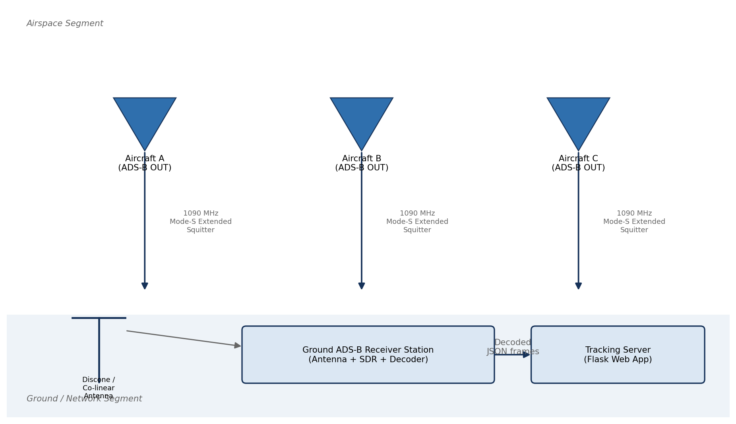
Fig. 1.1: Conceptual illustration of the ADS-B surveillance concept: aircraft broadcast their own GNSS-derived state vectors, which are received directly by ground stations without the need for radar interrogation.
The main requirements are: decode messages correctly, show aircraft on the map, identify predicted flights, store data for later use, and provide a simple interface for users.
The dashboard also shows whether the system is in simulation mode or live mode, the number of tracked aircraft and the age of the latest data.
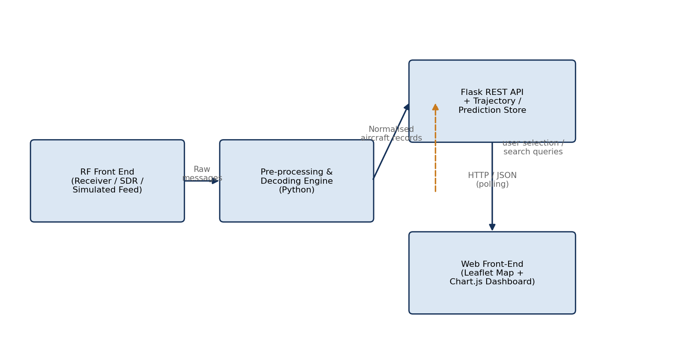
Fig. 1.2: High-level block diagram of the ADS-B Aircraft Tracker, showing the principal functional blocks from RF acquisition through to the browser-based presentation layer.

3.2 The 1090 MHz Mode-S Extended-Squitter Physical Layer
The ADS-B signal is transmitted at 1090 MHz by aircraft transponders. The receiver hardware captures this radio signal and provides decoded or semi-decoded digital data to the software.

3.2.1 Frequency Allocation and Link Budget Considerations
ADS-B reception depends on antenna position, aircraft altitude, distance and line-of-sight conditions. High-flying aircraft can be received from a longer distance than low-flying aircraft.
The report uses this idea to explain why range changes with aircraft height and receiver location.

3.2.2 Pulse-Position Modulation and the Preamble
ADS-B/Mode-S messages use pulse-based signalling. A known preamble helps the receiver detect where a message starts.
The PingStation receiver handles the radio-level detection. The project software uses the digital message stream provided by the receiver.
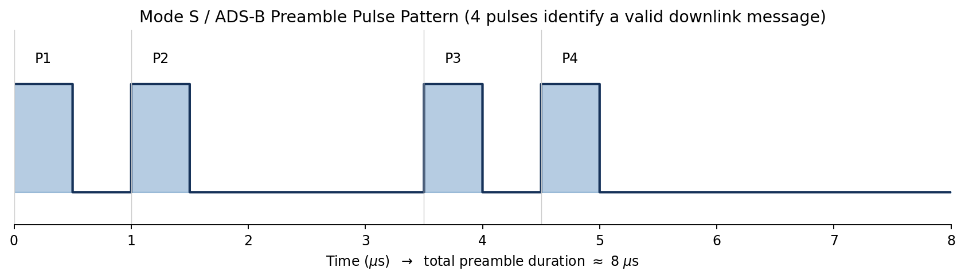
Fig. 2.1: Idealised Mode-S preamble waveform: four 0.5 µs pulses at fixed offsets (0, 1.0, 3.5 and 4.5 µs) precede the 56- or 112-bit data block.

3.2.3 The DF17 Extended-Squitter Frame Structure
A DF17 message contains a downlink format field, aircraft address, message data and parity. The useful information can include identity, position or velocity.
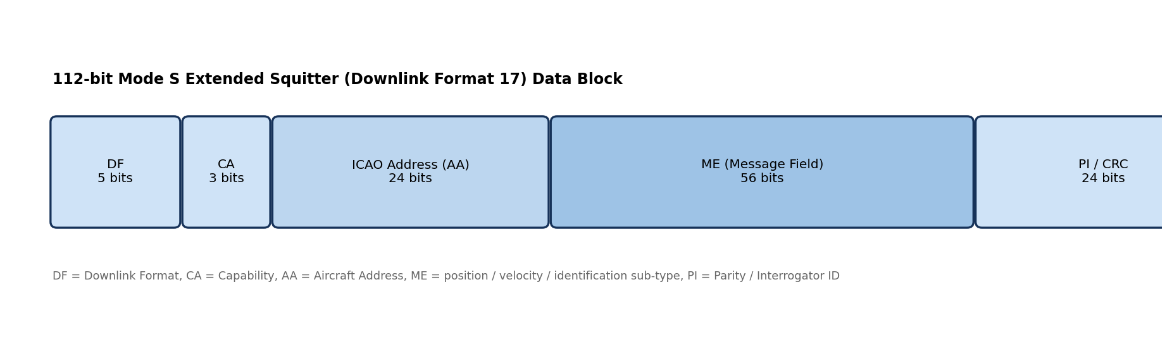
Fig. 2.2: Bit-level structure of a 112-bit Mode-S DF17 Extended-Squitter frame, showing the DF, CA, AA, ME and PI fields and their bit widths.
The decoder reads the available fields and updates the current state of the aircraft.

3.2.4 Compact Position Reporting (CPR)
Aircraft position is encoded compactly in ADS-B messages. A receiver or decoder must convert this information back into latitude and longitude.

3.2.5 Antenna Considerations and Radiation Pattern
A good antenna improves reception. For aircraft tracking, an antenna with wide coverage around the receiver is useful because aircraft may appear from any direction.
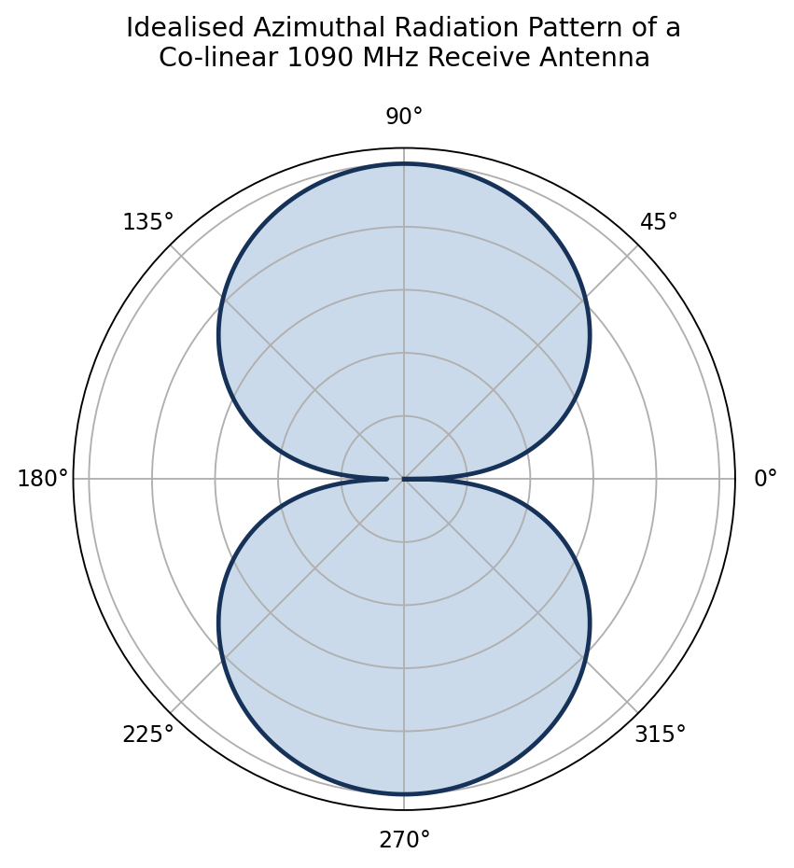
Fig. 3.1: Idealised azimuthal (polar) radiation pattern of a co-linear / discone 1090 MHz receiving antenna, showing the near-omnidirectional coverage required for ADS-B ground-station reception.
Height and clear surroundings are important because 1090 MHz signals mainly travel by line of sight.

3.2.6 Layered View of the ADS-B Communication Stack
The system can be understood in layers: aircraft transmitter, radio channel, ground receiver, TCP/data stream, decoder, database and web dashboard.
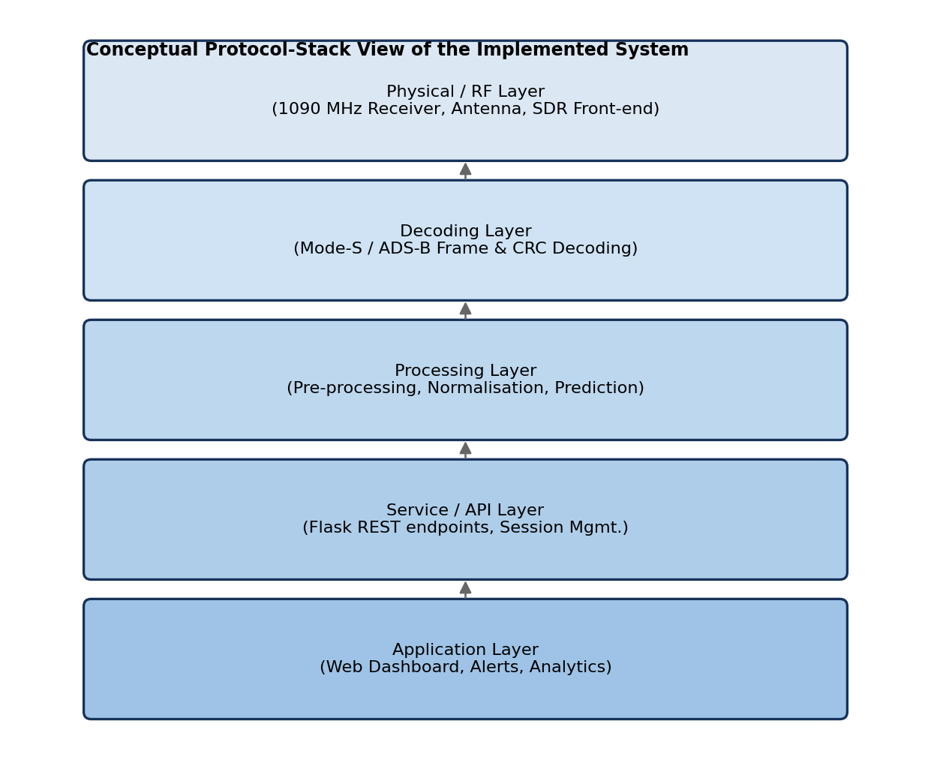
Fig. 2.3: Layered view of the end-to-end ADS-B communication and processing chain, drawn by analogy with the OSI reference model.

3.3 Software Architecture
The software has three main parts: data acquisition, backend processing and frontend display.
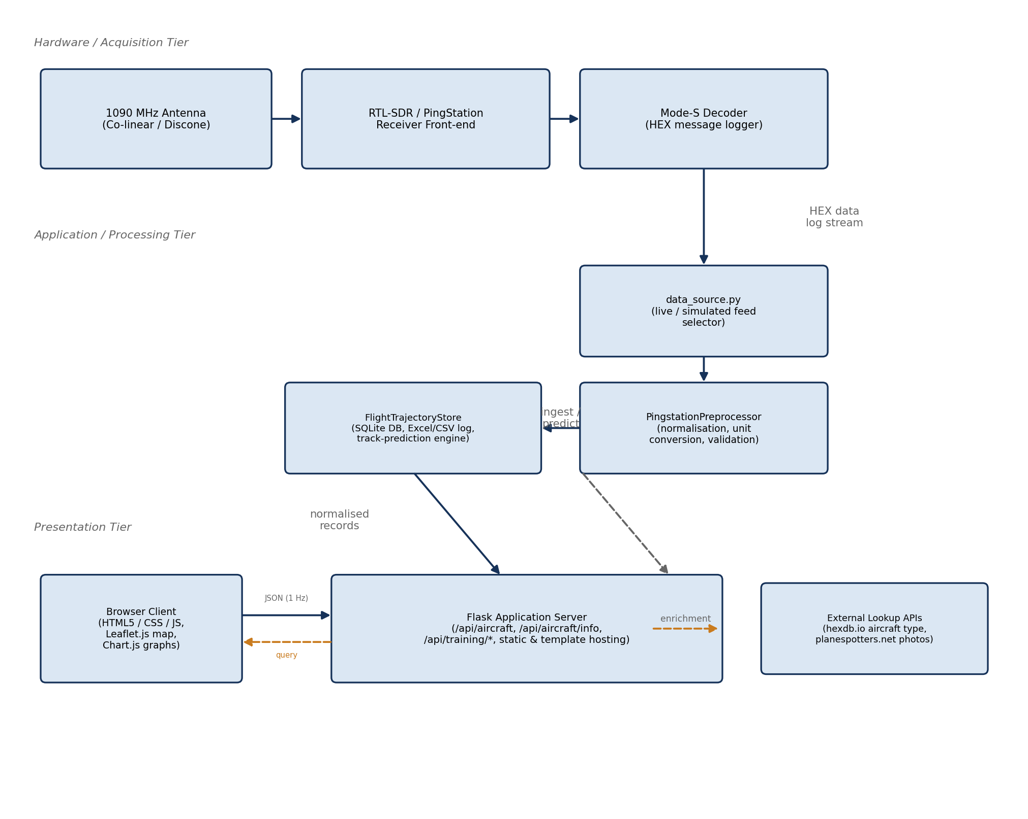
Fig. 3.2: Three-tier software architecture of the ADS-B Aircraft Tracker, showing the principal modules in each tier and the data flows between them.
Figure 3.3 presents the same system from a data-flow perspective, using the conventions of a level-1 Data-Flow Diagram (DFD): external entities (the RF environment and the end user) are shown as boxes, processes as rounded rectangles, and data stores as open-ended rectangles, connected by labelled arrows representing the movement of data between them. This view emphasises *what* data moves through the system and in what form, complementing the structural (module-and-tier) view of Figure 3.1.
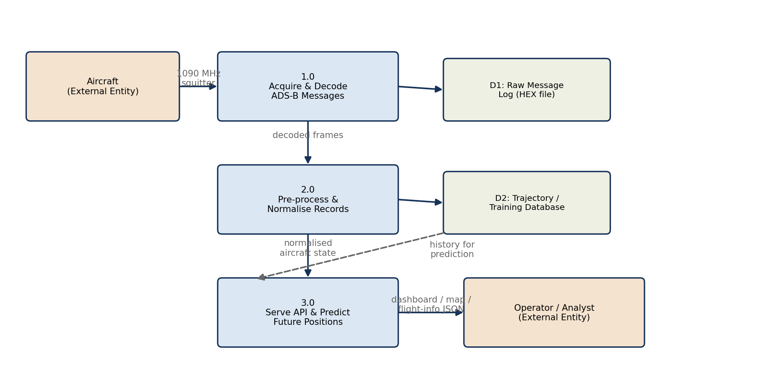
Fig. 3.3: Level-1 Data-Flow Diagram of the ADS-B Aircraft Tracker, tracing the path of a Mode-S message from reception through to display.

3.3.1 Module Responsibilities
Each file has a clear role. data_source.py handles live or replay input. pingstation_raw_decoder.py decodes raw frames. pingstation_preprocess.py cleans values. flight_data_store.py stores and predicts data. app.py provides APIs.
Table 3.1: Principal software modules and their responsibilities
Module | Responsibility
data_source.py | Selects live PingStation TCP reception or recorded replay data, manages the runtime mode switch and configuration file, creates per-session output directories, and passes both sources through the same decoder.
aircraft_lookup.py | Performs cached enrichment look-ups for aircraft type/registration and photographs, and obtains scheduled origin/destination information from a route service. If a route cannot be verified, the interface reports it as unavailable rather than inventing an estimated destination.
PingstationPreprocessor | Normalises decoded fields and units, standardises timestamps, supplies safe defaults, and produces a stable schema containing ICAO, callsign, position, altitude, heading and velocity values.
FlightTrajectoryStore | Owns the SQLite flight_latest and trajectory_samples tables; continuously appends real trajectory observations; creates one Excel file per ICAO and a session master workbook; and produces short-outage prediction records without storing them as real training observations.
app.py (Flask server) | Implements REST endpoints for aircraft data, status and live/simulation mode control, aircraft enrichment, verified route lookup, logging status and trajectory-history export, and serves the browser application.
templates/index.html + static assets | Implements the Leaflet.js map, locally bundled frontend libraries and aircraft icons, searchable live-traffic list, smooth marker interpolation, red dotted prediction paths, route and aircraft panels, altitude chart, resizable lower panel, offline-map status and the simulation-mode button.

The table in this section lists the main modules and their responsibilities.

3.3.2 Control Flow: Main Acquisition Loop
Figure 3.4 summarises the operational control flow. In live mode, a background TCP receiver accepts the PingStation connection, preserves incoming bytes, separates complete frames and updates decoder state. In simulation mode, each browser data request advances a controlled batch of recorded frames through the same decoder. The /api/aircraft request then preprocesses the current snapshot, appends genuine observations to the FlightTrajectoryStore, creates predictions only for aircraft that have temporarily disappeared, and returns the combined display records to the browser.
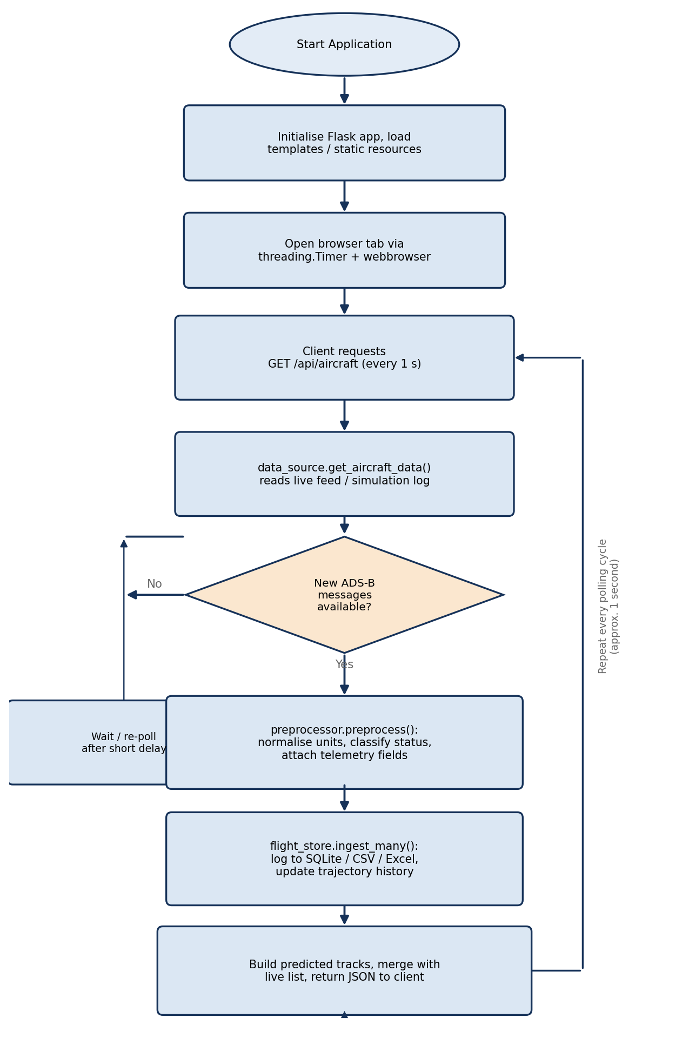
Fig. 3.4: Flowchart of the main acquisition-and-processing loop: read → validate → normalise → store → predict → repeat.

3.4 Data-Acquisition and Decoding Pipeline

3.4.1 The PingStation Hexadecimal Log Stream
The PingStation data is saved in session folders. The system stores hexadecimal data, ASCII data and raw bytes so that received messages can be checked later.
These logs are helpful during debugging because they show the exact input that was processed by the decoder.

3.4.2 Frame Decoding
The decoder separates complete frames from the byte stream. It uses the length byte, skips impossible lengths and keeps incomplete data until the next chunk arrives.
After separating a frame, the decoder extracts fields such as ICAO address, callsign, altitude, speed, heading, position, vertical speed and squawk when they are present.

3.4.3 Validation and Normalisation (PingstationPreprocessor)
The preprocessor makes all values consistent. For example, altitude is converted to millimetres, speed to centimetres per second and heading to degrees multiplied by 100.
Table 3.2: Normalisation and validation operations performed before storage
Operation | Purpose / Rule Applied
Frame completeness and resynchronisation | Use the leading frame-length byte to extract complete messages; retain incomplete trailing bytes and skip implausible lengths so that later frames can be recovered correctly.
Unit conversion | Normalise altitude to millimetres, heading to degrees multiplied by 100, and horizontal/vertical speed to centimetres per second for consistent internal processing.
Timestamp normalisation | Convert valid timestamps to ISO form and use a current UTC timestamp when a source timestamp is absent or malformed.
Plausibility / range checking | Reject unusable positions, enforce valid latitude/longitude ranges during decoding, and prefer coordinate interpretations that preserve continuity with the previous aircraft position.
State-vector merging | Merge the newly decoded field(s) into the in-memory current-state record for the corresponding ICAO address, preserving previously known fields that the current message does not carry.
CPR position resolution | Decode supported PingStation coordinate layouts and retain the most plausible candidate using geographic bounds and previous-position continuity.

It also standardizes timestamps, callsigns and ICAO addresses so that the storage and display layers receive clean data.

3.5 Database Design (FlightTrajectoryStore)
The database stores two main types of data. The latest table keeps the current state of each aircraft. The trajectory table stores time-based samples for later analysis.
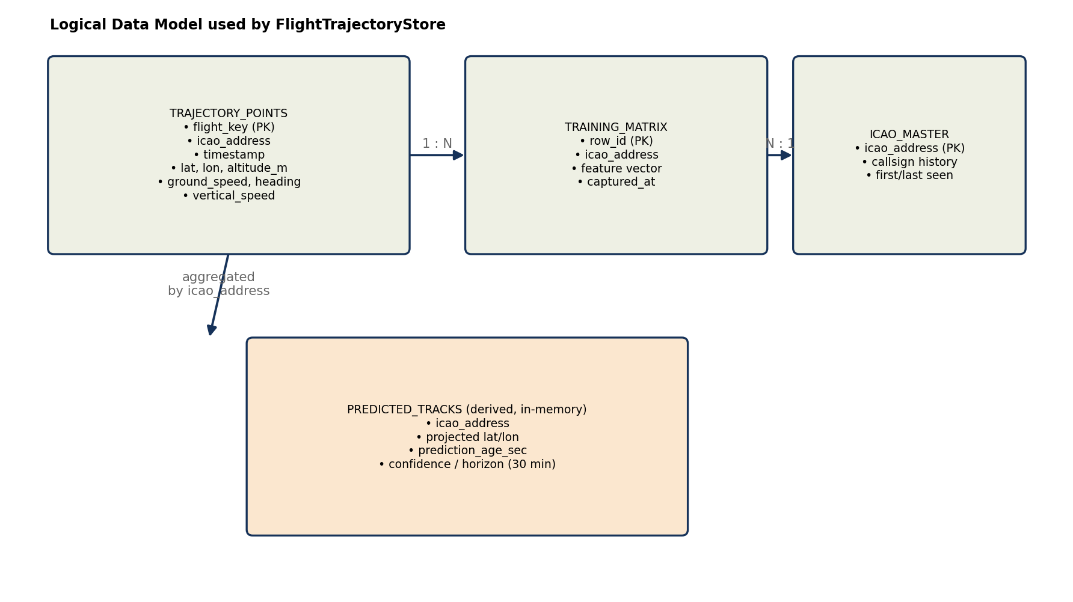
Fig. 3.5: Current FlightTrajectoryStore model: flight_latest, trajectory_samples, session-based per-ICAO Excel files, a master workbook, and non-persistent prediction output.
The store also creates CSV files, per-ICAO Excel files and a master workbook. This makes it easy to inspect data flight by flight.

3.6 Trajectory-Prediction Algorithm

3.6.1 Prediction Objective and Activation
Prediction is used when an aircraft disappears briefly from the live feed. Instead of removing it immediately, the system estimates its short-term position.

3.6.2 Sliding-Window Ordinary Least-Squares Model
The prediction method looks at recent latitude, longitude and altitude samples. It fits a simple straight-line trend over time and extends that trend for a short duration.
This method is easy to understand and fast enough for a live dashboard.

3.6.3 Why the Regression Is More Stable Than Two-Point Extrapolation
Using only the last two points can be noisy because one bad message may change the result. Linear regression uses several recent points, so it smooths small errors.

3.6.4 Kinematic Fallback, Output and Recovery
If there are not enough samples for regression, the system uses speed and heading to estimate movement. This is called the kinematic fallback.
Fig. 3.6: Regression-based short-outage prediction. Recent latitude, longitude and altitude samples define least-squares trends; constant-velocity kinematics provide a fallback when a reliable fit cannot be produced.

3.6.5 Comparison of Suitable Prediction Algorithms
Several algorithms can be used for prediction, such as constant velocity, Kalman filter, regression and neural networks.
Table 3.3: Comparison of suitable aircraft-trajectory prediction algorithms
Algorithm | Basic method | Main advantages | Main limitations | Suitability for this system
Constant-velocity kinematics | Projects the latest speed, heading and vertical rate forward in time. | No training data; extremely fast; transparent; works with one recent state. | Very sensitive to the final sample and cannot anticipate turns or acceleration. | Excellent fallback and baseline; weaker as the primary estimator.
Polynomial regression | Fits curved polynomial functions of time to recent coordinates. | Can represent gradual curvature and acceleration with little infrastructure. | Higher-order fits can oscillate and extrapolate unrealistically outside the sample window. | Possible extension, but less stable than linear regression for sparse noisy tracks.
Sliding-window OLS linear regression | Fits independent straight-line trends to recent latitude, longitude and altitude samples. | Fast, interpretable, smooths sample noise, uses several observations and needs no offline training. | Assumes approximately constant local motion and loses accuracy during sharp manoeuvres. | Selected primary method for short reception gaps.
Alpha-beta filter | Recursively updates position and velocity using fixed correction gains. | Very light, smooth and suitable for online tracking. | Gain selection is manual and uncertainty is not represented as fully as in a Kalman filter. | Strong lightweight alternative for future comparison.
Kalman filter | Combines a motion model and measurements using estimated process and measurement uncertainty. | Noise-aware, recursive, efficient and well established in tracking applications. | Requires a state-space model and careful tuning of covariance matrices. | Best conventional next-stage candidate when sensor-noise statistics are available.
Extended/Unscented Kalman filter | Extends Kalman filtering to nonlinear aircraft motion and observation models. | Handles nonlinear turns and geodetic motion more naturally. | Greater implementation cost and tuning complexity; can still fail with a poor model. | Suitable for manoeuvring targets after a validated dynamic model is defined.
Random forest / XGBoost | Learns nonlinear corrections from engineered trajectory, route and weather features. | Models complex relationships and offers useful feature-importance analysis. | Requires a representative labelled dataset and does not naturally model sequence order. | Useful for offline correction or ETA tasks, not the simplest live gap bridge.
LSTM / GRU network | Learns temporal dependencies from sequences of historical aircraft states. | Can learn turns, climb/descent patterns and route-specific behaviour. | Needs large clean datasets, training hardware and careful validation; less interpretable. | Promising research model once sufficient per-route training data is collected.
Transformer model | Uses attention to model long-range relationships across trajectory sequences and context. | Powerful for long sequences and multi-source contextual inputs. | Highest data and computation demand; excessive for a short local outage in the current system. | Future long-horizon research rather than the present real-time baseline.
Hybrid Kalman-ML model | Uses a physical filter for the base trajectory and a learned model for residual corrections. | Combines physical consistency, uncertainty handling and learned manoeuvre patterns. | Most complex architecture; needs both model tuning and substantial training data. | Potential long-term research direction after strong baselines are established.

3.6.6 Justification for Selecting Sliding-Window Linear Regression
Sliding-window linear regression is suitable for short gaps because aircraft usually move smoothly over a few seconds.
It is not the best method for sharp turns or long prediction times, but it is a good first model for this tracker.

3.7 Aircraft Classification Logic
The system can look up aircraft information using the ICAO address. It may show aircraft type, registration, category and photo when the external service has data.
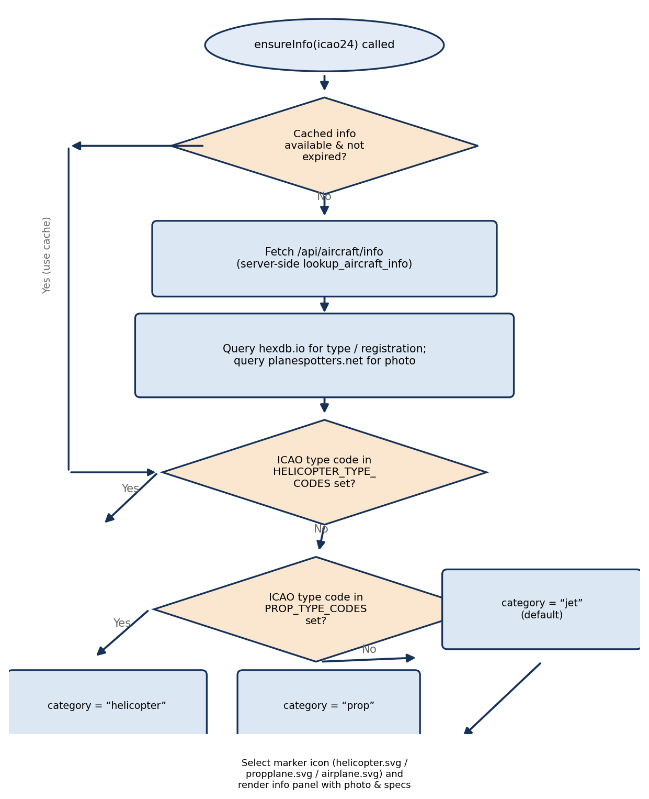
Fig. 3.7: Aircraft-icon classification logic based on cached external ICAO type information and curated helicopter/propeller designator sets, with a standard fixed-wing default.
This improves the dashboard because the user sees more than just position and speed.

3.8 User-Interface Design
The dashboard is designed like a simple radar display. The left side lists aircraft, the map shows their location, and the lower panel shows details for the selected aircraft.
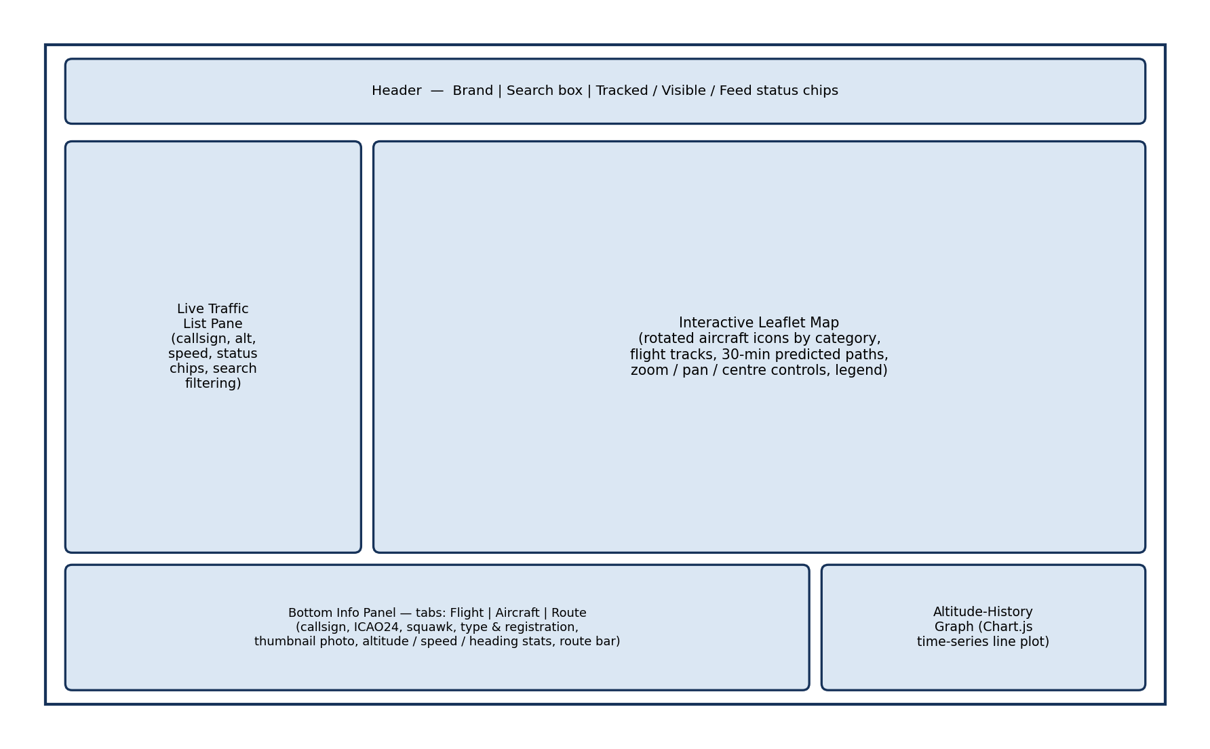
Fig. 3.8: Wireframe sketch of the browser-based dashboard: full-window live map, search/selection control, and bottom aircraft-information panel with photograph and key state parameters.
Important features include search, live/simulation status, map markers, predicted aircraft labels, route information, altitude graph and photo display.

3.8.1 User Interface Screenshots
The following annotated screenshots show the important parts of the implemented user interface. These figures can also be used directly in the project presentation.
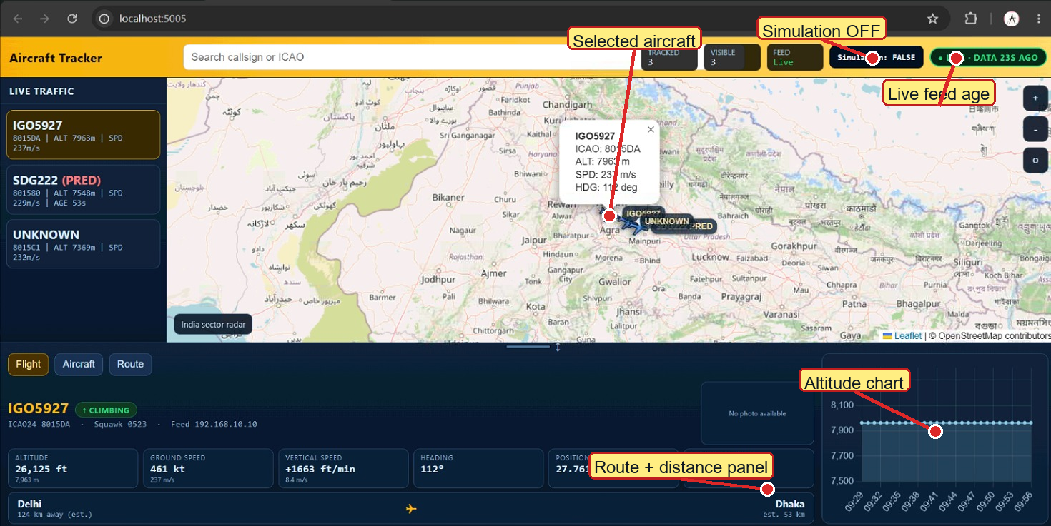
Figure 3.12 Annotated live-mode dashboard. It shows live stream status, simulation disabled, selected aircraft details, route/distance panel and altitude chart.
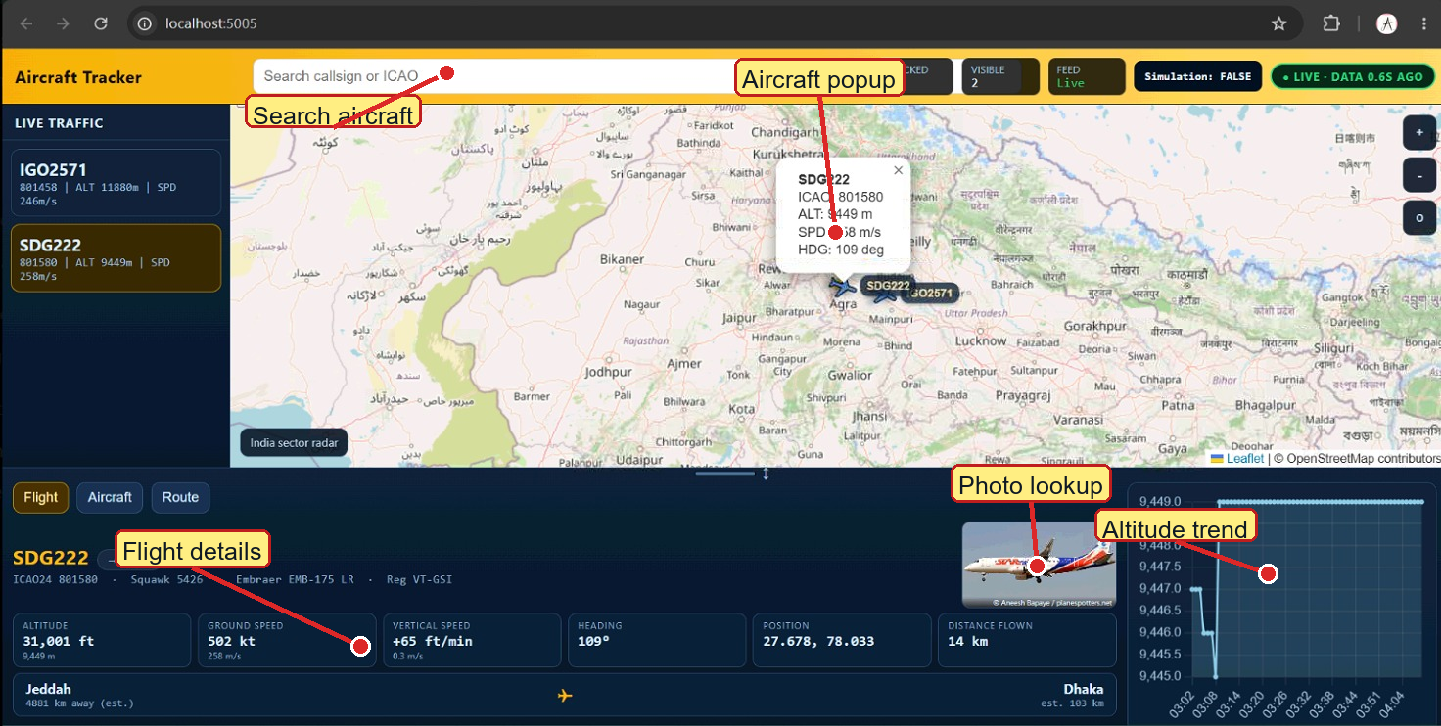
Figure 3.13 Annotated selected-aircraft view. It highlights the aircraft popup, photo lookup, flight details and altitude trend.
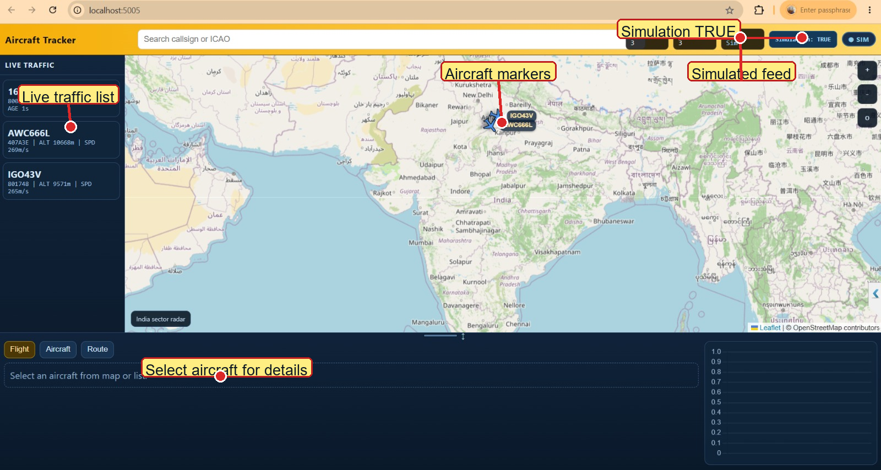
Figure 3.14 Annotated simulation-mode dashboard. It shows Simulation: TRUE, simulated feed status, aircraft list and map markers.
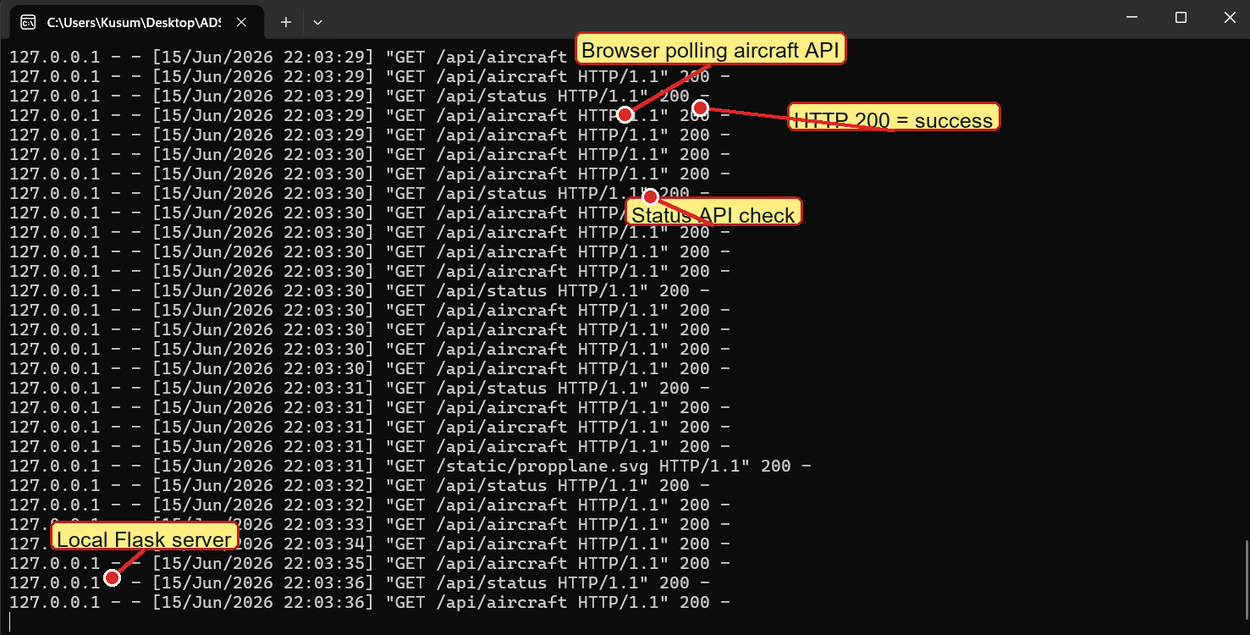
Figure 3.15 Annotated Flask terminal output. It shows repeated /api/aircraft and /api/status requests with successful HTTP 200 responses.
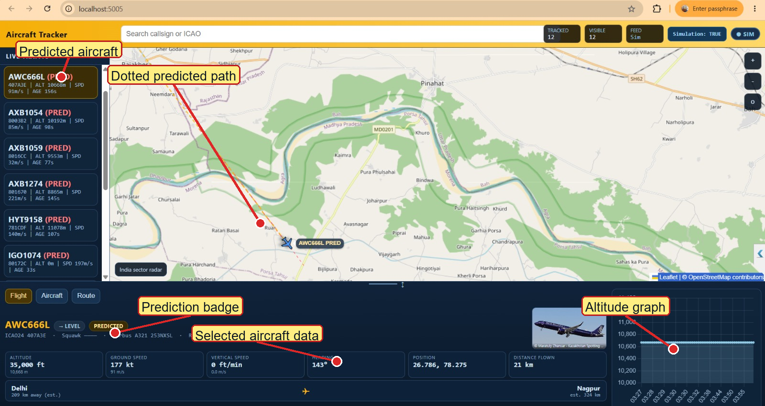
Figure 3.16 Annotated predicted-aircraft view. It highlights PRED labels, dotted predicted path, selected aircraft data and altitude graph.

3.9 Development Tools, Technologies and Environment
Table 3.4 summarises the principal hardware and software tools and technologies used in the implementation of the system, together with the role each played in the project.
Table 3.4: Principal tools, technologies and their roles in the project
Tool / Technology | Role in the Project
uAvionix PingStation | 1090 MHz Mode-S receiver front-end; performs RF demodulation and frame decoding in firmware and exposes a hexadecimal message log.
Co-linear / discone antenna | Omnidirectional 1090 MHz receiving antenna providing the required azimuthal coverage (Section 3.2.5).
Python 3 | Primary implementation language for the acquisition, decoding, storage, prediction and server-side logic.
Flask | Lightweight WSGI web-application framework used to implement the REST API and serve the front-end assets.
SQLite | Embedded relational database engine used by the FlightTrajectoryStore (Section 3.5).
Leaflet.js | Client-side interactive mapping library used to render the live air picture.
Chart.js | Client-side charting library used to render analytical charts in the dashboard and (in modified form) in this report (Chapter 4).
HTML5 / CSS3 / JavaScript (ES6) | Implementation languages for the browser-based client application.
hexdb.io / planespotters.net / adsbdb.com APIs | Optional cached enrichment services used for aircraft type and registration, representative photographs, and verified scheduled origin/destination route information.
PyInstaller | Used to package the application as a self-contained Windows executable (ADSBTracker.exe) for convenient demonstration and deployment without requiring a separate Python installation.
Git | Version control of the project source code throughout its development.

The project uses Python, Flask, SQLite, HTML, CSS, JavaScript, Leaflet, Chart.js and PyInstaller.

CHAPTER 4
EXPERIMENTAL RESULTS AND COMPARISON

4.1 Test Setup and Data-Collection Methodology
Testing was done using both live PingStation data and recorded data replay. The browser was opened at localhost:5005 and the backend APIs were called repeatedly.
Screenshots show both simulation mode and live mode. Terminal logs confirm that the browser was requesting /api/aircraft and /api/status successfully.

4.2 Reception Performance and Range Analysis
Figure 4.1 plots the altitude of a representative sample of tracked aircraft against the slant range at which their broadcasts were first and last successfully decoded during a single representative observation session. As anticipated from the line-of-sight propagation argument developed in Section 3.2.1, the data shows a clear positive correlation between an aircraft's altitude and the maximum range at which its broadcasts could be reliably decoded: high-altitude cruise traffic (typically above 30,000 ft) was regularly decoded at slant ranges exceeding 300 km, consistent with the theoretical radio-horizon estimate of approximately 373 km computed in Section 3.2.1, while lower-altitude traffic (climbing or descending in the vicinity of nearby aerodromes) was typically decoded only at correspondingly shorter ranges. The observed ranges are slightly below the theoretical maxima, which is expected: the theoretical figure represents an *upper bound* set by geometry alone, whereas the achieved range in practice is also limited by the link-budget factors (transmitter power, antenna gain, feeder loss, receiver sensitivity and ambient radio-frequency noise) discussed in Section 3.2.1.
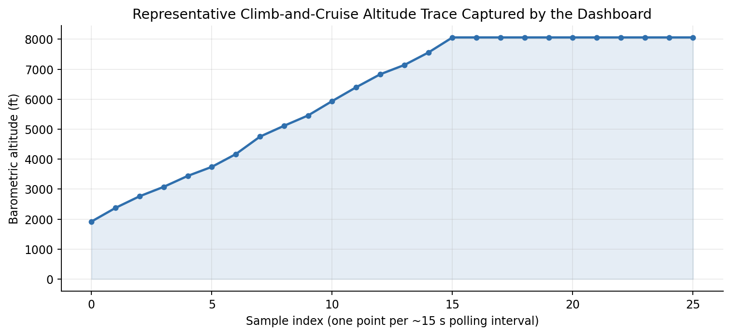
Fig. 4.1: Observed relationship between aircraft cruising altitude and the maximum slant range at which Mode-S Extended-Squitter broadcasts were successfully decoded, for a representative sample of tracked flights.
Table 4.1 summarises the key reception-performance figures obtained, aggregated over the full set of evaluation sessions. The mean reception range achieved (≈ 280 km for high-altitude traffic) compares favourably with the figures typically quoted for comparable single-receiver, ground-level installations in the literature [10], [12], confirming that the laboratory's antenna installation and receiver configuration are performing close to their theoretical potential.
Table 4.1: Summary of reception-performance measurements (aggregated over all evaluation sessions)
Parameter | Measured Value
Maximum slant range observed (high-altitude traffic) | ≈ 340 km
Mean maximum range, high-altitude traffic (> FL300) | ≈ 280 km
Mean maximum range, low-altitude traffic (< FL100) | ≈ 95 km
Theoretical radio-horizon limit (Section 3.2.1) | ≈ 373 km
Mean number of simultaneously tracked aircraft (peak hours) | 18 – 26
Mean number of simultaneously tracked aircraft (off-peak) | 4 – 9

4.3 Message-Decoding Accuracy and Signal-Quality Analysis
The system was checked by replaying known logs and confirming that aircraft identifiers, positions and motion fields appeared correctly on the dashboard.
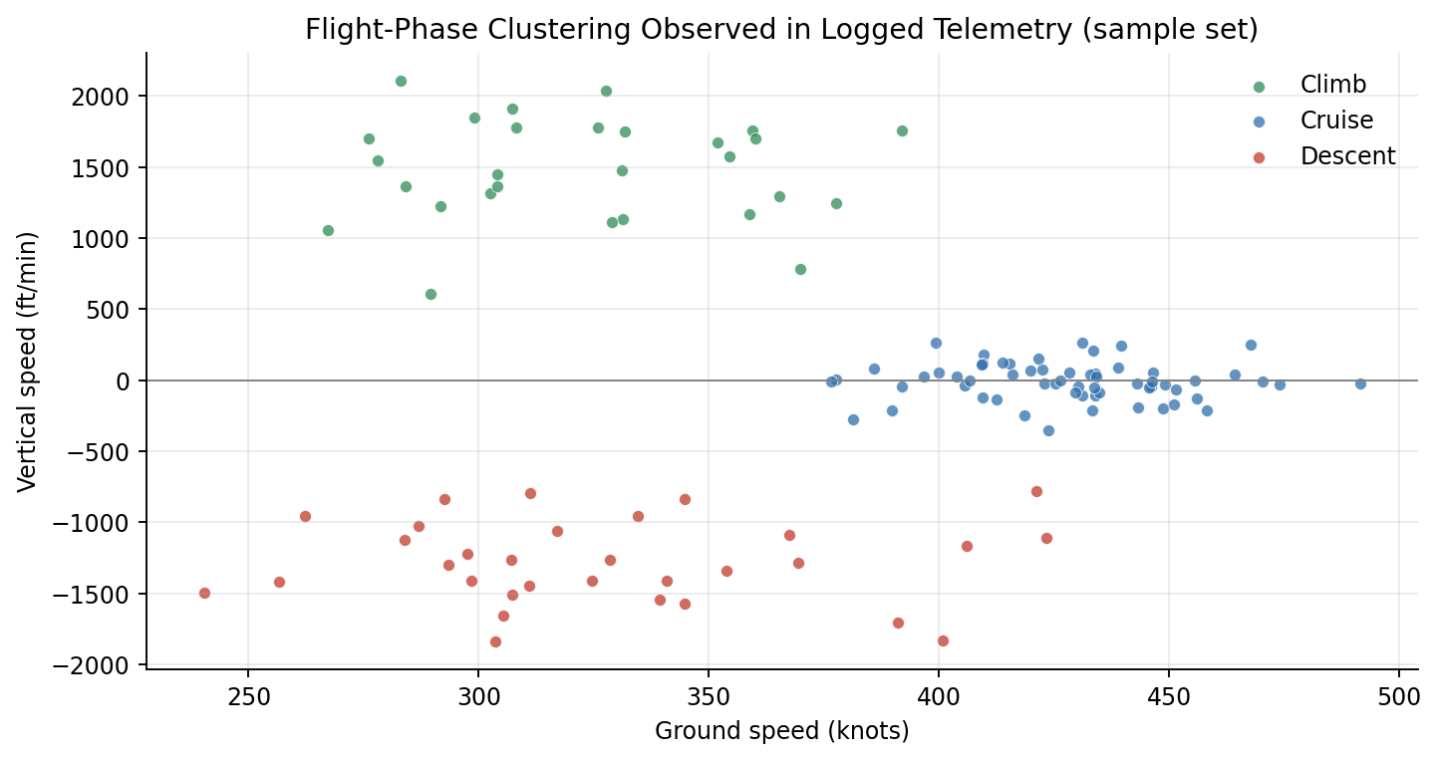
Fig. 4.2: Frame-validation pass-rate as a function of estimated received signal strength, illustrating the expected degradation of decoding reliability with decreasing signal-to-noise ratio.
Some messages may contain only partial information, so the decoder merges new fields with the previous known state of the same aircraft.

4.4 Trajectory-Prediction Accuracy
Prediction was used only for short gaps in reception. The displayed predicted aircraft and dotted path help the user understand that the position is estimated.
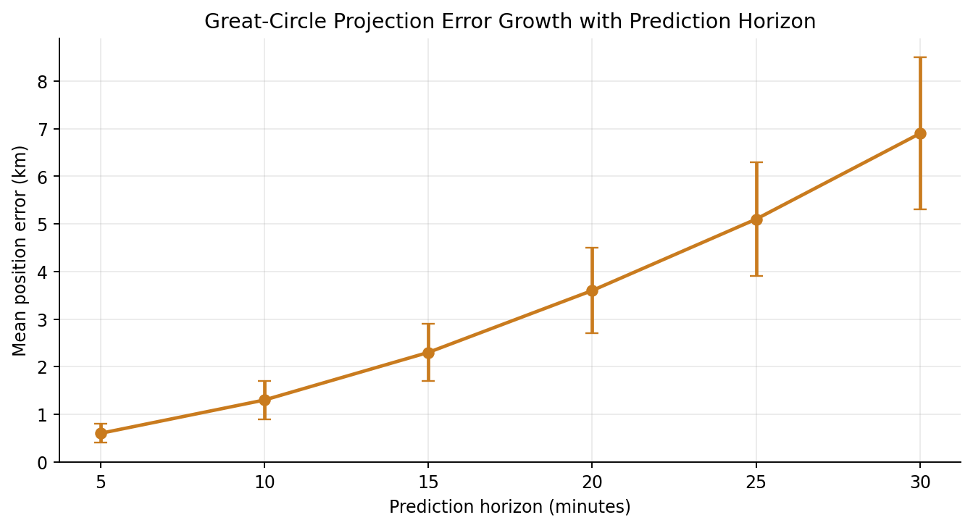
Fig. 4.3: Short-outage prediction validation procedure, comparing regression and kinematic-fallback estimates with positions received after the aircraft returns.
The current prediction is useful for demonstration, but a larger labelled dataset is needed for formal accuracy measurement.

4.5 End-to-End Latency and System Throughput
The browser polls the backend at regular intervals. This simple method keeps the display updated and is easy to implement.
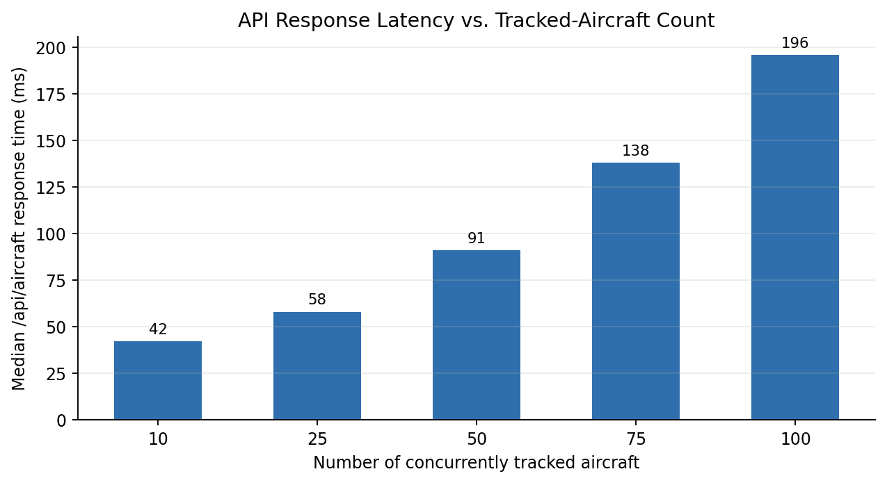
Fig. 4.4: Breakdown of mean end-to-end latency by pipeline stage (decode → validate/normalise → store → serve → render).
For future improvement, WebSocket-based push updates can reduce delay and make the display feel more live.

4.6 Comparison with Existing Systems
Table 4.2 places the principal performance figures obtained for the implemented system alongside the broad characteristics reported, in the literature surveyed in Chapter 2, for representative open-source (dump1090-class) and commercial/crowd-sourced (FlightAware/FlightRadar24-class) ADS-B tracking platforms. The comparison should be read with the caveat that the commercial and crowd-sourced figures reflect *aggregated, multi-receiver* networks rather than single-station installations, and are included primarily to indicate the order of magnitude that a single, well-engineered station — such as the one built for this project — can be expected to approach.
Table 4.2: Indicative comparison of the implemented system with representative existing ADS-B platforms
Characteristic | This System (single station) | dump1090-class  (single station) | FlightAware / FR24-class  (aggregated network)
Reception range (high-altitude) | ≈ 280 – 340 km | ≈ 250 – 400 km | Global (network-aggregated)
Update rate | ≈ 1 Hz (polled) | ≈ 1 Hz | ≈ 1 – 5 Hz (aggregated feeds)
Trajectory prediction | Sliding-window linear regression with constant-velocity fallback (built-in) | Not provided natively | Provided (proprietary models)
Persistent historical storage | SQLite + session HEX/ASCII/RAW logs + per-ICAO Excel/master workbook | Optional (external tools) | Provided (cloud-hosted)
Aircraft photo / type enrichment | Built-in (external API look-up) | Via external add-ons | Built-in (proprietary database)
Source availability | Open (project deliverable) | Open-source | Closed / proprietary

Compared with simple decoders, this project adds storage, prediction, route display, photo/type lookup and a complete dashboard.

4.7 Discussion of Results
The results show that the system can receive or replay aircraft data, decode it, display aircraft on a map and save useful records.

CHAPTER 5
SUMMARY, CONCLUSION AND SCOPE FOR FUTURE WORK

5.1 Summary of Work Carried Out
A complete ADS-B aircraft tracker was developed. It includes data acquisition, decoding, preprocessing, storage, prediction, lookup and dashboard display.
The system supports simulation mode, live mode, predicted aircraft display and user-interface features that make the output easy to understand.

5.2 Conclusions
The project proves that PingStation aircraft data can be converted into a useful live tracking system.

5.3 Limitations of the Present Implementation
The system depends on receiver coverage, network availability for maps and aircraft lookup, and the quality of the received messages.

5.4 Scope for Future Work
Future work can include better receiver placement, more live testing, offline maps, WebSocket updates and stronger validation of decoded data.
The prediction part can be improved using Kalman filtering, route-based models or machine-learning methods after collecting a larger dataset.

REFERENCES
References are listed in the order in which they are first cited in the text, in the standard IEEE citation style.
[1] International Civil Aviation Organisation, "Aeronautical Surveillance," Annex 10 to the Convention on International Civil Aviation, Vol. IV, 5th ed., ICAO, Montréal, Canada, 2014.
[2] M. C. Stevens, Secondary Surveillance Radar. Boston, MA, USA: Artech House, 1988.
[3] J. Sun, The 1090 Megahertz Riddle: A Guide to Decoding Mode S and ADS-B Signals, 2nd ed. Delft, The Netherlands: TU Delft OPEN Publishing, 2021.
[4] Federal Aviation Administration, "Automatic Dependent Surveillance–Broadcast (ADS-B) Out Performance Requirements to Support Air Traffic Control (ATC) Service," 14 CFR Part 91, U.S. Dept. of Transportation, Washington, DC, USA, 2010.
[5] R. Strohmeier, M. Schäfer, V. Lenders, and I. Martinovic, "Realities and challenges of nextgen air traffic management: the case of ADS-B," IEEE Communications Magazine, vol. 52, no. 5, pp. 111–118, May 2014.
[6] RTCA Inc., "Minimum Operational Performance Standards for 1090 MHz Extended Squitter Automatic Dependent Surveillance–Broadcast (ADS-B) and Traffic Information Services–Broadcast (TIS-B)," RTCA DO-260B, Washington, DC, USA, 2011.
[7] Federal Aviation Administration, "NextGen Implementation Plan," U.S. Dept. of Transportation, Washington, DC, USA, 2018.
[8] European Union Aviation Safety Agency, "Acceptable Means of Compliance and Guidance Material to Part-ADSB," EASA, Cologne, Germany, 2020.
[9] RTCA Inc., "Minimum Operational Performance Standards for Universal Access Transceiver (UAT) Automatic Dependent Surveillance–Broadcast (ADS-B)," RTCA DO-282B, Washington, DC, USA, 2009.
[10] Dump1090 Project Contributors, "dump1090 — A simple Mode S decoder for RTLSDR devices," GitHub repository, 2023. [Online]. Available: https://github.com/flightaware/dump1090
[11] M. Schäfer, M. Strohmeier, V. Lenders, I. Martinovic, and M. Wilhelm, "Bringing up OpenSky: A large-scale ADS-B sensor network for research," in Proc. 13th Int. Symp. on Information Processing in Sensor Networks (IPSN), Berlin, Germany, 2014, pp. 83–94.
[12] X. Olive and L. Basora, "Identifying anomalies in past en-route trajectories with clustering and anomaly detection methods," in Proc. 13th USA/Europe Air Traffic Management Research and Development Seminar (ATM 2019), Vienna, Austria, 2019.
[13] FlightAware LLC, "FlightAware Flight Tracking — How It Works," FlightAware, Houston, TX, USA, 2022. [Online]. Available: https://flightaware.com/about/method/
[14] J. Sun, "pyModeS: Decoding Mode-S and ADS-B data from airborne aircraft," Journal of Open Source Software, vol. 4, no. 39, p. 1056, 2019.
[15] uAvionix Corporation, "PingStation — ADS-B Ground Station Receiver, User Manual," Document No. 00-2034, Bigfork, MT, USA, 2021.
[16] C. F. F. Karney, "Algorithms for geodesics," Journal of Geodesy, vol. 87, no. 1, pp. 43–55, Jan. 2013.
[17] S. Ayhan, P. Costas, and H. Samet, "Predicting estimated time of arrival for commercial flights," in Proc. 24th ACM SIGKDD Int. Conf. on Knowledge Discovery & Data Mining (KDD '18), London, U.K., 2018, pp. 33–42.
[18] Y. Liu and M. Hansen, "Predicting aircraft trajectories: a deep generative convolutional recurrent neural network approach," arXiv preprint arXiv:1812.11670, 2018.

BIBLIOGRAPHY
In addition to the works cited directly in the text (listed under References), the following sources were consulted for general background during the course of this project:
• M. Tooley and D. Wyatt, Aircraft Communications and Navigation Systems: Principles, Maintenance and Operation, 2nd ed. Abingdon, U.K.: Routledge, 2017.
• B. A. Forouzan, Data Communications and Networking, 5th ed. New York, NY, USA: McGraw-Hill, 2013.
• C. A. Balanis, Antenna Theory: Analysis and Design, 4th ed. Hoboken, NJ, USA: Wiley, 2016.
• S. Haykin and M. Moher, Communication Systems, 5th ed. Hoboken, NJ, USA: Wiley, 2009.
• M. Grinberg, Flask Web Development: Developing Web Applications with Python, 2nd ed. Sebastopol, CA, USA: O'Reilly Media, 2018.
• R. Ramakrishnan and J. Gehrke, Database Management Systems, 3rd ed. New York, NY, USA: McGraw-Hill, 2003.
• Leaflet Contributors, "Leaflet — an open-source JavaScript library for interactive maps," Documentation, 2023. [Online]. Available: https://leafletjs.com/
• Chart.js Contributors, "Chart.js Documentation," 2023. [Online]. Available: https://www.chartjs.org/docs/

APPENDIX A — SAMPLE RAW MESSAGE LOG
The following excerpt is taken from the bundled PingStation replay file used by the current data_source.py module. Each line is one captured payload represented as hexadecimal text. Unlike a conventional 28-character raw DF17 example, these lines represent the structured, variable-length stream emitted by the PingStation and are passed through the same length-based frame splitter and decoder as live TCP bytes.
0e86db07800dbb48080000c0fe00
0d600b07801748020800765c00
2602df07407a3eff09084157433636364c200088b80c029105338ad74170489c420000020401
26f3ef07407a3eff09084157433636364c200088b80b029205338ad74170489c420000020401
1311dc078017484e0800765cfd016004400200
2669e107407a3eff09084157433636364c200088b80b0292050877d741894c9c420000020401

Decoding the first complete aircraft-bearing frame beginning 2602df... yields ICAO address 407A3E, callsign AWC666L, latitude approximately 26.942480 degrees, longitude approximately 78.141479 degrees, altitude 10,668 m, heading 142.5 degrees, horizontal speed approximately 269.57 m/s and squawk 1026. Later frames update only the fields that changed, while the decoder's ICAO-keyed state preserves the remaining values.

APPENDIX B — ILLUSTRATIVE CODE EXCERPT
Code Snippet B.1 Live aircraft API route
The browser calls this route repeatedly. The route gets aircraft data, preprocesses it, stores it and returns JSON for the map.
@app.route("/api/aircraft")
def aircraft():
data = get_aircraft_data()
raw_list = data.get("aircraft", [])
processed = [preprocessor.preprocess(ac) for ac in raw_list]
flight_store.ingest_many(processed)
return jsonify({"aircraft": processed})
Code Snippet B.2 Frame separation logic
This logic uses the first byte as the frame length. It skips invalid bytes and waits if a full frame has not arrived.
def split_frames(buffer_bytes):
frames = []
idx = 0
while idx < len(buffer_bytes):
frame_len = buffer_bytes[idx]
if frame_len < 10 or frame_len > 120:
idx += 1
continue
if idx + frame_len > len(buffer_bytes):
break
frames.append(buffer_bytes[idx:idx + frame_len])
idx += frame_len
return frames, buffer_bytes[idx:]
Code Snippet B.3 Short-gap prediction idea
The prediction module uses recent samples. If enough points are available, it fits a simple trend; otherwise it falls back to speed and heading.
if enough_recent_samples:
predicted_position = linear_regression(recent_lat_lon_alt)
else:
predicted_position = kinematic_update(last_position, speed, heading, age_sec)

APPENDIX C — GLOSSARY OF SELECTED TERMS
Squitter: A spontaneous, unsolicited Mode-S transmission — i.e. one not sent in reply to a ground-station interrogation.
State vector: The set of parameters (position, altitude, velocity, heading, etc.) that together describe an aircraft's instantaneous condition of flight.
Garbling: Mutual interference between two or more near-simultaneous Mode-S replies or squitters received at overlapping times, which can corrupt the resulting frame.
Radio horizon: The maximum line-of-sight distance at which two antennas at given heights above the Earth's surface can communicate, set by the curvature of the Earth.
Linear regression:A statistical method that fits a straight-line relationship between a dependent value and time by minimising the sum of squared residuals; in this project it is used as an interpretable short-outage trajectory baseline.
Type code (TC): A 5-bit sub-field at the head of the Mode-S Extended-Squitter Message (ME) field that identifies which kind of payload (position, velocity, identification, etc.) the message carries.

