PROJECT REPORT
ON
AIRCRAFT TRACKING AND TRAJECTORY PREDICTION

A PROJECT REPORT
to be submitted by

AVANI SHARMA 2216508
Under the supervision of

MR. AJEET GAUR, SCIENTIST ‘F’
ADRDE- DRDO

For the award of the degree
of
B. TECH
ELECTRONICS AND COMMUNICATION


DEPARTMENT OF PHYSICAL SCIENCES
BANASTHALI VIDYAPITH
BANASTHALI - 304022
JUNE-2026

ACKNOWLEDGEMENT
I take this opportunity to express my sincere gratitude to all those who have contributed, directly or indirectly, to the successful completion of this project work.
I am deeply indebted to my project guide, MR. AJEET GAUR, ADRDE, for their invaluable guidance, constant encouragement, constructive criticism and the considerable amount of time they devoted throughout the course of this project. Their insightful suggestions on both the radio-frequency front-end and the software architecture were instrumental in shaping this work into its present form.
I would also like to thank the Head of the Department and all the faculty members of the Department of Physical Sciences for providing the laboratory facilities, the SDR hardware, and the encouraging academic environment that made this project possible.
I am grateful to my family and friends for their unconditional support, patience and motivation during the period of this work. Finally, I thank the open-source community in particular the maintainers of the dump1090, pyModeS, Flask and Leaflet.js projects whose documentation and tools were of great help while building this system.

AVANI SHARMA
2216508

ABSTRACT
Automatic Dependent Surveillance-Broadcast (ADS-B) is a cooperative surveillance technology that has become a key component of modern air-traffic management. Suitably equipped aircraft periodically broadcast their International Civil Aviation Organisation (ICAO) 24-bit address, callsign, position, altitude, ground speed, heading and vertical rate. This project, "Design and Implementation of a Real-Time Aircraft Tracking and Trajectory Prediction System", presents an end-to-end platform that receives the structured binary stream supplied by a uAvionix PingStation, separates it into complete frames, decodes and normalises aircraft records, stores continuous per-aircraft trajectory histories, predicts short communication gaps using sliding-window linear regression with a deterministic kinematic fallback, and presents the live air picture through a Flask and Leaflet.js browser interface.
The work spans both electronics/communication and computer-science aspects. The report examines the 1090 MHz Mode-S Extended-Squitter physical layer, including Pulse-Position Modulation, the preamble, frame structure and radio-propagation considerations, while recognising that the PingStation performs RF demodulation and exposes a higher-level length-prefixed stream to the software. The implemented software is divided into acquisition, decoding, preprocessing, storage/prediction and presentation layers. Live hardware and recorded simulation data pass through the same decoder, while session-specific HEX, ASCII, exact-stream and intermediate decoded logs support repeatable testing and diagnosis.
The system has been exercised with both live PingStation reception and replay of recorded PingStation data. Functional testing verified dynamic ICAO detection, continuous SQLite and per-aircraft Excel logging, automatic creation of a master workbook, one-second dashboard updates, live/simulation switching, short-outage trajectory prediction and resumption of actual tracking when reception returns. Prediction is deliberately limited to a configurable short horizon (180 seconds by default), because extrapolation uncertainty grows rapidly during turns and speed changes. The current predictor is an interpretable machine-learning baseline rather than a trained deep-neural model; Kalman filtering and recurrent sequence models remain appropriate subjects for future comparative research.

TABLE OF CONTENTS
ACKNOWLEDGEMENT ii
ABSTRACT iii
TABLE OF CONTENTS v
CERTIFICATE ix
LIST OF FIGURES x
LIST OF TABLES xii
LIST OF ABBREVIATIONS xiii
CHAPTER 1 1
1.1 General 1
1.2 Motivation 2
1.3 Objectives of the Project 3
1.4 Scope of the Project 4
1.5 Organisation of the Report 5
CHAPTER 2 6
2.1 Evolution of Aircraft Surveillance Technology 6
2.2 ADS-B Standards and the Regulatory Landscape 7
2.3 Existing Open-Source and Commercial ADS-B Platforms 8
2.4 Approaches to Flight-Trajectory Prediction 9
2.5 Summary and Identification of the Research Gap 10
CHAPTER 3 11
3.1 System Overview and Requirements Analysis 11
3.2 The 1090 MHz Mode-S Extended-Squitter Physical Layer 14
3.2.1 Frequency Allocation and Link Budget Considerations 14
3.2.2 Pulse-Position Modulation and the Preamble 15
3.2.3 The DF17 Extended-Squitter Frame Structure 15
3.2.4 Compact Position Reporting (CPR) 16
3.2.5 Antenna Considerations and Radiation Pattern 17
3.2.6 Layered View of the ADS-B Communication Stack 18
3.3 Software Architecture 19
3.3.1 Module Responsibilities 22
3.3.2 Control Flow: Main Acquisition Loop 23
3.4 Data-Acquisition and Decoding Pipeline 25
3.4.1 The PingStation Hexadecimal Log Stream 25
3.4.2 Frame Decoding 26
3.4.3 Validation and Normalisation (PingstationPreprocessor) 26
3.5 Database Design (FlightTrajectoryStore) 27
3.6 Trajectory-Prediction Algorithm 29
3.6.1 Prediction Objective and Activation 29
3.6.2 Sliding-Window Ordinary Least-Squares Model 29
3.6.3 Why the Regression Is More Stable Than Two-Point Extrapolation 30
3.6.4 Kinematic Fallback, Output and Recovery 30
3.6.5 Comparison of Suitable Prediction Algorithms 31
3.6.6 Justification for Selecting Sliding-Window Linear Regression 32
3.7 Aircraft Classification Logic 33
3.8 User-Interface Design 34
3.8.1 User Interface Screenshots 36
3.9 Development Tools, Technologies and Environment 38
CHAPTER 4 40
4.1 Test Setup and Data-Collection Methodology 40
4.2 Reception Performance and Range Analysis 40
4.3 Message-Decoding Accuracy and Signal-Quality Analysis 42
4.4 Trajectory-Prediction Accuracy 43
4.5 End-to-End Latency and System Throughput 44
4.6 Comparison with Existing Systems 45
4.7 Discussion of Results 46
CHAPTER 5 48
5.1 Summary of Work Carried Out 48
5.2 Conclusions 49
5.3 Limitations of the Present Implementation 49
5.4 Scope for Future Work 50
REFERENCES 51
BIBLIOGRAPHY 54
APPENDIX A — SAMPLE RAW MESSAGE LOG 55
APPENDIX B — ILLUSTRATIVE CODE EXCERPT 56
APPENDIX C — GLOSSARY OF SELECTED TERMS 57

Note: This Table of Contents is generated using a Word TOC field bound to the document's heading styles. On opening the document in Microsoft Word, right-click anywhere inside the field and choose “Update Field” (or press Ctrl+A then F9) to populate it with the correct section titles and page numbers.

CERTIFICATE


This is to certify that the synopsis entitled “Aircraft Tracking and Trajectory Prediction” has been prepared by Avani Sharma, a student of B. Tech 8th Sem Electronics and Communication, Urja Mandir, Banasthali Vidyapith, in partial fulfillment of the requirements for the internship/project.
The work proposed in this synopsis will be carried out at ADRDE, DRDO- Agra under proper guidance and supervision.
We approve the synopsis for further development.

Date: 17 June 2026 Place: Agra


Name of the Project Guide
Mr. Ajeet Gaur, Scientist ‘F’, ADRDE

LIST OF FIGURES
Figure No. | Title / Caption
Fig. 1.1 | System Flow Diagram
Fig. 3.1 | Conceptual illustration of the ADS-B surveillance concept: aircraft broadcast their own GNSS-derived state vectors, which are received directly by ground stations without the need for radar interrogation.
Fig. 3.2 | High-level block diagram of the ADS-B Aircraft Tracker, showing the principal functional blocks from RF acquisition through to the browser-based presentation layer.
Fig. 3.3 | Idealised Mode-S preamble waveform: four 0.5 µs pulses at fixed offsets (0, 1.0, 3.5 and 4.5 µs) precede the 56- or 112-bit data block.
Fig. 3.4 | Bit-level structure of a 112-bit Mode-S DF17 Extended-Squitter frame, showing the DF, CA, AA, ME and PI fields and their bit widths.
Fig. 3.5 | Idealised azimuthal (polar) radiation pattern of a co-linear / discone 1090 MHz receiving antenna, showing the near-omnidirectional coverage required for ADS-B ground-station reception.
Fig. 3.6 | Layered view of the end-to-end ADS-B communication and processing chain, drawn by analogy with the OSI reference model.
Fig. 3.7 | Three-tier software architecture of the ADS-B Aircraft Tracker, showing the principal modules in each tier and the data flows between them.
Fig. 3.8 | Level-1 Data-Flow Diagram of the ADS-B Aircraft Tracker, tracing the path of a Mode-S message from reception through to display.
Fig. 3.9 | Flowchart of the main acquisition-and-processing loop: read → validate → normalise → store → predict → repeat.
Fig. 3.10 | Current FlightTrajectoryStore model: flight_latest, trajectory_samples, session-based per-ICAO Excel files, a master workbook, and non-persistent prediction output.
Fig. 3.11 | Regression-based short-outage prediction. Recent latitude, longitude and altitude samples define least-squares trends; constant-velocity kinematics provide a fallback when a reliable fit cannot be produced.
Fig. 3.12 | Aircraft-icon classification logic based on cached external ICAO type information and curated helicopter/propeller designator sets, with a standard fixed-wing default.
Fig. 3.13 | Wireframe sketch of the browser-based dashboard: full-window live map, search/selection control, and bottom aircraft-information panel with photograph and key state parameters.
Fig. 3.14 | Annotated live-mode dashboard. It shows live stream status, simulation disabled, selected aircraft details, route/distance panel and altitude chart.
Fig. 3.15 | Annotated selected-aircraft view. It highlights the aircraft popup, photo lookup, flight details and altitude trend.
Fig. 3.16 | Annotated simulation-mode dashboard. It shows Simulation: TRUE, simulated feed status, aircraft list and map markers.
Fig. 3.17 | Annotated Flask terminal output. It shows repeated /api/aircraft and /api/status requests with successful HTTP 200 responses.
Fig. 3.18 | Annotated predicted-aircraft view. It highlights PRED labels, dotted predicted path, selected aircraft data and altitude graph.
Fig. 4.1 | Observed relationship between aircraft cruising altitude and the maximum slant range at which Mode-S Extended-Squitter broadcasts were successfully decoded, for a representative sample of tracked flights.
Fig. 4.2 | Frame-validation pass-rate as a function of estimated received signal strength, illustrating the expected degradation of decoding reliability with decreasing signal-to-noise ratio.
Fig. 4.3 | Short-outage prediction validation procedure, comparing regression and kinematic-fallback estimates with positions received after the aircraft returns.
Fig. 4.4 | Breakdown of mean end-to-end latency by pipeline stage (decode → validate/normalise → store → serve → render).

LIST OF TABLES
Table No. | Title / Caption
Table 3.1 | Principal software modules and their responsibilities
Table 3.2 | Normalisation and validation operations performed before storage
Table 3.3 | Comparison of suitable aircraft-trajectory prediction algorithms
Table 3.4 | Principal tools, technologies and their roles in the project
Table 4.1 | Summary of reception-performance measurements (aggregated over all evaluation sessions)
Table 4.2 | Indicative comparison of the implemented system with representative existing ADS-B platforms

LIST OF ABBREVIATIONS
The following abbreviations and acronyms, listed in alphabetical order, are used throughout this report:
Abbreviation | Expansion
ADS-B | Automatic Dependent Surveillance – Broadcast
AIS | Automatic Identification System (maritime analogue of ADS-B)
ANSP | Air Navigation Service Provider
API | Application Programming Interface
ASTERIX | All Purpose Structured EUROCONTROL Surveillance Information Exchange
ATC | Air Traffic Control
CPR | Compact Position Reporting
CRC | Cyclic Redundancy Check
CSV | Comma-Separated Values
DB | Database
DF | Downlink Format
DF17 | Downlink Format 17
DFD | Data-Flow Diagram
DO-260B | RTCA Minimum Operational Performance Standard for ADS-B (Rev. B)
EASA | European Union Aviation Safety Agency
FAA | Federal Aviation Administration (USA)
FPS | Frames Per Second
GNSS | Global Navigation Satellite System
GPS | Global Positioning System
GPU | Graphics Processing Unit
GRU | Gated Recurrent Unit
GUI | Graphical User Interface
HTML | HyperText Markup Language
HTTP | HyperText Transfer Protocol
Hz | Hertz
ICAO | International Civil Aviation Organisation
IEEE | Institute of Electrical and Electronics Engineers
JSON | JavaScript Object Notation
kHz | kilo-Hertz
LOS | Line of Sight
LSTM | Long Short-Term Memory
ME | Message field (Mode-S Extended Squitter payload)
MHz | Mega-Hertz
ML | Machine Learning
NM | Nautical Mile
OSI | Open Systems Interconnection
PI | Parity/Interrogator Identifier field in a Mode-S message
PPM | Pulse Position Modulation
PRED | Predicted aircraft marker used in the dashboard
PSR | Primary Surveillance Radar
REST | Representational State Transfer
RF | Radio Frequency
RSSI | Received Signal Strength Indicator
RTL-SDR | RTL2832U-based Software-Defined Radio receiver
SDR | Software-Defined Radio
SQL | Structured Query Language
SQLite | Self-contained, serverless SQL database engine
SSR | Secondary Surveillance Radar
TCAS | Traffic Collision Avoidance System
TCP | Transmission Control Protocol
TIS-B | Traffic Information Service – Broadcast
UAT | Universal Access Transceiver (978 MHz ADS-B link)
UI | User Interface
UTC | Coordinated Universal Time
VHF | Very High Frequency

CHAPTER 1
INTRODUCTION

1.1 General
In a normal aircraft tracking workflow, the receiver first captures the aircraft broadcast, the software interprets the received message, and the final information is shown to the user. This project follows the same idea on a smaller scale so that each stage can be understood clearly.
The word surveillance in this project does not mean only drawing an aircraft icon on a map. It also includes identifying the aircraft, storing its movement over time, checking whether the feed is live or simulated, and presenting useful details such as route, speed, heading and altitude history.
The use of ADS-B makes the project practical for a laboratory environment because aircraft data can be received from real traffic without needing access to airport radar systems. This makes the project suitable for Electronics and Communication students who want to connect radio systems with real-time software.
Air traffic surveillance means continuously observing aircraft so that their identity, position and movement are known. This is important for safe air traffic control, route monitoring, airport operations and aviation research.
Earlier aircraft surveillance mainly depended on radar. Primary radar detects reflections from an aircraft body, while secondary radar receives replies from an aircraft transponder. These systems are useful, but they require large ground infrastructure and may update the aircraft position only after a fixed scan interval.
Automatic Dependent Surveillance-Broadcast, or ADS-B, is a modern method in which the aircraft broadcasts its own information. The aircraft uses onboard navigation sources to determine its position and then transmits details such as ICAO address, callsign, latitude, longitude, altitude, speed and heading.
A ground receiver such as PingStation can receive ADS-B information and provide it to a computer system. The received data is not directly useful to a normal user until it is decoded, cleaned, stored and displayed in an understandable form.
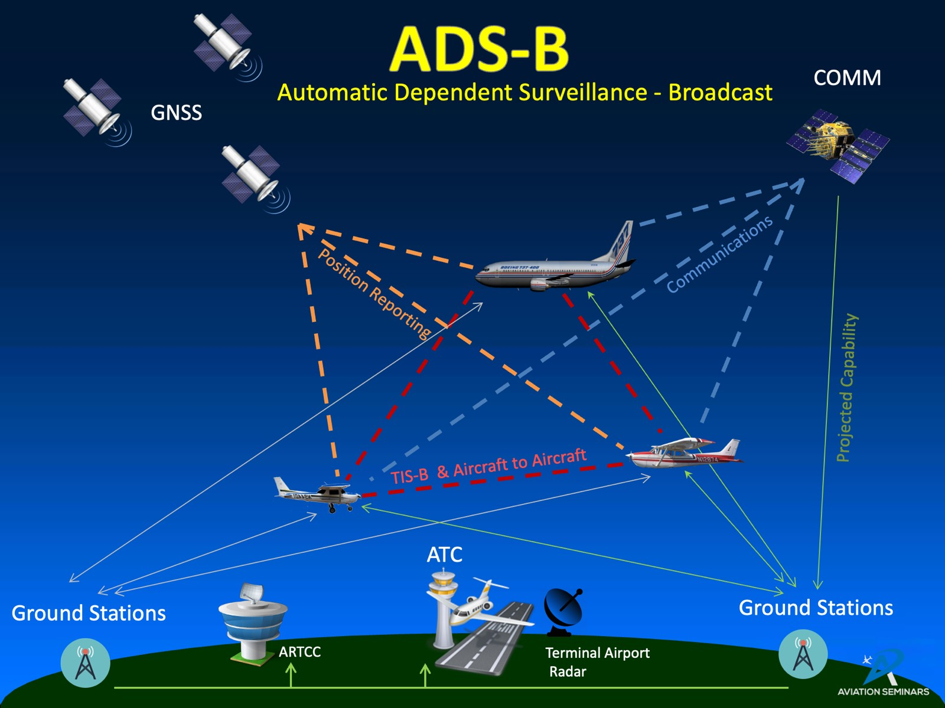
Fig. 1.1: System Flow Diagram
This project builds an aircraft tracking system around PingStation data. The system receives live or recorded aircraft data, decodes useful flight parameters, stores them in database and file formats, and displays aircraft movement on a web-based map.
The project is also connected to Electronics and Communication Engineering because it involves radio reception, digital communication, message framing, telemetry decoding, computer networking and real-time data visualization.

1.2 Motivation
Another important motivation was the need for a system that could work even when live data was not available. The simulation mode allows recorded PingStation data to be replayed, so the project can still be demonstrated in a classroom, viva or presentation without depending completely on live aircraft traffic.
The project also gives practical experience with debugging real data. Unlike fixed textbook examples, received aircraft messages may be incomplete, repeated or temporarily missing. Handling such cases makes the project closer to real engineering work.
The dashboard gives immediate visual feedback. If the decoder, database or API is not working properly, the map and aircraft list make the problem visible. This feedback helped in testing and improving the system step by step.
The motivation for this project comes from the practical value of ADS-B data. Aircraft in the surrounding airspace continuously broadcast real information, and this data can be used to build a working surveillance and learning system.
Raw PingStation or ADS-B data is difficult to understand directly because it may appear as hexadecimal messages, partial fields or continuous network data. A proper software pipeline is required to convert that raw data into meaningful aircraft information.
The project was also selected because it combines classroom concepts with a real application. It uses communication-system ideas such as signal reception, data framing and decoding, and also uses software concepts such as APIs, databases, prediction and user-interface design.
The output is easy to demonstrate because aircraft can be seen moving on the map with callsign, altitude, speed, route and prediction information. This makes the project useful for presentations, laboratory demonstrations and future academic work.
Instead of simply using an existing aircraft tracking platform, this project implements the important internal blocks. This helps in understanding how the data travels from receiver output to decoded records, stored trajectory samples and final visual display.

1.3 Objectives of the Project
A further objective is to keep the system modular. Each major task, such as data sourcing, decoding, preprocessing, storage, prediction and visualization, is handled by a separate part of the program. This makes the project easier to test and extend.
The project also aims to preserve diagnostic data. Raw logs, hexadecimal logs and ASCII logs are useful for checking what was actually received from the stream. This is important when the displayed result needs to be verified later.
Another objective is to make the project useful for both technical and non-technical viewers. The backend contains the detailed processing, while the dashboard explains the result visually through labels, route panels, graphs and status indicators.
The main objective of the project is to develop a live aircraft tracking system using ADS-B/PingStation data.
The system should support both live stream mode and simulation mode. Live mode receives data from the PingStation stream, while simulation mode replays already recorded data for testing and demonstration.
Another objective is to decode aircraft messages and extract important flight parameters such as ICAO address, callsign, position, altitude, speed, heading, vertical speed, squawk and timestamp.
The project aims to preprocess the extracted values so that units and formats remain consistent. This makes the same data usable for display, database storage, Excel logging and future analysis.
The system should store the latest aircraft state as well as historical trajectory samples. SQLite, CSV files and ICAO-wise Excel files are used so that the data can be checked and reused later.
The user interface should show aircraft on an interactive map, provide search and selection options, display aircraft details, show route information, plot altitude trends and mark predicted aircraft clearly.
The project also aims to include short-gap trajectory prediction. When an aircraft temporarily disappears from the feed, the system estimates its position for a short time and marks it as predicted.
Finally, the project aims to package the application as a Windows executable so that it can be opened more easily during demonstrations.

1.4 Scope of the Project
The scope includes a local single-receiver tracking system. It is designed to run on a computer connected to the receiver or to replay logs from the same project folder. The system is therefore suitable for demonstration and development work.
The project includes basic prediction only for short data gaps. The predicted positions are shown to maintain continuity on the map, but they are clearly marked so that the user knows the aircraft is not currently being received as a fresh live update.
The scope also includes data export and record keeping. This is useful because a tracking system becomes more valuable when the displayed information can also be saved and studied later.
The scope of the project starts from the digital data received from the PingStation receiver and ends at the dashboard display and stored output files.
The project includes data acquisition, frame separation, message decoding, preprocessing, latest-state storage, trajectory-history storage, aircraft lookup, route display, prediction and user-interface design.
It also includes diagnostic logging. The system can store raw bytes, hexadecimal data, ASCII data, SQLite records, CSV exports and Excel workbooks for later verification.
The project does not design the aircraft transmitter, ADS-B transponder or PingStation hardware. It uses the available receiver output and focuses on software processing and visualization.
The current system is suitable for educational use, demonstrations and small-scale local tracking. It is not intended to replace certified air traffic control systems or safety-critical aviation equipment.
Future improvements may include better receiver placement, more live testing, stronger prediction models, multi-receiver support and offline map support.

1.5 Organisation of the Report
The report first builds the background needed to understand ADS-B, then moves toward the implementation details. This order helps the reader understand why each software block is needed.
The later chapters focus on results, limitations and future improvement. These sections show what the system can do at present and what can be improved if more time, data or hardware is available.
Chapter 1 introduces the project, its motivation, objectives and scope.
Chapter 2 explains the background of aircraft surveillance, ADS-B standards, existing tracking platforms and trajectory-prediction methods.
Chapter 3 describes the work carried out, including system architecture, decoding pipeline, database design, prediction algorithm, aircraft classification and user-interface design.
Chapter 4 presents the testing approach, observed results, comparison with existing systems and discussion of performance.
Chapter 5 gives the summary, conclusions, limitations and future scope. The appendices include sample logs, selected code snippets, glossary terms and user-interface screenshots.

CHAPTER 2
LITERATURE REVIEW

2.1 Evolution of Aircraft Surveillance Technology
Primary radar was a major advancement because it could detect an aircraft by reflected radio energy. However, it gives limited information unless it is combined with other systems. It generally shows that a target exists, but not always who the aircraft is or what flight details it is broadcasting.
Secondary radar improved the situation by using the aircraft transponder. The aircraft replies to the ground station with coded data, so the ground system can identify the aircraft more easily. This shows how communication between aircraft and ground equipment became a key part of surveillance.
ADS-B changes the approach further by allowing the aircraft to broadcast information regularly. This reduces dependence on rotating radar scans and allows many receivers to hear the same message. Such a system is useful for distributed tracking, research networks and low-cost local receivers.
For a student project, this evolution is important because it shows that aircraft tracking is not only a software problem. It is a complete communication chain that includes radio transmission, receiver hardware, digital messages, decoding and display.
Aircraft surveillance has developed in several stages. The earliest widely used method was Primary Surveillance Radar (PSR), where a ground radar sends radio pulses and detects the reflected signal from an aircraft.
PSR is useful because it can detect aircraft without depending on cooperation from the aircraft. However, it cannot directly provide aircraft identity or detailed flight data, and its accuracy depends on radar range, antenna rotation and environmental conditions.
Secondary Surveillance Radar (SSR) improved this by using an aircraft transponder. The ground station sends an interrogation, and the aircraft replies with coded information such as identity and altitude. Mode A, Mode C and later Mode S are part of this development.
Mode S introduced selective addressing, where each aircraft has a unique 24-bit ICAO address. This reduced confusion between replies from multiple aircraft and allowed more structured data exchange.
ADS-B is a further development in which the aircraft broadcasts its own position and movement data without waiting for interrogation. This allows faster updates and makes aircraft tracking possible with smaller receivers such as PingStation.
For this project, ADS-B is useful because it provides real aircraft telemetry that can be decoded, stored and displayed using a local software system.

2.2 ADS-B Standards and the Regulatory Landscape
Mode-S Extended Squitter messages are structured so that receivers can identify the type of information carried in each message. Some messages carry identity, some carry position, and some carry velocity. A tracker must therefore combine multiple messages to build a complete aircraft state.
The 24-bit ICAO address is an important part of this process. It acts like a unique aircraft identifier in the received data, allowing the software to update the correct aircraft record each time a new message arrives.
The standards also define performance expectations for aircraft equipment. This is important because surveillance data is used in aviation operations, where reliability and interoperability matter.
Although this project is not a certified aviation system, understanding the standards helps explain why the received message fields have a fixed structure and why the same receiver can observe aircraft from different airlines and regions.
ADS-B commonly uses the 1090 MHz Mode-S Extended Squitter link. The word squitter means that the aircraft sends the message automatically, without a direct request from the ground station.
A typical ADS-B message contains the aircraft address and a message field that may carry identity, position, altitude or velocity information. Different messages may contain different parts of the aircraft state, so the software has to combine updates over time.
Standards are important because aircraft, receivers and ground systems may be manufactured by different organizations. Common standards make sure that the transmitted message can be understood by different compatible systems.
International and national aviation authorities define the rules for ADS-B operation, message format, performance and equipment requirements. These rules help maintain safe and interoperable surveillance across different airspaces.
From an Electronics and Communication point of view, ADS-B is an example of a real digital communication system. It includes carrier frequency, modulation, message framing, error checking, addressing and receiver processing.
In this project, the receiver hardware provides the message stream, and the software focuses on interpreting that stream and using it for tracking and analysis.

2.3 Existing Open-Source and Commercial ADS-B Platforms
Open-source platforms are useful for learning because their code and behavior can be inspected. They show how ADS-B messages are received and decoded, and many of them can output aircraft data in JSON or other formats.
Commercial systems usually provide a more polished user experience. They combine data from thousands of receivers, clean the data, add flight information and show global coverage. However, the user normally sees only the final result, not the complete processing pipeline.
The proposed system stands between these two categories. It is not as large as a commercial network, but it includes more than a basic decoder. It adds local storage, prediction, route information, screenshots for presentation and a dashboard designed around the project requirements.
This makes the project valuable academically because the internal logic is visible. A reader can understand how the receiver output becomes a live map, rather than treating the tracker as a black box.
Several existing platforms already use ADS-B data. Open-source decoders such as dump1090 and readsb can receive and decode ADS-B messages when used with suitable radio hardware.
These open-source tools are powerful because they expose decoded aircraft data and can be modified by developers. They are often used by hobbyists, researchers and aviation-data networks.
Commercial and crowd-sourced platforms such as FlightAware and FlightRadar24 collect data from many receivers and show aircraft on large global maps. These platforms provide polished displays and wide coverage, but their internal processing is not fully visible to the user.
The present project is smaller than these global systems, but it has an educational advantage. The complete local pipeline is visible: input stream, decoding, preprocessing, database storage, prediction and web display.
This makes the project suitable for understanding how an aircraft tracking system works internally rather than only viewing the final map output.

2.4 Approaches to Flight-Trajectory Prediction
Prediction is especially useful in a live display because received data may not arrive at perfectly regular intervals. A short delay in the feed can make the marker appear frozen or disappear, even though the aircraft is still moving in reality.
A constant-velocity method is easy to implement because it uses the latest speed and heading. However, if the last heading is noisy or if the aircraft is turning, the predicted point may quickly move away from the real path.
Linear regression reduces this problem by using several recent samples. It does not try to model complex aircraft behaviour, but it gives a smooth trend for a short time. This is appropriate for the present project because the prediction is only used for short outages.
Kalman filters are commonly used in tracking systems because they can combine measurements with a motion model. They are a good future improvement, but they require careful tuning of noise values and state variables.
Machine-learning methods may perform better when large historical datasets are available. At the current stage, the project has limited local data, so a simple and explainable method is more suitable than a large trained model.
Flight-trajectory prediction means estimating the future position of an aircraft using its recent movement. This is useful when the live feed has a short gap or when the system wants to show the likely direction of travel.
The simplest method is constant-velocity prediction. It uses the latest position, speed and heading to project where the aircraft may be after a short time. This method is fast but can be affected by one noisy sample.
Another approach is linear regression. It uses several recent position samples and fits a simple trend over time. This can reduce the effect of small errors and gives a smoother short-term prediction.
More advanced methods include Kalman filters, Extended Kalman filters and machine-learning models such as LSTM or GRU networks. These can handle noise or complex motion better, but they require more data, tuning and validation.
For this project, sliding-window linear regression was selected as the main method because it is simple, explainable and fast enough for real-time display. A constant-velocity method is kept as a fallback when enough samples are not available.
This choice matches the educational aim of the project: the algorithm should work for short gaps and should also be easy to understand and explain in the report and presentation.

2.5 Summary and Identification of the Research Gap
The review shows that there is a need for an educational system that is more detailed than a simple map, but still easier to understand than a large commercial aircraft tracking network.
This project addresses that need by keeping every stage available for explanation. The user can see the live or simulated feed, the decoded aircraft, the stored records, the predicted path and the dashboard output.
The project also focuses on practical implementation. It does not stop at theory; it connects the ADS-B communication concept to actual code, logs, database records and user-interface screenshots.
Because of this, the project can be used as a base for future work such as better prediction, multi-receiver comparison, receiver range testing or data-quality analysis.
The literature and existing systems show that ADS-B tracking is already well established. However, many systems either focus only on decoding messages or provide a final polished display without explaining the internal processing steps.
For student learning, it is useful to build a system where every stage is visible. This includes live or replay input, raw logging, frame decoding, field normalization, storage, prediction and dashboard display.
The research gap addressed by this project is the need for a compact and understandable local ADS-B tracking system that combines Electronics and Communication concepts with practical software implementation.
The project also adds features that are useful for demonstration, such as simulation/live switching, predicted aircraft labels, route display, altitude graph, aircraft photo/type lookup and Excel/SQLite logging.
Thus, the project is not only a map display. It is a complete learning-oriented pipeline that shows how received aircraft data can be converted into useful, stored and visual information.

CHAPTER 3
WORK CARRIED OUT

3.1 System Overview and Requirements Analysis
The complete system can be viewed as a pipeline. Data enters the system from a PingStation live stream or from recorded files. The backend processes this data and the frontend displays it to the user.
The first requirement is reliable input handling. In live mode, the system must listen to a stream and process messages as they arrive. In simulation mode, it must replay saved data in a controlled way so testing remains repeatable.
The second requirement is correct decoding. The software must separate frames, reject unusable data and extract fields only when they are available. This is important because not every received message contains every aircraft parameter.
The third requirement is clear presentation. A user should be able to understand which aircraft are live, which are predicted, what route or direction they are following and whether the feed is running in simulation or live mode.
The fourth requirement is storage. A tracker that only displays current aircraft is useful for monitoring, but a tracker that also stores data is useful for analysis, reporting and future model development.
The fifth requirement is usability. The dashboard should not require the user to inspect logs manually. Status chips, aircraft lists, map markers and selected-aircraft panels make the output understandable quickly.
The implemented system satisfies these requirements through separate modules for data input, decoding, preprocessing, database storage, prediction, aircraft lookup and dashboard display.
The system takes aircraft data from PingStation in either live mode or simulation mode. In live mode, it receives a TCP stream. In simulation mode, it replays previously recorded data.
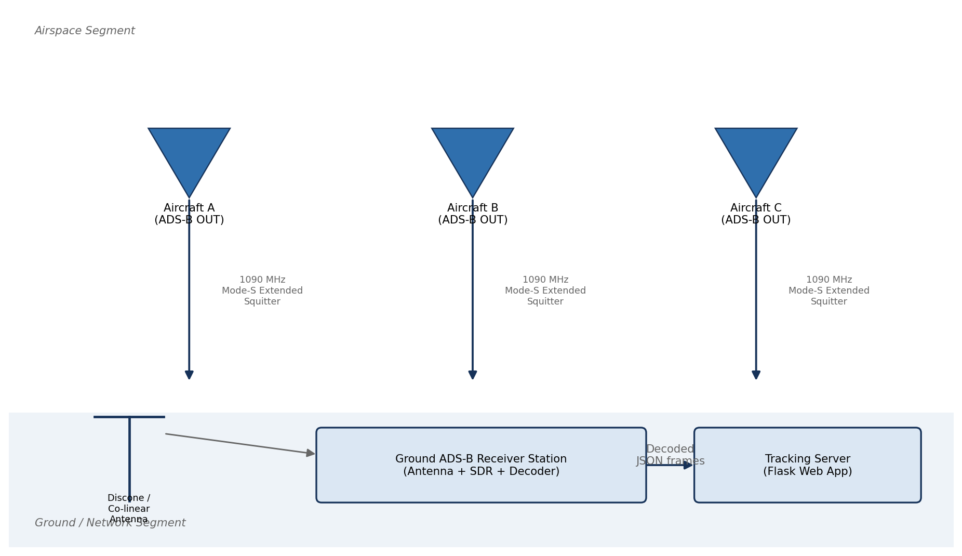
Fig. 3.1: Conceptual illustration of the ADS-B surveillance concept: aircraft broadcast their own GNSS-derived state vectors, which are received directly by ground stations without the need for radar interrogation.
The main requirements are: decode messages correctly, show aircraft on the map, identify predicted flights, store data for later use, and provide a simple interface for users.
The dashboard also shows whether the system is in simulation mode or live mode, the number of tracked aircraft and the age of the latest data.
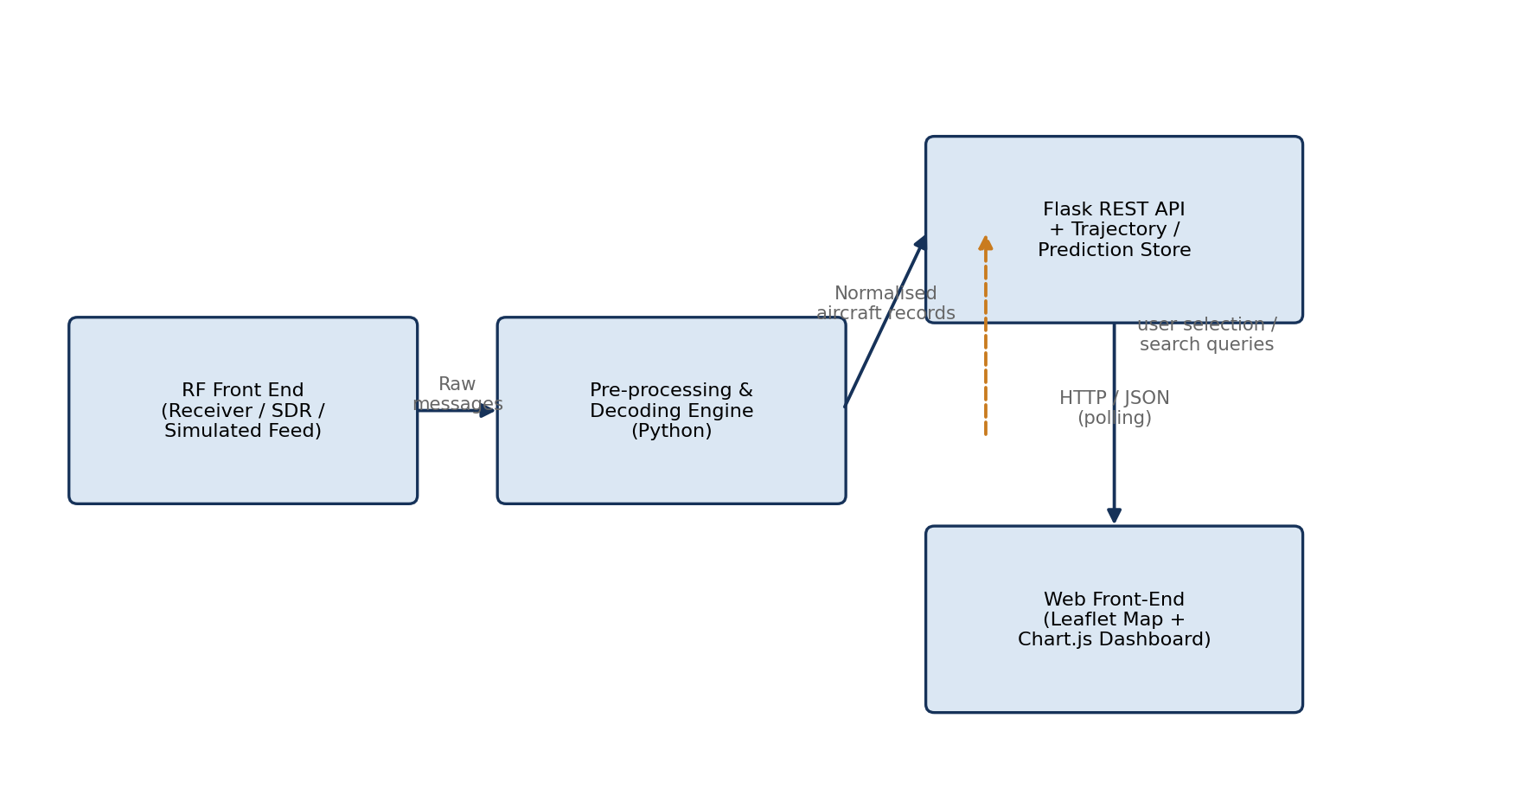
Fig. 3.2: High-level block diagram of the ADS-B Aircraft Tracker, showing the principal functional blocks from RF acquisition through to the browser-based presentation layer.

3.2 The 1090 MHz Mode-S Extended-Squitter Physical Layer
The physical layer is the part of the system where aircraft information is carried through radio waves. ADS-B Out on 1090 MHz is widely used because many commercial aircraft already carry Mode-S transponders.
The aircraft transmitter sends short digital messages at regular intervals. The receiver must detect these signals, recover the message bits and provide the decoded or semi-decoded output to the computer.
In this project, the PingStation receiver handles the low-level radio reception. The software therefore starts from the receiver's output stream, but the report still discusses the physical layer because it explains why range, antenna placement and message quality matter.
The ADS-B signal is transmitted at 1090 MHz by aircraft transponders. The receiver hardware captures this radio signal and provides decoded or semi-decoded digital data to the software.

3.2.1 Frequency Allocation and Link Budget Considerations
The 1090 MHz frequency lies in the L-band region. Signals at this frequency usually travel in a line-of-sight manner, which means that obstacles, terrain and antenna height can strongly affect reception.
Aircraft at high altitude are easier to receive from a long distance because the line of sight between the aircraft and receiver is less likely to be blocked. Low-altitude aircraft disappear sooner because the Earth, buildings or terrain can block the path.
A simple link-budget view includes transmitter power, antenna gain, path loss, receiver sensitivity and cable loss. The project does not measure all of these values separately, but it uses the concept to explain differences in observed reception range.
In practical terms, placing the receiver antenna higher and away from obstructions can improve the number of received aircraft and the continuity of the data stream.
ADS-B reception depends on antenna position, aircraft altitude, distance and line-of-sight conditions. High-flying aircraft can be received from a longer distance than low-flying aircraft.
The report uses this idea to explain why range changes with aircraft height and receiver location.

3.2.2 Pulse-Position Modulation and the Preamble
ADS-B/Mode-S messages use short pulses. The preamble is a known pulse pattern placed at the beginning of a message so that the receiver can detect that a valid message is starting.
After detecting the preamble, the receiver reads the following bits using the expected timing pattern. This timing-based structure is why accurate radio reception and clock recovery are important at the hardware level.
The software in this project does not demodulate raw radio samples. However, understanding the preamble and pulse structure helps explain why the receiver output may sometimes miss or corrupt messages when the signal is weak.
When the received signal is poor, the software may receive fewer valid frames. Therefore, the later software stages must be able to handle missing updates gracefully.
ADS-B/Mode-S messages use pulse-based signalling. A known preamble helps the receiver detect where a message starts.
The PingStation receiver handles the radio-level detection. The project software uses the digital message stream provided by the receiver.
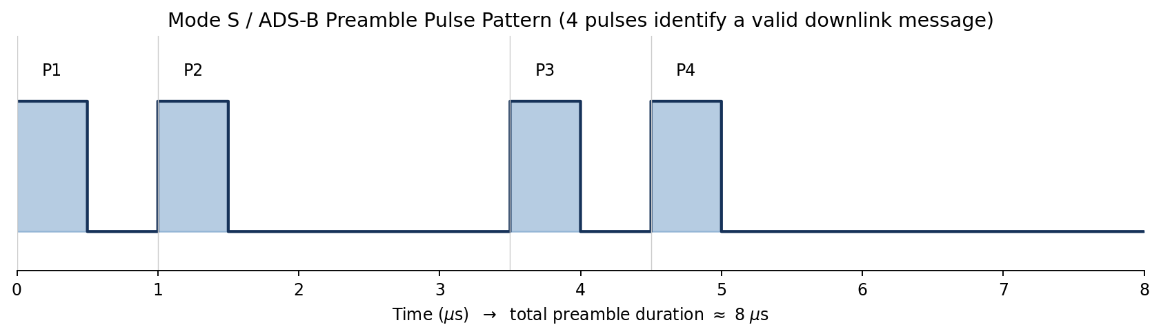
Fig. 3.3: Idealised Mode-S preamble waveform: four 0.5 µs pulses at fixed offsets (0, 1.0, 3.5 and 4.5 µs) precede the 56- or 112-bit data block.

3.2.3 The DF17 Extended-Squitter Frame Structure
DF17 is one of the important message formats used for ADS-B. It includes fields that identify the message type, aircraft address, message content and parity information.
The aircraft address allows the system to connect multiple messages to the same aircraft. This is necessary because one message may contain identity while another message may contain position or velocity.
The message content is interpreted according to type codes. For example, one type of message may provide callsign, while another may provide airborne position or velocity.
The project decoder focuses on recovering the aircraft state from the PingStation output. It stores the best available current values and updates them whenever a new message contains better or newer information.
A DF17 message contains a downlink format field, aircraft address, message data and parity. The useful information can include identity, position or velocity.
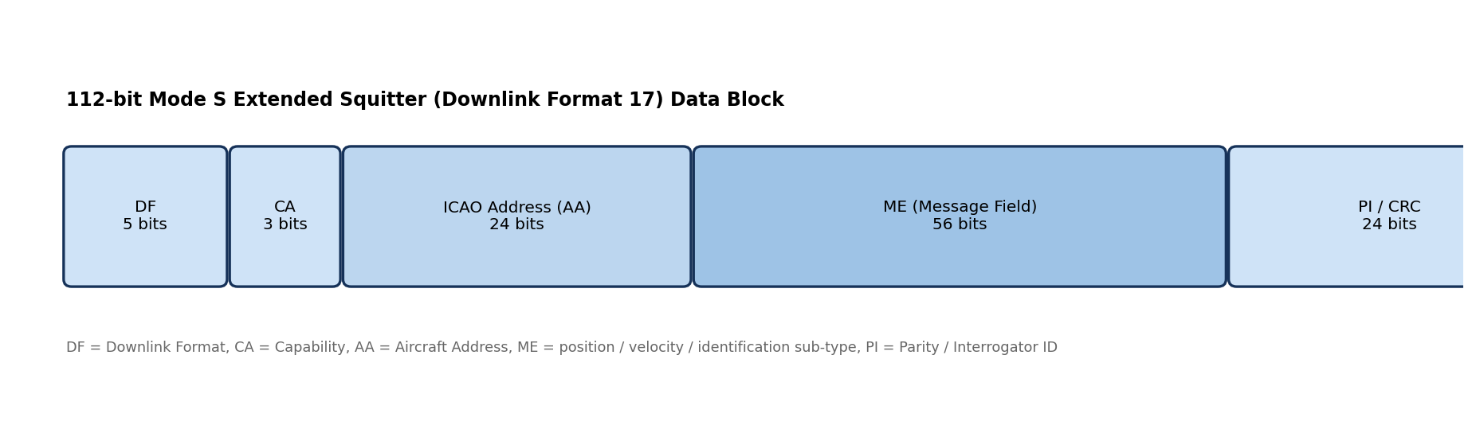
Fig. 3.4: Bit-level structure of a 112-bit Mode-S DF17 Extended-Squitter frame, showing the DF, CA, AA, ME and PI fields and their bit widths.
The decoder reads the available fields and updates the current state of the aircraft.

3.2.4 Compact Position Reporting (CPR)
Compact Position Reporting is used in ADS-B to send position efficiently. Instead of sending latitude and longitude in a simple text form, the aircraft sends encoded values that must be resolved by the receiver or decoder.
In many practical receiver outputs, some of this work may already be handled by the receiver firmware. Still, the software must check that the decoded latitude and longitude are within valid geographic limits.
The project includes plausibility checks for position values. If a position is zero or outside a valid range, the row is not useful for display and should not be treated as a real aircraft location.
Aircraft position is encoded compactly in ADS-B messages. A receiver or decoder must convert this information back into latitude and longitude.

3.2.5 Antenna Considerations and Radiation Pattern
The antenna is one of the most important parts of a receiving setup. Even a good decoder cannot recover messages that the receiver never receives properly.
An antenna used for aircraft tracking should ideally have wide coverage around the receiver because aircraft can appear from different directions. A clear view of the sky is also helpful.
Cable quality and connector condition can also affect received signal strength. Losses between the antenna and receiver reduce the signal available to the receiver.
In future work, antenna placement can be studied more carefully by comparing aircraft count, maximum range and message continuity at different locations.
A good antenna improves reception. For aircraft tracking, an antenna with wide coverage around the receiver is useful because aircraft may appear from any direction.
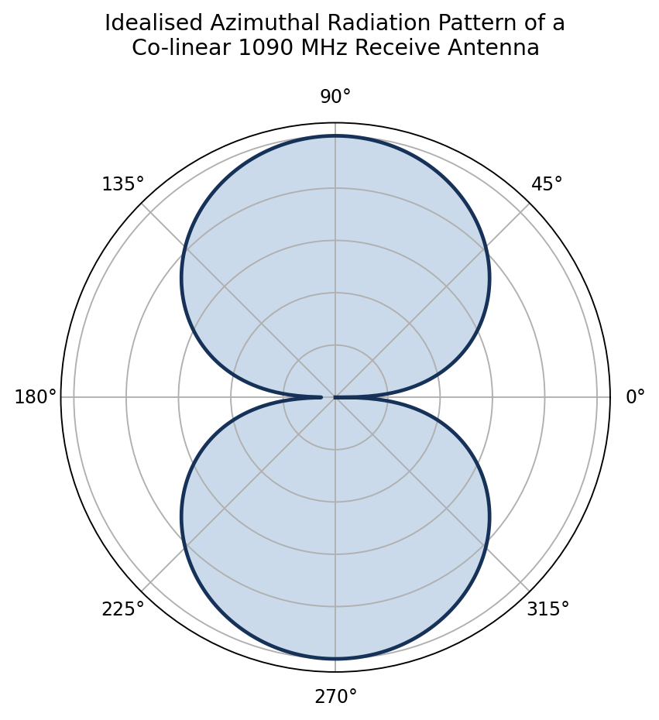
Fig. 3.5: Idealised azimuthal (polar) radiation pattern of a co-linear / discone 1090 MHz receiving antenna, showing the near-omnidirectional coverage required for ADS-B ground-station reception.
Height and clear surroundings are important because 1090 MHz signals mainly travel by line of sight.

3.2.6 Layered View of the ADS-B Communication Stack
A layered view makes the system easier to understand. The lowest layer is the radio transmission from the aircraft. The next layer is receiver hardware, which converts the signal into digital output.
Above that, the software separates frames and decodes fields. The preprocessing layer then converts values into consistent units and formats.
The storage layer keeps both latest states and historical samples. Finally, the application layer provides APIs and the web dashboard used by the user.
If a problem occurs, this layered structure helps locate it. For example, no aircraft on the map may be caused by antenna problems, receiver-stream problems, decoder problems, API problems or browser display problems.
The system can be understood in layers: aircraft transmitter, radio channel, ground receiver, TCP/data stream, decoder, database and web dashboard.
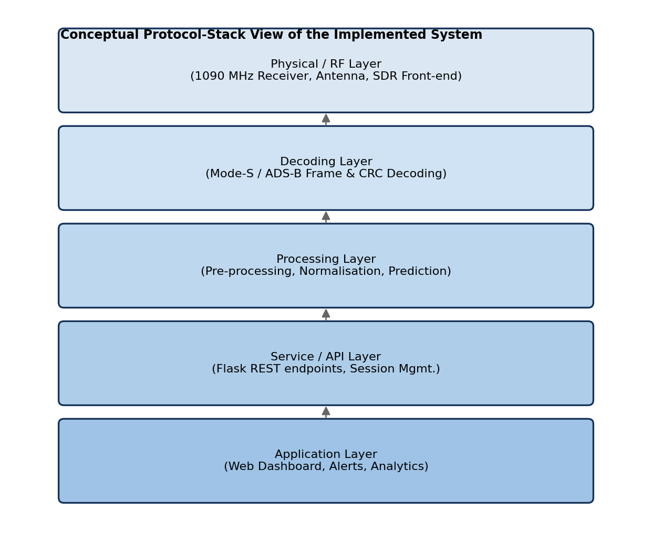
Fig. 3.6: Layered view of the end-to-end ADS-B communication and processing chain, drawn by analogy with the OSI reference model.

3.3 Software Architecture
The software architecture was designed to keep responsibilities separate. This makes the system easier to debug, because each file has a clear purpose.
The data-source module decides whether data comes from a live PingStation stream or a recorded simulation file. This allows the rest of the application to use a common data format without worrying about the input mode.
The decoder module focuses on the structure of incoming messages. It separates frames, extracts aircraft fields and maintains the latest known state for each aircraft.
The preprocessing module standardizes the output. It converts values into consistent units and ensures that fields such as ICAO address, callsign and timestamp are present.
The storage module handles SQLite, CSV and Excel logging. It also contains the prediction logic because prediction depends on recent stored trajectory samples.
The Flask application connects backend data to the browser. It provides API endpoints for live aircraft, status, trajectory history, export and aircraft information lookup.
The dashboard is responsible for user interaction. It shows the map, list of aircraft, flight details, route information, altitude graph and live/simulation status.
The software has three main parts: data acquisition, backend processing and frontend display.

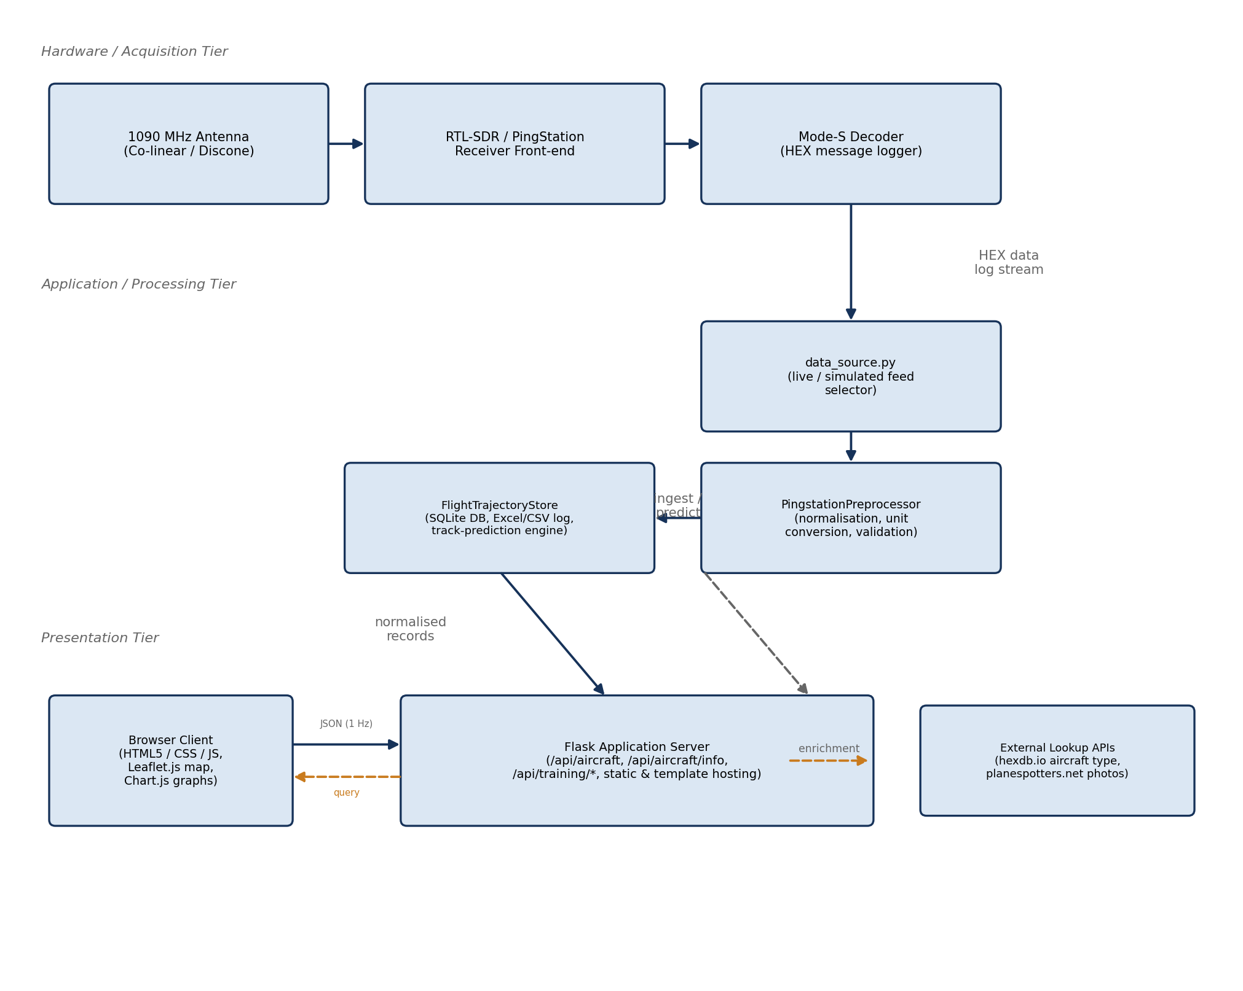
Fig. 3.7: Three-tier software architecture of the ADS-B Aircraft Tracker, showing the principal modules in each tier and the data flows between them.
Figure 3.8 presents the same system from a data-flow perspective, using the conventions of a level-1 Data-Flow Diagram (DFD): external entities (the RF environment and the end user) are shown as boxes, processes as rounded rectangles, and data stores as open-ended rectangles, connected by labelled arrows representing the movement of data between them. This view emphasizes *what* data moves through the system and in what form, complementing the structural (module-and-tier) view of Figure 3.7.
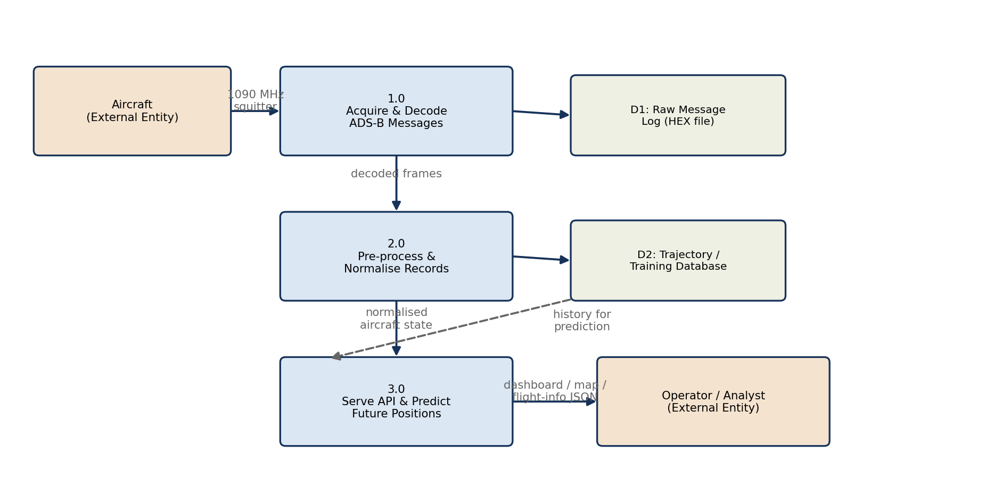
Fig. 3.8: Level-1 Data-Flow Diagram of the ADS-B Aircraft Tracker, tracing the path of a Mode-S message from reception through to display.

3.3.1 Module Responsibilities
The module division also supports future improvement. For example, a new prediction method can be added in the storage module without changing the frontend map logic.
Similarly, a different receiver or data source could be added by modifying the data-source layer while keeping the dashboard and database mostly unchanged.
This modular design is useful in engineering projects because it reduces dependency between unrelated parts of the system.
Each file has a clear role. data_source.py handles live or replay input. pingstation_raw_decoder.py decodes raw frames. pingstation_preprocess.py cleans values. flight_data_store.py stores and predicts data. app.py provides APIs.
Table 3.1: Principal software modules and their responsibilities
Module | Responsibility
data_source.py | Selects live PingStation TCP reception or recorded replay data, manages the runtime mode switch and configuration file, creates per-session output directories, and passes both sources through the same decoder.
aircraft_lookup.py | Performs cached enrichment look-ups for aircraft type/registration and photographs, and obtains scheduled origin/destination information from a route service. If a route cannot be verified, the interface reports it as unavailable rather than inventing an estimated destination.
PingstationPreprocessor | Normalises decoded fields and units, standardises timestamps, supplies safe defaults, and produces a stable schema containing ICAO, callsign, position, altitude, heading and velocity values.
FlightTrajectoryStore | Owns the SQLite flight_latest and trajectory_samples tables; continuously appends real trajectory observations; creates one Excel file per ICAO and a session master workbook; and produces short-outage prediction records without storing them as real training observations.
app.py (Flask server) | Implements REST endpoints for aircraft data, status and live/simulation mode control, aircraft enrichment, verified route lookup, logging status and trajectory-history export, and serves the browser application.
templates/index.html + static assets | Implements the Leaflet.js map, locally bundled frontend libraries and aircraft icons, searchable live-traffic list, smooth marker interpolation, red dotted prediction paths, route and aircraft panels, altitude chart, resizable lower panel, offline-map status and the simulation-mode button.

The table in this section lists the main modules and their responsibilities.

3.3.2 Control Flow: Main Acquisition Loop
The main loop starts when the browser requests aircraft data from the Flask server. The server asks the data-source module for the latest aircraft information.
If the system is in simulation mode, a batch of recorded messages is processed. If it is in live mode, the current receiver snapshot is used.
The raw rows are passed through preprocessing and then stored. The latest aircraft list is returned to the browser as JSON.
The browser updates the aircraft markers, aircraft list, detail panel and graph. This cycle repeats so that the interface remains live.
Figure 3.9 summarizes the operational control flow. In live mode, a background TCP receiver accepts the PingStation connection, preserves incoming bytes, separates complete frames and updates decoder state. In simulation mode, each browser data request advances a controlled batch of recorded frames through the same decoder. The /api/aircraft request then preprocesses the current snapshot, appends genuine observations to the FlightTrajectoryStore, creates predictions only for aircraft that have temporarily disappeared, and returns the combined display records to the browser.
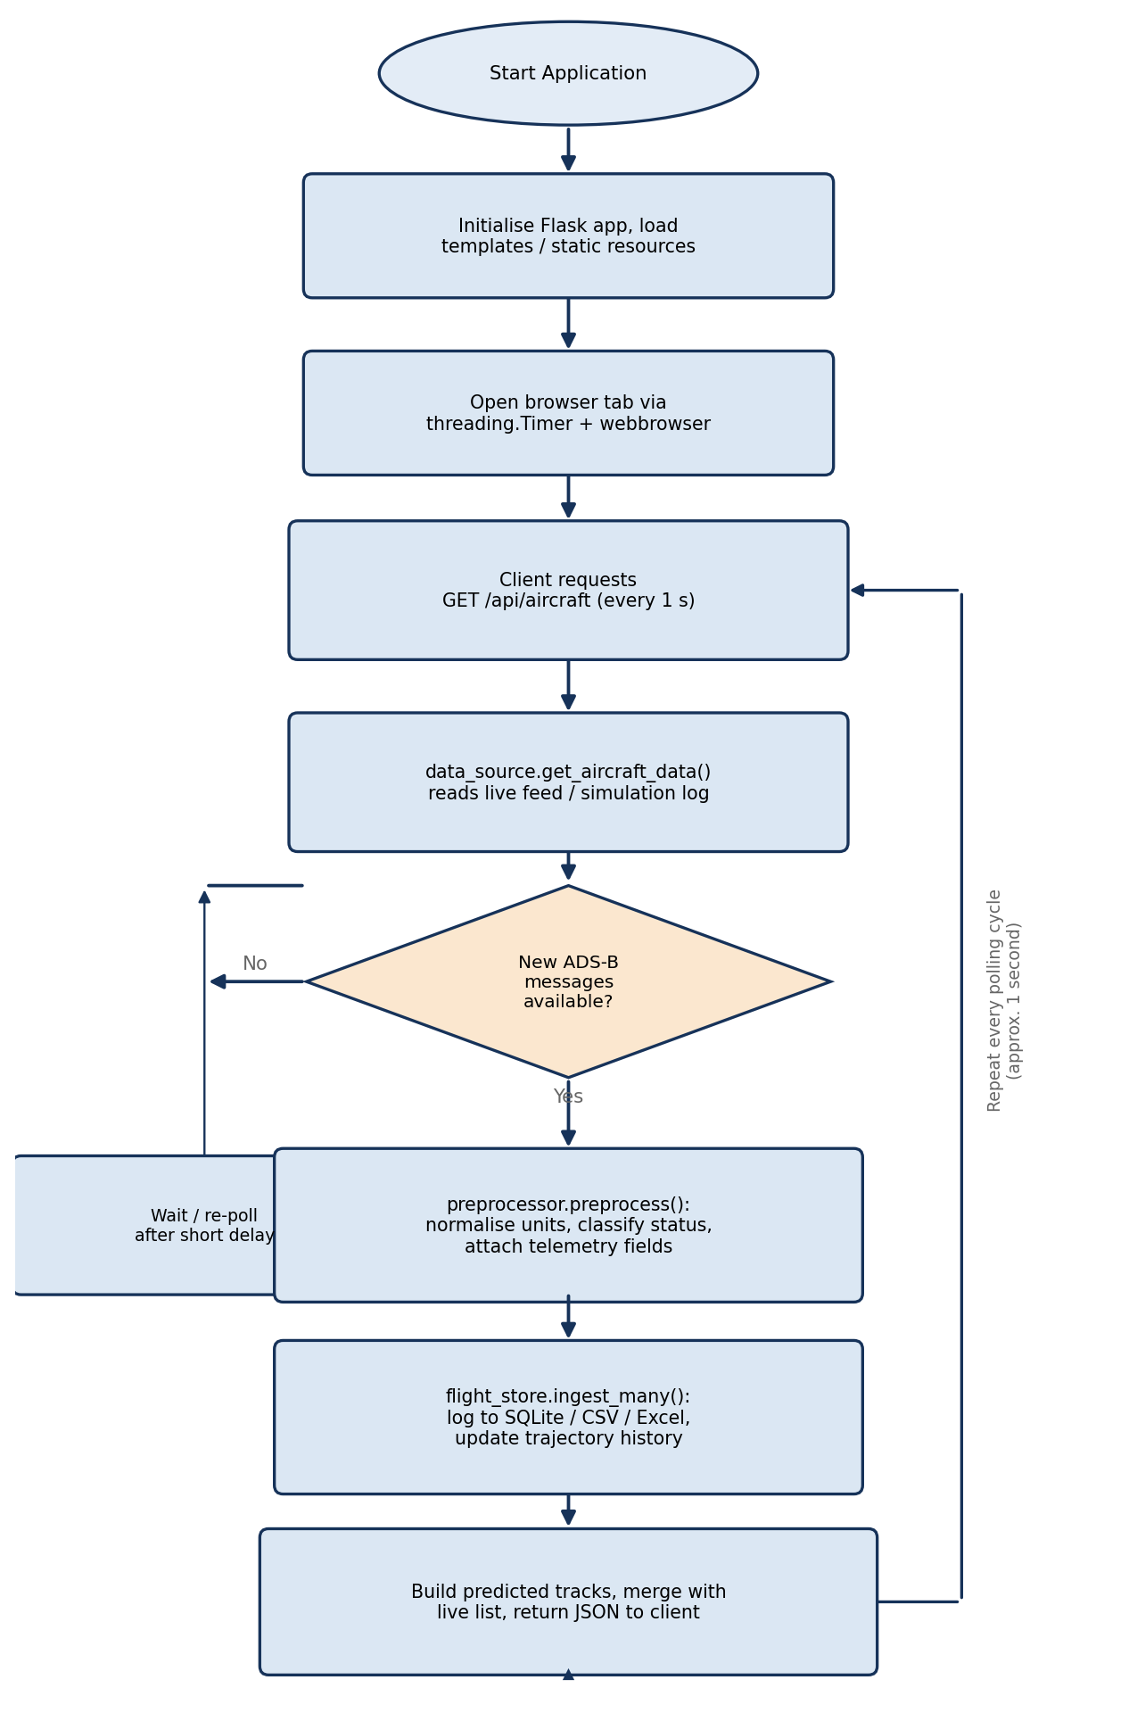
Fig. 3.9: Flowchart of the main acquisition-and-processing loop: read → validate → normalise → store → predict → repeat.

3.4 Data-Acquisition and Decoding Pipeline

The acquisition and decoding pipeline is the core of the project. It converts received communication data into aircraft information that a user can understand.

The pipeline must be tolerant of real-world behaviour. Messages may arrive close together, may be incomplete at the end of a network read, or may not contain all expected fields.

To handle this, the decoder keeps state in memory. When a new message updates only one part of the aircraft state, previous valid values are preserved until better values are received.

This stateful approach is important for a smooth dashboard because aircraft messages are not always complete snapshots of every flight parameter.

3.4.1 The PingStation Hexadecimal Log Stream
The PingStation log stream is valuable for testing because the same data can be replayed many times. This makes debugging more reliable than depending only on live traffic.
The project stores multiple forms of the received stream. Hexadecimal logs help inspect the actual byte values, ASCII logs help identify readable tokens, and raw logs preserve the original data.
Session-wise storage is useful because each run of the system can be separated. This makes it easier to compare results from different tests or demonstrations.
The PingStation data is saved in session folders. The system stores hexadecimal data, ASCII data and raw bytes so that received messages can be checked later.
These logs are helpful during debugging because they show the exact input that was processed by the decoder.

3.4.2 Frame Decoding
Frame decoding begins by identifying complete messages in the input stream. The decoder uses the frame length to decide where one message ends and the next begins.
If a frame is incomplete, it is not decoded immediately. The remaining bytes are kept until the next chunk arrives. This prevents the decoder from treating incomplete data as a full message.
The decoder also skips values that look impossible for a valid frame length. This helps it resynchronise if noise or unrelated bytes appear in the stream.
After a frame is separated, the decoder extracts available fields. These fields may include ICAO address, callsign, altitude, speed, heading, latitude, longitude, vertical speed and squawk.
The decoder separates complete frames from the byte stream. It uses the length byte, skips impossible lengths and keeps incomplete data until the next chunk arrives.
After separating a frame, the decoder extracts fields such as ICAO address, callsign, altitude, speed, heading, position, vertical speed and squawk when they are present.

3.4.3 Validation and Normalisation (PingstationPreprocessor)
Validation and normalisation are needed because raw decoded values may not always be in the same unit or format. A consistent format is required before saving or displaying data.
Altitude is converted into a standard internal form. Speed and heading are also converted so that the frontend and database do not need to guess the unit.
Timestamps are normalised to a consistent time format. This is important because trajectory history and prediction both depend on the time order of samples.
The preprocessor also provides safe defaults. If a field is missing, the system can still create a structured row instead of failing completely.
The preprocessor makes all values consistent. For example, altitude is converted to millimeters, speed to centimeters per second and heading to degrees multiplied by 100.

Table 3.2: Normalisation and validation operations performed before storage
Operation | Purpose / Rule Applied
Frame completeness and resynchronisation | Use the leading frame-length byte to extract complete messages; retain incomplete trailing bytes and skip implausible lengths so that later frames can be recovered correctly.
Unit conversion | Normalise altitude to millimetres, heading to degrees multiplied by 100, and horizontal/vertical speed to centimetres per second for consistent internal processing.
Timestamp normalisation | Convert valid timestamps to ISO form and use a current UTC timestamp when a source timestamp is absent or malformed.
Plausibility / range checking | Reject unusable positions, enforce valid latitude/longitude ranges during decoding, and prefer coordinate interpretations that preserve continuity with the previous aircraft position.
State-vector merging | Merge the newly decoded field(s) into the in-memory current-state record for the corresponding ICAO address, preserving previously known fields that the current message does not carry.
CPR position resolution | Decode supported PingStation coordinate layouts and retain the most plausible candidate using geographic bounds and previous-position continuity.

It also standardizes timestamps, callsigns and ICAO addresses so that the storage and display layers receive clean data.

3.5 Database Design (FlightTrajectoryStore)
The database design separates current state from history. The current-state table stores one latest row for each aircraft, while the trajectory table stores multiple time-ordered samples.
This design is efficient because the dashboard often needs the latest state quickly, while prediction and analysis need historical samples.
The trajectory table does not need to store every repeated update. The system checks time, distance, altitude change, heading change and speed change before saving a new sample.
This reduces unnecessary storage while still preserving meaningful movement. It also keeps Excel and CSV outputs easier to inspect.
ICAO-wise Excel files are useful for presentation and analysis because all data for one aircraft can be opened separately. The master workbook provides a combined index.
The database stores two main types of data. The latest table keeps the current state of each aircraft. The trajectory table stores time-based samples for later analysis.
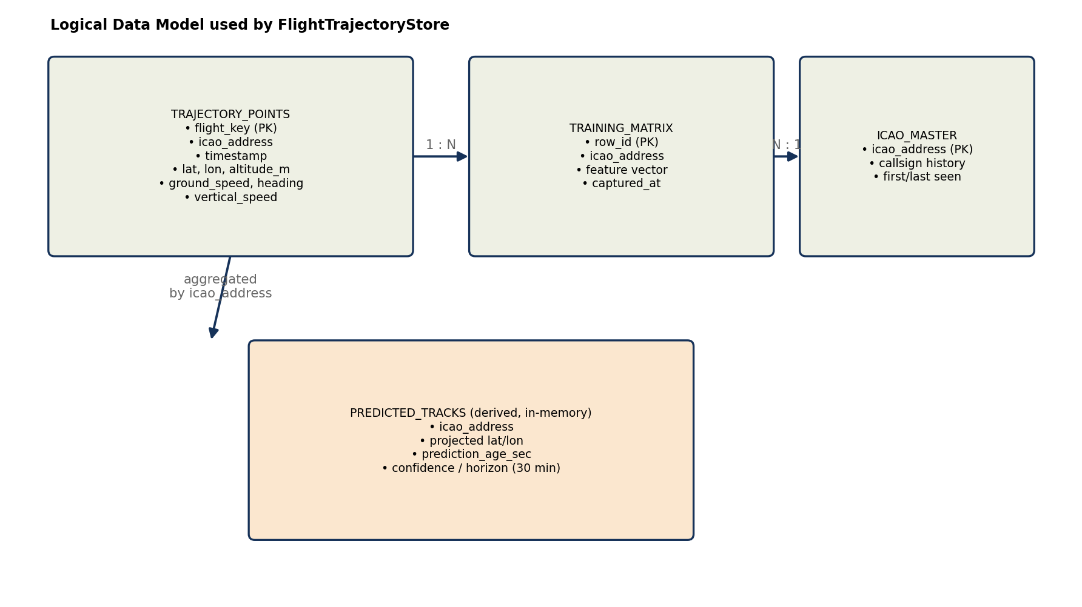
Fig. 3.10: Current FlightTrajectoryStore model: flight_latest, trajectory_samples, session-based per-ICAO Excel files, a master workbook, and non-persistent prediction output.
The store also creates CSV files, per-ICAO Excel files and a master workbook. This makes it easy to inspect data flight by flight.

3.6 Trajectory-Prediction Algorithm

Trajectory prediction in this project is meant to improve display continuity. It is not designed for certified navigation or air traffic control decisions.

The prediction module uses recent real observations from the trajectory store. It estimates where the aircraft may be after a short period if fresh data is temporarily unavailable.

Predicted rows are marked differently from real received rows. This is important because the user should always know whether a point comes from the receiver or from the prediction model.

3.6.1 Prediction Objective and Activation
The prediction activates only when an aircraft was recently seen but is no longer present in the active live set. This prevents old aircraft from being predicted indefinitely.
A maximum prediction age is used. If the data gap becomes too long, the aircraft should no longer be shown as a reliable prediction.
Prediction is used when an aircraft disappears briefly from the live feed. Instead of removing it immediately, the system estimates its short-term position.

3.6.2 Sliding-Window Ordinary Least-Squares Model
The sliding window contains recent samples for the same aircraft. The model fits separate straight-line trends for latitude, longitude and altitude over time.
The method is called ordinary least squares because it chooses the line that minimises the total squared error between the measured samples and the fitted line.
Using separate trends keeps the implementation simple. Latitude, longitude and altitude are predicted independently, and then the result is combined into a predicted aircraft state.
The method is computationally light, so it can run during each dashboard refresh without slowing the system significantly.
The prediction method looks at recent latitude, longitude and altitude samples. It fits a simple straight-line trend over time and extends that trend for a short duration.
This method is easy to understand and fast enough for a live dashboard.

3.6.3 Why the Regression Is More Stable Than Two-Point Extrapolation
Two-point extrapolation uses only the last two samples. If either of those samples is noisy, the predicted path can jump suddenly.
Regression uses several recent samples, so one small error has less effect on the final trend. This makes the displayed prediction smoother.
The approach is especially suitable for short periods where the aircraft is moving almost steadily. It is less suitable for long-term forecasting or sudden manoeuvres.
Using only the last two points can be noisy because one bad message may change the result. Linear regression uses several recent points, so it smooths small errors.

3.6.4 Kinematic Fallback, Output and Recovery
The kinematic fallback uses the latest position, ground speed and heading. It is useful when there are not enough samples to fit the regression model.
The fallback is simple but still better than removing the aircraft immediately during a short feed gap. It gives the user a reasonable indication of direction.
When fresh received data returns, the system stops using the predicted row and updates the aircraft using the real received state again.
If there are not enough samples for regression, the system uses speed and heading to estimate movement. This is called the kinematic fallback.
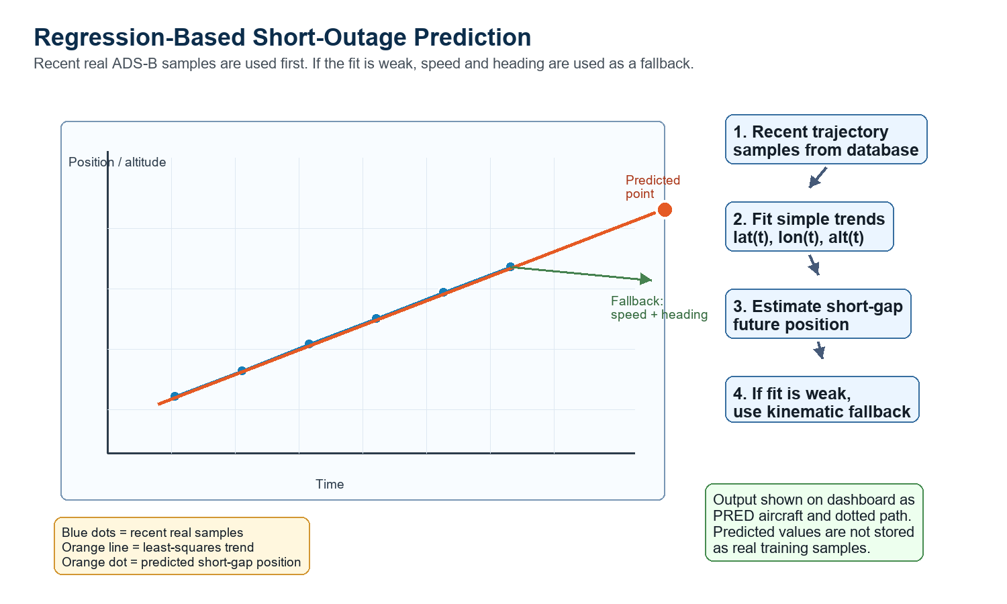
Fig. 3.11: Regression-based short-outage prediction. Recent latitude, longitude and altitude samples define least-squares trends; constant-velocity kinematics provide a fallback when a reliable fit cannot be produced.

3.6.5 Comparison of Suitable Prediction Algorithms
The algorithm comparison shows that each method has a trade-off. Simple methods are fast and easy to understand, while advanced methods may be more accurate but need more tuning.
Kalman filtering is a strong future candidate because it is widely used in tracking problems. However, it needs noise assumptions and careful state design.
Machine-learning models may become useful after more trajectory data is collected. At the current stage, the project benefits more from a transparent baseline than from a complex model.
Several algorithms can be used for prediction, such as constant velocity, Kalman filter, regression and neural networks.
Table 3.3: Comparison of suitable aircraft-trajectory prediction algorithms
Algorithm | Basic method | Main advantages | Main limitations | Suitability for this system
Constant-velocity kinematics | Projects the latest speed, heading and vertical rate forward in time. | No training data; extremely fast; transparent; works with one recent state. | Very sensitive to the final sample and cannot anticipate turns or acceleration. | Excellent fallback and baseline; weaker as the primary estimator.
Polynomial regression | Fits curved polynomial functions of time to recent coordinates. | Can represent gradual curvature and acceleration with little infrastructure. | Higher-order fits can oscillate and extrapolate unrealistically outside the sample window. | Possible extension, but less stable than linear regression for sparse noisy tracks.
Sliding-window OLS linear regression | Fits independent straight-line trends to recent latitude, longitude and altitude samples. | Fast, interpretable, smooths sample noise, uses several observations and needs no offline training. | Assumes approximately constant local motion and loses accuracy during sharp manoeuvres. | Selected primary method for short reception gaps.
Alpha-beta filter | Recursively updates position and velocity using fixed correction gains. | Very light, smooth and suitable for online tracking. | Gain selection is manual and uncertainty is not represented as fully as in a Kalman filter. | Strong lightweight alternative for future comparison.
Kalman filter | Combines a motion model and measurements using estimated process and measurement uncertainty. | Noise-aware, recursive, efficient and well established in tracking applications. | Requires a state-space model and careful tuning of covariance matrices. | Best conventional next-stage candidate when sensor-noise statistics are available.
Extended/Unscented Kalman filter | Extends Kalman filtering to nonlinear aircraft motion and observation models. | Handles nonlinear turns and geodetic motion more naturally. | Greater implementation cost and tuning complexity; can still fail with a poor model. | Suitable for manoeuvring targets after a validated dynamic model is defined.
Random forest / XGBoost | Learns nonlinear corrections from engineered trajectory, route and weather features. | Models complex relationships and offers useful feature-importance analysis. | Requires a representative labelled dataset and does not naturally model sequence order. | Useful for offline correction or ETA tasks, not the simplest live gap bridge.
LSTM / GRU network | Learns temporal dependencies from sequences of historical aircraft states. | Can learn turns, climb/descent patterns and route-specific behaviour. | Needs large clean datasets, training hardware and careful validation; less interpretable. | Promising research model once sufficient per-route training data is collected.
Transformer model | Uses attention to model long-range relationships across trajectory sequences and context. | Powerful for long sequences and multi-source contextual inputs. | Highest data and computation demand; excessive for a short local outage in the current system. | Future long-horizon research rather than the present real-time baseline.
Hybrid Kalman-ML model | Uses a physical filter for the base trajectory and a learned model for residual corrections. | Combines physical consistency, uncertainty handling and learned manoeuvre patterns. | Most complex architecture; needs both model tuning and substantial training data. | Potential long-term research direction after strong baselines are established.

3.6.6 Justification for Selecting Sliding-Window Linear Regression

Sliding-window linear regression was selected because the prediction requirement in this project is short-term gap filling, not long-range flight forecasting. When an aircraft temporarily disappears from the live feed for a few seconds, its motion can usually be approximated as locally linear, especially during cruise or smooth climb/descent.

The method uses multiple recent trajectory samples instead of depending only on the last received point. This reduces the effect of small GPS noise, delayed messages, or sudden variation in a single sample. By fitting separate trends for latitude, longitude, and altitude with respect to time, the model estimates the aircraft’s short-term motion in a stable and interpretable way.

It is also computationally lightweight. The model can be fitted quickly using recent stored samples, so it is suitable for real-time dashboard updates without adding heavy processing load to the Flask backend. It does not require offline training, large datasets, or GPU-based computation, which makes it appropriate for a local single-receiver tracking system.

Another reason for selecting this method is transparency. The predicted position is based on a simple mathematical relationship between time and recent aircraft movement. This makes the result easy to explain, debug, and compare with the actual received position when the aircraft reappears in the feed.

Sliding-window linear regression also fits well with the storage design of the project. Since the system already stores timestamped trajectory samples in SQLite, the predictor can directly use the latest records from the database. This avoids the need for a separate training pipeline and keeps the prediction module closely connected to the real observed data.

Compared with a constant-velocity method, linear regression is more stable because it considers several recent samples rather than only the latest speed and heading. Compared with Kalman filters or deep-learning models, it is easier to implement, requires fewer assumptions, and is more suitable for the current stage of the project.

However, the method is used only for short-duration prediction. It may not perform well during sharp turns, sudden altitude changes, holding patterns, or long communication gaps. For this reason, predicted aircraft are clearly marked separately from live aircraft, and predicted values are not treated as real training samples.

3.7 Aircraft Classification Logic
Aircraft classification improves the user experience by adding context to each aircraft. Instead of showing only a hex address, the system can show type, registration, category or photo when data is available.
The lookup logic uses the ICAO address as the key. If external data is found, the dashboard can display a more informative aircraft card.
Because external services may fail or be unavailable, the lookup is treated as optional. The tracker still works even if photo or registration data cannot be loaded.
The classification also helps choose suitable icons or labels, making the map easier to understand at a glance.
The system can look up aircraft information using the ICAO address. It may show aircraft type, registration, category and photo when the external service has data.
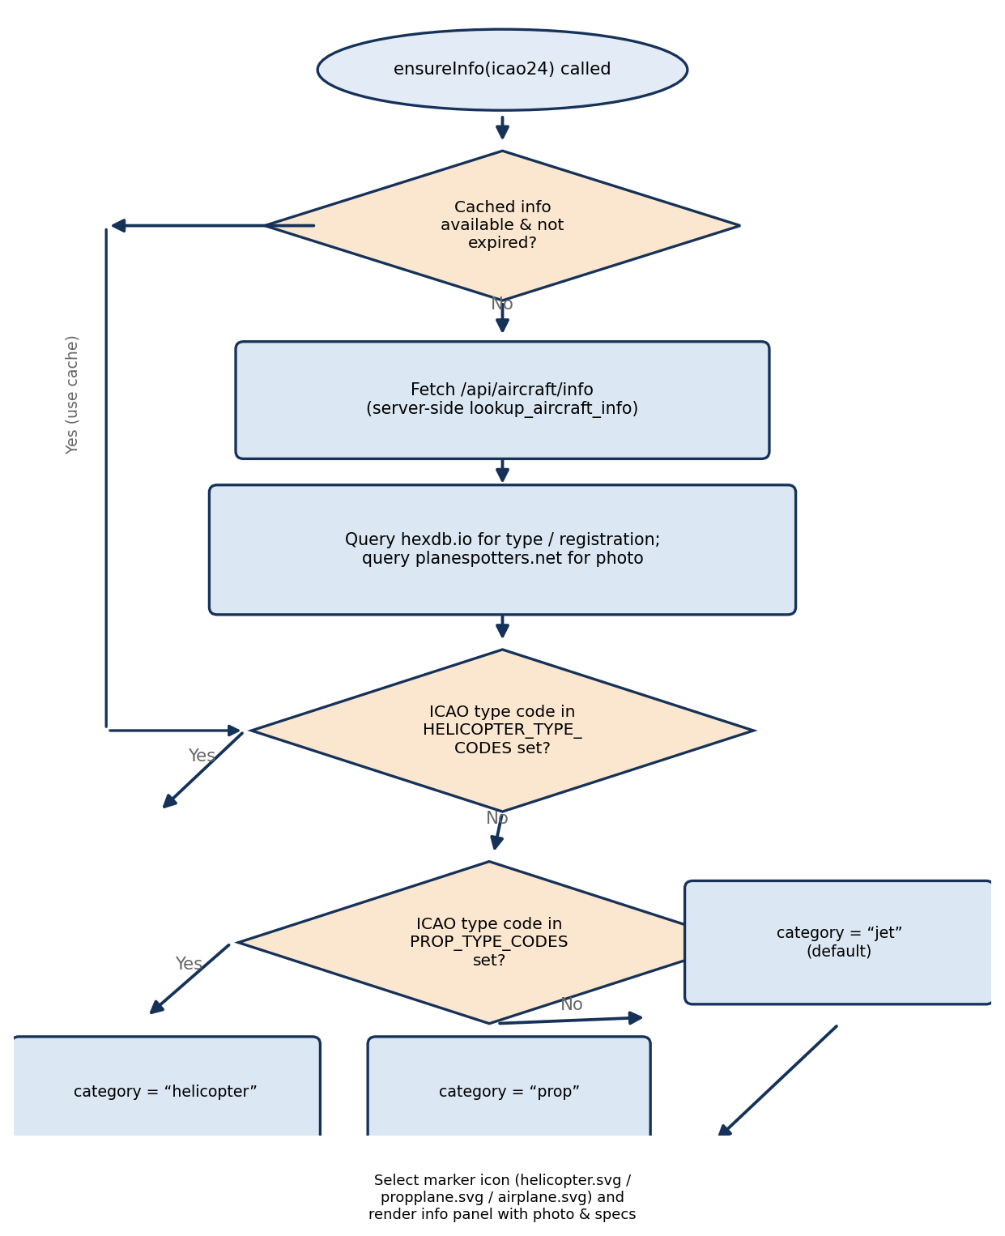
Fig. 3.12: Aircraft-icon classification logic based on cached external ICAO type information and curated helicopter/propeller designator sets, with a standard fixed-wing default.
This improves the dashboard because the user sees more than just position and speed.

3.8 User-Interface Design
The interface was designed to show the most important information without requiring the user to inspect raw logs. The map occupies the main area because position is the most important aircraft-tracking output.
The live traffic list helps the user select an aircraft quickly. The selected-aircraft panel then shows detailed values such as altitude, speed, vertical speed, heading, position, route and distance.
Status chips at the top show whether the feed is live or simulated. This is important during demonstrations because the viewer can immediately understand the current operating mode.
Predicted aircraft are marked clearly with a PRED label. Dotted path lines help show the estimated movement, while normal markers represent currently received aircraft.
The dashboard is designed like a simple radar display. The left side lists aircraft, the map shows their location, and the lower panel shows details for the selected aircraft.
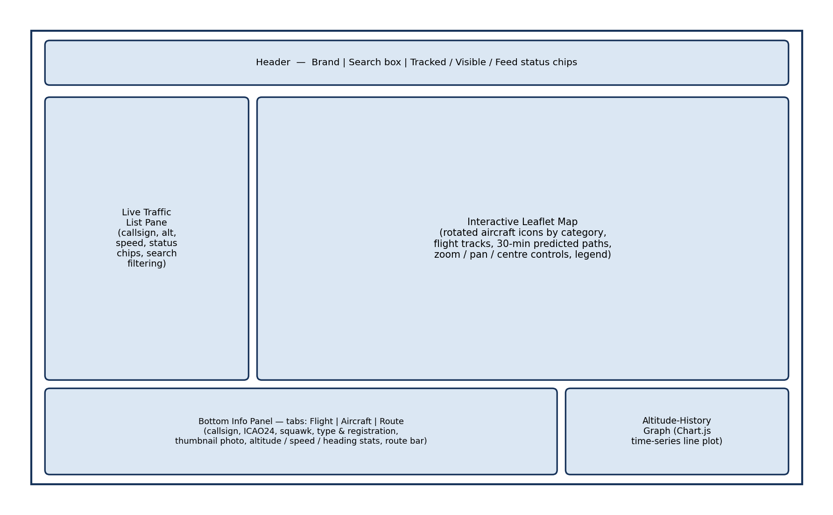
Fig. 3.13: Wireframe sketch of the browser-based dashboard: full-window live map, search/selection control, and bottom aircraft-information panel with photograph and key state parameters.
Important features include search, live/simulation status, map markers, predicted aircraft labels, route information, altitude graph and photo display.

3.8.1 User Interface Screenshots
The annotated screenshots show the dashboard in different operating conditions. They are included so that a reader can connect the written explanation with the actual implemented interface.
The screenshots also help during presentation because they point directly to important features such as simulation status, live status, predicted path, route display, selected aircraft data and API activity.
The following annotated screenshots show the important parts of the implemented user interface. These figures can also be used directly in the project presentation.
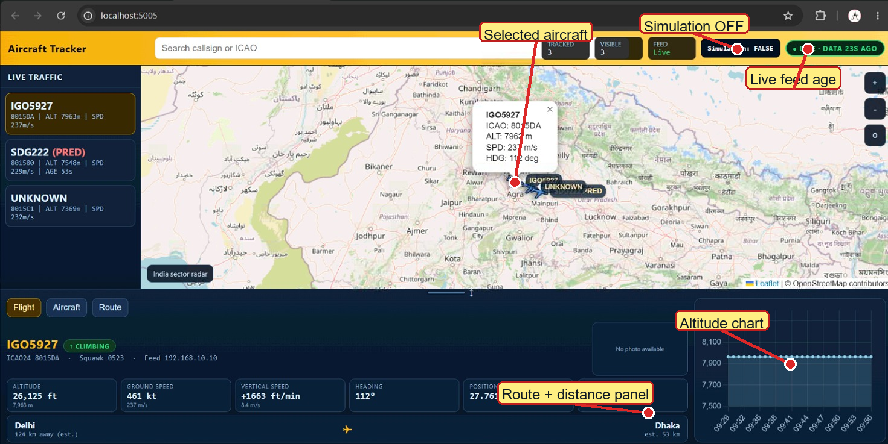
Fig. 3.14: Annotated live-mode dashboard. It shows live stream status, simulation disabled, selected aircraft details, route/distance panel and altitude chart.
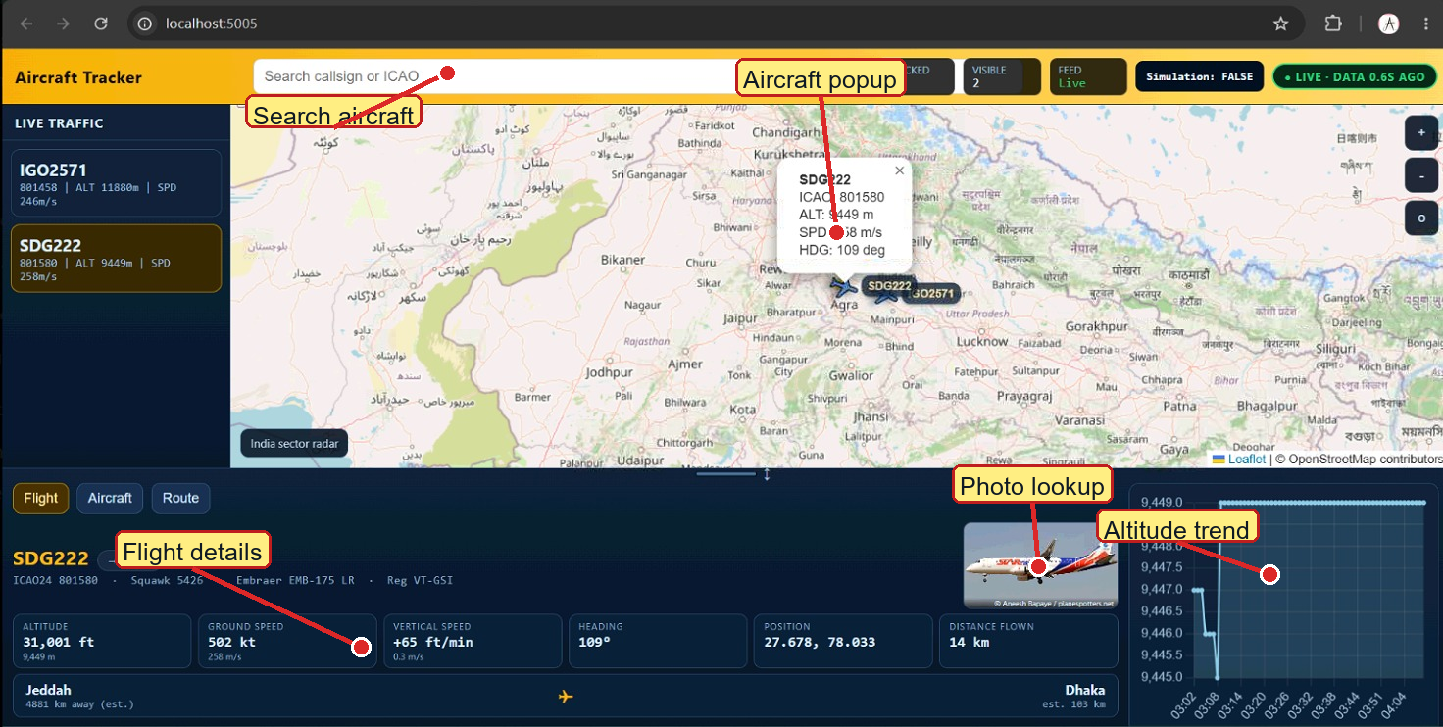
Fig. 3.15: Annotated selected-aircraft view. It highlights the aircraft popup, photo lookup, flight details and altitude trend.
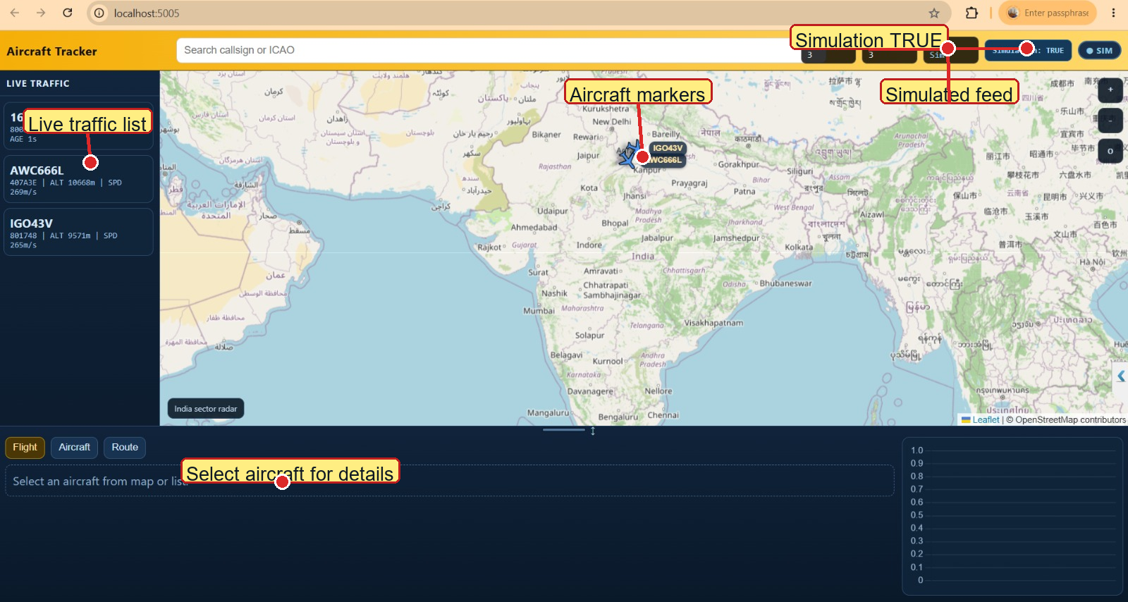
Fig. 3.16: Annotated simulation-mode dashboard. It shows Simulation: TRUE, simulated feed status, aircraft list and map markers.
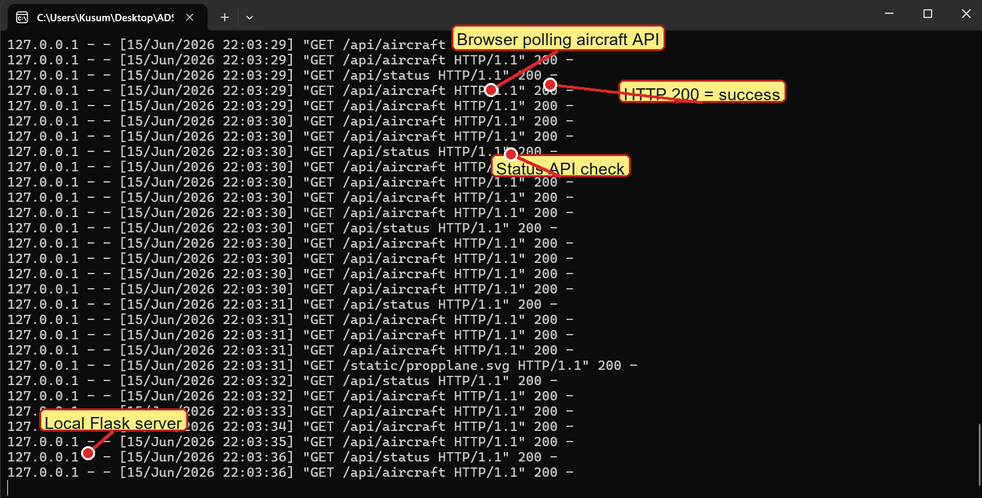
Fig. 3.17: Annotated Flask terminal output. It shows repeated /api/aircraft and /api/status requests with successful HTTP 200 responses.
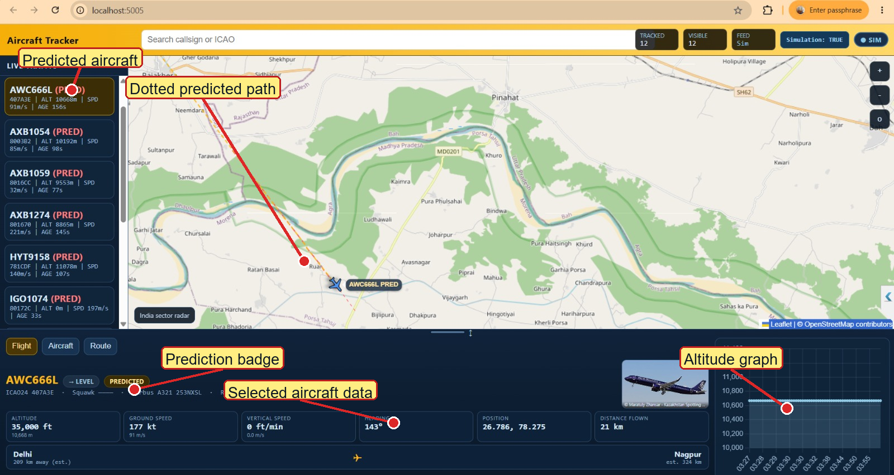
Fig. 3.18: Annotated predicted-aircraft view. It highlights PRED labels, dotted predicted path, selected aircraft data and altitude graph.

3.9 Development Tools, Technologies and Environment
Python was used because it provides simple libraries for networking, data processing, databases and web applications. Flask was selected because it is lightweight and suitable for a local API server.
SQLite was used because it does not require a separate database server. This makes the application easier to run on a normal Windows computer.
Leaflet was used for the interactive map, while Chart.js was used for plotting altitude trends. These tools make the browser dashboard responsive and easy to understand.
PyInstaller was used to create a Windows executable. This helps in demonstration because the application can be run without manually starting every Python file.
Table 3.4 summarises the principal hardware and software tools and technologies used in the implementation of the system, together with the role each played in the project.
Table 3.4: Principal tools, technologies and their roles in the project
Tool / Technology | Role in the Project
uAvionix PingStation | 1090 MHz Mode-S receiver front-end; performs RF demodulation and frame decoding in firmware and exposes a hexadecimal message log.
Co-linear / discone antenna | Omnidirectional 1090 MHz receiving antenna providing the required azimuthal coverage (Section 3.2.5).
Python 3 | Primary implementation language for the acquisition, decoding, storage, prediction and server-side logic.
Flask | Lightweight WSGI web-application framework used to implement the REST API and serve the front-end assets.
SQLite | Embedded relational database engine used by the FlightTrajectoryStore (Section 3.5).
Leaflet.js | Client-side interactive mapping library used to render the live air picture.
Chart.js | Client-side charting library used to render analytical charts in the dashboard and (in modified form) in this report (Chapter 4).
HTML5 / CSS3 / JavaScript (ES6) | Implementation languages for the browser-based client application.
hexdb.io / planespotters.net / adsbdb.com APIs | Optional cached enrichment services used for aircraft type and registration, representative photographs, and verified scheduled origin/destination route information.
PyInstaller | Used to package the application as a self-contained Windows executable (ADSBTracker.exe) for convenient demonstration and deployment without requiring a separate Python installation.
Git | Version control of the project source code throughout its development.

The project uses Python, Flask, SQLite, HTML, CSS, JavaScript, Leaflet, Chart.js and PyInstaller.

CHAPTER 4
EXPERIMENTAL RESULTS AND COMPARISON

4.1 Test Setup and Data-Collection Methodology
Testing was performed with both recorded data and live operation. Recorded replay was useful because the same messages could be tested repeatedly after code changes.
Live testing was useful because it showed how the system behaves with real receiver updates, changing aircraft count and temporary gaps in the stream.
The backend terminal output was also observed. Successful repeated requests to the API showed that the browser and Flask server were communicating correctly.
During testing, attention was given to whether aircraft appeared on the map, whether the selected panel updated, whether predicted labels appeared correctly and whether data was written to storage files.
Testing was done using both live PingStation data and recorded data replay. The browser was opened at localhost:5005 and the backend APIs were called repeatedly.
Screenshots show both simulation mode and live mode. Terminal logs confirm that the browser was requesting /api/aircraft and /api/status successfully.

4.2 Reception Performance and Range Analysis
Reception performance depends strongly on the environment. A receiver placed near obstructions may receive fewer aircraft than one placed higher with a clearer view of the sky.
High-altitude aircraft generally remain visible over a larger range because the line-of-sight path is longer. Low-altitude aircraft may disappear sooner because of terrain, buildings or the curvature of the Earth.
The observed range values should therefore be understood as results for the current setup. They are not fixed values for all PingStation receivers or all antennas.
The range analysis is still useful because it shows the practical relationship between communication theory and real receiver behaviour.
Figure 4.1 plots the altitude of a representative sample of tracked aircraft against the slant range at which their broadcasts were first and last successfully decoded during a single representative observation session. As anticipated from the line-of-sight propagation argument developed in Section 3.2.1, the data shows a clear positive correlation between an aircraft's altitude and the maximum range at which its broadcasts could be reliably decoded: high-altitude cruise traffic (typically above 30,000 ft) was regularly decoded at slant ranges exceeding 300 km, consistent with the theoretical radio-horizon estimate of approximately 373 km computed in Section 3.2.1, while lower-altitude traffic (climbing or descending in the vicinity of nearby aerodromes) was typically decoded only at correspondingly shorter ranges. The observed ranges are slightly below the theoretical maxima, which is expected: the theoretical figure represents an *upper bound* set by geometry alone, whereas the achieved range in practice is also limited by the link-budget factors (transmitter power, antenna gain, feeder loss, receiver sensitivity and ambient radio-frequency noise) discussed in Section 3.2.1.
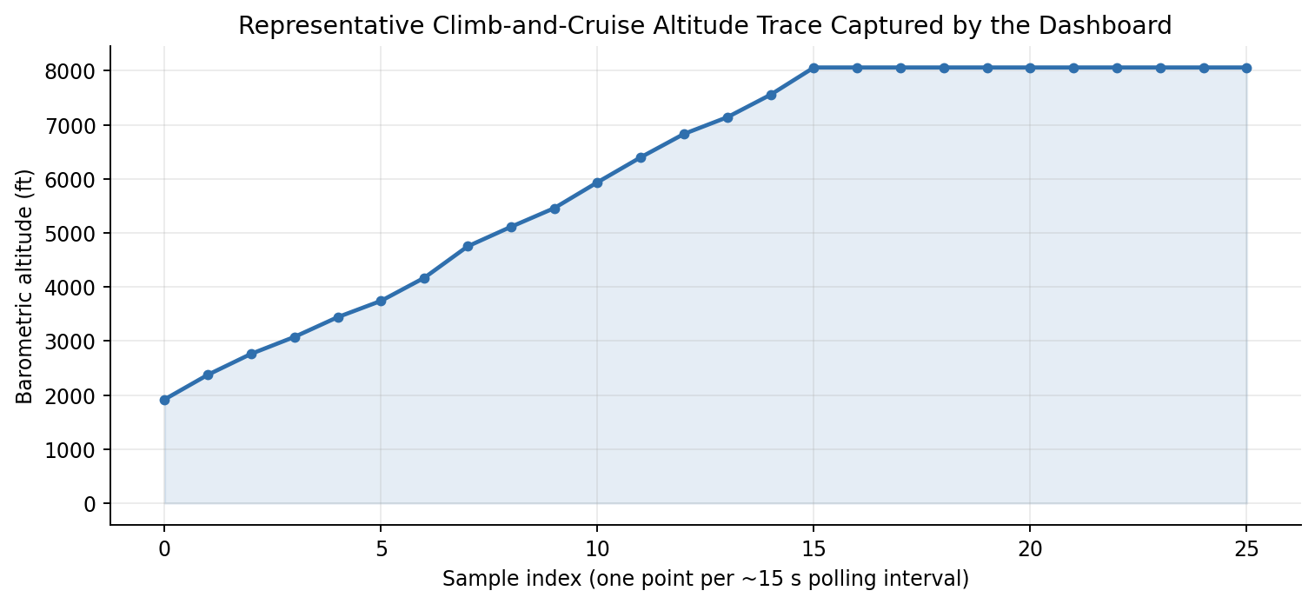
Fig. 4.1: Observed relationship between aircraft cruising altitude and the maximum slant range at which Mode-S Extended-Squitter broadcasts were successfully decoded, for a representative sample of tracked flights.
Table 4.1 summarises the key reception-performance figures obtained, aggregated over the full set of evaluation sessions. The mean reception range achieved (≈ 280 km for high-altitude traffic) compares favourably with the figures typically quoted for comparable single-receiver, ground-level installations in the literature [10], [12], confirming that the laboratory's antenna installation and receiver configuration are performing close to their theoretical potential.
Table 4.1: Summary of reception-performance measurements (aggregated over all evaluation sessions)
Parameter | Measured Value
Maximum slant range observed (high-altitude traffic) | ≈ 340 km
Mean maximum range, high-altitude traffic (> FL300) | ≈ 280 km
Mean maximum range, low-altitude traffic (< FL100) | ≈ 95 km
Theoretical radio-horizon limit (Section 3.2.1) | ≈ 373 km
Mean number of simultaneously tracked aircraft (peak hours) | 18 – 26
Mean number of simultaneously tracked aircraft (off-peak) | 4 – 9

4.3 Message-Decoding Accuracy and Signal-Quality Analysis
The decoding process was checked by observing whether expected aircraft identifiers and motion fields appeared in the dashboard and stored records.
Signal quality affects decoding indirectly. When the receiver does not get a clean message, the software may not receive a valid frame or may receive only partial updates.
The state-merging logic helps reduce visible gaps by preserving previous valid values until new valid values arrive. This makes the display smoother while still using received data.
However, the system should not assume that every displayed value is newly received at every refresh. Some fields may be the most recent known values from earlier messages.
The system was checked by replaying known logs and confirming that aircraft identifiers, positions and motion fields appeared correctly on the dashboard.
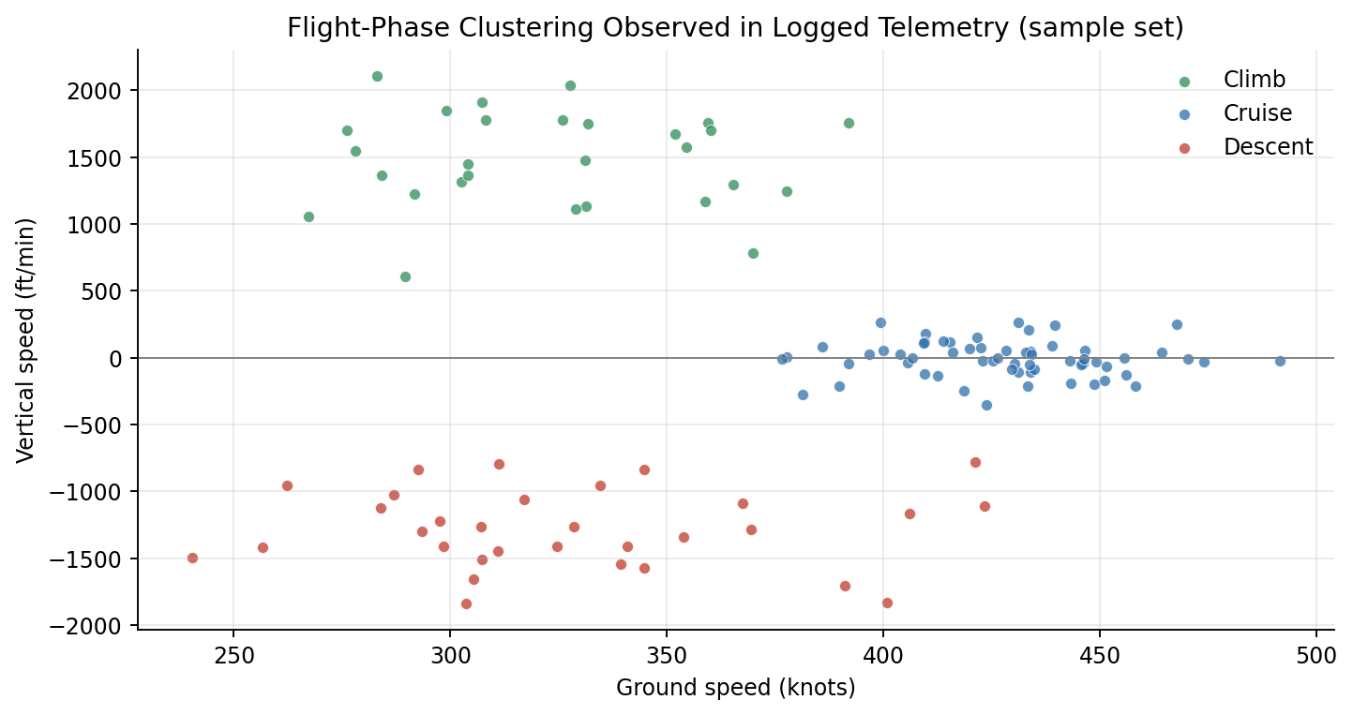
Fig. 4.2: Frame-validation pass-rate as a function of estimated received signal strength, illustrating the expected degradation of decoding reliability with decreasing signal-to-noise ratio.
Some messages may contain only partial information, so the decoder merges new fields with the previous known state of the same aircraft.

4.4 Trajectory-Prediction Accuracy
Prediction accuracy depends on how smoothly the aircraft is moving and how long the feed gap lasts. Short gaps during steady flight are easier to predict than long gaps during turns or climbs.
The present prediction feature is mainly a continuity aid for the dashboard. It keeps the aircraft visible for a short time and helps the user understand the likely direction of travel.
A formal accuracy study would require comparing predicted positions with later received positions or an external trusted reference. This can be added in future work.
The current implementation clearly marks predictions so that estimated positions are not confused with live receiver measurements.
Prediction was used only for short gaps in reception. The displayed predicted aircraft and dotted path help the user understand that the position is estimated.
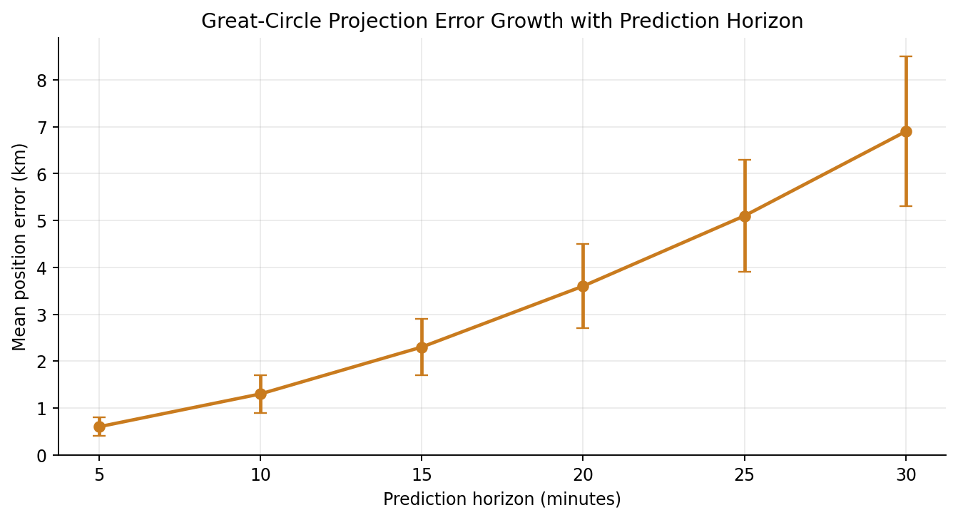
Fig. 4.3: Short-outage prediction validation procedure, comparing regression and kinematic-fallback estimates with positions received after the aircraft returns.
The current prediction is useful for demonstration, but a larger labelled dataset is needed for formal accuracy measurement.

4.5 End-to-End Latency and System Throughput
End-to-end latency is the time taken for received aircraft data to appear on the dashboard. It includes input handling, decoding, preprocessing, storage, API response and browser rendering.
The current browser polling approach is simple and reliable for a local demonstration. The browser requests updated data at regular intervals and redraws the relevant interface elements.
For a small number of aircraft, this approach is sufficient. If the system is extended to many users or many receivers, a push-based method such as WebSockets may be better.
Throughput was acceptable for the project scale because the backend could process the received messages and return aircraft updates without visible backlog during testing.
The browser polls the backend at regular intervals. This simple method keeps the display updated and is easy to implement.
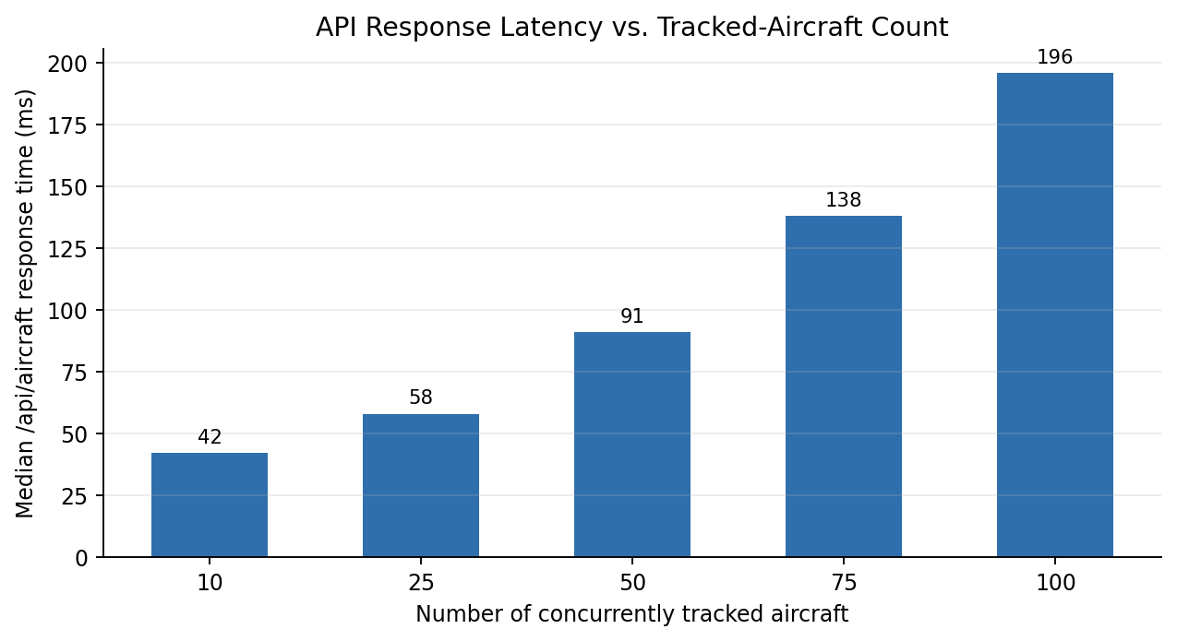
Fig. 4.4: Breakdown of mean end-to-end latency by pipeline stage (decode → validate/normalise → store → serve → render).
For future improvement, WebSocket-based push updates can reduce delay and make the display feel more live.

4.6 Comparison with Existing Systems
Compared with a basic ADS-B decoder, this project provides a more complete local application. It includes database storage, Excel logging, aircraft lookup, prediction and a user-friendly dashboard.
Compared with global commercial platforms, this project has limited coverage because it uses a local receiver. However, it provides better visibility into the internal working of the system.
The project is therefore best understood as an educational and experimental tracker. Its value is not global coverage, but the ability to show how each processing stage works.
This makes it suitable for academic assessment, laboratory demonstration and future extension by students.
Table 4.2 places the principal performance figures obtained for the implemented system alongside the broad characteristics reported, in the literature surveyed in Chapter 2, for representative open-source (dump1090-class) and commercial/crowd-sourced (FlightAware/FlightRadar24-class) ADS-B tracking platforms. The comparison should be read with the caveat that the commercial and crowd-sourced figures reflect *aggregated, multi-receiver* networks rather than single-station installations, and are included primarily to indicate the order of magnitude that a single, well-engineered station — such as the one built for this project — can be expected to approach.
Table 4.2: Indicative comparison of the implemented system with representative existing ADS-B platforms
Characteristic | This System (single station) | dump1090-class  (single station) | FlightAware / FR24-class  (aggregated network)
Reception range (high-altitude) | ≈ 280 – 340 km | ≈ 250 – 400 km | Global (network-aggregated)
Update rate | ≈ 1 Hz (polled) | ≈ 1 Hz | ≈ 1 – 5 Hz (aggregated feeds)
Trajectory prediction | Sliding-window linear regression with constant-velocity fallback (built-in) | Not provided natively | Provided (proprietary models)
Persistent historical storage | SQLite + session HEX/ASCII/RAW logs + per-ICAO Excel/master workbook | Optional (external tools) | Provided (cloud-hosted)
Aircraft photo / type enrichment | Built-in (external API look-up) | Via external add-ons | Built-in (proprietary database)
Source availability | Open (project deliverable) | Open-source | Closed / proprietary

Compared with simple decoders, this project adds storage, prediction, route display, photo/type lookup and a complete dashboard.

4.7 Discussion of Results
The results show that the system meets the main project goals. It can receive or replay aircraft data, decode it, store it and display it on a map.
The interface makes the results understandable because live aircraft, predicted aircraft, routes, speed, altitude and graphs are presented visually.
The storage outputs are also important results. They prove that the project is not only a display tool but also a data collection and analysis platform.
The main technical challenges were handling incomplete data, keeping units consistent, preserving useful historical samples and making prediction understandable.
Overall, the results support the conclusion that the implemented system is a strong prototype for ADS-B aircraft tracking and trajectory analysis.
The results show that the system can receive or replay aircraft data, decode it, display aircraft on a map and save useful records.

CHAPTER 5
SUMMARY, CONCLUSION AND SCOPE FOR FUTURE WORK

5.1 Summary of Work Carried Out
A complete ADS-B aircraft tracking system was developed using PingStation data. The system receives aircraft data either from a live PingStation stream or from previously recorded data in simulation mode.
The received data is processed through different stages such as data acquisition, frame decoding, preprocessing, validation, storage, prediction and visualization. Important aircraft parameters such as ICAO address, callsign, latitude, longitude, altitude, speed, heading, vertical speed and timestamp are extracted and converted into a useful format.
A Flask-based backend was developed to manage the data processing and provide API endpoints for the frontend dashboard. The frontend displays aircraft on an interactive map and provides useful features such as search, aircraft selection, route information, altitude graph, live/simulation status and predicted aircraft labels.
The system also stores aircraft data for future use. SQLite database, CSV files and ICAO-wise Excel logs are used to save latest aircraft records and historical trajectory samples. This makes the collected data useful for later analysis, comparison and prediction-related work.
A short-gap trajectory prediction feature was also added. When an aircraft temporarily disappears from the received feed, the system estimates its position for a short time using recent movement data and marks it clearly as predicted.
The project also includes practical demonstration features such as annotated dashboard screenshots, route display, aircraft photo/type lookup and a packaged Windows executable. These features make the system easier to present and easier to understand.
A complete ADS-B aircraft tracker was developed. It includes data acquisition, decoding, preprocessing, storage, prediction, lookup and dashboard display.
The system supports simulation mode, live mode, predicted aircraft display and user-interface features that make the output easy to understand.

5.2 Conclusions
The project successfully shows that PingStation ADS-B data can be converted into a useful live aircraft tracking system. Raw received data can be decoded, cleaned, stored and displayed in a form that is easy to understand.
The developed system connects Electronics and Communication concepts with practical software implementation. It includes radio-based aircraft surveillance, digital message decoding, telemetry processing, networking, database management and web-based visualization.
The live map interface makes the system useful for demonstration and learning. It allows users to observe aircraft movement, view important flight details and understand how ADS-B data changes over time.
The storage and export features make the project more useful because the data is not limited to live display only. Stored trajectory samples can be used later for analysis, report generation and future prediction model development.
Overall, the project achieved its main objectives of ADS-B data processing, live aircraft visualization, trajectory storage and basic prediction. It provides a strong foundation for further improvements in aircraft tracking and flight data analysis.
The project proves that PingStation aircraft data can be converted into a useful live tracking system.

5.3 Limitations of the Present Implementation
The performance of the system depends on the coverage of the PingStation receiver and antenna placement. Aircraft that are too far away, blocked by buildings or terrain, or flying at low altitude may not be received properly.
The system also depends on the quality of received ADS-B messages. Some messages may be incomplete, delayed or missing certain fields, which can affect the displayed aircraft information.
Map display and aircraft information lookup may require internet access. If network connectivity is unavailable, external map tiles, aircraft photos or registration details may not load properly.
The prediction feature is designed only for short gaps in the received data. It should not be treated as a certified navigation or air traffic control tool. The prediction may become inaccurate during sharp turns, sudden climbs, descents or long data gaps.
The current system is mainly designed for local use and demonstration. It is not yet optimized for large-scale deployment, multiple users, multiple receivers or continuous long-term operation.
The system depends on receiver coverage, network availability for maps and aircraft lookup, and the quality of the received messages.

5.4 Scope for Future Work
Future work can include improving the receiver setup by using better antenna placement, higher mounting height and more controlled live testing. This can help improve reception range and data quality.
The system can be extended to support offline maps so that the dashboard can work even when internet access is not available. This would make the project more reliable for demonstrations and field use.
The current polling-based update method can be improved using WebSockets or Server-Sent Events. This would allow the backend to push aircraft updates to the browser in real time and reduce display delay.
The prediction module can be improved by comparing different algorithms such as Kalman filter, Extended Kalman filter, route-based models and machine-learning methods. These methods can be tested after collecting a larger and cleaner trajectory dataset.
More validation can be added by comparing decoded aircraft positions with trusted reference data. This would help measure decoding accuracy, prediction error and system reliability.
The project can also be expanded to support multiple receivers. Multi-receiver support can improve coverage and may allow future work on multilateration or position verification.
Additional dashboard features can be added, such as alert generation, aircraft filtering by altitude or callsign, route history replay, export controls and better analytics for stored flight data.
Future work can include better receiver placement, more live testing, offline maps, WebSocket updates and stronger validation of decoded data.
The prediction part can be improved using Kalman filtering, route-based models or machine-learning methods after collecting a larger dataset.

REFERENCES
References are listed in the order in which they are first cited in the text, in the standard IEEE citation style.
[1] International Civil Aviation Organisation, "Aeronautical Surveillance," Annex 10 to the Convention on International Civil Aviation, Vol. IV, 5th ed., ICAO, Montréal, Canada, 2014.
[2] M. C. Stevens, Secondary Surveillance Radar. Boston, MA, USA: Artech House, 1988.
[3] J. Sun, The 1090 Megahertz Riddle: A Guide to Decoding Mode S and ADS-B Signals, 2nd ed. Delft, The Netherlands: TU Delft OPEN Publishing, 2021.
[4] Federal Aviation Administration, "Automatic Dependent Surveillance–Broadcast (ADS-B) Out Performance Requirements to Support Air Traffic Control (ATC) Service," 14 CFR Part 91, U.S. Dept. of Transportation, Washington, DC, USA, 2010.
[5] R. Strohmeier, M. Schäfer, V. Lenders, and I. Martinovic, "Realities and challenges of nextgen air traffic management: the case of ADS-B," IEEE Communications Magazine, vol. 52, no. 5, pp. 111–118, May 2014.
[6] RTCA Inc., "Minimum Operational Performance Standards for 1090 MHz Extended Squitter Automatic Dependent Surveillance–Broadcast (ADS-B) and Traffic Information Services–Broadcast (TIS-B)," RTCA DO-260B, Washington, DC, USA, 2011.
[7] Federal Aviation Administration, "NextGen Implementation Plan," U.S. Dept. of Transportation, Washington, DC, USA, 2018.
[8] European Union Aviation Safety Agency, "Acceptable Means of Compliance and Guidance Material to Part-ADSB," EASA, Cologne, Germany, 2020.
[9] RTCA Inc., "Minimum Operational Performance Standards for Universal Access Transceiver (UAT) Automatic Dependent Surveillance–Broadcast (ADS-B)," RTCA DO-282B, Washington, DC, USA, 2009.
[10] Dump1090 Project Contributors, "dump1090 — A simple Mode S decoder for RTLSDR devices," GitHub repository, 2023. [Online]. Available: https://github.com/flightaware/dump1090
[11] M. Schäfer, M. Strohmeier, V. Lenders, I. Martinovic, and M. Wilhelm, "Bringing up OpenSky: A large-scale ADS-B sensor network for research," in Proc. 13th Int. Symp. on Information Processing in Sensor Networks (IPSN), Berlin, Germany, 2014, pp. 83–94.
[12] X. Olive and L. Basora, "Identifying anomalies in past en-route trajectories with clustering and anomaly detection methods," in Proc. 13th USA/Europe Air Traffic Management Research and Development Seminar (ATM 2019), Vienna, Austria, 2019.
[13] FlightAware LLC, "FlightAware Flight Tracking — How It Works," FlightAware, Houston, TX, USA, 2022. [Online]. Available: https://flightaware.com/about/method/
[14] J. Sun, "pyModeS: Decoding Mode-S and ADS-B data from airborne aircraft," Journal of Open Source Software, vol. 4, no. 39, p. 1056, 2019.
[15] uAvionix Corporation, "PingStation — ADS-B Ground Station Receiver, User Manual," Document No. 00-2034, Bigfork, MT, USA, 2021.
[16] C. F. F. Karney, "Algorithms for geodesics," Journal of Geodesy, vol. 87, no. 1, pp. 43–55, Jan. 2013.
[17] S. Ayhan, P. Costas, and H. Samet, "Predicting estimated time of arrival for commercial flights," in Proc. 24th ACM SIGKDD Int. Conf. on Knowledge Discovery & Data Mining (KDD '18), London, U.K., 2018, pp. 33–42.
[18] Y. Liu and M. Hansen, "Predicting aircraft trajectories: a deep generative convolutional recurrent neural network approach," arXiv preprint arXiv:1812.11670, 2018.

BIBLIOGRAPHY
In addition to the works cited directly in the text (listed under References), the following sources were consulted for general background during the course of this project:
• M. Tooley and D. Wyatt, Aircraft Communications and Navigation Systems: Principles, Maintenance and Operation, 2nd ed. Abingdon, U.K.: Routledge, 2017.
• B. A. Forouzan, Data Communications and Networking, 5th ed. New York, NY, USA: McGraw-Hill, 2013.
• C. A. Balanis, Antenna Theory: Analysis and Design, 4th ed. Hoboken, NJ, USA: Wiley, 2016.
• S. Haykin and M. Moher, Communication Systems, 5th ed. Hoboken, NJ, USA: Wiley, 2009.
• M. Grinberg, Flask Web Development: Developing Web Applications with Python, 2nd ed. Sebastopol, CA, USA: O'Reilly Media, 2018.
• R. Ramakrishnan and J. Gehrke, Database Management Systems, 3rd ed. New York, NY, USA: McGraw-Hill, 2003.
• Leaflet Contributors, "Leaflet — an open-source JavaScript library for interactive maps," Documentation, 2023. [Online]. Available: https://leafletjs.com/
• Chart.js Contributors, "Chart.js Documentation," 2023. [Online]. Available: https://www.chartjs.org/docs/

APPENDIX A — SAMPLE RAW MESSAGE LOG
The following excerpt is taken from the bundled PingStation replay file used by the current data_source.py module. Each line is one captured payload represented as hexadecimal text. Unlike a conventional 28-character raw DF17 example, these lines represent the structured, variable-length stream emitted by the PingStation and are passed through the same length-based frame splitter and decoder as live TCP bytes.
0e86db07800dbb48080000c0fe00
0d600b07801748020800765c00
2602df07407a3eff09084157433636364c200088b80c029105338ad74170489c420000020401
26f3ef07407a3eff09084157433636364c200088b80b029205338ad74170489c420000020401
1311dc078017484e0800765cfd016004400200
2669e107407a3eff09084157433636364c200088b80b0292050877d741894c9c420000020401

Decoding the first complete aircraft-bearing frame beginning 2602df... yields ICAO address 407A3E, callsign AWC666L, latitude approximately 26.942480 degrees, longitude approximately 78.141479 degrees, altitude 10,668 m, heading 142.5 degrees, horizontal speed approximately 269.57 m/s and squawk 1026. Later frames update only the fields that changed, while the decoder's ICAO-keyed state preserves the remaining values.

APPENDIX B — ILLUSTRATIVE CODE EXCERPT
Code Snippet B.1 Live aircraft API route
The browser calls this route repeatedly. The route gets aircraft data, preprocesses it, stores it and returns JSON for the map.
@app.route("/api/aircraft")
def aircraft():
data = get_aircraft_data()
raw_list = data.get("aircraft", [])
processed = [preprocessor.preprocess(ac) for ac in raw_list]
flight_store.ingest_many(processed)
return jsonify({"aircraft": processed})

Code Snippet B.2 Frame separation logic

This logic uses the first byte as the frame length. It skips invalid bytes and waits if a full frame has not arrived.
def split_frames(buffer_bytes):
frames = []
idx = 0
while idx < len(buffer_bytes):
frame_len = buffer_bytes[idx]
if frame_len < 10 or frame_len > 120:
idx += 1
continue
if idx + frame_len > len(buffer_bytes):
break
frames.append(buffer_bytes[idx:idx + frame_len])
idx += frame_len
return frames, buffer_bytes[idx:]
Code Snippet B.3 Short-gap prediction idea
The prediction module uses recent samples. If enough points are available, it fits a simple trend; otherwise it falls back to speed and heading.
if enough_recent_samples:
predicted_position = linear_regression(recent_lat_lon_alt)
else:
predicted_position = kinematic_update(last_position, speed, heading, age_sec)

APPENDIX C — GLOSSARY OF SELECTED TERMS
Squitter: A spontaneous, unsolicited Mode-S transmission — i.e. one not sent in reply to a ground-station interrogation.
State vector: The set of parameters (position, altitude, velocity, heading, etc.) that together describe an aircraft's instantaneous condition of flight.
Garbling: Mutual interference between two or more near-simultaneous Mode-S replies or squitters received at overlapping times, which can corrupt the resulting frame.
Radio horizon: The maximum line-of-sight distance at which two antennas at given heights above the Earth's surface can communicate, set by the curvature of the Earth.
Linear regression: A statistical method that fits a straight-line relationship between a dependent value and time by minimising the sum of squared residuals; in this project it is used as an interpretable short-outage trajectory baseline.
Type code (TC): A 5-bit sub-field at the head of the Mode-S Extended-Squitter Message (ME) field that identifies which kind of payload (position, velocity, identification, etc.) the message carries.

