**Performance Test Task** **2**

**Setup and Steps** **2**

**Test Site 1. Toptal Site** **3**

Test Results for Toptal 3

Test Summary 3

Recommendation load test scenarios 3

**Test Site 2. Themoviedb.org site** **5**

Test Reports for Themoviedb site 5

Test Summary 6

Recommendation load test scenarios 6

### Performance Test Task

Load test needs to simulate 1000 users who will visit the homepage in a period of 15s. Measure web application response time before and during the test run.

Performance Testing Tool used - <https://locust.io/>

### Setup and Steps

1 . Install locust in your python environment for testing ( included in project requirements.txt)

2. Go to tests/performance folder of project

3. Create locustfile.py with task called index to load main webpage

Example

**from** locust **import** HttpLocust, TaskSet, task

**class** UserBehavior(TaskSet):

@task

**def** index(self):

self.client.get(**"/"**)

**class** WebsiteUser(HttpLocust):

task_set = UserBehavior

4. Go to terminal and in project directory for performance where locustfile.py is saved and start locust

Command to start

$ locust --host='<https://www.toptal.com>'

Or

$locust --host='<https://www.themoviedb.org/>'

5.Open UI in browser <http://localhost:8089/>

6. Enter number of users to simulate-100 and users spawned/second-15 and start test

7. Observe number of failure as test progresses and response time changes

### Test Site 1. Toptal Site

<https://www.toptal.com>

Issue - Totpal site started giving failures with 100 users per 15 second scenario could be due to rate limiting ( This site can be tested from inside of internal toptal system where certain ips are not blocked due to rate limiting )

Exceptions -

1. HTTPError('429 Client Error: Too Many Requests for url: <https://www.toptal.com/>)
2. ConnectionError(MaxRetryError("HTTPSConnectionPool(host='www.toptal.com', port=443)

#### Test Results for Toptal site

Test Duration 1 minute

|  |  |  |  |  |  |  |  |  |  |
| --- | --- | --- | --- | --- | --- | --- | --- | --- | --- |
| **Method** | **Name** | **# requests** | **# failures** | **Median response time** | **Average response time** | **Min response time** | **Max response time** | **Average Content Size** | **Requests/s** |
| **GET** | / | 2675 | 1994 | 550 | 962 | 75 | 9467 | 39753 | 76.44 |
| **None** | Total | 2675 | 1994 | 550 | 962 | 75 | 9467 | 39753 | 76.44 |

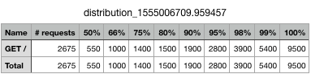

#### Test Summary

Toptal site shows failures with 100 user and 15 seconds load . 429 failures are mainly due to rate limiting.However Average response time is less than 1000 ms not downgraded .

#### Recommendation load test scenarios

Toptal.com site can be tested internally without rate limiting or distributed load testing system to find out site behaviour and response time

* 100 user per 10 seconds for duration of 10 mins
* 100 user per 10 seconds time for duration of 30 mins
* 100 user per 1 minute time for duration of 30 mins
* 1000 user per 1 minute time for duration of 10 mins

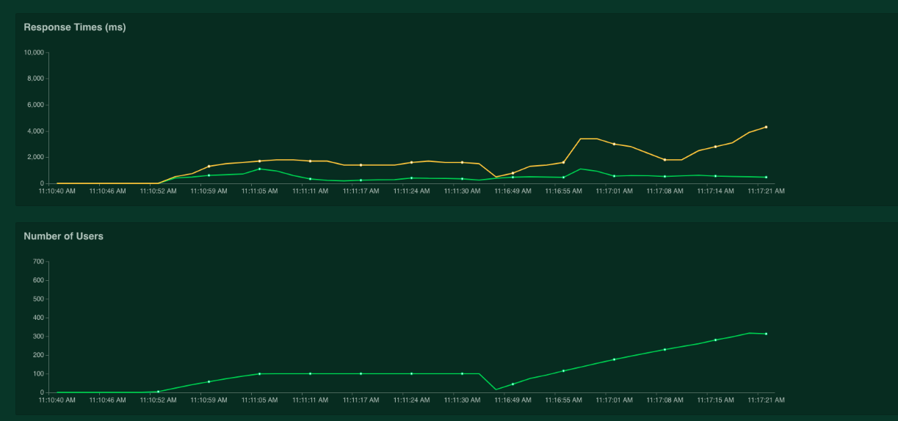

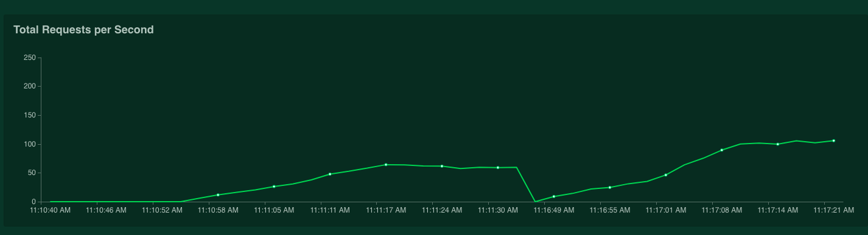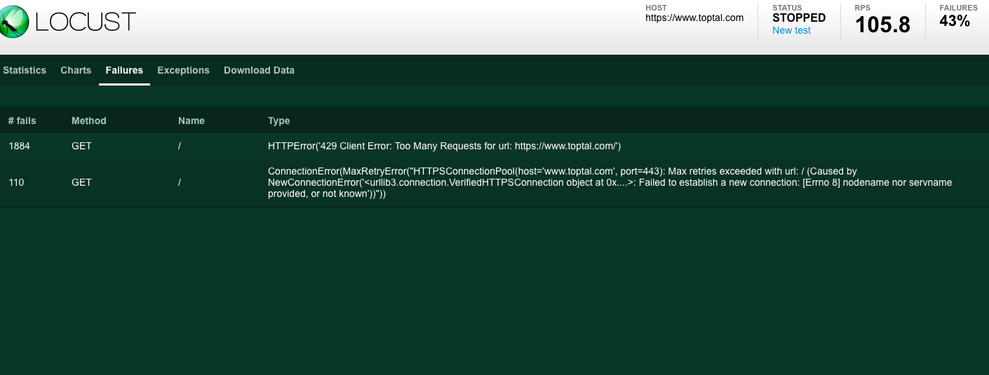

### 

### Test Site 2. Themoviedb.org site

URL - <https://www.themoviedb.org/>

Test Duration -100 users with users spawned/second-15 and duration 1 minute.

#### Test Reports for Themoviedb site

|  |  |  |  |  |  |  |  |  |  |
| --- | --- | --- | --- | --- | --- | --- | --- | --- | --- |
| **Method** | **Name** | **# requests** | **# failures** | **Median response time** | **Average response time** | **Min response time** | **Max response time** | **Average Content Size** | **Requests/s** |
| **GET** | / | 5689 | 0 | 620 | 748 | 229 | 6071 | 50410 | 54.54 |
| **None** | Total | 5689 | 0 | 620 | 748 | 229 | 6071 | 50410 | 54.54 |

distribution_1555009320.85484

|  |  |  |  |  |  |  |  |  |  |  |
| --- | --- | --- | --- | --- | --- | --- | --- | --- | --- | --- |
| **Name** | **# requests** | **50%** | **66%** | **75%** | **80%** | **90%** | **95%** | **98%** | **99%** | **100%** |
| **GET /** | 5689 | 620 | 720 | 850 | 950 | 1300 | 1600 | 1900 | 2500 | 6100 |
| **Total** | 5689 | 620 | 720 | 850 | 950 | 1300 | 1600 | 1900 | 2500 | 6100 |

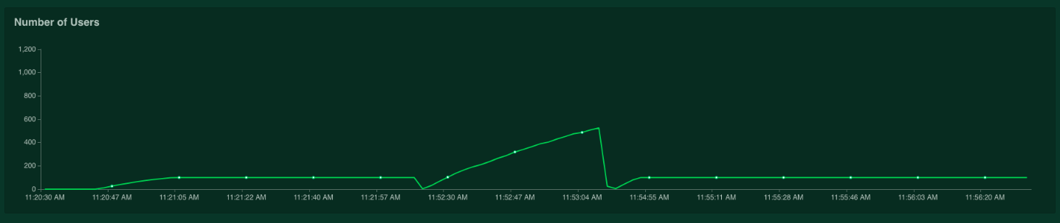

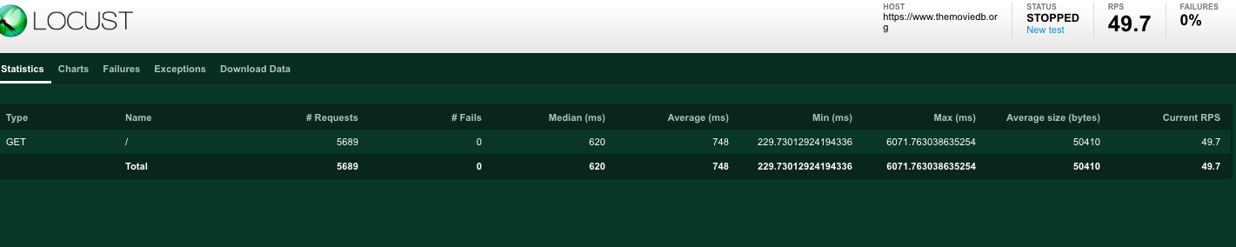

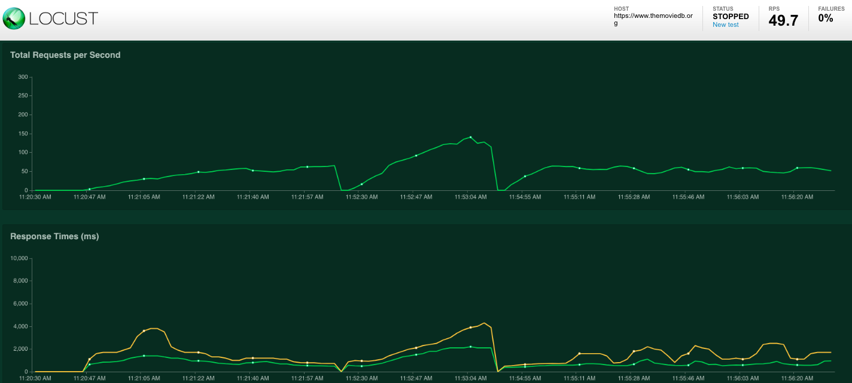

#### Test Summary

moviedb site showed average response time is less than 700 ms during 1 minute of load test for 100 users per 15 seconds . No exceptions or failure during this test time .

#### Recommendation load test scenarios

themoviedb.com site can be tested more with distributed load as this ip is getting blocked due to rate limiting when tried more than 100 users .

More load testing scenarios for themoviedb.org

* 100 user per 10 seconds for duration of 10 mins
* 100 user per 10 seconds time for duration of 30 mins
* 1000 user per 1 minute time for duration of 30 mins
* 100 user per 10 second search for a movie for 10 mins
* 1000 user per 1 minute time search for a movie for duration of 30 mins