**CS 613 – MACHINE LEARNING**

AVANI JAIN

**PART 1: - GRAYSCALE**

Conversion of colorful image into a grayscale image is a complicated process as the colorful image has some important features like contrasts, sharpness and structure of the image which we have to preserve so for that we are using the formula:- Y= 0.2989R + 0.5870G + 0.1140B where Y represents the grayscale value and R,G and B are the intensity values of Red, Green and Blue. The grayscale image converted from this algorithm preserves all the important features of the original image which was very interesting to see.

**PART 2: - CONTRAST STRETCHING**

Contrast Stretching is a process that changes the range of the pixel intensity values. It then brightens the image if the image is in poor contrast. The transformation function which we are using is a linear function. For stretching the image, the intensity values which we are using are between 0-255 but firstly I was not getting the values between them so I clipped the values and got the resulting image. This process is widely used in medical field.

**PART 3: - GAUSSIAN BLUR**

A gaussian smoothening is the result of blurring an image by a gaussian function . It is a widely used effect in graphics software, typically to reduce image noise and reduce detail with sigma=1. After applying this function, the image results in a blur that preserves boundaries and edges better than any other function.

**PART 4: - SOBEL EDGE DETECTION**

Sobel Edge Detection was the toughest part for me to complete in this assignment. The problem I encountered was that it was difficult to reduce the noise by just implementing image smoothing. But after doing smoothing, I was able to generate a grey image instead of black. So to encounter this problem, I set upper and lower bound values of the image to ‘*o’ and ‘255’* respectively and was able to generate the black image. After completing this part, I realized that it has several advantages which are a) It performs better noise suppression b) It is best for using image smoothing. But has one disadvantage that its diagonal direction points are not always preserved.

**PART 5: - COLOR TRANSFER**

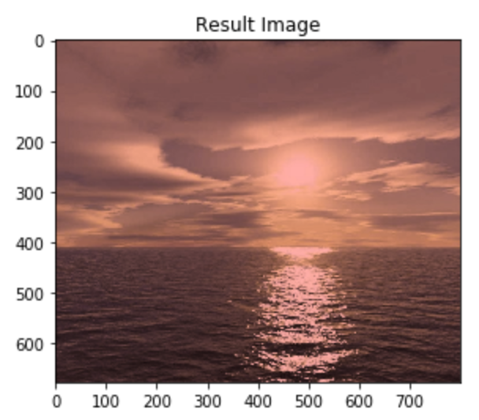

Color transfer can be explained as the mapping algorithm that transforms the colors of the image.

In image color transfer algorithm, it is keeping the scene of the source image and accurately applying all the dominant color styles of the target image. In this part I am using the Lab color transfer method to transfer the colors by doing matrix multiplication and by calculating the mean and standard deviation of the source and destination image and applied all this to the result image. Color transfer is used in the cameras for further processing using two or more sample images.