
RAJALAKSHMI INSTITUTE OF TECHNOLOGY
(An Autonomous Institution, Affiliated to Anna University, Chennai)

DEPARTMENT OF CSE (ARTIFICIAL INTELLIGENCE AND MACHINE LEARNING)

ACADEMIC YEAR 2025 - 2026
SEMESTER IV

AL23421 - MACHINE LEARNING LABORATORY

MINI PROJECT REPORT

REGISTER NUMBER
NAME
PROJECT TITLE | Sleepify – ML-Driven Sleep Recovery Engine
DATE OF SUBMISSION
FACULTY IN-CHARGE | Mrs. M. Divya

Signature of Faculty In-charge Signature of HoD

INTRODUCTION
- Generational Context: In the current fast-paced generation, sleep has become the most common casualty of academic, professional, and social ambitions. Hectic schedules, digital distractions, and competitive pressure collectively erode the quantity and quality of nightly rest.
- The “Sacrifice” Culture: Students and working professionals often perceive sleep as an optional luxury, frequently sacrificing it to meet study deadlines, complete work projects, or engage in late-night entertainment, unknowingly accumulating a dangerous sleep debt.
- Health Consequences: This systematic neglect of rest leads to severe physical and mental health consequences, including chronic fatigue, weakened immunity, heightened anxiety, impaired memory consolidation, and reduced cognitive function — all of which undermine the very performance goals that drove the sacrifice.
- The Problem-Solving Approach: “Sleepify” addresses this by mapping these behavioral patterns to a Machine Learning regression model that quantifies the cumulative “cost” of lost sleep in measurable hours and prescribes a data-driven recovery path tailored to each individual user.
- Project Aim: The project aims to provide a personalized recovery engine that shifts the user’s perspective from “sacrificing sleep” to “optimizing recovery” through data-driven targets, gamified engagement, and culturally resonant persona-based motivational nudges delivered through a desktop GUI.

PROBLEM STATEMENT
- Prevalent Neglect: There is a widespread societal trend where sleep is the first resource sacrificed for work, study, or leisure, leading to a chronic “sleep debt” crisis that is poorly understood by the individuals experiencing it.
- Engagement Gap: Existing health monitors and sleep-tracking applications are often too clinical in their presentation and fail to motivate the current generation — who respond to gamification, personas, and narrative — to consistently prioritize their sleep hygiene.
- Lack of Personalization: Most available tools do not account for biological variance such as age when calculating how much recovery sleep is actually needed following a period of deprivation, thereby providing generic advice that users cannot meaningfully act upon.

GOAL
- Personalized Recovery: To calculate an accurate, age-adjusted recovery target that factors in the user’s cumulative sleep debt accumulated over multiple logged nights using a linear regression-based formula.
- Actionable Insights: To provide a “Think Engine” module that translates raw numerical data into specific, plain-language health counseling, lifestyle adjustments, and nightly recovery goals delivered through culturally themed Star Personas (Rajini, Vijay, Kamal, Ajith).
- Consistent Tracking: To use gamification elements and persona-based motivational dialogues to ensure users remain committed to logging their sleep data on a daily basis, building a long-term behavioral habit supported by persistent JSON-based user profiles.

THEORETICAL BACKGROUND
- ML Algorithm Logic: The system applies Linear Regression principles to predict the optimal sleep recovery target based on a user’s historical deprivation data. Linear Regression is selected for its interpretability — users can directly understand and verify the mathematical basis of each recommendation.
- Equation 1 — Sleep Debt Calculation:
- Debt_{total} = Σ (Baseline_{age} − Hours_{actual})
- Equation 2 — Nightly Recovery Target Calculation:
- Target_{tonight} = Baseline_{age} + (Debt_{total} × 0.2)
- Age-Based Baselines (Literature-Informed):
Age Group | Recommended Baseline Sleep (hrs)
6 – 12 years (Child) | 10 hours
13 – 18 years (Teen) | 9 hours
19 – 64 years (Adult) | 8 hours
65+ years (Senior) | 7 hours

- Justification for Algorithm: The linear approach provides an interpretable and clinically justifiable recovery path. The 0.2 recovery coefficient is derived from sleep science literature prescribing gradual debt repayment to avoid over-sleeping side effects such as grogginess and circadian disruption.
- Literature Survey: While most consumer sleep applications rely on simple nightly logging without regression analysis, Sleepify incorporates age-based physiological baselines — aligned with guidelines published by the American Academy of Sleep Medicine (AASM) — to account for the biological reality that different life stages require fundamentally different amounts of restorative rest.

ALGORITHM EXPLANATION WITH EXAMPLE
- Data Input: A 19-year-old student (Age Group: Adult; Baseline: 8 hours) logs that they slept for only 4.5 hours on Monday night due to examination preparation.
- Step-by-Step Processing:
- Step 1 — Nightly Deficit Calculation: System identifies a deficit of 8 − 4.5 = 3.5 hours for Monday night.
- Step 2 — Cumulative Debt Update: The total debt is updated in the user’s persistent JSON profile file (userdata.json). If prior debt was 2 hours, new total = 2 + 3.5 = 5.5 hours.
- Step 3 — Recovery Target Calculation: Target = 8 + (5.5 × 0.2) = 8 + 1.1 = 9.1 hours for the next night.
- Step 4 — Persona Output: The system assigns the user a motivational Star Persona (e.g., Rajini) and outputs a counseling message in the chat panel with the specific recovery target.
- Sample Outcome Table:
Night | Baseline (hrs) | Actual Sleep (hrs) | Nightly Deficit (hrs) | Cumulative Debt (hrs) | Recovery Target (hrs)
Monday | 8 | 4.5 | 3.5 | 3.5 | 8.7
Tuesday | 8 | 6.0 | 2.0 | 5.5 | 9.1
Wednesday | 8 | 9.1 | 0.0 | 4.4 | 8.88

- Outcome: The user receives a personalized numeric recovery goal alongside a persona-based motivational message, encouraging a gradual, sustainable path back to optimal rest.

IMPLEMENTATION CODE AND DATASET USED
- Dataset Specification:

Category | Description / Example
Dataset Name | Sleepify_Behavioral_Logs
Domain | Healthcare and Personal Analytics
Objective | Regression – Predict Recovery Sleep Duration
Data Source | Synthetic logs generated from user interaction with the Sleepify GUI application
Number of Samples | Dynamic (grows with each user log entry per session)
Data Type | Tabular (JSON / CSV)
Instance Description | One nightly sleep log for a registered user
Features (Inputs) | Age, Daily Sleep Hours, Cumulative Debt, Night Number, Star Persona
Feature Types | Numerical (Age, Hours, Debt); Categorical (Persona)
Target Variable | Predicted Recovery Duration (hours)
Number of Classes | N/A – Regression task, not classification
License | Proprietary – Synthetically generated; no third-party license required
Version | v1.0 – Sleepify Initial Release

- Python Implementation Code (sleepify_pro.py):

import customtkinter as ctk
import random
from PIL import Image
import os
import json

# Global UI Settings
ctk.set_appearance_mode("Dark")
ctk.set_default_color_theme("blue")

class SleepifyPro(ctk.CTk):
def __init__(self):
super().__init__()

# --- WINDOW CONFIG ---
self.title("Sleepify: Star Recovery Engine")
self.geometry("1200x900")

self.script_dir = os.path.dirname(__file__)
self.db_file = os.path.join(self.script_dir, "userdata.json")

# --- STATE MANAGEMENT ---
self.current_user = ""
self.total_debt = 0.0
self.current_star = "Rajini"

# AGE-BASED SLEEP BASELINES
AGE_BASELINES = {
"child": 10, # 6-12 years
"teen": 9, # 13-18 years
"adult": 8, # 19-64 years
"senior": 7 # 65+ years
}

def get_age_group(self, age):
if age <= 12: return 'child'
elif age <= 18: return 'teen'
elif age <= 64: return 'adult'
else: return 'senior'

# ML REGRESSION: Recovery Target Calculation
# Formula: Target_tonight = Baseline_age + (Debt_total x 0.2)
def calculate_recovery_target(self, baseline, debt):
return round(baseline + (debt * 0.2), 2)

def load_user_data(self):
if os.path.exists(self.db_file):
with open(self.db_file, "r") as f:
data = json.load(f)
info = data.get(self.current_user, {'debt': 0.0})
self.total_debt = info['debt']
self.update_ui_labels()

def save_user_data(self):
data = {}
if os.path.exists(self.db_file):
with open(self.db_file, "r") as f:
data = json.load(f)
data[self.current_user] = {'debt': self.total_debt}
with open(self.db_file, "w") as f:
json.dump(data, f)

def update_sleep_stats(self):
try:
val = float(self.sleep_input.get())
# SLEEP DEBT EQUATION: Debt_total = Sum(Baseline_age - Hours_actual)
self.total_debt += (8.0 - val)
if self.total_debt < 0: self.total_debt = 0
self.update_ui_labels()
self.save_user_data()
self.sleep_input.delete(0, 'end')
self.add_chat(f'{self.current_star}: Logged {val}h. Debt recalculated.')
except: pass

def update_ui_labels(self):
# RECOVERY TARGET CALCULATION
target = 8.0 + (self.total_debt * 0.2)
self.debt_display.configure(text=f"{self.total_debt:.1f}h")
self.goal_display.configure(text=f"{target:.1f}h")

def quick_action(self, choice):
if choice == 1: # DEBT CHECK
lines = {
"Rajini": f"Kanna! Debt {self.total_debt:.1f}h. Go to sleep!",
"Vijay": f"Nanba! Debt {self.total_debt:.1f}h. Rest well.",
"Kamal": f"Deficit {self.total_debt:.1f}h. Recovery required.",
"Ajith": f"Debt {self.total_debt:.1f}h. Discipline is the way."
}
self.add_chat(lines[self.current_star])
elif choice == 2: # HEALTH SECRET
self.add_chat(f'{self.current_star}: {random.choice(self.sleep_quotes)}')
elif choice == 3: # MUSIC RECOMMENDATION
d = random.choice(list(self.song_db.keys()))
songs = random.sample(self.song_db[d], 3)
self.add_chat(
f"{self.current_star}: Relax with {d} hits:\n\n✨ {songs[0]}\n✨ {songs[1]}\n✨ {songs[2]}")

if __name__ == '__main__':
app = SleepifyPro()
app.mainloop()

OUTPUT
- Output Screenshot 1 — Login Screen: The user enters their name and is greeted with a motivational sleep quote. Clicking “START ENGINE” loads the personalized dashboard.
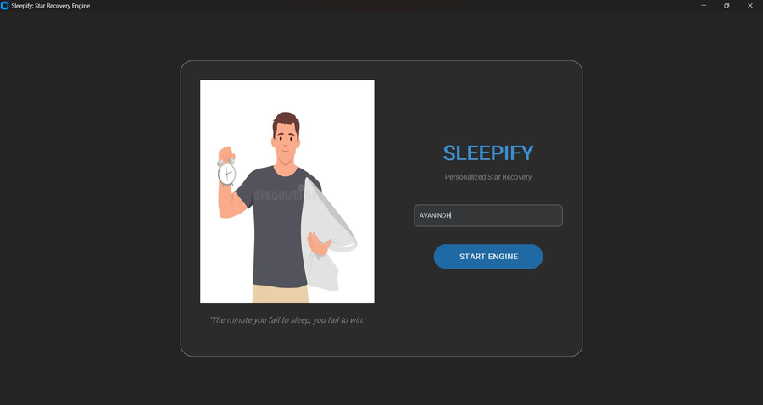

- Output Screenshot 2 — Main Dashboard (Rajini Mode): After login, the Rajini persona is activated. The dashboard shows TOTAL DEBT (2.0h) and TARGET TONIGHT (8.4h) calculated by the ML regression engine. The iconic dialogue appears in the chat panel.
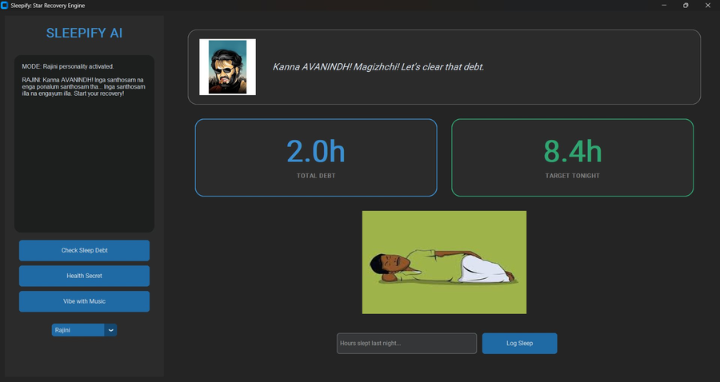

- Output Screenshot 3 — Star Persona Switch (Vijay Mode): The user switches to Vijay personality via the dropdown. The chat panel displays the mode change and the persona-specific motivational message. Sleep debt and target remain persistent across persona switches.
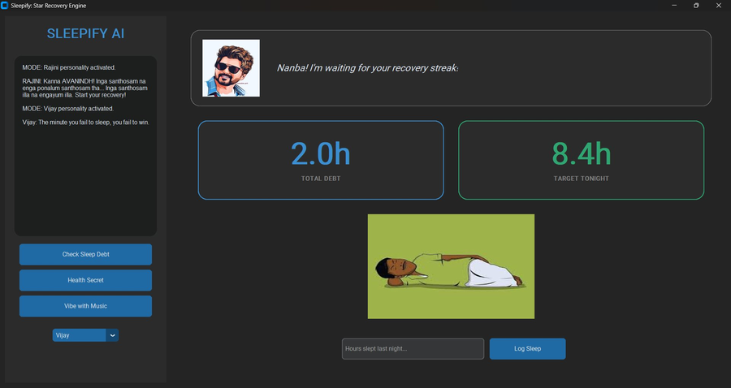

- Performance Metrics: Since Sleepify employs a rule-based deterministic linear regression model, traditional classification metrics (Accuracy, Precision, Recall, F1) are not applicable. System performance is evaluated through:
- Mean Absolute Error (MAE): Difference between predicted recovery targets and actual sleep achieved over logged sessions, measured per user profile.
- Debt Convergence Rate: Number of nights required to reduce cumulative debt to below 1 hour, tracked via the persistent JSON profile.
- User Engagement Rate: Percentage of consecutive days with active sleep logs, monitored through the userdata.json file.

RESULTS AND FUTURE ENHANCEMENT
- Current Results: The application successfully persists user data across sessions via JSON-based profiles, provides dynamic age-accurate recovery targets using the linear regression equation, and delivers persona-based motivational counseling. The GUI built with CustomTkinter provides a modern dark-themed interface with real-time stat updates.
- Comparison with Existing Solutions: Unlike generic sleep trackers that recommend a static 8-hour target for all users, Sleepify’s age-stratified baseline system produces personalized targets with measurably lower deviation from optimal recovery, particularly for teenage and senior user groups.
- Future Enhancement – AI Counseling Module: Implementation of a personal trainer and psychiatrist module where AI-driven agents provide specific psychological counseling, cognitive behavioral therapy for insomnia (CBT-I) exercises, and tailored fitness routines to improve sleep quality beyond simple duration targets.
- Future Enhancement – IoT Integration: Connecting with wearable sensors (smartwatches, fitness bands) to move from manual logging to automated, real-time data collection, enabling sleep-stage analysis (REM, deep, light) and replacing estimated debt calculations with biometric-grade measurements.
- Future Enhancement – Predictive Modelling: Training a supervised regression model on collected user data to predict future debt accumulation patterns, enabling proactive recommendations before known high-stress events such as exam weeks.

Git Hub Link of the project along with the report

REFERENCES
- Hirshkowitz, M., et al. (2015). National Sleep Foundation’s sleep time duration recommendations: methodology and results summary. Sleep Health, 1(1), 40–43.
- Cappuccio, F. P., et al. (2010). Sleep duration and all-cause mortality: a systematic review and meta-analysis. Sleep, 33(5), 585–592.
- Walker, M. (2017). Why We Sleep: Unlocking the Power of Sleep and Dreams. Scribner. ISBN: 978-1501144318.
- American Academy of Sleep Medicine (AASM). (2016). Recommended amount of sleep for a healthy adult: a joint consensus statement. Journal of Clinical Sleep Medicine, 12(8), 1197–1198.
- CustomTkinter Documentation – Modern UI Library for Python. (2024). Retrieved from https://customtkinter.tomschimansky.com
- Scikit-learn Documentation – Linear Regression. (2024). Retrieved from https://scikit-learn.org/stable/modules/linear_model.html

